Using El Niño Southern Oscillation (ENSO) Cycle as a Predictor for Dengue Transmission in Iquitos Peru: Supplementry figures

Sophia Drewry

2021-12-13

This file houses the supplementary material not included in the final manuscript.

## 0.1 Exploratory Data Analysis

### 0.1.1 Weather Predictors

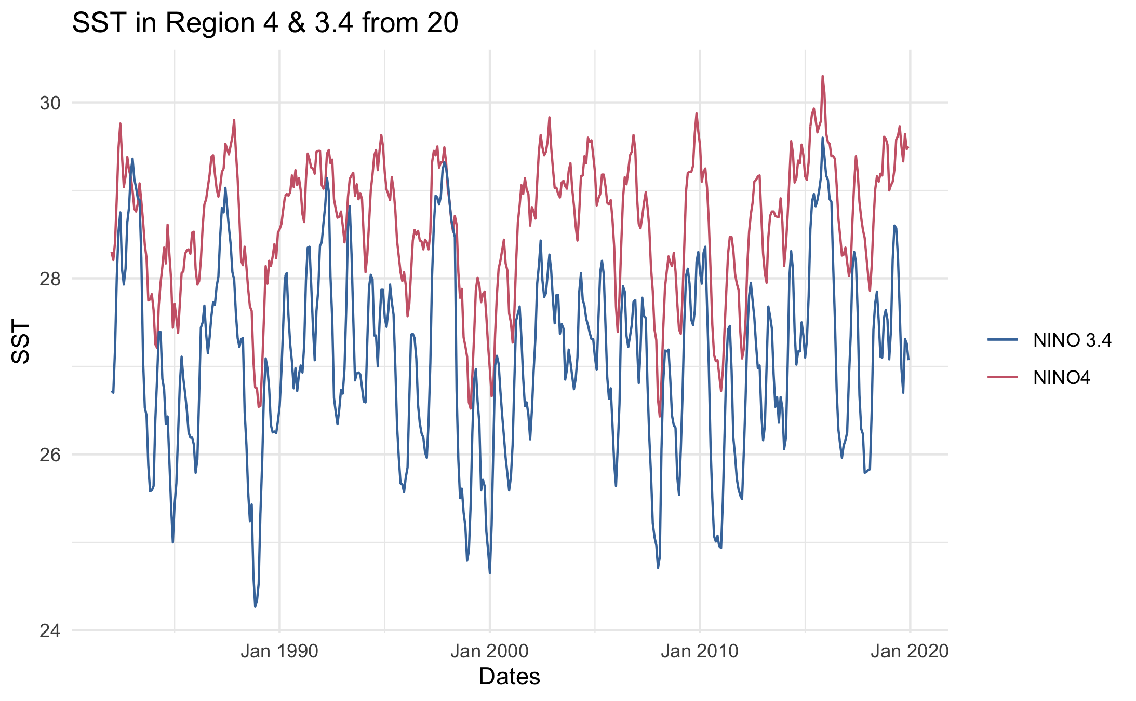

Figure 0.1: EDAfig1.

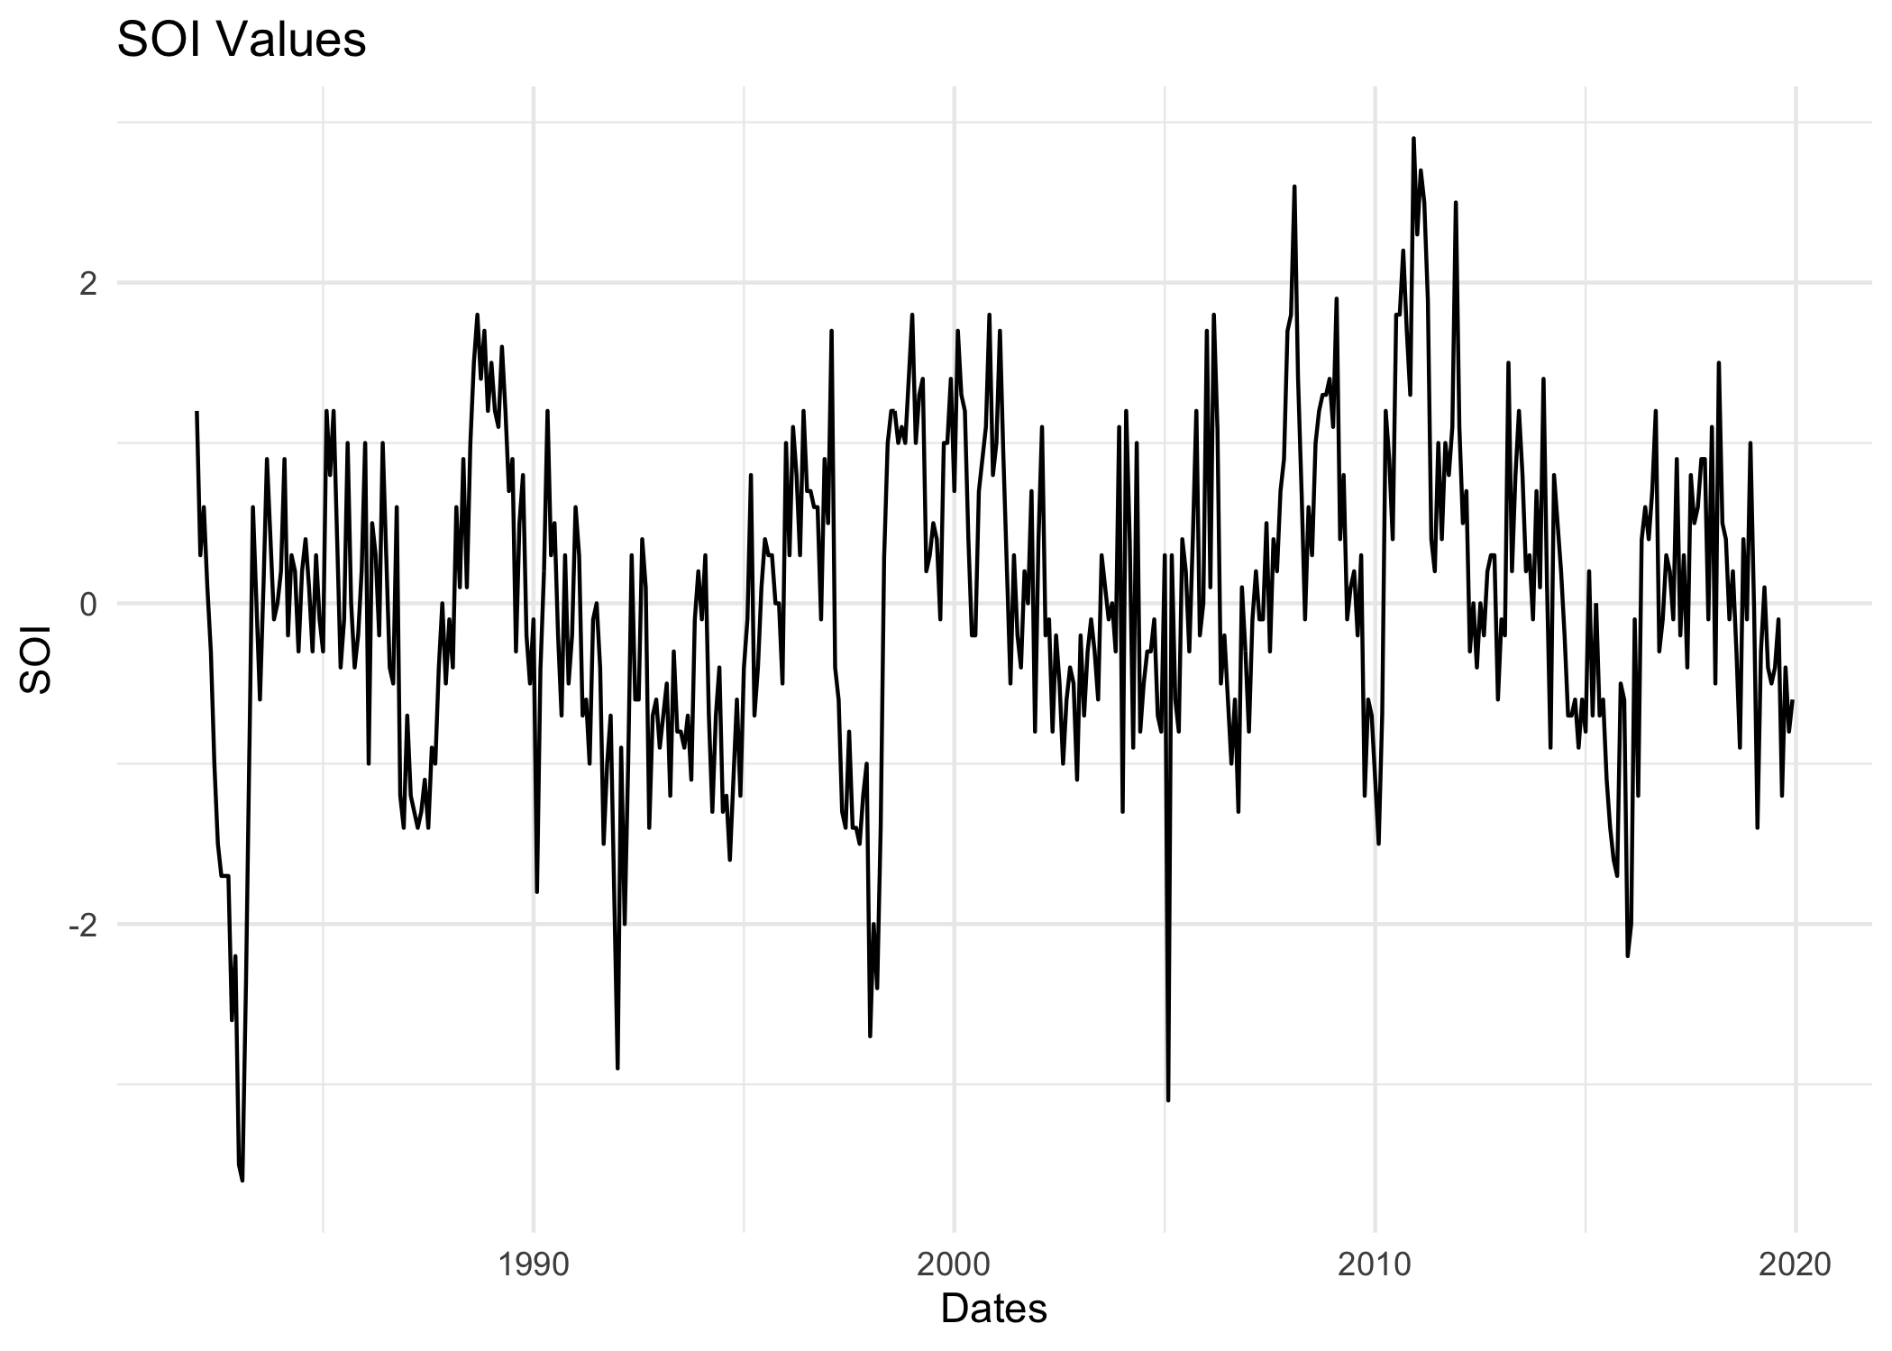

Figure 0.2: EDAfig2.

Here is a summarizing table that looks at weather by season. Here you can note the seasonality in the data and the general trend. This figure accompanies the cumulative dengue incidence by season. 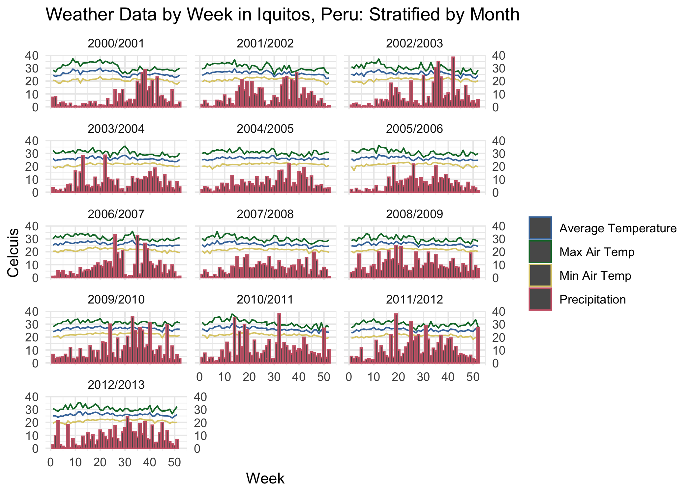 ### Dengue Distribution

### 0.1.2 Bivariate Interaction between Dengue Distribution and Weather Predictors

This graph is looking at dengue IR and the average temperature. 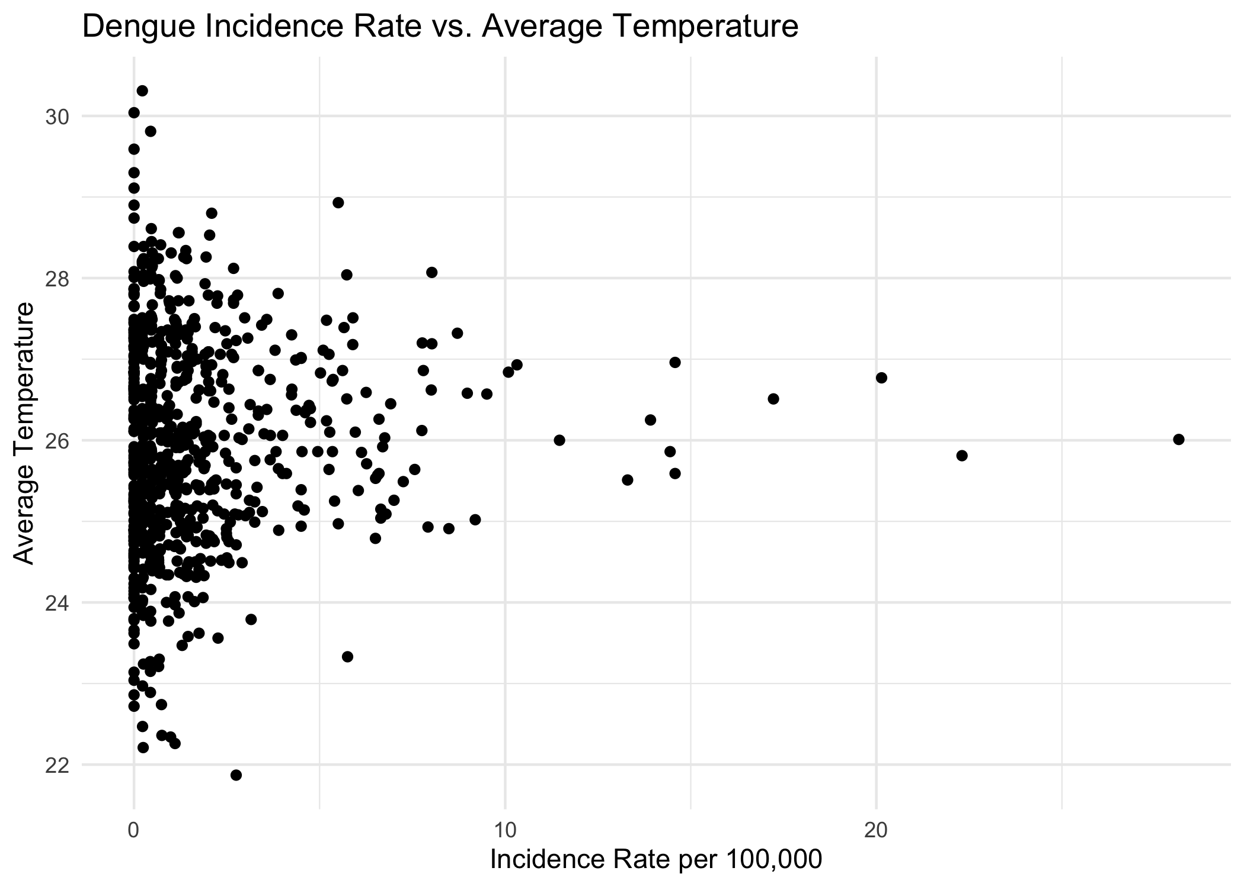 This graph is looking at dengue IR and precipitation. Similar relationship to the above. This may be because the lag period is not accounted for. 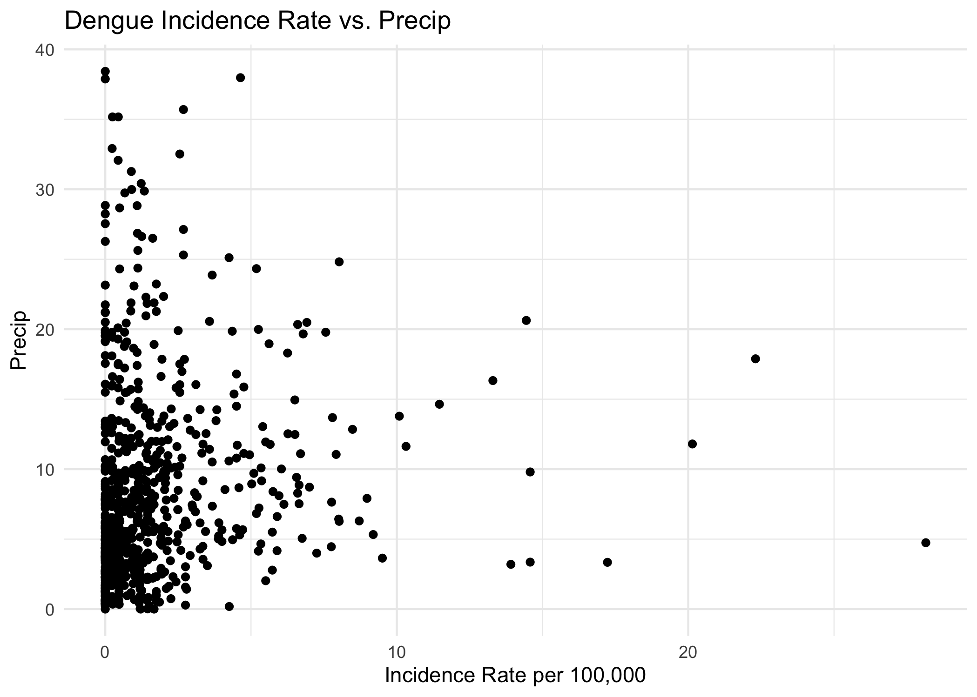

# 1 Modeling Figures and Rationale

The figue represent all the data compared on a time series format. 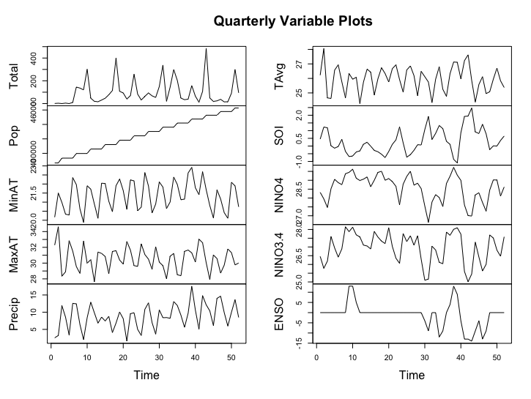

The following two figures are checking to see if data is normally distributed in both histogram form and QQ plot form 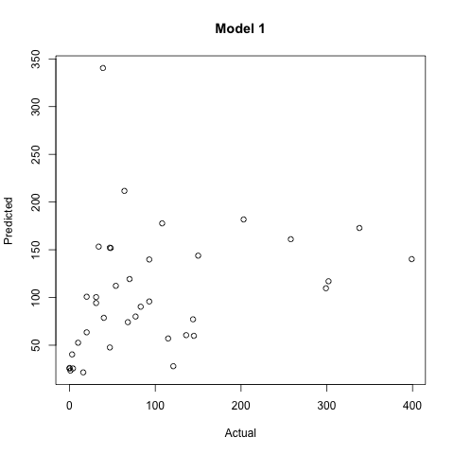

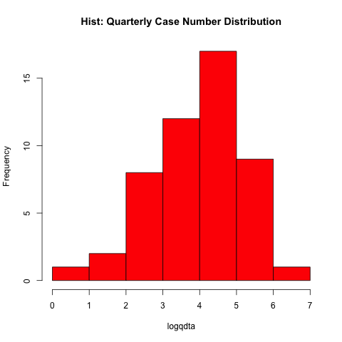

(#fig:A1P4.png)A1P4

### 1.0.1 Multiple Linear Regression with PCA

Below are the two Principal Component Analysis figues produced. 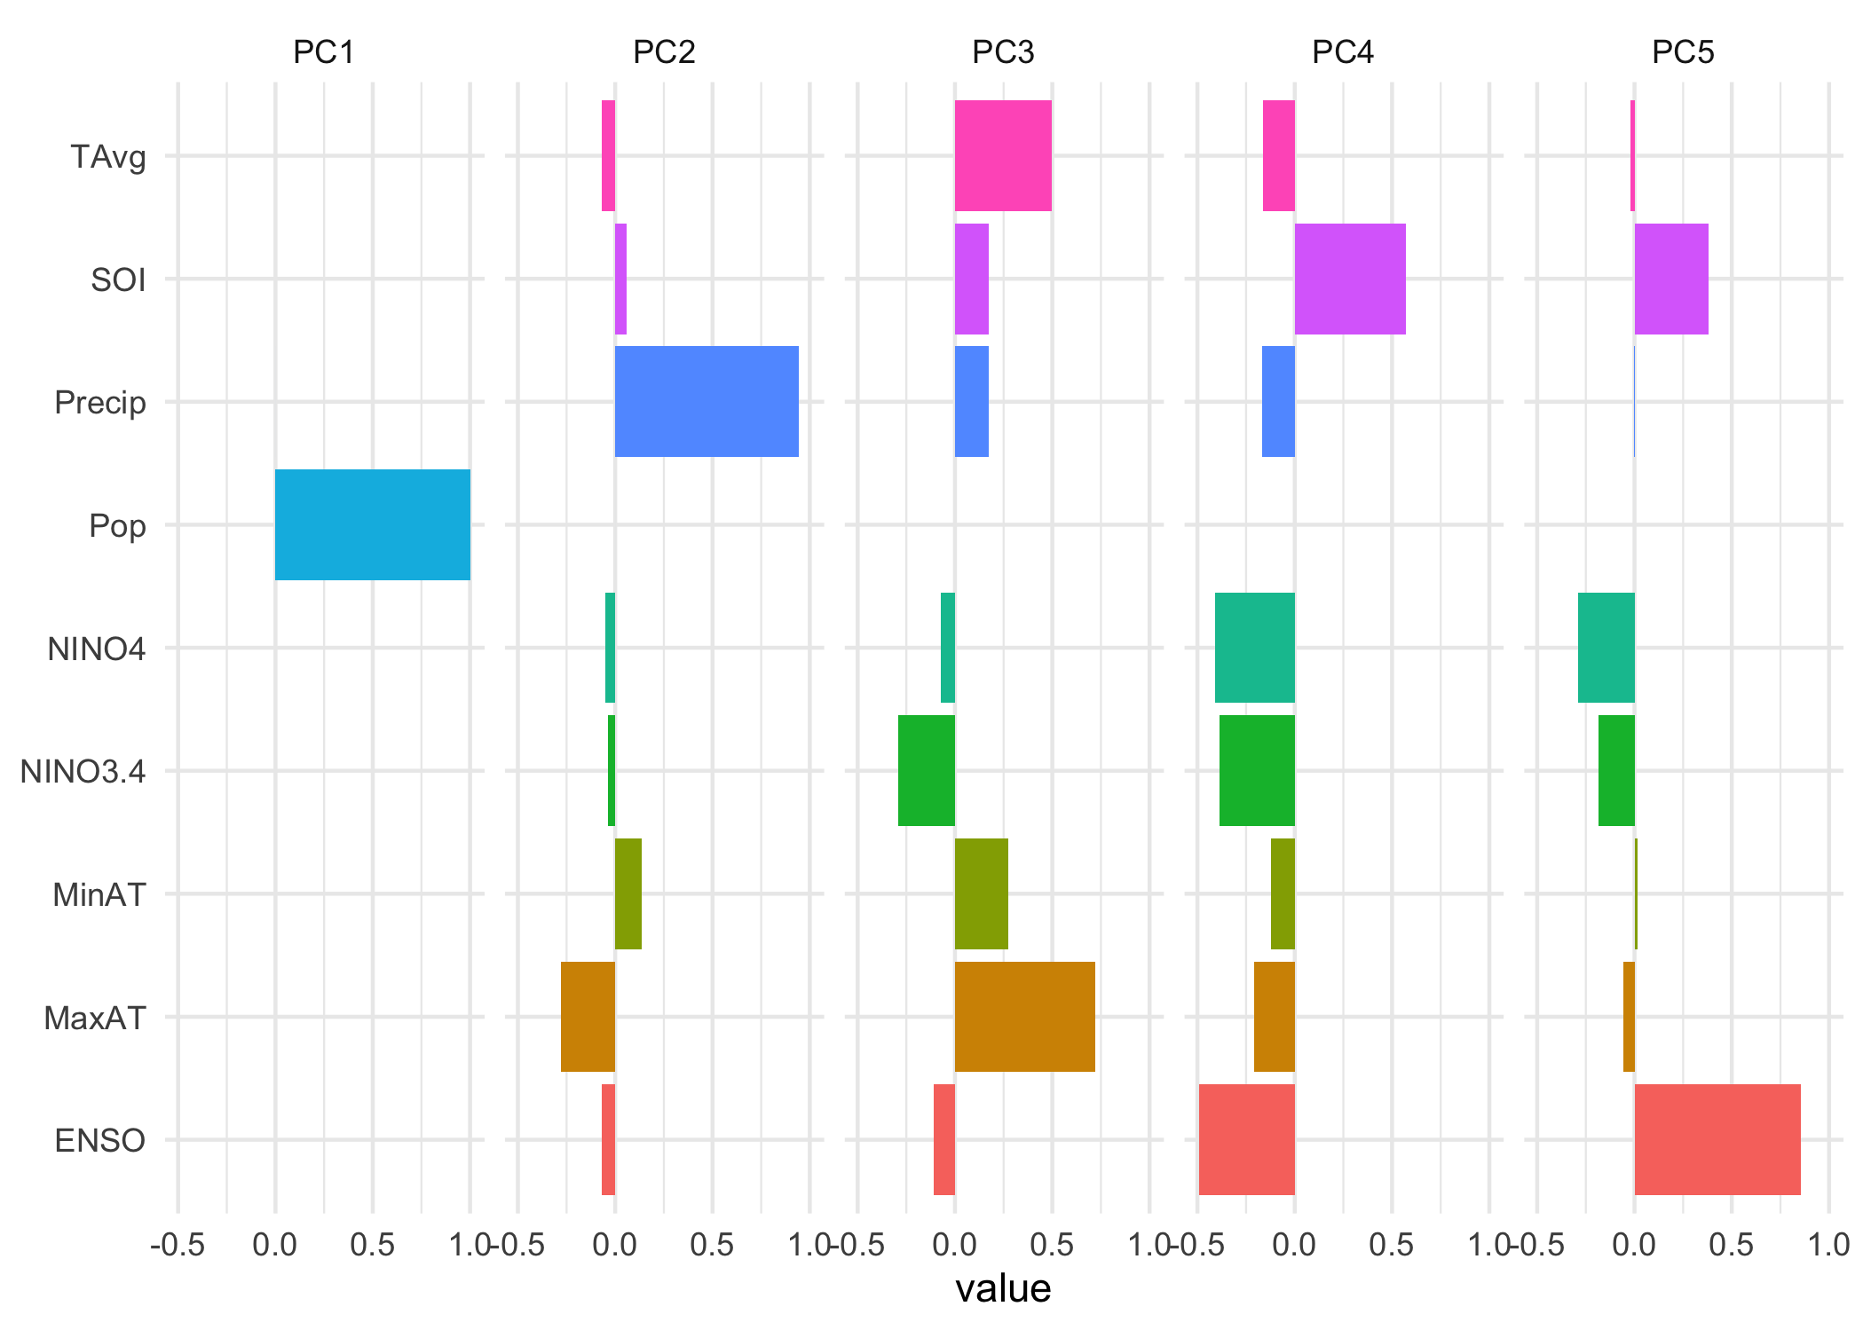

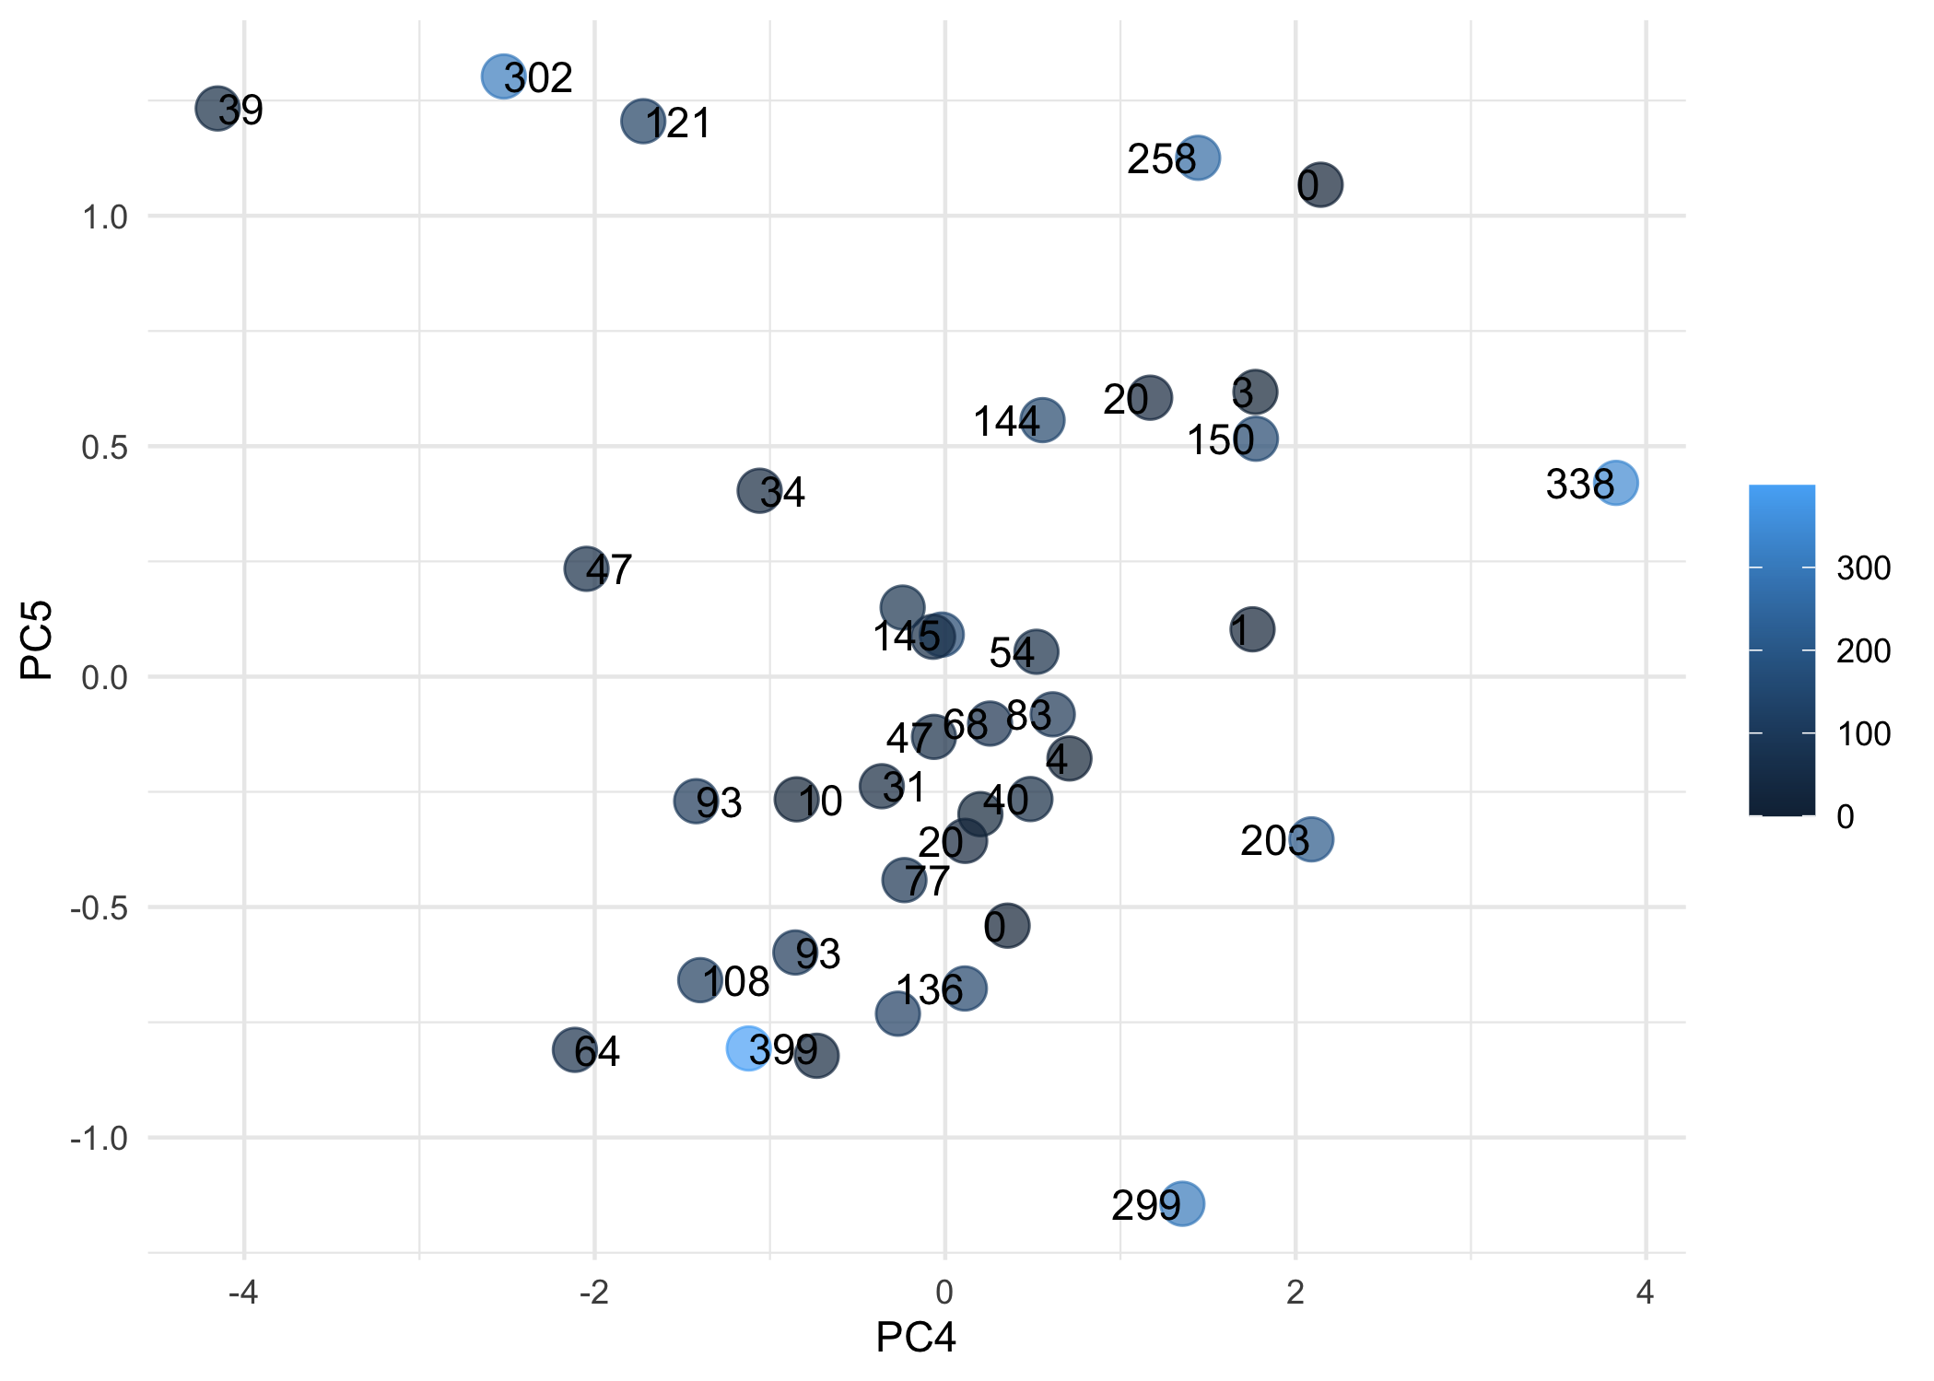 Looks like PCA1 has to do mainly with population, not sure why it popped up. PCA 2-5 look the most interesting. Based on ENSO value, it looks like PCA2 and PCA3 describe “normal” weather phases, or neither El Nino or La Nina classified as 0 ENSO. PCA4 appears Cooler phases or La Nina cycle, and PCA5 seems to describe El Nino, however Precipitation is not very representative of this.

### 1.0.2 Poission Regression

Residual plot for Poission Regression 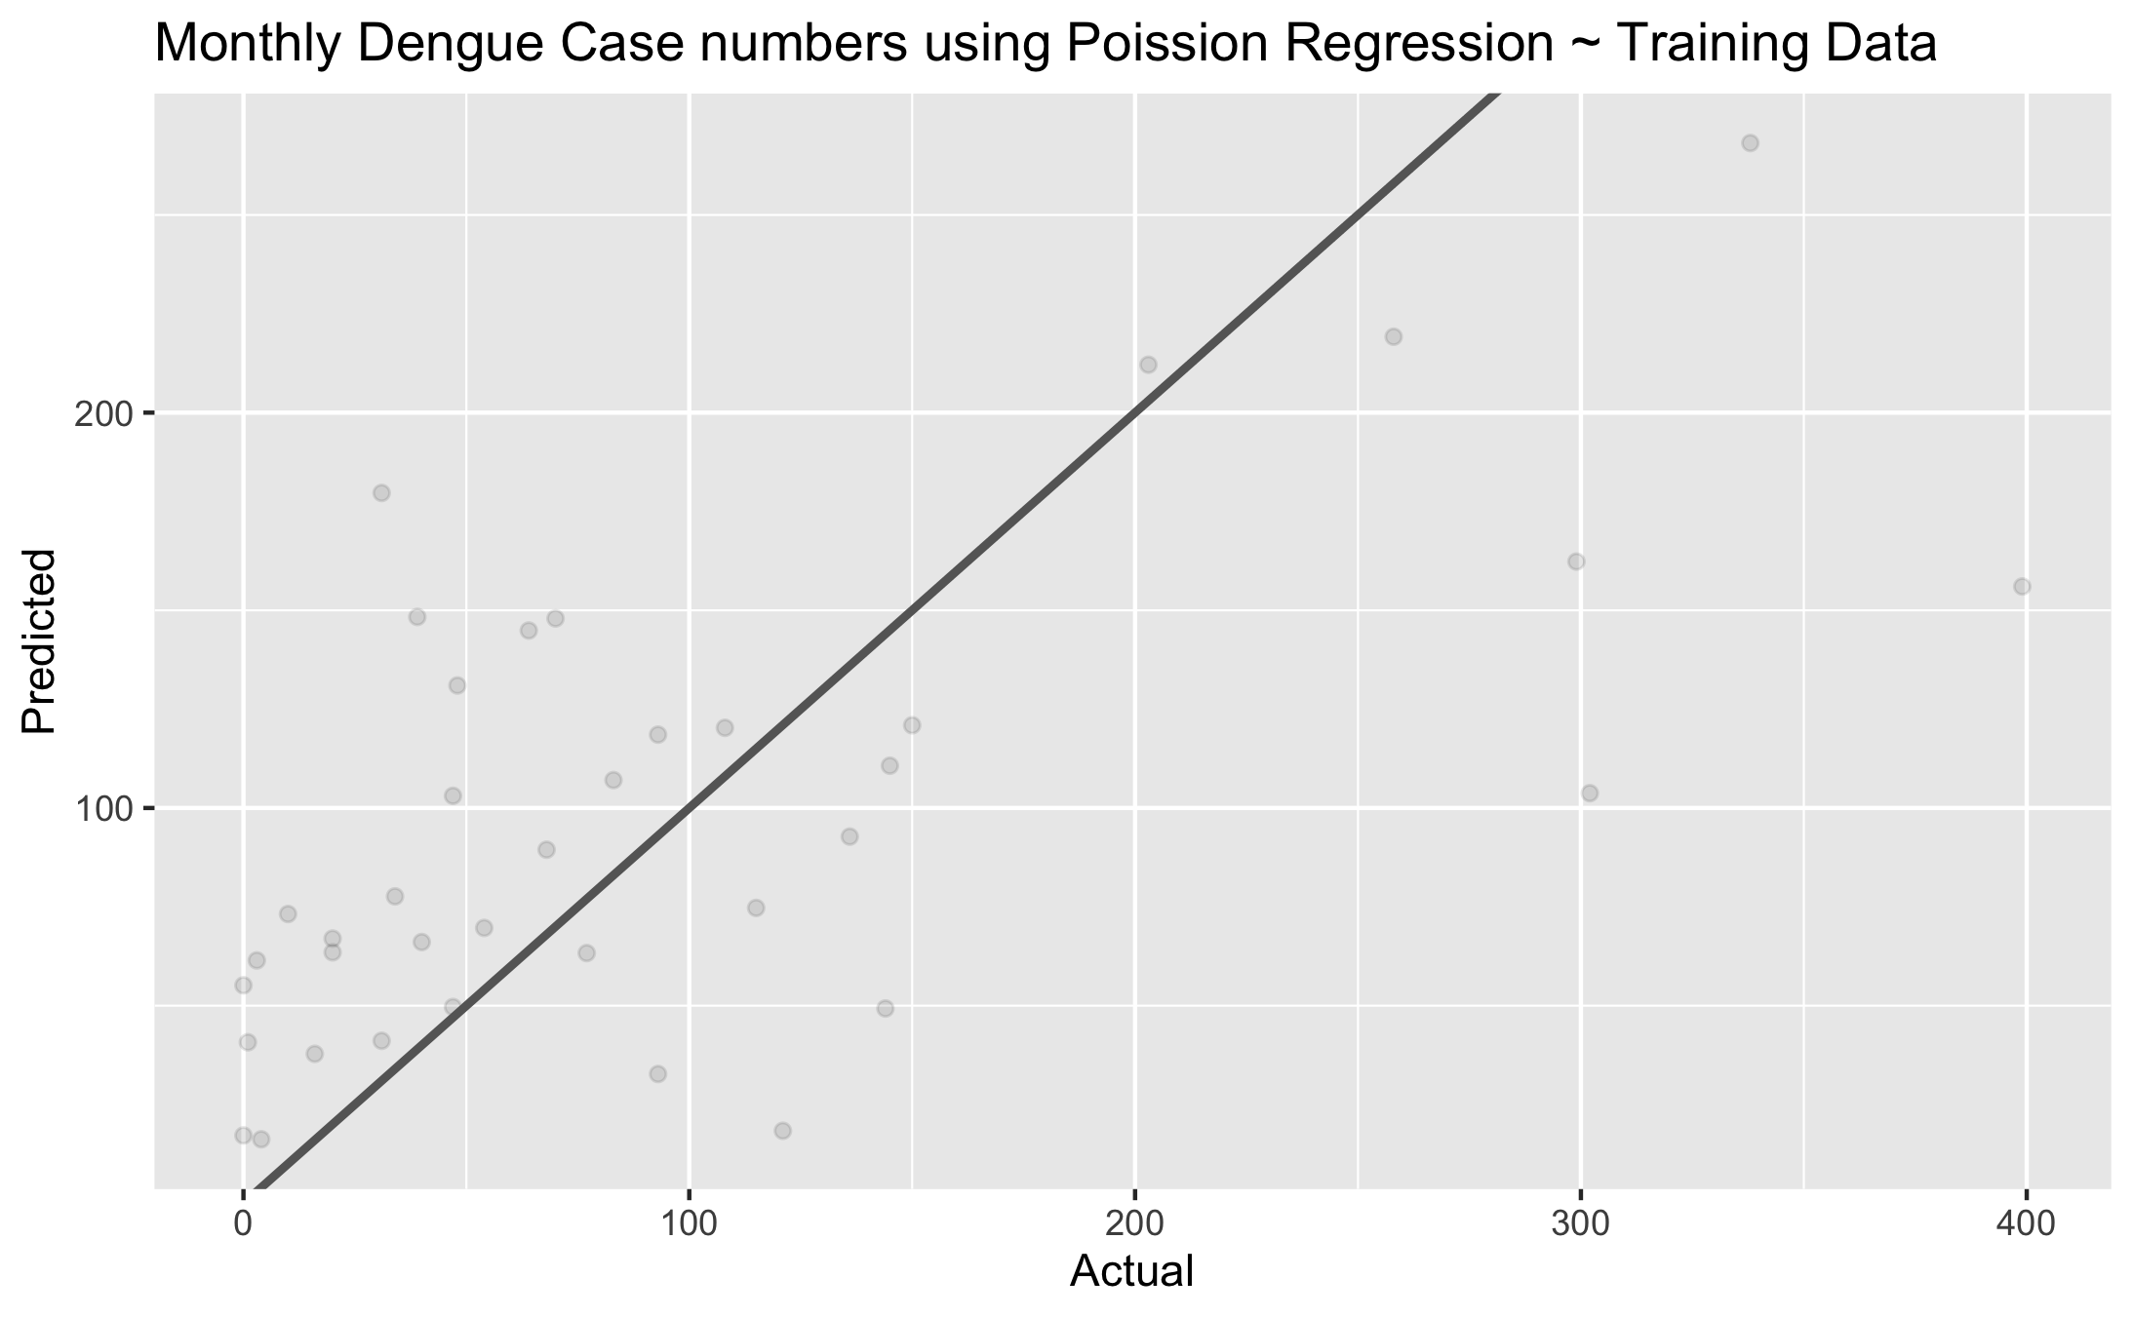

### 1.0.3 Decision Tree

RMSE plot for Decision TreeS 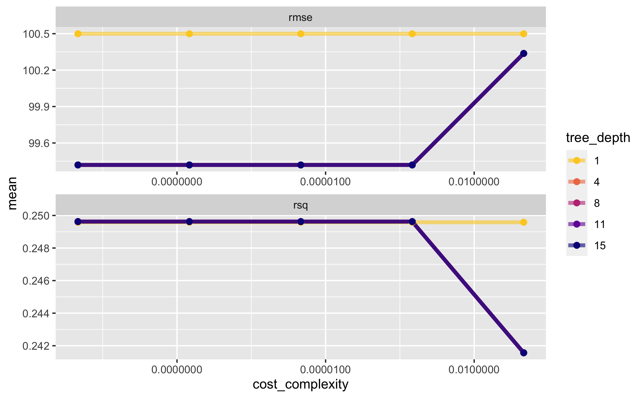

### 1.0.4 K Nearest Neighbors Model

RMSE plot for K Nearest Neighbors Model 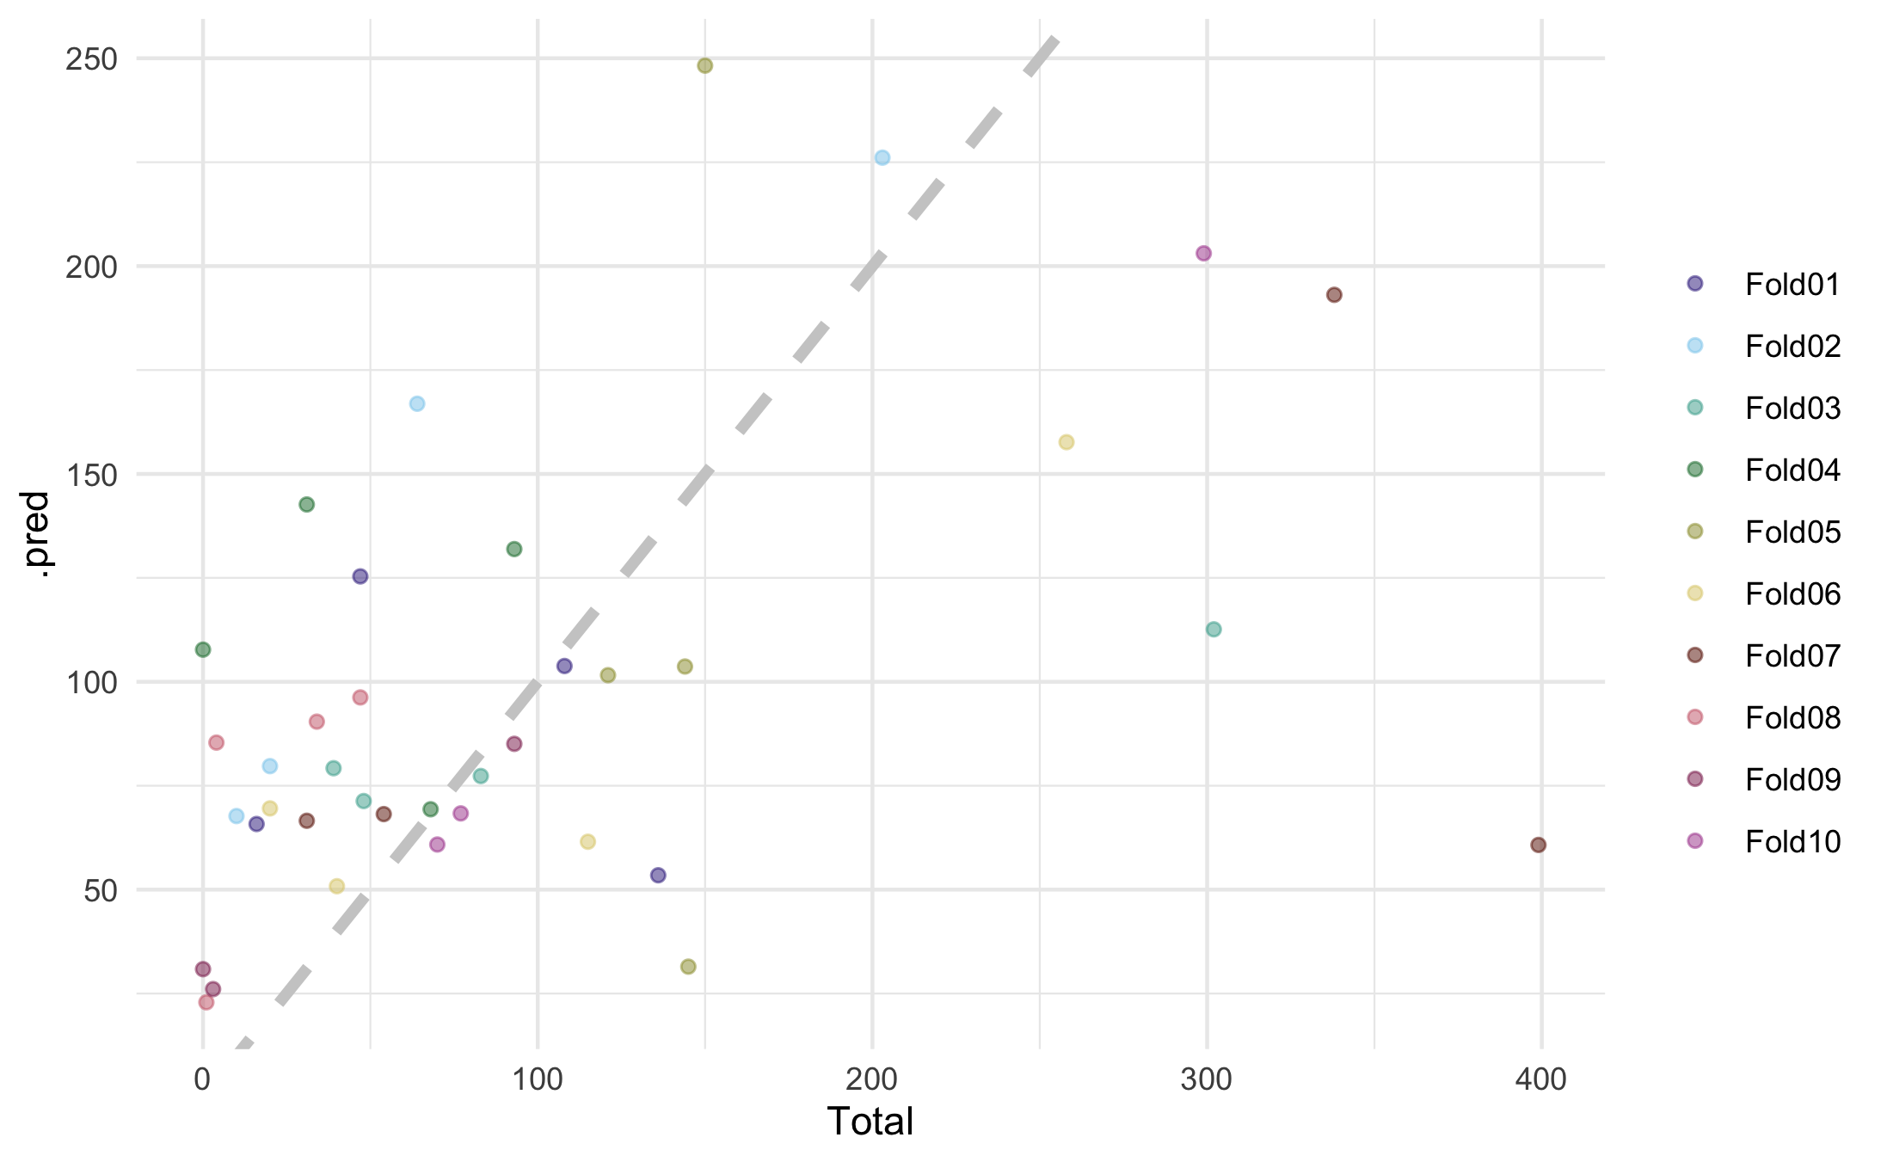

### 1.0.5 K Nearest Neighbors Model

RMSE plot for fINAL model:Poisson Regression 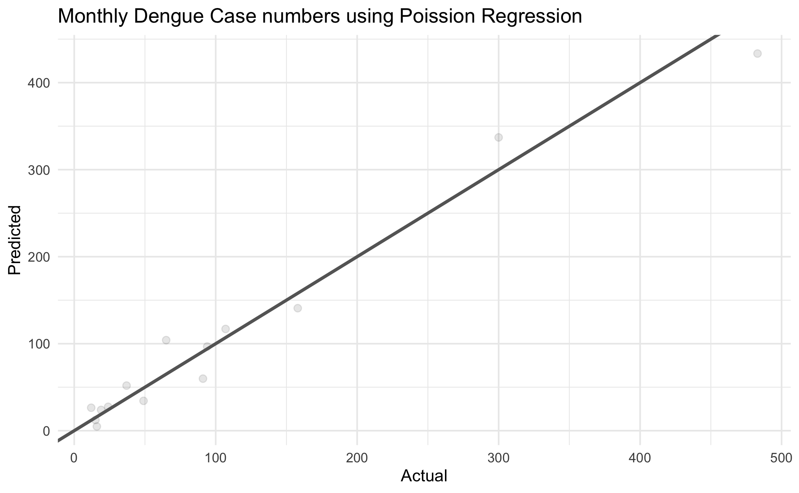

Null Model | 100.3227  
Multi Linear Regression Model | 93.03668  
Poisson Regression | 77.94448  
Negative binomial regression | 101 Decision Trees | 98.81927 LASSO | 113.3661  
K Nearest Neighbors Model | 77.7879416