Using El Niño Southern Oscillation (ENSO) Cycle as a Predictor for Dengue Transmission in Iquitos Peru

Sophia Drewry

2021-12-13

# 1 Background

Since the start of the 20th century, dengue fever and dengue hemorrhagic fever have caused a significant burden in many parts of the world. According to the WHO, dengue incidence has increased 30-fold in the past 50 years (WHO, 2012). Environmental impacts on the breeding patterns and overall population of dengue’s primary host, the aedes Aegypti mosquito can be the suspected cause of this increase incidence. Factors such as rapid urbanization, change in weather and conditions, and poor sanitation contribute to the population growth of such Aedes vectors (Medlock & Leach, 2015). Dengue has 4 main serotypes, all of which have been found to circulate in South America. The country of Peru has experienced intermittent dengue outbreaks, some lasting as log as 10 years(Stoddard et al., 2014).It is also important to note that aedes Aegypti can also carry other arboviral diseases such as Zika, Chikungunya and West Nile, all of which are endemic to Peru to a smaller proportion. The city of Iquitos is conveniently located in close proximity to the Nanay, Itaya, and Amazon Rivers and has a detailed dengue surveillance program set up with the Peruvian Ministry of Health and the U.S. Naval Medical Research Unit (Stoddard et al., 2014). Iquitos proximity to the ocean and higher altitude make this city ideal to study large scale weather phenomena on an urban level. The El Niño Southern Oscillation (ENSO) cycle has been shown to impact climate and ecology around the world. Its effect on infectious diseases transmission across South America has only been studied as isolated incidences or as general patterns on a limited geographic span. Climate data is important factor when studying zoonotic diseases and their geographic range(Tantaléan Yépez et al., 2016). Waterborne and vector borne diseases usually see a spike in incidence rates when the host specie’s life cycle, habitat or breeding habits are altered, for this paper the Aedes aegypti mosquito host will be studied. The Aedes aegypti mosquito is the carrier of diseases found in south America such as dengue, Zika, West Nile virus, Chikungunya, and Venezuelan equine encephalitis (VEE) Vincenti-Gonzalez, Tami, Lizarazo, & Grillet (2018). Dengue is the most prevalent arboviral disease in south America (Vincenti-Gonzalez et al., 2018)

The impact of temperature and weather patterns has been shown to affect aedes Aegypti habitat and population dynamics. While as of 2021, dengue is mainly found in tropical and subtropical regions, studies have predicted that by 2050 southern United States and coastal eastern China and Japan will be at risk of endemic dengue transmission due to global climate change (Messina et al., 2019).

### 1.0.1 ENSO and Vector Population

Other countries such as India and Australia have been able to create predictive models, showing that a change in mean SOI values and rainfall variables are associated with either an increase or decrease of dengue incidence 3 months later Hu, Clements, Williams, & Tong (2010).

Dengue is a zoonotic disease and relies on vector dynamics, so it is important to understand the timeline between weather events and the increase or decrease in cases. This “lag” between climate data and disease incidence differs depending on region, weather and dominant mosquito. Lower temperatures result in shorter “lag” times due to mosquito’s mortality. The inverse can be seen with higher temperatures and humidity, having longer lag times due to favorable breeding conditions (Gharbi et al., 2011). Such a lag time has been measured to be anywhere form 4 to 18 weeks (Brunkard, Cifuentes, & Rothenberg, 2008).

Studies done in South America have also concluded similar lag times for weather anomalies and dengue prediction, and have ranged anywhere from 1 month to 5 months depending on season and variable Stewart-Ibarra & Lowe (2013). Since the ENSO cycle, both El El Niño and La Niña, can affect this lag time differently based on the 1-3 year cycles, no firm number has been found to be associated with ENSO related predictors, as discussed in greater detail in a recent paper by Dr.Stewart-Ibarra (Stewart-Ibarra & Lowe, 2013).

# 2 Description of data and data source

## 2.1 NOAA Data

El Niño and La Niña weather phenomena is measured as a function of the Southern Oscillation Index (SOI) and Sea Surface Temperature (SST). Both negative and positive SOI & SST values coincide abnormally warm and ocean waters across the eastern tropical & southern Pacific as well as change in air pressure. Other measures of outcomes of El Niño and La Niña episodes are ocean salinity, ocean temperature, ambient temperature, rainfall. SOI, SST and ENSO data for the years of 2001-2009 is publicly available and obtained from the National Oceanic and Atmospheric Administration (NOAA)

Our primary region of interest is 3.4, however in some cases data from region 4 is a better indicator for landfall values (NCEI.Monitoring.Info@noaa.gov, n.d.). For this reason, some variables will have both region 3.4 and 4 as predictors. If data from region 4 is used, it will be noted.

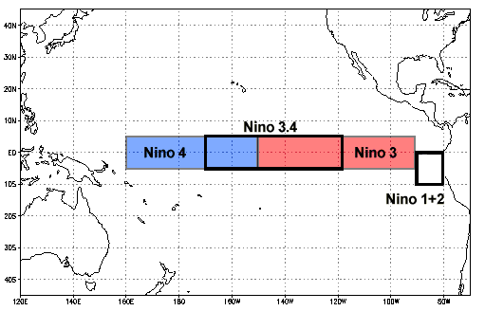 Image from (NCEI.Monitoring.Info@noaa.gov, n.d.)

## 2.2 Dengue Forecasting Project Data

Weekly dengue reported cases from 2001-2009 in Iquitos, Peru is obtained from the Dengue Forecasting Project partnership with CDC and NOAA. Since dengue incidence data was reported from serological tests, serotype(DENV1-4) is included. This publicly available dataset also includes yearly population and monthly average rainfall data as well.

## 2.3 Questions/Hypotheses to be addressed

With the data I have chosen, I am looking to see if the El Niño and La Niña weather phenomena can be used as a predictor of arboviral disease transmission, specifically dengue in Iquitos, Peru.

# 3 Methods and Results

## 3.1 Data import and cleaning

Data cleaning consisted of combining all NOAA data sets into one larger set. This was done by converting all dates into numerical forms across each platform as well as adding additional week numbers. It’s important to note that the dengue data sets count incidents both weekly and by the physical date. This season in which the weeks are counted are not done by traditional year (starting in Janurary) but by Peruvian dengue seasons, starting in May. For this reason I chose to join all data sets using the physical date at the beginning of each week (month-day-year). Each data set was trimmed to match the original range of the dengue data set given.

## 3.2 Exploratory analysis

Initial exploratory data analysis was done on individual data sets after cleaning. Once sets were merged, addition descriptive table and models were produced. With the exploratory date analysis, one of the main goals when looking at the ecological data was to understand the interaction between the NOAA variables, SOI, SST and ENSO classification. This is done in the following chart. As mentioned previously both region 4 and 3.4 included in the data set because both are deemed as appropriate indicators of SST for the coastal Atlantic region. Each differ slightly but both are used for predicting patterns on the South American Coast (cite source)

SOI values follow do not follow an obvious pattern of either region 4 and 3.4 SST value as pictured in Figure 3.1 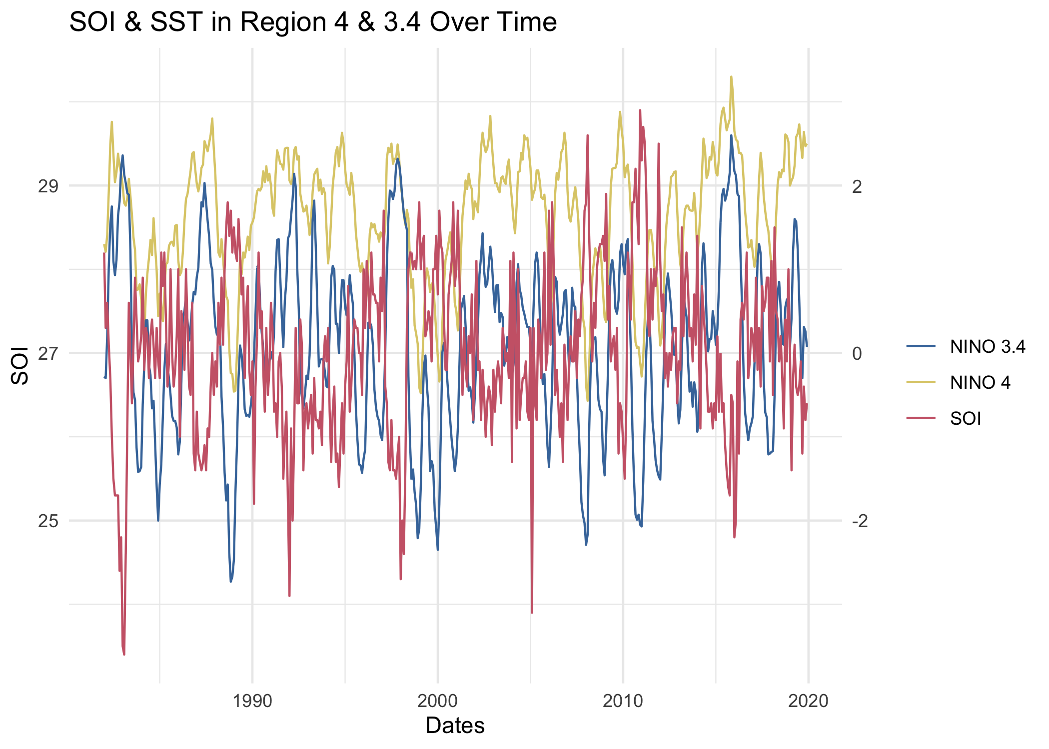

Figure 3.2 is a visualization of El Niño and La Niña occurrences. ENSO values coded red are El Niño and values coded blue are La Niña. These are the official classifications done by NOAA using various climate indices and are not as sensitive of an indicator. 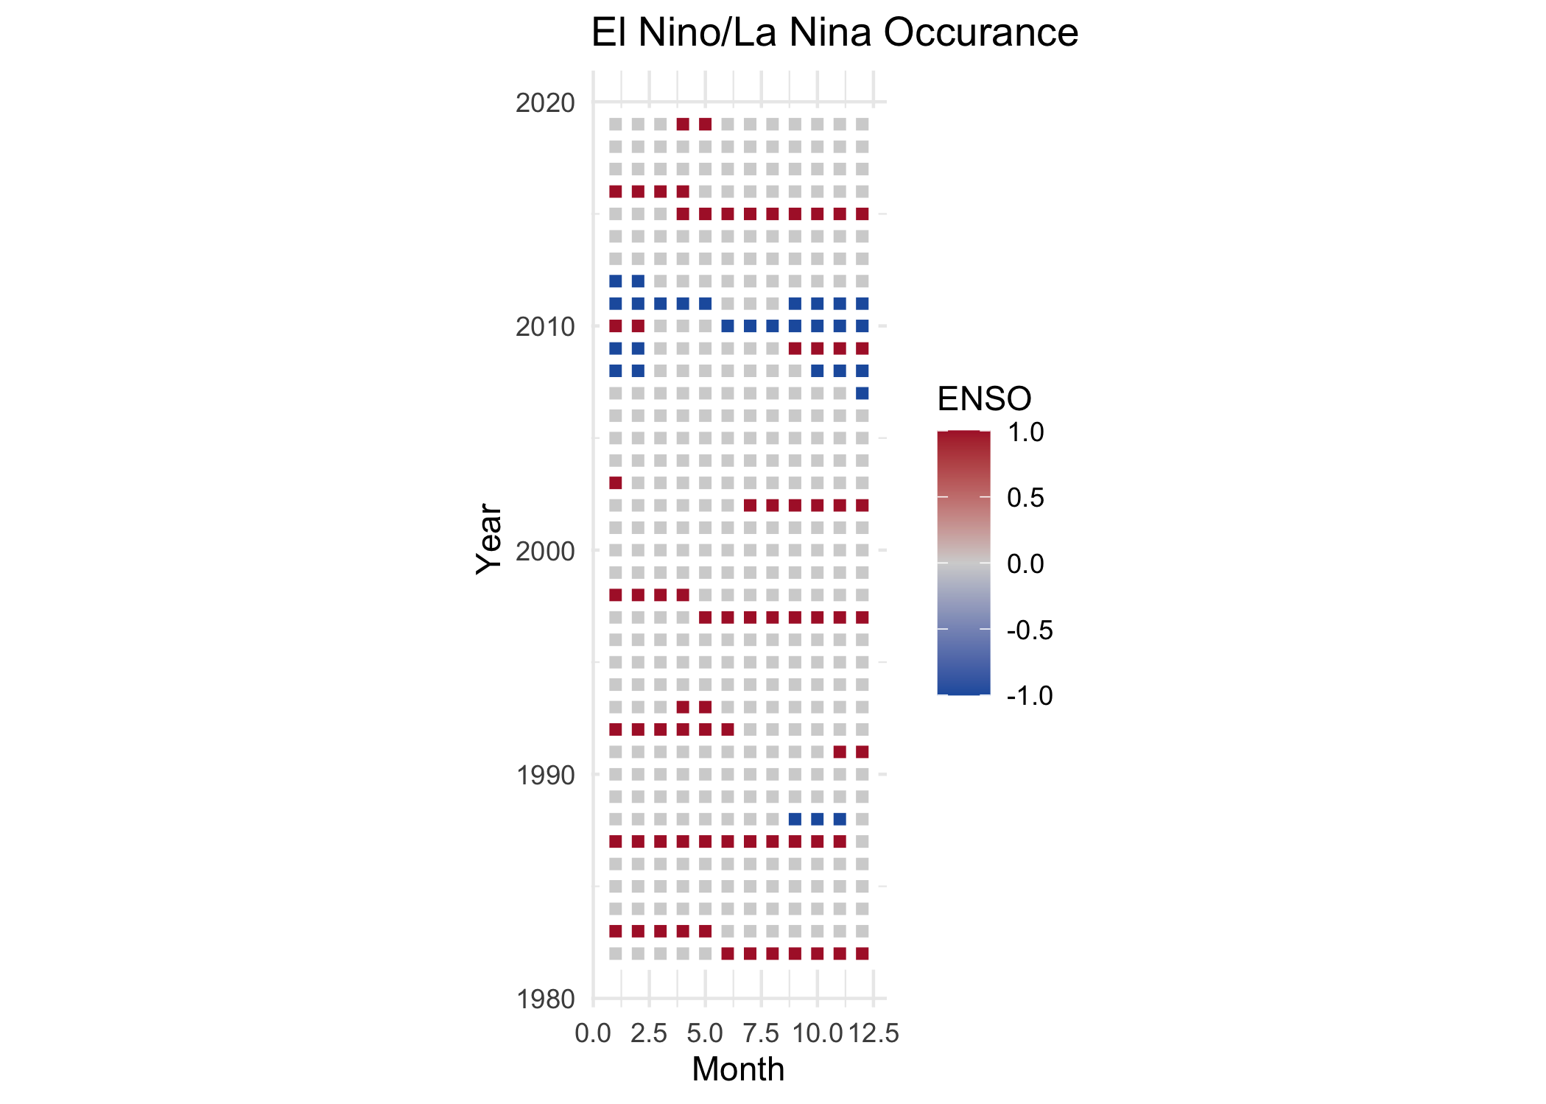

Dengue incidence in Iquitos Peru is represented in the following 3 graphs. Since all cases are reported via laboratory testing, serotyping can be done. Figure 3.3 show this distribution. Note the introduction of DENV-4 around 2008. 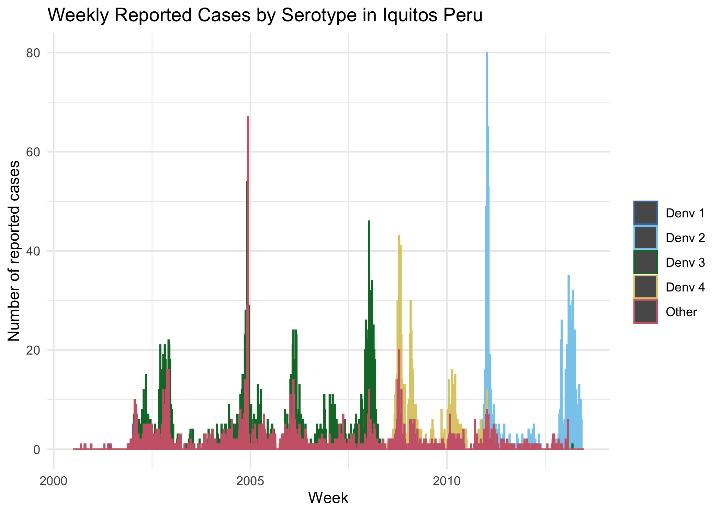

Cumulative incidence of reported dengue infection by year is shown in the following graph. Figure 3.4 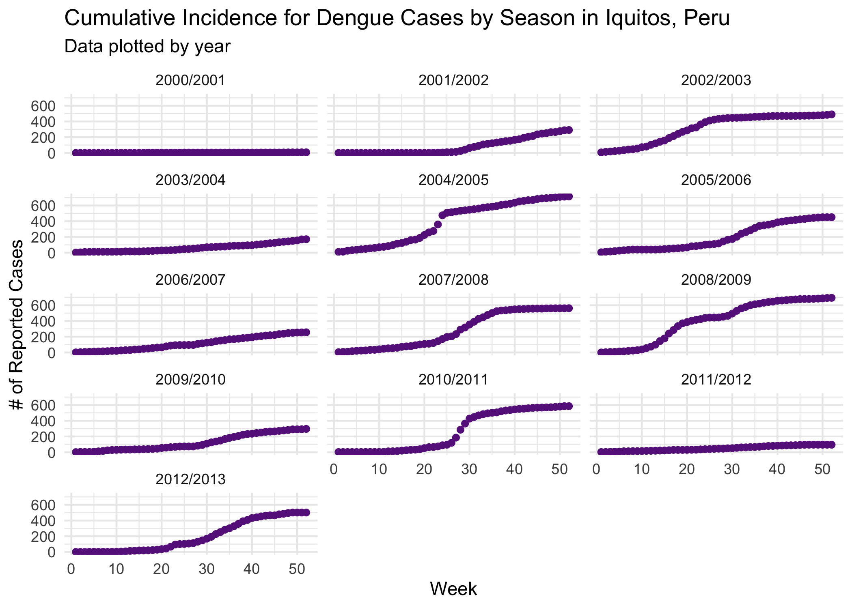

## 3.3 Full analysis

The goal of this analysis is to create and fit non-time series models from quarterly averaged data. Quarterly averaging was done to account for the variable lag period between ENSO related weather events and the increases or decreases in dengue incidence. This variable lag period can be anywhere between 3-6 weeks, with warmer temperatures correlated with shorter lag periods and vice versa as mentioned in introduction Stewart-Ibarra & Lowe (2013). This quarterly averaging will result in fewer data points and thus a weaker model, but was done for the sake of producing models within the scope that the MADA class has covered. This new quarterly averaged set answers weather or not monthly ENSO related weather variables predict monthly dengue case load.

Before any models were implemented, an analysis of covariance was done on predictor variables. Below are the results in a heatmap form. 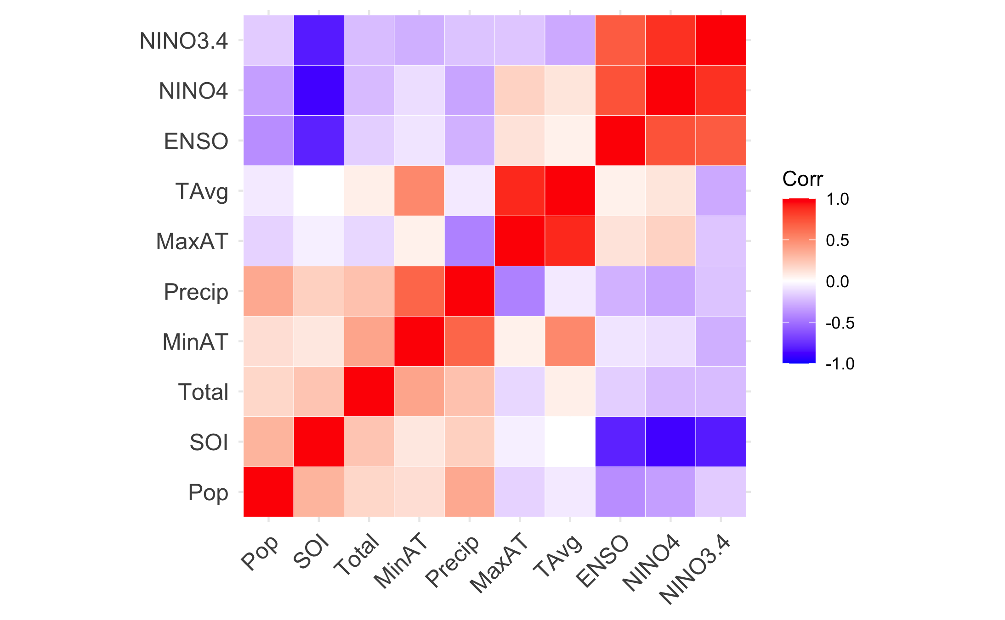

In General, ENSO and SST (3.4 & 4) all had signs of covariance. This was expected as SST and SOI are all included in ENSO classification. For simple regressions, an SST location (3.4 or 4) will be chosen to be the best predictor. Both min and max air temperature interacted with average air temperature. Average air temperature was omitted for non variable selection models.

Data was split into testing and training sets, with training data used to fit the 2000/2001- 2008/2009 season and testing set used to evaluate the 2009/2010-2012/2013 season. Data set was small (52 observations), but cross validation was chosen to ensure proper performance, ultimately accepting wider confidence intervals. Leave One Out (LOO) cross validation strategy was not used. While it is ideal for smaller datasets, the time series nature would not allow for enough variability in the training set to adequately predict dengue case numbers.

The primary outcome was monthly dengue case count, and used population adn various weather predictor variables such as Air Temp, Precipitation, ENSO, SOI and SST. A Multiple Linear Regression Model, Poisson Regression, Decision Trees, LASSO and K Nearest Forest Model were all done using the Tidymodels package in R. Negative binomial regression was done using the MASS package in R. Root Mean Square Error was used to compare models to null model. See the chart below for RMSE values of all models.

The Multi Linear Regression Model was fitted with principal component analysis to address the multi-colinearity that exists between the variables. While no official clusters were picked up, 2 principal components described what was interpreted to be some variation of ENSO values. For the Negative Binomial Regression, the model with Population, Precipitation, min/max air temperature and SOI value performed the best. The LASSO model performed similarly, choosing the same variables as well as ENSO classification. On the contrary, the Decision Trees model only ended up choosing min and max air temperature for final variables. The K Nearest Neighbors Model was chosen for its accurate performance with smaller data sets and was the best performing model,however did not perform as well on folded data set. The coefficent *k* was chosen as 6 to avoid any over fitting.

| Model | RMSE |
| --- | --- |
| Null Model | 100.3227 |
| Multi Linear Regression Model | 93.03668 |
| Poisson Regression | 77.94448 |
| Negative binomial regression | 101 |
| Decision Trees | 98.81927 |
| LASSO | 113.3661 |
| K Nearest Neighbors Model | 77.7879416 |

## 3.4 Final Model

Ultimately the Poisson Regression model was chosen for its simplicity. Below are the final fitted results on test data. For more detail on model fitting, see the supplemental file. The final RMSE was 23.20935. 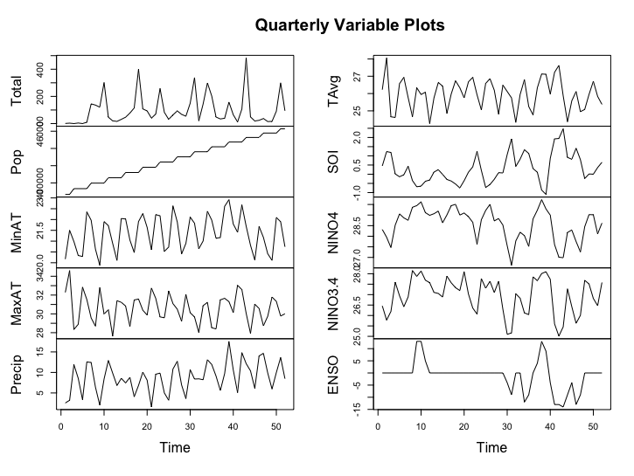

# 4 Discussion

It can be concluded that the Poisson Regression model chosen was not able to predict case number counts from given weather data due to small sample size. While the initial model was unsuccessful, principal component analysis yielded a larger and more comprehensive picture of the variable interaction during the ENSO cycle given the limited data. Further tuning of predictors in principal component analysis on a larger data set may provide useful graphics and trend visualization of monthly case counts and weather predictors. Note, that population is not accounted for in PCA and future analysis may consider using incidence rate. For further visualization of PCS, please refer to the supplemental document.

## 4.1 Strengths and Limitions

The variety of models allowed for more diverse analysis options, however such models are only as strong as their training data set. Ultimately the largest limitation Would be the small sample size used when data was divided quarterly. This small sample size in both training and testing did not allow for as many observations to be included into the model and therefore a larger standard of error. This can be the presumed reason for the final RMSE being so low.

# 5 Conclusion

Ultimately the greatest weakness was the smaller sample size within the data. A more complex auto regressive model would have been able capture the variable and seasonal lag periods between variables. It is highly recommended weekly data is used to understand the differing and seasonal-dependent lag periods for future analysis.

# References

Brunkard, J. M., Cifuentes, E., & Rothenberg, S. J. (2008). Assessing the roles of temperature, precipitation, and ENSO in dengue re-emergence on the texas-mexico border region. *Salud pública de México*, *50*(3), 227–234.

Earnest, A., Tan, S., & Wilder-Smith, A. (2012). Meteorological factors and el nino southern oscillation are independently associated with dengue infections. *Epidemiology & Infection*, *140*(7), 1244–1251.

Gharbi, M., Quenel, P., Gustave, J., Cassadou, S., La Ruche, G., Girdary, L., & Marrama, L. (2011). Time series analysis of dengue incidence in guadeloupe, french west indies: Forecasting models using climate variables as predictors. *BMC Infectious Diseases*, *11*(1), 1–13.

Hu, W., Clements, A., Williams, G., & Tong, S. (2010). Dengue fever and el nino/southern oscillation in queensland, australia: A time series predictive model. *Occupational and Environmental Medicine*, *67*(5), 307–311.

Medlock, J. M., & Leach, S. A. (2015). Effect of climate change on vector-borne disease risk in the UK. *The Lancet Infectious Diseases*, *15*(6), 721–730.

Messina, J. P., Brady, O. J., Golding, N., Kraemer, M. U., Wint, G. W., Ray, S. E., … others. (2019). The current and future global distribution and population at risk of dengue. *Nature Microbiology*, *4*(9), 1508–1515.

NCEI.Monitoring.Info@noaa.gov. (n.d.). El niño/southern oscillation (ENSO). Retrieved from <https://www.ncdc.noaa.gov/teleconnections/enso/sst>

Stewart-Ibarra, A. M., & Lowe, R. (2013). Climate and non-climate drivers of dengue epidemics in southern coastal ecuador. *The American Journal of Tropical Medicine and Hygiene*, *88*(5), 971.

Stoddard, S. T., Wearing, H. J., Reiner Jr, R. C., Morrison, A. C., Astete, H., Vilcarromero, S., … others. (2014). Long-term and seasonal dynamics of dengue in iquitos, peru. *PLoS Neglected Tropical Diseases*, *8*(7), e3003.

Tantaléan Yépez, D., Sánchez-Carbonel, J., Ulloa Urizar, G., Espinoza Morales, D., Silva-Caso, W., Pons, M. J., … Aguilar-Luis, M. A. (2016). *Arboviruses emerging in peru: Need for early detection of febrile syndrome during el niño episodes*.

Vincenti-Gonzalez, M., Tami, A., Lizarazo, E., & Grillet, M. (2018). ENSO-driven climate variability promotes periodic major outbreaks of dengue in venezuela. *Scientific Reports*, *8*(1), 1–11.

WHO. (2012). Global strategy for dengue prevention and control 2012–2020. *WHO Library Cataloguing-in-Publication Data, Switzerland*.