1. **登陆页面**

**http://62.234.79.95**

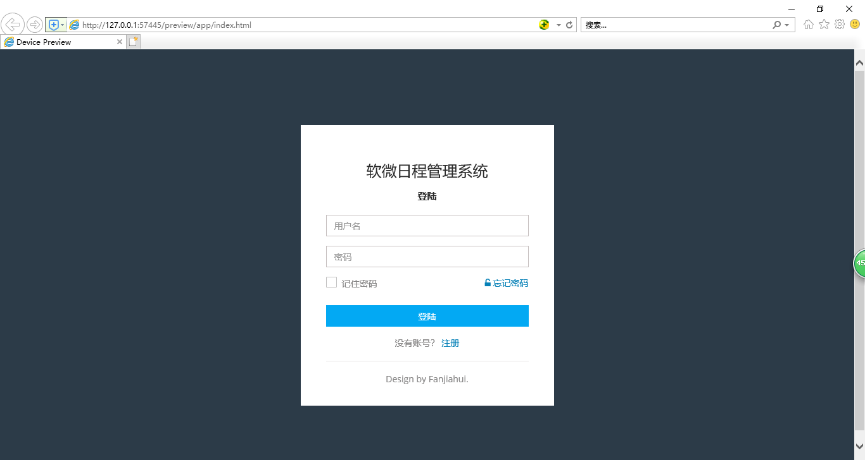

HTML文档

<!DOCTYPE html>

<html lang="en">

<head>

<meta charset="utf-8">

<meta name="viewport" content="width=device-width, initial-scale=1">

<meta name="keywords" content="">

<meta name="description" content="">

<meta name="author" content="">

<link rel="icon" href="assets/images/favicon.png" type="image/png">

<title></title>

<link href="assets/css/icons.css" rel="stylesheet">

<link href="assets/css/bootstrap.min.css" rel="stylesheet">

<link href="assets/css/style.css" rel="stylesheet">

<link href="assets/css/responsive.css" rel="stylesheet">

</head>

<body class="sticky-header">

<!--Start login Section-->

<section class="login-section">

<div class="container">

<div class="row">

<div class="login-wrapper">

<div class="login-inner">

<div class="logo">

<h3 >软微日程管理系统</h3>

</div>

<h2 class="header-title text-center">登陆</h2>

<form>

<div class="form-group">

<input type="text" class="form-control" placeholder="用户名" >

</div>

<div class="form-group">

<input type="text" class="form-control" placeholder="密码" >

</div>

<div class="form-group">

<div class="pull-left">

<div class="checkbox primary">

<input id="checkbox-2" type="checkbox">

<label for="checkbox-2">记住密码</label>

</div>

</div>

<div class="pull-right">

<a href="reset-password.html" class="a-link">

<i class="fa fa-unlock-alt"></i> 忘记密码

</a>

</div>

</div>

<div class="form-group">

<a href="timeline.html" class="btn btn-primary btn-block">登陆 </a>

</div>

<div class="form-group text-center">

没有账号？ <a href="">注册 </a>

</div>

</form>

<div class="copy-text">

<p class="m-0">Design by Fanjiahui. </p>

</div>

</div>

</div>

</div>

</div>

</section>

<!--End login Section-->

</body>

</html>

**二、个人主页**

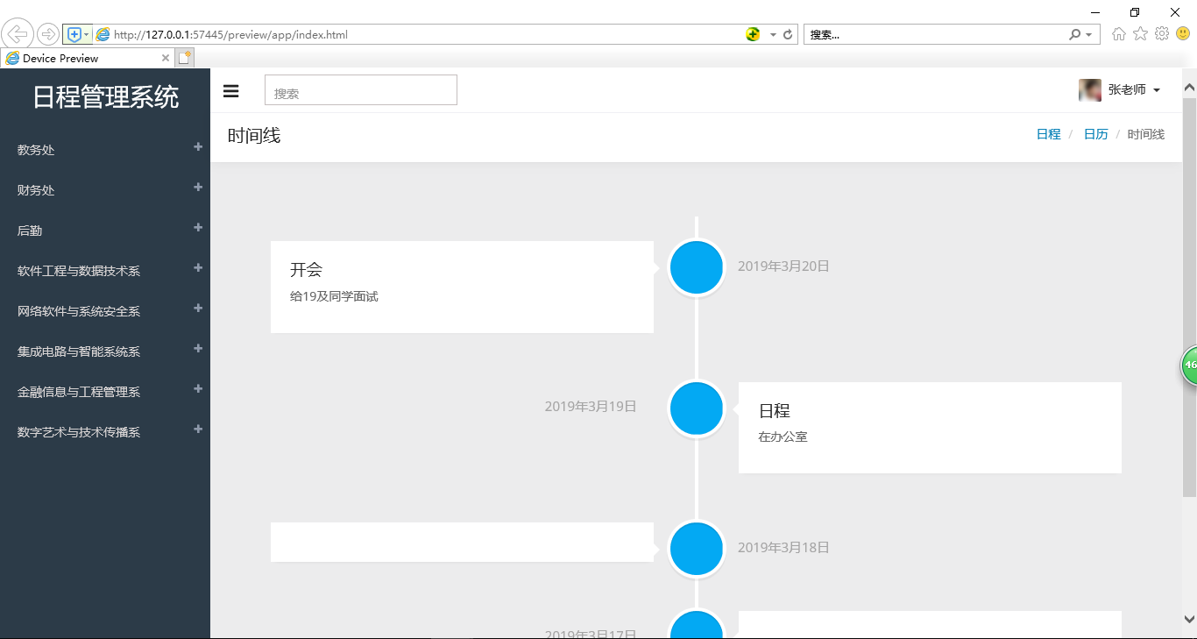

<!DOCTYPE html>

<html lang="en">

<head>

<meta charset="utf-8">

<meta name="viewport" content="width=device-width, initial-scale=1">

<meta name="keywords" content="">

<meta name="description" content="">

<meta name="author" content="">

<link rel="icon" href="assets/images/favicon.png" type="image/png">

<title></title>

<link href="assets/css/icons.css" rel="stylesheet">

<link href="assets/css/bootstrap.min.css" rel="stylesheet">

<link href="assets/css/style.css" rel="stylesheet">

<link href="assets/css/responsive.css" rel="stylesheet">

</head>

<body class="sticky-header">

<!--Start left side Menu-->

<div class="left-side sticky-left-side">

<!--日程管理系统-->

<div class="logo">

<a href="index.html">日程管理系统</a>

</div>

<!--logo-->

<div class="left-side-inner">

<!--Sidebar nav-->

<ul class="nav nav-pills nav-stacked custom-nav">

<li class="menu-list"><a href="index.html"> <span>教务处</span></a>

<ul class="sub-menu-list">

<li><a href="index.html"> 教务办公室 1</a></li>

<li><a href="dashboard2.html"> 教务办公室 2</a></li>

</ul>

</li>

<li class="menu-list"><a href="#"> <span>财务处</span></a>

<ul class="sub-menu-list">

<li><a href="ui-buttons.html"> 财务办公室 1</a></li>

<li ><a href="ui-panels.html"> 财务办公室 2</a></li>

</ul>

</li>

<li class="menu-list"><a href="#"> <span>后勤</span></a>

<ul class="sub-menu-list">

<li><a href="table-static.html"> 后勤办公室 1</a></li>

<li><a href="table-responsive.html">后勤办公室 2</a></li>

</ul>

</li>

<li class="menu-list"><a href="#"> <span>软件工程与数据技术系</span></a>

</li>

<li class="menu-list"><a href="#"> <span>网络软件与系统安全系</span></a>

</li>

<li class="menu-list"><a href="#"> <span>集成电路与智能系统系</span></a>

</li>

<li class="menu-list"><a href="calendar.html"><span>金融信息与工程管理系</span></a></li>

<li class="menu-list"><a href="widget.html"><span>数字艺术与技术传播系</span></a></li>

</ul>

<!--End sidebar nav-->

</div>

</div>

<!--End left side menu-->

<!-- main content start-->

<div class="main-content" >

<!-- header section start-->

<div class="header-section">

<a class="toggle-btn"><i class="fa fa-bars"></i></a>

<form class="searchform">

<input type="text" class="form-control" name="keyword" placeholder="搜索" />

</form>

<!--notification menu start -->

<div class="menu-right">

<ul class="notification-menu">

<li>

<a href="#" class="btn btn-default dropdown-toggle" data-toggle="dropdown">

<img src="assets/images/users/avatar-6.jpg" alt="" />

张老师

<span class="caret"></span>

</a>

<ul class="dropdown-menu dropdown-menu-usermenu pull-right">

<li> <a href="#"> <i class="fa fa-info"></i> 帮助 </a> </li>

<li> <a href="#"> <i class="fa fa-lock"></i> 退出 </a> </li>

</ul>

</li>

</ul>

</div>

<!--notification menu end -->

</div>

<!-- header section end-->

<!--body wrapper start-->

<div class="wrapper">

<!--Start Page Title-->

<div class="page-title-box">

<h4 class="page-title">时间线</h4>

<ol class="breadcrumb">

<li>

<a href="#">日程</a>

</li>

<li>

<a href="#">日历</a>

</li>

<li class="active">时间线</li>

</ol>

<div class="clearfix"></div>

</div>

<!--End Page Title-->

<!--Start row-->

<div class="row">

<div class="col-md-12">

<div id="timeline" class="container">

<div class="timeline-block">

<div class="timeline-img bg-primary"></div>

<div class="timeline-content">

<h3>开会</h3>

<p> 给19及同学面试</p>

<span class="date">2019年3月20日</span>

</div>

</div>

<div class="timeline-block">

<div class="timeline-img bg-primary"></div>

<div class="timeline-content">

<h3>日程</h3>

<p>在办公室 </p>

<span class="date">2019年3月19日</span> </div>

</div>

<div class="timeline-block">

<div class="timeline-img bg-primary"></div>

<div class="timeline-content">

<span class="date">2019年3月18日</span> </div>

</div>

<div class="timeline-block">

<div class="timeline-img bg-primary"></div>

<div class="timeline-content">

<span class="date">2019年3月17日</span> </div>

</div>

</div>

</div>

</div>

<!--End row-->

</div>

<!-- End Wrapper-->

<!--Start Footer -->

<footer class="footer-main">Design by Fanjiahui</footer>

<!--End footer -->

</div>

<!--End main content -->

</body>

</html>