**一．登陆页面**

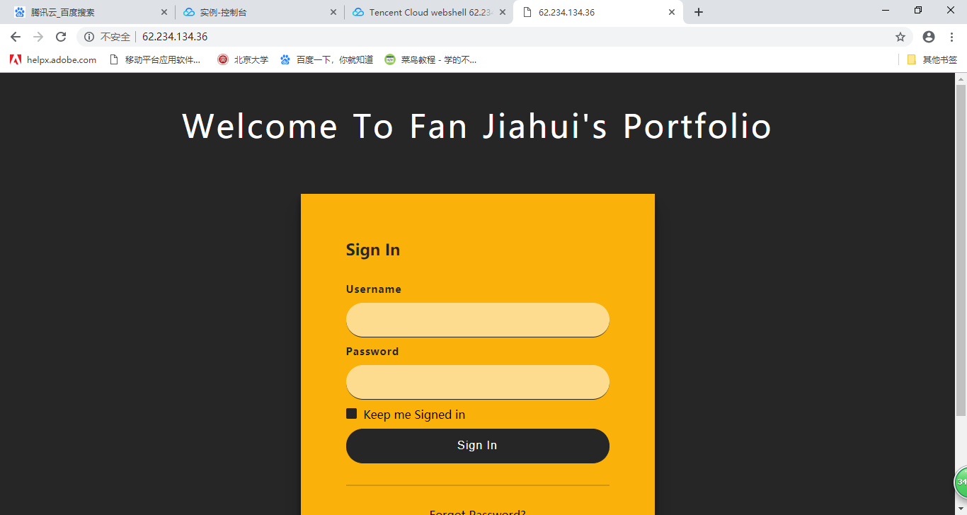

HTML文档

<!DOCTYPE html>

<html>

<head>

<meta name="viewport" content="width=device-width, initial-scale=1">

<meta charset="utf-8">

<!-- Index-Page-CSS -->

<link rel="stylesheet" href="css/style.css" type="text/css" media="all">

<!-- onlinefonts -->

<link href="//fonts.googleapis.com/css?family=Dosis:200,300,400,500,600,700,800" rel="stylesheet">

<!-- //Custom-Stylesheet-Links -->

</head>

<body>

<header>

<h1 class="title-agile text-center">Welcome to Fan Jiahui's Portfolio</h1>

</header>

<!-- //header -->

<section class="login-wrap">

<div class="main">

<input id="tab-1" type="radio" name="tab" class="sign-in">

<label for="tab-1" class="tab">Sign In</label>

<div class="login-form">

<div class="signin">

<form method="post" action="#">

<div class="group">

<label for="user" class="label">Username</label>

<input id="user" type="text" class="input" required>

</div>

<div class="group">

<label for="pass" class="label">Password</label>

<input id="pass" type="password" class="input" data-type="password" required>

</div>

<div class="group">

<input id="check" type="checkbox" class="check" checked>

<label for="check">

<span class="icon"></span> Keep me Signed in</label>

</div>

<div class="group">

<input type="submit" class="button" value="Sign In" >

</div>

<div class="hr"></div>

<div class="foot-lnk">

<h2><a href="#">Forgot Password?</a></h2>

</div>

</form>

</div>

</div>

</div>

</section>

<!-- //section -->

<footer>

<div class="footer text-center">

<p>portfolio of Fan Jiahui from 2014 ~ 2019 | Design by

<a href="/data/">@Fan Jiahui</a>

</p>

</div>

</footer>

<!-- //footer -->

</body>

<!-- //Body -->

</html>

CSS文档

html,

body,

div,

span,

applet,

object,

iframe,

h1,

h2,

h3,

h4,

h5,

h6,

p,

blockquote,

pre,

a,

abbr,

acronym,

address,

big,

cite,

code,

del,

dfn,

em,

img,

ins,

kbd,

q,

s,

samp,

small,

strike,

strong,

sub,

sup,

tt,

var,

b,

u,

i,

dl,

dt,

dd,

ol,

nav ul,

nav li,

fieldset,

form,

label,

legend,

table,

caption,

tbody,

tfoot,

thead,

tr,

th,

td,

article,

aside,

canvas,

details,

embed,

figure,

figcaption,

footer,

header,

hgroup,

menu,

nav,

output,

ruby,

section,

summary,

time,

mark,

audio,

video {

margin: 0;

padding: 0;

border: 0;

font-size: 100%;

font: inherit;

vertical-align: baseline;

}

article,

aside,

details,

figcaption,

figure,

footer,

header,

hgroup,

menu,

nav,

section {

display: block;

}

ol,

ul {

list-style: none;

margin: 0px;

padding: 0px;

}

blockquote,

q {

quotes: none;

}

blockquote:before,

blockquote:after,

q:before,

q:after {

content: '';

content: none;

}

table {

border-collapse: collapse;

border-spacing: 0;

}

/*--start editing from here--*/

a {

text-decoration: none;

}

.txt-rt {

text-align: right;

}

/* text align right */

.txt-lt {

text-align: left;

}

/* text align left */

.txt-center {

text-align: center;

}

/* text align center */

.float-rt {

float: right;

}

/* float right */

.float-lt {

float: left;

}

/* float left */

.clearfix {

clear: both;

}

/* clear float */

.pos-relative {

position: relative;

}

/* Position Relative */

.pos-absolute {

position: absolute;

}

/* Position Absolute */

.vertical-base {

vertical-align: baseline;

}

/* vertical align baseline */

.vertical-top {

vertical-align: top;

}

/* vertical align top */

nav.vertical ul li {

display: block;

}

/* vertical menu */

nav.horizontal ul li {

display: inline-block;

}

/* horizontal menu */

img {

max-width: 100%;

}

/*前面为初始化内容*/

body a:hover {

text-decoration: none;

}

.clearfix {

clear: both;

}

.text-center {

text-align: center;

}

/* content */

body {

background: #262626;

background-size: cover;

-webkit-background-size: cover;

-moz-background-size: cover;

-o-background-size: cover;

-ms-background-size: cover;

background-attachment: fixed;

font-family: 'Dosis', sans-serif;

}

h1.title-agile {

font-size: 2.8em;

text-transform: capitalize;

color: #ffffff;

letter-spacing: 3px;

word-spacing: 3px;

margin: 1em 1vw 1.5em;

text-align: center;

font-family: 'Dosis', sans-serif;

}

/*底边*/

.footer {

margin: 3em 0em;

}

.footer p {

color: #fab10a;

font-size: 17px;

letter-spacing: 1.5px;

}

.footer p a {

color: #FFFFFF;

}

/*白色框变宽*/

*,

:after,

:before {

box-sizing: border-box

}

.clearfix:after,

.clearfix:before {

content: '';

display: table

}

.clearfix:after {

clear: both;

display: block

}

a {

color: inherit;

text-decoration: none

}

/*section标签*/

.login-wrap {

margin: auto;

max-width: 500px;

min-height: 500px;

position: relative;

background: #fab10a;

box-shadow: 0 12px 15px 0 rgba(0, 0, 0, .24), 0 17px 50px 0 rgba(0, 0, 0, .19);

}

.main {

width: 100%;

height: 100%;

position: absolute;

padding: 4em;

background: rgba(250, 177, 10, 0.83);

-webkit-box-shadow: 0px 6px 11px 1px rgba(0, 0, 0, 0.17);

-moz-box-shadow: 0px 6px 11px 1px rgba(0, 0, 0, 0.17);

}

.main .signin, {

top: 0;

left: 0;

right: 0;

bottom: 0;

position: absolute;

transform: rotateY(180deg);

backface-visibility: hidden;

transition: all .4s linear;

}

.main .sign-in,

.login-form .group .check {

display: none;

}

.main .tab {

font-size: 22px;

font-weight: 600;

padding-bottom: 4px;

margin: 0 15px 10px 0;

display: inline-block;

border-bottom: 2px solid transparent;

color: #262626;

}

/*表格位置*/

.login-form {

min-height: 200px;

position: relative;

perspective: 1000px;

margin-top: 1em;

}

.login-form .group {

margin-bottom: 10px;

}

/*设置表格宽度铺满*/

.login-form .group .label,

.login-form .group .input,

.login-form .group .button {

width: 100%;

display: block;

}

/*表格颜色*/

.login-form .group .input,

.login-form .group .button {

border: none;

border-bottom: 1px solid #262626;

padding: 15px 15px;

border-radius: 25px;

background: rgba(255, 255, 255, 0.54);

letter-spacing: 1px;

font-size: 1em;

color: #000;

outline: none;

}

/*光标样式*/

.login-form .group .button {

cursor: pointer;

}

.login-form .group .label {

color: #262626;

font-weight: 600;

font-size: 14px;

letter-spacing: 1px;

margin-bottom: 10px;

}

.login-form .group .button {

background: #262626;

color:white;

}

.login-form .group label .icon {

width: 15px;

height: 15px;

border-radius: 2px;

position: relative;

display: inline-block;

background: #262626;

margin-right: 5px;

}

/*细线*/

.hr {

height: 2px;

margin: 30px 0;

background: rgba(38, 38, 38, .2);

}

/*forget password*/

.foot-lnk {

text-align: center;

}

**二、个人主页**

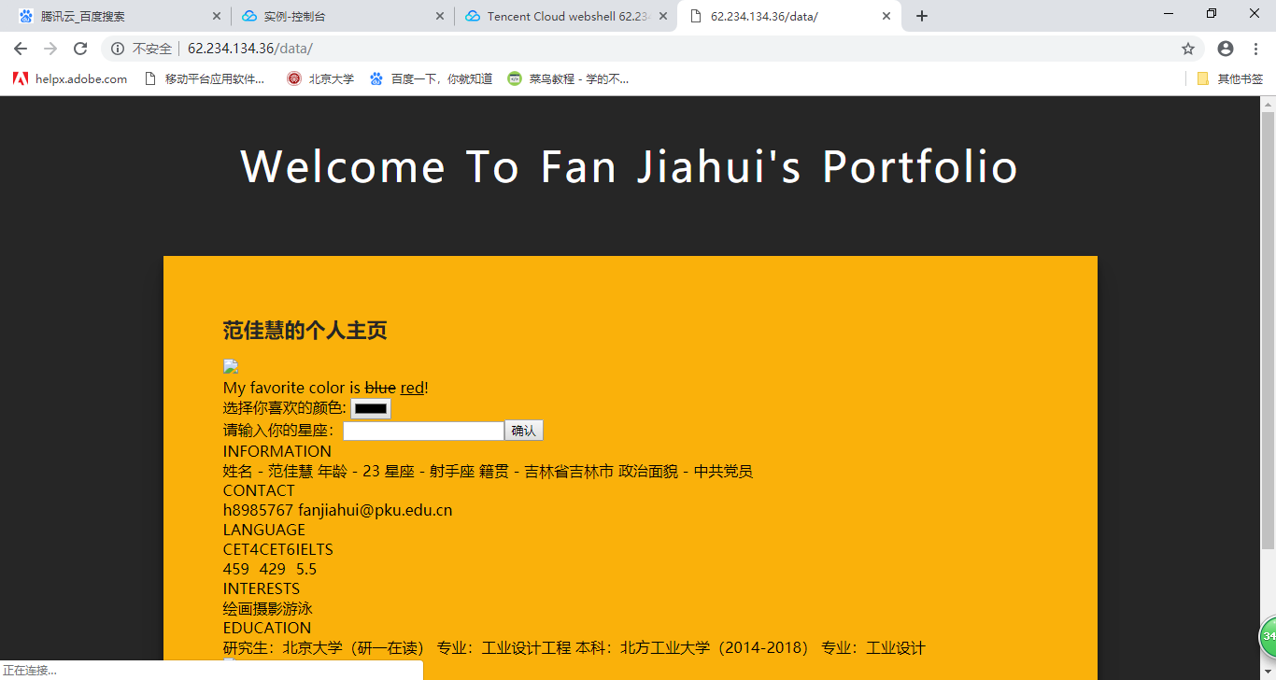

HTML文档

<!DOCTYPE html>

<html>

<head>

<meta name="viewport" content="width=device-width, initial-scale=1">

<meta charset="utf-8">

<!-- Index-Page-CSS -->

<link rel="stylesheet" href="css/style.css" type="text/css" media="all">

<!-- onlinefonts -->

<link href="//fonts.googleapis.com/css?family=Dosis:200,300,400,500,600,700,800" rel="stylesheet">

<!-- //Custom-Stylesheet-Links -->

</head>

<body>

<header>

<h1 class="title-agile text-center">Welcome to Fan Jiahui's Portfolio</h1>

</header>

<!-- //header -->

<section class="login-wrap">

<div class="main">

<h1 for="tab-1" class="tab">范佳慧的个人主页</h1>

<p>

<img src="../1.jpg"width=50 />

</p>

<div>

<p>My favorite color is <del>blue</del> <ins>red</ins>!</p>

<form class="label" action="../demo-form.php">

选择你喜欢的颜色: <input type="color" name="favcolor"><br>

请输入你的星座：<input type="确认"><button type="button">确认</button>

</form>

</div>

<div>

<h2 class="label">INFORMATION</h2>

<p>姓名 - 范佳慧

年龄 - 23

星座 - 射手座

籍贯 - 吉林省吉林市

政治面貌 - 中共党员

</p>

</div>

<div class="label">

<h2 class="label">CONTACT</h2>

<p class="label">

h8985767

fanjiahui@pku.edu.cn

</p>

</div>

<div>

<h2 class="label">LANGUAGE</h2>

<table border="1">

<tr class="label">

<td>CET4</td>

<td>CET6</td>

<td>IELTS</td>

</tr>

<tr>

<td>459</td>

<td>429</td>

<td>5.5</td>

</table>

<h2>INTERESTS</h2>

<table border="0">

<tr>

<td>绘画</td>

<td>摄影</td>

<td>游泳</td>

</tr>

</table>

<h2>EDUCATION</h2>

<p>研究生：北京大学（研一在读）

专业：工业设计工程

本科：北方工业大学（2014-2018）

专业：工业设计

</p>

</div>

<img src="../2.jpg"width=200 />

</div>

</section>

<!-- //section -->

<footer>

<div class="footer text-center">

<p>portfolio of Fan Jiahui from 2014 ~ 2019 | Design by

<a href="/data/">@Fan Jiahui</a>

</p>

</div>

</footer>

<!-- //footer -->

</body>

<!-- //Body -->

</html>

CSS文档

html,

body,

div,

span,

applet,

object,

iframe,

h1,

h2,

h3,

h4,

h5,

h6,

p,

blockquote,

pre,

a,

abbr,

acronym,

address,

big,

cite,

code,

del,

dfn,

em,

img,

ins,

kbd,

q,

s,

samp,

small,

strike,

strong,

sub,

sup,

tt,

var,

b,

u,

i,

dl,

dt,

dd,

ol,

nav ul,

nav li,

fieldset,

form,

label,

legend,

table,

caption,

tbody,

tfoot,

thead,

tr,

th,

td,

article,

aside,

canvas,

details,

embed,

figure,

figcaption,

footer,

header,

hgroup,

menu,

nav,

output,

ruby,

section,

summary,

time,

mark,

audio,

video {

margin: 0;

padding: 0;

border: 0;

font-size: 100%;

font: inherit;

vertical-align: baseline;

}

article,

aside,

details,

figcaption,

figure,

footer,

header,

hgroup,

menu,

nav,

section {

display: block;

}

ol,

ul {

list-style: none;

margin: 0px;

padding: 0px;

}

blockquote,

q {

quotes: none;

}

blockquote:before,

blockquote:after,

q:before,

q:after {

content: '';

content: none;

}

table {

border-collapse: collapse;

border-spacing: 0;

}

/*--start editing from here--*/

a {

text-decoration: none;

}

.txt-rt {

text-align: right;

}

/* text align right */

.txt-lt {

text-align: left;

}

/* text align left */

.txt-center {

text-align: center;

}

/* text align center */

.float-rt {

float: right;

}

/* float right */

.float-lt {

float: left;

}

/* float left */

.clearfix {

clear: both;

}

/* clear float */

.pos-relative {

position: relative;

}

/* Position Relative */

.pos-absolute {

position: absolute;

}

/* Position Absolute */

.vertical-base {

vertical-align: baseline;

}

/* vertical align baseline */

.vertical-top {

vertical-align: top;

}

/* vertical align top */

nav.vertical ul li {

display: block;

}

/* vertical menu */

nav.horizontal ul li {

display: inline-block;

}

/* horizontal menu */

img {

max-width: 100%;

}

/*前面为初始化内容*/

body a:hover {

text-decoration: none;

}

.clearfix {

clear: both;

}

.text-center {

text-align: center;

}

/* content */

body {

background: #262626;

background-size: cover;

-webkit-background-size: cover;

-moz-background-size: cover;

-o-background-size: cover;

-ms-background-size: cover;

background-attachment: fixed;

font-family: 'Dosis', sans-serif;

}

h1.title-agile {

font-size: 2.8em;

text-transform: capitalize;

color: #ffffff;

letter-spacing: 3px;

word-spacing: 3px;

margin: 1em 1vw 1.5em;

text-align: center;

font-family: 'Dosis', sans-serif;

}

/*底边*/

.footer {

margin: 3em 0em;

}

.footer p {

color: #fab10a;

font-size: 17px;

letter-spacing: 1.5px;

}

.footer p a {

color: #FFFFFF;

}

/*白色框变宽*/

*,

:after,

:before {

box-sizing: border-box

}

.clearfix:after,

.clearfix:before {

content: '';

display: table

}

.clearfix:after {

clear: both;

display: block

}

a {

color: inherit;

text-decoration: none

}

/*section标签*/

.login-wrap {

margin: auto;

max-width: 1000px;

min-height: 500px;

position: relative;

background: #fab10a;

box-shadow: 0 12px 15px 0 rgba(0, 0, 0, .24), 0 17px 50px 0 rgba(0, 0, 0, .19);

}

.main {

width: 100%;

height: 100%;

position: absolute;

padding: 4em;

background: rgba(250, 177, 10, 0.83);

-webkit-box-shadow: 0px 6px 11px 1px rgba(0, 0, 0, 0.17);

-moz-box-shadow: 0px 6px 11px 1px rgba(0, 0, 0, 0.17);

}

.main .signin, {

top: 0;

left: 0;

right: 0;

bottom: 0;

position: absolute;

transform: rotateY(180deg);

backface-visibility: hidden;

transition: all .4s linear;

}

.main .sign-in,

.login-form .group .check {

display: none;

}

.main .tab {

font-size: 22px;

font-weight: 600;

padding-bottom: 4px;

margin: 0 15px 10px 0;

display: inline-block;

border-bottom: 2px solid transparent;

color: #262626;

}

/*表格位置*/

.login-form {

min-height: 200px;

position: relative;

perspective: 1000px;

margin-top: 1em;

}

.login-form .group {

margin-bottom: 10px;

}

/*设置表格宽度铺满*/

.login-form .group .label,

.login-form .group .input,

.login-form .group .button {

width: 100%;

display: block;

}

/*表格颜色*/

.login-form .group .input,

.login-form .group .button {

border: none;

border-bottom: 1px solid #262626;

padding: 15px 15px;

border-radius: 25px;

background: rgba(255, 255, 255, 0.54);

letter-spacing: 1px;

font-size: 1em;

color: #000;

outline: none;

}

/*光标样式*/

.login-form .group .button {

cursor: pointer;

}

.login-form .group .label {

color: #262626;

font-weight: 600;

font-size: 14px;

letter-spacing: 1px;

margin-bottom: 10px;

}

.login-form .group .button {

background: #262626;

color:white;

}

.login-form .group label .icon {

width: 15px;

height: 15px;

border-radius: 2px;

position: relative;

display: inline-block;

background: #262626;

margin-right: 5px;

}

/*细线*/

.hr {

height: 2px;

margin: 30px 0;

background: rgba(38, 38, 38, .2);

}

/*forget password*/

.foot-lnk {

text-align: center;

}