**一、我的日程页面**

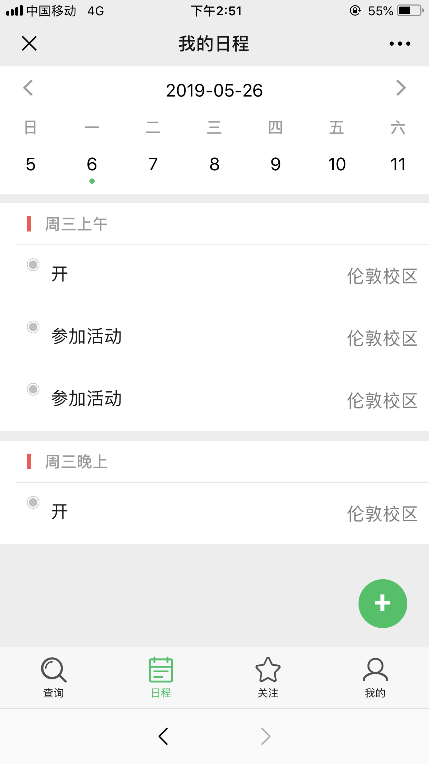

<!DOCTYPE html>

<html lang="zh-CN" style="height: 100%;">

<head>

<meta name="viewport" content="width=device-width, initial-scale=1, maximum-scale=1, user-scalable=no">

<meta charset="UTF-8">

<link rel="stylesheet" href="./css/weui.css">

<title>我的日程</title>

<style>

.weui-flex {

background-color: #FFFFFF;

text-align: center;

padding-bottom: 10px;

}

.today {

margin-left: auto;

margin-right: auto;

padding-top: auto;

margin-bottom: auto;

background-color: #07C160;

color: #FFFFFF;

width: 32px;

height: 32px;

border-radius: 3px;

}

a {

color: #353535;

font-size: 15px;

}

.week {

color: #9b9b9b;

font-size: 15px;

font-weight: bolder;

}

.margintop30 {

margin-top: 30px;

}

</style>

</head>

<body ontouchstart style="height: 100%; background-color: #ededed">

<div class="weui-tab">

<div class="weui-tab__panel">

<div style="position: fixed;top: 0px;z-index:9999;width: 100%;">

<div class="weui-flex" style="padding-top: 10px">

<div class="weui-flex__item">

<div class="placeholder" style="text-align: left;margin-left: 21px; color: #07C160"><img

src="./img/before.png" style="height: 17px"></div>

</div>

<div class="weui-flex__item">

<div class="placeholder" style="font-size: 17px">2019年5月10日</div>

</div>

<div class="weui-flex__item">

<div class="placeholder" style="text-align: right;margin-right: 21px; color: #07C160"><img

src="./img/after.png" style="height: 17px"></div>

</div>

</div>

<div class="weui-flex week">

<div class="weui-flex__item">

<div class="placeholder">日</div>

</div>

<div class="weui-flex__item">

<div class="placeholder">一</div>

</div>

<div class="weui-flex__item">

<div class="placeholder">二</div>

</div>

<div class="weui-flex__item">

<div class="placeholder">三</div>

</div>

<div class="weui-flex__item">

<div class="placeholder">四</div>

</div>

<div class="weui-flex__item">

<div class="placeholder">五</div>

</div>

<div class="weui-flex__item">

<div class="placeholder">六</div>

</div>

</div>

<div class="weui-flex days">

<div class="weui-flex__item">

<div class="placeholder"><a href="#">5</a></div>

</div>

<div class="weui-flex__item">

<div class="placeholder"><a href="#">6</a>

<div style="height: 5px;width: 5px;text-align:center;border-radius: 50%; background-color: #07C160;display: block;margin-left: auto;margin-right: auto"></div>

</div>

</div>

<div class="weui-flex__item">

<div class="placeholder"><a href="#">7</a></div>

</div>

<div class="weui-flex__item">

<div class="placeholder"><a href="#">8</a></div>

</div>

<div class="weui-flex__item">

<div class="placeholder"><a href="#">9</a></div>

</div>

<div class="weui-flex__item">

<a href="#" class="placeholder">

<div class="today">10</div>

</a>

</div>

<div class="weui-flex__item">

<div class="placeholder"><a href="#">11</a></div>

</div>

</div>

</div>

<div class="weui-cells" style="margin-top: 130px">

<div class="weui-panel__hd" style="padding: 10px 16px 10px;color:#9b9b9b;">

<div style="width: 4px;height: 15px;background-color:#FFBE00;display:inline-block;vertical-align:middle;margin: 0 10px 3px 10px"></div>

上午 8:30-11:30

</div>

<div class="weui-panel__bd">

<a href="javascript:void(0);" class="weui-media-box weui-media-box_appmsg"

style="padding: 10px;margin-left: 15px">

<div>

<img style="width: 14px;height: 14px;padding:2px 10px 18px 0px" src="./img/dian.png">

</div>

<div class="weui-media-box__bd">

<h4 class="weui-media-box__title">上课</h4>

<p class="weui-media-box__desc">今天上午在3303上课。</p>

</div>

<div class="weui-cell__ft">

<div style="margin-top: 0">大兴</div>

</div>

</a>

<a href="javascript:void(0);" class="weui-media-box weui-media-box_appmsg"

style="padding: 10px;margin-left: 15px">

<div>

<img style="width: 14px;height: 14px;padding:2px 10px 18px 0px" src="./img/dian.png">

</div>

<div class="weui-media-box__bd">

<h4 class="weui-media-box__title">上课</h4>

<p class="weui-media-box__desc">今天上午在3303上课。</p>

</div>

<div class="weui-cell__ft">

<div style="margin-top: 0">大兴</div>

</div>

</a>

</div>

</div>

<div class="weui-cells">

<div class="weui-panel__hd" style="padding: 10px 16px 10px;color:#9b9b9b;">

<div style="width: 4px;height: 15px;background-color:#FA5151;display:inline-block;vertical-align:middle;margin: 0 10px 3px 10px"></div>

下午 14:00-17:00

</div>

<div class="weui-panel__bd">

<a href="javascript:void(0);" class="weui-media-box weui-media-box_appmsg"

style="padding: 10px;margin-left: 15px">

<div>

<img style="width: 14px;height: 14px;padding:2px 10px 18px 0px" src="./img/dian.png">

</div>

<div class="weui-media-box__bd">

<h4 class="weui-media-box__title">上课</h4>

<p class="weui-media-box__desc">今天上午在3303上课。</p>

</div>

<div class="weui-cell__ft">

<div style="margin-top: 0">大兴</div>

</div>

</a>

<a href="javascript:void(0);" class="weui-media-box weui-media-box_appmsg"

style="padding: 10px;margin-left: 15px">

<div>

<img style="width: 14px;height: 14px;padding:2px 10px 18px 0px" src="./img/dian.png">

</div>

<div class="weui-media-box__bd">

<h4 class="weui-media-box__title">上课</h4>

<p class="weui-media-box__desc">今天上午在3303上课。</p>

</div>

<div class="weui-cell__ft">

<div style="margin-top: 0">大兴</div>

</div>

</a>

</div>

</div>

<div class="weui-cells">

<div class="weui-panel__hd" style="padding: 10px 16px 10px;color:#9b9b9b;">

<div style="width: 4px;height: 15px;background-color:#FA5151;display:inline-block;vertical-align:middle;margin: 0 10px 3px 10px"></div>

晚上 18:00-21:00

</div>

<div class="weui-panel__bd">

<a href="javascript:void(0);" class="weui-media-box weui-media-box_appmsg"

style="padding: 10px;margin-left: 15px">

<div>

<img style="width: 14px;height: 14px;padding:2px 10px 18px 0px" src="./img/dian.png">

</div>

<div class="weui-media-box__bd">

<h4 class="weui-media-box__title">上课</h4>

<p class="weui-media-box__desc">今天上午在3303上课。</p>

</div>

<div class="weui-cell__ft">

<div style="margin-top: 0">大兴</div>

</div>

</a>

<a href="javascript:void(0);" class="weui-media-box weui-media-box_appmsg"

style="padding: 10px;margin-left: 15px">

<div>

<img style="width: 14px;height: 14px;padding:2px 10px 18px 0px" src="./img/dian.png">

</div>

<div class="weui-media-box__bd">

<h4 class="weui-media-box__title">上课</h4>

<p class="weui-media-box__desc">今天上午在3303上课。</p>

</div>

<div class="weui-cell__ft">

<div style="margin-top: 0">大兴</div>

</div>

</a>

</div>

</div>

<div class="weui-btn-area" style="position: fixed;bottom:70px ;right:5px;z-index:9999;">

<a class="weui-btn weui-btn_block weui-btn_primary" href="wx-add.html" id="showTooltips" style="padding: 0px;font-size: 30px;font-weight:normal;width: 47px;height: 47px;border-radius: 50%">+</a>

</div>

</div>

<div class="weui-tabbar">

<a href="wx_search.html" class="weui-tabbar__item ">

<span style="display: inline-block;position: relative;">

<img src="./img/chaxun.png" alt="" class="weui-tabbar__icon">

</span>

<p class="weui-tabbar__label">查询</p>

</a>

<a href="wx_myagenda.html" class="weui-tabbar__item weui-bar__item_on">

<img src="./img/richeng_on.png" alt="" class="weui-tabbar__icon">

<p class="weui-tabbar__label">日程</p>

</a>

<a href="wx_attention.html" class="weui-tabbar__item">

<span style="display: inline-block;position: relative;">

<img src="./img/guanzhu-black.png" alt="" class="weui-tabbar__icon">

<p class="weui-tabbar__label">关注</p>

</span>

</a>

<a href="wx_me.html" class="weui-tabbar__item">

<img src="./img/wode.png" alt="" class="weui-tabbar__icon">

<p class="weui-tabbar__label">我的</p>

</a>

</div>

</div>

</body>

</html>

**二、查询领导日程页面**

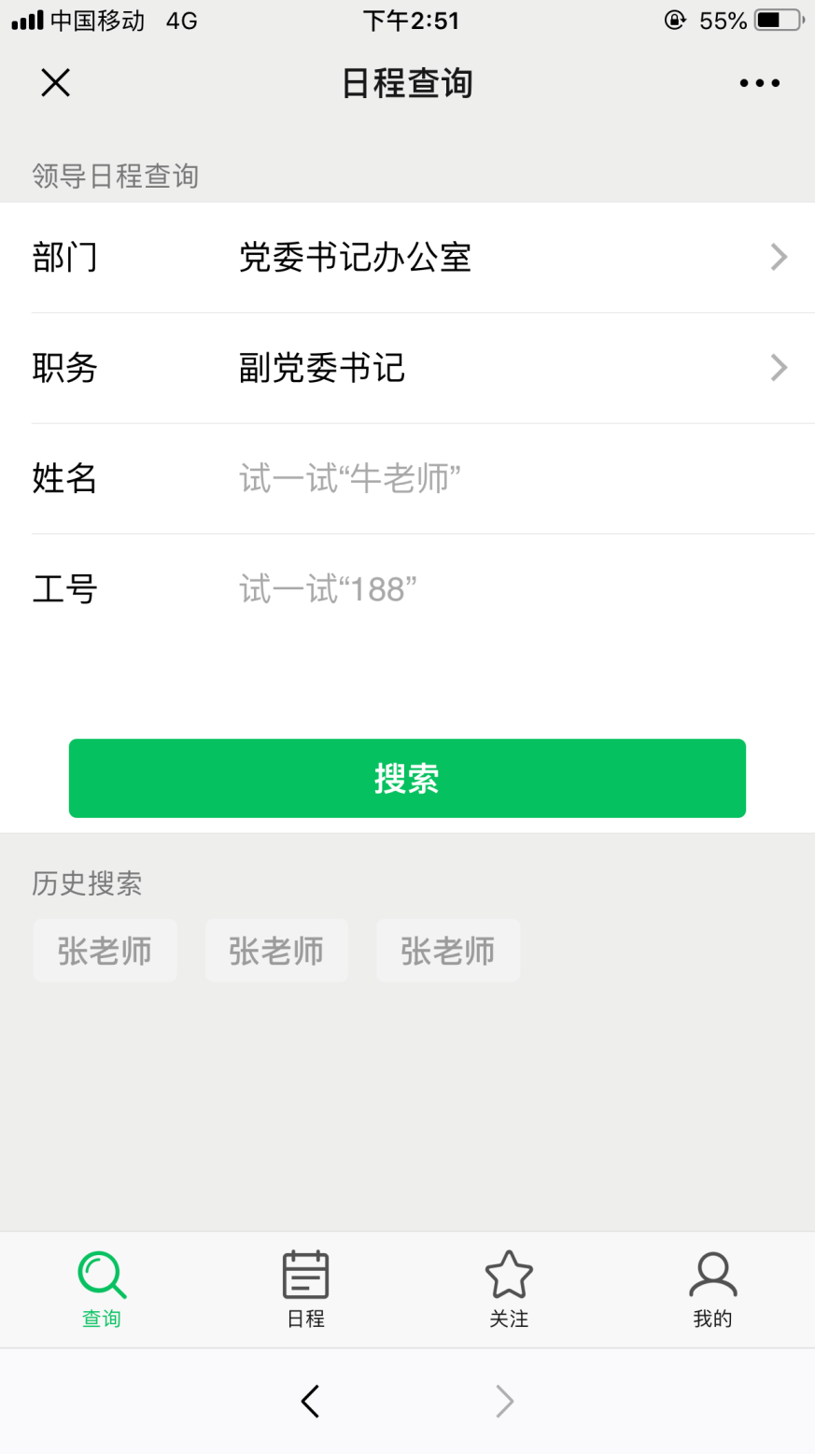

<!DOCTYPE html>

<html lang="zh-CN" style="height: 100%;">

<head>

<meta name="viewport" content="width=device-width, initial-scale=1, maximum-scale=1, user-scalable=no">

<meta charset="UTF-8">

<link rel="stylesheet" href="./css/weui.css">

<title>日程查询</title>

</head>

<body ontouchstart style="height: 100%; background-color: #ededed">

<div class="weui-tab">

<div class="weui-tab__panel">

<div class="weui-cells__title">领导日程查询</div>

<div class="weui-cells">

<div class="weui-cell weui-cell_select weui-cell_select-after">

<div class="weui-cell__hd">

<label class="weui-label">部门</label>

</div>

<div class="weui-cell__bd">

<select class="weui-select" name="select2">

<option value="1">学工部</option>

<option value="2">教务处</option>

<option value="3">后勤</option>

</select>

</div>

</div>

<div class="weui-cell weui-cell_select weui-cell_select-after">

<div class="weui-cell__hd">

<label class="weui-label">职务</label>

</div>

<div class="weui-cell__bd">

<select class="weui-select" name="select2">

<option value="1">主任</option>

<option value="2">教师</option>

<option value="3">其他</option>

</select>

</div>

</div>

<div class="weui-cell ">

<div class="weui-cell__hd">

<label class="weui-label">姓名</label>

</div>

<div class="weui-cell__bd">

<input class="weui-input" placeholder="请输入姓名">

</div>

</div>

<div class="weui-cell ">

<div class="weui-cell__hd">

<label class="weui-label">工号</label>

</div>

<div class="weui-cell__bd">

<input class="weui-input" type="number" placeholder="请输入工号">

</div>

</div>

</div>

<div class="weui-cells__title">历史搜索</div>

<div style="margin:0px 12px;">

<a href="javascript:;" class="weui-btn weui-btn_mini weui-btn_default" style="margin: 5px;color:#9b9b9b">张老师</a>

<a href="javascript:;" class="weui-btn weui-btn_mini weui-btn_default" style="margin: 5px;color:#9b9b9b">张老师</a>

<a href="javascript:;" class="weui-btn weui-btn_mini weui-btn_default" style="margin: 5px;color:#9b9b9b">张老师</a>

</div>

<div class="weui-btn-area">

<a class="weui-btn weui-btn_block weui-btn_primary" href="wx_searchlist.html" id="showTooltips">搜索</a>

</div>

</div>

<div class="weui-tabbar">

<a href="wx_search.html" class="weui-tabbar__item weui-bar__item_on">

<span style="display: inline-block;position: relative;">

<img src="./img/chaxun_on.png" alt="" class="weui-tabbar__icon">

</span>

<p class="weui-tabbar__label">查询</p>

</a>

<a href="wx_myagenda.html" class="weui-tabbar__item ">

<img src="./img/richeng.png" alt="" class="weui-tabbar__icon">

<p class="weui-tabbar__label">日程</p>

</a>

<a href="wx_attention.html" class="weui-tabbar__item">

<span style="display: inline-block;position: relative;">

<img src="./img/guanzhu-black.png" alt="" class="weui-tabbar__icon">

<p class="weui-tabbar__label">关注</p>

</span>

</a>

<a href="wx_me.html" class="weui-tabbar__item">

<img src="./img/wode.png" alt="" class="weui-tabbar__icon">

<p class="weui-tabbar__label">我的</p>

</a>

</div>

</div>

</body>

</html>

**三、领导日程页面**

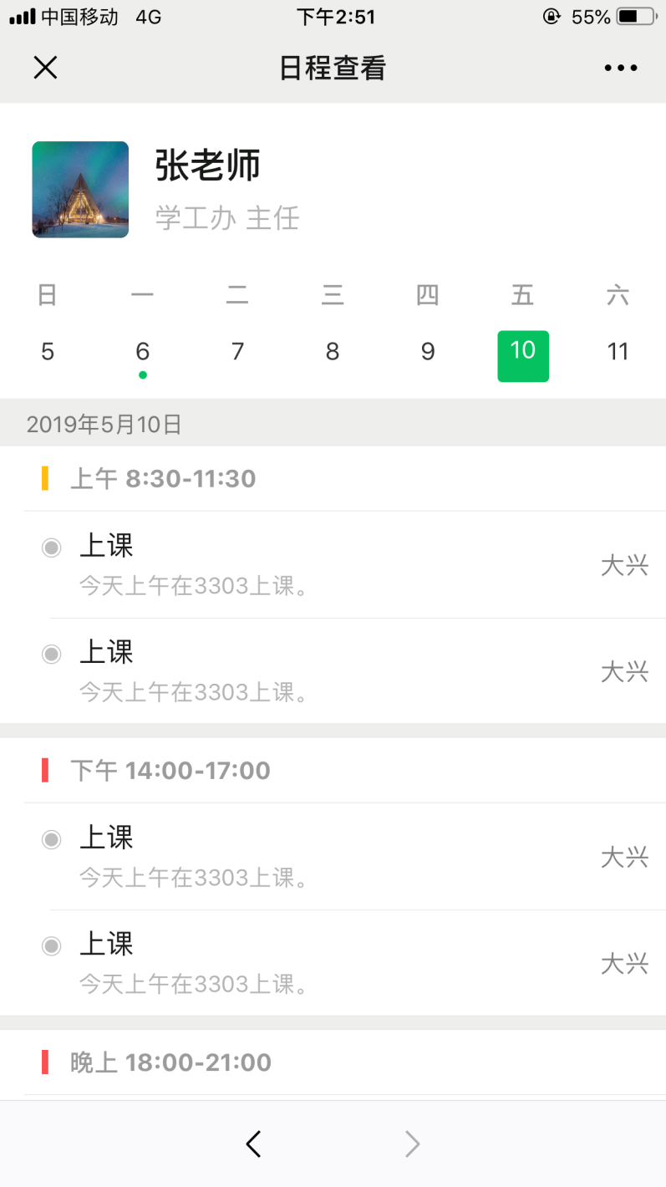

<!DOCTYPE html>

<html lang="zh-CN" style="height: 100%;">

<head>

<meta name="viewport" content="width=device-width, initial-scale=1, maximum-scale=1, user-scalable=no">

<meta charset="UTF-8">

<link rel="stylesheet" href="./css/weui.css">

<title>日程查看</title>

<style>

.weui-flex {

background-color: #FFFFFF;

text-align: center;

padding-bottom: 10px;

}

.today {

margin-left: auto;

margin-right: auto;

padding-top: auto;

margin-bottom: auto;

background-color: #07C160;

color: #FFFFFF;

width: 32px;

height: 32px;

border-radius: 3px;

}

a {

color: #353535;

font-size: 15px;

}

.week {

color: #9b9b9b;

font-size: 15px;

font-weight: bolder;

}

.margintop30 {

margin-top: 30px;

}

</style>

</head>

<body ontouchstart style="height: 100%; background-color: #ededed">

<div class="weui-tab">

<div class="weui-tab__panel">

<div style="position: fixed;top: 0px;z-index:9999;width: 100%">

<a href="#" class="weui-media-box weui-media-box_appmsg"

style="background-color: #FFFFFF;height: 75px;padding-left: 20px">

<div class="weui-media-box__hd">

<img class="weui-media-box__thumb" style="border-radius: 5px" src="./img/s.jpg">

</div>

<div class="weui-media-box__bd">

<h4 class="weui-media-box__title" style="font-size: 22px;font-weight: 700;margin-bottom: .1em">

张老师</h4>

<p class="weui-media-box__desc" style="font-size: 17px">学工办 主任</p>

</div>

<div class="weui-cell__ft" style="margin-right: 10px"><img src="./img/guanzhu.png" style="width: 28px;">

<div style="font-size:14px;color: rgba(0, 0, 0, 0.3)">关注</div>

</div>

</a>

<div class="weui-flex week">

<div class="weui-flex__item">

<div class="placeholder">日</div>

</div>

<div class="weui-flex__item">

<div class="placeholder">一</div>

</div>

<div class="weui-flex__item">

<div class="placeholder">二</div>

</div>

<div class="weui-flex__item">

<div class="placeholder">三</div>

</div>

<div class="weui-flex__item">

<div class="placeholder">四</div>

</div>

<div class="weui-flex__item">

<div class="placeholder">五</div>

</div>

<div class="weui-flex__item">

<div class="placeholder">六</div>

</div>

</div>

<div class="weui-flex days">

<div class="weui-flex__item">

<div class="placeholder"><a href="#">5</a></div>

</div>

<div class="weui-flex__item">

<div class="placeholder"><a href="#">6</a>

<div style="height: 5px;width: 5px;text-align:center;border-radius: 50%; background-color: #07C160;display: block;margin-left: auto;margin-right: auto"></div>

</div>

</div>

<div class="weui-flex__item">

<div class="placeholder"><a href="#">7</a></div>

</div>

<div class="weui-flex__item">

<div class="placeholder"><a href="#">8</a></div>

</div>

<div class="weui-flex__item">

<div class="placeholder"><a href="#">9</a></div>

</div>

<div class="weui-flex__item">

<a href="#" class="placeholder">

<div class="today">10</div>

</a>

</div>

<div class="weui-flex__item">

<div class="placeholder"><a href="#">11</a></div>

</div>

</div>

</div>

<div class="weui-cells__title" style="margin-top: 190px">2019年5月10日</div>

<div class="weui-cells">

<div class="weui-panel__hd" style="padding: 10px 16px 10px;color:#9b9b9b;">

<div style="width: 4px;height: 15px;background-color:#FFBE00;display:inline-block;vertical-align:middle;margin: 0 10px 3px 10px"></div>

上午 8:30-11:30

</div>

<div class="weui-panel__bd">

<a href="javascript:void(0);" class="weui-media-box weui-media-box_appmsg"

style="padding: 10px;margin-left: 15px">

<div>

<img style="width: 14px;height: 14px;padding:2px 10px 18px 0px" src="./img/dian.png">

</div>

<div class="weui-media-box__bd">

<h4 class="weui-media-box__title">上课</h4>

<p class="weui-media-box__desc">今天上午在3303上课。</p>

</div>

<div class="weui-cell__ft">

<div>大兴</div>

</div>

</a>

<a href="javascript:void(0);" class="weui-media-box weui-media-box_appmsg"

style="padding: 10px;margin-left: 15px">

<div>

<img style="width: 14px;height: 14px;padding:2px 10px 18px 0px" src="./img/dian.png">

</div>

<div class="weui-media-box__bd">

<h4 class="weui-media-box__title">上课</h4>

<p class="weui-media-box__desc">今天上午在3303上课。</p>

</div>

<div class="weui-cell__ft">

<div>大兴</div>

</div>

</a>

</div>

</div>

<div class="weui-cells">

<div class="weui-panel__hd" style="padding: 10px 16px 10px;color:#9b9b9b;">

<div style="width: 4px;height: 15px;background-color:#FA5151;display:inline-block;vertical-align:middle;margin: 0 10px 3px 10px"></div>

下午 14:00-17:00

</div>

<div class="weui-panel__bd">

<a href="javascript:void(0);" class="weui-media-box weui-media-box_appmsg"

style="padding: 10px;margin-left: 15px">

<div>

<img style="width: 14px;height: 14px;padding:2px 10px 18px 0px" src="./img/dian.png">

</div>

<div class="weui-media-box__bd">

<h4 class="weui-media-box__title">上课</h4>

<p class="weui-media-box__desc">今天上午在3303上课。</p>

</div>

<div class="weui-cell__ft">

<div>大兴</div>

</div>

</a>

<a href="javascript:void(0);" class="weui-media-box weui-media-box_appmsg"

style="padding: 10px;margin-left: 15px">

<div>

<img style="width: 14px;height: 14px;padding:2px 10px 18px 0px" src="./img/dian.png">

</div>

<div class="weui-media-box__bd">

<h4 class="weui-media-box__title">上课</h4>

<p class="weui-media-box__desc">今天上午在3303上课。</p>

</div>

<div class="weui-cell__ft">大兴</div>

</a>

</div>

</div>

<div class="weui-cells">

<div class="weui-panel__hd" style="padding: 10px 16px 10px;color:#9b9b9b;">

<div style="width: 4px;height: 15px;background-color:#FA5151;display:inline-block;vertical-align:middle;margin: 0 10px 3px 10px"></div>

晚上 18:00-21:00

</div>

<div class="weui-panel__bd">

<a href="javascript:void(0);" class="weui-media-box weui-media-box_appmsg"

style="padding: 10px;margin-left: 15px">

<div>

<img style="width: 14px;height: 14px;padding:2px 10px 18px 0px" src="./img/dian.png">

</div>

<div class="weui-media-box__bd">

<h4 class="weui-media-box__title">上课</h4>

<p class="weui-media-box__desc">今天上午在3303上课。</p>

</div>

<div class="weui-cell__ft">大兴</div>

</a>

<a href="javascript:void(0);" class="weui-media-box weui-media-box_appmsg"

style="padding: 10px;margin-left: 15px">

<div>

<img style="width: 14px;height: 14px;padding:2px 10px 18px 0px" src="./img/dian.png">

</div>

<div class="weui-media-box__bd">

<h4 class="weui-media-box__title">上课</h4>

<p class="weui-media-box__desc">今天上午在3303上课。</p>

</div>

<div class="weui-cell__ft">大兴</div>

</a>

</div>

</div>

</div>

</div>

</body>

</html>

**四、我的关注页面**

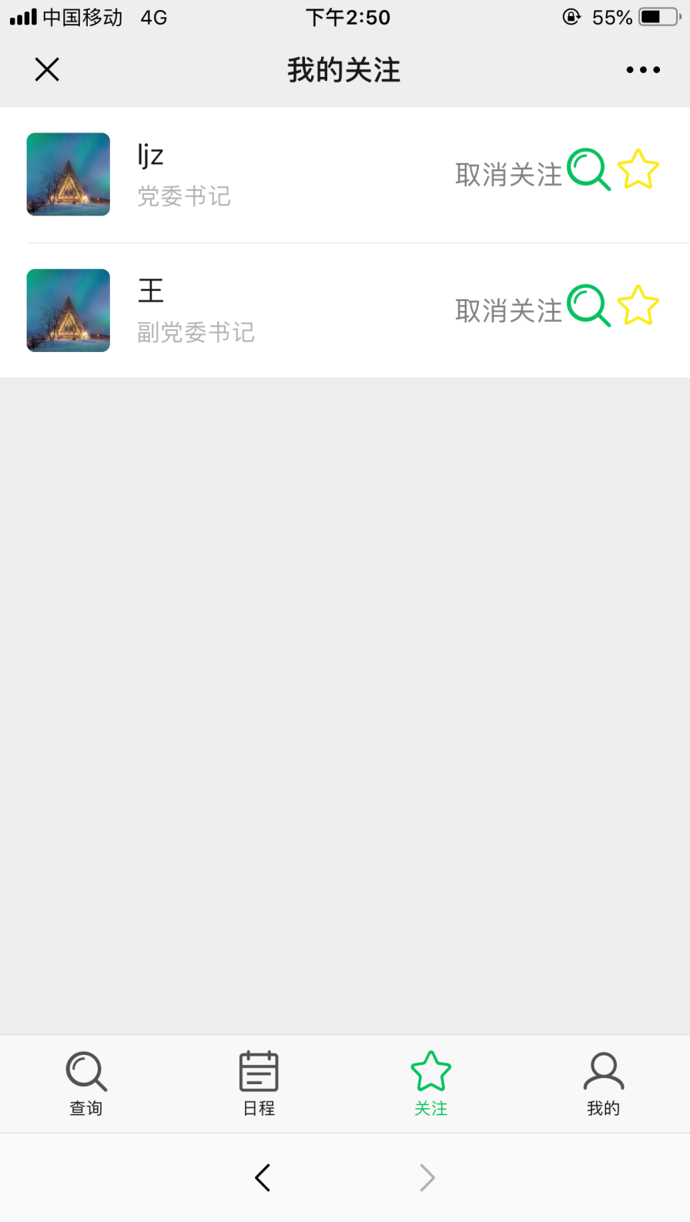

<!DOCTYPE html>

<html lang="zh-CN" style="height: 100%;">

<head>

<meta name="viewport" content="width=device-width, initial-scale=1, maximum-scale=1, user-scalable=no">

<meta charset="UTF-8">

<link rel="stylesheet" href="./css/weui.css">

<title>我的关注</title>

</head>

<body ontouchstart style="height: 100%; background-color: #ededed">

<div class="weui-tab">

<div class="weui-tab__panel">

<div class="weui-panel weui-panel_access">

<a class="weui-cell weui-cell_example" href="wx_agenda.html">

<div class="weui-cell__hd"><img src="./img/s.jpg" alt=""

style="width:50px;margin-right:16px;display:block;border-radius: 5px">

</div>

<div class="weui-cell__bd">

<h4 class="weui-media-box__title">张老师</h4>

<p class="weui-media-box__desc">学工办 主任</p>

</div>

<div class="weui-cell__ft">取消关注</div>

</a>

<a class="weui-cell weui-cell_example" href="wx_agenda.html">

<div class="weui-cell__hd"><img src="./img/s.jpg" alt=""

style="width:50px;margin-right:16px;display:block;border-radius: 5px">

</div>

<div class="weui-cell__bd">

<h4 class="weui-media-box__title">李老师</h4>

<p class="weui-media-box__desc">学工办 主任</p>

</div>

<div class="weui-cell__ft">取消关注</div>

</a>

<a class="weui-cell weui-cell_example" href="wx_agenda.html">

<div class="weui-cell__hd"><img src="./img/s.jpg" alt=""

style="width:50px;margin-right:16px;display:block;border-radius: 5px">

</div>

<div class="weui-cell__bd">

<h4 class="weui-media-box__title">王老师</h4>

<p class="weui-media-box__desc">学工办 主任</p>

</div>

<div class="weui-cell__ft">取消关注</div>

</a>

<a class="weui-cell weui-cell_example" href="wx_agenda.html">

<div class="weui-cell__hd"><img src="./img/s.jpg" alt=""

style="width:50px;margin-right:16px;display:block;border-radius: 5px">

</div>

<div class="weui-cell__bd">

<h4 class="weui-media-box__title">赵老师</h4>

<p class="weui-media-box__desc">学工办 主任</p>

</div>

<div class="weui-cell__ft">取消关注</div>

</a>

<a class="weui-cell weui-cell_example" href="wx_agenda.html">

<div class="weui-cell__hd"><img src="./img/s.jpg" alt=""

style="width:50px;margin-right:16px;display:block;border-radius: 5px">

</div>

<div class="weui-cell__bd">

<h4 class="weui-media-box__title">赵老师</h4>

<p class="weui-media-box__desc">学工办 主任</p>

</div>

<div class=" weui-cell__ft" ><object><a href="#"><img src="./img/guanzhu.png" width="30px"></a></object></div>

</a>

</div>

</div>

<div class="weui-tabbar">

<a href="wx_search.html" class="weui-tabbar__item ">

<span style="display: inline-block;position: relative;">

<img src="./img/chaxun.png" alt="" class="weui-tabbar__icon">

</span>

<p class="weui-tabbar__label">查询</p>

</a>

<a href="wx_myagenda.html" class="weui-tabbar__item ">

<img src="./img/richeng.png" alt="" class="weui-tabbar__icon">

<p class="weui-tabbar__label">日程</p>

</a>

<a href="wx_attention.html" class="weui-tabbar__item weui-bar__item_on">

<span style="display: inline-block;position: relative;">

<img src="./img/guanzhu-black_on.png" alt="" class="weui-tabbar__icon">

<p class="weui-tabbar__label">关注</p>

</span>

</a>

<a href="wx_me.html" class="weui-tabbar__item">

<img src="./img/wode.png" alt="" class="weui-tabbar__icon">

<p class="weui-tabbar__label">我的</p>

</a>

</div>

</div>

</body>

</html>

**五、个人主页页面**

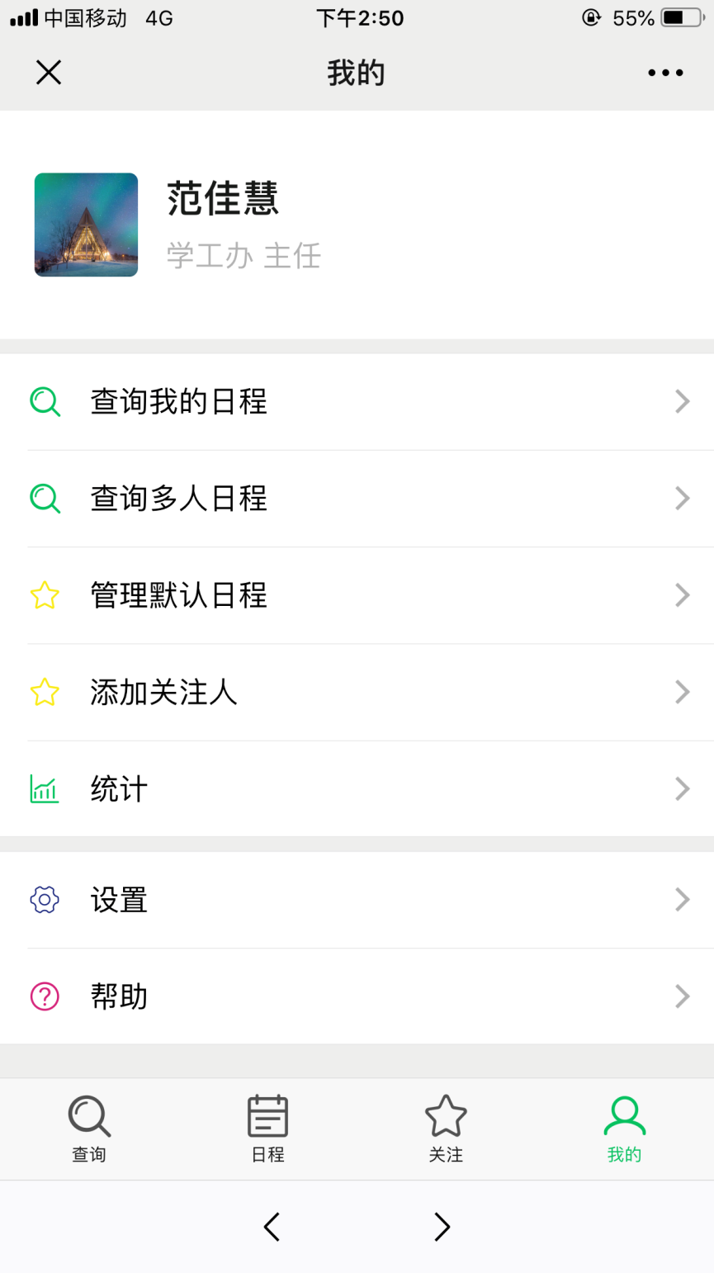

<!DOCTYPE html>

<html lang="zh-CN" style="height: 100%;">

<head>

<meta name="viewport" content="width=device-width, initial-scale=1, maximum-scale=1, user-scalable=no">

<meta charset="UTF-8">

<link rel="stylesheet" href="./css/weui.css">

<title>我的</title>

</head>

<body ontouchstart style="height: 100%; background-color: #ededed">

<div class="weui-tab">

<div class="weui-tab__panel">

<a href="#" class="weui-media-box weui-media-box_appmsg"

style="background-color: #FFFFFF;height: 100px;padding-left: 20px">

<div class="weui-media-box__hd">

<img class="weui-media-box__thumb" style="border-radius: 5px" src="./img/s.jpg">

</div>

<div class="weui-media-box__bd">

<h4 class="weui-media-box__title" style="font-size: 22px;font-weight: 700;margin-bottom: .1em">张老师</h4>

<p class="weui-media-box__desc" style="font-size: 17px">学工办 主任</p>

</div>

</a>

<div class="weui-cells">

<a class="weui-cell weui-cell_access weui-cell_example" href="javascript:;">

<div class="weui-cell__hd"><img

src="./img/guanzhu.png"

alt="" style="width:20px;margin-right:16px;display:block"></div>

<div class="weui-cell__bd">

<p>关注</p>

</div>

<div class="weui-cell__ft"></div>

</a>

<a class="weui-cell weui-cell_access weui-cell_example" href="javascript:;">

<div class="weui-cell__hd"><img

src="./img/tongji.png"

alt="" style="width:20px;margin-right:16px;display:block"></div>

<div class="weui-cell__bd">

<p>统计</p>

</div>

<div class="weui-cell__ft"></div>

</a>

</div>

<div class="weui-cells">

<a class="weui-cell weui-cell_access weui-cell_example" href="javascript:;">

<div class="weui-cell__hd"><img

src="./img/shezhi.png" alt="" style="width:20px;margin-right:16px;display:block"></div>

<div class="weui-cell__bd">

<p>设置</p>

</div>

<div class="weui-cell__ft"></div>

</a>

<a class="weui-cell weui-cell_access weui-cell_example" href="javascript:;">

<div class="weui-cell__hd"><img

src="./img/bangzhu.png"

alt="" style="width:20px;margin-right:16px;display:block"></div>

<div class="weui-cell__bd">

<p>帮助</p>

</div>

<div class="weui-cell__ft"></div>

</a>

</div>

</div>

<div class="weui-tabbar">

<a href="wx_search.html" class="weui-tabbar__item ">

<span style="display: inline-block;position: relative;">

<img src="./img/chaxun.png" alt="" class="weui-tabbar__icon">

</span>

<p class="weui-tabbar__label">查询</p>

</a>

<a href="wx_myagenda.html" class="weui-tabbar__item ">

<img src="./img/richeng.png" alt="" class="weui-tabbar__icon">

<p class="weui-tabbar__label">日程</p>

</a>

<a href="wx_attention.html" class="weui-tabbar__item">

<span style="display: inline-block;position: relative;">

<img src="./img/guanzhu-black.png" alt="" class="weui-tabbar__icon">

</span>

<p class="weui-tabbar__label">关注</p>

</a>

<a href="wx_me.html" class="weui-tabbar__item weui-bar__item_on">

<img src="./img/wode_on.png" alt="" class="weui-tabbar__icon">

<p class="weui-tabbar__label">我的</p>

</a>

</div>

</div>

</body>

</html>

**六、添加日程页面**

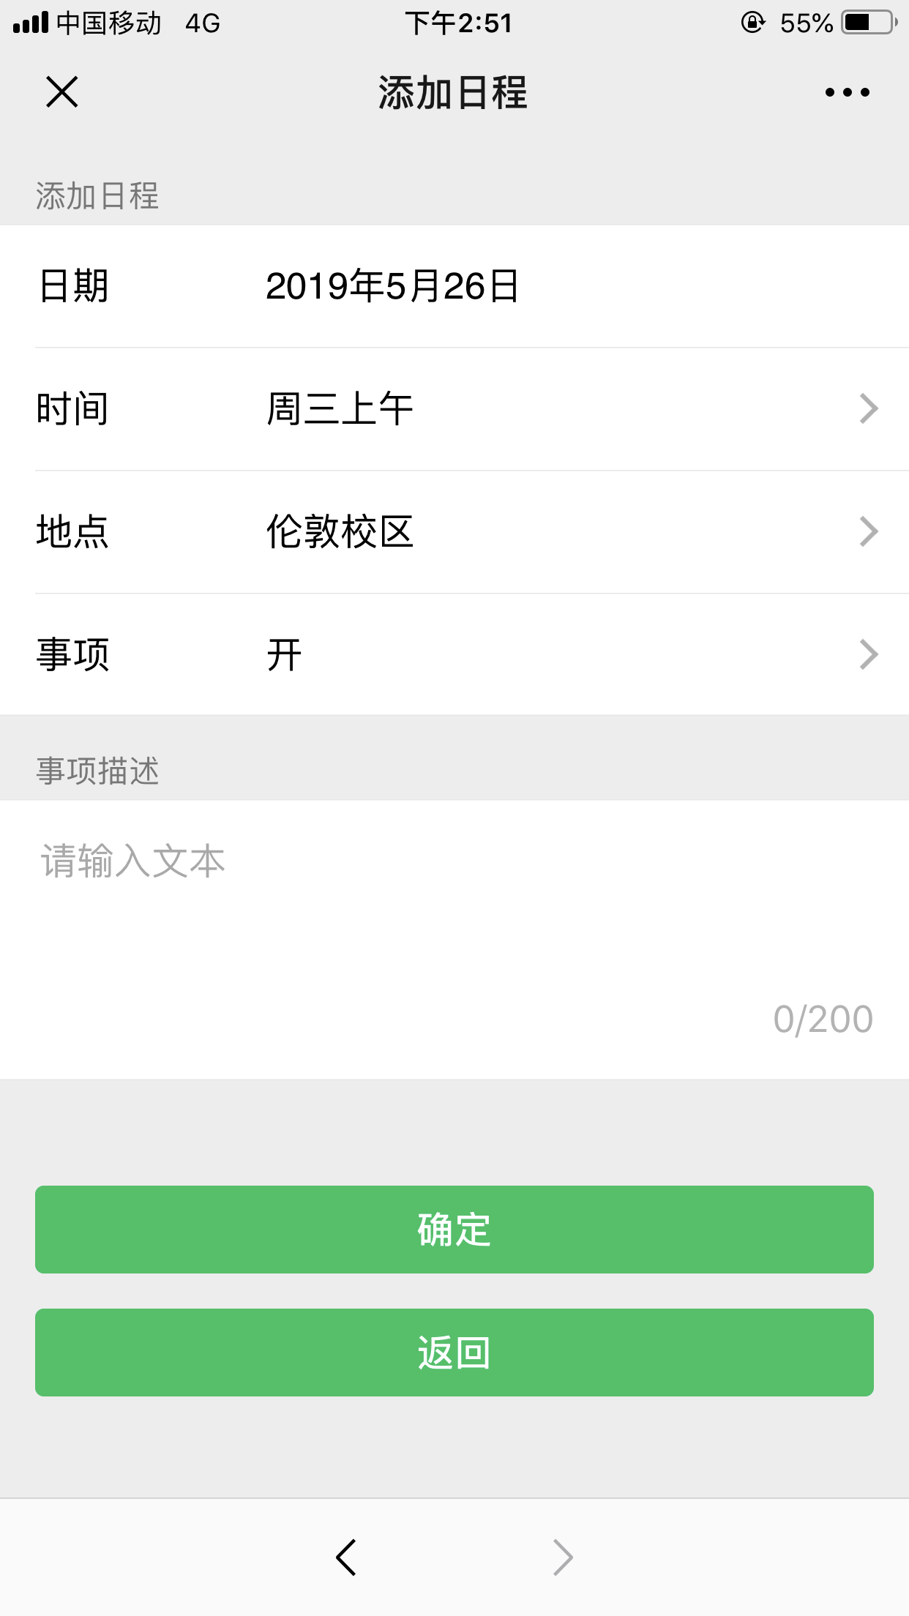

<!DOCTYPE html>

<html lang="zh-CN" style="height: 100%;">

<head>

<meta name="viewport" content="width=device-width, initial-scale=1, maximum-scale=1, user-scalable=no">

<meta charset="UTF-8">

<link rel="stylesheet" href="./css/weui.css">

<title>添加日程</title>

</head>

<body style="height: 100%; background-color: #ededed">

<div class="weui-tab">

<div class="weui-tab__panel">

<div class="weui-cells__title">新增日程</div>

<div class="weui-cells">

<div class="weui-cell">

<div class="weui-cell__hd"><label for="" class="weui-label">日期</label></div>

<div class="weui-cell__bd">

<input class="weui-input" type="date" value="">

</div>

</div>

<div class="weui-cell weui-cell_select weui-cell_select-after">

<div class="weui-cell__hd">

<label class="weui-label">时间</label>

</div>

<div class="weui-cell__bd">

<select class="weui-select" name="select2">

<option value="1">上午</option>

<option value="2">下午</option>

<option value="3">晚上</option>

</select>

</div>

</div>

<div class="weui-cell weui-cell_select weui-cell_select-after">

<div class="weui-cell__hd">

<label class="weui-label">地点</label>

</div>

<div class="weui-cell__bd">

<select class="weui-select" name="select2">

<option value="1">校本部</option>

<option value="2">大兴</option>

<option value="3">其他</option>

</select>

</div>

</div>

<div class="weui-cell weui-cell_select weui-cell_select-after">

<div class="weui-cell__hd">

<label class="weui-label">事项</label>

</div>

<div class="weui-cell__bd">

<select class="weui-select" name="select2">

<option value="1">上课</option>

<option value="2">开会</option>

<option value="3">其他</option>

</select>

</div>

</div>

</div>

<div class="weui-cells__title">事项描述</div>

<div class="weui-cells weui-cells_form">

<div class="weui-cell">

<div class="weui-cell__bd">

<textarea class="weui-textarea" placeholder="请输入文本" rows="3"></textarea>

<div class="weui-textarea-counter"><span>0</span>/200</div>

</div>

</div>

</div>

<div class="weui-btn-area">

<a class="weui-btn weui-btn_block weui-btn_primary" href="wx_myagenda.html" id="showTooltips">提交</a>

</div>

</div>

</div>

</body>

</html>