


BRAILLO-PHONE INTEGRATED COMMUNICATION SOFTWARE FOR VISUALLY CHALLENGED AND HEARING IMPAIRED

A PROJECT REPORT

Submitted by

SONIYA. K [REGISTER NO:211417104264]

SOPHIA GRACE LYDIA. D [REGISTER NO:211417104265]

VISHNU PRIYA. S [REGISTER NO:211417104305]

in partial fulfillment for the award of the degree

of

BACHELOR OF ENGINEERING

IN

COMPUTER SCIENCE AND ENGINEERING

PANIMALAR ENGINEERING COLLEGE, CHENNAI-600123.

ANNA UNIVERSITY: CHENNAI 600 025

APRIL 2021

BONAFIDE CERTIFICATE

Certified that this project report “BRAILLO-PHONE INTEGRATED COMMUNICATION SOFTWARE FOR VISUALLY CHALLENGED AND HEARING IMPAIRED” is the bonafide work of “SONIYA. K (211417104264), SOPHIA GRACE LYDIA D (211417104265) and VISHNU PRIYA. S (211417104305)” who carried out the project work under my supervision.

SIGNATURE | SIGNATURE
Dr.S.MURUGAVALLI,M.E.,Ph.D.,  HEAD OF THE DEPARTMENT | DR.D.ANURADHA,M.E., PGDBA., Ph.D  SUPERVISOR, PROFESSOR
DEPARTMENT OF CSE,  PANIMALAR ENGINEERING COLLEGE,  NASARATHPETTAI,  POONAMALLEE  CHENNAI-600 123. | DEPARTMENT OF CSE,  PANIMALAR ENGINEERING COLLEGE,  NASARATHPETTAI,  POONAMALLEE  CHENNAI-600 123.

Certified that the above candidates were examined in the Anna University Project Viva-Voce Examination held on...........................

INTERNAL EXAMINER EXTERNAL EXAMINER

ACKNOWLEDGEMENT

We express our deep gratitude to our respected Secretary and Correspondent Dr.P.CHINNADURAI, M.A., Ph.D. for his kind words and enthusiastic motivation, which inspired us a lot in completing this project.

We would like to extend our heartfelt and sincere thanks to our Directors Tmt.C.VIJAYARAJESWARI, Thiru.C.SAKTHIKUMAR,M.E., and Tmt. SARANYASREE SAKTHIKUMAR B.E., M.B.A., for providing us with the necessary facilities for completion of this project.

We also express our gratitude to our Principal Dr.K.Mani, M.E., Ph.D. for his timely concern and encouragement provided to us throughout the course.

We thank the HOD of CSE Department, Dr. S.MURUGAVALLI , M.E.,Ph.D., for the support extended throughout the project.

We would like to thank my Project Guide Dr. D.Anuradha, M.E., PGDBA., Ph.D Professor of CSE Department, and all the faculty members of the Department of CSE for their advice and suggestions for the successful completion of the project.

SONIYA. K
SOPHIA GRACE LYDIA.D
VISHNU PRIYA. S

ABSTRACT

From the olden days, Deaf-Blind people have used tactile sign language and braille to communicate with others. Currently, there are many technologies and devices for braille communication such as tellatouch, telebraille, and screen braille in which a deaf-blind person can read or write. However, since these devices are not portable, they face great difficulties in communicating with those who don't know braille during their travel.

Our proposed system is a device that converts human speech into braille text and vice versa. The device will contain a refreshable braille display and a Braille keypad with a microphone. The speech is given as input to the device through a microphone and speech is converted to braille text then displayed on the braille display which can be read by the blind person through contact. The blind person can communicate using a braille keypad whose input braille will be converted to human speech. Our device will help visually and hearing-impaired people to conveniently communicate, for educational purposes, and with others at convenience stores, shopping malls, and other areas.

TABLE OF CONTENTS

CHAPTER NO. | TITLE | PAGE NO.
 | ABSTRACT | Iii
 | LIST OF TABLES | Vii
 | LIST OF FIGURES | Viii
1. | INTRODUCTION
 | 1.1 Overview | 5
 | 1.2 Problem Definition | 6
2. | LITERATURE SURVEY | 7
3. | SYSTEM ANALYSIS
 | 3.1 Existing System | 15
 | 3.2 Proposed system | 18
 | 3.3 Requirement Analysis and Specification
 | 3.3.1 Software Environment | 19
 | 3.3.2 Hardware Environment | 19
 | 3.3.3 Functional Requirements | 19
 | 3.3.4 Package Requirements | 20
4. | SYSTEM DESIGN
 | 4.1 ER diagram | 22
 | 4.2 Data dictionary | 24
 | 4.3 Data Flow Diagram | 25
 | 4.4 UML Diagrams | 26
5. | SYSTEM ARCHITECTURE
 | 5.1 Architecture Overview | 34
 | 5.2 Module Design Specification | 35
 | 5.3 Program Design Language | 37
6. | SYSTEM IMPLEMENTATION
 | 6.1 Software Code | 40
 | 6.2 Arduino Code | 52
7. | SYSTEM TESTING
 | 7.1 Unit Testing & Integration Testing | 56
 | 7.2 Test Case & Reports | 58
8. | CONCLUSION
 | 8.1 Conclusion and Future Enhancements | 64
 | APPENDICES
 | A.1 Sample Screens | 68
 | A.2 Publications
 | REFERENCES | 69

LIST OF TABLES

Table No | Details | Page No
1 | User Data Set | 24
2 | Unicode value into Braille characters | 61
3 | English words into Braille table | 62

LIST OF FIGURES

FIGURE NO | DETAILS | PAGE NO
1.1 | Braille Alphabet and Numbers arrangements. | 2
4.1 | ER Diagram | 22
4.2.1 | Speech to Braille Conversion | 23
4.2.2 | Braille to Speech Conversion | 23
4.3 | Data Flow Diagram | 25
4.4.1 | Use Case Diagram | 26
4.4.2 | Class Diagram | 27
4.4.3 | State Chart Diagram | 28
4.4.4 | Activity Diagram | 29
4.4.5 | Sequence Diagram | 30
4.4.6 | Collaboration Diagram | 31
4.4.7 | Interface Diagram | 32
5.1 | Design Architecture | 34
5.2 | Module Design Specification | 36
FIGURE NO | DETAILS | PAGE NO
7.1 | Analysis Chart | 56
7.2.1 | Accuracy Report | 58
7.2.2 | Speech Recognition Score | 59
7.2.3 | Performance & Efficiency Result | 60
A.1.1 | An instance initiating the software to get the user input. | 65
A.1.2 | An instance showing the mapping of a single words to Braille characters. | 65
A.1.3 | The Mapping of a sentence to Braille characters. | 66
A.1.4 | An instance of Braille characters after mapping. | 66
A.1.5 | Status of the Output Generated. | 67
A.1.6 | Sample Hardware Design Implementation | 67

INTRODUCTION

CHAPTER 1
INTRODUCTION
Braille language is a tactile method of reading and writing used by blind or visually impaired people. It was created by Louis Braille. In the Braille system, the dot pattern was assigned to letter according to their position within the alphabetic order of the French alphabet. These characters have rectangular blocks called cells, that have tiny bumps called raised dots. The number and pattern of these dots differentiate one character from another. The most important thing is, it teaches us to spell and to understand the rules of grammar and punctuation. We are developing a system that converts the speech input into the braille and vice versa.

Initially, the system takes a human speech utterance as input and requires a string of words (or texts) as output; Then the texts are further transformed into the braille which will be displayed on the braillo-phone hardware device attached to that system. This text is converted to braille by mapping each English character symbol to the corresponding braille Unicode character according to the rules of braille. The refreshable braille display will be powered using Arduino and Micro servo motor SG90. The braille-phone hardware device will get the converted braille characters as input and display the output via refreshable braille-phone. Today, there are many systems to facilitate the communication between a deaf-blind person with others however all of them translate text input into braille. Our system aims to convert human speech is converted to braille and vice versa. It is a device comprising of a microphone, a braille keypad, and a refreshable braille display. Speech recognition systems can be classified in several different types by describing the type of speech utterance, type of speaker model and type of vocability that they have the ability to recognize.
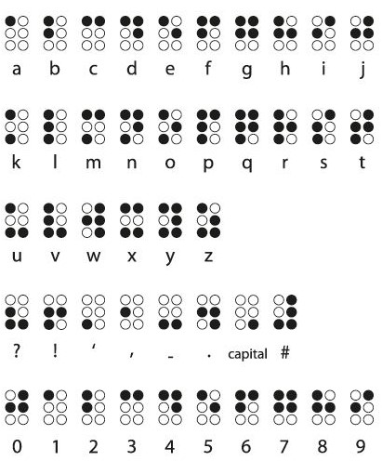
Fig.1.1 Braille Alphabet and Numbers arrangements.

A. Types of speech utterance Speech recognition are classified according to what type of utterance they have ability to recognize.

They are classified as:
1) Isolated word: Isolated word recognizer usually requires each spoken word to have quiet (lack of an audio signal) on bot h side of the sample window. It accepts single word at a time.
2) Connected word: It is similar to isolated word, but it allows separate utterances to “run-together‟ which contains a minimum pause in between them.
3) Continuous Speech: it allows the users to speak naturally and in parallel the computer will determine the content.
4) Spontaneous Speech: It is the type of speech which is natural sounding and is not rehearsed.

B. Types of speaker model Speech recognition system is broadly into two main categories based on speaker models namely speaker dependent and speaker independent.
1) Speaker dependent models: These systems are designed for a specific speaker. They are easier to develop and more accurate but they are not so flexible.
2) Speaker independent models: These systems are designed for variety of speaker. These systems are difficult to develop and less accurate but they are very much flexible.

C. Types of vocabulary the vocabulary size of speech recognition system affects the processing requirements, accuracy and complexity of the system. In voice recognition system: speech-to-text the types of vocabularies can be classified as follows:
1) Small vocabulary: single letter.
2) Medium vocabulary: two or three letter words.
3) Large vocabulary: more letter words.

1.1 OVERVIEW

The current era has been termed the learning age. People everywhere in the world are now proficient in accessing any information about any topic with great ease due to the initiation and advancement in the digital domain. The data are stored (commonly in the digital mode) is convenient either visually or, in some cases, through audio. Hence, both visual and hearing-impaired people have either quite inadequate or no reach to this information. They practice other means to obtain information, the Braille language implying one of them. People with difficulty in visual and hearing sense generally study using books printed in the Braille language.

We have developed a commercial device that helps the visually impaired to learn and communicate with the common people using the Braille alphabets, numbers, and various alphanumeric characters using a digital file as an input. This device can be elongated to turn an entire audio file into a physical output that any person with visual impliedness can understand efficiently. Braille is a tactile writing system used by the blind and the visually impaired. Visually impaired people are neglected from many modern communication and interaction procedures. This device supports technologies such as speech-to-braille and braille-to-speech are both ways of communication. The most generally used means of appending such visually impaired people with our Braillo-phone and one step closer to the common people.

1.2 PROBLEM DEFINITION

Deaf-Blind people from the olden days have used tactile sign language and braille to communicate with others for their day-to-day life. Due to dual sensory hardship, visual and hearing-impaired people are led to many difficulties while interacting with a normal person in the world, without an assistant or support they can’t communicate with others. Currently, there are multiple technologies and tools for braille communication such as tellatouch, telebraille, and screen braille in which a deaf-blind person can read or write braille using a braille keypad and a braille display. However, considering these devices are not transportable they encounter tremendous challenges in interacting with those who don't know braille during their travel or during their education process.

LITERATURE SURVEY

CHAPTER 2
LITERATURE SURVEY
A literature Survey is an objective, crucial outline of printed analysis literature relevant to a subject into account for analysis. Its purpose is to form familiarity with current thinking and analysis on a selected topic, and should justify future analysis into previously not noted or understudied space. it's the foremost vital a part of the report because it offers a direction within the space of analysis. It helps to line a goal for the analysis so giving out downside statement. A literature review in respect of the project, the researches created by varied analysts – their methodology (which is essentially their abstract) and therefore the conclusions they need found. It additionally offers an account of however this analysis has influenced the thesis.

[1] TITLE: The method of Feature Extraction in Automatic Speech Recognition System for Machine Interaction with Humans
DESCRIPTION: This paper typically explains the spoken words of person supported given speech signal information. It is referred to as Automatic Speech Recognition and speech to text conversion. The speech recognition techniques measures are classified on the idea of three approaches as follows Acoustic Phonetic Approach, Pattern Recognition Approach, computing Approach. To recognize the speech feature extraction and word recognition these two steps measures are followed. When feature extraction feature matching is performed for word recognition this describes the various feature extractions techniques like MFCC, LPC, LPC, DWT etc. Each technique includes a totally different recognition rate with different classification methodology. MFCC is that preferred feature extraction technique and DTW is that the additional popular classification methodology. The aim of this analysis work is to know the method of speech recognition to develop ASR system with nice accuracy. To develop Associate in ASR system with great accuracy is that the future work.

[2] TITLE: A summary of Recent Window based mostly Feature Extraction Algorithms for Speaker Recognition.
DESCRIPTION: This paper describes speaker recognition method in that the extraction of speech signal and reliable options that may determine speakers from speech signals. This paper compares and contrasts recent window frames algorithms mistreatment the middle for speech communication Understanding (CLSU) information through experiments. the various coefficients used and compared are: Real Cepstral Coefficients (RCC), Mel Cepstral Coefficients (MFCC), Linear prognosticative Cepstral Coefficients (LPCC), and sensory activity Linear prognosticative Cepstral Coefficients (PLPCC). The feature extraction strategies are going to be employed in conjunction with a Vector quantisation (VQ) methodology and a geometrician distance classifier to seek out the simplest recognition rate among the feature extraction options. A survey of revealed progressive, window-based, feature extraction strategies area unit evaluated against revealed results. The experiment used VQ and geometrician distance to acknowledge a speaker's identity through extracting the options of the speech signal by the subsequent methods: RCC, MFCC, MFCC + ∆MFCC, LPC, LPCC, PLPCC and Rasta PLPCC.The addition of the delta MFCC showed no important improvement to the popularity rate. This clearly shows that to effectively determine a speaker the speech sample has to be longer than one two-syllable word. once examination recognition time, MFCC was quicker than all different strategies. Overall MFCC in an exceedingly noise free setting was the simplest methodology in terms of recognition rate and recognition rate time.

[3] TITLE: An Overview of Recent Window Based Feature Extraction Algorithms for Speaker Recognition.
DESCRIPTION: Digital processing of speech signal and voice recognition algorithm is very important for fast and accurate automatic voice recognition technology. The voice is a signal of infinite information. A direct analysis and synthesizing the complex voice signal is due to too much information contained in the signal. Therefore, the digital signal processes such as Feature Extraction and Feature Matching are introduced to represent the voice signal. Several methods such as Liner Predictive Predictive Coding (LPC), Hidden Markov Model (HMM), Artificial Neural Network (ANN) and etc are evaluated with a view to identify a straight forward and effective method for voice signal. The extraction and matching process is implemented right after the Pre-Processing or filtering signal is performed. The non-parametric method for modelling the human auditory perception system, Mel Frequency Cepstral Coefficients (MFCCs) are utilized as extraction techniques. The nonlinear sequence alignment known as Dynamic Time Warping (DTW) introduced by Sakoe Chiba has been used as features matching techniques. Since it's obvious that the voice signal tends to have different temporal rate, the alignment is important to produce the better performance. This paper presents the viability of MFCC to extract features and DTW to compare the test patterns.

[4] TITLE: Voice Recognition System: Speech-to-Text.
DESCRIPTION: This paper describes how we get the input as speech and how the speech signal is converted into text format. This system consists of two elements, initial part is for process acoustic signal (Prosody, Gender information, Age, Accent) that is captured by electro-acoustic transducer and second part is to interpret the processed signal, then mapping of the signal to words. Model for every letter is going to be developed by using Hidden Markoff Model (HMM) algorithm. Feature extraction are going to be done by using Mel Frequency Cepstral constant (MFCC). Feature coaching of the dataset are going to be done by vector quantization and have testing of the dataset are going to be done by using viterbi algorithmic rule. By using these algorithms, we get text as output.

[5] TITLE: Conversion of Speech to text and Text to speech system
DESCRIPTION: Trivedi and Pant in a review of Speech to text and text to speech recognition systems examine the existing systems of speech digitization, recognition and conversion systems. TTS and STT are growing in popularity and are now used in many everyday applications. Quite a few speech recognition and conversion systems are used to assist the disabled such as Nuance Communications voice recognition which is used in Siri.

[6] TITLE: Conversion of Speech to Braille: Interaction device for Visual and Hearing Impaired
DESCRIPTION: This paper describes the implementation of an example device for each Visual and Hearing-impaired person get information from Speech signal to Braille output for this interaction device HM2007 IC is employed. It converts the speech signal into sequence of words, so as to develop techniques and systems for speech input to machine, suggested a formula enforced as a malicious program. Once the spoken digit has been recognized, the DSP processer can send the corresponding code to the PIC with necessary encoded information. The input is by receiving the speech signal and to acknowledge the digits. The output of this technique may be a Braille show. The Braille Cell consists of 3X2 dots for representing the Braille projections of corresponding character. Every dot within the Braille cell consists of coil mechanism that is coupled to the parallel output port of the coil driver. There area unit entirely six coil actuators, over them lies the dots. The coil mechanism gets motivated once they get the 5V power provide through PIC to those six coil (Braille Display) that corresponds the dots to be projected out, acts because the output device. The PIC microcontroller takes the encoded input from the DSP, decodes it and sends the acceptable recognized Braille cell trough the coil Driver. The whole system is enforced with receiving digits of the Tamil Thirukural as speech signal and therefore the output of the digits is tested with the Tamil Thirukural embossing each letter with delay time.

[7] TITLE: A Braille written text on Tamil Vowels and Consonants Text Image
DESCRIPTION: This paper describes the Speech and text is that the vital intermediate for human communication for those who have partial vision or blind man will get data from speech. The Braille coding system represents matter documents in a very decipherable format for the blind persons. This paper work is for changing the Tamil vowel and consonants text present on written text image to editable text and additionally rework recognized text into Braille script. The experimentation of the algorithms was dispensed on the Tamil text image dataset and results show that the projected methodology features a smart performance.

[8] TITLE: A Relatively High-Resolution Reading Aid for the Blind.
DESCRIPTION: This paper describes how we going to employ an auditory output consisting of a combination of tones indicating the black regions in a vertical slice through a letter space, or a tactile output consisting of a raised or vibrating image of the letter shapes. Maximum reading rates obtained by the majority of subjects with these reading aids have been less than ten correct words per minute. By analyzing the spatial spectral content of letter patterns, the most of these reading aids are using the well-known sampling theorem. The design of a reading aid is described based on the conclusions from this analysis of the sampling process, and on recent results from tactile research. The signal from each photosensor controls a tactile stimulator in a corresponding array of 144 stimulators, which are placed on a single finger. In preliminary reading tests with this device, four subjects have all read at rates greater than 10 correct words per minute, and two of the subjects have read at rates greater than 20 correct words per minute. Possibilities for obtaining still higher reading rates are discussed.

[9] TITLE: Braille printer
DESCRIPTION: This paper typically describes the common interface between blind and normal people. In the currently available systems used by normal person or blind person there is a need of system which provide a common interface to blind as well as normal person. Braille Printer is a device which provide such common interface. Braille is an important language used by the visually impaired to read and write. It is vital for communication and educational purposes. Braille Printer takes an input as a speech through microphone which is then converted to text using speech recognition and the recognized text is embossed in its respective Braille code. Here speech is the way of common interface through which blind person as well as normal person can interact with our system.

[10] TITLE: Conversion of Kannada text to Braille system.
DESCRIPTION: This algorithm maps each Kannada character to its equivalent braille character. It gives 100% accuracy in transliteration between braille and Kannada. The braille output is given to an embosser which prints and gives a hard copy of braille text which can be read by a visually impaired person.

SYSTEM ANALYSIS

CHAPTER 3
SYSTEM ANALYSIS

3.1 EXISTING SYSTEM

Braille is a very important writing system that is used for communication and the education of blind people. A number of braille devices have been created over time to assist the visually impaired people. An overview of common Braille devices is given below.

Braille embosser
Embossing is a process by which raised impressions are created on paper or metal. The braille embosser is an impact printer. It imprints braille characters onto paper. The invention of braille embosser made the production of braille books less time-consuming. Use of transliteration technology made the process of producing a document more convenient than before.

Perkins Brailler
It was created by David Abraham in 1951. The Perkins Brailler was a braille typewriter. Prior to its invention, writing in braille was a cumbersome process. Braille characters were written using a pen and a slate or with one of the expensive, complicated and fragile braille writing machines available during the era. The Perkins Brailler consisted a keyboard with a key for each of the six dots, a backspace, space and a line space key. It had rollers to move and hold the paper such that it avoided crushing the braille text created by the typewriter. Just like a typewriter, it had a carriage return lever and rollers to advance the paper.

Refreshable braille display
These are electro-magnetic devices that display braille text with the help of raised points on a flat surface. They translate the input text from a computer into braille characters and display them through raised dots with the help of piezo effect of some crystals which expand when voltage is given to them. Each pin is attached to a lever which is attached to a crystal. When voltage is applied, the crystal expands which in turn raises the dots on the surface. Refreshable Braille Displays can be connected to computers and tablets via USB and Bluetooth connections. The Braille displays assists the blind user and relays the information displayed on the computer or smartphone onto the Braille Display. The Refreshable braille display also helps the user in navigating through the devices various applications.

Braille e-book
The Braille e-book is a refreshable braille display that displays published books in a digital format. This refreshable braille display doesn’t use mechanical pins to display braille, rather it makes use of electroactive polymers and heated wax to display the text.

Braille notetakers
There are electronic portable note-taking devices that allow Braille input through the keyboard format of the Perkins Brailler. Notetakers show output in a one or two-line refreshable braille display consisting of tiny pins made of metal and plastic. Nowadays, notetaking devices have evolved from just taking notes to assisting in browsing the web, listening to music, reading books to interfacing with platforms such as Android.

Tellatouch
Developed by the American Foundation research laboratory, the Tellatouch allowed communication between a deaf-blind person and a sighted or blind person. It consisted of a keyboard with four rows. The top three rows had ten keys each and the fourth row had the standard braille keyboard. The sighted or blind person pressed the keys in the keyboard. At the other side of the device, there is a metal plate with a braille cell in the middle. The deaf-blind person kept his finger on it to feel the points rise corresponding to the key which was struck.

TelleBraille
It is a relay service that allows visual and hearing-impaired people to dial telephone calls to standard telephone users. To make the call, the deaf-blind person must dial a particular number. A communication assistant will pick up the call. The communication assistant will dial the number of the standard telephone user and relay the call between them.

Smart Display
They have the characteristics of both the braille display and the braille notetaker. They have a braille keyboard using which users can read and write and use functions like calendars and clocks. The Smart Display can be connected to computers, phones and tablets using Bluetooth and USB cables.

Braille Smartphone
Many Braille enabled phones have been built which display information in tactile Braille. The B-Touch phone developed by Zhenwei allows users to place calls, send messages and use applications like social media with ease. Indian company has built a prototype for a Braille smartphone with repressible Braille display.
3.2 PROPOSED SYSTEM
Today, there are many systems to facilitate the communication between a deaf-blind person with others however all of them translate text input into braille. Our system aims to convert human speech is converted to braille and vice versa. It is a device comprising of a microphone, a braille keypad and a refreshable braille display. There are two possible inputs to the device – first is human speech through a microphone and second is braille through a braille keypad.
The input speech is first converted to English text using speech recognition. The Mel-Frequency Cepstral Coefficient (MFCC) is used for feature extraction and Minimum Distance Classifier, Support Vector Machine (SVM) methods are used for speech classification. This text is converted to braille by mapping each English character symbol to the corresponding braille Unicode character according to the rules of braille. This will be displayed on the refreshable braille display.
Normally braille system consists of six dots. In this process we are going to connect each dot to one servo motor respectively. The input in the text form is fetched from the software. For each and every character the corresponding servo motor rotate. It will act like a keypad for displaying braille output to the visually challenged people. For example: for the letter “E” the corresponding servo motor will rotate this will turn to rise the letter upward so that the braille person can touch and know what is the exact letter. Braille text can be given as input through the braille keypad. This is converted to text by mapping each Unicode braille character to Unicode English alphabet character. This text is then converted to speech using ‘pyttsx3’ - the python library for text to speech conversion.

3.3 REQUIREMENT ANALYSIS AND SPECIFICATION

3.3.1 SOFTWARE ENVIRONMENT:
- Speech Recognition Toolkit: Kaldi5.5
- Dataset: Vosk Api
- Software: Visual Studio
- Program Language Version: Python 3.0, Pip3

3.3.2 HARDWARE ENVIRONMENT:
- OS: Windows 10
- RAM: 8 Gb
- Processor: intel i3
- Hard Disk: 500Gb
- Micro servo motor, Arduino, Connecting wires.
- 6 Volt Battery

3.3.3 FUNCTIONAL REQUIREMENTS
- System must be able to receive real-time audio input.
- System should determine whether the audio contains linguistic content.
- System should be able convert the audio input into Braille code
- System should display Braille text on a Refreshable Braille Display
- System should store the previous inputs in the database.

    - PACKAGE REQUIREMENTS
- Argparse,
- vosk
- sys
- json
- queue
- os
- sounddevice

SYSTEM DESIGN

CHAPTER 4
SYSTEM DESIGN
4.1 ER DIAGRAM:
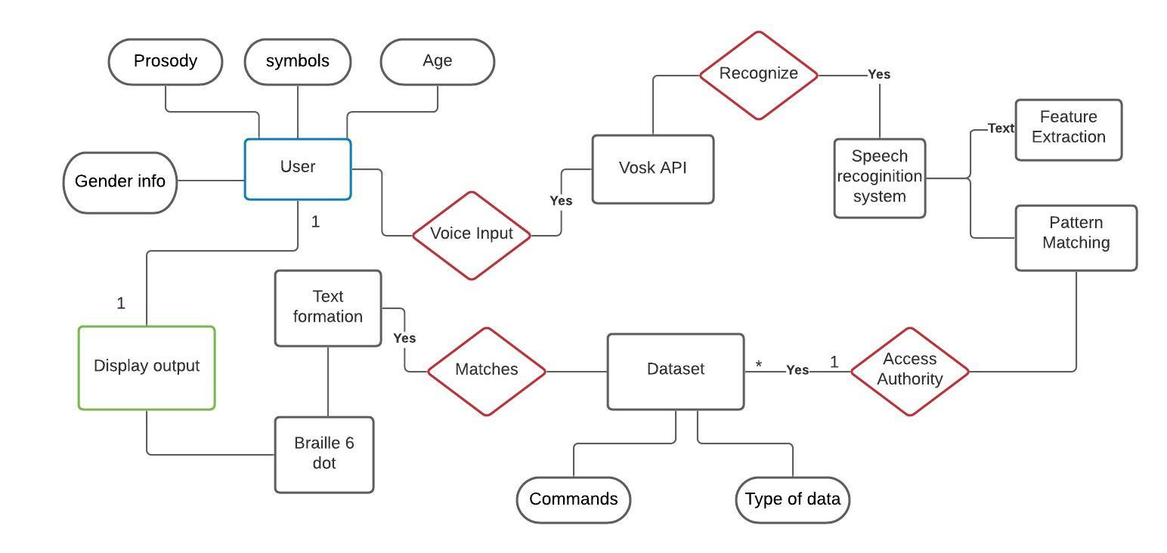
The E-R diagram is a simple way of representing the data entities being modelled and the relationships between these data entities. It is easy to transform E-R diagrams to the Relational Model (data entities correspond to relations and relationships correspond to the implied associations created by keys and foreign keys of relations).

Fig. 4.1 Entity Relationship diagram

Entities:
They represent the principle data objects about which information is to be collected. Entities represent concepts or concrete or abstract objects such as person, place, physical things, events.

Relationships:
A relationship represents some association between two or more entities. In an E-R diagram, a relationship is represented as a diamond shape, containing the name of the relationship between the entities.
FLOW CHART
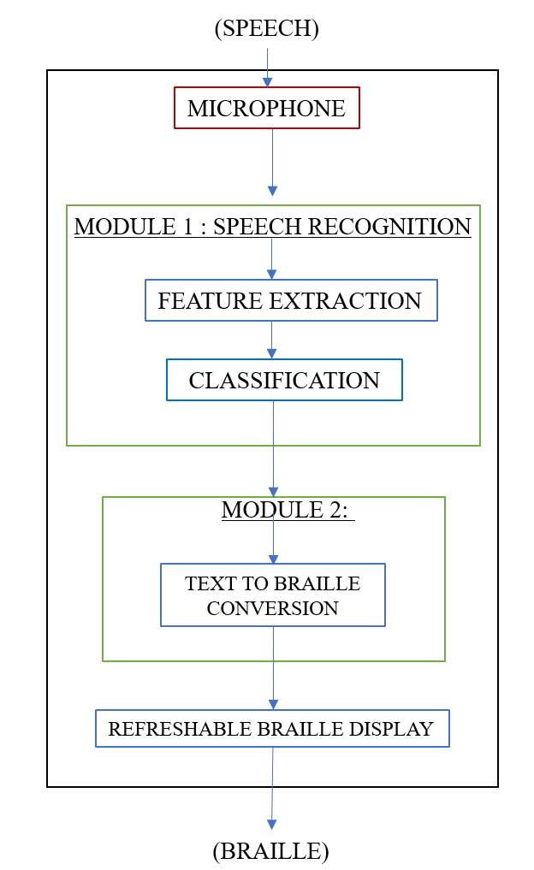
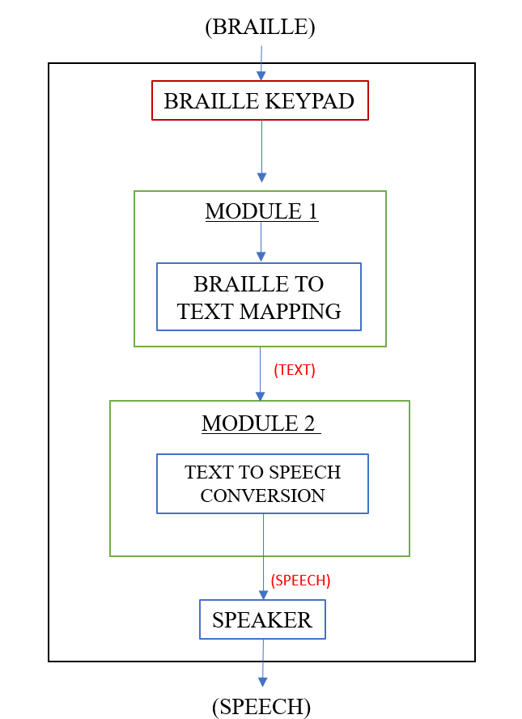
A flowchart is a type of diagram that represents a workflow or process. A flowchart can also be defined as a diagrammatic representation of an algorithm, a step-by-step approach to solving a task. This flow chart represents the conversion of speech to braille and also vice versa.

Fig. 4.2.1 Speech to Braille Conversion Fig. 4.2.2 Braille to Speech Conversion
4.2 DATA DICTIONARY

Machine learning typically works with two data sets: training and testing. In our project we are using only the testing part of dataset. For testing we use Vosk API and Kaldi 5.5. User provided speech signal is given to the Vosk API it will use python module to recognize the speech signal. Normally will enable 17 languages and dialect and provide large vocabulary transcription.

Field Name | Data Type | Data Format | Field Size | Description | Example
User-ID | Text | XNNNNN | 8 | Unique identification of each user | U123
User-Name | Text | ------ | 20 | User name | SSV
Gender | Text | ------ | 8 | User gender information | Female
Age | Number | ------ | 2 | User age info | 21
Symbol | Text | ------ | 15 | User pitch info | High

Table 1. User Data Set

4.3 DATA FLOW DIAGRAM
A data flow diagram is graphical tool used to describe and analyze movement of data in which the project progressed. In this, the workflow of the project is explained by this data flow diagram.
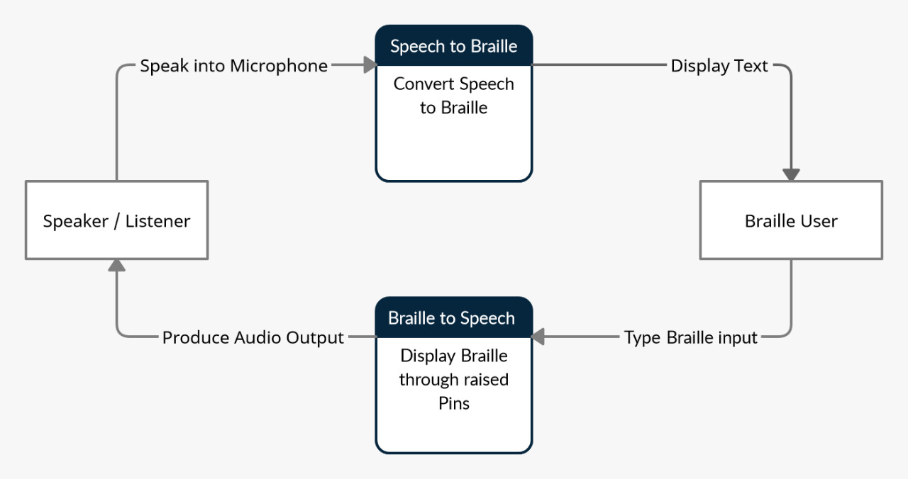

Fig. 4.3 Data Flow Diagram

4.4 UML DIAGRAM
The Unified Modeling Language is a general-purpose, developmental, modeling language in the field of software engineering that is intended to provide a standard way to visualize the design of a system.

- Use Case Diagram
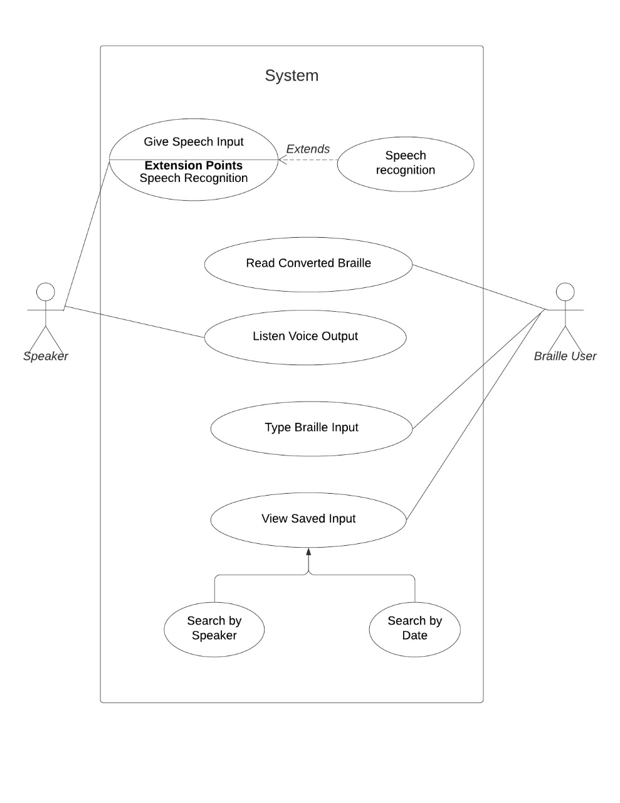
A use case diagram is a dynamic or behavior diagram in UML. Use case diagrams model the functionality of a system using actors and use cases. In this context, a "system" is something being developed or operated, such as a web site. The "actors" are people or entities operating under defined roles within the system.

Fig. 4.4.1 Use Case Diagram
- Class Diagram

The class diagram is the main building block of object-oriented modeling. It is used for general conceptual modeling of the structure of the application, and for detailed modeling translating the models into programming code. Class diagrams can also be used for data modeling. It is also a type of static structure diagram that describes the structure of a system by showing the system's classes, their attributes, operations, and the relationships among objects.

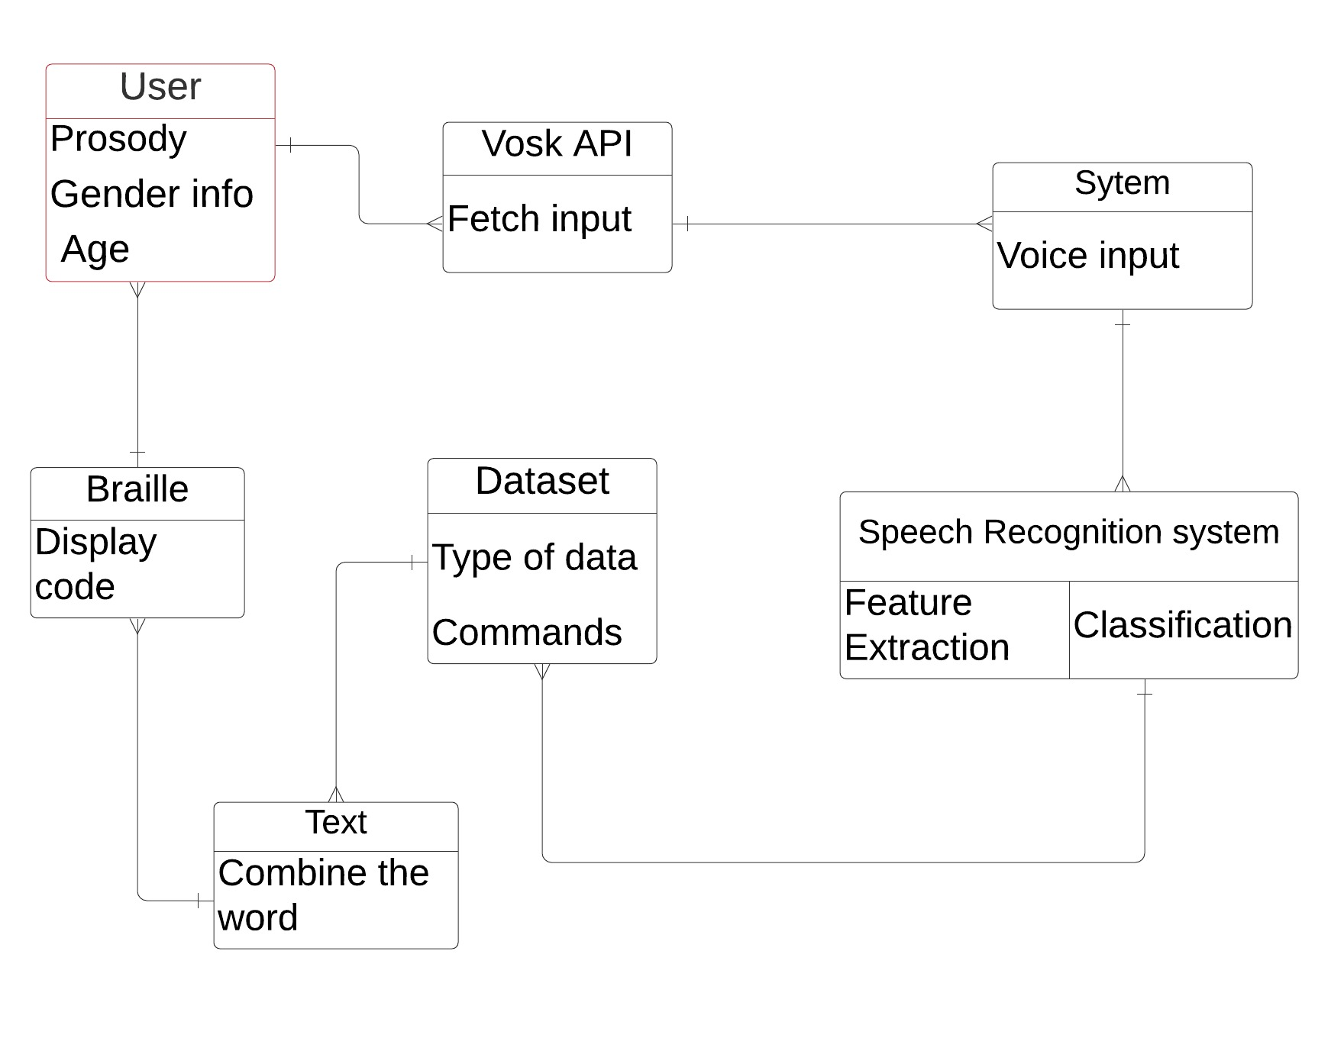

Fig. 4.4.2 Class Diagram

- State Chart Diagram
A state diagram is a type of diagram used in computer science and related fields to describe the behavior of systems. State diagrams require that the system described is composed of a finite number of states; sometimes, this is indeed the case, while at other times this is a reasonable abstraction.

The main purposes of using State chart diagrams:
- To model the dynamic aspect of a system.
- To model the life time of a reactive system.
- To describe different states of an object during its life time.
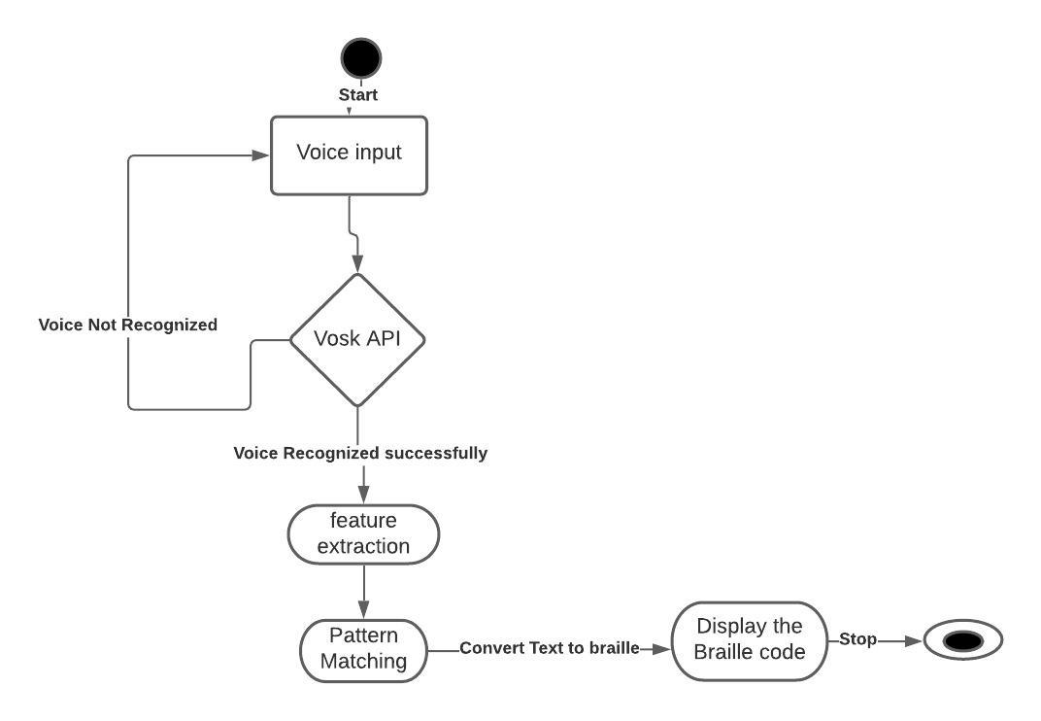
- Define a state machine to model the states of an object.

Fig. 4.4.3 State Chart Diagram

- Activity Diagram
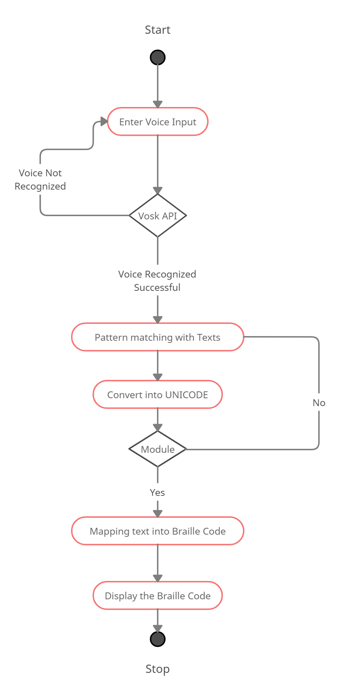
An activity diagram is a behavioral diagram i.e., it depicts the behavior of a system. An activity diagram portrays the control flow from a start point to a finish point showing the various decision paths that exist while the activity is being executed.

Fig. 4.4.4 Activity Diagram

- Sequence Diagram
A sequence diagram simply depicts interaction between objects in a sequential order i.e., the order in which these interactions take place. We can also use the terms event diagrams or event scenarios to refer to a sequence diagram. Sequence diagrams describe how and in what order the objects in a system function.
The main objectives are the following below:
- Objects taking part in the interaction.
- Message flows among the objects.
- The sequence in which the messages are flowing.
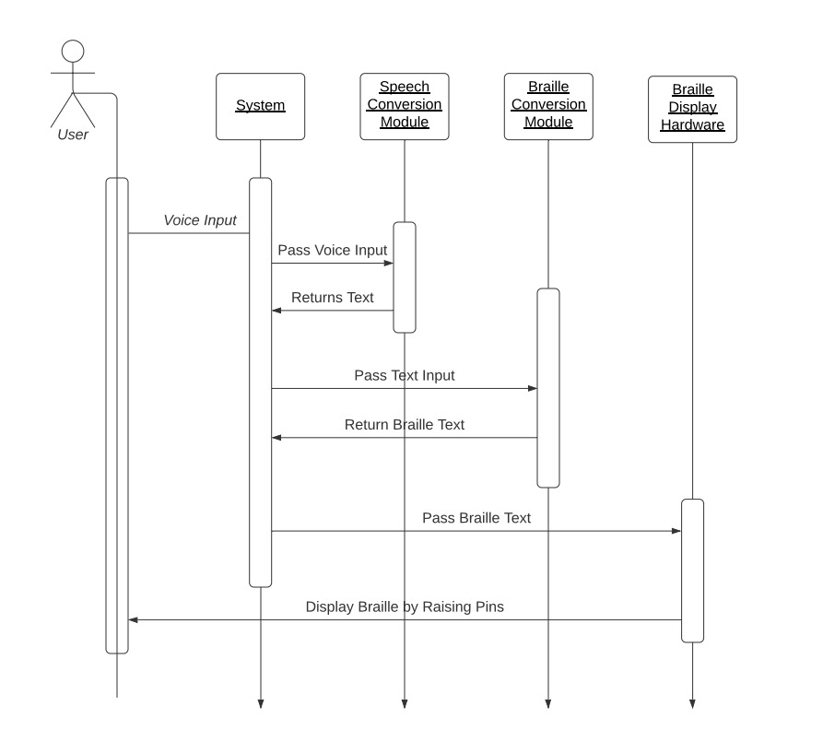
- Object organization.

Fig. 4.4.5 Sequence Diagram

- Collaboration Diagram
A collaboration diagram, also known as a communication diagram, is an illustration of the relationships and interactions among software objects in the Unified Modeling Language (UML). These diagrams can be used to portray the dynamic behavior of a particular use case and define the role of each object.

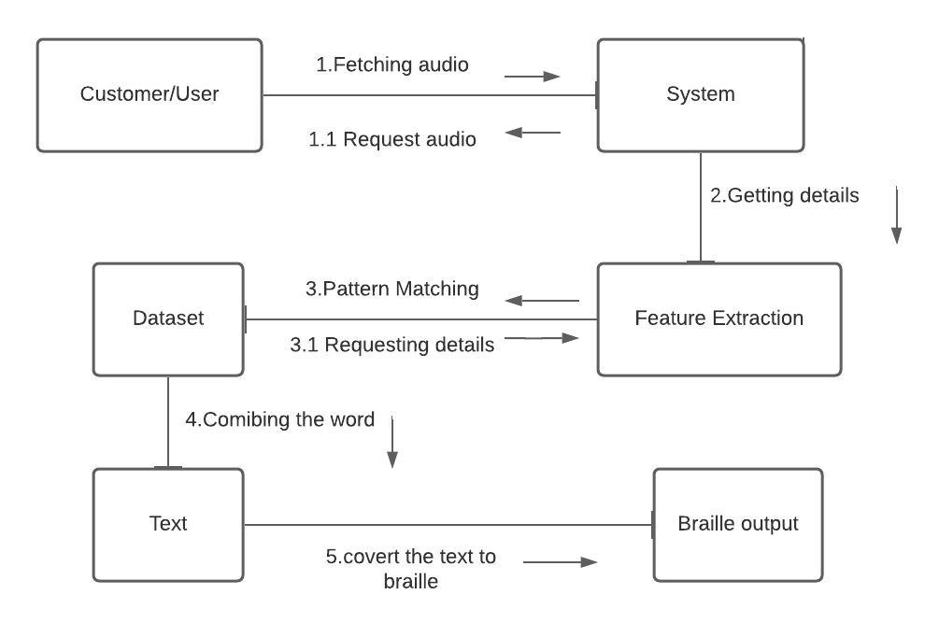
It shows the object organization as seen in the following diagram. In the collaboration diagram, the method call sequence is indicated by some numbering technique. The number indicates how the methods are called one after another. We have taken the same order management system to describe the collaboration diagram.

Fig. 4.4.6 Collaboration Diagram

- Interface Diagram
An interface is a classifier that declares of a set of coherent public features and obligations. An interface specifies a contract. Any instance of a classifier that realizes (implements) the interface must fulfil that contract and thus provides services described by contract. Since interfaces are declarations, they are not instantiable. Instead, an interface specification is implemented by an instance of an instantiable classifier, which means that the instantiable classifier presents a public facade that conforms to the interface specification.
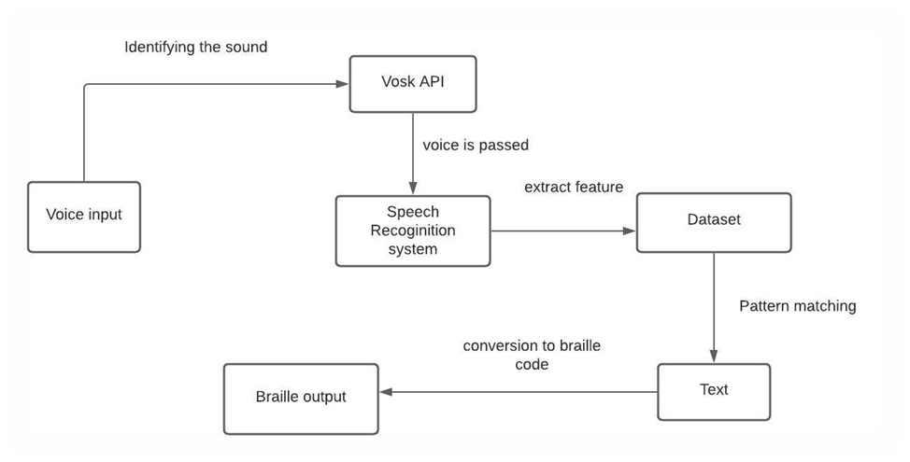

Fig 4.4.7 Interface Diagram

SYSTEM
ARCHITECTURE

CHAPTER 5
SYSTEM ARCHITECTURE

5.1 ARCHITECTURE OVERVIEW
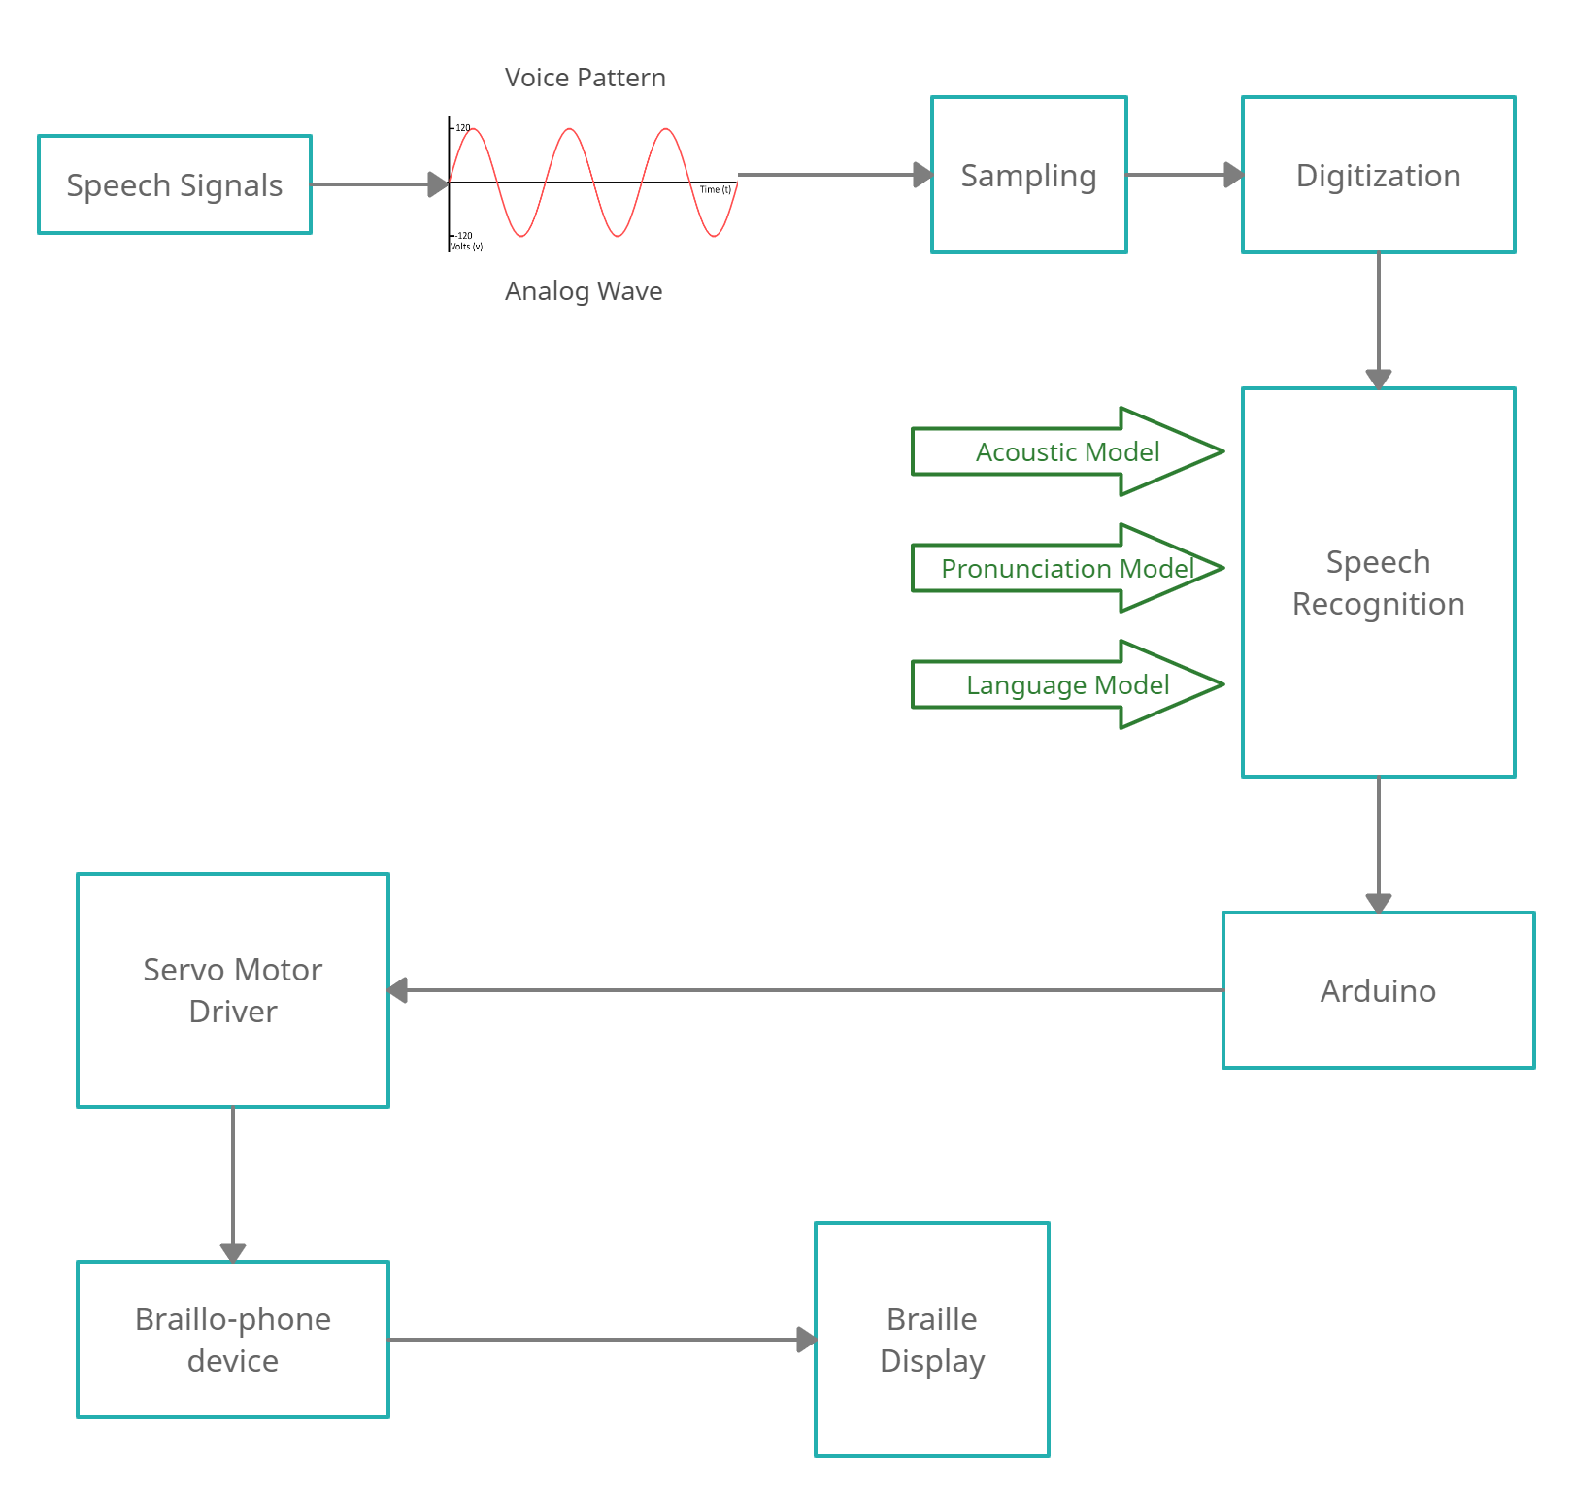
A system architecture is the conceptual model that defines the structure, behavior, and more views of a system. An architecture description is a formal description and representation of a system, organized in a way that supports reasoning about the structures and behaviors of the system.

Fig. 5.1 Design Architecture
At first, the speech signals are processed into analog waveforms. Later on, these waveforms are simplified and digitized. In the second level, they are sent to the speech recognition model where the speech signals are categorized into various factors by considering the pronunciation, acoustic model, gender of the speaker, and language. Finally, they are mapped with the corresponding braille characters and converted into braille alphabets. These alphabets are then displayed on the braillophone.

5.2 MODULE DESIGN SPECIFICATION
Our system aims to convert human speech is converted to braille and vice versa. It is a device comprising of a microphone, a braille keypad, and a refreshable braille display. There are two possible inputs to the device – the first is human speech through a microphone and the second is braille through a braille keypad. The input speech is first converted to English text using speech recognition. The Mel-Frequency Cepstral Coefficient (MFCC) is used for feature extraction and Minimum Distance Classifier, Support Vector Machine (SVM) methods are used for speech classification. This text is converted to braille by mapping each English character symbol to the corresponding braille Unicode character according to the rules of braille. The refreshable braille display will be powered using Arduino and Micro servo motor SG90.

Speech input and pattern recognition in the system.
The input is given via speech to the system, this speech is recognized and the patterns are identified using the Hidden Markov Models (HMM). Speech recognition is a method of transforming speech signals into a succession of words. HMMs will also provide an easy and effective framework for modeling time-deviating spectral vector sequences. Input signal- Voice input by the user. Feature Extraction- it should retain useful information of the signal, deduct redundant and unwanted information, show less variation from one speaking environment to another, occur normally and naturally in speech. Acoustic model- it contains statistical representations of each distinct sounds that makes up a word. Decoder- it will decode the input signal after feature extraction and will show the desired output. Language model- it assigns a probability to a sequence of words by means of a probability distribution. Output- interpreted text is given by the computer. The main of the project is to recognize speech using MFCC and VQ techniques. The feature extraction will be done using Mel Frequency Cepstral Coefficients (MFCC).

Steps involved in the speech recognition system:
Step1: At first, the raw speech signals are captured and converted from analog to digital signals respectively.

Step2: Then the speech is processed and analyzed for any unwanted noise or disturbance which will be eliminated in this phase.

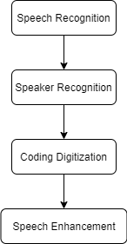
Step3: Recognition of the speech signals

Fig. 5.2 Module Design Specification (Speech Recognition System)

Step4: Feature Extraction: Retaining necessary information of the speech signal while rejecting the unwanted such as information like background disturbance, emotion, and noises etc.

Step5: Pattern Recognition: After the extraction of necessary features from the speech samples, pattern matching or classification will be done.

Collection of Vosk dataset for language identification.
The database is the pivotal point in the Speech-to-text conversion module. For any speech recognition system, the initial phase is to configure the database. The proposed system is implemented with the help of the python module for Vosk API to recognize the speech given by the user to the system.

This Vosk API focuses on life-long semi-supervised learning modules with huge datasets. It enables speech recognition models for over 17 languages, dialects and also provides continuous large vocabulary transcription.

Braillo-phone device for braille characters display.
Through the micro servo motor connected with Arduino, the code is embedded and displays the braille characters for the understanding of the visual and hearing-impaired people. This device for disabled persons can be efficiently accessed and handed with the level of priorities. This device is implemented using a Single Board Computer Arduino, as it is portable and practices Real-time experiments. After the implementation of the prototype, it has experimented with some visually impaired and both hearing-impaired people and successfully achieved the output of 100% accuracy.
5.3 PROGRAM DESIGN LANGUAGE

ALGORITHM
SpeechToBraille()
//Implements the speech to braille conversion algorithm
//Input: English language voice input
//Output: Braille text
define path of speech recognition dataset
listen for speech input
while (input is received)
accept the waveform
waveform undergoes feature extraction
output is given for classification with dataset
rec ← classified speech
while(true)
data ← extract rec and convert into dictionary
text ← extract the converted text from dictionary using json
braille ← AlphabetToBraille(text)

SYSTEM
IMPLEMENTATION

CHAPTER 6
SYSTEM IMPLEMENTATION
6.1 SOFTWARE CODE:
Speech to Braille Conversion:
import argparse
import os
import queue
import sounddevice as sd
import vosk
import sys
import json
import alphaToBraille
#import braille
q = queue.Queue()

def int_or_str(text):
"""Helper function for argument parsing."""
try:
return int(text)
except ValueError:
return text
def callback(indata, frames, time, status):
"""This is called (from a separate thread) for each audio block."""
if status:
print(status, file=sys.stderr)
q.put(indata)
parser = argparse.ArgumentParser(add_help=False)
parser.add_argument(
'-l', '--list-devices', action='store_true',
help='show list of audio devices and exit')
args, remaining = parser.parse_known_args()
if args.list_devices:
print(sd.query_devices())
parser.exit(0)
parser = argparse.ArgumentParser(
description=__doc__,
formatter_class=argparse.RawDescriptionHelpFormatter,
parents=[parser])
parser.add_argument(
'-f', '--filename', type=str, metavar='FILENAME',
help='audio file to store recording to')
parser.add_argument(
'-m', '--model', type=str, metavar='MODEL_PATH',
help='Path to the model')
parser.add_argument(
'-d', '--device', type=int_or_str,
help='input device (numeric ID or substring)')
parser.add_argument(
'-r', '--samplerate', type=int, help='sampling rate')
args = parser.parse_args(remaining)

try:
if args.model is None:
args.model = "model"
if not os.path.exists(args.model):
print ("Please download a model for your language from https://alphacephei.com/vosk/models")
print ("and unpack as 'model' in the current folder.")
parser.exit(0)
if args.samplerate is None:
device_info = sd.query_devices(args.device, 'input')
# soundfile expects an int, sounddevice provides a float:
args.samplerate = int(device_info['default_samplerate'])

model = vosk.Model(args.model)
if args.filename:
dump_fn = open(args.filename, "wb")
else:
dump_fn = None

with sd.RawInputStream(samplerate=args.samplerate, blocksize = 8000, device=args.device, dtype='int16',
channels=1, callback=callback):
print('#' * 80)
print('Press Ctrl+C to stop the recording')
print('#' * 80)

rec = vosk.KaldiRecognizer(model, args.samplerate)
while True:
data = q.get()
data = bytes(data)
if rec.AcceptWaveform(data):
#print(rec.Result())
res = json.loads(rec.Result())
res_text = res['text']
print (res_text)
print(alphaToBraille.translate(res_text))
# print(braille.textToBraille(res_text))
except KeyboardInterrupt:
print('\nDone')
parser.exit(0)
except Exception as e:
parser.exit(type(e).__name__ + ': ' + str(e))

Text to Braille impemntation:
letters = {'a': chr(10241),
'b': chr(10243),
'c': chr(10249),
'd': chr(10265),
'e': chr(10257),
'f': chr(10251),
'g': chr(10267),
'h': chr(10259),
'i': chr(10250),
'j': chr(10266),
'k': chr(10245),
'l': chr(10247),
'm': chr(10253),
'n': chr(10269),
'o': chr(10261),
'p': chr(10255),
'q': chr(10271),
'r': chr(10263),
's': chr(10254),
't': chr(10270),
'u': chr(10277),
'v': chr(10279),
'w': chr(10298),
'x': chr(10285),
'y': chr(10301),
'z': chr(10293)}

contractions = {'but': chr(10243),
'can': chr(10249),
'do': chr(10265),
'every': chr(10257),
'from': chr(10251),
'go': chr(10267),
'have': chr(10259),
'just': chr(10266),
'knowledge': chr(10280),
'like': chr(10296),
'more': chr(10253),
'not': chr(10269),
'people': chr(10255),
'quite': chr(10271),
'rather': chr(10263),
'so': chr(10254),
'that': chr(10270),
'us': chr(10277),
'very': chr(10279),
'it': chr(10285),
'you': chr(10301),
'as': chr(10293),
'and': chr(10287),
'for': chr(10303),
'of': chr(10295),
'the': chr(10286),
'with': chr(10302),
'will': chr(10298),
'his': chr(10278),
'in': chr(10260),
'was': chr(10292),
'to': chr(10262)}

punctuation = {',': chr(10242),
';': chr(10246),
':': chr(10258),
'.': chr(10290),
'!': chr(10262),
'(': chr(10294),
')': chr(10294),
'“': chr(10278),
'”': chr(10292),
'?': chr(10278),
'/': chr(10252),
'#': chr(10300),
'\'': chr(10244),
'…': chr(10290) + chr(10290) + chr(10290),
'’': chr(10244),
'': chr(10276),
'-': chr(10276),
'‐': chr(10276),
'-': chr(10276),
'‒': chr(10276),
'–': chr(10276),
'—': chr(10276),
'―': chr(10276)}

numbers = {'1': chr(10241),
'2': chr(10243),
'3': chr(10249),
'4': chr(10265),
'5': chr(10257),
'6': chr(10251),
'7': chr(10267),
'8': chr(10259),
'9': chr(10250),
'0': chr(10266)}
CAPITAL = chr(10272) # ⠠
NUMBER = chr(10300) # ⠼
UNRECOGNIZED = '?'

open_quotes = True
def extract_words(string):
words = string.split(" ")
result = []
for word in words:
temp = word.split("\n")
for item in temp:
result.append(item)
return result

def is_braille(char):
if len(char) > 1:
return False
return char in mapBrailleToAlpha.letters \
or char in mapBrailleToAlpha.numbers \
or char in mapBrailleToAlpha.punctuation \
or char in mapBrailleToAlpha.contractions \
or char == CAPITAL \
or char == NUMBER

def trim(word):
while len(word) != 0 and not word[0].isalnum():
word = word[1:]
while len(word) != 0 and not word[-1].isalnum():
word = word[:-1]
return word

def numbers_handler(word):
if word == "":
return word
result = word[0]
if word[0].isdigit():
result = NUMBER + numbers.get(word[0])
for i in range(1, len(word)):
if word[i].isdigit() and word[i-1].isdigit():
result += numbers.get(word[i])
elif word[i].isdigit():
result += NUMBER + numbers.get(word[i])
else:
result += word[i]
return result

def capital_letters_handler(word):
if word == "":
return word
result = ""
for char in word:
if char.isupper():
result += CAPITAL + char.lower()
else:
result += char.lower()
return result

def find_utf_code(char):
if len(char) != 1:
return -1
for i in range(0, 55000):
if char == chr(i):
return i

def char_to_braille(char):
if is_braille(char):
return char
elif char == "\n":
return "\n"
elif char == "\"":
global open_quotes
if open_quotes:
open_quotes = not open_quotes
return punctuation.get("“")
else:
open_quotes = not open_quotes
return punctuation.get("”")
elif char in letters and char.isupper():
return CAPITAL + letters.get(char)
elif char in letters:
return letters.get(char)
elif char in punctuation:
return punctuation.get(char)
else:
print("Unrecognized Symbol:", char, "with UTF code:", find_utf_code(char))
return UNRECOGNIZED

def word_to_braille(word):
if word in contractions:
return contractions.get(word)
else:
result = ""
for char in word:
result += char_to_braille(char)
return result

def build_braille_word(trimmed_word, shavings, index, braille):
if shavings == "":
braille += word_to_braille(trimmed_word)
else:
for i in range(0, len(shavings)):
if i == index and trimmed_word != "":
braille += word_to_braille(trimmed_word)
braille += word_to_braille(shavings[i])
if index == len(shavings):
braille += word_to_braille(trimmed_word)
return braille

def translate(string):
braille = ""
words = extract_words(string)
for word in words:
word = numbers_handler(word)
word = capital_letters_handler(word)
trimmed_word = trim(word)
untrimmed_word = word
index = untrimmed_word.find(trimmed_word)
shavings = untrimmed_word.replace(trimmed_word, "")
braille = build_braille_word(trimmed_word, shavings, index, braille) + " "
return braille[:-1]

6.2 ARDUINO CODE
To display the braille output
#include <Servo.h>
Servo s1; Servo s2; Servo s3; Servo s4; Servo s5; Servo s6;
int servopin1 = 9;
int servopin2 = 8;
int servopin3 = 7;
int servopin4 = 6;
int servopin5 = 5;
int servopin6 = 4;

void setup()
{
s1.attach(servopin1);s2.attach(servopin2);
s3.attach(servopin3); s4.attach(servopin4);
s5.attach(servopin5); s6.attach(servopin6);
}

void loop()
{
//while (Serial.available() == 0);
//String data = Serial.readStringUntil('\n');
String data = "hi";
//Serial.setTimeout(0.01);
for (int i = 0 ; data[i] != '\0'; i++) {
char ch = data[i];
switch (ch) {
case 'h' : {
s1.write(0);
s3.write(0);
s4.write(0);
delay(1000);
s1.write(90);
s3.write(90);
s4.write(90);
delay(1000);
s1.write(180);
s3.write(180);
s4.write(180);
delay(1000);
s1.write(0);
s3.write(0);
s4.write(0);
delay(1000);
s1.write(90);
s3.write(90);
s4.write(90);
delay(1000);
s1.write(180);
s3.write(180);
s4.write(180);
delay(1000);
break;
}
case 'i' : {
s2.write(0);
s4.write(0);
delay(1000);
s2.write(90);
s4.write(90);
delay(1000);
s2.write(180);
s4.write(180);
delay(1000);
s2.write(0);
s4.write(0);
delay(1000);
s2.write(90);
s4.write(90);
delay(1000);
s2.write(180);
s4.write(180);
delay(1000);
break;
}
}

}
}

SYSTEM TESTING

CHAPTER 7
SYSTEM TESTING

7.1 UNIT TESTING & INTEGRATION TESTING
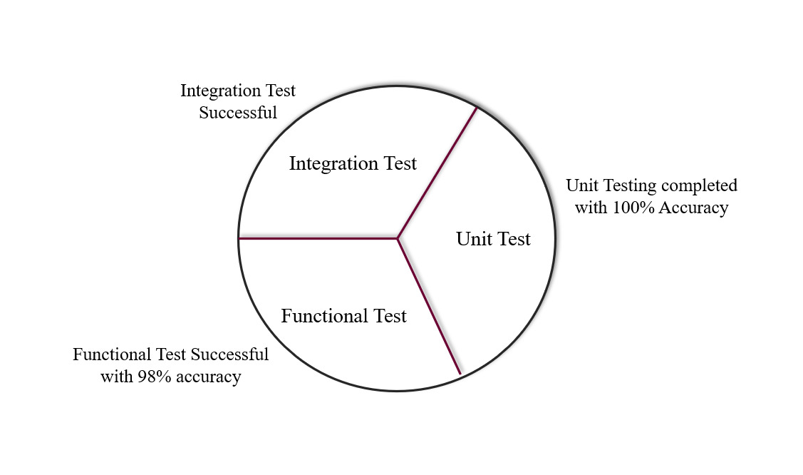
Unit testing ensures that all code meets quality standards before it's deployed. This ensures a reliable engineering environment where quality is paramount. Over the course of the product development life cycle, unit testing saves time and money, and helps developers write better code, more efficiently. Integrating testing is one of the phases in which software testing in which individual software modules are combined and tested as a group. Integration testing is conducted to evaluate the compliance of a system or component with specified functional requirements.

Fig. 7.1 Analysis Chart

Unit testing Code:
import sys
import alphaToBraille
import unittest
class TestStringMethods(unittest.TestCase):
def setUp(self):
pass
def test_hello(self):
self.assertEqual( alphaToBraille.translate("hello"), '⠓⠑⠇⠇⠕')
def test_how_are_you(self):
self.assertEqual( alphaToBraille.translate("how are you"), '⠓⠕⠺ ⠁⠗⠑ ⠽')
f _name_ == '_main_':
unittest.main()

Results:
----------------------------------------------------------------------------------------------------
Ran 2 tests in 0.001s
OK

7.2 TEST CASES & REPORTS
Accuracy report will talk about the efficiency achieved in our project. Initially provide speech signal as input containing number of words, then the speech signal is processed to various process of feature extraction and classification technique. As a result, we obtained the braille code in an efficient manner.

- For processing 129 words the efficiency rate is 94% and the error rate is only 6%.
- For processing 58 words the efficiency rate is 94% and the error rate is only 6%.
- For processing 68 words the efficiency rate is 89.7% and the error rate is only 10.3%.
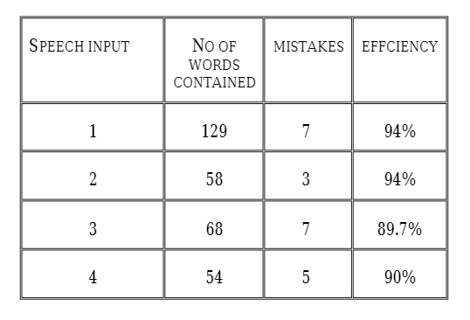
- For processing 54 words the efficiency rate is 90% and the error rate is only 10%.

Fig. 7.2.1 Accuracy Report

In this graph, x-axis will represent the percentage of recognition score and y-axis will represent the various condition. For processing the speech signal to braille Unicode, we must first determine the recognition score so that we can get to know the accuracy of concerting the speech to braille. This score not only help us to increase the efficiency rate but also to minimize the error rate in our project. The below chart explains the detailed report of the recognition score.
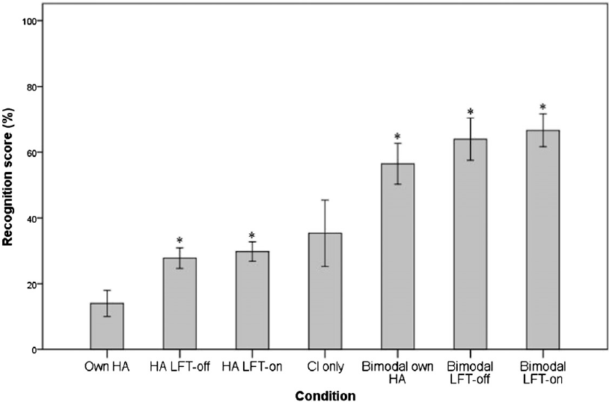

Fig 7.2.2 Speech Recognition Score

In this graph for calculating the performance, we took five samples as input after processing the input we obtained the better efficiency rate and very little error rate.
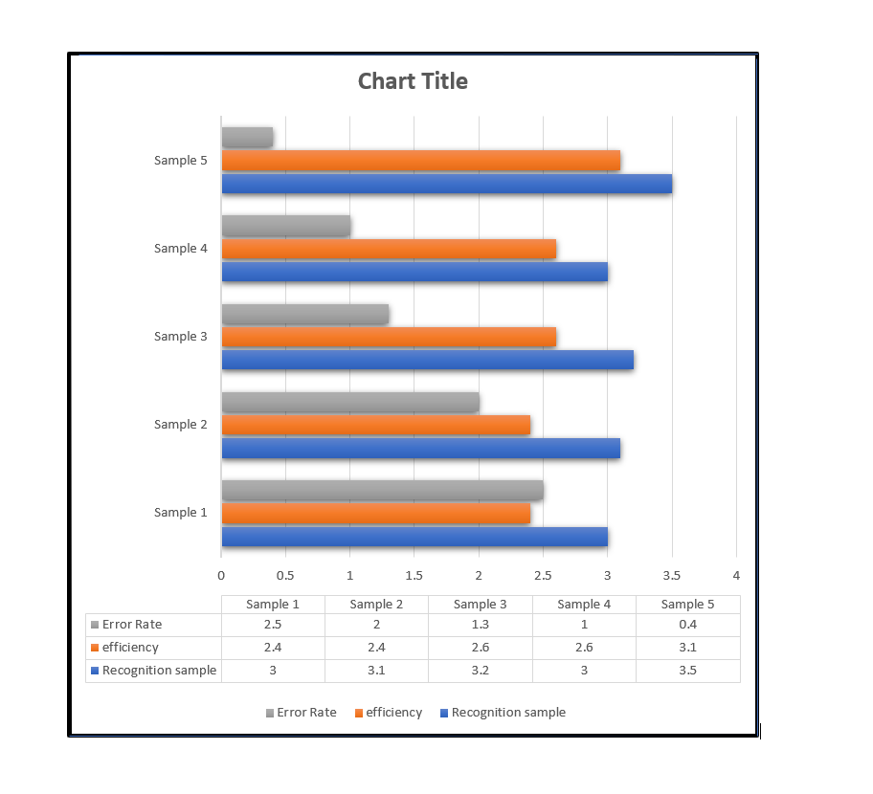
Initially take recognition sample as input after processing these sample we get efficiency as increase from “2.4” (sample 1) to “3.1” (sample 5) and error rate get decreased from “2.5” (sample 1) to “0.4” (sample 5).

Fig. 7.2.3 Performance & Efficiency Result

Corresponding braille characters to the compound English words.
Our system would convert the compound English words into their respective braille characters after the conversion from speech signals to texts. Each and every word is matched with the corresponding braille ASCII code and then braille characters are obtained.

For instance, in this sentence "Good Job" the letter 'G' is converted into the braille ASCII value say 111100. Then the ASCII value is mapped with its braille character ⠛ (braille pattern dots-1245). Similarly, each and every alphabet are mapped corresponding with its Unicode and successfully converted.

Alphabets | Braille Unicode Value | Braille Character
G | 111100 | ⠛
O | 100110 | ⠕
O | 100110 | ⠕
D | 110100 | ⠙
J | 011100 | ⠚
O | 100110 | ⠕
B | 101000 | ⠃

Table 2. Unicode value into Braille characters

The below table is some of the other examples that we have derived from our project. The words are matched with the corresponding braille characters for the dual impaired people to understand the words spoken by the common people. We have acquired the maximum accuracy for the words to be mapped wit its corresponding braille Unicode. These are some of the sample test case we have processed and depicted in the tabular format.

S.no | English words matching the speech signals | Corresponding Braille characters
1 | World | ⠺⠕⠗⠇⠙
2 | How are you | ⠓⠕⠺ ⠁⠗⠑ ⠽
3 | Good Morning | ⠛⠕⠕⠙ ⠍⠕⠗⠝⠊⠝⠛
4 | Welcome | ⠺⠑⠇⠉⠕⠍⠑
5 | Have a nice day | ⠓ ⠁ ⠝⠊⠉⠑ ⠙⠁⠽
6 | Reading | ⠗⠑⠁⠙⠊⠝⠛
7 | Guide me | ⠛⠥⠊⠙⠑ ⠍⠑
8 | All the very best | ⠁⠇⠇ ⠮ ⠧ ⠃⠑⠎⠞
9 | Oh my God | ⠕⠓ ⠍⠽ ⠛⠕⠙
10 | Can you Wait | ⠉ ⠽ ⠺⠁⠊⠞

Table 3. English words into Braille table

CONCLUSION

CHAPTER 8
CONCLUSION
8.1 CONCLUSION AND FUTURE ENHANCEMENT

Speech is one of the primary ways to communicate with other people in our day-to-day life. However, a person with visually challenged and hearing impaired always has some discomfort to communicate in public. The key concept of this project was to implement and illustrate the use of a communication device used for visual and hearing-impaired people to have an efficient way of communication with a common people. Due to dual sensory hardship, visual and hearing-impaired people are led to many difficulties while interacting with a normal person in the world, without an assistant or support they can’t communicate with others. One of the major advantages of the Braillo-Phone is for education purposes, during bank transactions, grocery shop communication, and medical emergencies. The perks of this model empower them to socialize with others without any companion.

As a future enhancement, this system can be further expanded to include features like user account creation, login and authentication. Cloud storage facility can be provided that can store all the previously given input (both audio and braille) and the converted data. The speech recognition algorithm can be refined such that it can identify the speaker and classify them according to age, accent, gender among others. Search mechanism can also be provided that can effectively search for the previously given audio and braille inputs by filtering the search according to the speaker, the date and the keywords in the content.

APPENDICES
A.1 SAMPLE SCREENS
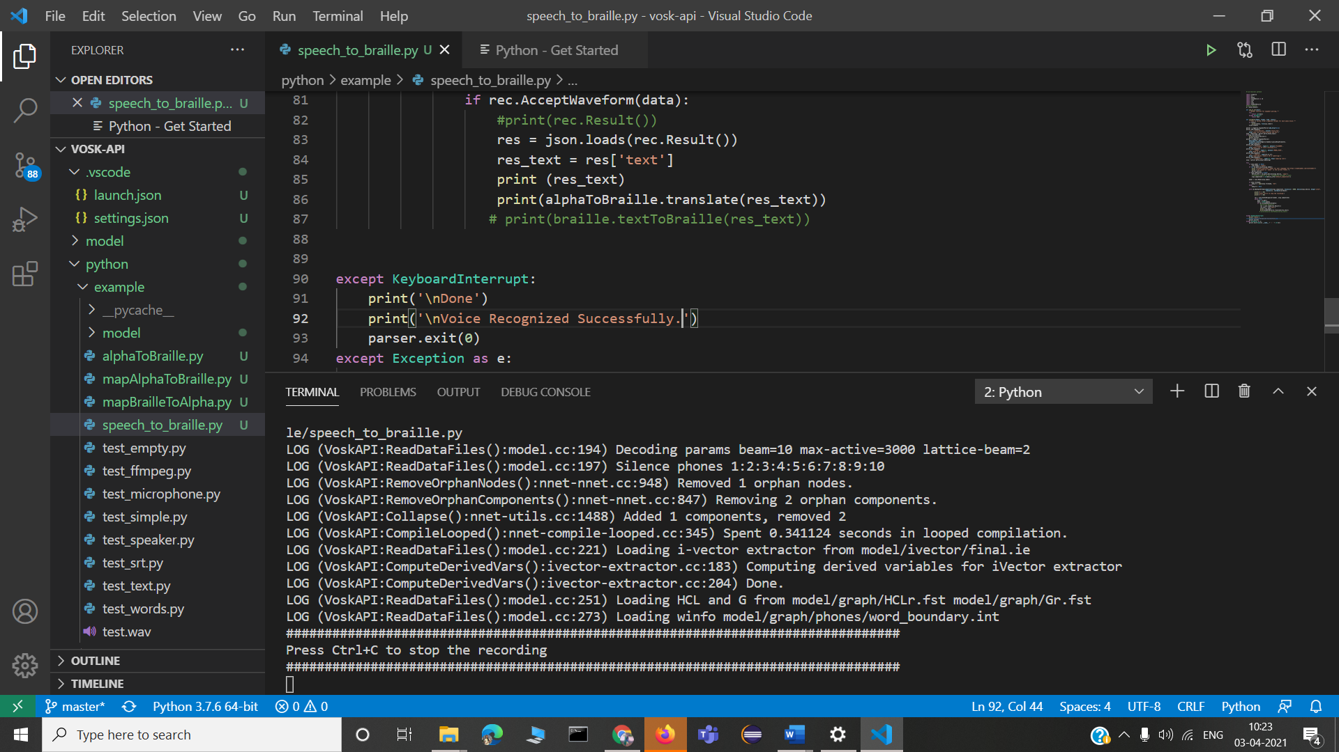
Our proposed approach converts speech input into Braille script via texts and vice versa. It eliminates all the mapping errors in the conversion process and provides accurate output. It also maps Braille code back to speech signals successfully. The transliteration process gives 100% accuracy for speech to Braille as well as Braille to speech conversion

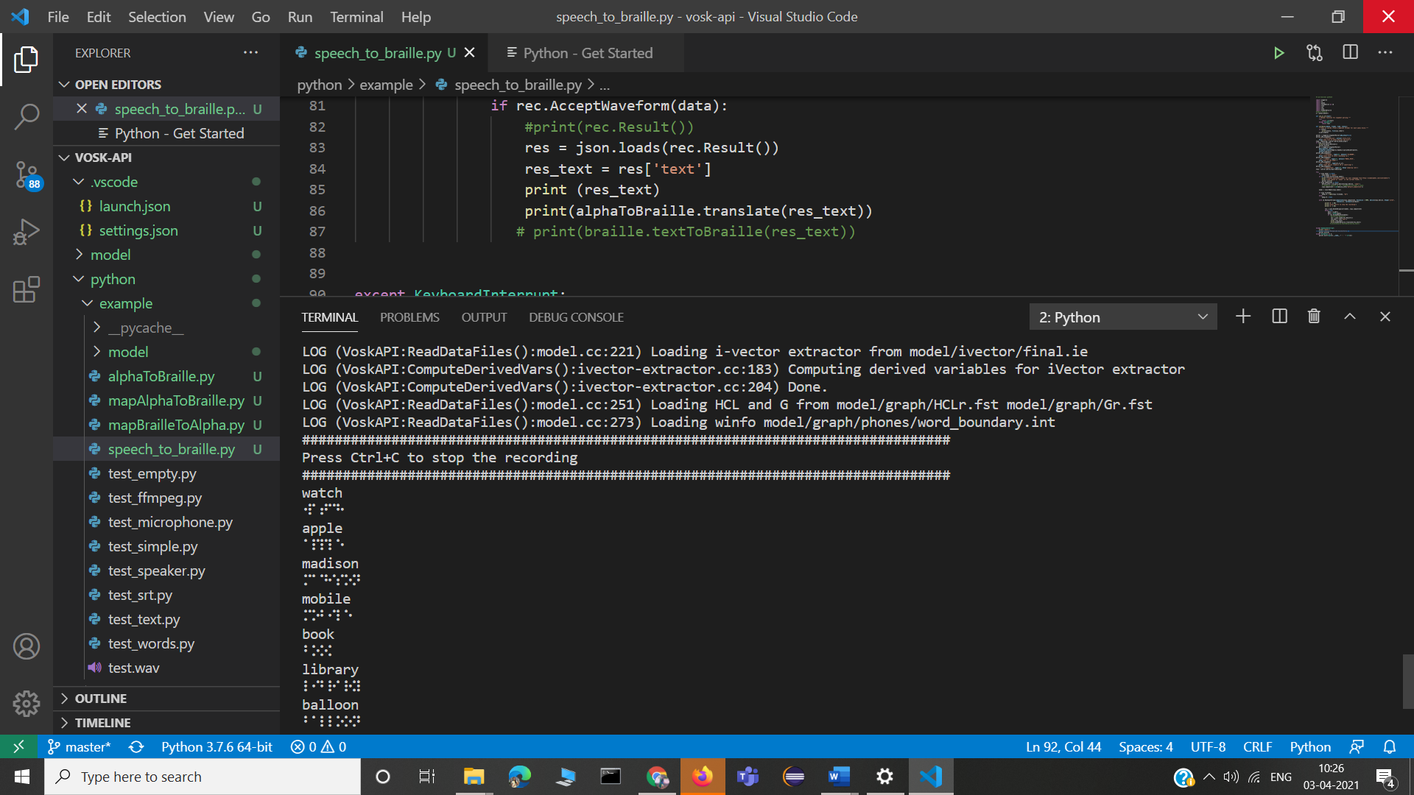
Fig. A.1.1 An instance initiating the software to get the user input.

Fig. A.1.2 An instance showing the mapping of a single words to Braille characters.
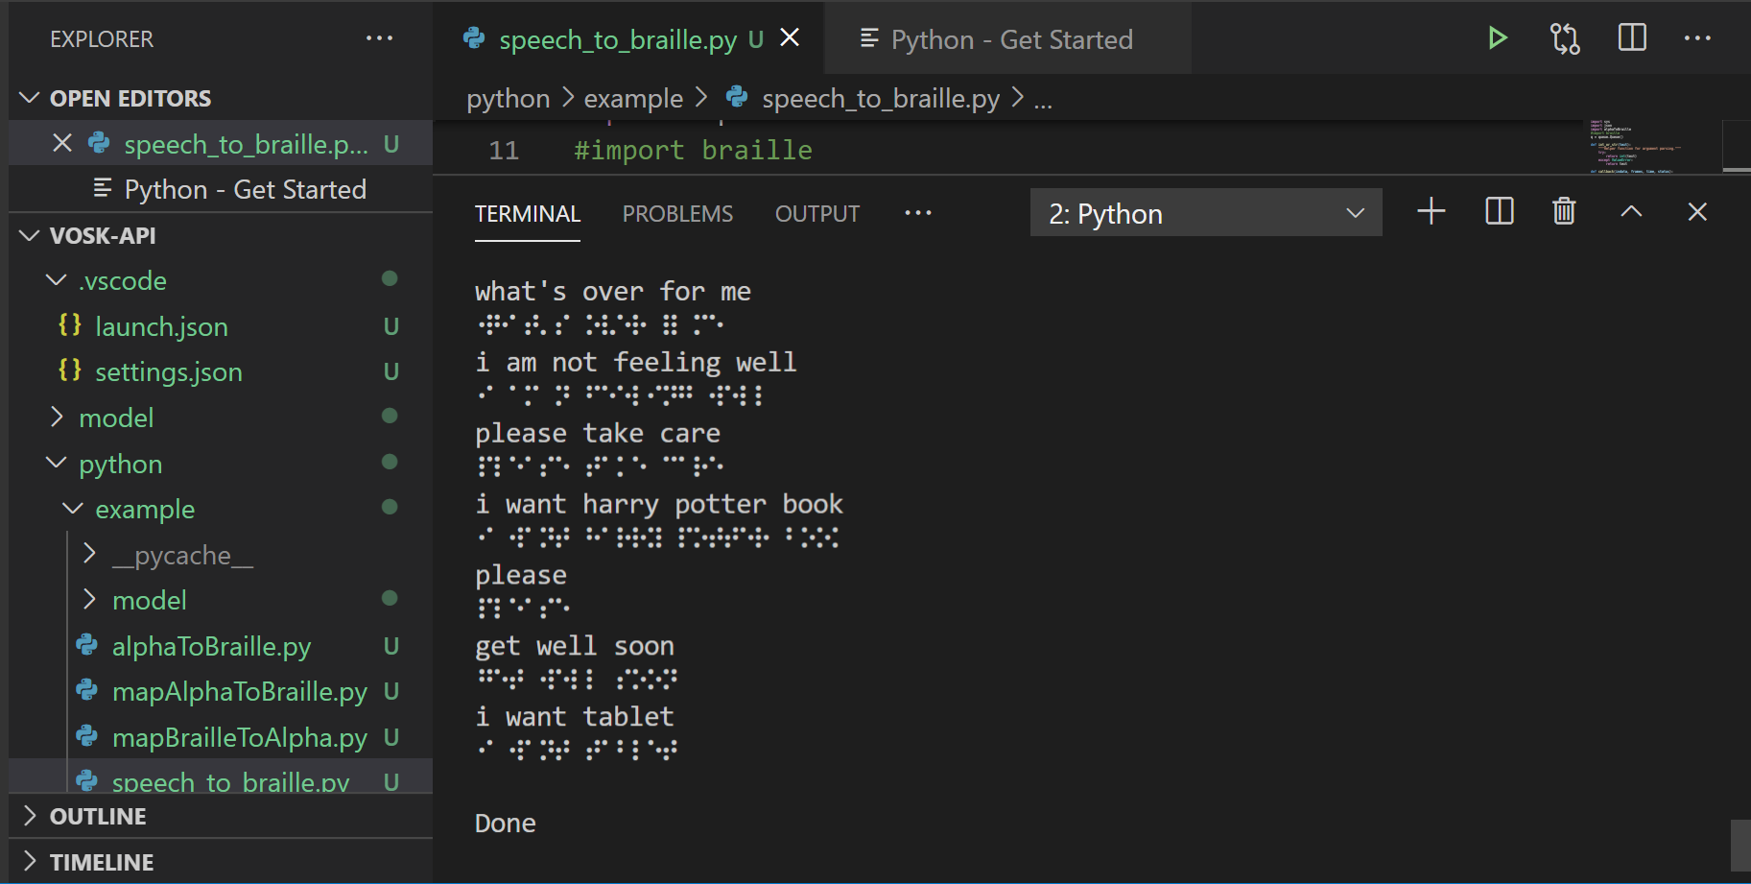

Fig. A.1.3 The Mapping of a sentence to Braille characters.

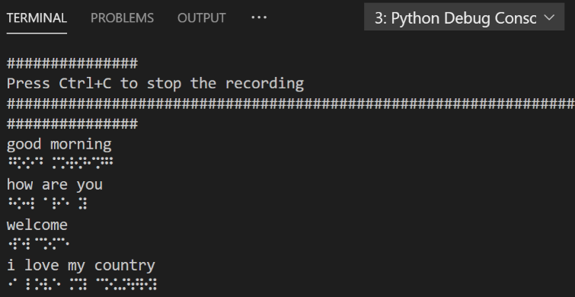

Fig. A.1.4 An instance of Braille characters after mapping.

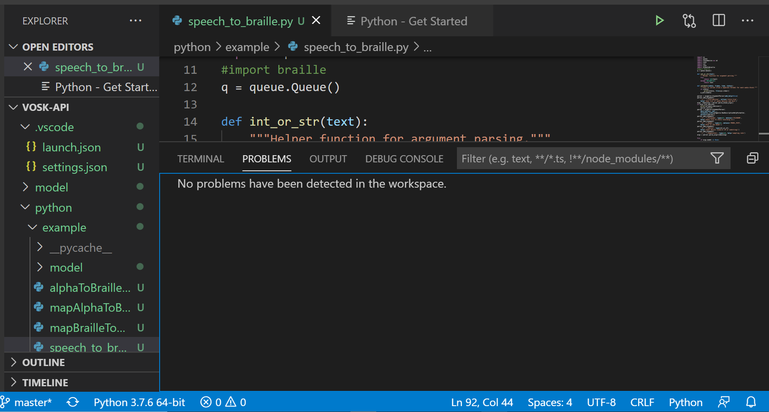

Fig. A.1.5 Status of the Output Generated.

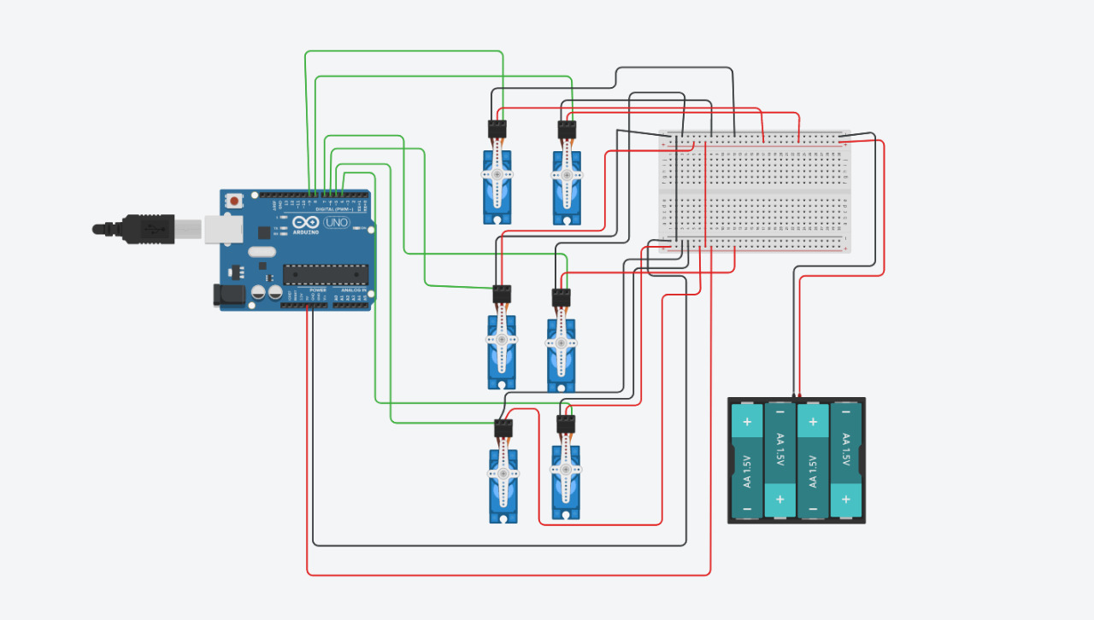
Normally braille system consists of six dots, to connect each dot to one servo motor respectively. The input in the text form is fetched from the software. For each and every character corresponding servo motor rotate. It will act like a keypad for displaying braille output to the visually challenged people. For Instance, for the letter “E” the corresponding servo motor will rotate this will turn to rise the letter upward so that the braille person can touch and know what is the exact letter.
Fig. A.1.6 Sample Hardware Design Implementation
A.2 PUBLICATIONS

Patent Application:
“A Novel Approach - Braillo-Phone Integrated Communication Software for Visually Challenged and Hearing Impaired”, Provisional filed May 11, 2021.

Country:
Australia

Application number:
2021102464

Applicant Name(s) and Address(es):

- Dr. D. Anuradha, M.E. PGDBA Ph.D Professor and Head, Department of Computer Science and, and Business Systems, Panimalar Engineering College Tamil Nadu, Chennai India

- Dr. S. Murugavalli, M.E. Ph.D Professor and Head, Department of Computer Science and, Engineering, Panimalar Engineering College Tamil Nadu, Chennai India

- Sophia Grace Lydia D of UG student, Department of CSE, Panimalar Engineering College Tamil Nadu, Chennai India

- Soniya K of UG student, Department of CSE, Panimalar Engineering College Tamil Nadu, Chennai India

- Vishnu Priya S of UG student, Department of CSE, Panimalar Engineering College Tamil Nadu, Chennai India

REFERENCES
- Dr.V. Ajantha Devi., M.Sc., PhD, Conversion of Speech to Braille: Interaction device for Visual and Hearing Impaired, 2017 4th International Conference on Signal Processing, Communications and Networking (ICSCN -2017), March 16 – 18, 2017, Chennai, INDIA.

- BRL: Braille through Remote Learning - http://brl.org/refdesk/brlcont.html

- Hyun-Cheol Cho et.al, “Development of a Braille Display using Piezr” in SICE-ICASE International Joint Conference: Bexco, Busan, Korea: October 2006

- Cater, John P., Electronically Hearing: Computer Voice and speech Recognition,Howard W Sams& Co., Indianapolis, IN, 1984.

- Wu Xiaosong, Zhu Haihong, Kim Seong-Hyok, Allen Mark G., “A Portable Pneumatically-Actueted Refreshable Braille Cell”, The 14th International Conference on Solid-State Sensors, Actuators and Microsystems, Lyon, France, June 10-14, 2007

- Fezari, M.; Khati, A.E, “New Speech Processor and Ultrasonic sensors based embedded system to improve the control of a motorized wheelchair,” Design and Test Workshop, 2008. IDT 2008. 3rd International 20-22 Dec. 2008; pg.:345- 349

- Bhupinder Singh, Rupinder Kaur, Nidhi Devgun, Ramandeep Kaur, “The process of Feature Extraction in Automatic Speech Recognition System for Computer Machine Interaction with Humans: A Review”, IJARCSSE, Volume 2, Issue 2, February 2012.

- Genevieve I. Sapijaszko, Wasfy B. Mikhael, “An Overview of Recent Window Based Feature Extraction Algorithms for Speaker Recognition”, IEEE, pp 880-883, 2012

- Lindasalwa Muda, Mumtaj Begam and I. Elamvazuthi, “Voice Recognition Algorithms using Mel Frequency Cepstral Coefficient (MFCC) and Dynamic Time Warping (DTW) Techniques”, JOURNAL OF COMPUTING, pp 138-143, VOLUME 2, ISSUE 3, MARCH 2010.

- Jorge MARTINEZ*, Hector PEREZ, Enrique ESCAMILLA, Masahisa Mabo SUZUKI, “Speaker recognition using Mel Frequency Cepstral Coefficients (MFCC) and Vector Quantization (VQ) Techniques, IEEE, pp 248-251, 2012.

- G.G. Devi, “A Braille transliteration on Tamil vowels and Consonants Text Image”. International journal of applied engineering research, 13(11), 2018, pp. 8907-8912.

- S. Padmavathi, S.S. Reddy and D. Meenakshy, “Conversion of Braille to text in English, Hindi and Tamil languages”. arXiv preprint arXiv:1307.2997, 2013.

- Srinath, S., & Kumar, C. R. “Recognition of hand punched Kannada Braille characters using knowledge based multi decision concept: Basic symbols”. In Proceedings of International Conference on Advances in Computing, pp. 847- 857, Springer, New Delhi., 2013.

- Bliss James C, “A Relatively High Resolution Reading Aid for the Blind”, IEEE Transactions on Man-Machine Systems, Volume MMS-10, No. 1, March 1996.

- Iain Murray, and Andrew Pasquale (2006), "A Portable Device for the Translation of Braille to Literary Text", Proceedings of ACM Conference on Assistive Technologies (ASSETS), pp. 231- 232

- Koo1Igmo, Jung Kwangmok, Koo Jachoon, Jea-do Nam, Lee Youngkwan and Choi HyoukRyeol, “Wearable Fingertip Tactile Display”, SICE-ICASE International Joint Conference 2006 in Bexco, Busan, Korea.Oct. 18- 21, 2006.

- Rozeha A. Rashid, Nur HijaMahalin, MohdAdibSarijari and Ahmad Aizuddin Abdul Aziz, “Security System Using Biometric System: Design and Implementation of Voice Recognition System (VRS)”, Proceedings of the International Conference on Computer and Communication Engineering, pp 898-902, ISBN :978-1- 4244-1692-9, May 2008.

- Capt.Dr.S Santhosh Baboo, V.Ajantha Devi; "COMPUTER BASED TAMIL BRAILLE SYSTEM - A Review";11th International Tamil Internet Conference, Annamalai University, Chidambaram, India , Jointly conducted by International Forum for Information Technology (INFITT) and Annamalai University Dec 28- 30, 2012. Pg.57 -61

- VandanaPushe, Nidhi Bhalla and Rupinderdeep Kaur, “Architecture of Gurmukhi to Braille conversion system”, International Journal of Computer Science and Inormation Technology & Security (IJCSITS), Vol.2, No.2, April 2012, pp. 467-771

- Analysis and Evaluation of Braille to Text Conversion Methods https://www.hindawi.com/journals/misy/2020/3461651/

- Real-Time Text to Braille and Audio Convertor https://www.irjet.net/archives/V7/i8/IRJET-V7I8485.pdf

- A Review on Gujarati to Braille Character Recognition https://www.ijcrt.org/papers/IJCRT2003176.pdf

- BRAILLE TO TEXT AND SPEECH FOR CECITY PERSONS https://ijret.org/volumes/2015v04/i01/IJRET20150401039.pdf

- Conversion of Braille to Text in English, Hindi and Tamil Languages https://www.researchgate.net/publication/248395006_Conversion_of_Braille_to_Text_in_English_Hindi_and_Tamil_Languages

- A system for converting print into braill https://ieeexplore.ieee.org/document/593266

- Literature Survey on Braille to Text Conversion for Visual and Hearing-Impaired Persons http://www.gjstx-e.cn/gallery/99-june2020.pdf

- Efficient Approach for English Braille to Text Conversion https://www.ijareeie.com/upload/2016/april/165_MR151203_Megha_Paper_V1.pdf

- Refreshing Refreshable Braille Displays https://www.researchgate.net/publication/275051459_Refreshing_Refreshable_Braille_Displays

- BRAILLE KEYBOARD AND PRINTER INTERFACED https://www.irjet.net/archives/V7/i5/IRJET-V7I5542.pdf

- Analysis of Different Braille Devices for Implementing a Cost-effective and Portable Braille System for the Visually Impaired People https://research.ijcaonline.org/volume60/number9/pxc3883073.pdf

- BrailleKey: An alternative Braille text input system: Comparative study of an innovative simplified text input system for the visually impaired https://ieeexplore.ieee.org/document/6481790

