Goal: Using what data we have on Pteropus rufus population dynamics in the Mangoro River Valley and underlying transmission dynamics, can we generate pathogen persistence?

LITERATURE SEARCH

* Pathogen persistence in bat populations
* Bat disease dynamics
* Bat disease simulations

DATA:  
- subpopulation count

* Subpopulation connectivity from telemetry data

MODEL:

* Best SIR model from Brook et al

STEPS  
1. Understand how disease model works

2. make it stochastic

3. make it a metapopulation model

4. use telemetry data to figure out subpopulation connectivity

5. add subpopulation connectivity estimates into model

6. simulate!

- disease persistence – throw in some disease under differing conditions (diff disease params i.e. different pathogens, immigrating into diff staring in metapopulations, starting at diff times of the year)

?? under what condition persistence is and is not achieved!

Simulating more broadly

* Different model structures – msirs, msirn, msili
  + i.e. in the vaccination code
  + Vary
* Rayna 2016 paper
* Ali peel 2018 scientific reports
* Mistakes in how the parameters are calculate
  + Rates instead of probabilities
  + Some of scaling from year to biweek might change
  + Look at dengue model to see where there are changes in parameter estimates
* Check out Cambodia

**STEP 1: Understand how the model works**

* Fit to henipa/filovirus transmission dynamics i.e. can only be used to simulate henipa/filovirus dynamics
  + Allows us to restrict range of simulated pathogens
    - i.e. pull gamma, beta, etc from literature of henipa/filo in bats
* Biweek vs nyat 26?
  + Keep
* Rho?
* Logistic waning maternal immunity vs fixed

**STEP 2: Make it Stochastic**

* For select parameters, draw from a distribution for each simulation instead of using fixed – ability to turn on and off (for each param? For infection vs demographic? Is this something I’ll be testing?)
* What params should be stochastic?
  + Disease parameters
    - Beta
    - Gamma
    - Wane
    - Sigma
    - Mu.sick
    - Add.inf.mort
  + Demographic parameters
    - Age 1st reprod
    - Juvenile survival
    - Adult survival
    - Fecundity
    - Avg lifespan
* What should the distribution of each param be?
  + Normal? Input mean & sd – from literature?

**STEP 3: Make it a metapopulation model**

* Vectorize population and infection
* What variables are global versus local?
  + Global - parameters
    - All infection parameters
    - All demographic parameters
  + Local – state variables
    - Population size in each subpop
    - Dispersal probability?

**STEP 4: Use the telemetry data to figure out subpopulation connectivity**

* Key metric: kernel density estimates – probability of finding a bat in any given area at any given time
  + Each day a dispersal event happens (i.e. departing the roost at night)
  + Bats from all three roosts have overlapping probability estimates
  + Can be stochastic (draw from some distribution made by replicate bats (uniform between two values?))
  + Can change prob density monthly/seasonally
  + **Prob density impacts beta?? – CONTACT i.e. foraging site**
  + **Occasional population size change – roost switching**
* 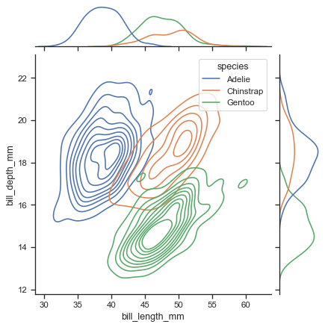**If representation from each subpop covers wet and dry season, can treat each subpop as independent, otherwise need to pool**



**STEP 5: Add dispersal/interaction**

* add multiplier to beta – or some other representation of contact rate
  + equal prob that contact is a bat at any stage of infection
* add per-day roost switching probability (into another metapop or out of the dynamics entirely)

**STEP 6 : Evaluate under what conditions persistence is achieved – invasion analysis?**

* Vary:
  + Pathogen parameters (i.e. different pathogens)
  + Subpop infection starts
  + Time of year starts
  + Stochasticity?
* Quantify:
  + Annual persistence: prob of pathogen persistence after 1 year
  + Long-term persistence: prob of pathogen persistence after 100 years

FIGURES

1. Telemetry data covered what portion of year over seasonality

Black = subpop 1, yellow = subpop 2, green = subpop 3