Sophia Andrea. Ibanez  
2ECE-A

Experiment No. 8

**PROOF OF TESTING**

**Problem 1.**

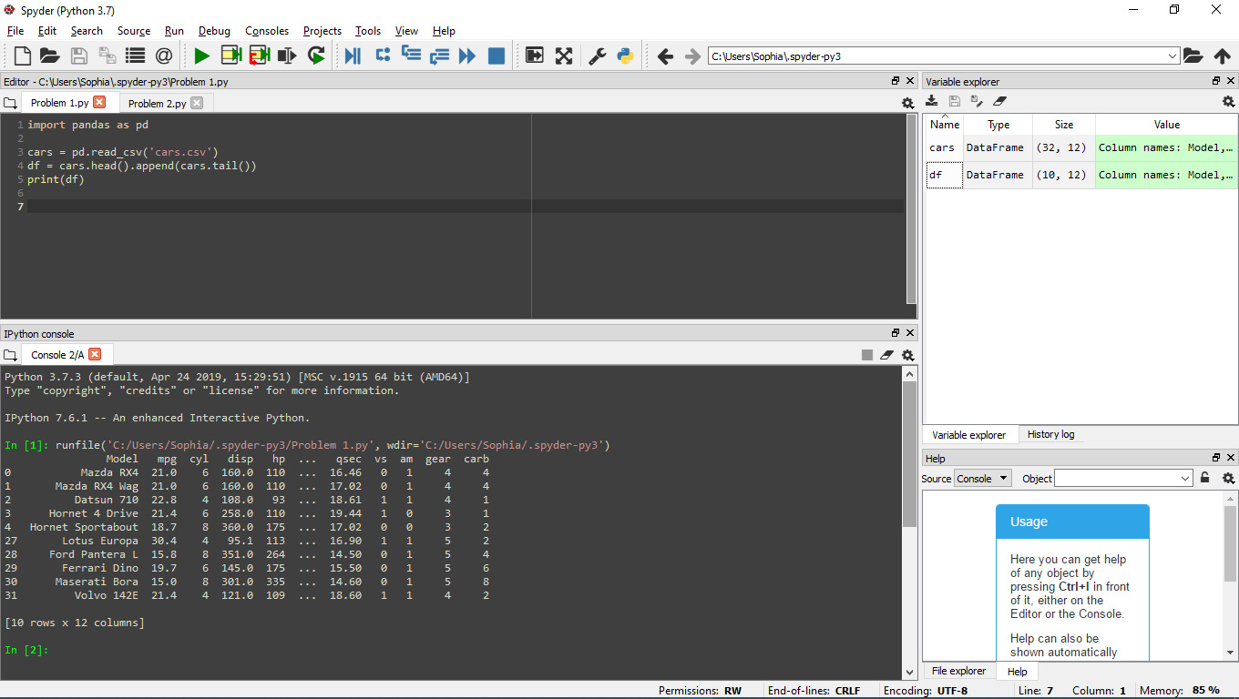

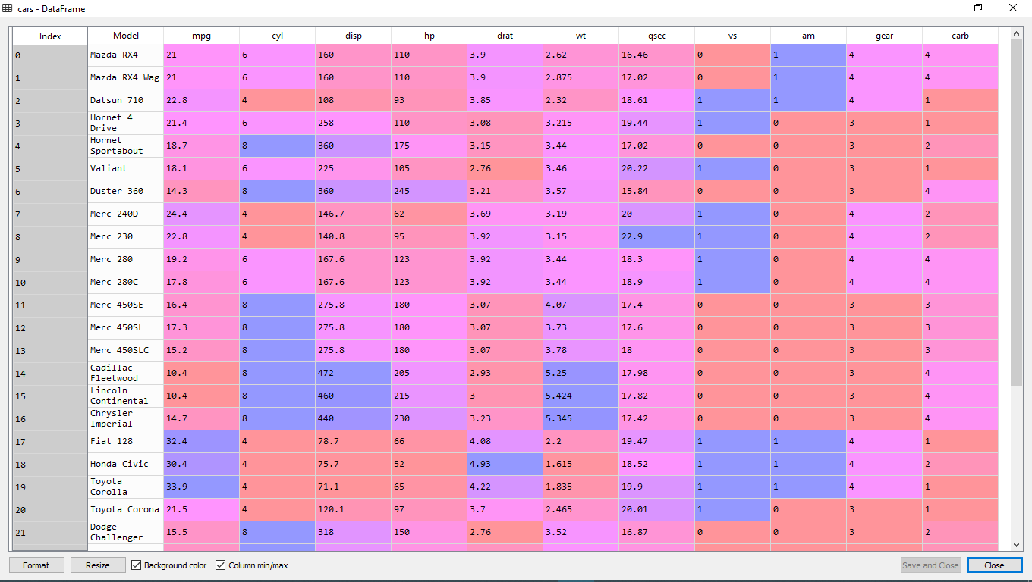**Problem 1.a.**

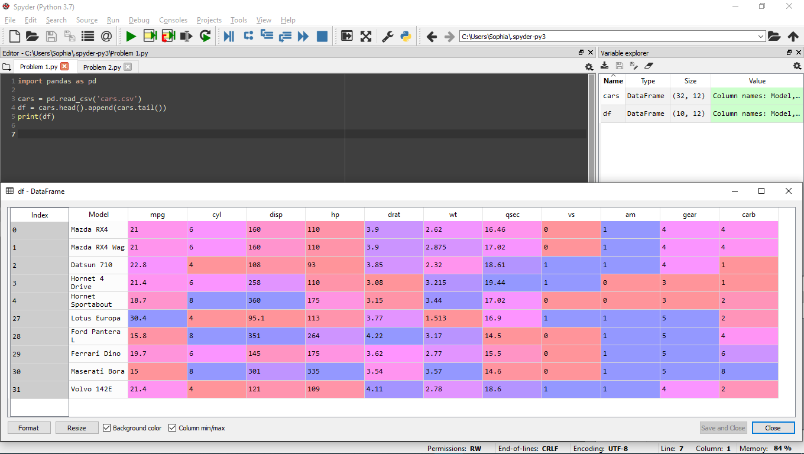**Problem 1.b.**

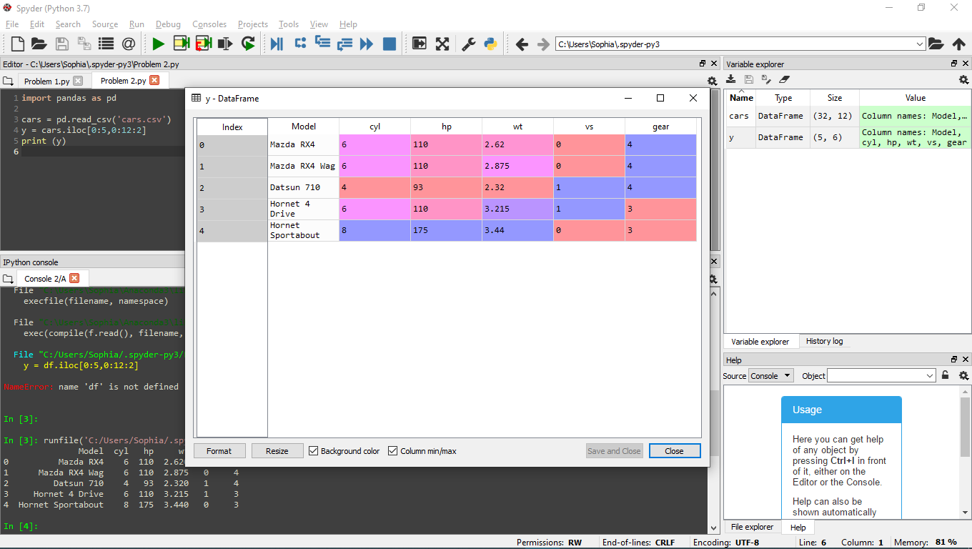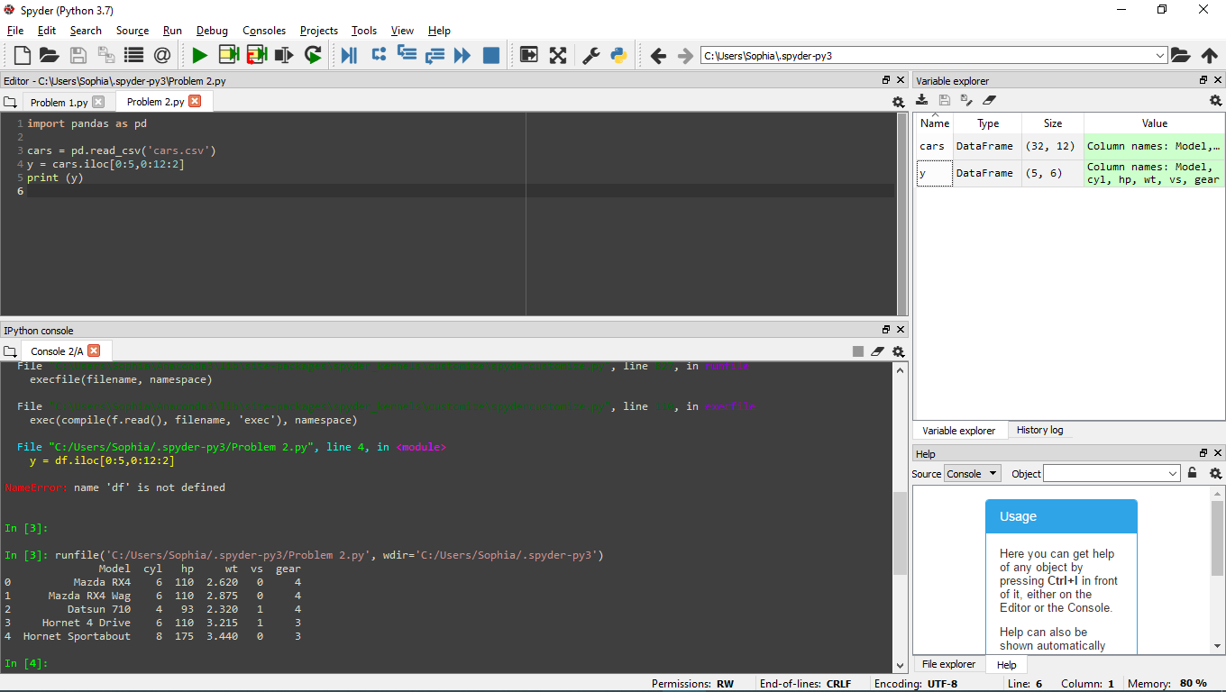**Problem 2.a.**

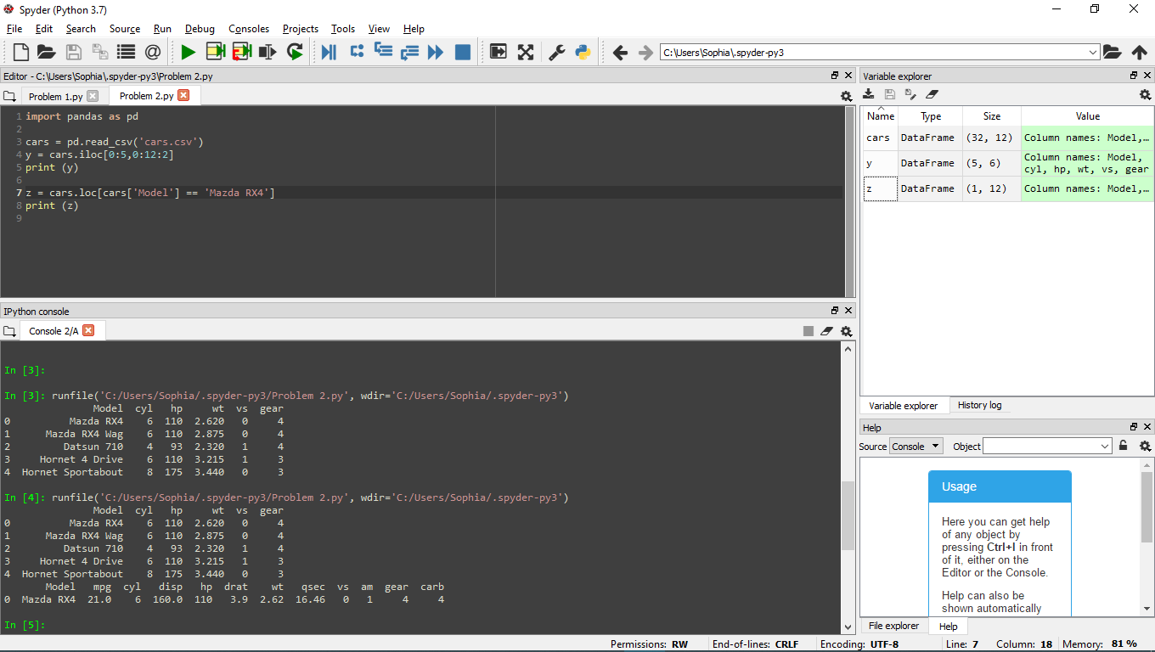**Problem 2.b.**

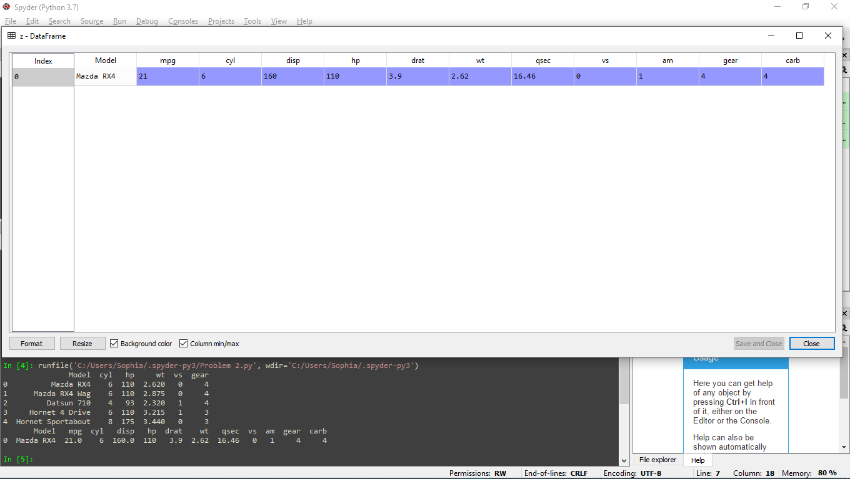

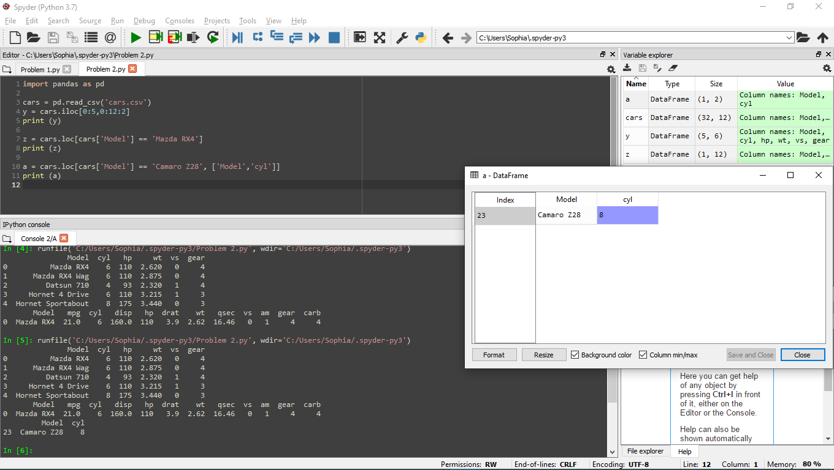 **Problem2.c.  
  
Answer: 8**

**Problem 2.d.**

**Answer:**

|  |  |  |
| --- | --- | --- |
| **Model** | **cyl** | **gear** |
| **Mazda RX4 Wag** | **6** | **4** |
| **Honda Civic** | **4** | **4** |
| **Ford Pantera L** | **8** | **5** |

