Plot 1: Now, let’S have a look How are the discounts offered on products?
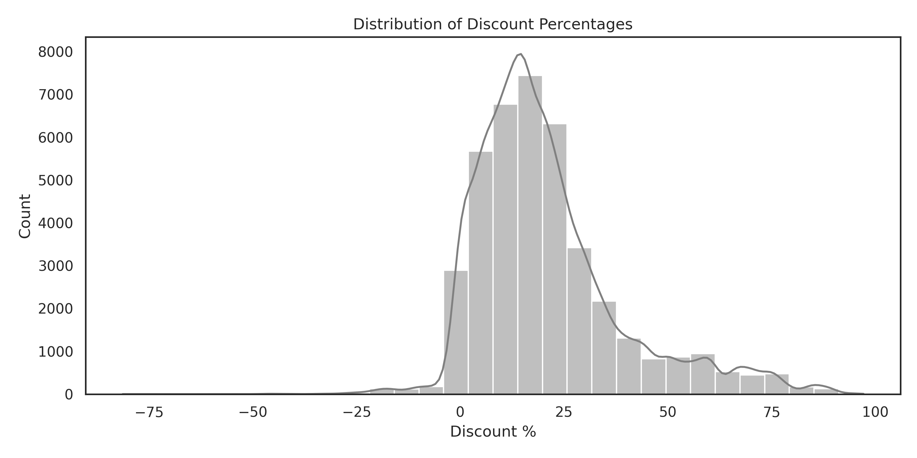
- Count of the discount%
- nogoproducts_df['total_discount'] = nogoproducts_df['price'] - nogoproducts_df['unit_price']
- nogoproducts_df["discount%"] = ((nogoproducts_df["total_discount"]/nogoproducts_df["price"])*100).round(2)

- sns.histplot(nogoproducts_df['discount%'], bins=30, color='gray', kde=True)

- The majority of discounts are within range 15–20%,
- the distribution is right-skewed suggesting fewer products receiving deeper discounts
- typically 15–20% discount range is aggressive for core Apple products because discounts for apple branded products fall between 5-10% even during big sale events
- if 15–20% discount range include accessories, then this discounting is appropriate

Plot 2 : Distribution of sale price (unit_price) across Top 10 categories
Next, we want to compare the actual selling price (using unit_price) of discounted vs. non-discounted products based on top 10 most frequent product categories (count of number of product).
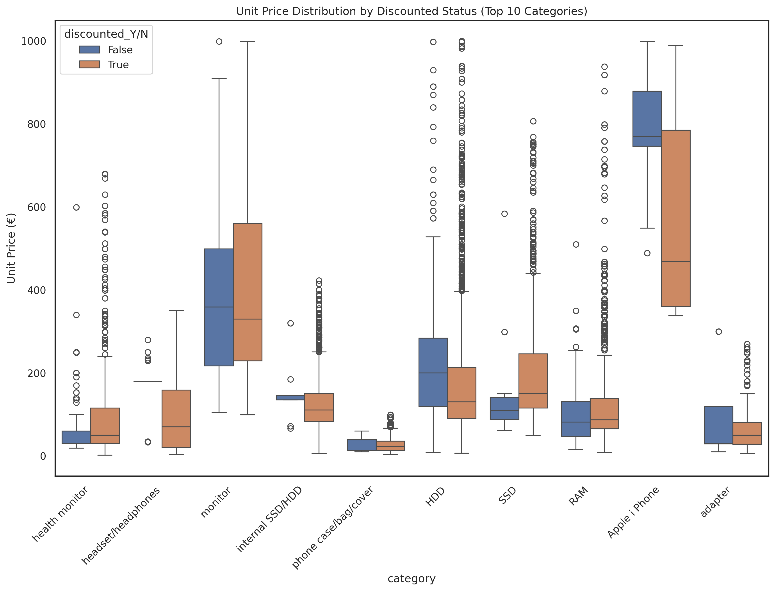
-Plotting unit_price shows whether the discounted products are actually cheaper than the non-discounted ones — which is the goal of this visualization.
-top 10 most frequent product categories (based on the count of the category) value counts.
-Using boxplot to shows price variation within categories

top10_categories = nogoproducts_df['category'].value_counts().head(10).index.tolist()
filtered_df = nogoproducts_df[nogoproducts_df['category'].isin(top10_categories)]
sns.boxplot(data=filtered_df, x='category', y='unit_price', hue='discounted_Y/N')

nogoproducts_df['discounted_Y/N'] = nogoproducts_df['unit_price'] < nogoproducts_df['price']
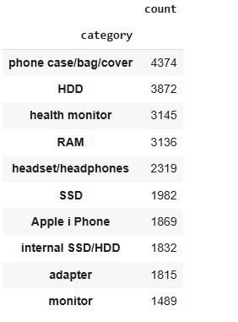
For each category, the boxplot is split by the discounted_Y/N hue:
- One box = discounted products
- One box = non-discounted products
Each box shows:
- Median price (line inside box)
- Spread of prices (box = interquartile range)
- Outliers (dots)
- Whiskers = variability within 1.5 IQR
LETS’ HAVE A LOOK WHAT ARE SIGNIFICANT:
- discounted box of iphone is much lower than non-discounted box, A long IQR and very low median for discounted iPhones:
Discount is applied to higher-priced item, driving sales of more expensive products. Beneficial if it leads to high volume sale:
- discounted box higher than the non-discounted could mean misleading pricing strategies
- Outliers (premium or unusually priced products
Plot 3: Does higher discount by category lead to more revenue?

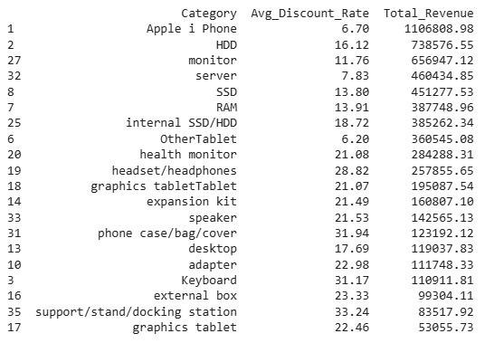
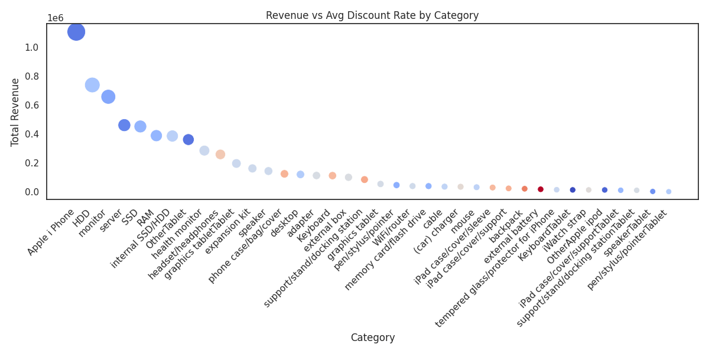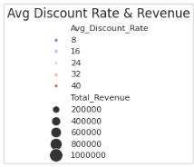

Method:
category_summary = nogoproducts_df.groupby('category').agg({'discount%': 'mean','total_sale_price': 'sum'}).reset_index()

rename : category_summary.columns = ['Category', 'Avg_Discount_Rate', 'Total_Revenue']

sorting: category_summary = category_summary.sort_values(by='Total_Revenue', ascending=False)

sns.scatterplot(data=category_summary, x='Category',y='Total_Revenue',size='Total_Revenue',hue='Avg_Discount_Rate',palette='coolwarm',sizes=(50, 500), legend='brief')

- Products with 10–25% discounts generate the highest total revenue, suggesting this is a sweet spot for price-sensitive categories.
- Very high discounts (30%+) do not consistently drive revenue — possibly pointing to poor product-market fit or overstock issues.
- Top revenue categories like Apple iPhones sell well with minimal discounting — showing strong brand-driven demand. Suggesting profitable products for the company that strives on brand and quality , not discounts
Conclusion, Moderate discounts (10–20%) (iPhone, HDD, monitor, server) appear to be most effective — they support strong sales without requiring heavy discounting."
Phone case/bag/cover, keyboard, docking station has > 30% discount rate but very low revenue, suggests overstock but low demand
Plot4: Are discounted products generating more revenue over a period?
Lets have a look how revenue trends over time differ between discounted and non-discounted products.
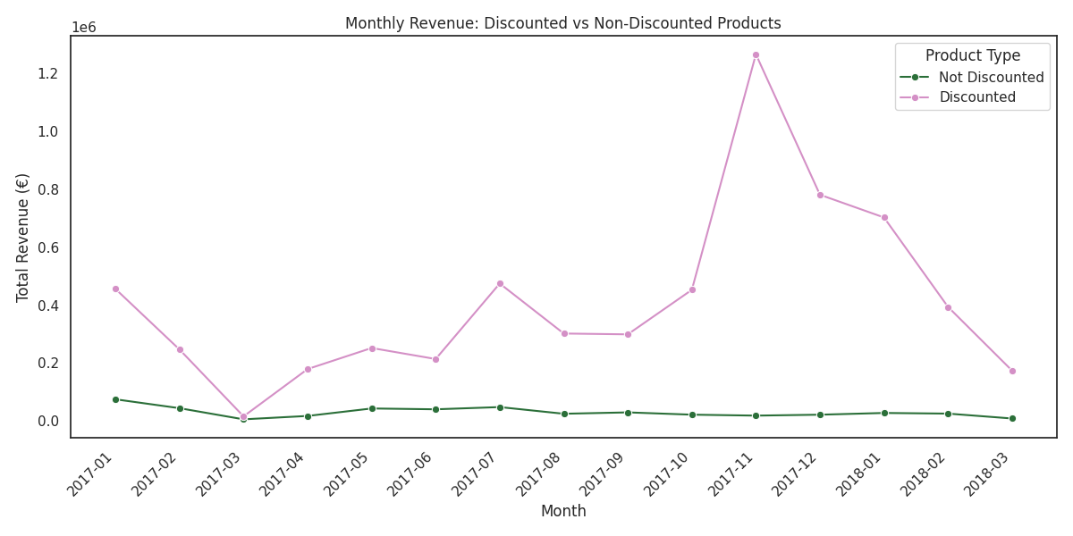
nogoproducts_df['date'] = pd.to_datetime(nogoproducts_df['date'])
nogoproducts_df['year_month'] = nogoproducts_df['date'].dt.to_period('M').dt.to_timestamp()
nogoproducts_df['year_month'] = nogoproducts_df['year_month'].dt.to_period('M')

monthly_revenue_by_discount = nogoproducts_df.groupby(['year_month', 'discounted_Y/N'])['total_sale_price'].sum().reset_index()
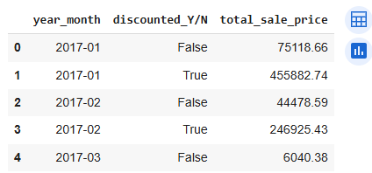

#grouping the boolean from discounted_Y/N to labels before plotting
monthly_revenue_by_discount['discounted_Y/N'] = monthly_revenue_by_discount['discounted_Y/N'].map({True: 'Discounted',False:'Not Discounted'})
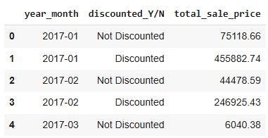

sns.lineplot(data=monthly_revenue_by_discount, x ='year_month', y='total_sale_price', hue='discounted_Y/N',marker='o', palette='cubehelix')

- we can observe that :Discounting Is a Major Revenue Driver : revenue of discounted products is consistently higher than non-discounted, with noticeable spikes in January, July, and a peak in Nov as Naba has explained , it suggests sales campaigns or clearance events had measurable impact
- Seasonal promotions are effective, it boosts sale

we would like to summarize the following

firstly, Discount rate 10 - 25% is most effective at driving higher revenue
- iPhone Leads with Low Discount (8%): suggest strong demand & brand power, discount is strategic but is it essential?
Secondly, High Discount, Low Revenue Categories: several categories with >30% discount are underperforming, they do not generate proportionally higher revenue
in our analysis we do not haave cost data, thus not able to optimize discounting analysis

Next we would like to recommend the following:
Cost is required to optimize discount strategy, we don’t want to over discount or giving away discount more than our cost
- 2ndly, it is important to Reevaluate the Categories with > 30 % discounts but generating low revenue, shall we remove underperforming categories?
- 3rdly, perhaps it is important to Investigate the product pricing structure, due to unusually priced HDD, SSD, RAM (as they have extreme outliers)
- we would recommend to Promote categories within 10-25% discount range (as they are the top revenue drivers)
- lastly, iPhone is the revenue leader. Maybe it is essential for ENIAC to Maintain iphone pricing & 8% discount. This category Appears strong, but is it really profitable?

Plot 5: Profitability Analysis: Are discounted products more profitable?

Why Profitability Matters More Than Revenue
🔑 "Revenue is vanity, profit is sanity."
Discounts may increase sales and revenue, but they can also destroy margin and profit — the actual money you keep.
A discounted product might sell more but if:
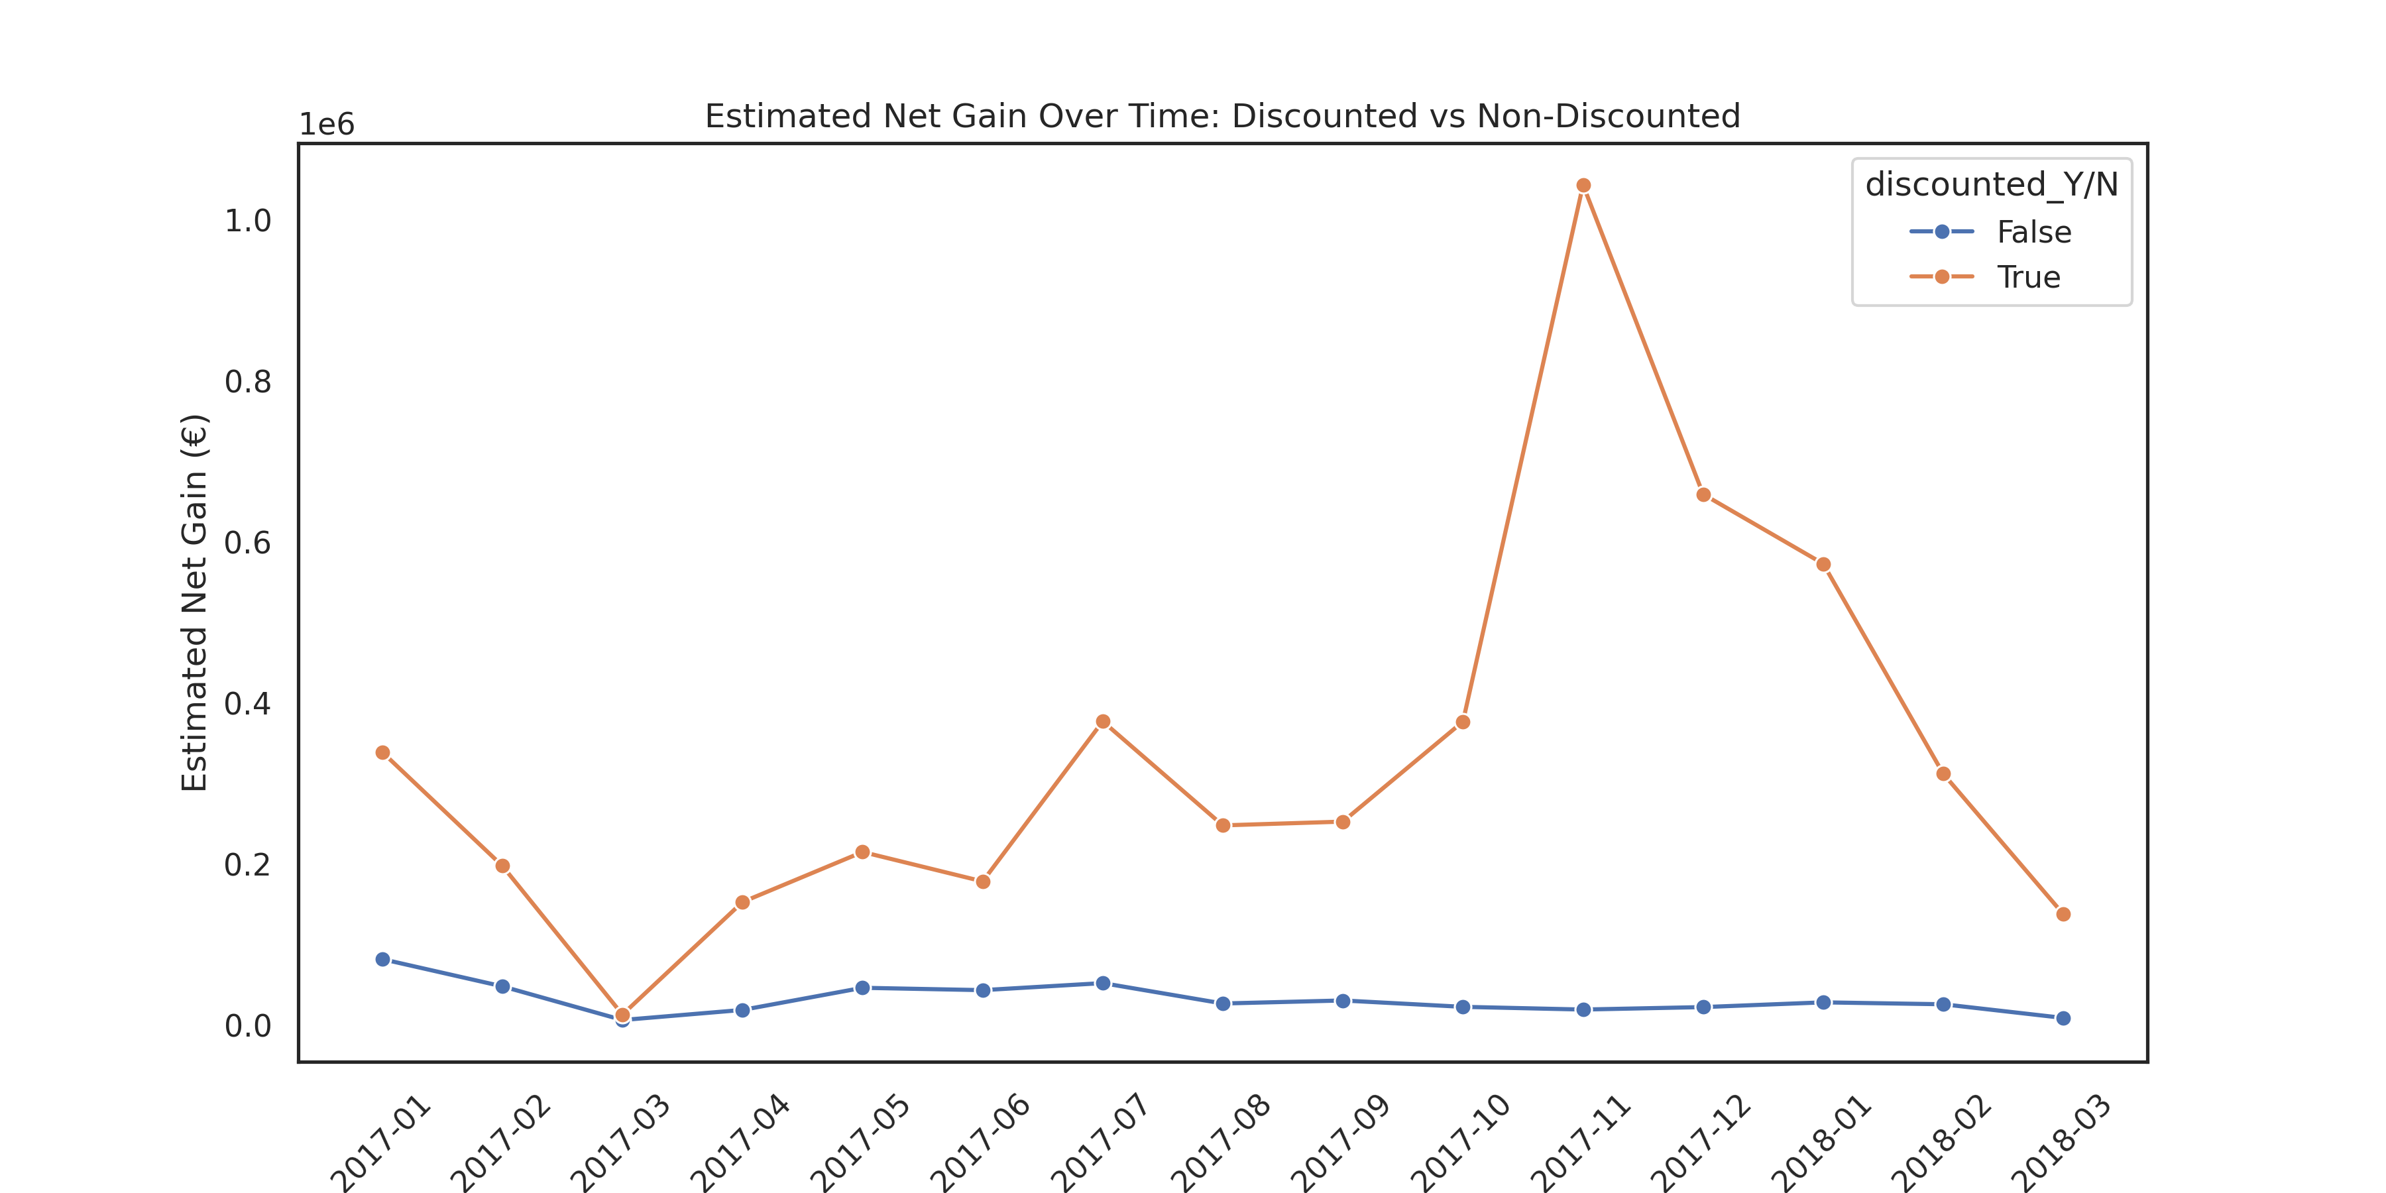
- It’s sold below cost, we lose money
monthly_profit = (nogoproducts_df.groupby(['year_month', 'discounted_Y/N']).agg(total_sale_price=('total_sale_price', 'sum'),total_discount_given=('total_discount', 'sum'))).reset_index()
monthly_profit = monthly_profit.copy()
monthly_profit.head()
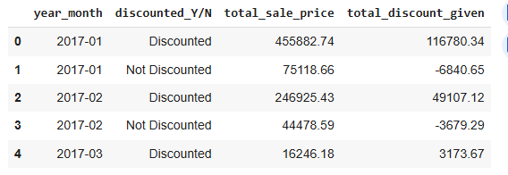

Using industry benchmark as assumption— simplified estimates based on how margins usually behave in ecommerce: 15% for Discounted and 30% for Non-Discounted

estimated_profit = total_sale_price * margin

assign margins
margin_map = {'Discounted': 0.15, 'Not Discounted': 0.30}
monthly_profit['assumed_margin'] = monthly_profit['discounted_Y/N'].map(margin_map)
monthly_profit['estimated_profit'] = monthly_profit['total_sale_price'] * monthly_profit['assumed_margin']
monthly_profit.head()
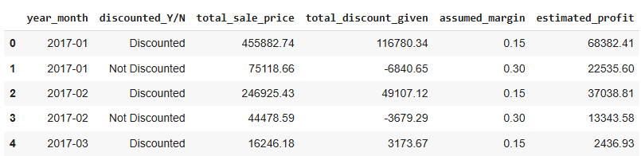

Applies that assumption to each row of your monthly_profit DataFrame based on whether it's discounted or not

sns.lineplot(data=monthly_profit,x='year_month',y='estimated_profit',hue='discounted_Y/N',marker='o'

