## Tech Journal Wiki

|  |
| --- |
| Documentation is critical for today's IT professional. Consistent, updated and accurate notes on tasks you have performed and problems you have solved are invaluable for later use. This assignment begins that process. |

Tasks: Watch the following [video](https://drive.google.com/open?id=1usSQ9x1X70fQbMpbmUijTikD_nWyOsub) and then register for a student GitHub account if you do not already have one. Create a Tech Journal Home Page that looks similar to this: <https://github.com/gmcyber/tech-journal/wiki> (note that you will not be able to see the wiki until you’ve logged in with your account!)

For each of your lab assignments in NET-150, you will be asked to add an entry to your tech journal containing the following information:

* A *brief* (one sentence) summary describing what you did in the lab.
* Any commands or instructions that you found useful and will need to use again in the future.
* Any problems you ran into during the lab, and what troubleshooting steps you took to fix them.
* Individual labs will also contain specific items to include or questions to answer within your tech journal.

Be sure to add your instructor's GitHub account as a collaborator if your wiki is not public:

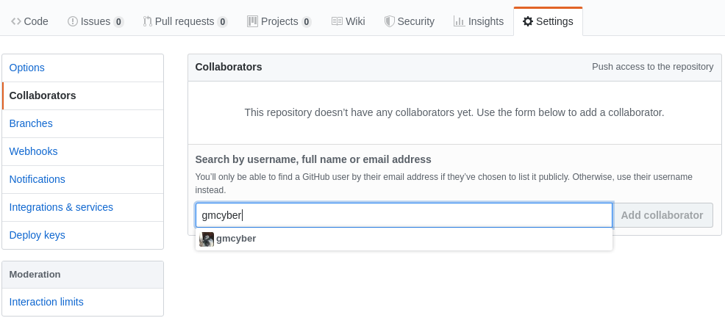

*Note: gmcyber is Devin's account. Ask your instructor for their preferred GitHub account name if you are sharing your private wiki.

**SUBMISSION FOR THIS ASSIGNMENT: A hyperlink to your GitHub wiki.**