**About the data**

What to monitor ?

The variable ‘load’ is better to monitor. It correspond to the real time measures divided by the monitor capacity. They represent the production of photovoltaic energy (upstream or before the domestic consumption).

We have data each 15 minutes or daily data. The data recorded each 15 minutes <100 (since we monitor the load and not the real time measures).

It is better to start with daily data, which may be divided by 96.

Yt = St + or * errors *levels (weather/altitude)

1) Apply a rescaling (to put the regions or suppliers on the same level).

Too large : do not remove all changes, too small: remove all differences between the suppliers.

Additive = subtract a long MA from the data

Multiplicative = rescale the data with ‘scaling factors’ => better

There are intrinsic differences between the regions:

Clouds, Weather conditions, Levels due to altitude or weather (close to the sea). Also depending on the topography, vegetation or constructions of a region (shadows).

These levels are probably multiplicative (not additive since there is no background level when there is no Sun).

<http://www.heliorama.com/jsp/heliomask/app-heliomask.jsp>

<https://energieplus-lesite.be/theories/climat8/ensoleillement-d8/>

2) The median of the networks appears to be a good estimator for St. It could be divided (then it accentuates the values around minima) or subtracted (it accentuates then values around maxima). Try both methods to remove St.

[ 3) If the data have different levels, remove this level. ] => No

4) Compute an IC pool and standardize the data.

Which types of errors or anomalies could happen:

Short-term: transmission cut-off (due to electricity breakdown). Few minutes to few days.

The solar energy is well produced but due to the internet or power cut-off, the installation do not send information to the network anymore.

Long-term: degradation of the installations could also cause drift along months. The monitored capacity is not updated in real-time. So if a lot of news installations are added to the network or in the contrary, if the installations are in majority old, the ‘registered’ monitored capacity do not correspond to the actual monitored capacity (which is lower).

Benchmarks:

Anomaly in RESA in 2015

IVEC in 2015

In different suppliers instances in 2019, 14 September (IMEA) : gaps

2017, 8 March-21 Mai, problems in different suppliers (sudden changes, gaps but more visible with 15 minutes data).

The data contains a lot of zeros (nights), can we just neglect them for the analysis => missing values.

La Belgique se caractérise par des variations géographiques relativement faibles, inférieures à ± 5 % pour l’ensemble du pays, à l’exception de la région côtière et du pays gaumais où des écarts annuels de 10 % par rapport à Uccle sont atteints et même dépassés (+ 18 % à Luxembourg).

Ensoleillement :

-couverture nuageuse

- montagnes, relief qui limite l’ensoleillement (pas d’impact pour le photovoltaique car c’est l’irradience diffuse qui compte)

- végétation immédiate et bâtiments qui limitent aussi l’ensoleillement

-l’altitude du lieu

-la hauteur du soleil dans le ciel (épaisseur de l’atmosphère)

-la durée du jour

-composition de l’atmosphère (pollution !)

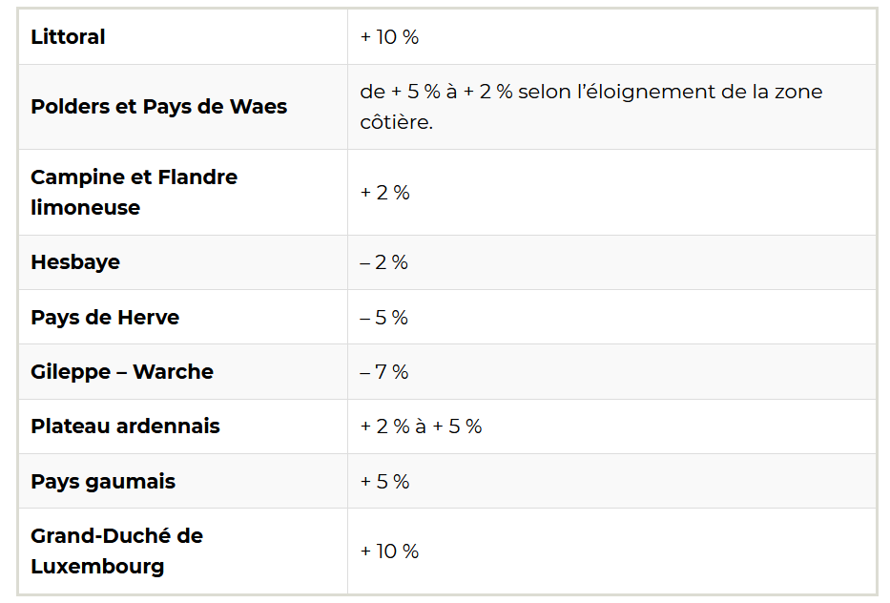

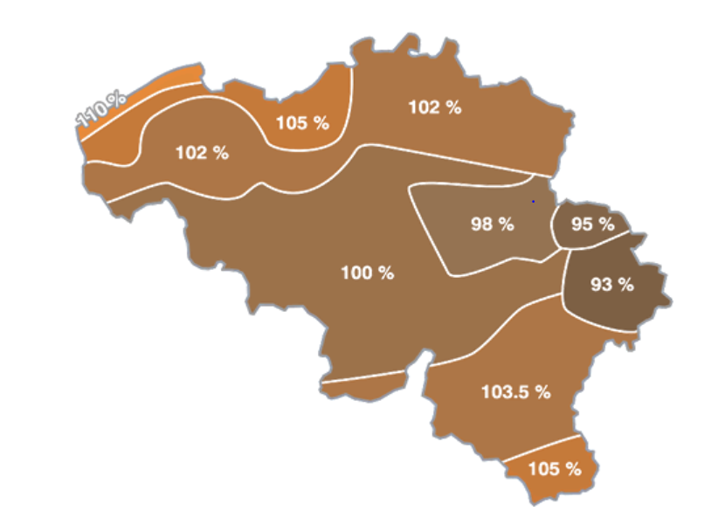

Questions :

1) Which suppliers are ‘in-control’ ? Are they bad suppliers ?

It appears that Gaselwest, Infrax West, Ores Est, Ores Luxembourg, Ores Mouscron, Ores Vervier and Resa have different distributions that the others. They are ‘OC’ ?

2) Is it possible to obtain the following information:

- size of the installations

- number of different installations

3) Should we standardize the data with IC parameters ? Or by parameters computed on the all panel ? Or standardize the IC data by IC parameters and OC data by OC parameters ?

* Enlever 2015 et voir si ça marche encore ?
* Ores est ? Très petit ?
* Diviser par 96 quand on charge les données
* Plutôt modèle multiplicatif pour le niveau
* 1/4d’heure pour 2017(1h sans signal avant corrections)

Ici on mesure la production photovoltaique (mesuré àl’onduleur, en amont de la consommation électrique particulière)

<https://www.cwape.be/mon-grd/4480>

<http://www.synergrid.be/index.cfm?PageID=16823&language_code=FRA>