Electrode Localization Procedure

Table of Contents
Obtaining the CT and pre-operative MRI scans 2
Aligning the CT scan to the pre-operative MRI scan 3
Marking lead locations on registered ct 10
Freesurfer Transformation 13
MER location in native space (to deal with surgery displacements of microelectrode) 16
Obtaining MER location in MNI space with 3D Slicer 18
plotting the points in Lead dbs 23

Obtaining the CT and pre-operative MRI scans
- Navigate to Citrix and click on Citrix- Sectra IDS7 PACS application
- Navigate to the search icon at the top of the page and look up the patient by their MRN number.
- Identify the T1 weighted axial MRI scan and axial CT scan with the greatest number of slices. The MRI should be pre surgery and the CT scan should be post-surgery. The dates of the scans will be able to tell you this.
- Download the CT and MRI by right clicking from the loading page and selecting “export to media”. This will allow you to select on the MRI and CT that you want. Be sure you are saving to your local computer and not the server.
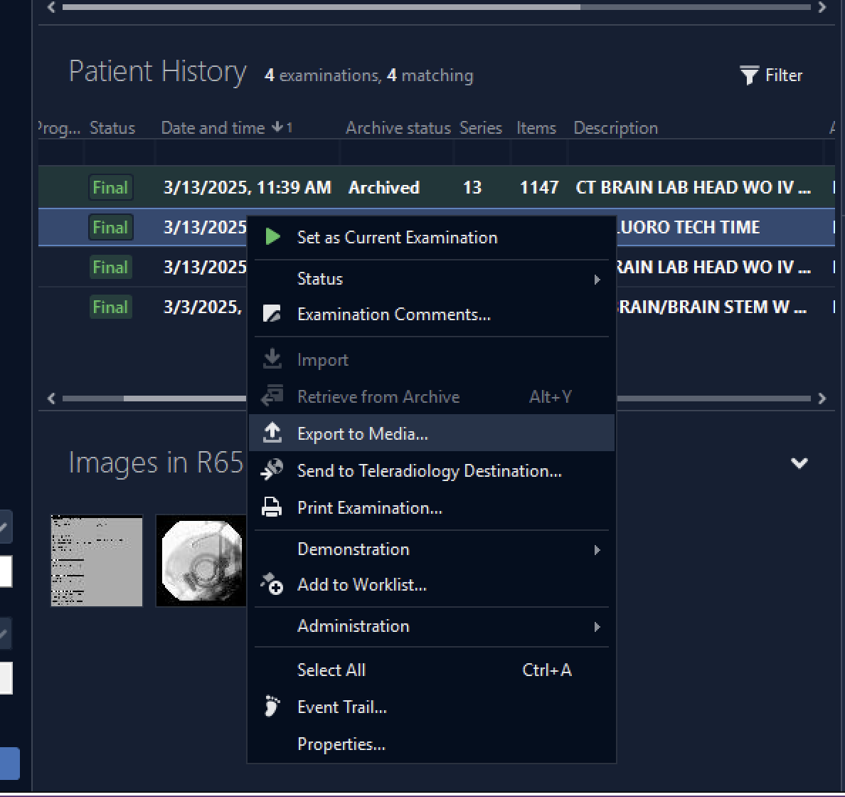
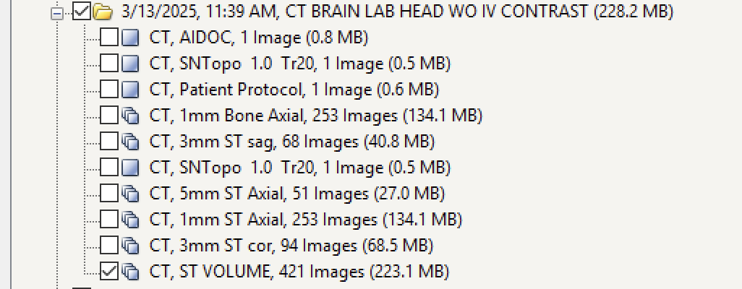
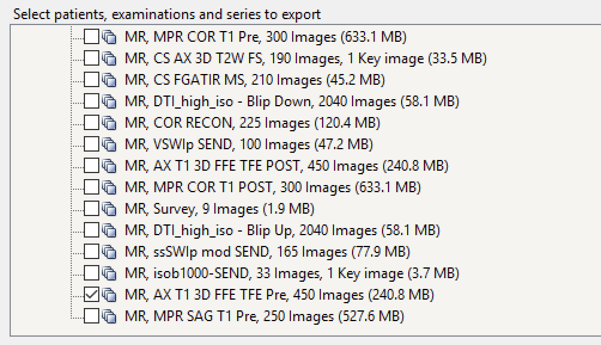

Aligning the CT scan to the pre-operative MRI scan
- Open 3dSlicer and load your files. From Sectra, it gets downloaded as a DICOM file. Import the DICOM file you just saved. 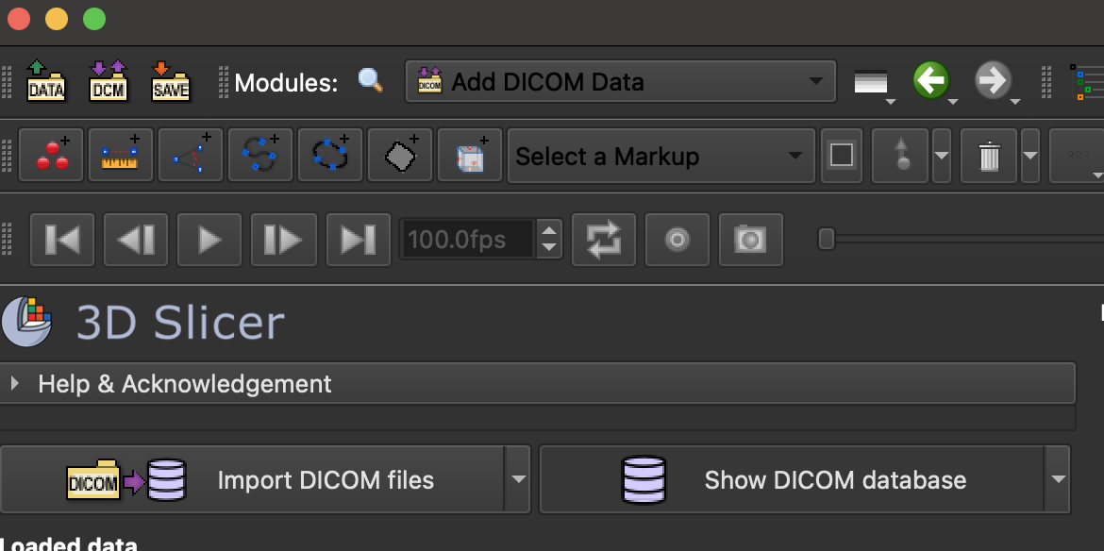

- Double click on the data and navigate to the data module. You should see the scans you downloaded now.
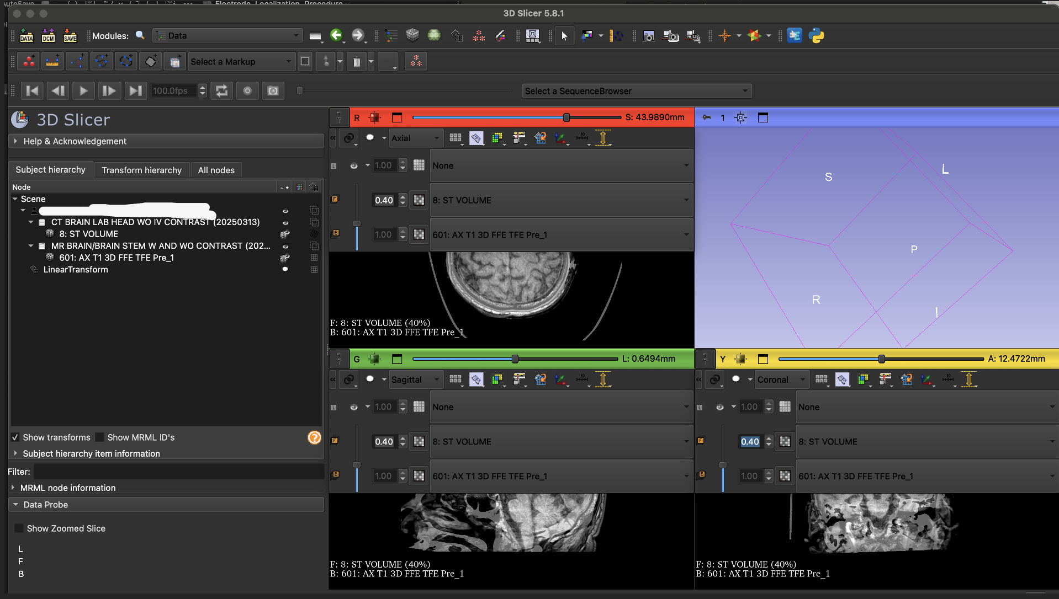
- Use the pin icon above each to see both images and adjust the opacity. You can click on the grid box to center the image
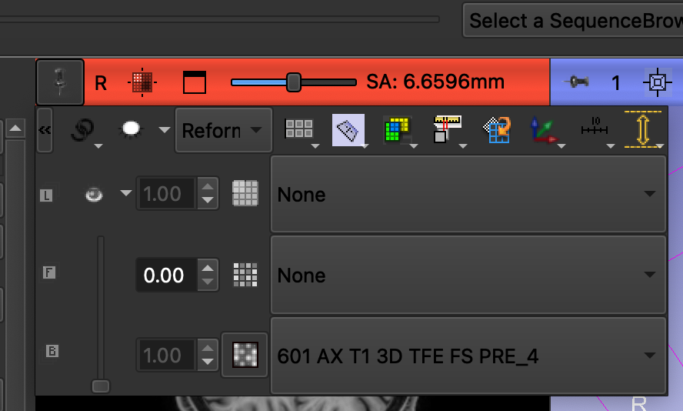
- You’ll notice that your alignment between the CT scan and the MRI are off. You will need to correct this by transforming the CT. Take note of the mm differences between the CT and MRI. This will determine how much you need to transform the CT image
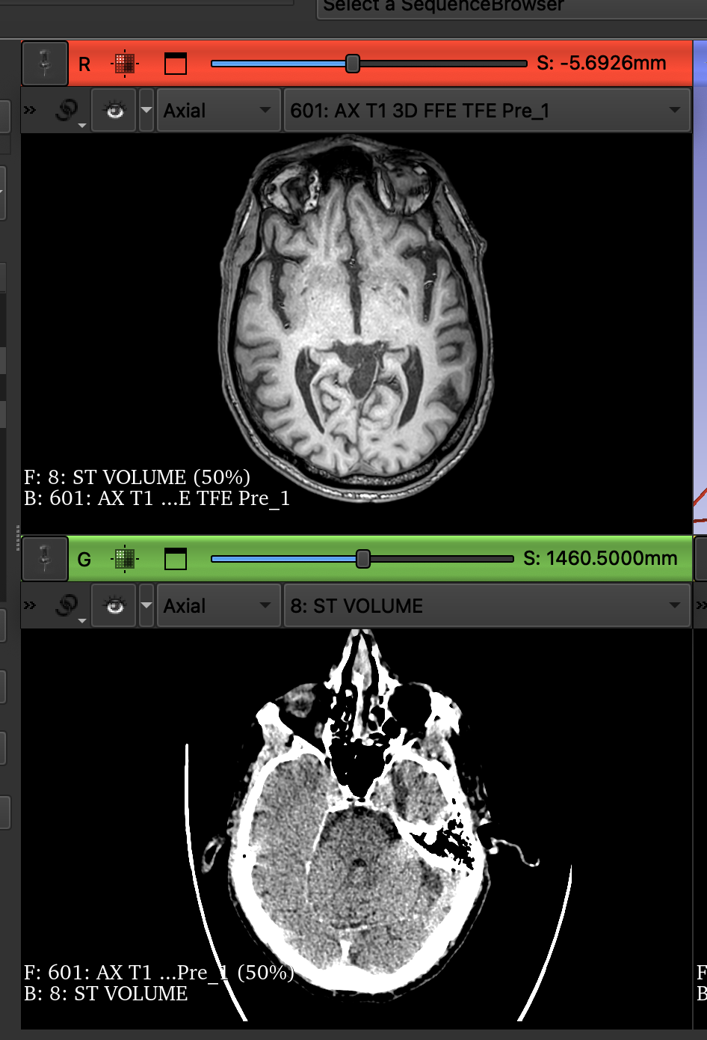
- Navigate to transforms-> create a new linear transform. Under the apply transform -> select the CT scan -> click the right green arrow. You should now see your CT under the “transformed” column. Please also make sure the images are linked and you are viewing both images. See pictures below. (Note: you may not be able to see the CT and MRI in the same box yet because the CT hasn’t been transformed into the same field of view as the MRI.) See next step.
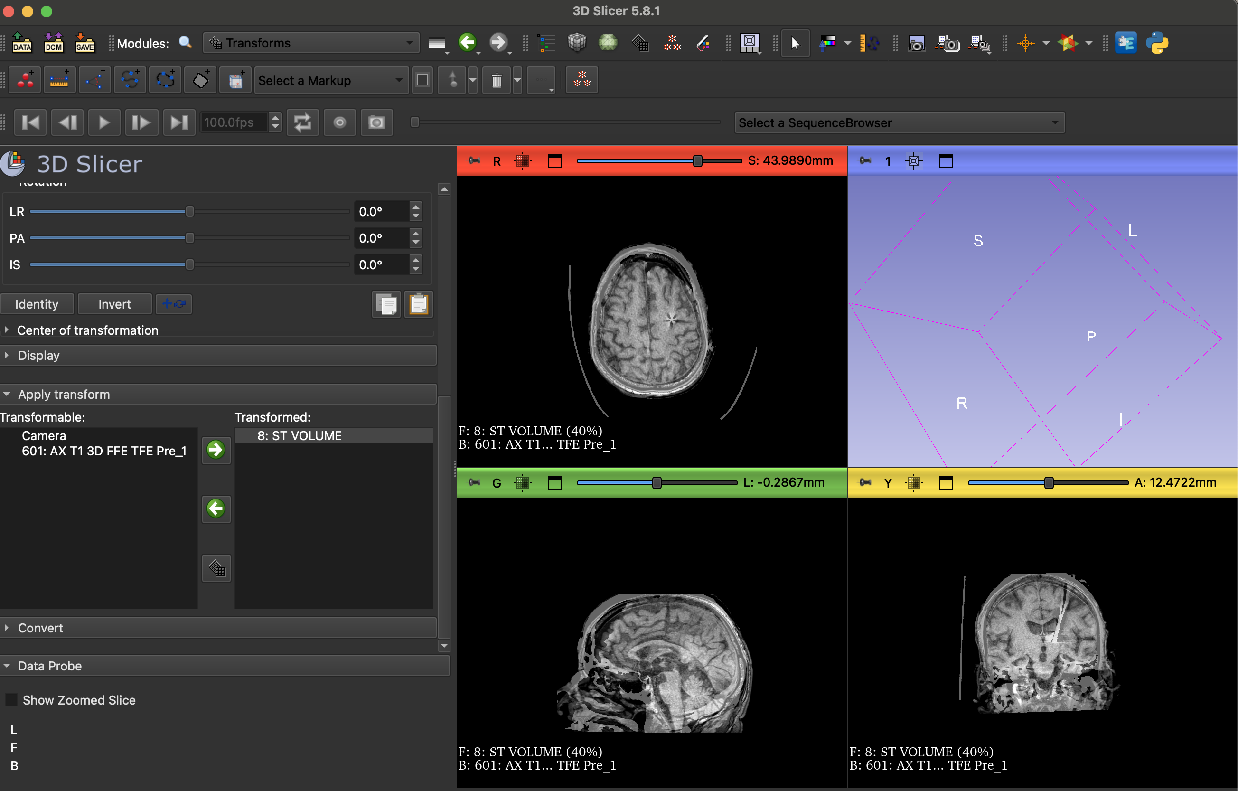
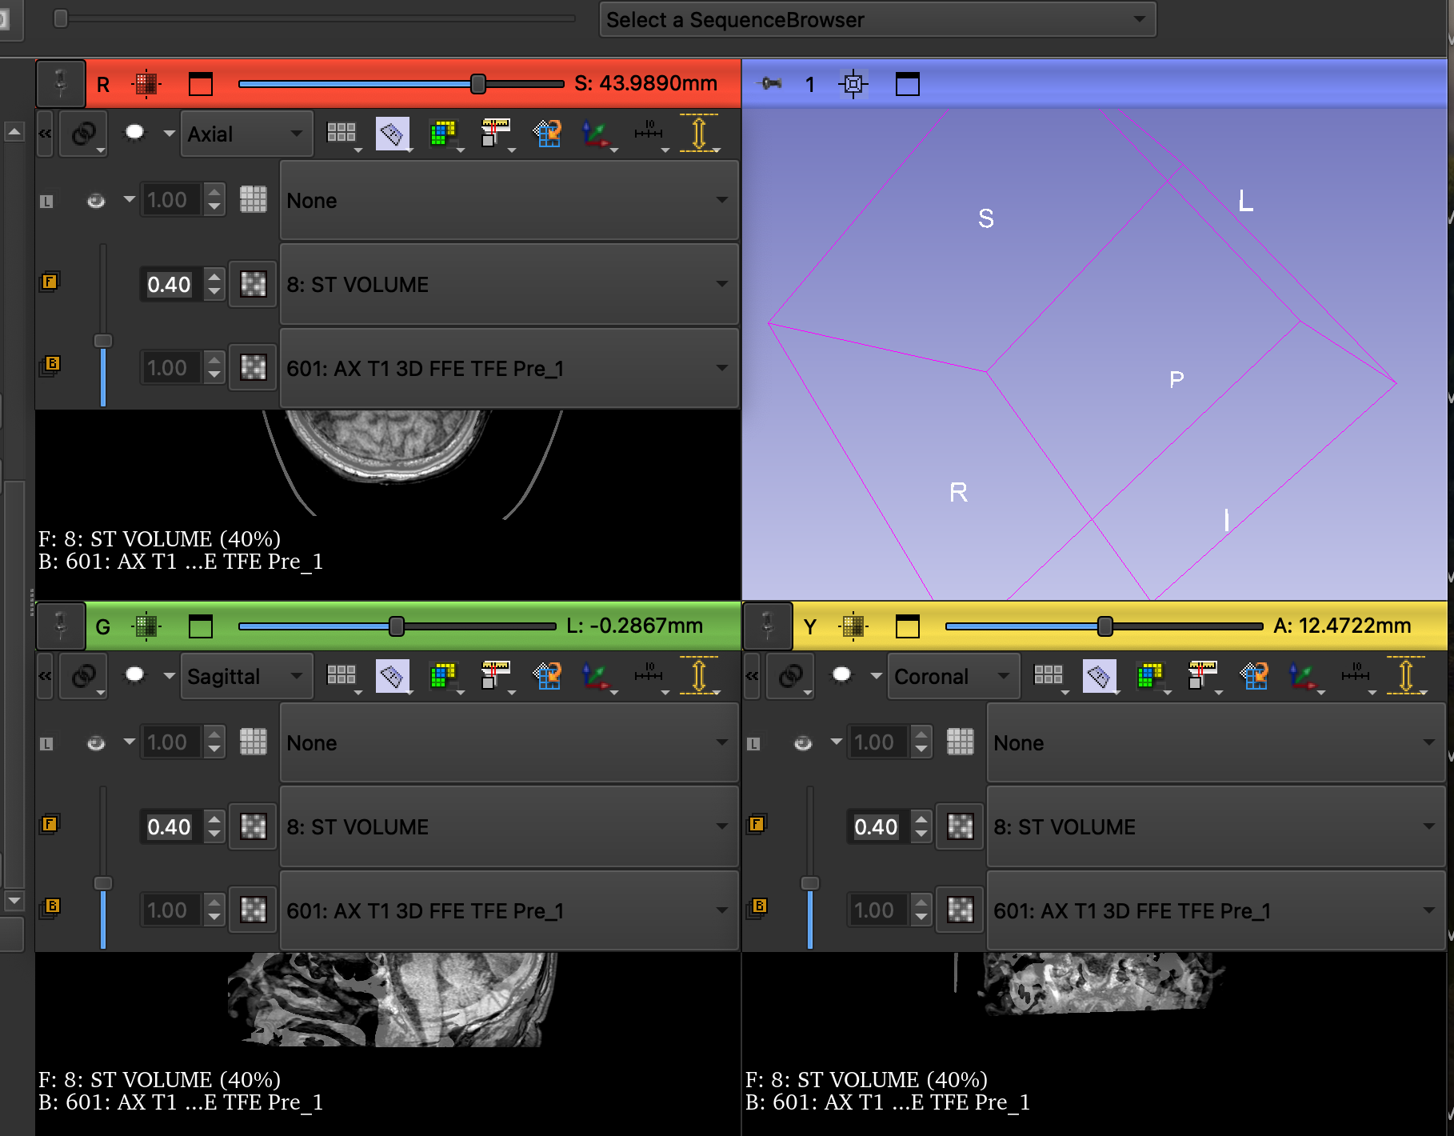
- You will now adjust the translation (LR, PA, IS) and rotation (LR, PA, and IS) to see the images in the same plane. Note the mm differences from step 8 to adjust the min and max translation. Continue to move the translation and rotation so that all views (axial, sagittal, and coronal) are lined up as best as possible. Ensure the eye sockets and skull are aligned.
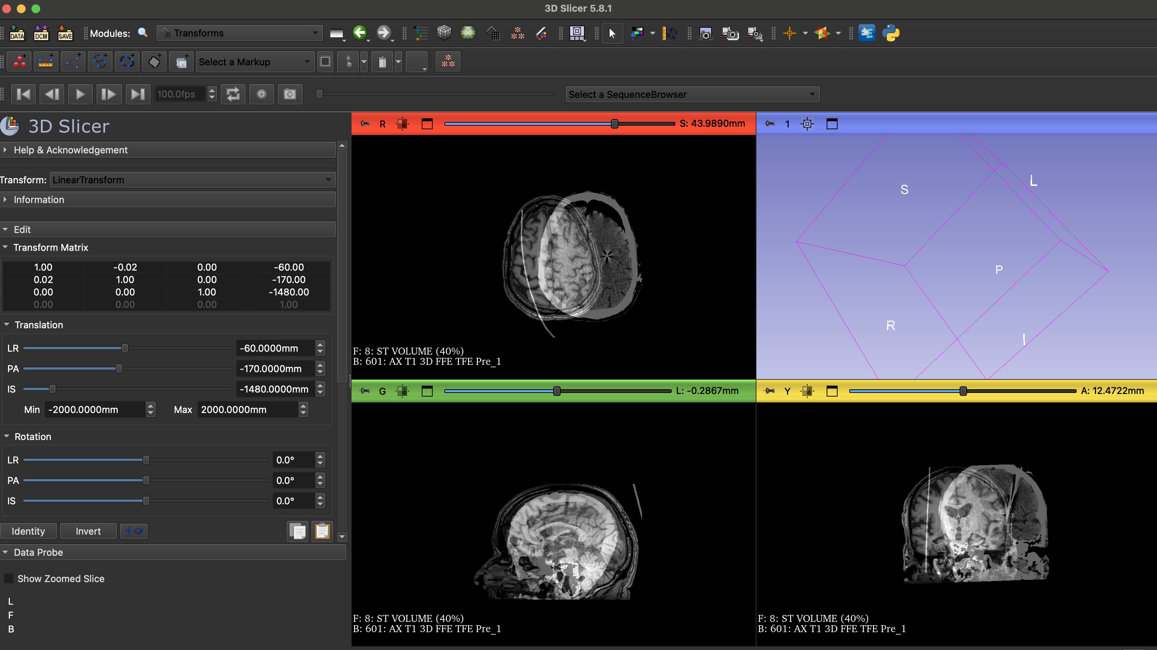
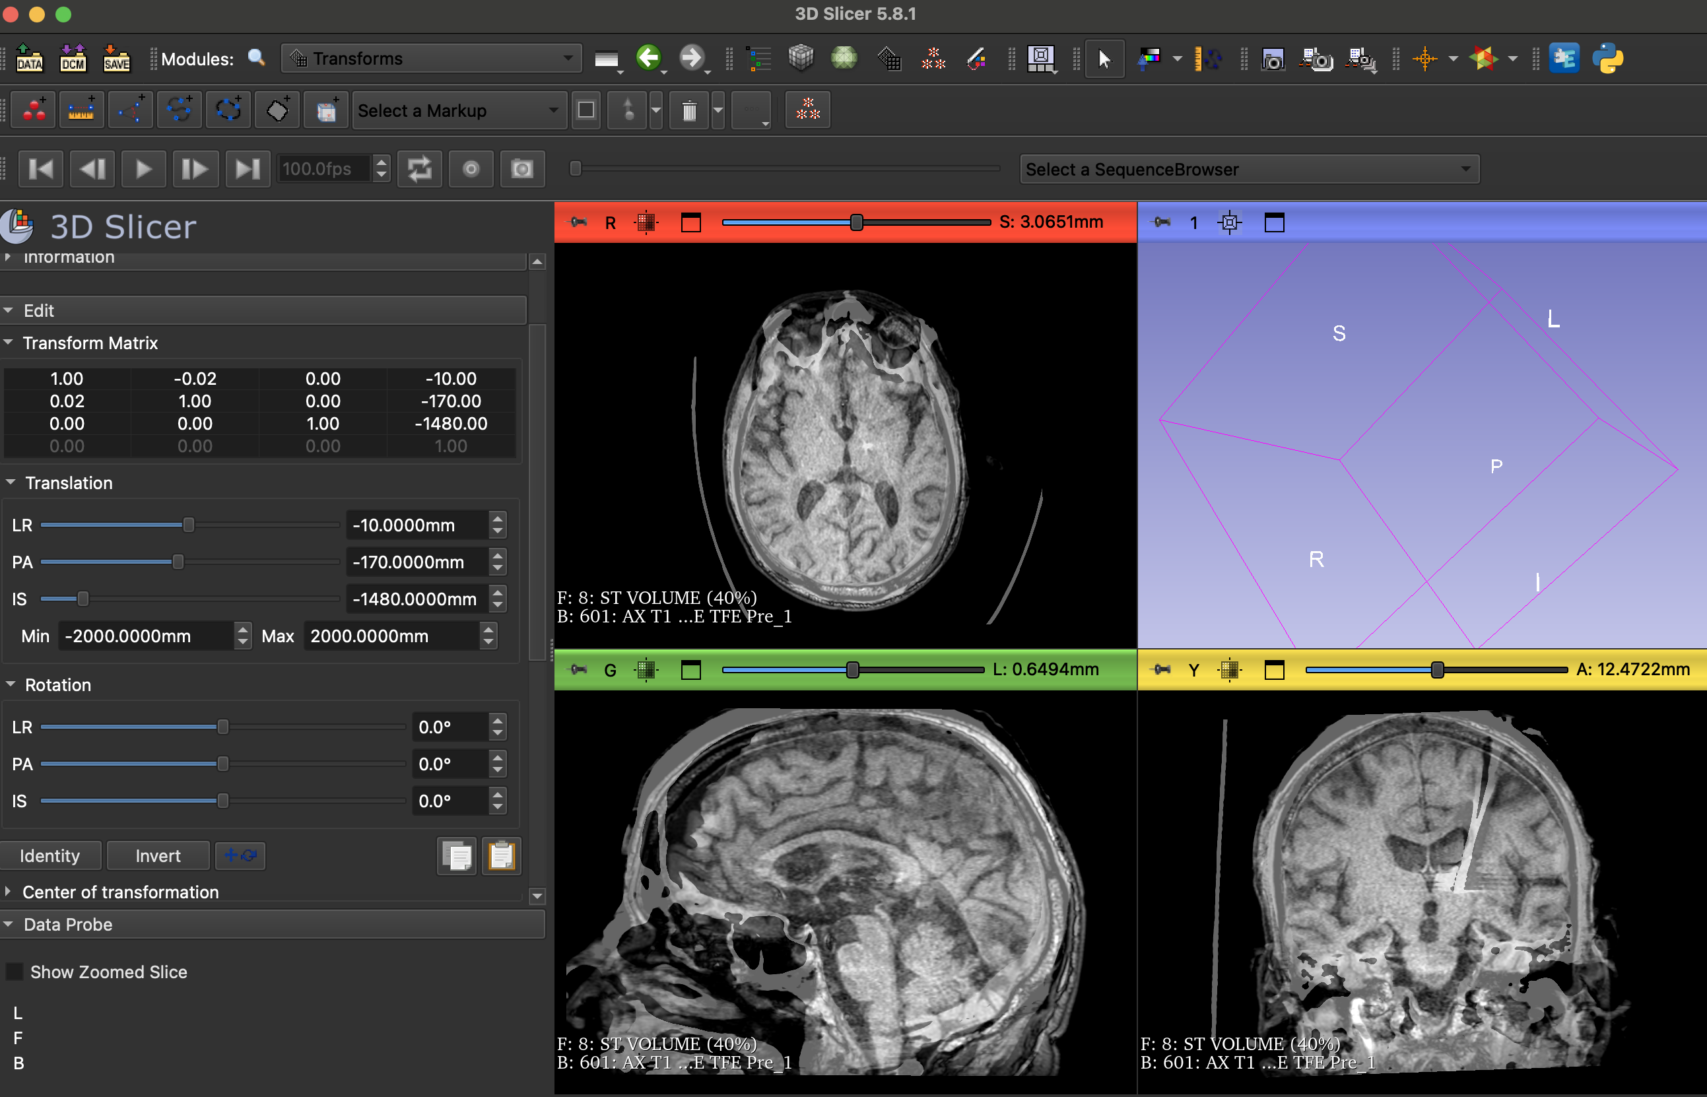
- Once you have aligned the CT and MRI, harden the CT image by selecting it in the right “transformed” column and clicking on the grid icon. Once hardened, it will move back to the left column.
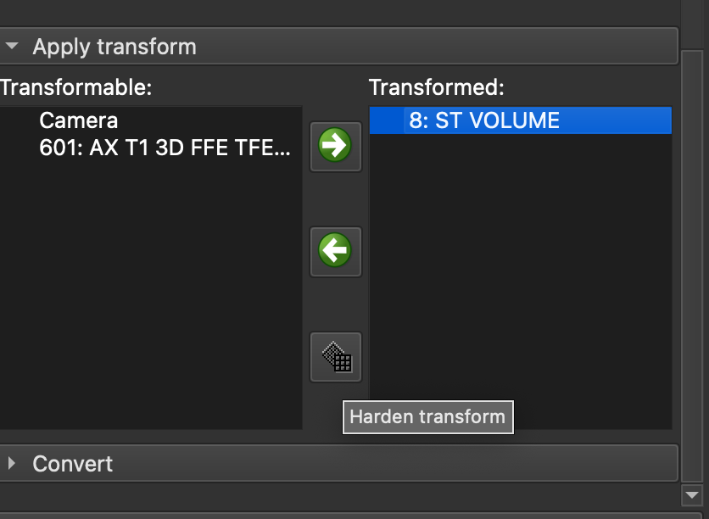
- Navigate to the registration module -> select general registration (BRAINS). Select your MRI as the “Fixed Image Volume” and the CT as the “Moving Image Volume”. Change the Input Images “Percentage of Samples” to 0.2. Under Output Settings, select “Output Image Volume”-> “Create Volume As” and name your ct “registered_ct. Check the box under Registration Phases for “Rigid (6DOF).” Select apply and wait for program to run. It may take a few minutes.
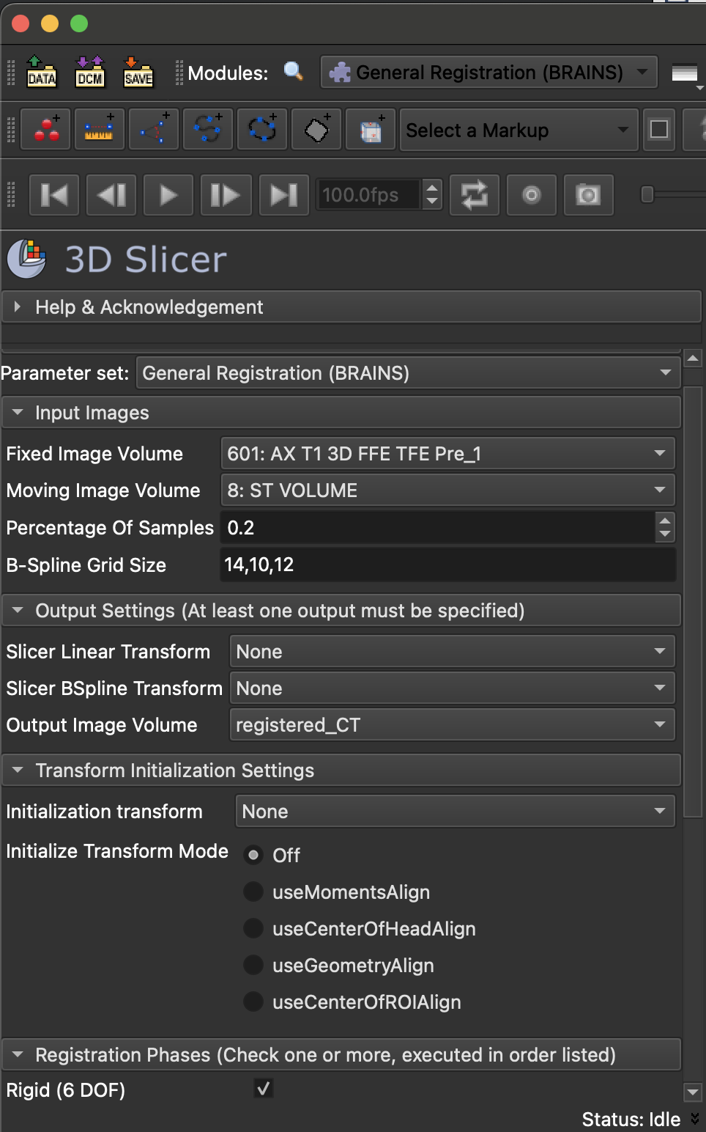
- Save your registered_ct and MRI as nifty (.nii.gz) files.
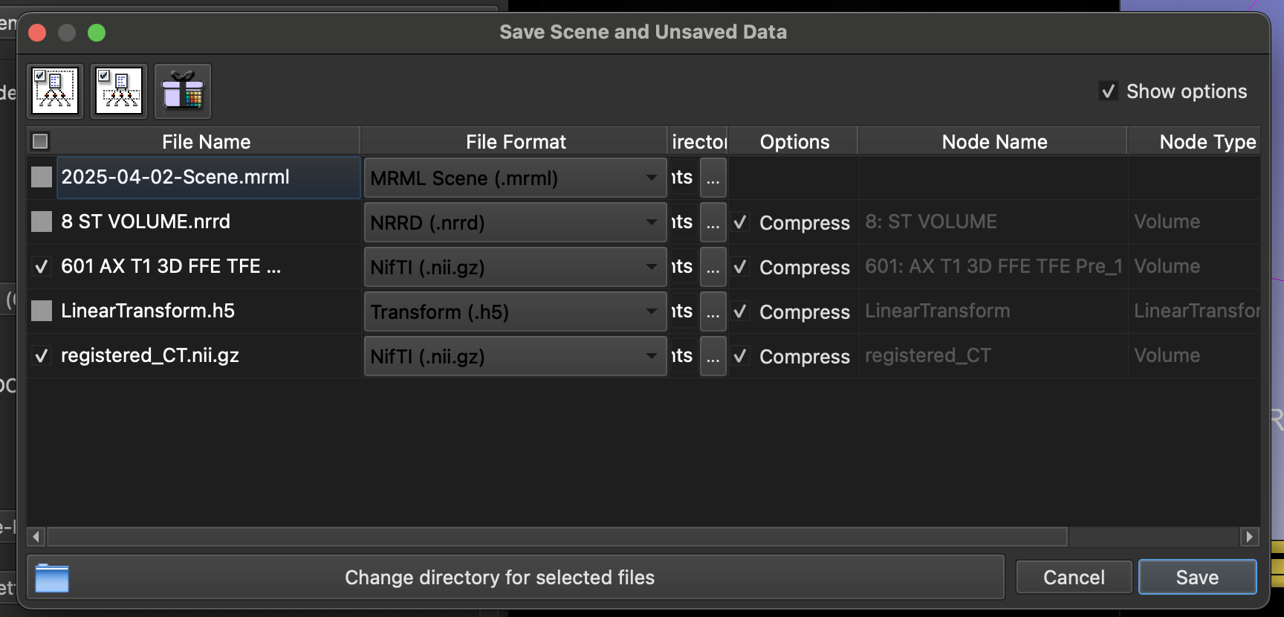
- Now, close out 3dSlicer.

Marking lead locations on registered ct
- Open 3d Slicer and load only the registered_ct and MRI .nii.gz files you just saved.
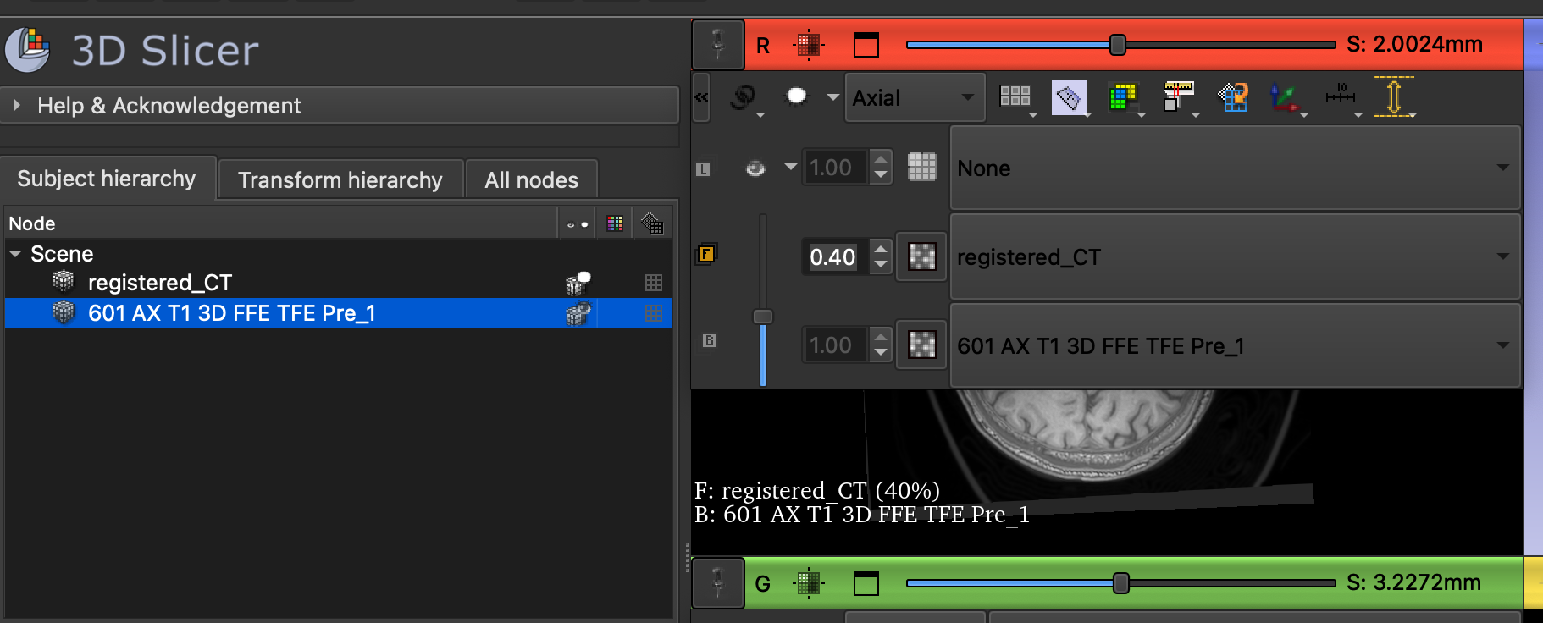
- We will now move through the slices to mark up all the points on the axial scan where the electrode first appears until it can be seen contiguously with the skull bone. In the red viewing pane, adjust the opacity to show the registered_CT. Scroll through slices (using the bar above the image pane or the mouse scrolling function) to make sure you can see where the electrode first appears and track it until it is on skull. If you are having trouble seeing the electrode, navigate to the Volumes module and toggle the window/level. You will be able to see the screen darken.
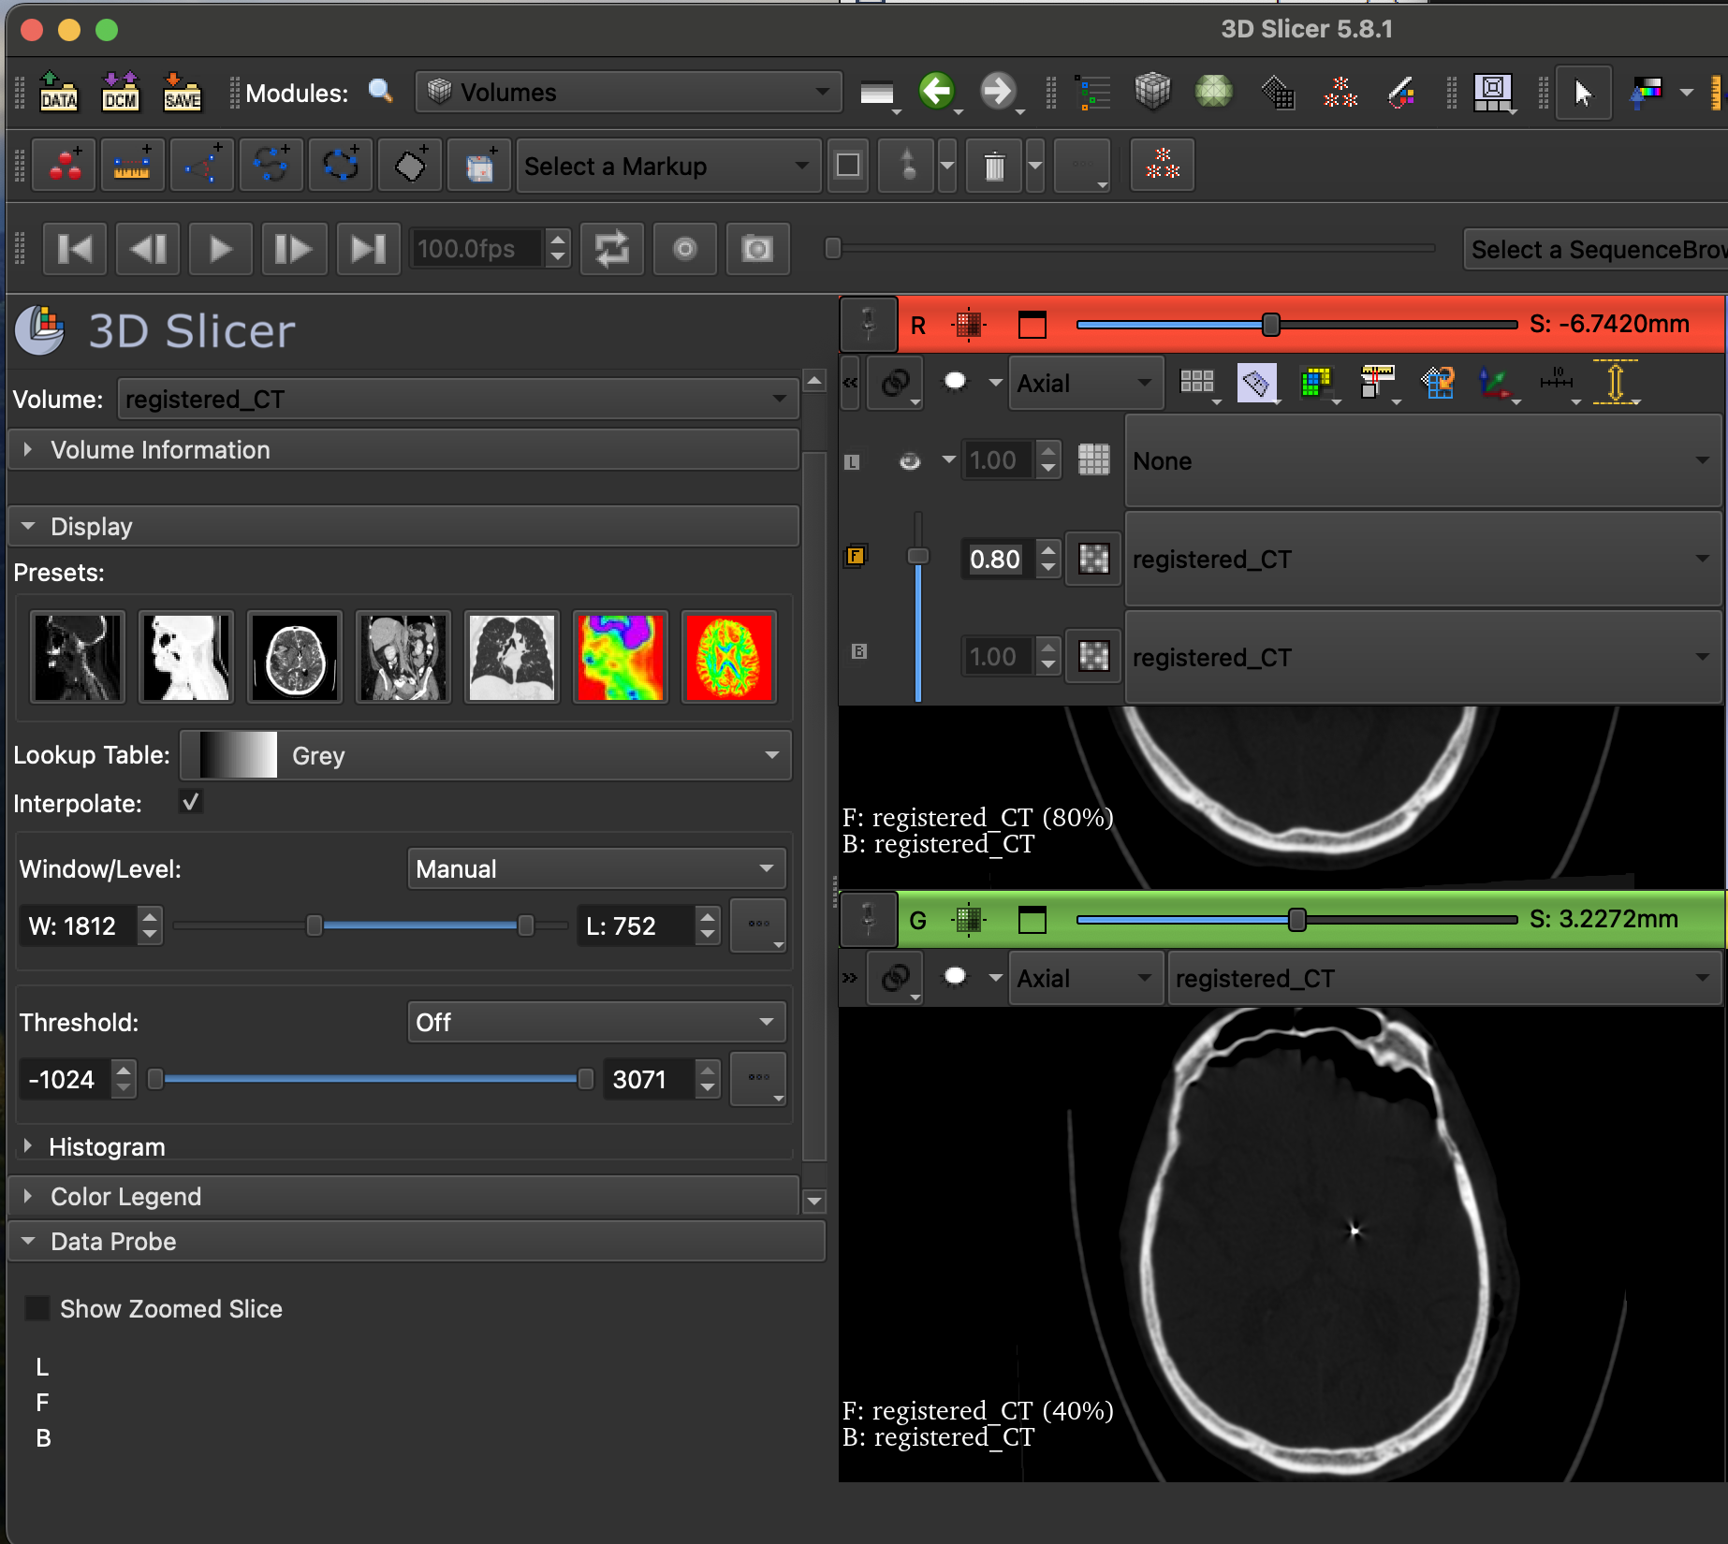
- Navigate to the Markups module. Select Point List. You should see “F” appear under Node. Navigate to the icon at the top bar with a red circle and blue line. There should be an option to check “Place multiple control points”
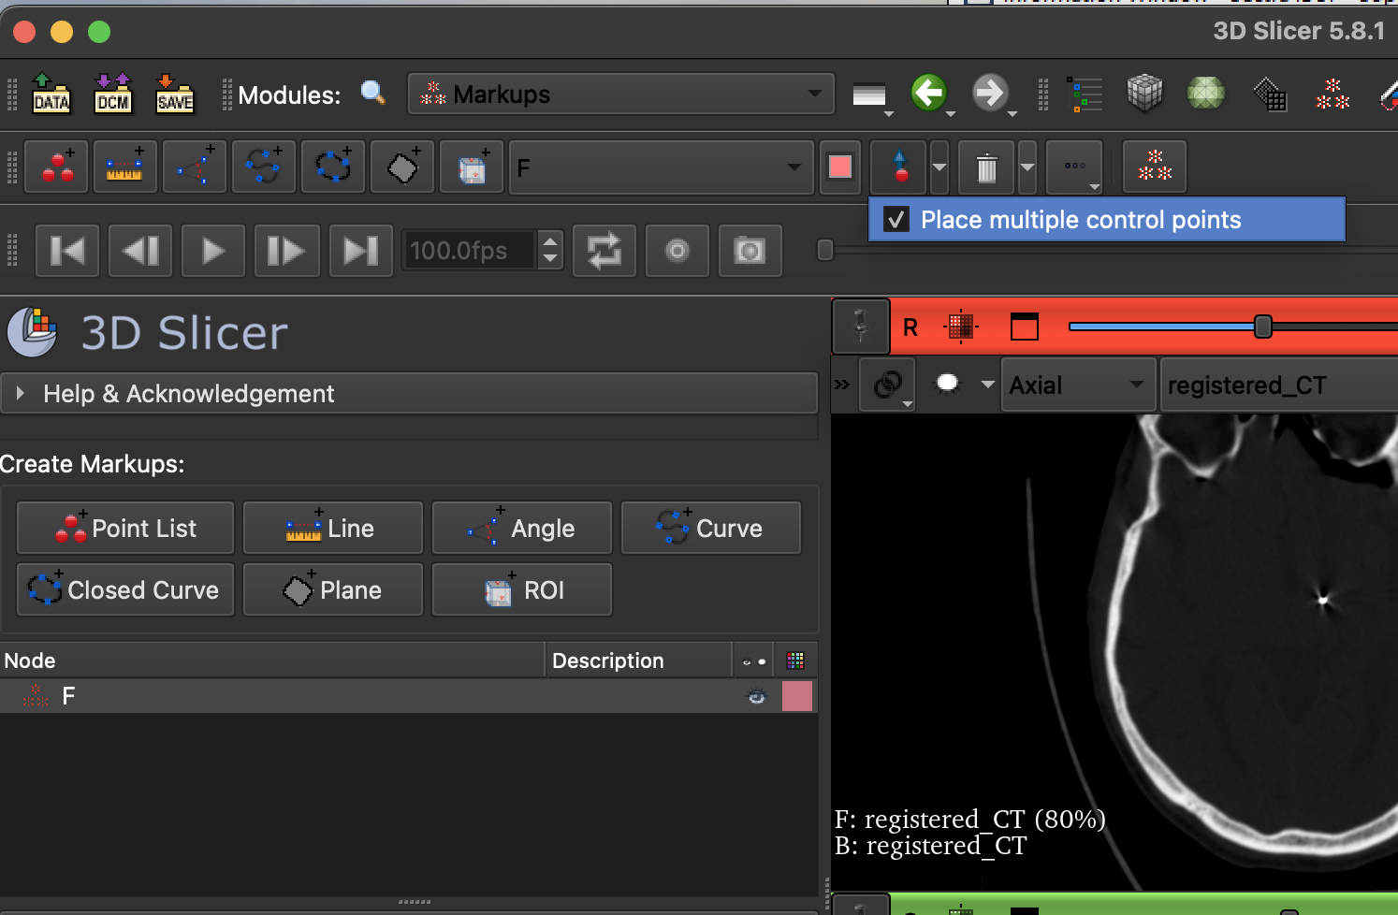
- Navigate to your axial view of the CT scan. Zoom in and scroll through the slices so that you can find identify where the electrode first appears. Click on this point with your cursor (it should be F-1). Scroll to the next slice, click on the center of the electrode point. Continue to do this until you get to the skull. You should see your points being added to the coordinates list on the left side of the screen.
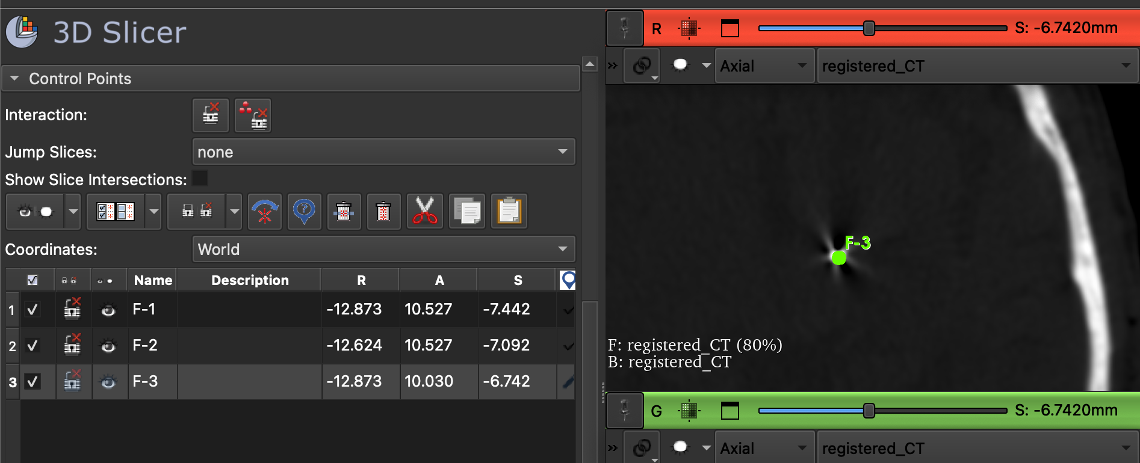
- Once you are done with your points, save the point list as a .fcsv file. You will likely encounter an error message to save the file. The file should still save. Just look for a F.fcsv file in the directory you chose to verify. 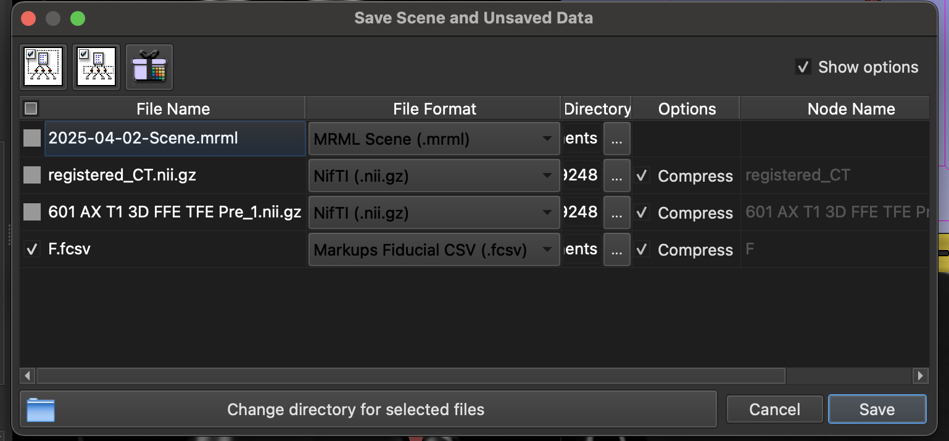

Freesurfer Transformation
- You will now need to navigate to freesurfer. I successfully used freesurfer 7.3.2 with a Rosetta terminal since I had issues with 8.0.0 version. I have a Mac with an M3 chip so this step might depend on your laptop. Steps to do this on a mac are below:

- Inside the Rosetta terminal run the following. Be sure to change the location to wherever you downloaded freesurfer
- 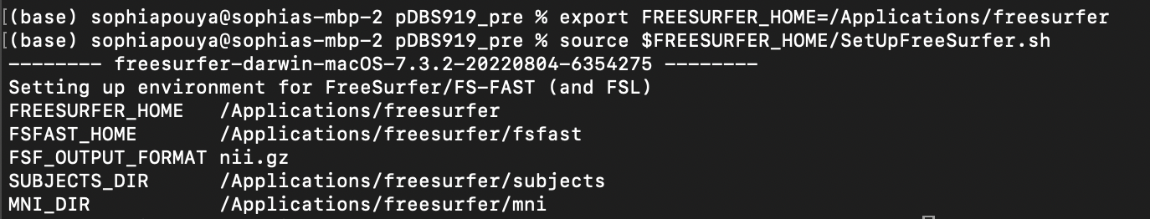
- You now need to create a patient folder and add their T1 MRI scan to it. Call the folder pDBS###_pre where ### are the first three numbers of the patient’s MRN. Copy the T1 MRI scan (.nii. gz) to the patient folder and name this scan “pre.nii.gz” 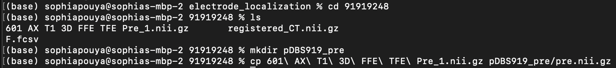
- Now you need to set variables.
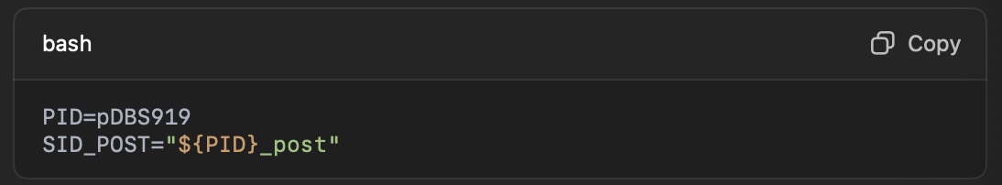
- From your pDBS###_pre directory, run the following command: (Note this will likely take a while. Don’t exit before it’s done)
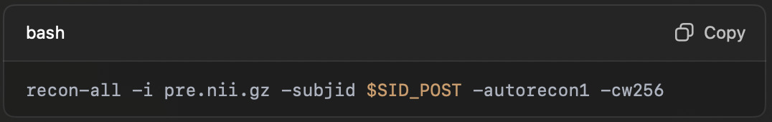
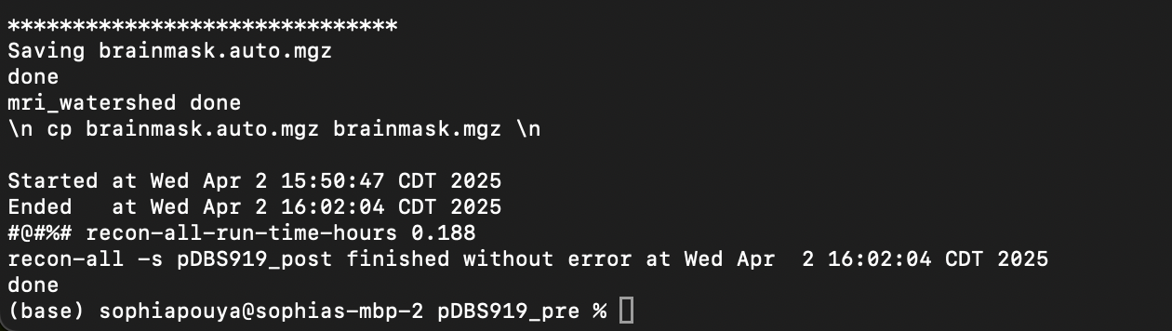
- Now run the following command:
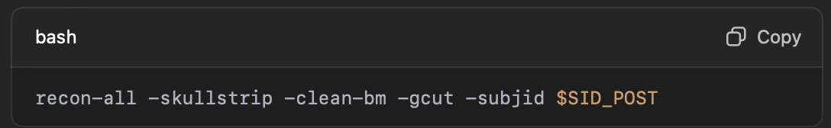

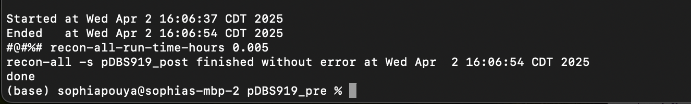
- Now you will need ANTs. If you haven’t already downloaded see link here for precompiled binaries for Mac or Linux. Once you’ve downloaded ANTs, you need to export paths. You will need the dbs_template.mgz file. Run the following commands (make the paths specific to where the files are located on your computer):
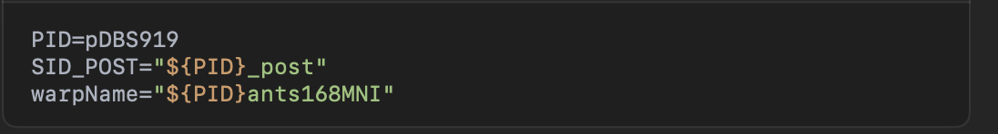
- Navigate to your subjects/mni directory. The subjects directory should be in the same place that you downloaded freesurfer.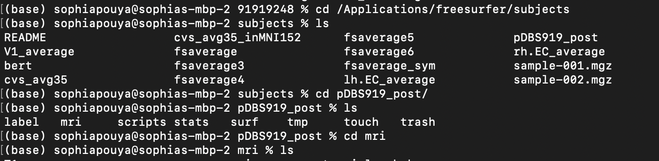
- Run the following command for ants registration. If you are on Mac, you may get a permissions issue that you can allow by going to settings-> privacy.
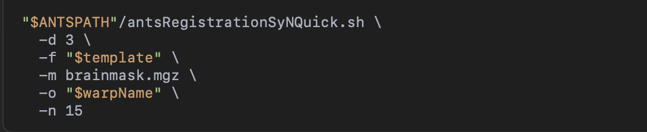
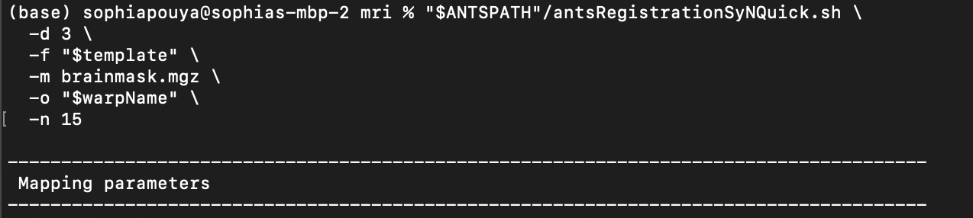
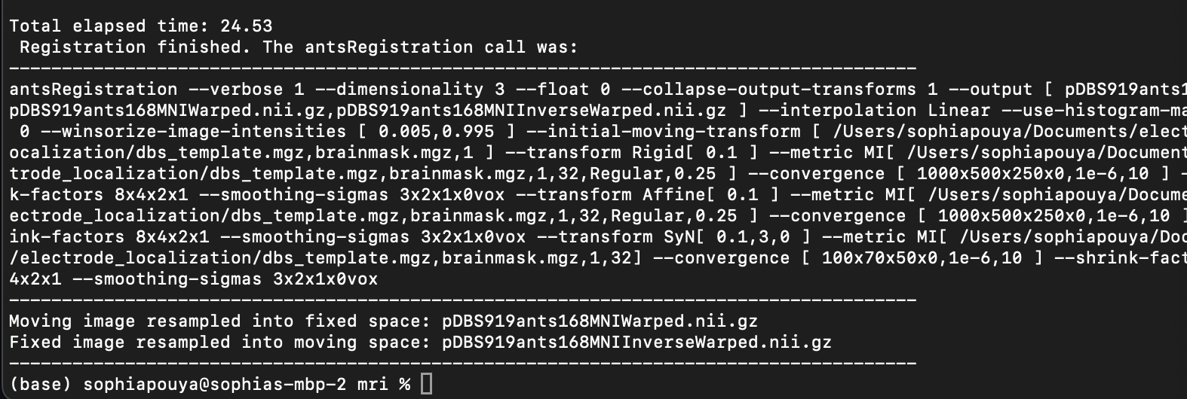
- Congrats, the freesurfer registration is complete now! The files you need will be located in your subjects/mri directory that you ran the ants registration from above. You will need *ants168MNI0GenericAffine.mat and *ants168MNI1Warp.nii.gz files

MER location in native space (to deal with surgery displacements of microelectrode)
- You will now need to open up matlab with the following two scripts: determine_mer_position.m and importDBSlead.m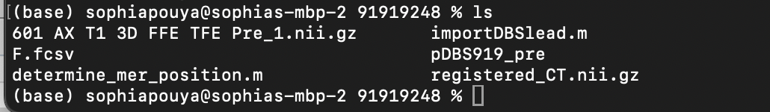
- Run the determine_mer_position.m. A pop up window will open up allowing you to select your F.fcsv file you created in slicer.
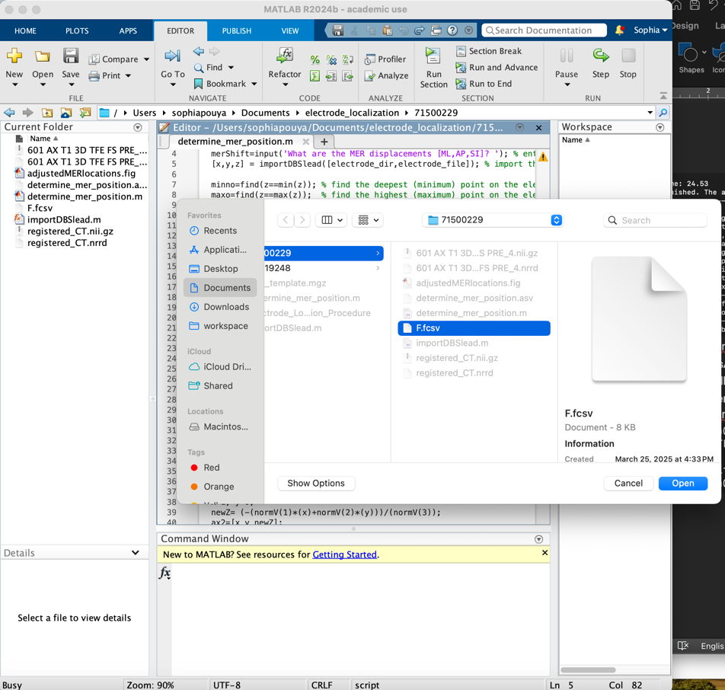
- You will then need to enter the displacement. You should have a distance from target in the surgery notes. Enter the MER displacements as [0,0, distance_from_target]. Take note of the newRel.
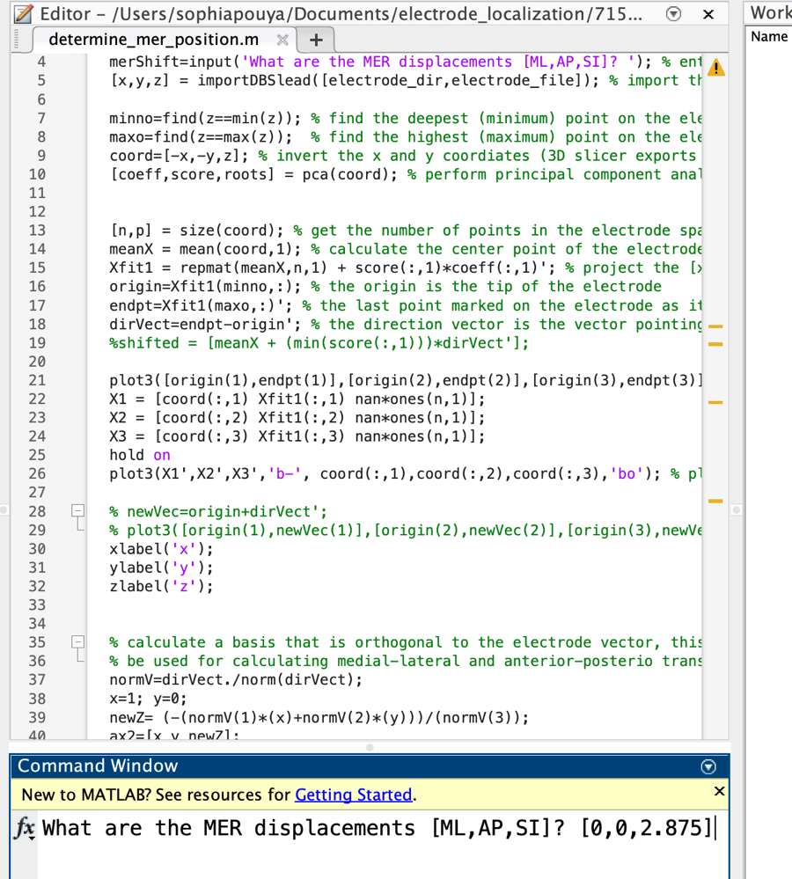
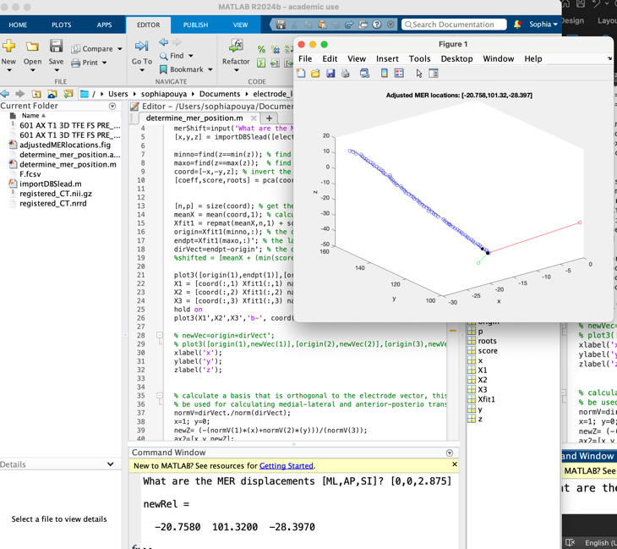

Obtaining MER location in MNI space with 3D Slicer
- Open 3d slicer with the following files: 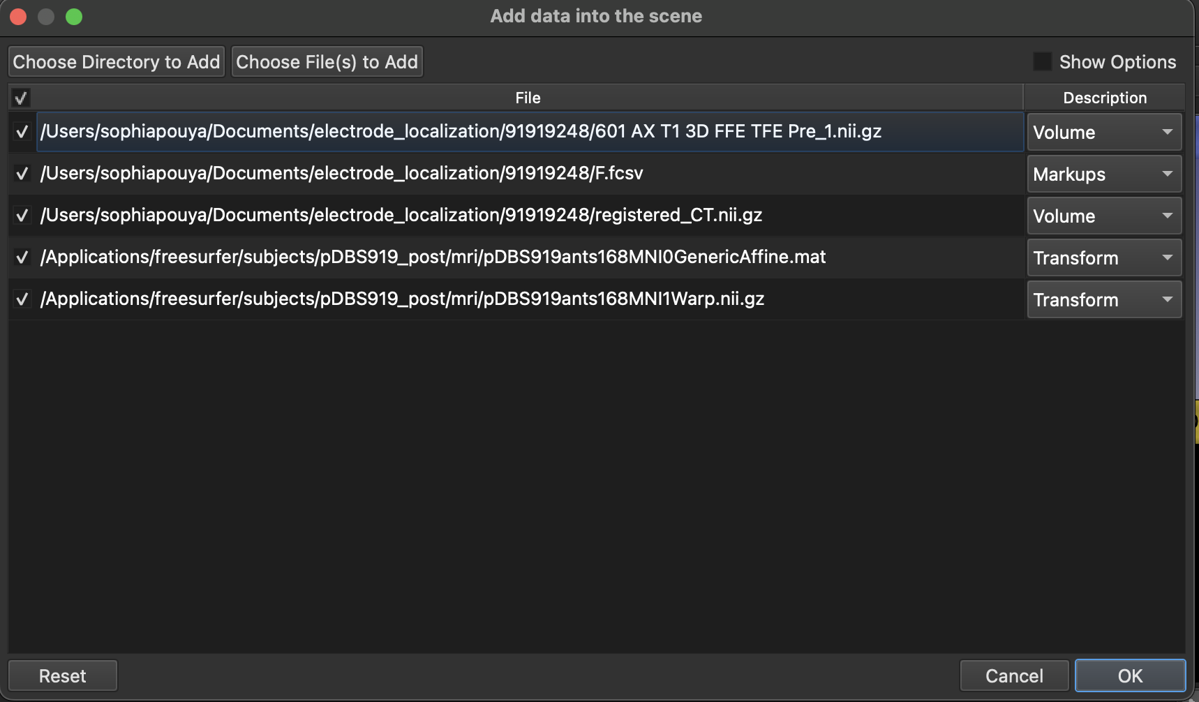
- You will now create a point with the coordinates you got for MER location in native space. Navigate to markups module and select point list. Create a point anywhere on the screen. Point F_1-1 was created in the example below. Go to the control points section and enter the coordinates you got for MER location in native space.
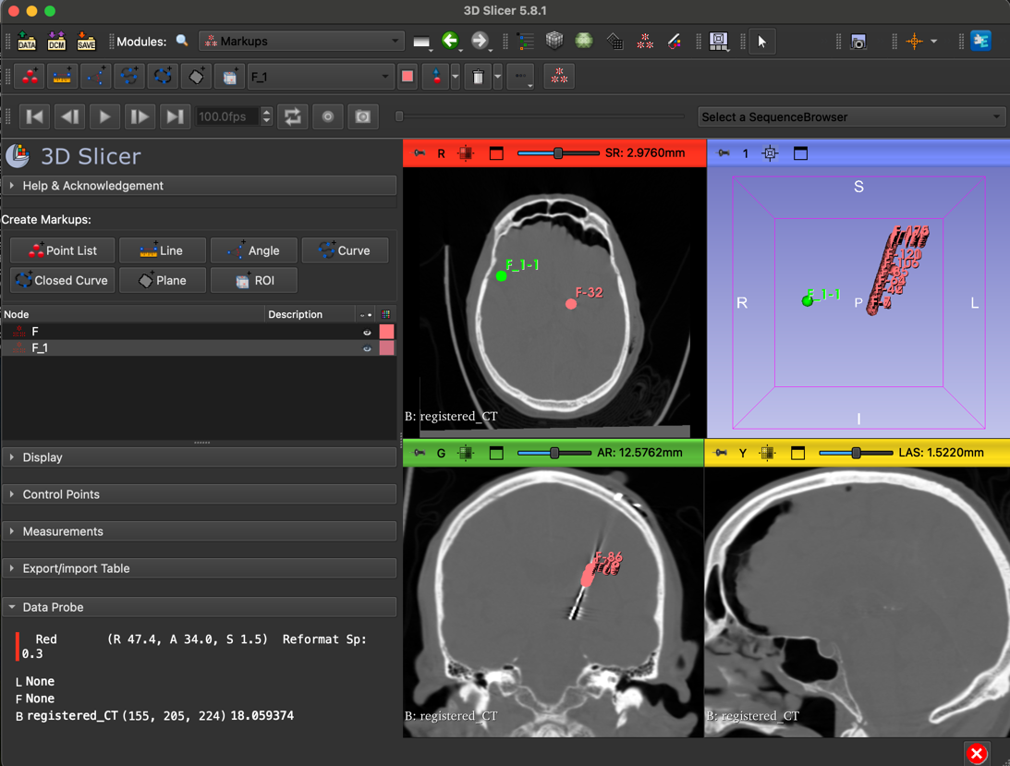
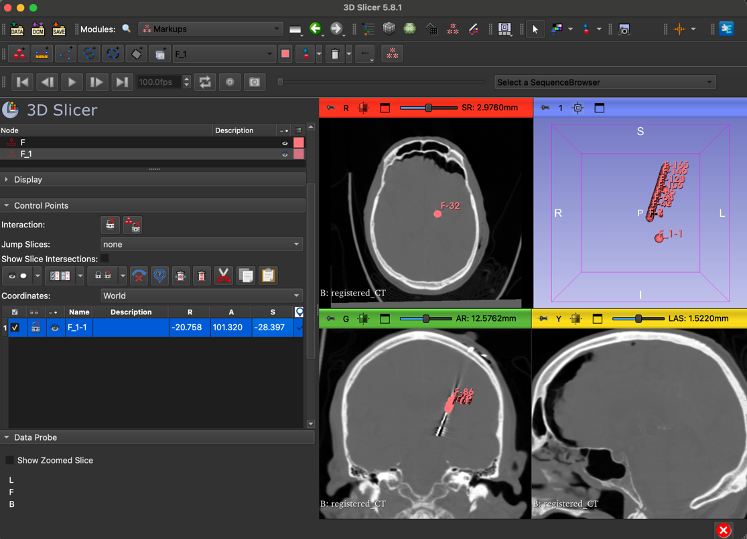
- Navigate to the transforms module. Select the pDBS***ants168GenericAffine. 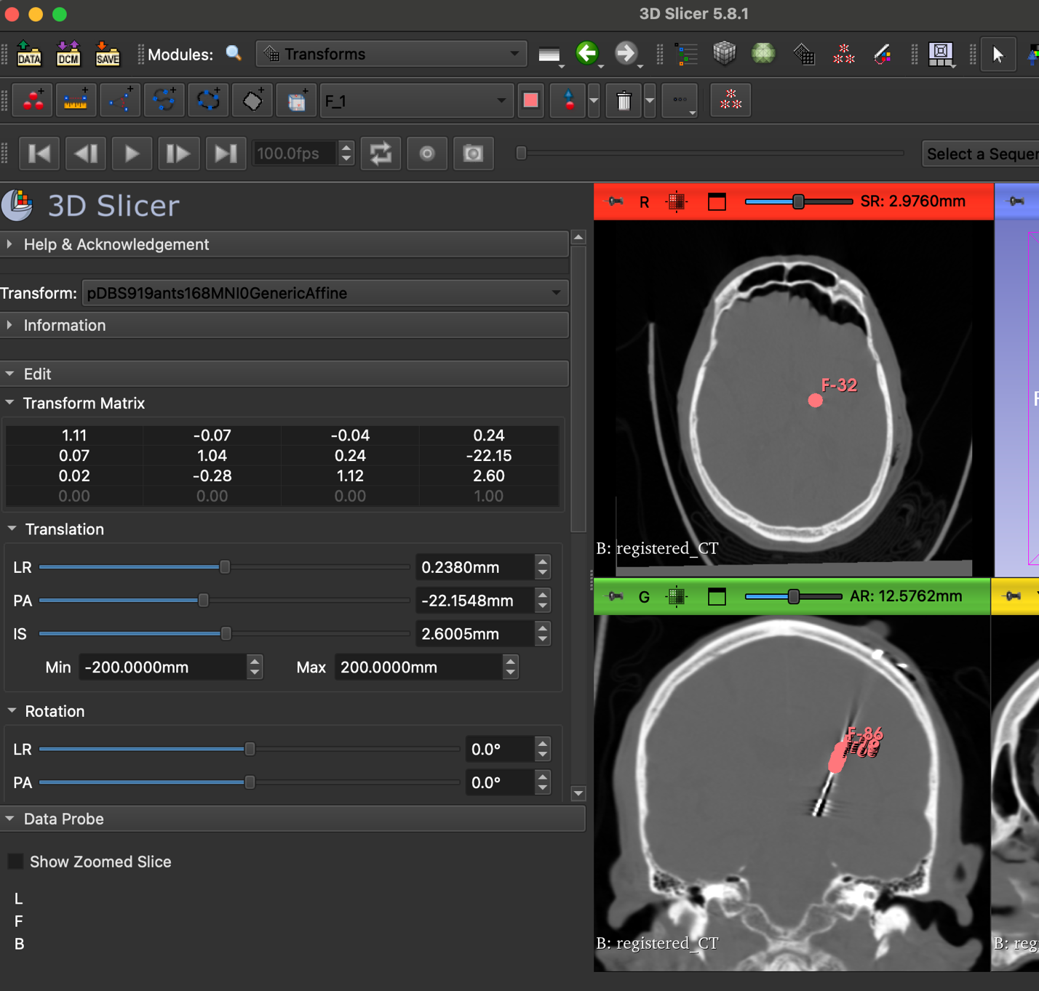
- Scroll down to transformable and select the MRI. Click the green arrow to move it to the transformed column. Do the same for your point list F, registered_CT, and newRel point (F_1 in my example). Select control (or command on Mac) and highlight all of the scans in the transformed column. Once all scans are highlighted, harden this transform by selecting the grid icon. Once they are hardened, the scans should move to the “transformable” column.
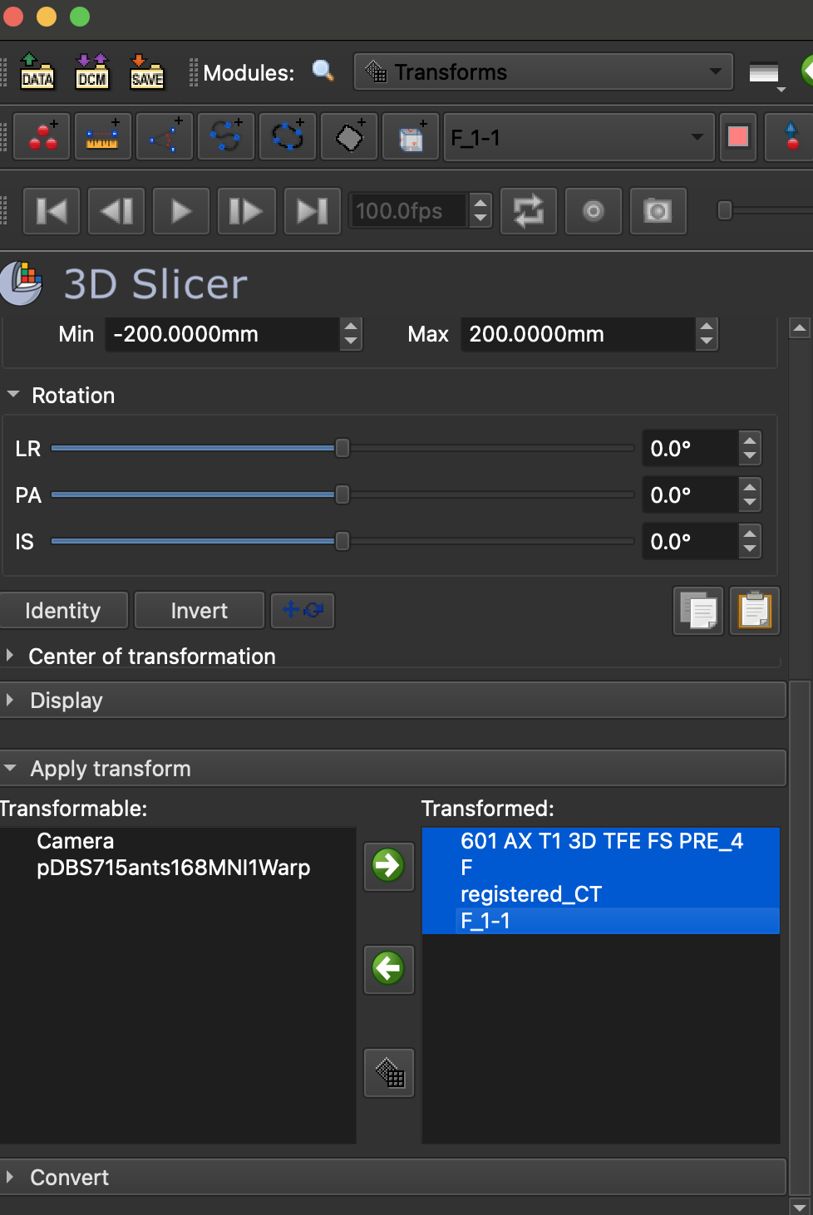
- Repeat Step 4 but instead of using the pDBS***ants168GenericAffine.mat in step 3, select the pDBS***168MNIwarp file under “Transform”
- Your final point will be the transformed F_1! Click on this point to see where the microelectrode is.

plotting the points in Lead dbs
- Download LeadDBS if you don’t have it already. See link here.
- You will also need SPM. See link here if you don’t already have it downloaded.
- Open MATLAB and the leaddbs directory. Add the path to spm. This should pull up a LEAD-DBS gui.
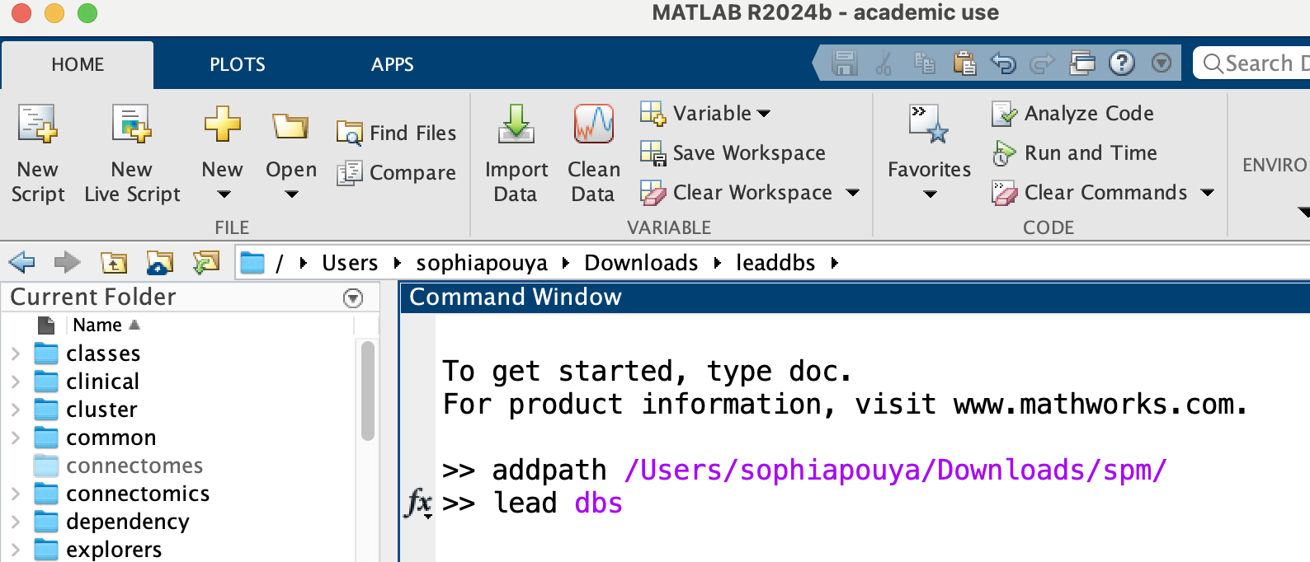
- Check the box for “Render 3D” and run. A few screens should show up including the brain rendering. The atlas control will allow you to choose which regions you want shown. You will likely need to navigate to tools and select rotate3D and/or move the mouse to adjust the image so that you can see the structures.
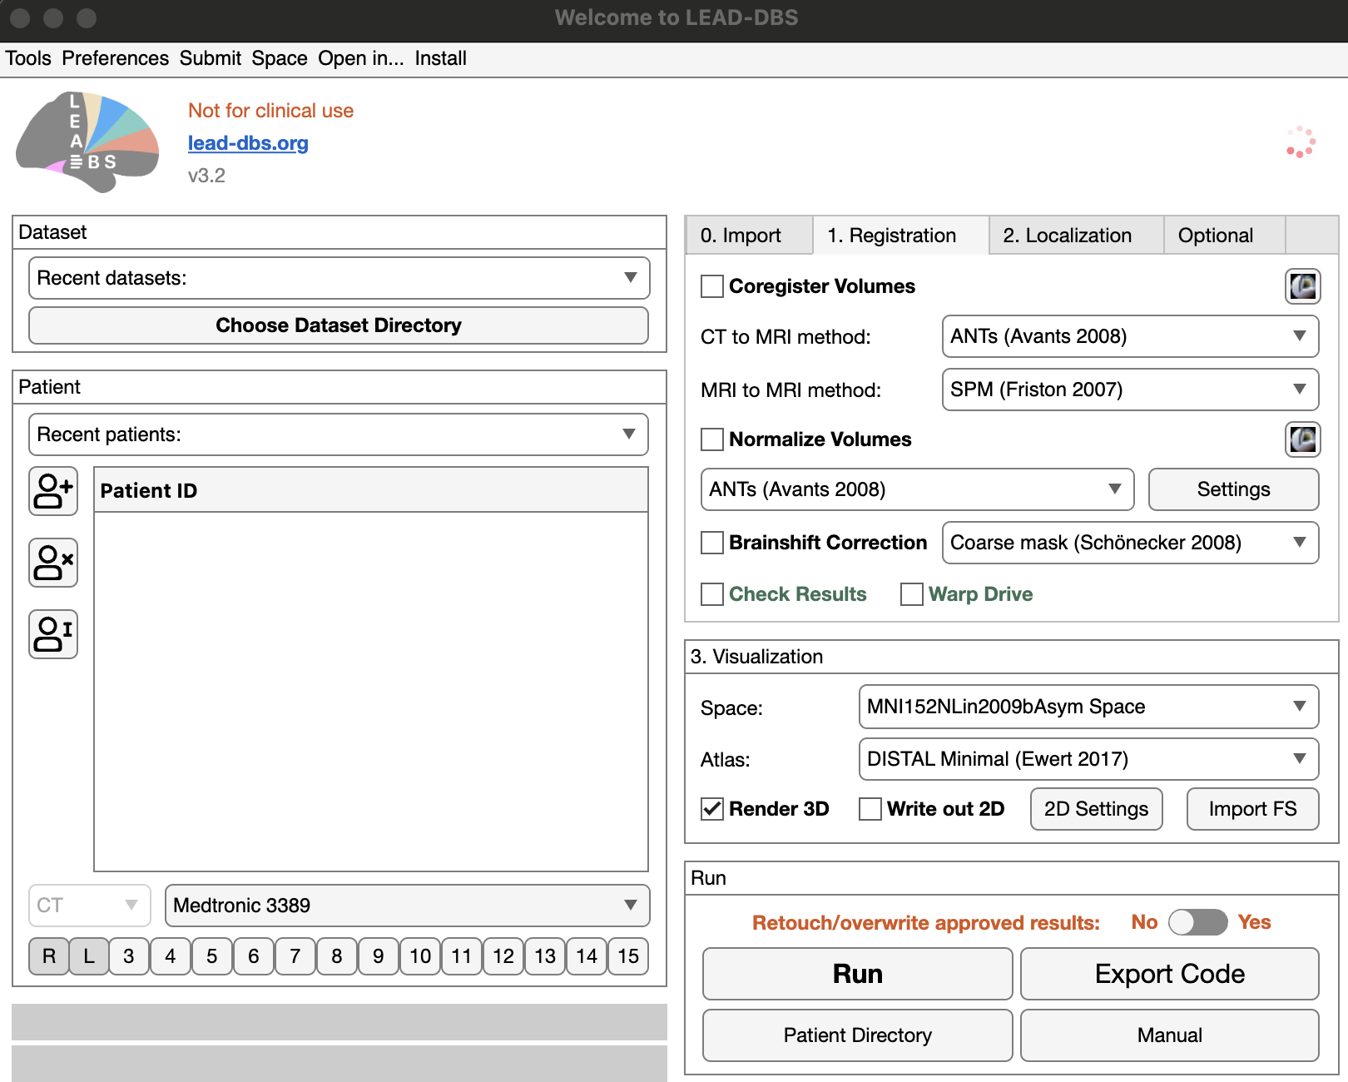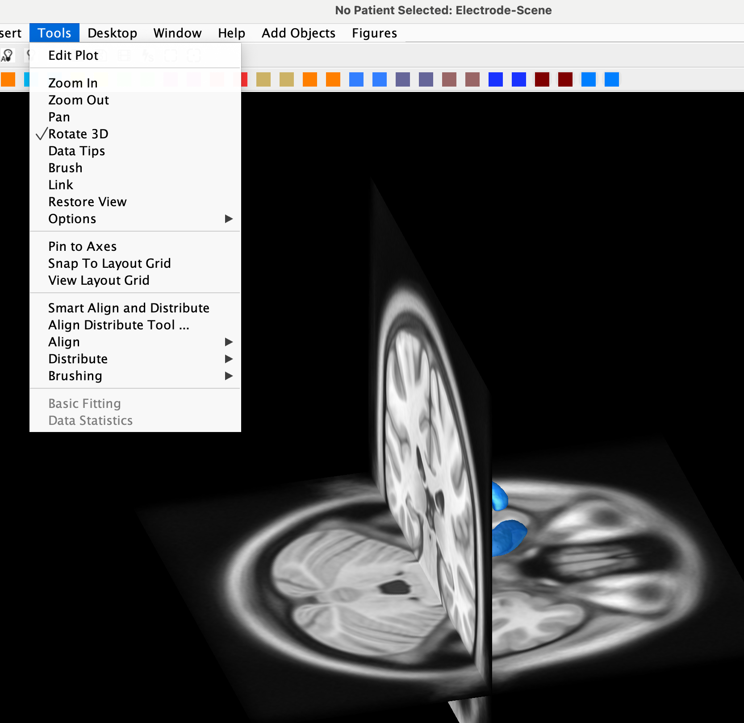
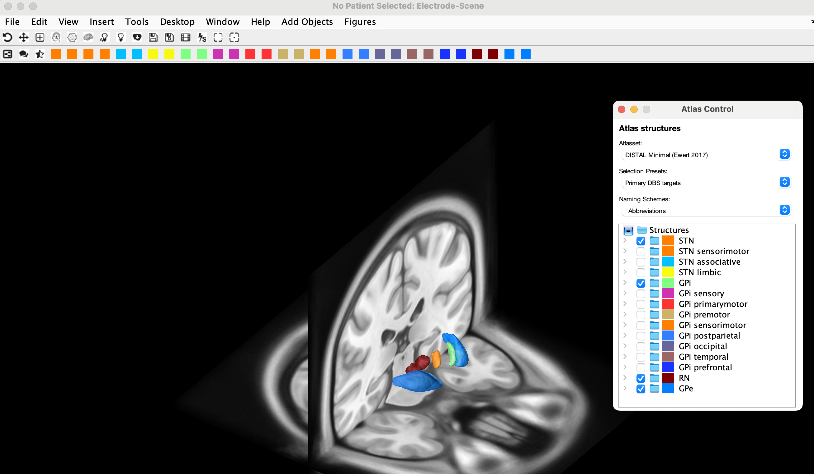
- Save the brain as a matlab fig. You will now edit the script I made “add_points_to_brain.m”. You will edit this script with the name and location of the brain image you just saved in addition to however many points you want to plot. Each point is the transformed point from the final transformation done above (The MER location in MNI space, F_1-1 in my example). Note that each point is a single patient’s microelectrode location.
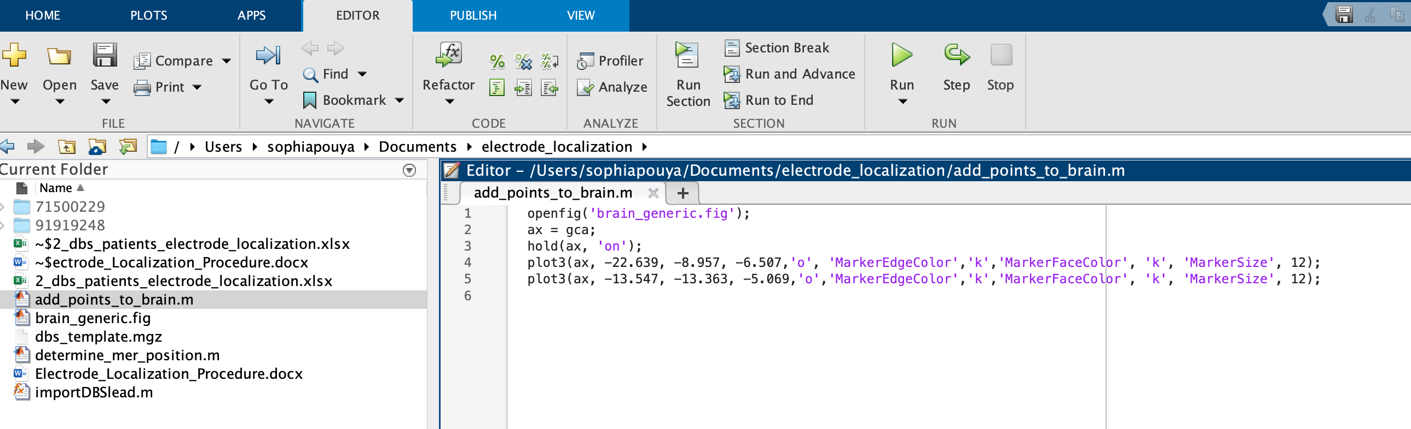
- Upon running this script, you should see the microelectrode points as dark circles plotted onto the brain image in the region you expect. You might have to rotate the image a bit to clearer see them. If you can’t see them, the points may not be in the right coordinate space. 