Terbio, Sophia Louisse L.

2ECE-E

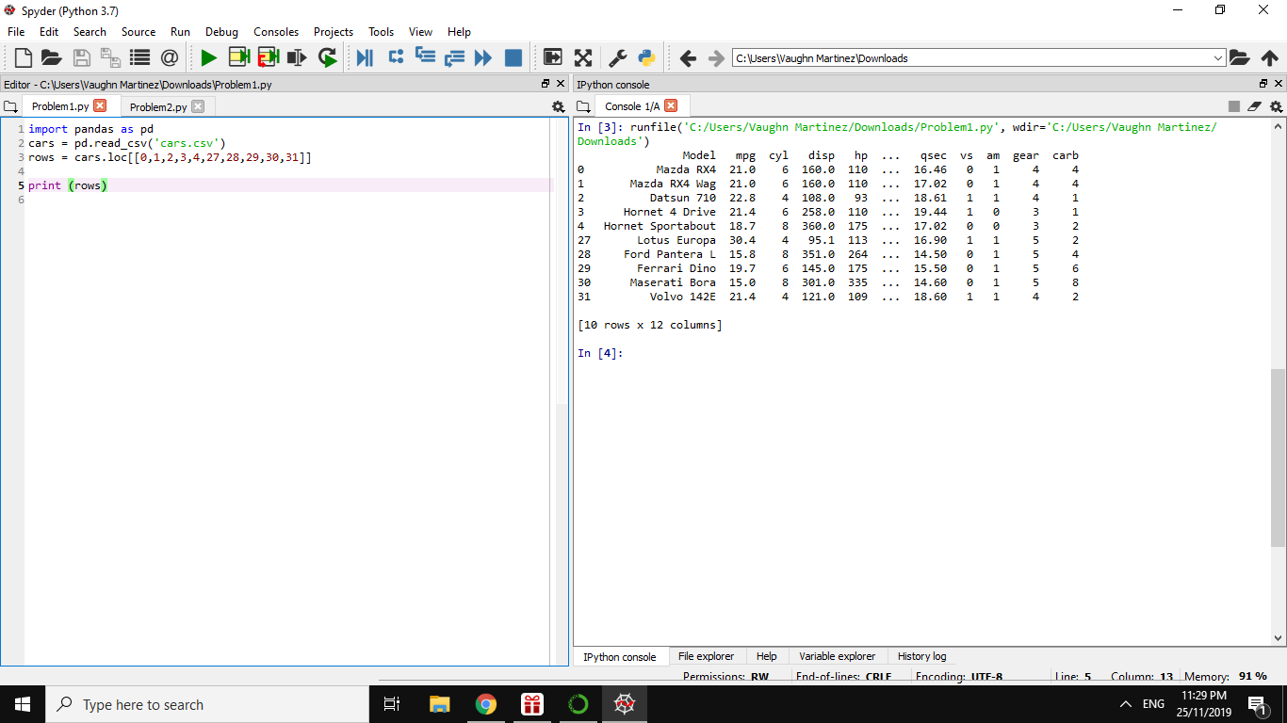

*PROBLEM 1*

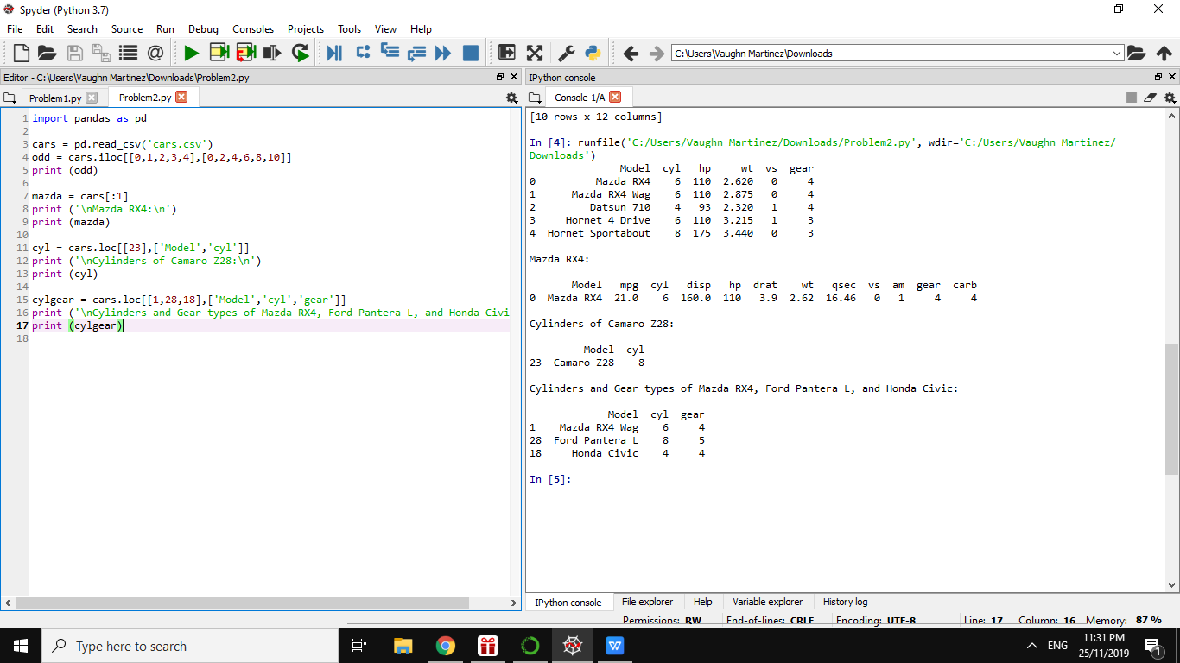

*PROBLEM 2*