Terbio, Sophia Louisse L.

2ECE-E

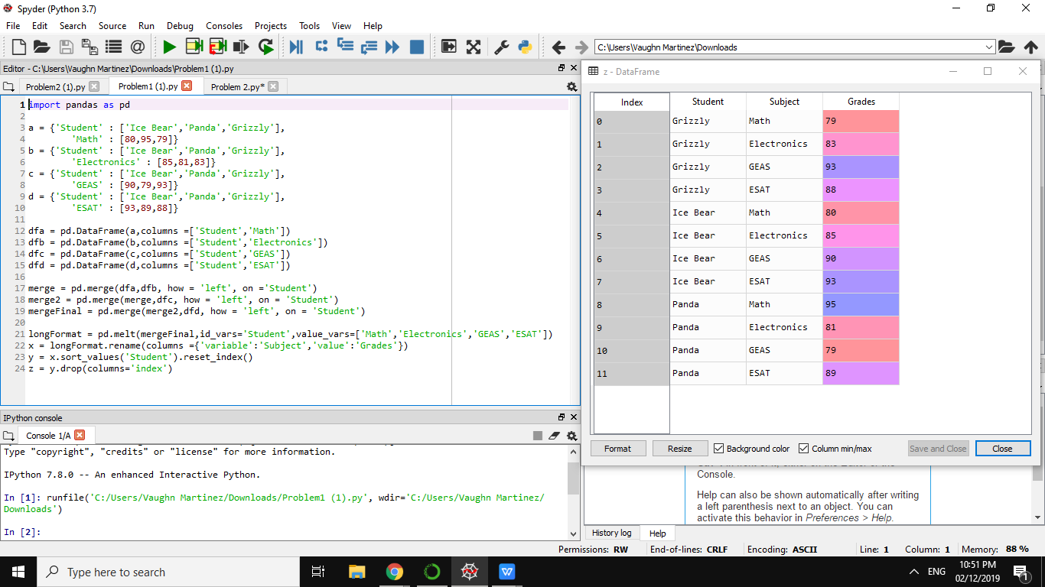

***PROBLEM 1***

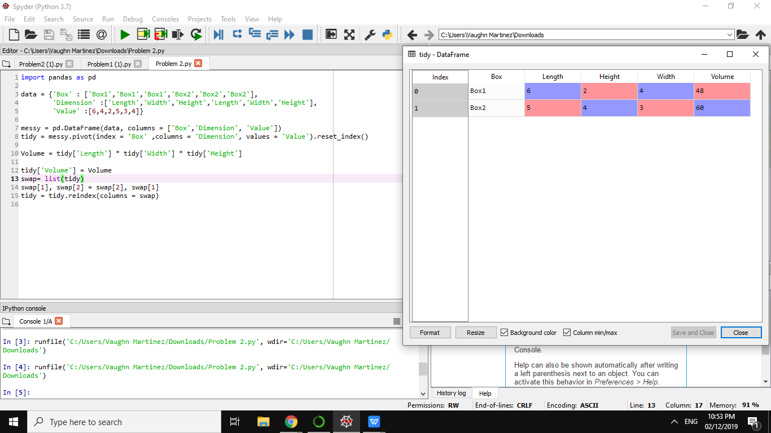

***PROBLEM 2***