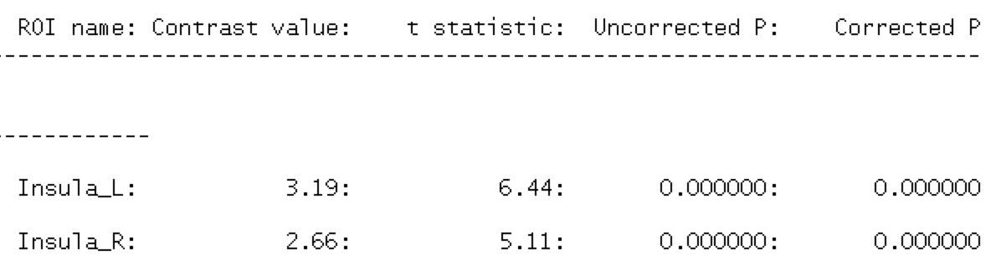
This shows agency > non contrast for the insula on both sides using MARSBaR ROI analysis for subject 1 only.

As a control, we'll check to see if occipital cortex exhibits a significant difference (it shouldn't because both types are equally visual):
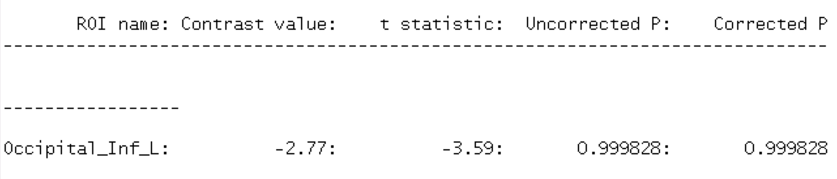
Yay! It works!

