On the origin of citations

Sophia Uddin

September 15, 2015

# Load the data

## Using read.delim

counts_raw=read.delim("data/counts-raw.txt.gz")  
counts_norm=read.delim("data/counts-norm.txt.gz")

# Data exploration

What's the distribution of authors in all articles of our data set?

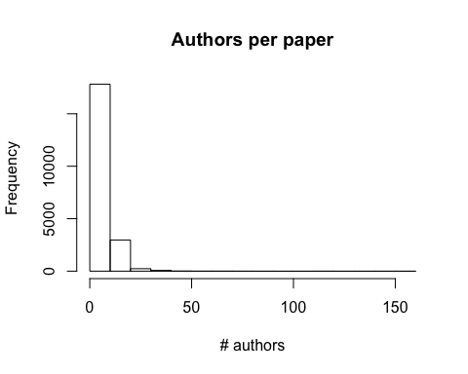

What's the number of facebook shares per article? 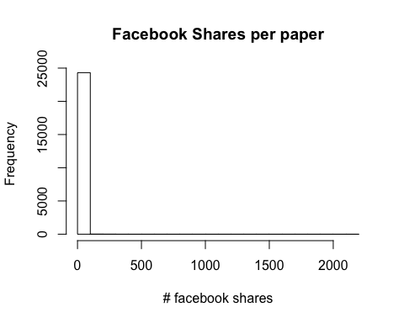

The average number of facebook shares in the data set is 0.6524187