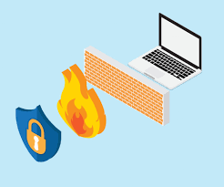

pfSense Setup and Port Forwarding

Sophia Zhang | Period 5 Cybersecurity | 2022-2023



**Purpose:**

The purpose of this lab was to configure pfSense, an open-source firewall, on a laptop.

**Background:**

PFSense is an open-source firewall that you can download for free off the internet. It is installed on either a physical machine or a VM. It ranks #3 in terms of firewalls. PFSense is good because if you have an extra laptop, you can use it as a firewall and so it is very cheap.

In this Lab we used laptops and downloaded PFSense of the web into a USB and used that to configure PFSense into the laptops. It has some issues but still works. PFSense is typically used for DHCP and DNS. For our case we used it for DHCP. We also had to configure port forwarding which is configured using the GUI. We have to change the version of Firefox in order to do it.

Like other Firewalls PF sense has packet inspection, load balancing, among other features that are commonly found on firewalls. PF sense is a software and can be used as either a firewall or a router. PF sense comes with built in intrusion detection and packet inspection, so it is better than normal routers in that regard. PF sense was made by Rubicon Communications. The project started in 2004 under a different name. That name was m0n0wall project lead by Chris Bueller and Scot Ullrich. This was launched late 2006. The name comes from being a packet filtering tool.

PF sense can be installed on a 64 processor. It can act as a VPN by using IPsec or PPTP, it also acts as a stateful firewall. In 2021 it got an added Wire guard feature. PFSense itself is based on FreeBSD. What we used is the community addition there is also a plus and a pro edition. The OS family is FreeBSD.

**Lab Procedure:**

1. Click on “pfSense-CE-2.6.0-RELEASE-amd64.iso.gz in downloads.

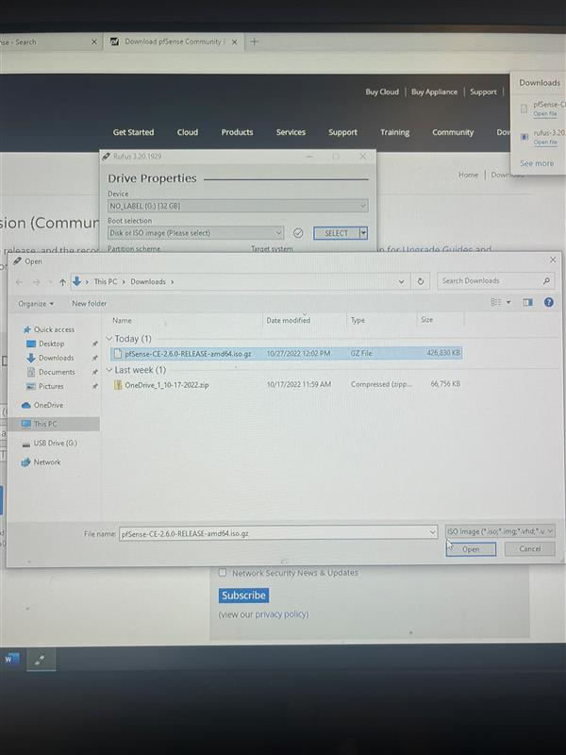

1. Install pfSense by selecting “Install pfSense”

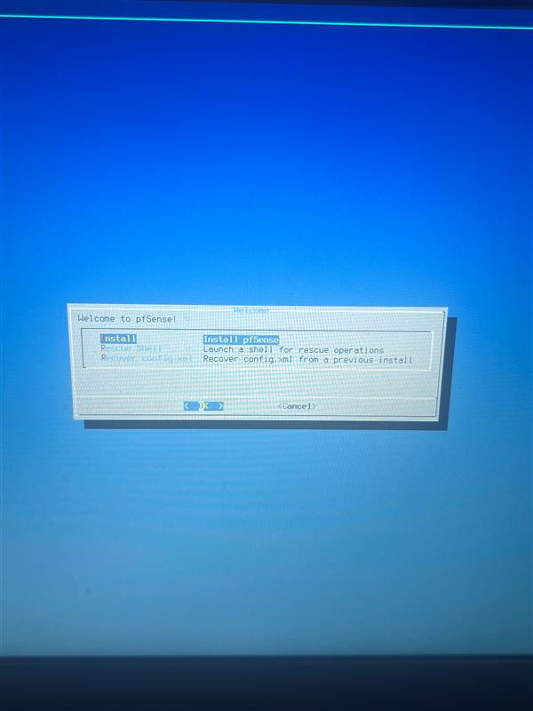

1. Select “continue with default laptop”

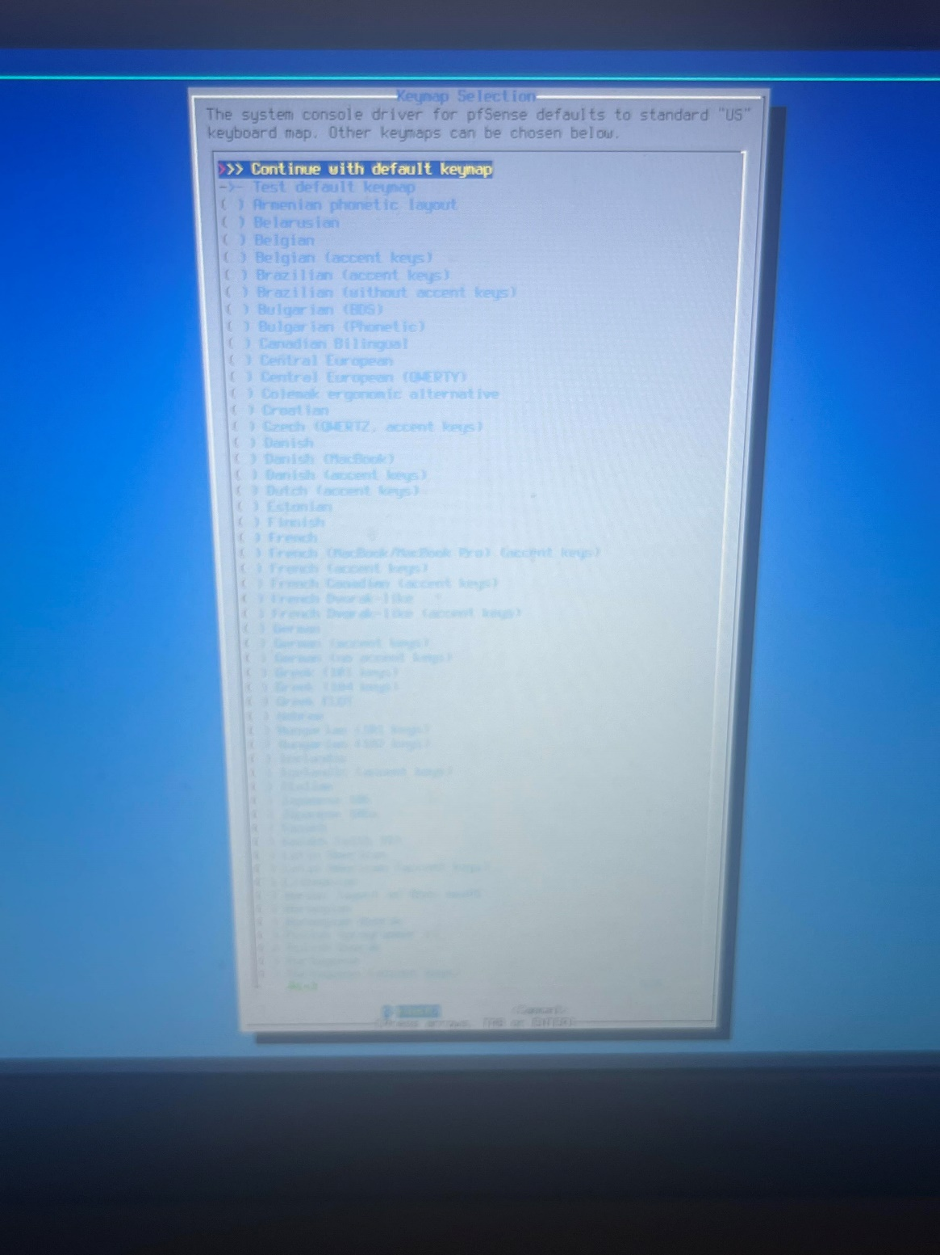

1. Make sure that the correct wires are plugged in:

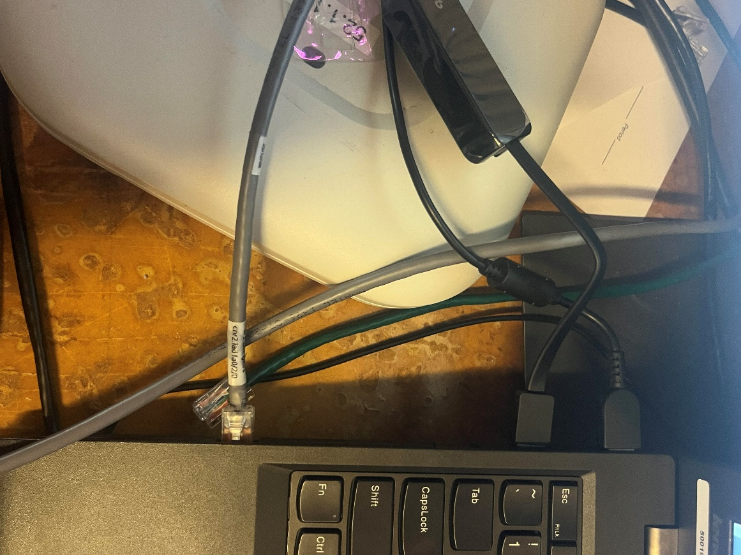

1. When asked “how would you like to partition your disk?”, select “Guided disk setup using UEFI boot method”

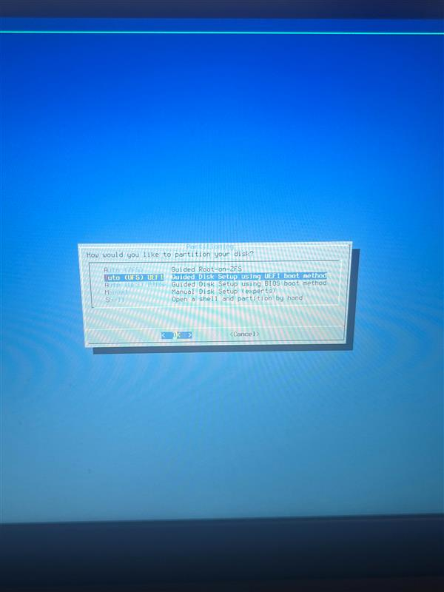

1. This screen should show:

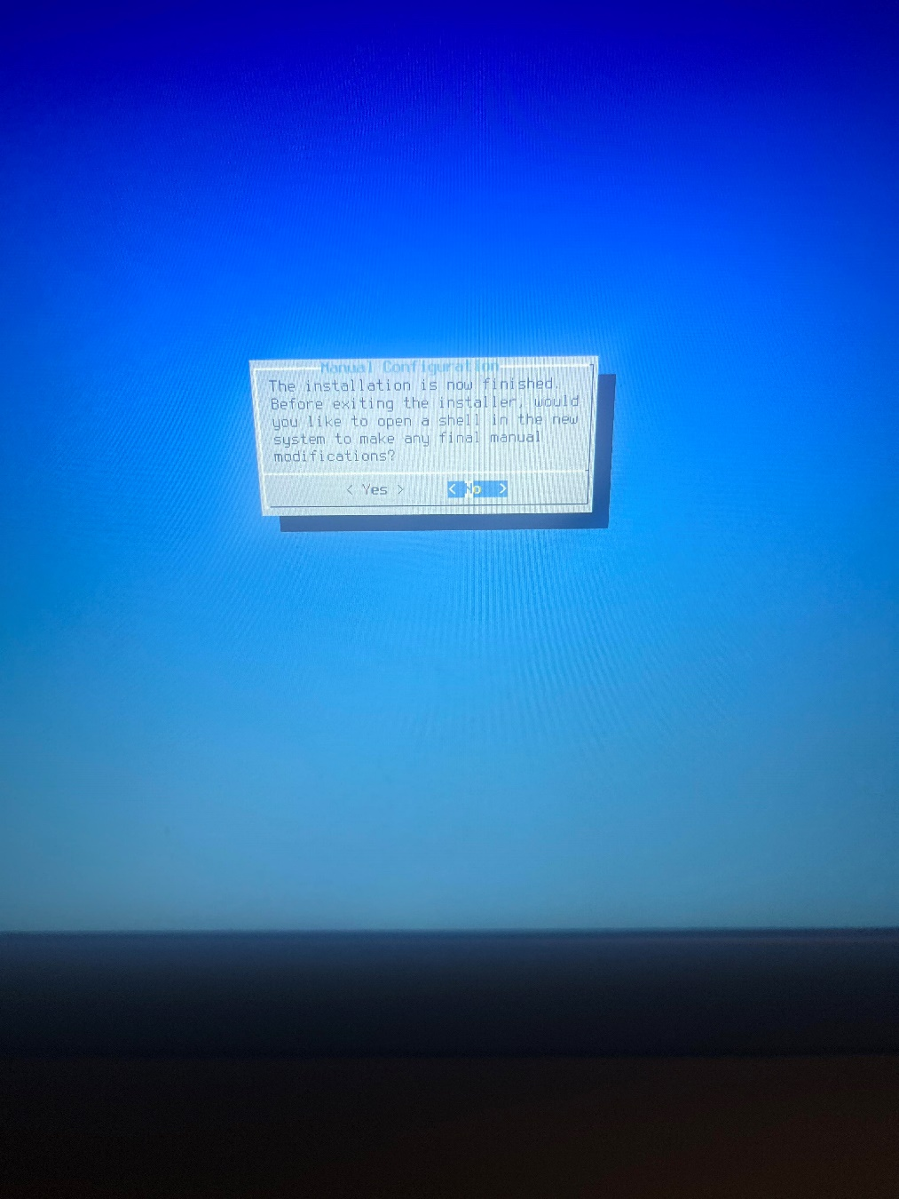

1. Reboot into the installed system:

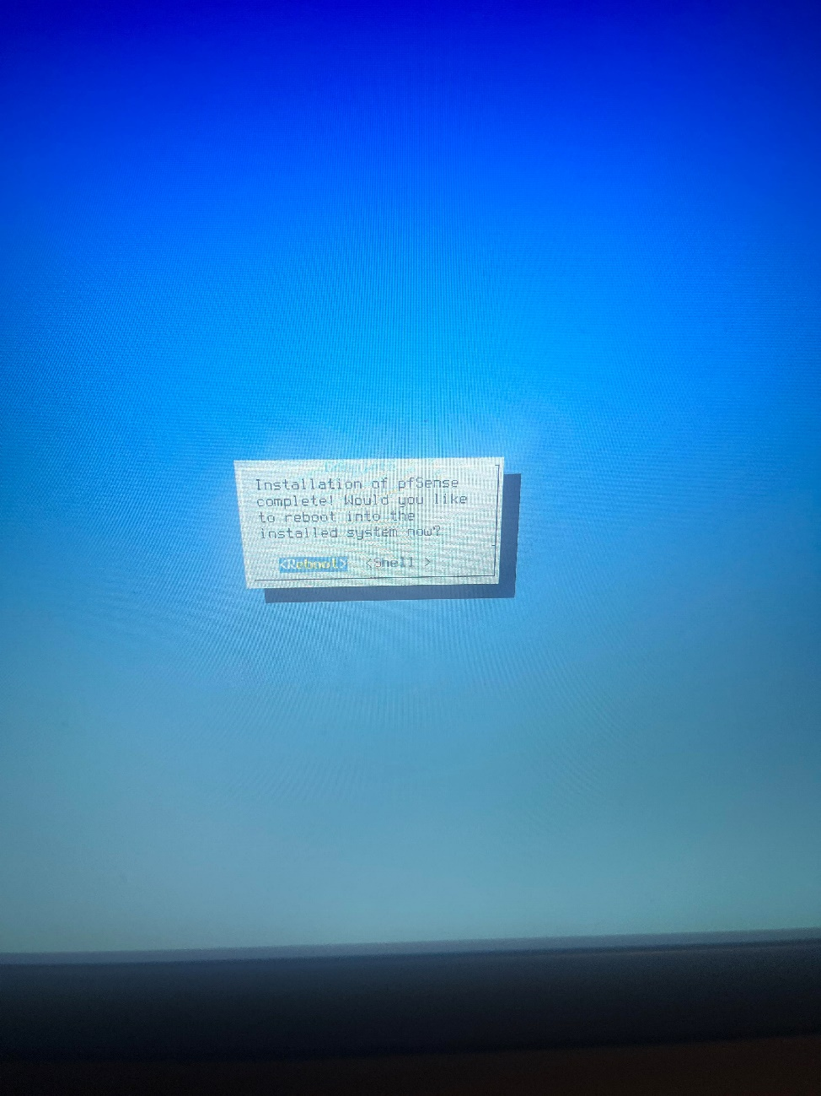

1. connect ue0 to LAN and em0 to WAN

should VLANs be set up?  
n

enter WAN interface name  
em0

enter LAN interface name   
ue0

assign interfaces:   
WAN as DHCP client  
LAN as DHCP server

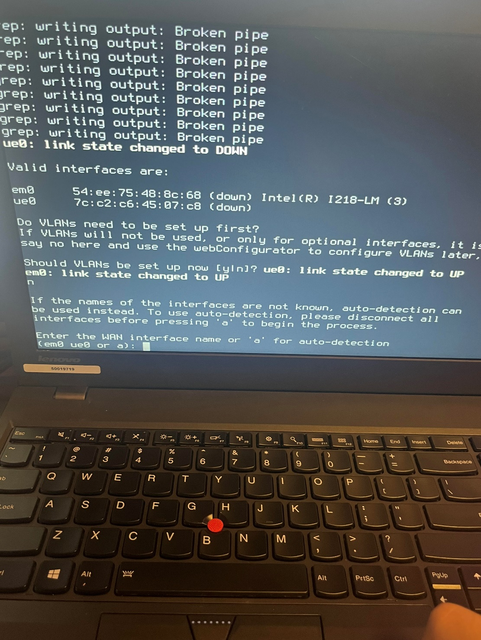

1. This screen should show:

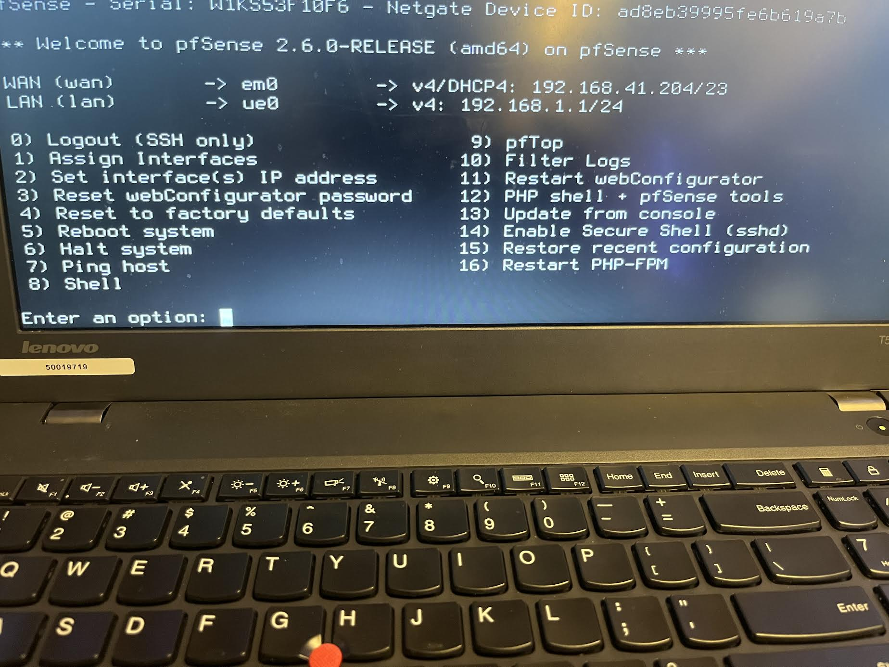

1. Go to firefox, and type in 192.168.1.1 into the search bar. The following screen should show. Enter your username and password:

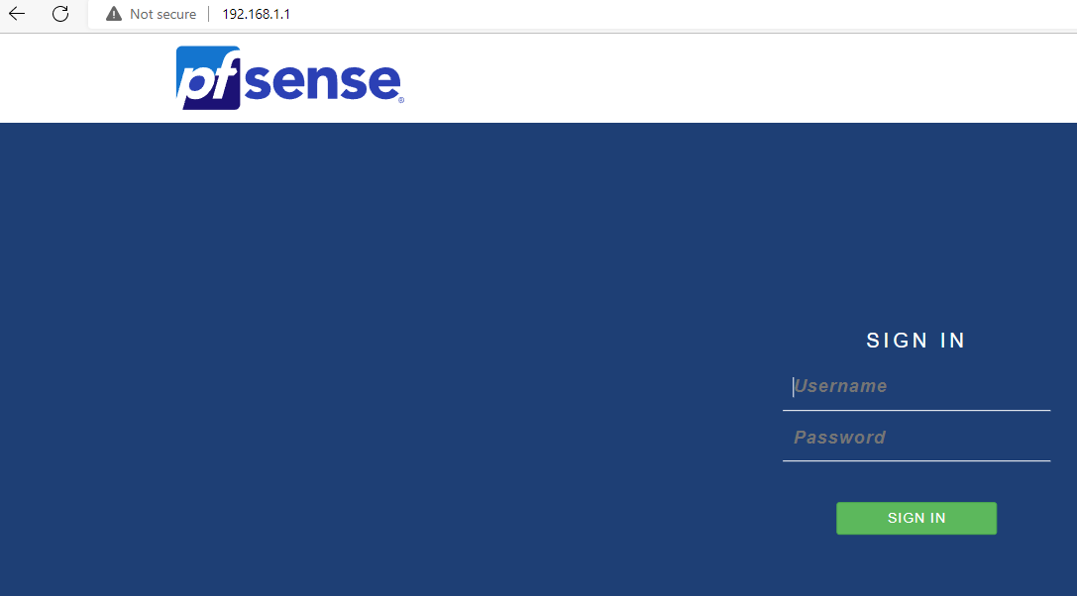

1. Go to Firewall, and select “NAT”

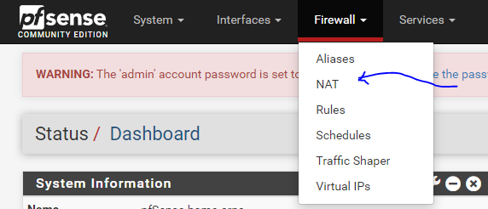

1. Configure as shown below:

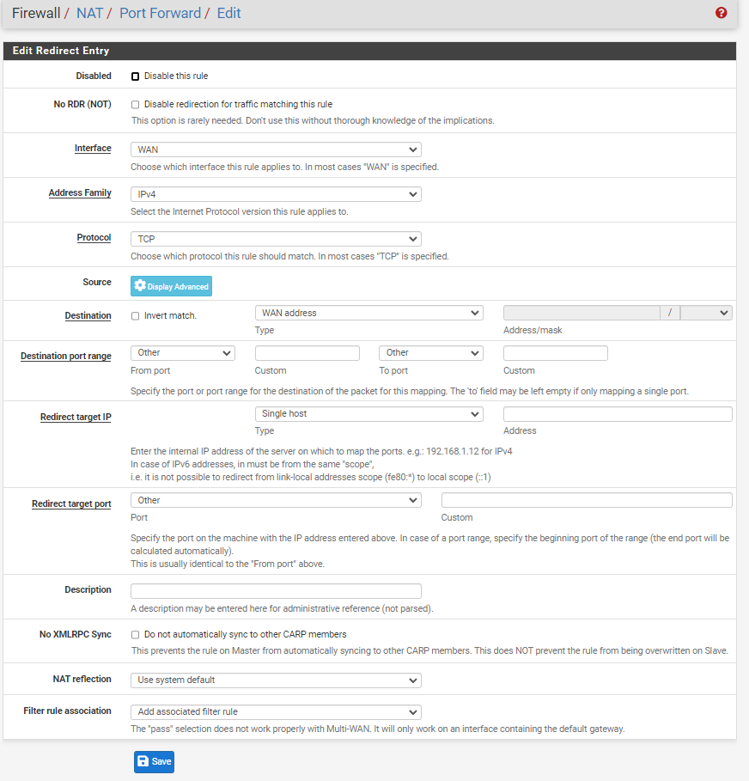

1. Enter the IP address:

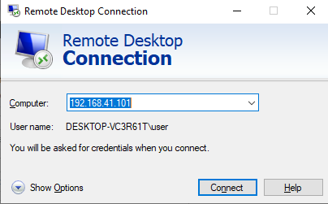

**Problems:**

The main issue that we faced was our computer repeatedly crashed. After completing all the configurations, we were left to restarting all our configurations again as a result of the crashes. After multiple times, we restarted the entire lab again on a brand new laptop.

Also, during the allotted time during class to complete this lab, both my partner and I were sick at home, resulting in the delay of the submission of the lab and the write-up.

**Conclusion:**

In this lab, we configured pfSense on a laptop.