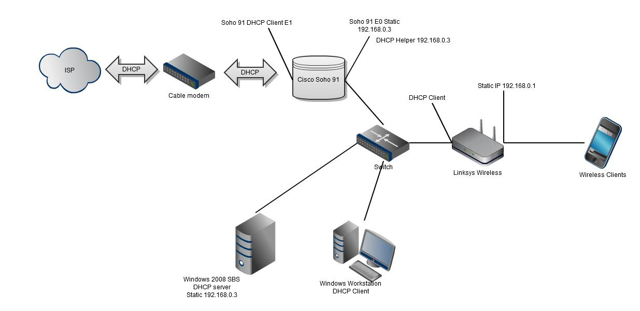

SOHO Network Configuration Lab Writeup

Sophia Zhang | Period 5 Cybersecurity | 2022-2023



**Purpose:**

The purpose of this lab was to configure a SOHO network and to connect to the internet via firewall.

**Background:**

A SOHO network is a single or small office/home office network. A SOHO network is used by small, privately-owned businesses that need to access internet for their work. Because the businesses are mostly on the internet, SOHO networks are also small LANs (local area networks). SOHO networks usually have less than 10 computers. Usually, businesses need printers and VoIP and fax over IP technology, so SOHO networks typically include those aspects.

SOHO networks can be a small wired Ethernet LAN, or made of both wired and wireless computers. Other network service servers such as DNS server, email server, and web server etc. are usually configured outside of the SOHO network. SOHO routers connect to internet via wired Ethernet.

A SOHO network will contain a router, specifically a broadband router. They also very commonly have a switch built into them with four interfaces. In a SOHO network, there usually is not much to configure. The network address translation between WAN ports and LAN ports, and network address translation is all configured automatically.

**Lab Procedure:**

1. Connect a UTP cable from your computer to the Palo Alto firewall’s management port
2. Configure the computer’s ethernet port to have the IP address 192.168.1.2 and the netmask 255.255.255.0.
3. Open Firefox and go to the website <https://192.168.1.1>. The default login information is username: admin; password: admin;
4. To create security zones, go to Network 🡪 Zones and click “add”. Create 3 zones: Untrust-L3, Type Layer3; Trust-L2, Type Layer3; Trust-L2, Type Layer2; Below is the Untrust-L3, Type Layer3 configuration

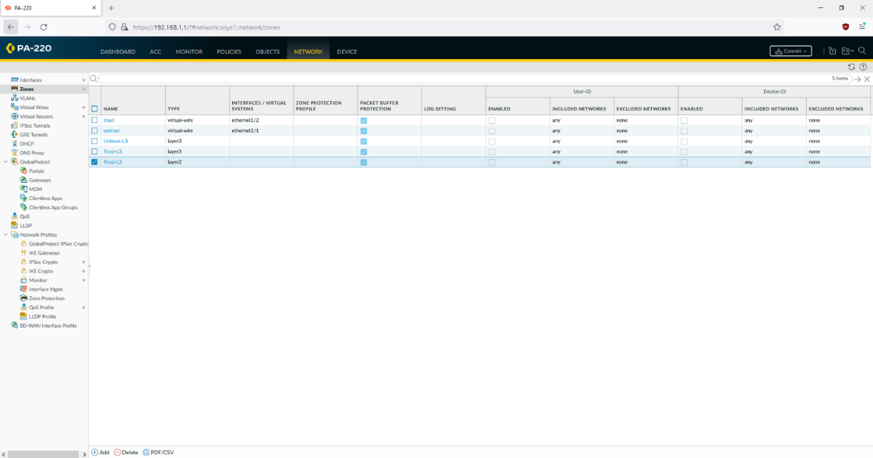

1. Connect a UTP cable from the ISP modem to port ethernet 1/1 on the firewall
2. Go to config 🡪 Interfaces on the web GUI and configure ethernet 1/1
3. On Config, configure the ethernet 1/1 interface type as Layer 3; set the virtual router to default; set security zone to Untrust-L3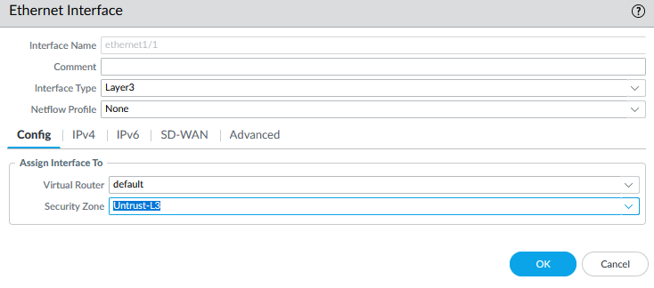
4. Under IPv4, set the type of interface ethernet 1/1 as DHCP Client.

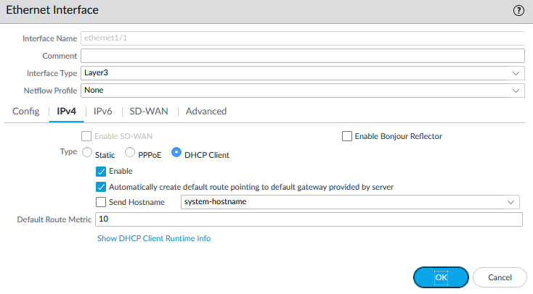

1. Add the static IP address/netmask
2. Go to Network 🡪 virtual routers 🡪 default 🡪 static routes 🡪 IPv4, and add a static route pointing to the ISP’s next hop
3. To create a VLAN object, go to Network 🡪 VLANs and click “Add”. Enter a name and select “v” for VLAN Interface
4. To configure the Layer2 Ports and VLAN object, go to network 🡪 interfaces 🡪 ethernet. Edit the settings for ethernet1/2 interface:

Interface type: Layer2

Netflow Profile: None

VLAN: VLAN object

Security Zone: Trust-L2

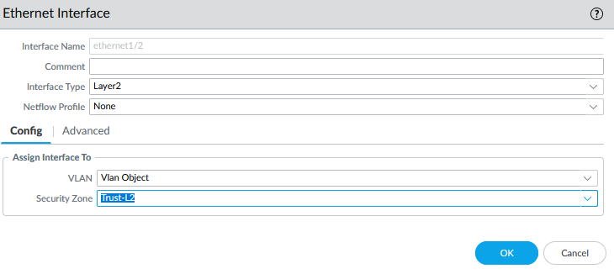

1. Repeat for ethernet 1/3 and ethernet 1/4 interfaces.
2. To configure the VLAN interface, go to network 🡪 interfaces 🡪 VLAN and edit the following things in the Config Tab:

VLAN: VLAN object

Virtual Router: default

Security Zone: Trust-L3

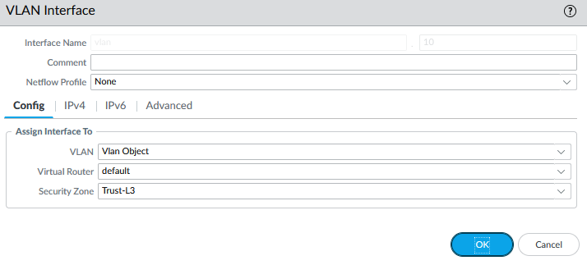

1. In the IPv4 tab, click “add” and enter IP address 192.168.1.254/24:

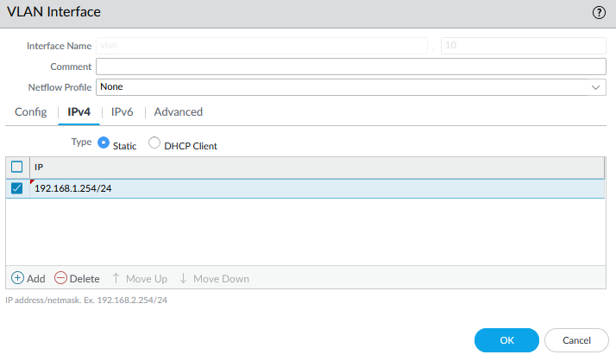

1. To configure the DHCP server, go to Network 🡪 DHCP 🡪 DHCP Server and click “add”
2. Edit the DHCP server settings as shown.

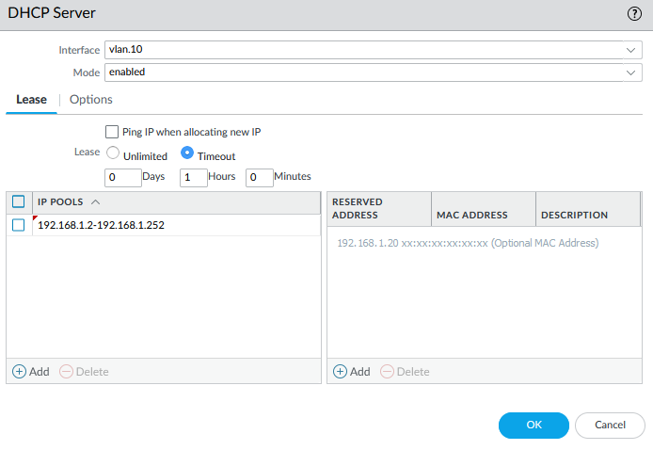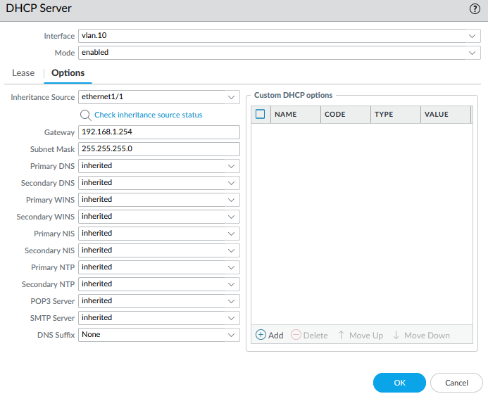

1. To define a security profile group, go to Objects 🡪 security profile groups and click “add”
2. Edit the following Security Profile Group settings

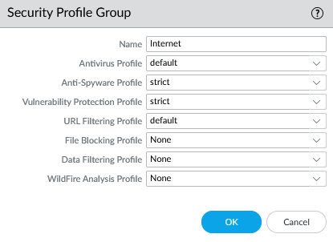

1. To configure Outbound Internet Security Policy, go to Policies 🡪 Security, and click “add”
2. Enter a name and Description:

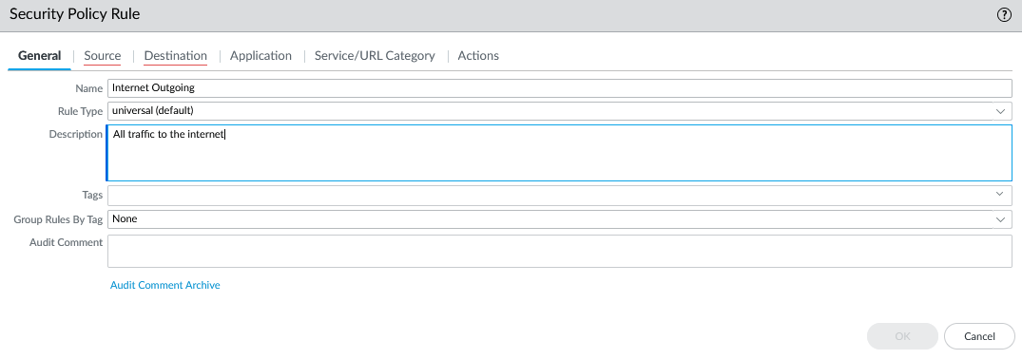

1. Add the source zone:

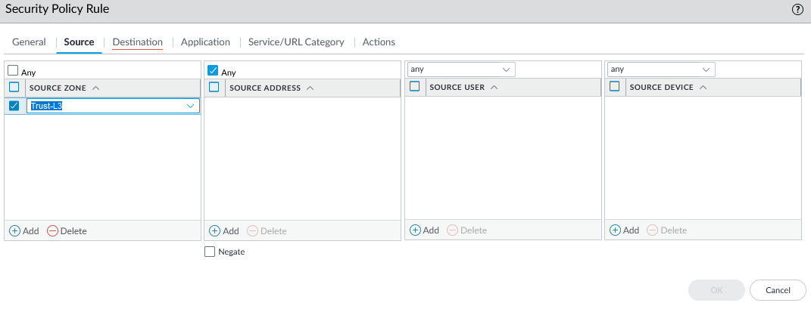

1. Add the destination zone:

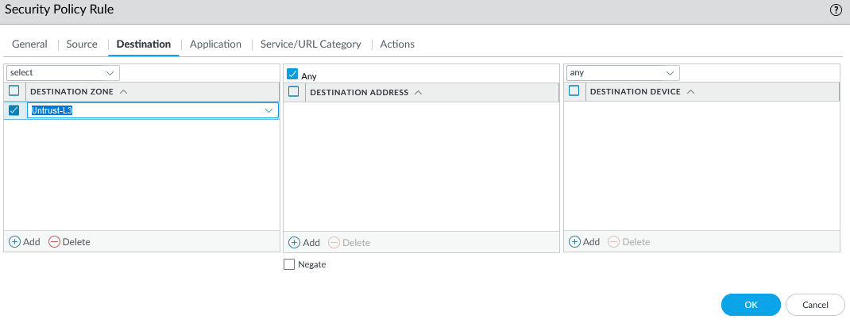

1. Specify the action as Allow and complete the Profile Setting:

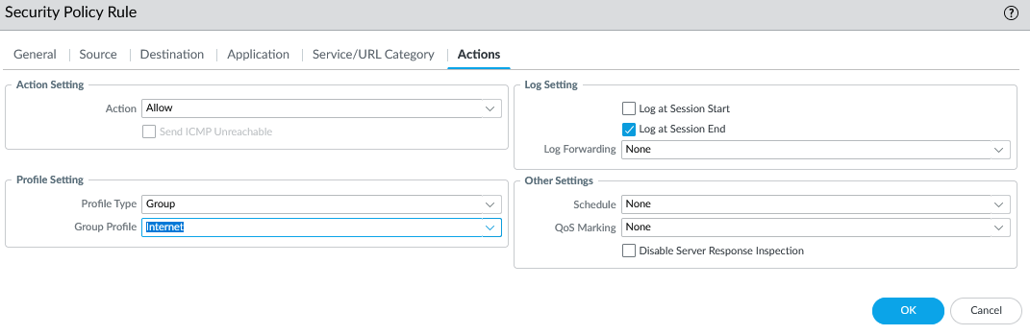

1. To configure Outbound Internet NAT policy, go to Policies 🡪 NAT and click “add”
2. Enter a name and check IPv4 for NAT type

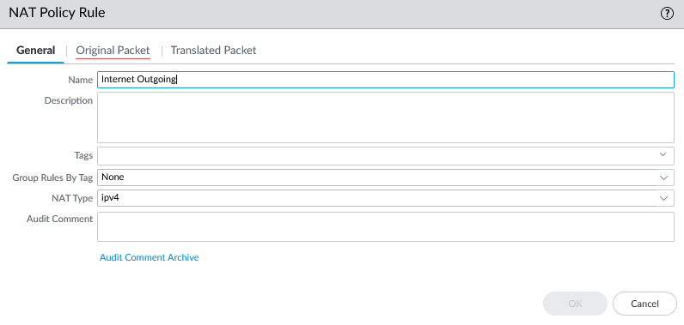

1. On Original Packet, specify the Source Zone, Destination Zone, and Destination Interface



1. On Translated Packet, set:

Translation type: dynamic IP and port

Address type: Interface Address

Interface: ethernet 1/1

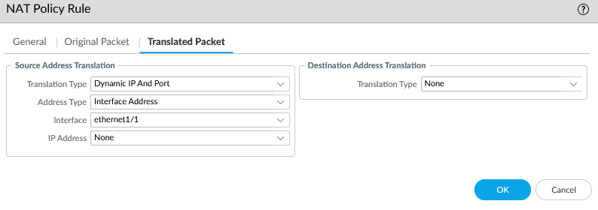

1. To configure the MGMT IP, go to device 🡪 setup🡪management and specify the following management interface settings:

IP address

Netmask

Default Gateway

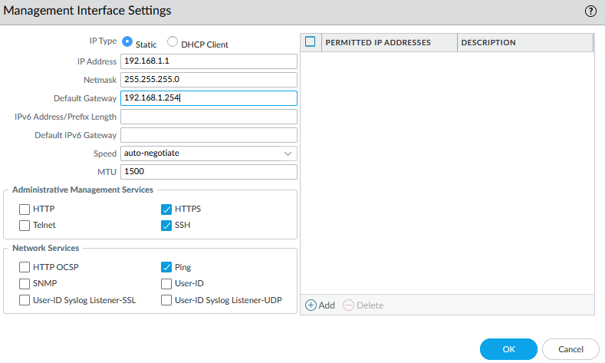

1. To set DNS for MGMT, go to device 🡪 setup 🡪 Services and enter the DNS server IPs:

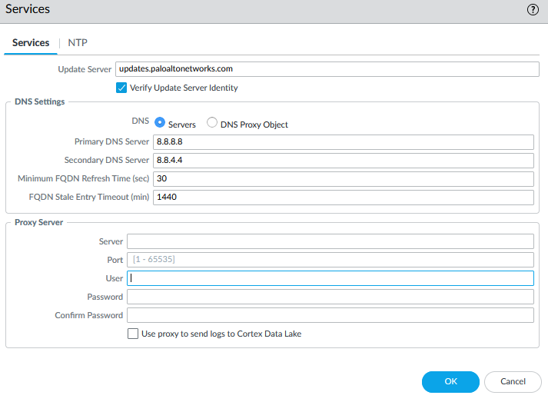

1. Commit the changes. If the commit is unsuccessful, troubleshoot and try again.

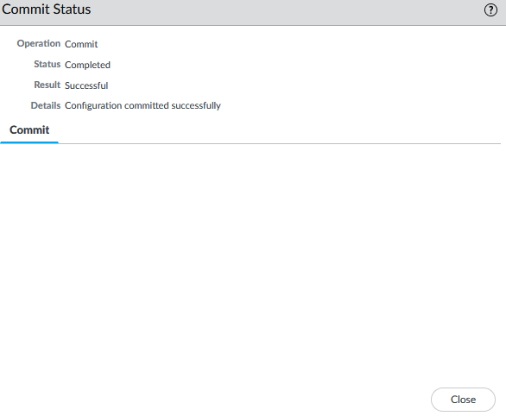

**Problems:**

We had multiple problems throughout this lab, but the most significant one was that we were not able to connect to the internet via ethernet. Our internet was successful on one day, but the next day it was broken. Another time, we had internet, but could not jumper, meaning that we were not able to connect to the firewall without going directly through the management port. After figuring out how to jumper, there was no internet. With each of these issues, we had to go back through the lab procedure, through each step. This was time consuming and tedious, but eventually led us to the solution.

**Conclusion**

In this lab, we configured a SOHO network, connecting to internet through ethernet on the firewall.