Oil Prices Visualizations

Kamau Kamau

29/03/2021

|  |  |  |  |  |  |  |  |  |
| --- | --- | --- | --- | --- | --- | --- | --- | --- |
| .; | Date | Price Per Barell | Exrates | PMS | AGO | Kero | Average | ppb_ken |
| 0 | 2010-01-14 | 89.15 | 80.56800 | 94.03 | 87.45 | 75.83 | 85.77000 | 45.17666 |
| 1 | 2011-01-14 | 89.17 | 81.02907 | 95.67 | 88.71 | 77.51 | 87.29667 | 45.44539 |
| 2 | 2011-02-14 | 88.58 | 81.47340 | 98.08 | 91.72 | 79.52 | 89.77333 | 45.39225 |
| 3 | 2011-03-14 | 102.86 | 84.20551 | 102.44 | 94.53 | 83.97 | 93.64667 | 54.47751 |
| 4 | 2011-04-14 | 109.53 | 83.88982 | 111.17 | 107.52 | 90.91 | 103.20000 | 57.79264 |
| 5 | 2011-05-14 | 100.90 | 85.43301 | 115.35 | 108.02 | 92.61 | 105.32667 | 54.21845 |

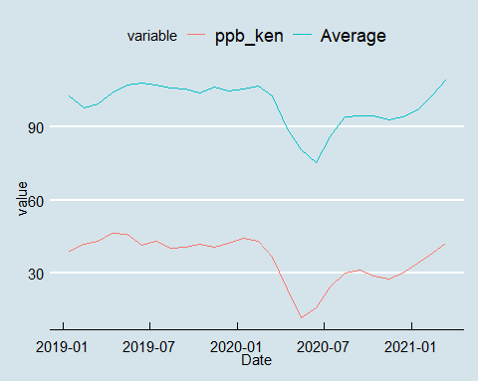

# percentage change

