Modeling Life Expectancy and Country Development Indicators

Abstract
This project is geared towards providing an understanding of how different development indicators, particularly BMI, immunization rates, and schooling and GDP, contribute to a country’s life expectancy and development status. Various methods, such as visualization plots (bar, histogram, line, scatter), statistical tests (t-test, correlation test), and machine learning models (linear, generalized linear, random forest, support vector machine) were applied to these ends. By applying these methods, insights into possible targets for further development initiatives could be developed through different correlations, trends, and impacts on life expectancy and development status:
- While an overall increase in life expectancy across development statuses has occurred, there is still a significant difference between developed and developing countries.
- Africa as a region, while improving, has displayed the lowest life expectancy and BMI, displaying the consistent inequities in the region.
- BMI has increased across all regions.
- Adult mortality and infant death rates have decreased in both developed and developing countries.
- Working on immunization rates, childhood nutrition, infant death rates, and schooling levels can make progress towards increasing life expectancy and improving development.
- While GDP per capita has a positive correlation with life expectancy, it is not enough of an indicator to be the only factor.

Introduction
As we move into 2025, a decade has passed since the evaluation of the United Nation’s Millenium Development Goals, which were set to be completed between the years of 2000 to 2015. These goals included topics that were intended to increase the development index of countries worldwide, such as eliminating poverty, increasing educational rates, promoting gender equality and maternal and neonatal health, and eradicating epidemic diseases like malaria and HIV (MDG Monitor, n.d.). Following this incredible progress, the Sustainable Development Goals were adopted, which hopes to leverage and continue the work done with the MDGs to accomplish additional goals such as providing clean water and sanitation, combat climate change, and ensure clean energy (Nations, n.d.)
To achieve these goals, it is essential to understand the data collected in the past to establish trends and relations between different development markers as they relate to each other and overall success. Therefore, this project is geared towards providing an understanding of how different development indicators, particularly BMI, immunization rates, and schooling and GDP, contribute to a country’s life expectancy and development status.
First, an understanding of the dataset is necessary, as there are various development indicators with highly specific definitions and various measurements and aggregations. A statistical summary of these factors was performed to note distribution trends and potential correlations and outliers. Visualization plots were developed to break down distribution and analyze changes in life expectancy by region and development status, BMI frequency by region, and correlation between adult mortality and infant death rates. Each chart was provided with a form of comparison over time. Next, two statistical tests were performed: a t-test to check significance of differences in life expectancy by country status, and a correlation test to show density plots, scatter plots, and correlation coefficients between adult mortality, alcohol consumption, HIV incidents, GDP per capita, and life expectancy. Finally, with this information gathered, four different machine learning models were developed: a linear regression model and random forest model to predict life expectancy, and both a generalized linear model and support vector machine (with polynomial kernel) model to predict development status.

Description of Dataset
The dataset used in this project, entitled “Life Expectancy WHO (Fixed)”, was sourced from Kaggle, whose landing page states that the information was collected from World Health Organization, World Bank Data, Our World in Data, and United Nations reports and websites. This dataset provides development indicators for a total of 179 countries from the years of 2000 to 2015, as well as classification into status (developed or developing) and region (nine divisions). Further information on the factors is provided in Table 1.
There are various choices made in this dataset that are worth noting. For missing values, the creator of the dataset, rather than leaving it empty, provided a value either matching the closest three-year average for the country, or with the region’s average. Any countries missing more than four datapoints were not included. Additionally, countries can classify themselves as either developed or developing, and while the UN has reference sources, classifications can vary.
Indicator and Unit | WHO Definition and Notes
Life Expectancy at Birth (years) | Average number of years a newborn can expect to live for a specific year in a specific area; Value for both sexes provided here, though can be disaggregated by sex
Adult Mortality (per 1000 in population) | Probability that a 15-year-old person will die before reaching their 60th birthday; Value for both sexes provided here, though can be disaggregated by sex
Infant deaths (per 1000 live births) | Number of deaths among children under 1-year old per 1000 live births in population; Cumulative value provided here, though can be disaggregated by age and cause of death
Under five deaths (per 1000) | Number of deaths among children under 5-years old per 1000 in population; Cumulative value, through can be disaggregated by age and cause of death
Alcohol consumption (liters) | Recorded amount of alcohol (liters) consumed per capita for everyone over 15 years old per calendar year per country
Hepatitis B coverage (%) | Percentage of 1-year olds who have received 3 doses of Hepatitis B vaccine per year
Measles coverage (%) | Percentage of children under one year old who have received at least one dose of measles vaccine per year; Age adjusted based on country recommendations; CDC recommendations are 2 doses (1 @ 12-15 months, 1 @ 4-6 years)
Body Mass Index (kg/m²) | WHO recommends 18.5 – 24.9 as normal; Best use for adults, as calculated with z-scores for children
Polio coverage (%) | Percentage of one-year olds who have received three doses of polio vaccine per year; CDC recommends 4 doses (3 by 18 months, 4th @ 4-6 years old)
Diphtheria coverage (%) | Percentage of one-year olds who have received three doses of combined diphtheria/tetanus/pertussis vaccine per year; CDC recommends 5 doses (4 by 18 months, 1 by 6 years)
HIV incidents (per 1000) | Measured in uninfected population aged 15 - 49
Gross Domestic Product per capita ($USD) | Measured as GDP divided by midyear population
Population (millions) | Midyear estimates regardless of citizenship
Prevalence of thinness in teens 10-19 y/o (% of population) | Measured as BMI less than 2 standard deviations below median; Value combined for sexes
Prevalence of thinness in children 5-9 y/o (% of population) | Measured as BMI less than 2 standard deviations below median; Value combined for sexes
Schooling (yrs) | Average years adults 25+ spent in formal education
Table 1: Definitions and Notes on Development Indicators Tracked in Project Dataset. All definitions directly sourced from World Health Organization and Centers for Disease Control.

Statistical Summary
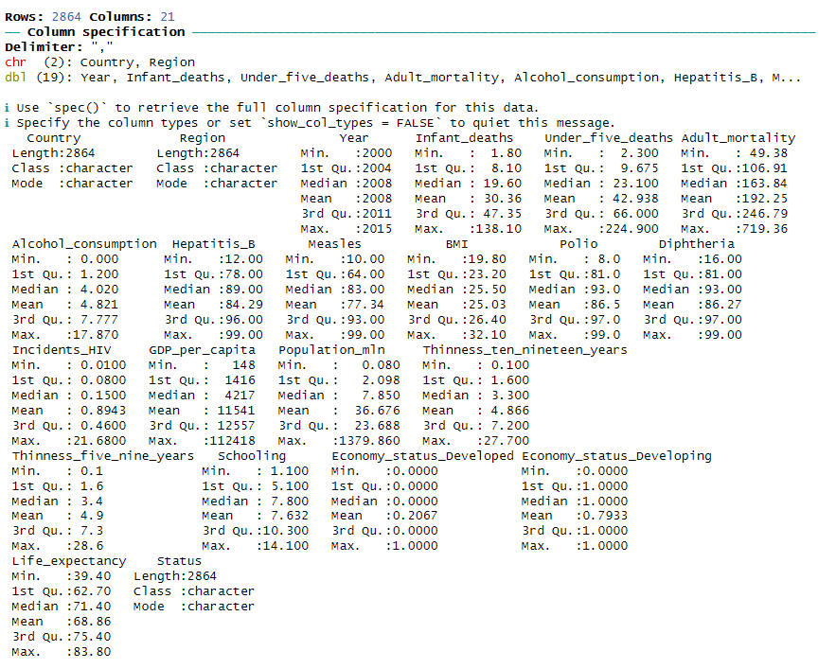
Image 1: Statistical Summary of Life Expectancy Dataset, generated in R-Studio by Student Researcher
The above image displays the five number summaries and mean for each numerical value in the dataset.
Mortality and burden of disease: Infant deaths, under five deaths, and adult mortality
All three mortality and burden of disease indicators have what appears to be quite large ranges, which are all unimodal and right-skewed. This pattern could show significant differences either over time, between regions, or both.
Alcohol consumption
Alcohol consumption as an indicator displays a unimodal and right-skewed distribution. It is possible that the minimum serves as an outlier or issue with measurement, as when looking at the definition, it is likely that much of the alcohol consumption for people under the country’s legal drinking age is going unreported or underreported. Additionally, the correlation with country status could go either way: higher alcohol rates could indicate a lax and affluent society, or poverty and lack of resources.
Disease: Measles, Hepatitis B, Polio, Diphtheria, HIV
It must be noted again that HIV here is measured by incidents, while the other indicators are measured by immunization rates. Here, the factors measured by immunization rates have an upward bound of 100%, and maximum values of 99% are the realistic value for reaching full immunization. All indicators of immunization coverage display a left-skewed distribution while HIV incidents skew to the right. Measles, notably, shows a possible bimodal distribution as well. This, as expected, suggests an inverse relationship between strong immunization programs and disease incidence, even if related to a different disease.
Nutrition: BMI, thinness factors
BMI appears to have a unimodal and symmetrical distribution with a smaller range that points to the possibility of a normal distribution. However, this could change when the data is disaggregated and separated by region and development status. Like alcohol, BMI as correlated to country status could go either way, either as a sign of affluence or under-resourced populations. Thinness, in comparison, shows a unimodal and right-skewed distribution for both age groups.
Economic and intellectual: GDP per capita, schooling, economy status
As economy status was given as a series of binary columns, information about the distribution of developed versus developing countries can be found. As the mean is lower for developed countries than developing, it can be inferred that more countries are classified as developing than developed. Checks must be performed to see if status changes throughout the years or remains static. GDP per capita displays a right-skewed and unimodal distribution, suggesting extreme wealth disparity between countries. Schooling shows a fairly normal distribution with few outliers.

Visualization Plots
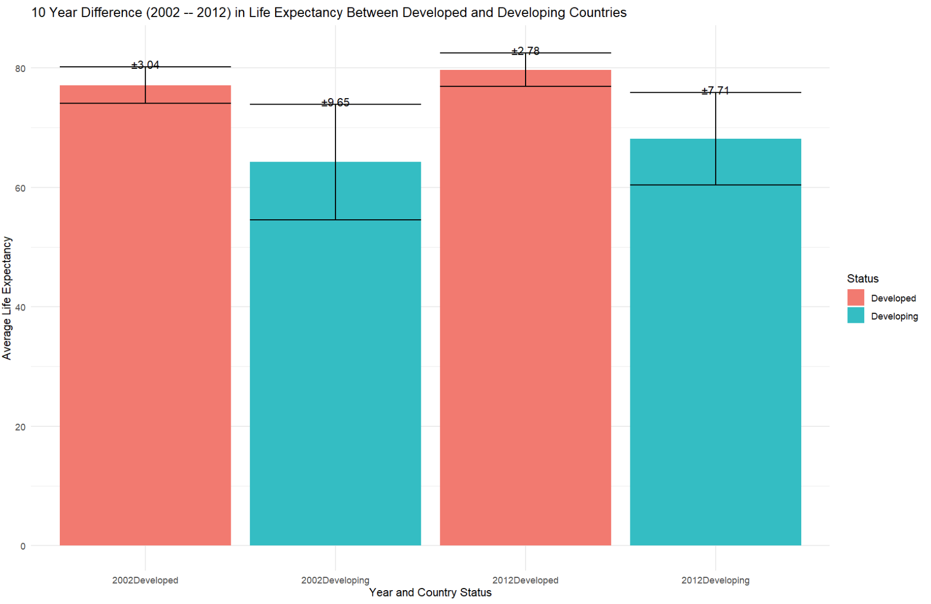
Image 2: 10 Year Difference in Average Life Expectancy Between Developed and Developing Countries, Bar Chart generated in R-Studio by Student Researcher
The above image displays a bar chart generated by dividing the dataset into development status (developed vs developing), then taking the mean life expectancy based on every country in that status group. The results for 2002 and 2012, by development status, were plotted here, to show both the difference in life expectancy by status and the change over time. A significant difference here is shown between statuses, as in both groups, there is little to no overlap between the standard deviations (plus and minus one standard deviation as given by the number on top of the bar is shown by the black horizontal bars). During that ten-year period, life expectancy increased for both status groups, while the standard deviation decreased, showing that health outcomes may be improving more uniformly especially in developing countries. Additionally, developing countries showed a greater net increase than developed countries, which suggests progress in addressing health inequities in these countries, showing the success of initiatives made by the Millenium Development Goals. Despite this progress, developing and developed countries still maintain a significant difference in life expectancy, showing there is further progress to be made.
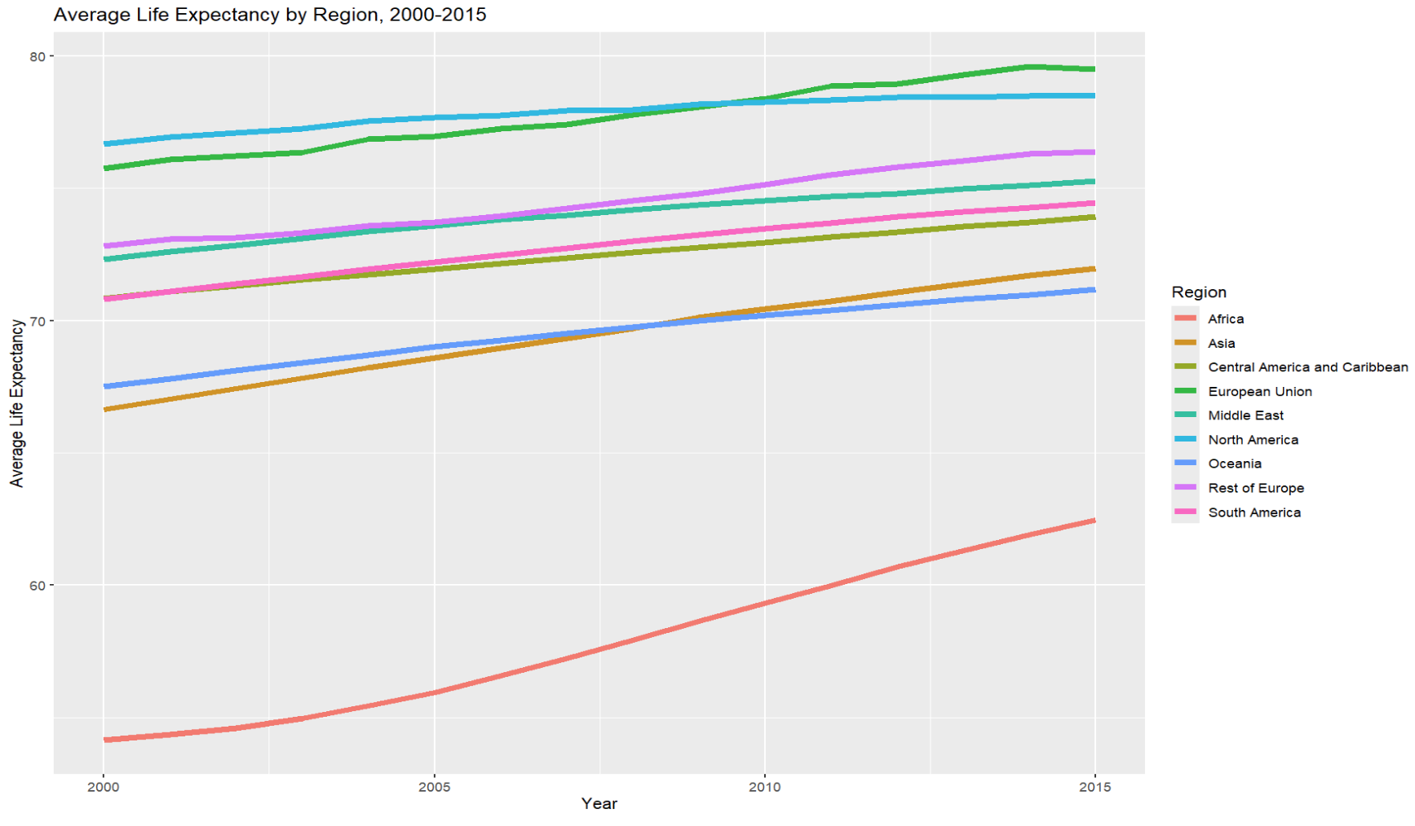
Image 3: Average Life Expectancy by Region 2000-2015, Line Chart generated in R-Studio by Student Researcher
The above line chart shows the average life expectancy for all countries by region for a given year, over the period of 2000 to 2015. This format allows visualization of the change year by year as well as the differences between regions, which differs from the aggregation by development status and the choice of only two years in Image 2. There are various inferences that can be drawn from this visualization. First, it shows that Africa has the lowest life expectancy of all regions for the entire period, highlighting significant challenges in the region and a target for further initiatives. As for the highest, North America begins as displaying the top life expectancy but is overtaken by the European Union by 2015, reflecting the significant reforms in healthcare in Europe over this period. Over time, all regions displayed an increase in life expectancy, but developed regions showed less change, with North America showing the least change as indicated by its flattest slope. This may show two things: first, developed regions are reaching their “limit” on life expectancy, though this may change in future years with significant changes in technology. Second, North America’s drop from the top and slow change might be further explained by research into policy during the period, as well as breakdowns between causes of death and demographic populations.
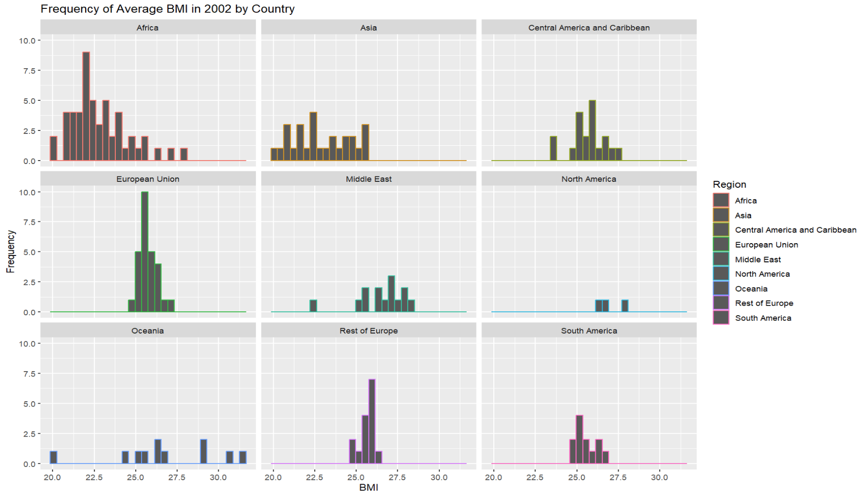
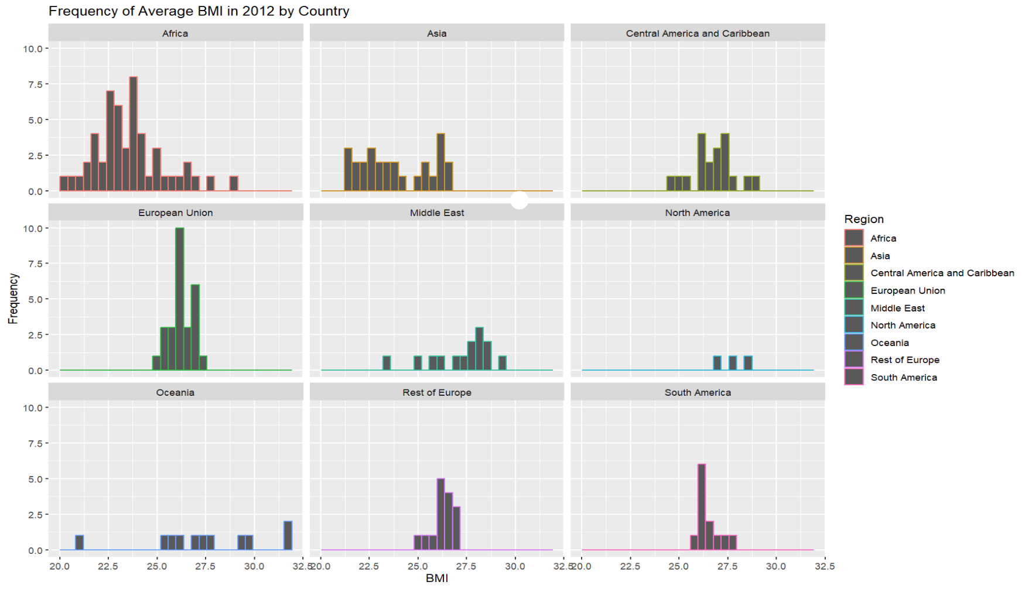
Image 4: Frequency of Average BMI by Country, 2002 and 2012, Disaggregated by Region, Histogram generated in R-Studio by Student Researcher
The above series of images shows the frequency of average BMI by country, disaggregated by region, in both 2002 and 2012. This is important because BMI is a common indicator of nutritional status, which can be linked to both development and life expectancy, and development status can generally pool with region. In both sets of plots, Africa displays the overall lowest BMIs, while Oceania, North America, and the European Union display the highest BMIs. When looking directly at the dataset, Tonga and Samoa are the countries displaying the highest BMIs, which can show that BMI can vary based on ethnicity. Comparing the two plots displays an overall demographic shift towards higher BMIs in all regions. In the future, with reports from more current years, it would be interesting to see if this trend has continued and if the higher weights, associated with obesity and heart disease, cause a downward trend in life expectancy.

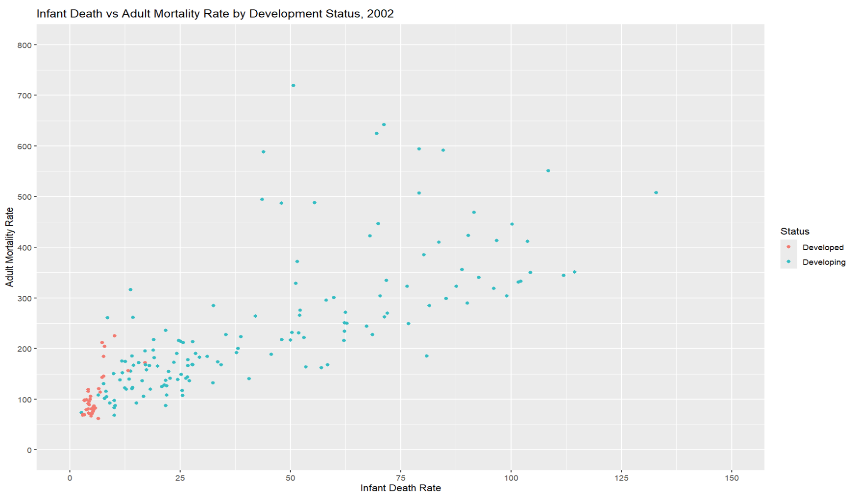
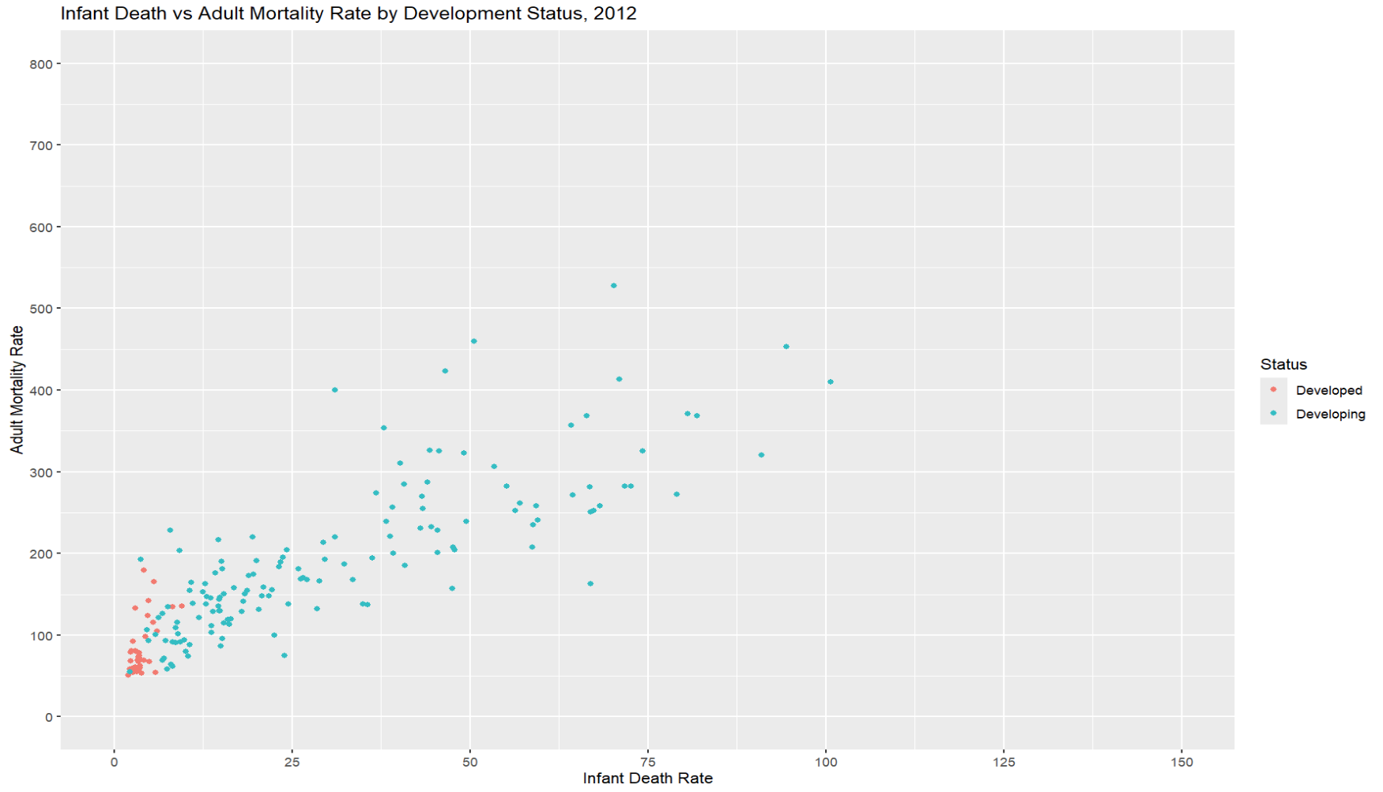
Image 5: Infant Death vs Adult Mortality Rate by Development Status, 2002 and 2012, Scatter Plot generated in R-Studio by Student Researcher
The above images plot infant death rate against adult mortality rate for all countries, in 2002 then in 2012, color-coding by development status. Points clustered closer to the bottom left-hand corner show both low infant death and adult mortality rates, which are, as to be expected, features of developed countries. In comparing the two charts, there are a few noticeable differences: by 2012, there are fewer outliers and the points are clustering closer to the bottom-left hand corner. This cluster, indicating by the developed countries, has also dropped, showing improvements across both statuses. This shows successful endeavors in all regions, though there is still a clear disparity between development statuses.

Statistical Tests
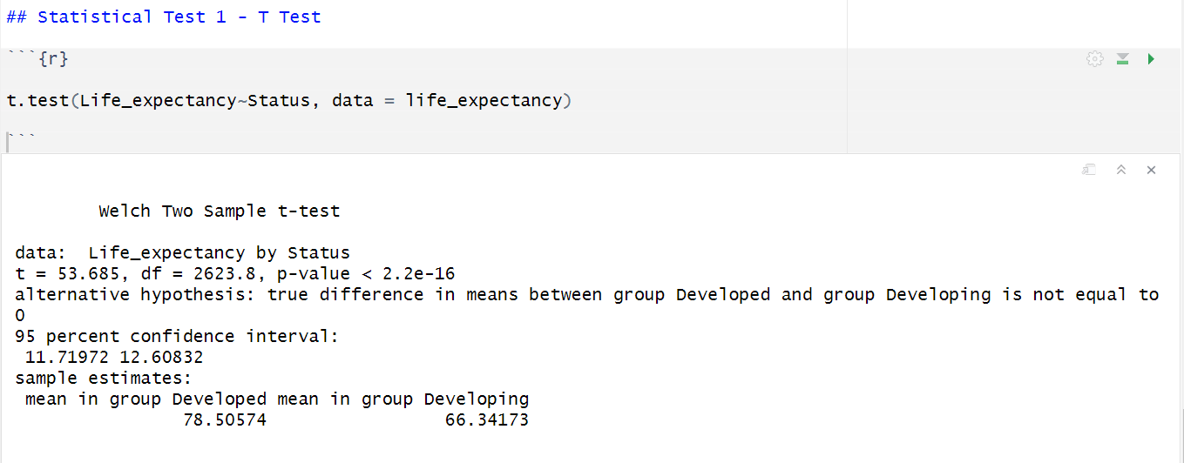
Image 6: T-test Code and Results in R-Studio, performed by Student Researcher
This statistical test is a t-test to determine if there is a statistically significant difference in life expectancy by country status (developed or developing). The null hypothesis would state that there is no difference in life expectancy between each country status. Since the p-value is below the threshold value of 0.05, as it is reported as being less than 2.2e-16, the null hypothesis is rejected and can accept the alternative hypothesis that there is a statistically significant difference in life expectancy between country development status. This shows a profound difference between life expectancy as indicated by development status and the indicators that then contribute to development, such as healthcare systems, lifestyle, educational quality, and nutrition and other basic needs. With 95% confidence, the difference in mean life expectancy by development status lies between 11.71972 and 12.60832 years, with the developed countries having the higher-on-average life expectancy. This also fits expected results from the t-test and the data gathered from Image 2.
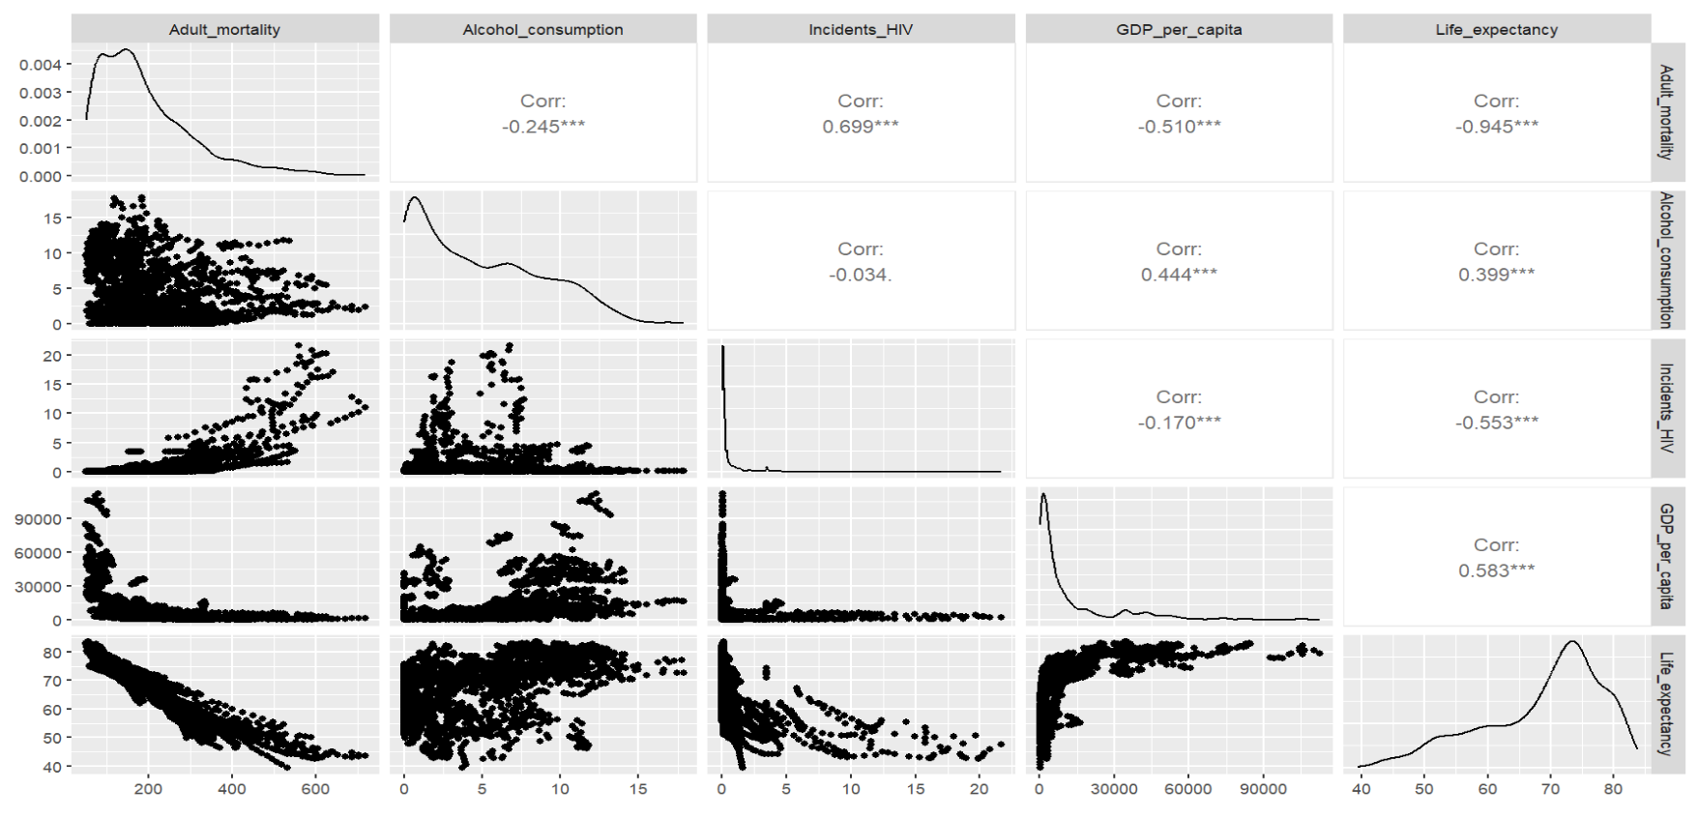
Image 7: Correlation test Code and Results in R-Studio, performed by Student Researcher
The above image shows a correlogram- a matrix of correlation tests showing correlation coefficient, scatter plots, and density plots- between the adult mortality, alcohol consumption, HIV incidents, GDP per capita, and life expectancy indicators. This allows the viewer to see the correlation between multiple factors at once.
Adult mortality and life expectancy exhibit a strong negative correlation (-0.945), which is an intuitive correlation and works effectively as a smoke test. GDP per capita and life expectancy display a moderate positive correlation (0.583), which is logical, as more affluent countries are likely able to make more investment in programs that would increase life expectancy. However, it is not a perfect correlation, meaning that GDP, which is a great signifier of an economy, does not necessarily mean “development” in terms of quality of life, and cannot be the only factor targeted by development initiatives. HIV and adult mortality have a strong positive correlation, so working on minimizing HIV incidents is a great way to decrease adult mortality and therefore increase life expectancy. As of 2024, great strides have been made in this department, with commercially available pre-exposure prophylaxis medicine available for people diagnosed with HIV to stop the spread and minimize its effects, though lots of work can be done in the department of drug patenting and distribution. Alcohol consumption and life expectancy show a weaker positive correlation (0.399), which follows the logic that alcohol consumption could go either way, and more insight is needed into cultural norms, demographics, and measurement to indicate its broader effect. The following correlations are weak or not significant, and perhaps should not be used in further analysis: HIV incidents vs alcohol consumption and GDP per capita vs HIV incidents.

Models
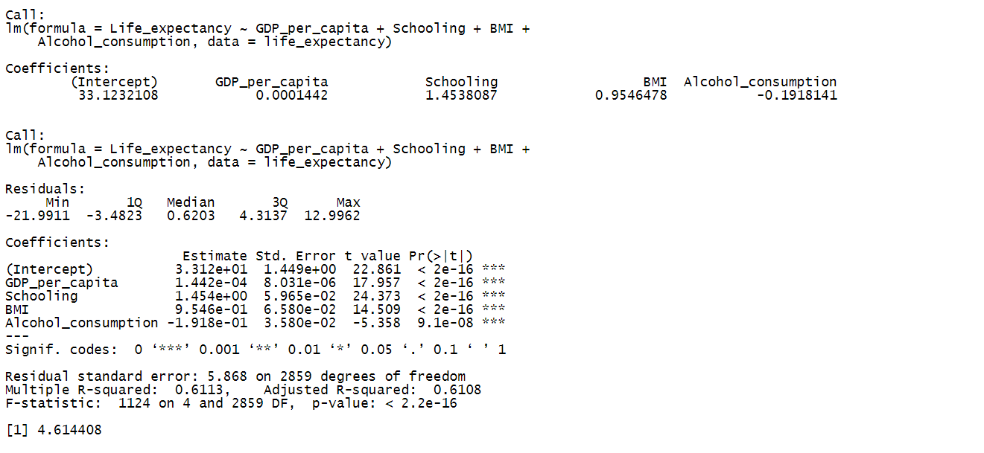
Image 8: Results of Linear Model for Life Expectancy, generated in R-Studio by Student Researcher
The above image displays the result of a linear regression model developed to predict life expectancy based on GDP per capita, schooling level, BMI, and alcohol consumption. The above factors were chosen based on previous correlation and statistical analysis. The model was based on the entire dataset then run on the entire dataset; it was not partitioned into training and testing data, though later models use this method.
GDP per capita has a small positive relationship (as given by the coefficient) and a statistically significant impact (as given by the p-value), suggesting that economic development is not sufficient to improve life expectancy to developed conditions, and other factors may be more impactful. Alcohol consumption displays a small, statistically significant negative effect on life expectancy, while BMI exhibits a moderate positive relationship with life expectancy. However, as mentioned before, these could be counterintuitive, and perhaps more research with further disaggregated data would be helpful. Schooling time shows a statistically significant, stronger positive relationship with life expectancy, showing that policies regarding education can have an overall positive impact on public health and other related factors, so global education should continue to be a target for improving life expectancy, development, and likely overall quality of life.
The multiple R-squared value indicates that 61.13% of the variance in life expectancy can be explained by the above factors, and the p-value shows that this is a statistically significant relationship that provides a better model than without the predictors.
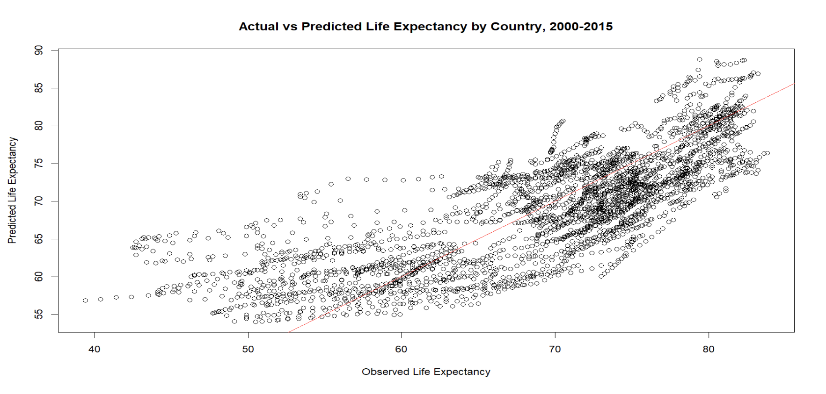
Image 9: Actual vs Predicted Life Expectancy by Country 2000-2015, Scatter Plot generated in R-Studio by Student Researcher
The above image uses the linear model as explained in Image 8 to plot the actual life expectancy in the dataset against the life expectancy predicted by the model, with the red diagonal line displaying complete accuracy. The closer the datapoints are clustered around the red line, the more accurate the model. This graph shows some more extreme variations, particularly among entries with lower life expectancies. Additionally, the mean absolute error was calculated to be 4.614408, which could be quite significant. This indicates that perhaps there is not a strict linear relationship between these predictors and life expectancy.
Image 10: Results of GLM Model for Development Status, generated in R-Studio by Student Researcher
The above image displays the results of the generalized linear model predicting development status based on immunization rates (hepatitis B, measles, polio, diphtheria), thinness (for children 5-9 and 10-19 years old), and GDP per capita. A GLM model was chosen as development status can easily be converted into a binomial distribution, where there are only two possible outcomes: developed or developing. Here, the dataset was split into 80% training, 20% testing.
First, it is shown by the p-values that thinness for children 5-9 years old and hepatitis B are not statistically significant as it exceeds the threshold of 0.05, and polio sits right on the border of not being significant. The strongest relationships with status lie in measles immunization rates (positive), polio immunization rates (positive), diphtheria immunization rates (positive), thinness 10-19 years old (negative), and GDP (positive). The large difference between the null and residual deviance rates shows that the variance in the predictors explains a large amount of the variance in the predicted variable, suggesting a well-fitted model. These results have implications for policy, showing that making efforts towards increasing childhood nutrition and immunization rates can push towards development, increased life expectancy, and overall quality of life.
A confusion matrix was generated to evaluate the model, which is shown in the bottom of Image 10. In this case, 0 means developing, and 1 means developed. The following table shows the values for each metric of the confusion table for this model.
Metric | Formula | Result
Precision: correct positive predictions | True Positive / (True Positive + False Positive) | 103 / 116 = 0.8879
Recall: complete positive predictions | True Positive / (True Positive + False Negative) | 103 / 123 = 0.8374
Specificity: correct negative predictions | True Negative / (True Negative + False Positive) | 437 / 450 = 0.9711
Accuracy: correctly classified | (True Positive + True Negative) / (True Positive + True Negative + False Positive + False Negative) | 540 / 573 = 0.9424
Table 2: Confusion Matrix Metrics for GLM Model
The above table provides insight into the GLM model detailed in Image 10. The model has an overall accuracy of 94.24% which is highly successful, but might be skewed by the fact that the statuses are not evenly distributed throughout the data, and it might be more successful in one case than another. For example, the specificity (97.11%) shows that the model is more successful at correctly identifying negative (developing) cases than positive (developed) cases, given by the precision (88.79%). The precision and recall rates show that the model has more issues with classifying developed countries, missing some true positive and classifying some false positives.
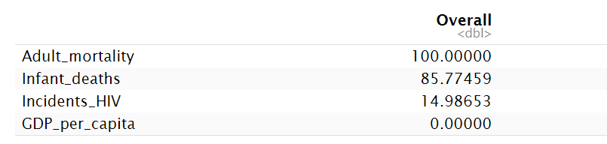
Image 11: Factor Importance Results from Random Forest Model for Life Expectancy, generated in R-Studio by Student Researcher
The above image shows the factor importance results from the random forest model performance to predict life expectancy based on infant deaths, adult mortality, HIV incidents, and GDP per capita. A random forest model was chosen as it is good for complex models that can display both linear and nonlinear relationships, can help reduce overfitting, and is great for feature selection. In this model, the data was split into 60% training, 40% testing, and a 5-fold cross-validation technique was applied. The results are given as a feature importance chart, where the feature with a score of 100 (adult mortality) is the most important feature contributing to the model, and each following feature’s score shows its proportion to the top score in terms of importance. This shows clearly that adult mortality is the most important feature in determining life expectancy, which works as a smoke test. Following that is infant deaths, and after a significant gap, is HIV incidents. GDP has a score of 0, meaning it is not important in this model, and can be removed as a feature. This model shows that a focus on decreasing infant deaths would be an essential step towards achieving development goals. Additionally, this model provides a root mean square error of 0.7987866, which is a measure of the difference between the predicted and observed value. This is a very small RMSE, showing that the model is a strong fit.
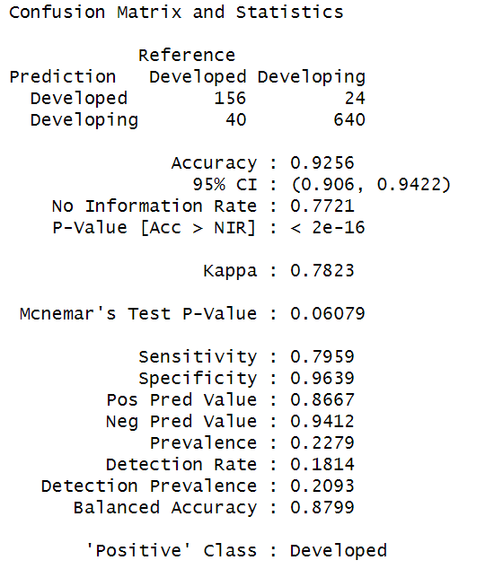
Image 12: Results of Confusion Matrix from SVMPoly Model for Development Status, generated in R-Studio by Student Researcher
The above image displays the results of the confusion matrix generated by the SVM with polynomial kernel model to predict development status based on schooling, BMI, alcohol consumption, and measles. This model used a 70% training, 30% testing split of the dataset. The model gives an overall accuracy rate of 92.56% which is very successful, but similar to the results of Table 2, this could be skewed by the inherent skew of the dataset. Similar to the GLM model, the SVMPoly model is more successful at predicting negative classes (developing) than positive. Perhaps providing a smaller portion of the dataset that will set equal the distribution of statuses can increase its success with positive (developed) cases.

Summary of Learning
In executing this project, I learned various skills and revelations about performing a data analysis. My first and foremost challenge was finding a dataset that provided relevant, easy-to-use, well-formatted information without complicated internal coding. This goes hand in hand with the next important revelation, which is that an understanding of the data features, their methods and measurements, and the absolute definition is essential, and a large possible source of error and misinterpretation. I also learned that finding the best visualization for different data that tells the story effectively, accurately, and intuitively is a huge challenge- and very satisfying to figure out. That was the most exciting part, getting to learn new skills as I went through the project, encountered different challenges, and asked different questions. For example, I stumbled upon the correlogram because I knew there must be a more efficient way to find multiple correlation coefficients than running each test individually. I also enjoyed getting to tie in skills from science fair and my statistics course this semester.

References and Resources
MDG Monitor. (n.d.). Retrieved from Millenium Development Goals: https://www.mdgmonitor.org/millennium-development-goals/
Nations, U. (n.d.). Sustainable Development Goals. Retrieved from Goals: https://sdgs.un.org/goals

More information about this dataset can be found at the following source: https://www.kaggle.com/datasets/lashagoch/life-expectancy-who-updated
Links to each relevant indicator is provided in the Kaggle source dataset
Resource on how to add standard deviation bars to charts found here: Plot mean and standard deviation using ggplot2 in R - GeeksforGeeks
More information on Europe’s Health Systems Reforms can be found here: Eurohealth-24-2-23-28-eng.pdf
More information on how to create and interpret correlograms can be found here: Correlogram – from Data to Viz
More information on this method can be found at this source: How to Plot Predicted Values in R (With Examples)
Resources for how to interpret GLM output found at the following source: How to Interpret glm Output in R (With Example)
More information on feature importance charts can be found at the following source: Interpreting Random Forest Classification Results - GeeksforGeeks

