Before university I had no idea whom I wanted to be in future. At that time Computer Science were not very spread among people to learn it and I did not know what it is about, I did not even know what it is the program code and how does it works. Then my sister's boyfriend was at university at the Faculty of Applied Mathematics towards programming, he told me “Sofia, if you like math, you love and know how to solve logic problems, you constantly evolve and ready to learn - that is your way towards programming. Therefore, it is the most promising industry in Ukraine and studying computer science - this is another way of looking at technology on the other side and be involved in the creation of new ideas and implement them in cool innovative technologies that assist people in life”.

Well, these words encouraged me to study information technology. Therefore, I decided to go to university, the faculty of Computer Science. Unfortunately, by the time, the IT industry is not popularized in schools and very few pupils guessed what it really is from the developing side.

So, there is a great lack of information about such industry, and I think that this information needs to be disseminated in schools and begin to teach programming at schools. In Ukraine it is a problem that is why I would like to give presentations in schools to encourage more students to study computer science and join this university faculty.

Well, in my university very small proportion of women studying computer science. For example, in my group, I am one of three girls and 25 boys make up the rest. Here both the party look, because then a lot of attention and assistance in any matters on the part of the boys :) Nevertheless, of course I am kidding. That is less than 1/5 the average girls studying IT at university, a figure that applies not only to my class, but really for all IT-related departments at university, there are groups which has one girl at all. Therefore, it is in principle throughout Ukraine. Sure, there are girls who graduated from very different areas of study learn independently and go to work in IT, for example on the same QC engineers. However, it is still generally very small amount. As we can see, this problem affects the whole world, maybe in Europe and America, this percentage is a little bit bigger, but I think an average is less 20% of girls are enrolled in computer science.

I love my university and I like the teachers in my department, but unfortunately, there is a problem, which is in principle in all Ukrainian universities - training system is old, which has been rooted in the USSR. Teaching is going in rather outdated materials, as technologies are developing very fast, and presenting information lags far behind our time, perhaps because of that many students are not so interesting to study. Therefore, I believe that you need to change completely the system of training in Ukrainian universities to increase the level of qualifications of students and cultivate their love and inspiration to learn. Therefore, even in my university do particularly nothing for women to encourage them to study technical subjects, and in this case, now everything depends on the choice and the will of the girls.

In general, my university provides different programming competitions where students can win different prizes, and students with rather good grades get bonuses to their scholarship.

I think that is difficult to specify the precise impacts on women to study technical subjects. Now a small number of girls my age are interested in technology in terms of its design, not use, but still they are. Well first of all girls enrolled in these faculties like studying different technologies, to solve complex problems, to be involved in the practical development projects. However, honestly taking into account the situation in Ukraine today, its economic situation, the citizens of Ukraine are going through difficult times, except that now the war engulfed the entire east of the country, the crisis has worsened the lives of some Ukrainian. People in Ukraine are very poor and very difficult to survive on one salary or pension that government can provide. So I think that as a factor that be software engineers are very promising in the sense that there may be high enough wages and is a significant factor at this time, unfortunately, of course. I hope that in the near future things will change for the better.

Since I started working in the direction to conduct various training sessions for the girls from this year, I plan to organize some of them just at my university. If I were the Head of the Computer Science department, first I would work on inspiring girls, who are enrolled at the university, to create different ideas for developing interesting projects, real projects, such as application that will improve the infrastructure of our city. First, each study group, that now is consisting of 25 students in average, I will divide them into smaller teams, which will include 5-10 people in each. Team members will have work together in developing the project. It can be included in their bachelor project. Moreover, the most interesting project will be implemented in reality for the city needs, and students of the team that developed this project, will be awarded to certain grants or coupons for books. Well this is one idea. Also can be created a purely female teams and where girls will develop some projects with implementation of interesting ideas.  
I also want to change the way of teaching and decrease the number of unnecessary subjects. I would add a more interesting practice in teaching, because theory does not capture so far as doing the same with their hands.

To attract girls to join the University in this department I would conduct more interesting training sessions and presentations on encouraging girls at that time when they are studying in school, and thinking about the choice of specialty. I also have many different ideas, but it seems that those I have named are those from which we should start working in my university to solve the problem.

**Bachelor’s project**

The idea of my bachelor’s project is about how to optimize process of tracking and reporting bugs for software products. As usual, most, for example, web applications are getting feedback from their users (about found bugs or requests for some improvements) on product owners’ email. Then QC engineers or sometimes software engineers take to account all users feedback, especially about found bugs, and begin to report them in some reporting system, as usual IT companies do. I am good familiar with JIRA reporting system, which is very popular in many IT companies.

 JIRA is a [proprietary](http://en.wikipedia.org/wiki/Proprietary_software) [issue-tracking](http://en.wikipedia.org/wiki/Issue_tracking_system) product, developed by [Atlassian](http://en.wikipedia.org/wiki/Atlassian). It provides [bug tracking](http://en.wikipedia.org/wiki/Bug_tracking_system), issue tracking, and [project management](http://en.wikipedia.org/wiki/Project_management) functions. Although normally styled JIRA, the product name is not an acronym, but a truncation of Gojira, the Japanese name for [Godzilla](http://en.wikipedia.org/wiki/Godzilla). It has been developed since 2002.

JIRA is written in [Java](http://en.wikipedia.org/wiki/Java_programming_language) and uses the Pico [inversion of control](http://en.wikipedia.org/wiki/Inversion_of_control) container, [Apache OFBiz](http://en.wikipedia.org/wiki/Apache_OFBiz) entity engine, and WebWork 1 technology stack. For [remote procedure calls](http://en.wikipedia.org/wiki/Remote_procedure_calls) (RPC), JIRA supports [SOAP](http://en.wikipedia.org/wiki/SOAP), [XML-RPC](http://en.wikipedia.org/wiki/XML-RPC) and [REST](http://en.wikipedia.org/wiki/REST). JIRA integrates with [source control](http://en.wikipedia.org/wiki/Revision_control) programs such as [Subversion](http://en.wikipedia.org/wiki/Subversion_%28software%29), [CVS](http://en.wikipedia.org/wiki/Concurrent_Versions_System), [Git](http://en.wikipedia.org/wiki/Git_%28software%29), [Clearcase](http://en.wikipedia.org/wiki/Clearcase), [Team Foundation Server](http://en.wikipedia.org/wiki/Team_Foundation_Server), [Mercurial](http://en.wikipedia.org/wiki/Mercurial), and [Perforce](http://en.wikipedia.org/wiki/Perforce). Some of the organizations using JIRA for bug-tracking and project management are [Linden Lab](http://en.wikipedia.org/wiki/Linden_Lab), [JBoss](http://en.wikipedia.org/wiki/JBoss), [Spring Framework](http://en.wikipedia.org/wiki/Spring_Framework), [Hibernate](http://en.wikipedia.org/wiki/Hibernate_%28Java%29), [Fedora Commons](http://en.wikipedia.org/wiki/Fedora_%28software%29) and [Skype](http://en.wikipedia.org/wiki/Skype). The [Apache Software Foundation](http://en.wikipedia.org/wiki/Apache_Software_Foundation) uses JIRA and [Bugzilla](http://en.wikipedia.org/wiki/Bugzilla).

I am interested in developing web-applications, so I found out that JIRA provides service Jira API for developers, and decided to create web-application called “Customer Feedback” (my research project got name “Integration Jira API service into Web Application”). The REST API in updated JIRA 5.0 charges ahead with the ability to create and edit issues via the REST API.

Using this REST API service in JIRA API, I have created software product, that allows customers of applications, to create and report bugs immediately into Jira system, or even to add issues with requests of any improvements. I think that my web application reduces and optimize processes in teamwork with decreasing of additional reporting tasks into Jira system.

How I learned to use Jira API service? Well, I got a good experience in this, because API services were something new for me, that was hard to obtain for me firstly. Fortunately Jira provides all related documentations about its services.

 The Atlassian REST APIs provide a standard interface for interacting with JIRA and other applications. REST APIs provide access to resources (data entities) via URI paths. To use a REST API, the application should make an HTTP request and parse the response. The methods should be the standard HTTP methods like GET, PUT, POST and DELETE. REST APIs operate over HTTP(s) making it easy to use with any programming language or framework. The input and output format for the JIRA REST APIs is [JSON](http://www.json.org/). JIRA uses the [Atlassian REST plugin](https://developer.atlassian.com/display/JIRADEV/REST+Plugin+Module+Type) to implement the JIRA APIs. The REST plugin is bundled with JIRA. Because the REST API is based on open standards, so any web development language can be used to access the API. I used C# and .Net Framework libraries to work with HTTP client.

Unfortunately, Jira service is not for free, so I had to register on the site <https://www.atlassian.com/software/jira/try/> and tried free-trial of Jira service. I had limited period to use JIRA and to develop my web-application based on JIRA API requests and responses. I spent 2 days on getting the grasp of it all and creating first request through API to JIRA with response status code “OK”. It was really hard to obtain, I were looking for answers and examples on different developers blogs, and finally I got good results in my developing.

Firstly, I created ASP.Net MVC project with all needed controllers, few action methods and three main views.

I created login page and two tables in DB for user authentication. I implemented *Custom Membership Provider* class for users’ credentials validation. Login page of my web-application looks like:



**Creating an Issue in JIRA through API**

A few points to note:

* Content type in the request is set to 'application/json'.
* POST the JSON to JIRA server. In my app, the server is <http://localhost:2990/jira/rest/api/2/issue/>.
* The application uses basic authentication, with a username of admin and password of admin.
* I added a project to the instance before running, and get the project ID of the project to which can be added to the issue beforehand.

A simple REST request contains the POST data:

|  |
| --- |
| {      "fields": {         "project":         {            "id": "10000"         },         "summary": "No REST for the Wicked.",         "description": "Creating of an issue using ids for projects and issue types using the REST API",         "issuetype": {            "id": "3"         }     }  } |

I sent request to the next my local jira:

|  |
| --- |
| http://localhost:2990/jira/rest/api/2/issue/ |
|  |

The response provides the issue ID, issue key, and the URL to the issue (which can then be used to GET additional data, PUT updates, etc).

|  |
| --- |
| {     "id":"10009",     "key":"TEST-10",      "self":"[http://localhost:2990/jira/rest/api/2/issue/10009"](http://localhost:2990/jira/rest/api/2/issue/10009)  } |

Instead of using numeric identifiers for the project and issue type, I also used the key and name of the type instead. For example:

|  |
| --- |
| {      "fields": {         "project":         {            "key": "TEST"         },         "summary": "REST ye merry gentlemen.",         "description": "Creating of an issue using project keys and issue type names using the REST API",         "issuetype": {            "name": "Task"         } }} |

Here is a piece of my code, implementation of the action method for creating issue in Jira:

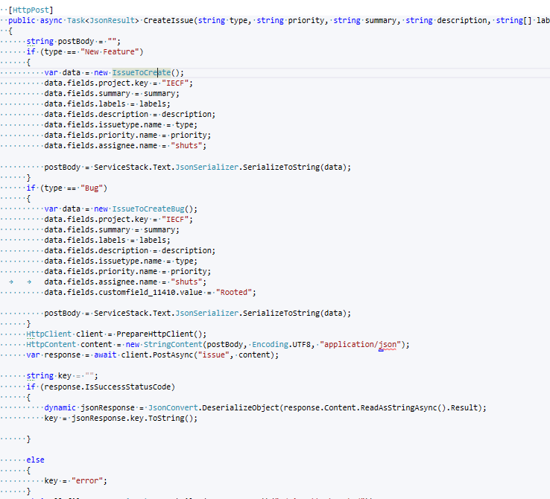

Here is the interface of my application, with fields for creation application.

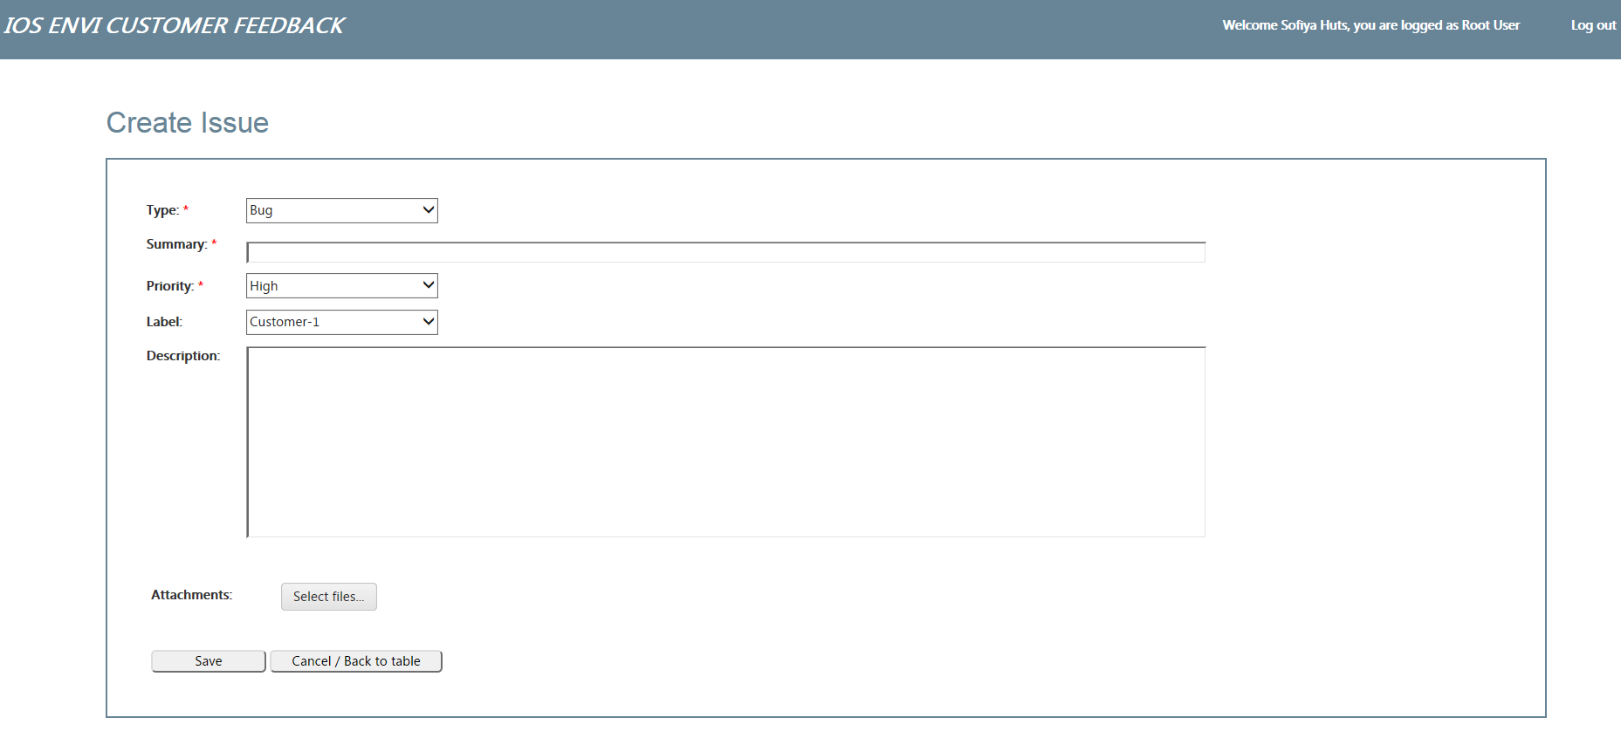

**Getting an Issue in JIRA through API**

The REST API allows to send a JQL query and receive a subset issues. In this example, I supplied a single URL parameter (jql) which contains the JQL query.

**Request** with appropriate jql-search parameters for issues retrieving:

http:// localhost:2990/rest/api/2/search?jql=**assignee**=**fred**

**Response:**

{

    "expand": "schema,names",

    "startAt": 0,

    "maxResults": 50,

    "total": 6,

    "issues": [

        {

            "expand": "html",

            "id": "10230",

            "self": "[http:// localhost:2990/rest/api/2/issue/BULK-62"](http://kelpie9:8081/rest/api/2/issue/BULK-62),

            "key": "BULK-62",

            "fields": {

                "summary": "testing",

                "timetracking": null,

                "issuetype": {

                    "self": "[http:// localhost:2990/rest/api/2/issuetype/5"](http://kelpie9:8081/rest/api/2/issuetype/5),

                    "id": "5",

                    "description": "The sub-task of the issue",

                    "iconUrl": "[http:// localhost:2990/images/icons/issue_subtask.gif"](http://kelpie9:8081/images/icons/issue_subtask.gif),

                    "name": "Sub-task",

                    "subtask": true

        }

    ]

}

Action method for getting issues from response by making http request with JQL-query:

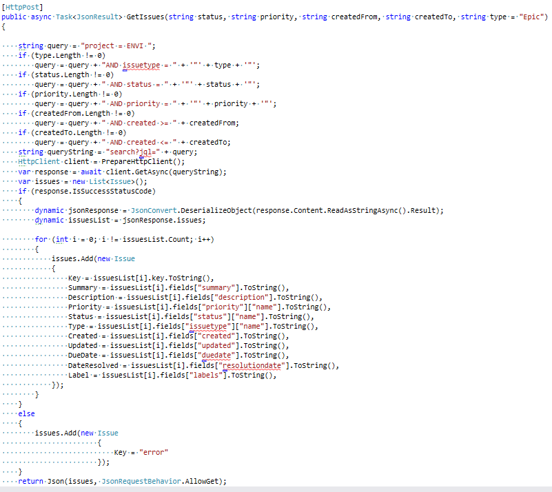

View with grid of retrieved Jira’s issues from JSON response and theirs details below (screenshot of my application):

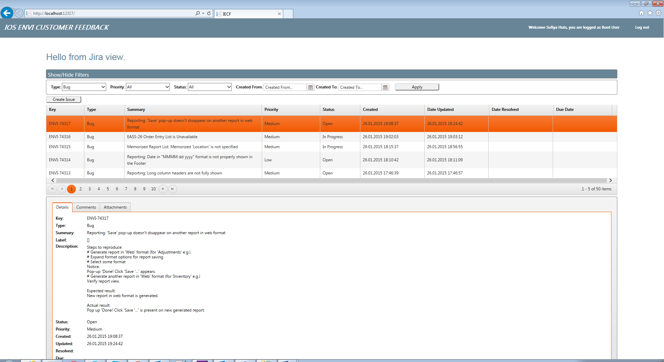

Bugs view from Jira’s site look like:

