Thesis Questions:
- Does OXXO cause an increase of the crime rate in its surroundings
- What is the causal effect of an OXXO store arrival on UPZ level crime rates?
- Do OXXO openings change local crime rates in treated UPZs relative to untreated UPZs, and do effects vary by crime type and time since opening
Do proximity retail chains influence urban safety? Evaluating the impact of OXXO expansions on criminal activity across Bogotá’s UPZs using a quarterly panel approach.
Do proximity-store openings act as crime generators or deterrents? Evaluating the causal effect of OXXO expansion on felony rates in Bogotá’s UPZs
FINAL QUESTION:
What is the causal effect of OXXO openings on local crime activity in treated UPZs relative to untreated UPZs, and do effects vary by crime type and time since opening?
Main objective
This paper aims to

INTRODUCTION:
Although Bogotá, the capital city of Colombia, has experienced a significant reduction in crime since the 1990s \parencite{rodriguez2017ciudad, godoy2018security}, delinquency and insecurity remain major public concerns. Despite the implementation of preventive programs and policies by Bogotá’s administrations since the 2000s, along with other measures targeting crime hotspots \parencite{godoy2018security}, personal theft has reamined high and the perception of insecurity has grown, affecting the daily lives of citizens in recent years \parencite{CCB2026}. This suggests that there are additional urban factors that current policies do not address, and may be shaping patterns of criminal activity in Bogotá. Thus, considering these unexplored factors may provide a better undestading of these patterns.\\

One factor discussed in urban crime literature is the role of commercial establishments in shaping local patterns of criminal activity \parencite{Dugato2026, askey2018fast, Nazzari2026, Wellford1997, Davis2021}. Within this category of establishments, OXXO, a convenience store chain that has steadily expanded across Bogotá since 2009, is a case study of this phenomenon \parencite{godoy2025}. In particular, due to their long operating hours, strategic locations in high-traffic areas and commercial corridors, availability of basic goods, and constant customer flows throughout the day and night \parencite{marcos2022}, the arrival of this chain may alter surrounding patterns of mobility and social interaction in ways that could influence nearby criminal activity \parencite{Dugato2026, marcos2022}.\\

There is a duality in the crime literature regarding the relationship between convenience stores and crime. On the one hand, these establishments have been identified as \textit{crime generators} because they increase foot traffic and create incidental criminal opportunities \parencite{Dugato2026}. Similarly, \textcite{Wellford1997} classify them as robbery-prone commercial establishments due to the availability of cash on hand. On the other hand, \textcite{Davis2021} offer a different perspective, arguing that convenience stores may also function as crime deterrents by increasing natural surveillance and generating \textit{eyes on the street} through extended operating hours and improved lighting. These two lines of reasoning highlight the importance of analysing the role of convenience stores within the surrounding criminal environment, particularly because, as \textcite{Dugato2026} argue, addressing the urban conditions that facilitate criminal behavior may be more effective for long-term crime reduction than traditional repressive approaches.\\

OXXO’s footprint in Colombia is strikingly centralized, with over 300 of the more than 500 stores in the country concentrated in the capital city \parencite{godoy2025}. This high density within a single metropolitan area provides an "urban laboratory" to conduct a granular, intraurban crime analysis. By exploiting the staggered arrival of these establishments across Bogotá’s Zonal Planning Units (UPZs), this thesis evaluates the causal impact of OXXO openings on local criminal activity. Specifically, I examine how these effects vary by crime category, and whether the impact intensifies or dissipates over time following the store's opening.\\

To estimate this impact, I constructed a quarterly panel dataset covering the period from 2015 to 2022, aggregated at the UPZ-level. The panel combines Colombia’s public georeferenced crime records from the National Police’s Statistical, Criminal, Contraventional, and Operational Information System (SIEDCO) with a georeferenced database of OXXO establishments that accounts for both opening and, when applicable, closure dates. Using this information, I calculated quarterly crime rates for each UPZ and identified the number of OXXO stores operating within each unit over time.

Additionally, I employed Two-Way Fixed Effects (TWFE) and the Callaway and Sant’Anna (C\&S) estimator, along with their corresponding event-study specifications, as the main empirical strategies of this research. The TWFE model was used to estimate the average relationship between the expansion of OXXO stores and crime rates across UPZs over time. However, because staggered treatment adoption may generate bias under treatment-effect heterogeneity, the C\&S estimator provided more robust estimates and assessed the consistency of the TWFE results. Finally, event-study analyses were conducted to examine the dynamic evolution of treatment effects over time and to evaluate the parallel trends assumption for both empirical approaches.\\

I found that the staggered entry of OXXO stores had no statistically significant effect on criminal activity across Bogotá. Using both aggregated specifications through the TWFE model and dynamic specifications through event-study analyses, I found no evidence that the expansion of OXXO affected different types of crime in the city. Additionally, after controlling for the presence of other similar commercial establishments located near OXXO stores, such as hard-discount retailers, which have also been associated with changes in criminal activity in Bogotá, the estimated effects remained statistically insignificant. These findings suggest that, both in the short and long run, OXXO stores do not appear to significantly alter Bogotá’s security dynamics.
This may be because \hl{ANOTHER EXPLANATION}.\\

Despite extensive research on urban crime in Bogotá, no study has systematically examined the causal impact of convenience store proliferation, particularly OXXO, on local crime patterns. Current research has focused on public transport infrastructure \parencite{Bacares2013a,Bacares2013b,Garcia2005}, large-scale police interventions \parencite{Blattman2017,Blattman2021}, alcohol sales restrictions \parencite{Mello2013}, and socioeconomic determinants \parencite{Escobar2012}. One recent study examined the relationship between \textit{Tiendas D1} hard-discount stores and crime \parencite{Lopez2024}, and found a statisically significant effect of D1 openings on criminal activity; nonetheless, the effect of OXXO on crime is hypothesized to follow a different pattern, as it represents a distinct retail model characterized by 24-hour operations, and a higher availability of alcohol and \textit{grab-and-go} items, which may create different criminal opportunities compared to hard-discount formats.\\

In the next section I briefly introduce OXXO’s expansion across Bogotá, and the city’s crime rates over the years. Then, in Section 3 I present the related literature about the spatial nexus of crime and convenience stores. In Sections 4 and 5 I describe the data sources used and the general descriptive statistics. After that I explain in Section 6 the econometric models used, and in Section 7 I show the results obtained. In Section 8 I include some robustness checks related with the unit of analysis used, the control and treatment groups, and the specification of some variables. Finally, Section 9 discusses possible mechanisms that may influence the results obtained.

BACKGROUND:
a. OXXO
Although OXXO has been operating in Colombia for almost 17 years, it only consolidated itself as one of the main convenience store chains in the country after the pandemic \parencite{ElEconomista2026}. In fact, in Bogota the number of establishments rose sharply from 82 in 2020 to 384 in 2025, this represents an increment of over 368\% in only five years. Figure~\ref{fig:EVOLUTION_OXXO} depicts this accelerated growth in Bogotá, as it shows the number of OXXO locations in the capital by year since its arrival. This OXXO expansion can be due to some of its intrinsic characteristics; for example, 95\% of its establishments function in a 24-hour format \parencite{oxxo_faqs}, providing a competitive advantage by being the primary option of consumers whenever they need to satisfy spontaneous consumption needs \parencite{LaRepublica2026}.\\

The proliferation of OXXO stores began in the northern part of the city before spreading throughout the eastern region. Figure~\ref{fig:fourpanelOXXO_evolution_UPZ} illustrates this evolution, showing that OXXO is now present in nearly 70\% of the city’s Zonal Planning Units (UPZ), these being units that group neighborhoods based on socioeconomic stratification, land use, housing characteristics, and the living conditions of their inhabitants \parencite{alcaldia_bogota_upz}. Furthermore, it can be observed that OXXO presence has a primary concentration in the northeastern neighborhoods of Bogotá. Currently, the only areas lacking OXXO establishments are in the far southern reaches of the city. These places correspond to UPZs with lower levels of economic performance, socioeconomic stratification, and urban transport connectivity \parencite{Guzman2017, Bocarejo2013, PRISMBogota}, where residents continue to rely heavily on traditional neighborhood stores \parencite{RicoPencue2021}. \\

This expansion over time positively correlates with the inherent characteristics of northeastern Bogotá, where high traffic, spatial accessibility provide an ideal environment for the convenience store model \hl{(citation)}. Figure~\ref{fig:oxxo_transmilenio_vias} illustrates this behavior by mapping the city’s arterial roads, main avenues, and Transmilenio stations (Bogotá's Bus Rapid Transit system); it demonstrates that as of 2025, OXXO locations tended to cluster along these major transport corridors. Section~\ref{sec:Statistics} provides a statistical analysis confirming the positive correlation between these variables and store locations.\\

OXXO locations are centrally administered by FEMSA with the purpose of standardizing processes, logistics, services, and products \parencite{oxxo_faqs}. This implies that store placement is strategically determined according to the company’s broader commercial objectives rather than being randomly distributed across space. Such non-aleatory allocation may complicate econometric identification, since the characteristics that attract OXXO establishments may also affect crime behavior.\\

The concern about endogenous OXXO placement, however, may be mitigated through the use of TWFE estimators, because many determinants of store location are either time-invariant or evolve only gradually over the sample period, allowing UPZ fixed effects to absorb a substantial portion of the selection process. Nonetheless, some bias may persist if an OXXO opening responds to time-varying local trends correlated with crime activity. For example, FEMSA may prioritize expansion into UPZs experiencing increases in commercial activity, population density, household income, pedestrian flows, or improvements in public security, all of which could independently influence criminal activity. In such cases, TWFE estimates can only partially capture the causal effect of OXXO on crime.

2. criminal activity in Bogotá over the years
During the 1980s and 1990s, Bogotá was among the most unsafe cities in Colombia, experiencing a surge in narcoterrorism and the assassination of political leaders; in fact, in 1991, it reached a rate of 1,287 crimes per 100,000 inhabitants, exceeding that of Medellín (1,160) and Cali (537) \parencite{rodriguez2017ciudad}. However, at the end of the 90s and beginning of the 2000s, crime started to decrease; for example, between 1993 and 2002 Bogotá saw an estimated 65\% decrease in the homicide rate, while robbery fell by about 33\%. This shift was driven by citizen culture programs, large-scale urban renewal projects, and institutional reforms implemented by the majors of this period \parencite{Sanchez2003, mockus2012building}. In recent years, however, urban crime has shown a fluctuating behavior. Following the 2019 covid pandemic, criminality had a rebound, with personal theft surpassing pre-pandemic levels in 2022 and 2023 \parencite{siedco_portal}. By 2024, despite continued institutional efforts and a decrease in crime rates in the city \parencite{siedco_portal}, 69.3\% of households believed insecurity had raised \parencite{ccb_security_perception_2025}.\\

Currently, crime in Bogotá, as in most cities, tends to cluster in specific zones \parencite{Enriquez2014,GimenezSantana2018}. The most insecure Localities (a unit of territorial division that gathers many UPZ) are primarily located in the southeastern region of the city, a pattern associated with the presence of criminal organizations, high levels of informality, and deficiencies in human development \parencite{probogota2024indice}. However, this spatial concentration does not imply that all categories of crime peak in the same areas. While homicide rates generally follow this pattern, personal theft exhibits a distinct geographic distribution, with higher concentrations in the northeastern sector of the city \parencite{probogota2022informe}.\\

Figure~\ref{fig:fourpanelCrime} illustrates this behaviour as it displays how personal theft rates distribute throughout Bogotá´s UPZs over the years (Appendix~\ref{sec:othercrimemaps} shows how other crimes distribute). These maps also highlight that between 2015 and 2021 (and even later, as it can be noted in ProBogota’s annual security reports) this tendency has not drastically changed. This persistence suggests that there are environmental characteristics that keep favoring robberies or attracting offenders. Among these characteristics are high pedestrian traffic, a dense concentration of commercial land use, and proximity to the city’s main transit corridors.\\

It is precisely within these high-activity environments that OXXO has focused its expansion. Consequently, for this research, factors that favor crime clustering must be taken into account. If OXXO stores tend to locate in inherently high-crime areas, it becomes essential to assess whether their presence contributes to an increase in crime or whether both the stores and offenders are are simply drawn to the same high-activity ‘nodes.’ In this sense, OXXO locations may function either as crime generators or as crime attractors.

LITERATURE REVIEW:
In the context of urban economics, spatial econometrics and crime literature, various studies have explored how built environment features and infrastructure shape crime activity in cities. A number of empirical analyses have investigated this by exploring the causal impact of urban public transit on crime. \cite{ijgi10100632}, for example, assessed the impact of two new subway lines implemented in 2017 in ZG city, China, on thefts in the surrounding areas. By employing a Difference-in-Differences (DiD) framework, they found that in the short run, theft increased by 15\%. Others, on the other hand, have ventured to explore the paper of new urban policies and infrastructure interventions on this topic. \cite{dominguez2022crimetime} paper is one case, as they study the causal effect of ambient light on crime in Santiago, Chile, by using the "Daylight Saving Time" policy as a natural experiment. Due to this policy, they could find that an increase of one hour of ambient light exposure between 7 and 9 reduced thefts by 30\%. These studies emphasize that urban interventions do not just shift crime spatially, but actively reshape the rational choice of offenders by creating or eliminating environmental opportunities for illicit activity.\\
Retail chains can be considered as built environment features that may influence urban crime activity. While different studies have extensively explored their role, these previous inquiries have their own limitations. A substantial body of research dates back to the pre-2000s era, meaning that their findings do not contemplate the current urban dynamics of modern cities. Nonetheless, these foundational studies provide a critical perspective on the underlying mechanics of crime. For instance, early investigations focused on identifying the characteristics that influenced the propensity of convenience stores to be targeted for robbery. They identified that stores that operated for longer hours at night were more likely to be robbed, as there are fewer people around \parencitecite{dalessio1990crime}. Others found that these types of stores were more prone to be robbed due to the lack of visible security such as police presence, security guards, or effective alarm systems \parencitecite{Wellford1997, Dugato2026}. Although useful, they fail to account for convenience stores’ role on crime of their immediate surroundings.\\
On the other hand, other recent publications have examined the influence of analogous commercial establishments on urban crime. While some of these studies do not focus exclusively on convenience stores, they utilize other retail outlets with similar operational profiles which can serve as proxies for what this thesis aims to investigate. \textcite{askey2018fast} is and example as the authors pooled data from fast-food restaurants and convenience stores in Seattle. They used sales revenue as a proxy for human activity to count the different levels of operational intensity across locations, and aimed to explain crime patterns in the immediate surroundings of these establishments. Their results indicate that stores with higher average sales were associated with with a 7.4\% increase in expected crime counts. Conversely, \cite{feng2019aggravating} contribute to this discussion by finding that alcohol outlets influenced the likelihood of aggravated assault and street robbery in New York City. Their findings reveal differential impacts depending on the type of outlet (if it is a bar, a grocery store, or other similar establishment); for instance, the authors highlighted that in Manhattan and the Bronx, proximity within two blocks of a grocery store increased the relative risk of street robbery by more than sixfold.\\
Another investigation is the one of \parencite{shin2024dollar}. Shin used a DiD approach to invetigate the impact of dollar stores on localized violent crime patterns in Chicago. To ensure the treatment and control groups were as homogeneous as possible, the author created localized areas using a 250-feet buffer for the treatment group and a 250-to-354-feet outer ring as the control. At the end, this research found that store openings lead to a 21.5\% increase in violent crime (0.17 incidents per quarter), a result primarily driven by a 38\% surge in robberies.\\
Although these studies offer a useful baseline of how convenience stores, and specifically OXXO, impact nearby crime, they present an incomplete perspective as they exclusively explored this nexus in cities of high-income nations. To build a more robust theory, these hypotheses must be tested within Latin American cities which have particular urban dynamics. Many papers argue that convenience stores are normally located in socio-economically disadvantaged areas where poverty, social disorganization, and lack of community resources exacerbate crime risks \parencite{shin2024dollar, Dugato2026}, but in cities like Bogotá the situation is not analogous. OXXO in Bogotá, for instance, does not follow this rule as it instead prioritizes to open locations in middle to high income neighborhoods, and places with high commercial activity and influx of people.\\
In Latin America, the economic literature regarding convenience stores remains limited. Recent investigations have explored their causal role on various labor market indicators \parencite{delgado2024, marcos2022}. However, despite this growing interest in labor dynamics, the spatial relationship between these establishments and urban security in the region has been largely overlooked. Specifically in Bogotá crime literature has primarily focused on public transport, general socioeconomic urban caracteristics, and policy intervention impact on crime \parencite{moreno2005impacto, bacares2013impact}.\\
The investigations that have actually explored this topic are counted. For example, \cite{jaramillo2021low} used the same method as \parencite{shin2024dollar} to study the effect of D1 hard discount stores on the crime around the areas where they open in Bogotá. Although D1s are not convenience stores per se, they attract a similar type of costumers and and often share similar spatial locations with OXXO outlets. By analyzing the period of 2016 to 2019 and employing the same information utilized in this thesis (within SIEDCO infromation system), the authors found that D1 openings caused a 33.4\% average reduction in crime density per block. They attributed this impact to the 'eyes on the street' phenomenon, suggesting that the increased pedestrian flow acts as a form of informal guardianship that deters criminal activity \parencite{jacobs1961death, jaramillo2021low}.\\
As noted, the body of literature that explores the impact of convenience stores on crime in Latinamerica is reduced, and virtually non-existent in the Colombian context. In this thesis I aim to fill this gap by evaluating the impact of OXXO store openings on local crime in Bogotá. Given their rapid expansion and market dominance, OXXO stores serve as a primary actor and a representative proxy for modern convenience retail in the city. Additionally, this analisis is particularly relevant in a context where crime remains a public policy priority and a growing concern for Bogota’s inhabitants.

DATA SOURCES AND UNIT OF ANALYSIS
UPZs are used as the unit of analysis because they constitute a feasible and consistent territorial division of Bogotá. The city maintains continuity in the availability of data aggregated at the UPZ level across time, and security policies and interventions are frequently designed and implemented using this geographic scale \hl{(cita)}. Additionally, UPZs preserve a certain degree of urbanistic and socioeconomic homogeneity by grouping neighborhoods with similar characteristics, while also providing an intermediate level of aggregation between localities and street blocks (\textit{manzanas}).\\

For the results of this study I employ four main data sources (see appendix~\ref{sec:variables_descripcion_detallada}). For measuring crime rate in Bogotá I used the georeferenced crime events stored in SIEDCO \footnote{Access at \url{ https://oaiee.scj.gov.co/agc/rest/services/Tematicos_Pub/SIEDCO_Delitos_Pub/FeatureServer}} spanning from 2015 to 2022. SIEDCO is Colombia’s official Police database that consolidate real-time citizen reports and administrative records of criminal activity. Here, for each incident recorded the system saves details including type of crime (e.g., homicide, personal theft, commercial burglary, or cell phone theft), the precise geographic coordinates of the event, date and time of the incident, and the victim’s gender. With this information, I aggregated the crime data at the UPZ-quarter level, categorizing incidents by offense type. To ensure comparability across quarters and UPZs, I normalized these counts using annual population estimates for each UPZ. This allowed for the construction of a crime rate per 10,000 inhabitants, as shown in this equation:
\begin{equation}
crime\_type\_index_{upz,year}=\frac{total\_incidents_{upz,year}}{population_{upz,year}} ; \quad \forall upz,year
\end{equation}
Rates were then smoothed using an Empirical Bayes technique to reduce the influence of extreme values in UPZs with small populations.
The period from 2015 to 2022 is appropriate for this analysis, as it encompasses both the year of its initial steady expansion and the first years of its explosive growth Bogotá. This timeframe provides sufficient temporal and spatial variation, as a larger number of UPZs enter treatment during the study period rather than before it. Before 2015, the lack of new store openings in other UPZs would result in an insufficient number of newly treated units, limiting the identifying variation necessary for using TWFE.
Personal theft is the only crime type evaluated across 2015 and 2018, as I the National police has not made this data available for public use. In this sense, results for this crime type must be anayzed with caution, as they are obtained from data encompassing a shorter time span than other crime types.\\
Additionally, using data from the Unified Business and Social Registry (RUES) \footnote{Access at \url{https://www.rues.org.co}}, Colombia’s central business registry, I identified the opening and closing years of each OXXO store. Furthermore, with Google Maps API I obtained the precise georeferenced location of each store. Concerns may arise regarding the accuracy of this matching process, particularly for stores that are no longer in operation. To address this, I manually verified each location using official OXXO sources, and as a result 95\% of establishments were properly assigned.\\
I followed the same procedure with D1, Justo\&Bueno and ARA hard-discount chains. I considered these brands because they often share similar spatial locations with OXXO stores; in fact, retailers tend to cluster in certain areas to take advantage of agglomeration benefits \parencite{Konishi2005, Seong2022}. Also, given that prior research suggests hard-discount stores influence both crime and commercial activity \parencite{delgado2024, jaramillo2021low}, their inclusion as control variables is important to evaluate the validity of my results .\\
Finally, I used the Quality of Life Survey of Bogotá (2007) \footnote{Access at \url{https://www.dane.gov.co/index.php/estadisticas-por-tema/salud/calidad-de-vida-ecv/encuesta-nacional-de-calidad-de-vida-2007-bogota}} to characterize the baseline socioeconomic conditions of treated and never-treated UPZs prior to the arrival of OXXO in 2009. Additionally, data from Mapas Bogotá were used to construct time-invariant socioeconomic and environmental controls at the UPZ level. These variables are included for descriptive purposes to assess the non-random spatial distribution of OXXO stores, although they are absorbed by the two-way fixed effects (TWFE) specification.

STATISTICS
First, it is important to illustrate the preliminary differences between controlled and treated UPZs, not only in terms of crime activity, but also regarding socioeconomic and accessibility variables. Table~\ref{tab:treatment_distribution_years} presents the staggered arrival of OXXO stores across UPZs per year between 2015 to 2022. Although the panel was constructed quarterly, the arrival of locations do not variate drastically among quarters per year. This table shows that there was an increase in treated UPZs starting in 2019, while a substantial number of control units remained available for comparison over the years.\\
This variation shown may not be as drastic as OXXO´s stores growth depicted in figure~\ref{fig:EVOLUTION_OXXO}. This suggests that some UPZs host a disproportionately higher number of establishments in order to account for the overall increase in OXXO stores across Bogotá. Moreover, this raises the question of whether treatment intensity should be explicitly considered in the analysis. Although Figure~\ref{fig:Treatment_intensity} does not provide a detailed spatial distribution of OXXO stores at the UPZ level over time, it illustrates the evolution of the average number of stores per cohort. The figure shows that, in early periods, differences between cohorts were relatively small (less than one store on average), whereas in later periods these differences became more pronounced. This pattern suggests that variation in treatment intensity may play a role in shaping the estimated relationship between OXXO presence and crime, and therefore warrants further evaluation.\\
On the other hand, Figure~\ref{fig:Treatment_intensity} presents preliminary evidence the behavior of different types of crime rates across the periods. Specifically, they report the difference in mean crime rates between treated and not-yet-treated UPZs for each quarter, along with an indication of whether these differences are statistically significant at the 5\% level. For instance, Panel~\ref{fig:diff_people} shows that, for personal theft, there was a statistically significant difference between groups during the quarters from 2015-Q1 to 2019-Q1. This indicates that, on average, treated UPZs exhibited higher crime rates than those not yet treated.\\
These results are consistent with expectations, as theft is the crime category most likely to be positively associated with the presence of OXXO stores. This finding aligns with the hypothesis that such establishments may function as crime attractors by increasing the flow of suitable targets. However, this pattern may also reflect the possibility that OXXO stores are disproportionately located in UPZs with inherently higher theft rates. Moreover, the graphs indicate that differences for other types of crime are not generally statistically significant. This fits the pattern expected, as crimes such as sexual violence or vehicle and motorcycle theft are less likely to be influenced by OXXO presence. These offenses often rely on different spatial and social dynamics, such as secluded areas or long-term parking patterns, which remain largely unaffected by convenience retail expansion \hl{cita}.\\
Table~\ref{tab:diferencias_medias_controles_fijos} also shows preliminary differences between treated and never treated groups. The variables chosen help to visualize that OXXOs are located in areas where there is higher traffic, accessibility, quality of life, and purchasing power. Moreover, these results indicate that potential market size may not be adequately captured by population measures alone (such as total inhabitants or household size in 2007), but rather by indicators of economic activity and consumption capacity. Since OXXO's product mix consists primarily of non-essential daily goods and convenience items rather than vital necessities, this retail chain prioritizes locations with high-income transit rather than just high residential density. These results are consistent with what was confirmed by \textcite{marcos2022}, where convenience store chains in Mexico were found to be distributed by similar characteristics.\\
I also evaluated whether there was indeed a tendency for hard discount stores, such as D1, Ara, and Justo \& Bueno, to locate near OXXO establishments. In Appendix~\ref{sec:controles_cadenas_descuento}, I show some of the results, and in general find that for all years these hard discount stores were significantly more prone to locate in UPZs treated with OXXO than in those without. With this evidence, I will include these chains as regressors mainly due to their probable influence on the dependent variables, as shown by \cite{jaramillo2021low} in their investigation. However, I considered them in the regression as baseline covariates, meaning that I only took into account their presence in the UPZ in the quarter before the analysis to avoid confounding effects.\\
Although I considered hard discount chains as factors that may bias the estimation, other unobserved variables could also affect the results. For instance, public works can reduce pedestrian and vehicular traffic for certain periods within the analysis; a new park may attract different demographic flows; and the presence of other commercial establishments, such as bars, nightclubs, or grocery stores, may impact the estimation of the causal effect, especially if they open or close during the period of study. Nonetheless, some of these variables may remain constant from 2015 to 2022. Furthermore, other establishments may be controlled for by unit fixed effects, as they tend to be located in areas that maintain their core characteristics; for example, nightclubs often open in places already recognized as nightlife districts.

EMPIRICAL STRATEGY

This research explores with two main econometric models the causal effect of OXXO openings on local crime activity in Bogotá. The first one I used is TWFE. This econometric strategy takes into account that the the arrival of OXXO’s occurs in a staggered manner. Additionally, it inherently controls for fixed effects for unit (UPZ) and time. The former is useful for capturing time-invariant unobserved characteristics of each UPZ (such as geographic location, historical infrastructure or fixed socieconomic and urban characteristics during the period of analysis), while the latter absorbs common shocks that affect all units simultaneously (such as city-wide security policies or macroeconomic fluctuations). Although TWFE is and adequate method for estimating the average treatement effect (ATT) of OXXO on crime activity, two identification assumptions are needed to prevent bias. This ones will be considered later, but let us first introduce the basic regression form of TWFE:\\

\begin{equation}
Y_{i,t} = \alpha_i + \alpha_t +\beta^{twfe} D_{i,t} + \varepsilon_{i}
\label{eq:twfe}
\end{equation}\\

Where $ Y_{i,t} $ represents the crime rate for UPZ $i$ in quarter $t$. This rate corresponds to either a specific crime category or the aggregate of all crimes analyzed in this study. $D_{i,t}$ is a binary indicator that equals one if UPZ $i$ has at least one OXXO store in quarter $t$ , and zero otherwise. Furthermore, as Figure \hl{XXXX} suggests that intensity of treatment may be a factor that influences crime. Section \ref{sec:Results} also evaluated $D_{i,t}$ as the number of OXXO establishments that an UPZ has at a certain quarter. Finally, $\alpha_i$ and $\alpha_t$ are the unit and time fixed effects respectively.\\

A critical identification assumption for the TWFE estimator is the homogeneity of treatment effects. This implies that these effects must be constant among treatment cohorts and over time \parencite{deChaisemartin2023survey}. This assumption may be violated if treatment effects vary based on UPZs’ characteristics or if the impact of an OXXO opening on crime evolves as the store becomes established in the area. Consequently, to diagnose the potential bias arising from these heterogeneities, I employ the Goodman-Bacon decomposition \parencite{GoodmanBacon2021}. This theorem decompoeses the $\beta^{twfe}$ as a weighted average of all possible 2×2 difference-in-differences comparisons among cohorts, and the primary concern in this decomposition is to avoid having negative weights as they indicate that the estimator may be biased from heterogeneous treatment effects \parencite{GoodmanBacon2021}.\\

Parallel trends is the other condition to guarantee an unbiased ATT, as it ensures that, in the absence of treatment, the average outcomes of the treated and control groups would have followed the same trajectory over time. To evaluate the validity of this assumption, I implement an Event Study design. This model requires no anticipation to treatment, and in this context it is highly unlikely that perpetrators or residents altered their behavior in expectation of an OXXO opening, as these commercial developments are typically not publicized far enough in advance to influence local criminal dynamics beforehand. The Events Study is estimated by using the following equation:\\

\begin{equation}
Y_{i,t} = \alpha_i + \alpha_t
+ \sum_{k=-K}^{-2} \gamma^{lead}_k D^k_{i,t}
+ \sum_{k=0}^{L} \gamma^{lag}_k D^k_{i,t}
+ \varepsilon_{i,t}
\label{eq:eventstudy}
\end{equation}\\

Equation \eqref{eq:eventstudy}allows to analyze the significance of the coeficients $\gamma^{lead}_k$ and suggests the existence of parallel trends before the arrival of OXXO. Additionally, the coefficients $\gamma^{lag}_k$ reflect the temporal dynamics of the impact after the treatment.\\

Finally, for robustness purposes, I will also estimate the Callaway \& Sant’Anna (CS) model. This approach accounts for treatment effect heterogeneity by estimating ATTs by cohort and period, subsequently combining these effects through a weighted average \parencite{RiosAvila_Callaway_SantAnna_2021_csdid_slides,Callaway_SantAnna_2021}. o achieve this, the model utilizes the following doubly robust estimator for the ATT of each cohort $g$ at time $t$:

\begin{equation}
ATT(g, t) = \mathbb{E} \left[ \left( \frac{G_g}{\mathbb{E}[G_g]} - \frac{\frac{p_{g,t}(X)(1 - D_t)}{1 - p_{g,t}(X)}}{\mathbb{E} \left[ \frac{p_{g,t}(X)(1 - D_t)}{1 - p_{g,t}(X)} \right]} \right) (Y_t - Y_{g-1}) \right]
\end{equation}\\

Where $t$ is a particular time period, $ G_g$ Gis a binary indicator for whether an observation belongs to cohort $g$, $ D_t $ treatment status at time t, and $(1 - D_t)$identifies observations that have not yet been treated, serving as the control group. Additionally, the approach I chose uses Inverse Probability Weighting (IPW) to assign greater weight to control observations that more closely resemble the treated cohort $G_g$.

Subsequently, to aggregate all ATT(g,t) estimates into a single summary parameter, the authors propose the following aggregation strategy:

\begin{equation}
\theta = \sum_{g \in \mathcal{G}} \sum_{t=2}^{\mathcal{T}} w(g, t) \cdot ATT(g, t) \end{equation}\\

Where $w(g,t)$ represents the weights determined by the researcher. In this analysis, I employ a simple averaging scheme mwhere w(g,t) is the same for all treated periods. The objective of this comparison is to determine if the Callaway \& Sant’Anna (CS) estimates an Events Studies align with the Two-Way Fixed Effects (TWFE) results. A similar behavior between the two models would reinforce the validity of the TWFE estimates and suggest that the possible bias of heterogeneous effects is not a preoccupation
\parencite{RiosAvila_Callaway_SantAnna_2021_csdid_slides,Callaway_SantAnna_2021}.
RESULTS

Table~\ref{tab:resultados_regresion} presents the estimates for the equation ~\ref{eq:twfe} for each type of crime. All estimates, except the one of Homicide, show that OXXO presence in an UPZ reduces crime activity. Nonetheless, these results, including sexual offences, thefts to motorbike and vehicle crimes, are statistically insignificant, suggesting that OXXO presence does not affect crime activity at the UPZ level.\\

Homicide is the only crime category for which the estimated effect is statistically significant. The results suggest that the arrival of an OXXO store in a UPZ increases the homicide rate by 0.0699 homicides per 10,000 inhabitants relative to a UPZ without an OXXO store. Comparing with the mean of the never treated group, this represents a relative increment of 9,68\%. The effect for this crime runs counter to my expectations, as I expected personal theft to exhibit a statistically significant coefficient and, if homicide was also significant, I expected both effects to move in the same direction.\\

Figure~\ref{fig:fourpanelESFE} shows the events study (ES) of each crime type for the TWFE approach. In terms of parallel trends assumption, it can be observed that both personal theft and sexual offences violate the condition near period -1, meaning that their estimates are not correctly identified with this empirical strategy. Other, crimes do not show this problem, and after the first OXXO arrival they maintain statatistically insignificant dynamic effects, which allign with the coefficients’ of Table~\ref{tab:resultados_regresion}.\\

Theft to people exhibits a counterintuitive pattern in terms of dynamic effects. It suggests that, following the opening of the first OXXO store, theft tends to increase over time. This tendency contrasts with the coefficient previously reported in Table ~\ref{tab:resultados_regresion}, where the overall effect is negative and statistically insignificant. While this pattern could suggest that OXXO increases theft activity in the medium and long term, such an interpretation would only hold if the parallel trends were satisfied and if the estimator of Table~\ref{tab:resultados_regresion} had the same sign as the ES tendency. Since these conditions are not met, it is more likely that the TWFE coefficient is biased and incorrectly identified.\\

The CS approach will be useful to examine this hypothesis and assess the possibility of heterogeneous effects in the TWFE results. Although I applied the Goodman-Bacon decomposition to each regression and obtained positive weights, the CS estimator serves as an additional robustness check to verify the absence of bias if both approaches (TWFE and CS) display similar patterns. Table~\ref{tab:resultados_ES} shows the ATT comparison between TWFE and CS. Despite coefficients are not exactly the same, most of them present the same direction and a similar magnitude, and most maintain statistically insignificant, suggesting absense of bias.\\

Homicide requires further examination, as both estimators produce coefficients of similar magnitude and direction, yet the estimate becomes statistically insignificant under the CS specification. Given the consistency of the estimated effects across approaches, the difference appears to stem primarily from a loss of statistical precision rather than from a substantive change in the estimated impact. Therefore, I place greater emphasis on the TWFE estimate when interpreting the effect of OXXO presence on homicide rates.\\

Apart from contrasting the ATTs, Figure~\ref{fig:fourpanelESCompared} compares how the CS and TWFE ES behave in each crime type. These graphs reveal that both have a similar evolution in most crimes, which again indicate that there is no bias in the TWFE specification. Additionally, CS ES present more robust results as all crimes satisfy the parallel trends assumption, this indicates that Sexual Offenses and Theft to People CS estimates are more reliable.\\

Theft to people is the only crime category that exhibits a clear temporal trend in both the TWFE and CS event studies after the opening of the first OXXO store; however, the estimated trends differ in direction across the two specifications. These differences can be explained by the nature of each event study approach. The TWFE specification only considers treated units and includes always-treated observations. In fact, during this period (from 2015 to 2018), 65\% of the 26 treated UPZs were already treated at the beginning of the sample, leaving only nine UPZs that received treatment after 2015-Q1. In contrast, the CS excludes always-treated units and compares only these nine newly treated UPZs with not-yet-treated ones. This indicates that the positive trend observed in the TWFE specification is largely driven by the always-treated UPZs, whereas the control units in the CS one offset these differences by providing a more appropriate counterfactual. Overall, this evidence reinforces the interpretation that the TWFE coefficient for theft to people is biased and does not accurately identify the causal effect of OXXO entry.\\

Finally, Table~\ref{tab:resultados_regresion_intensity} presents the TWFE estimates using treatment intensity. The results differ substantially from those reported in Table~\ref{tab:resultados_regresion}. In particular, theft to people becomes positive and statistically significant, a finding that is consistent with the hypothesis that OXXO stores may act as crime attractors. However, the estimated magnitude is considerably large and raises concerns about the robustness of the result, particularly given the substantial variation in the estimated effect for personal theft across specifications. Theft to motorbike also becomes statistically significant while retaining a negative coefficient.\\

Incorporating treatment intensity constitutes a relevant extension of the baseline analysis, given the heterogeneous evolution in the number of OXXO stores across treatment cohorts illustrated in Figure~\ref{fig:Treatment_intensity}. The intensity specification may better capture differences in exposure to OXXO presence that are not reflected by a binary treatment indicator. Since the Callaway and Sant’Anna estimator is not defined for continuous treatment intensity, these estimates cannot be directly validated using this approach.\\

As an additional robustness check, I included the presence of other convenience store chains, namely Justo \& Bueno, D1, and Ara, as controls in all specifications. The inclusion of these variables did not substantially alter the main results. In general, the estimated effects became statistically insignificant across all crime categories and, in some cases, the violation of the parallel trends assumption became more pronounced. For the treatment-intensity specification, the coefficient for personal theft decreased in magnitude, although the overall pattern of results remained unchanged. The complete set of estimates is reported in Appendix~\ref{sec:otherresultstable}.

The number of UPZs used for the analysis was reduced compared to the number used in the Stadistical analysis section because there are some UPZs in which the number of OXXO establishments decreased over the years.
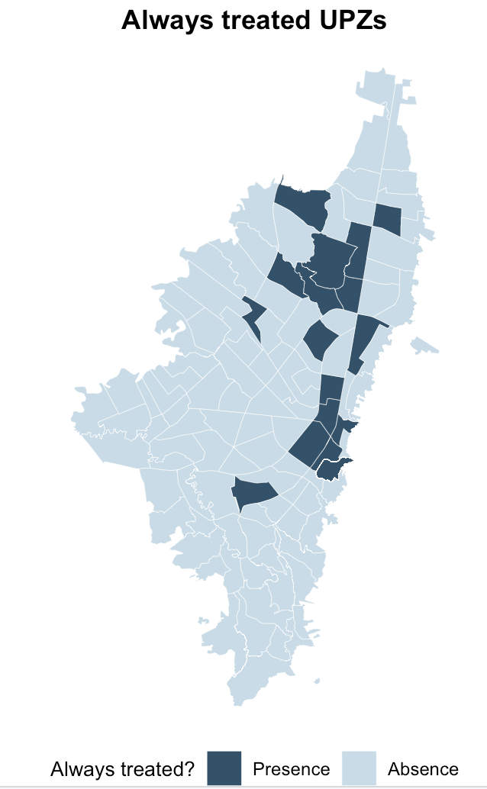
drop if codigo_upz == 97 | codigo_upz == 91 | codigo_upz == 93
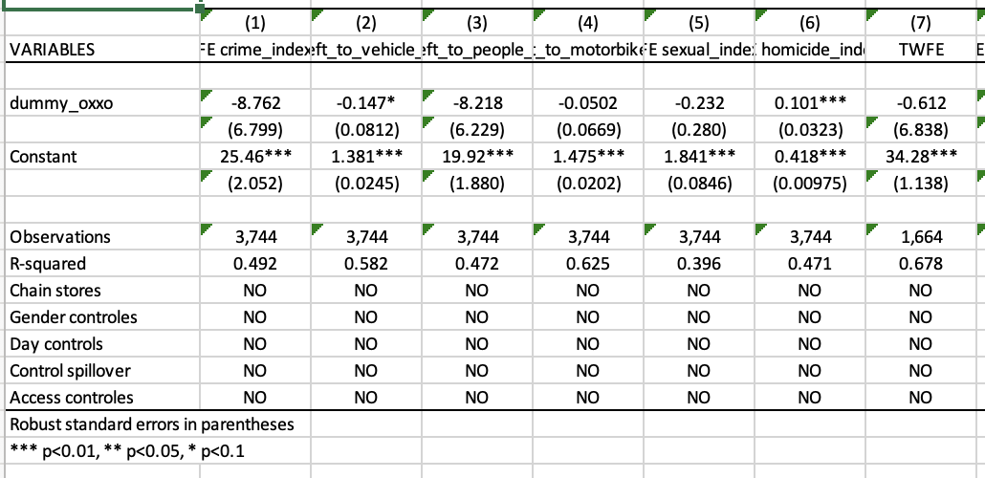
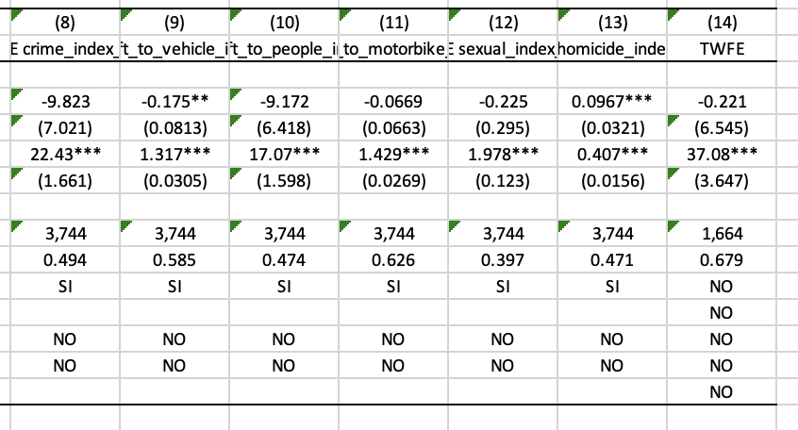
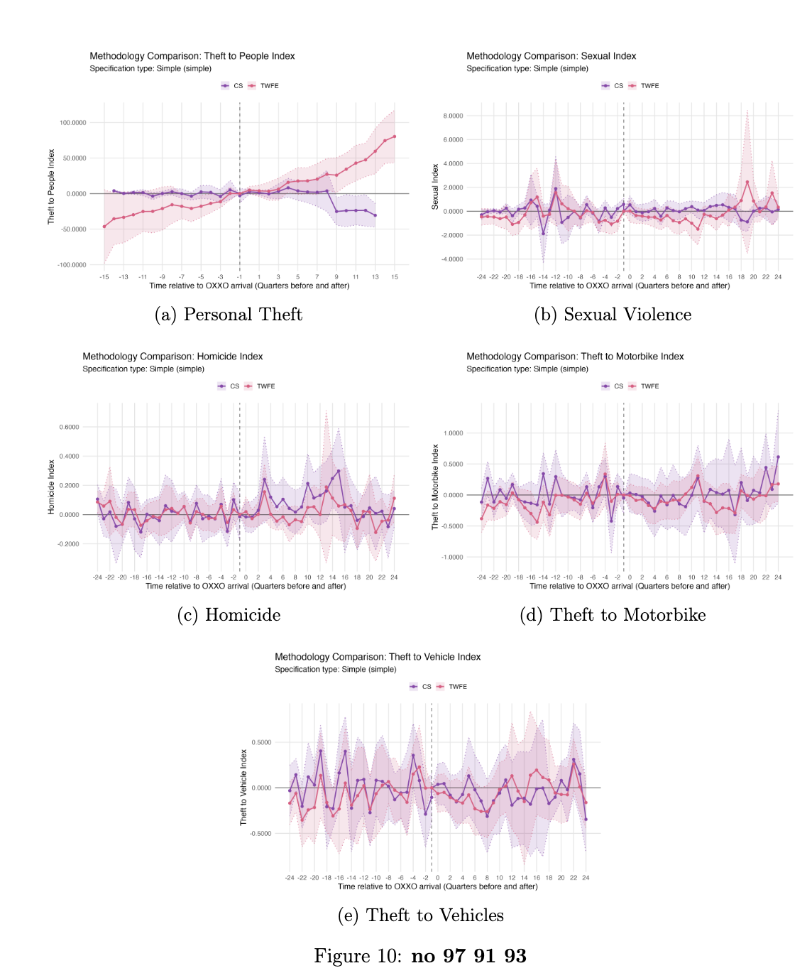
Intensity
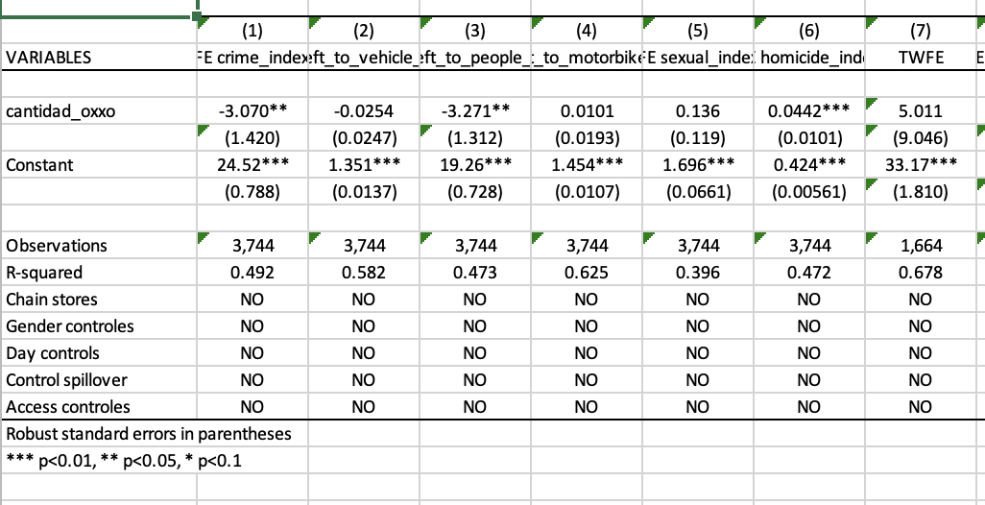
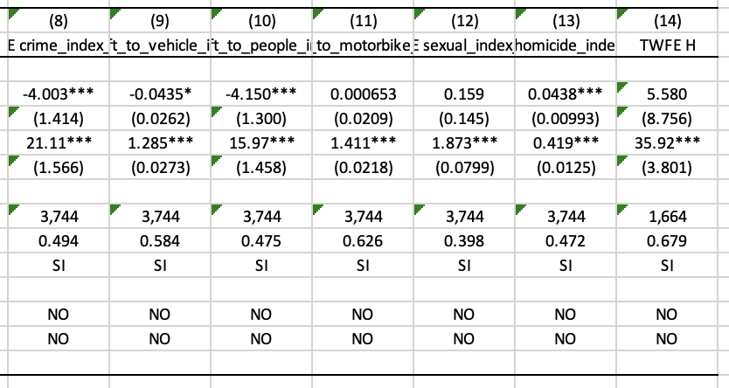
replace outliers = 1 if codigo_upz == 97 | codigo_upz == 91 | codigo_upz == 93 | theft_to_people_index_eb > 400
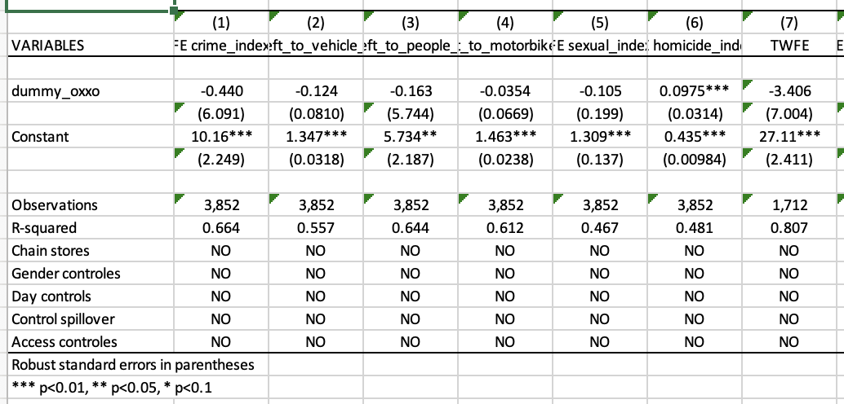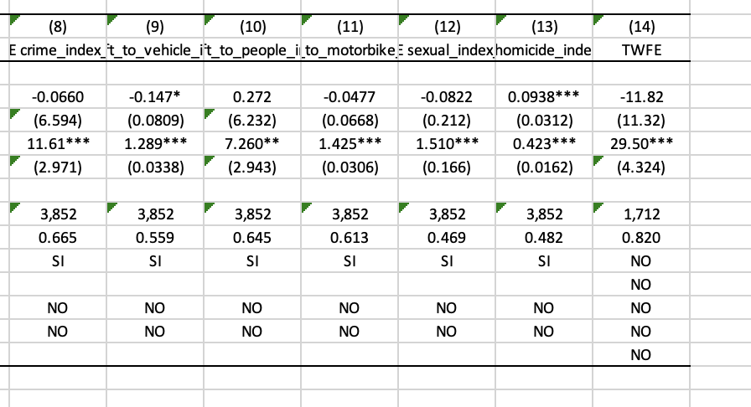
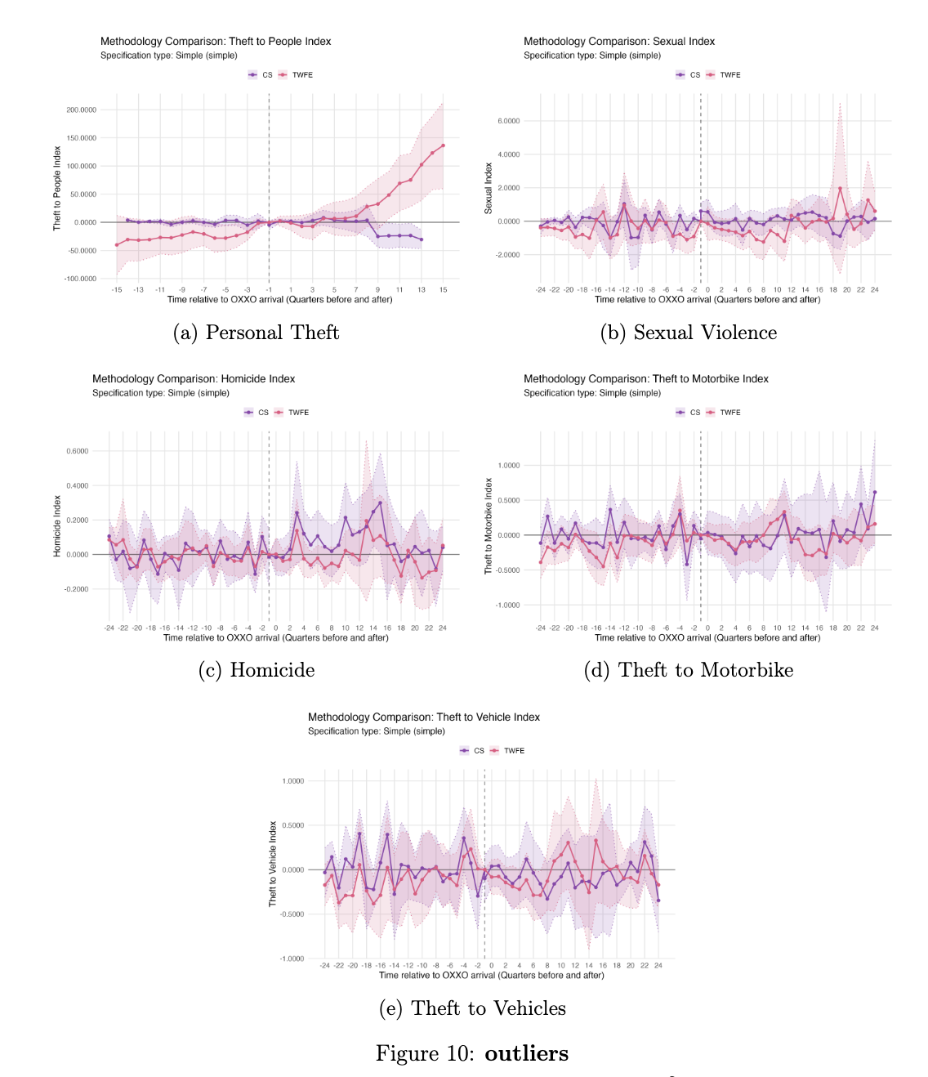
intensidad
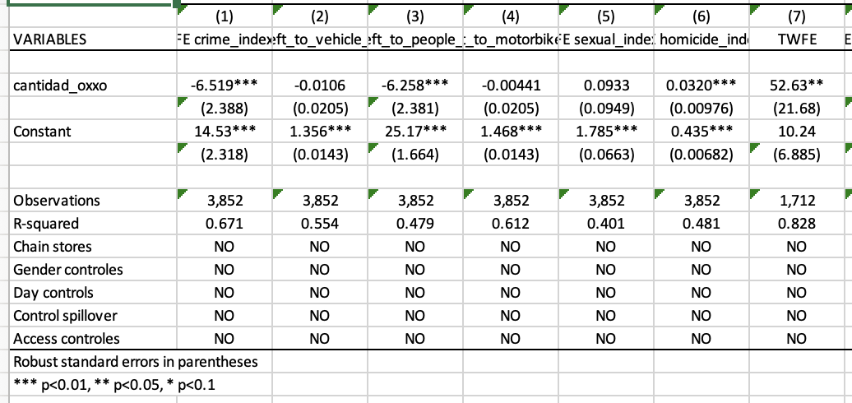
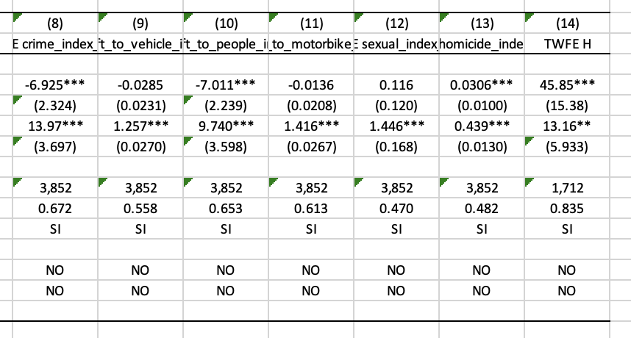

QUITAR LOS ALWAYS TREATED: 12 19 20 22 24 25 27 29 39 91 93 94 97 100 101 102 116

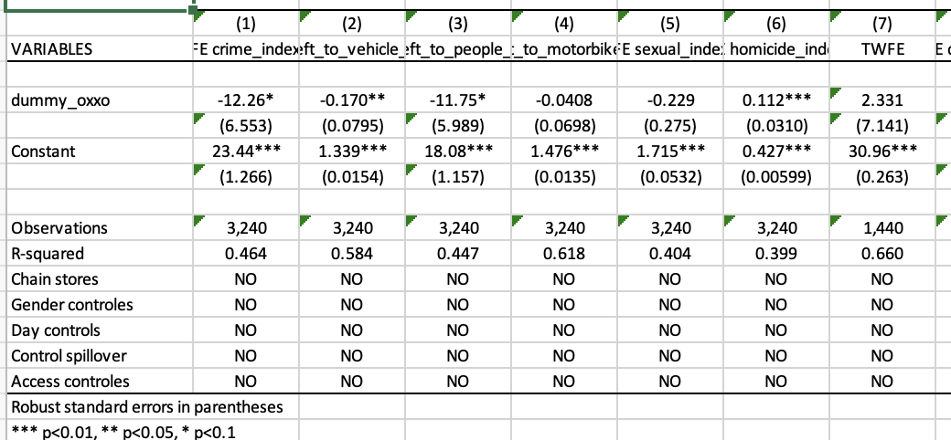

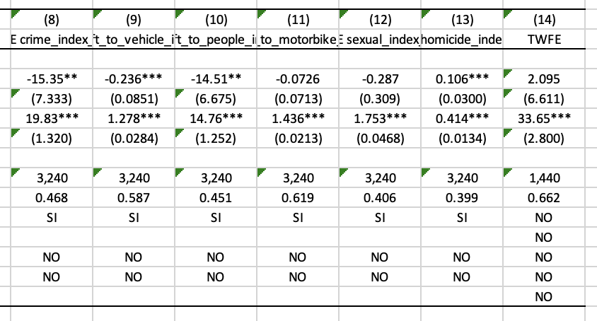
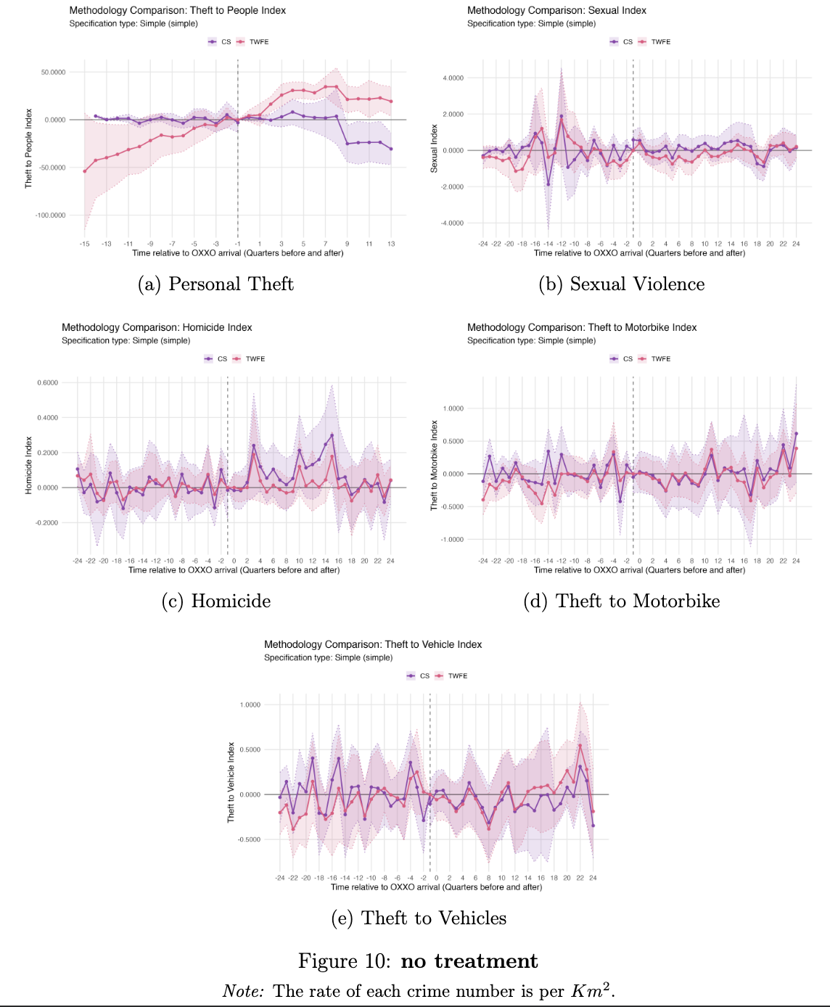
Intensity
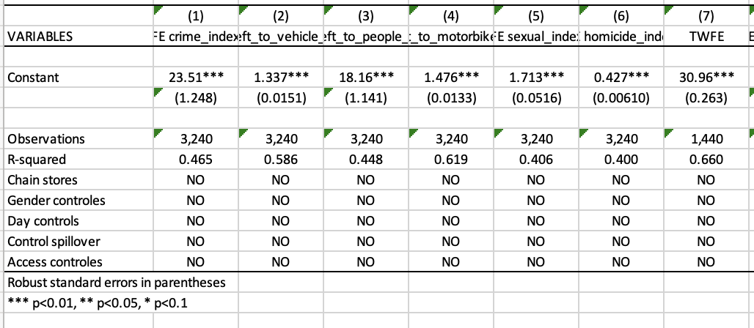
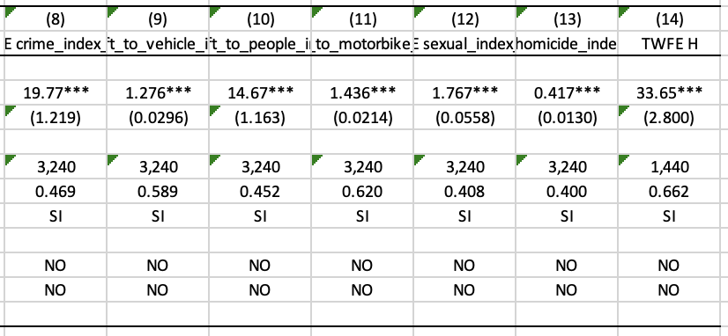

ROBUSTNESS CHECKS

QUITAR LOS ALWAYS TREATED: 12 19 20 22 24 25 27 29 39 91 93 94 97 100 101 102 116
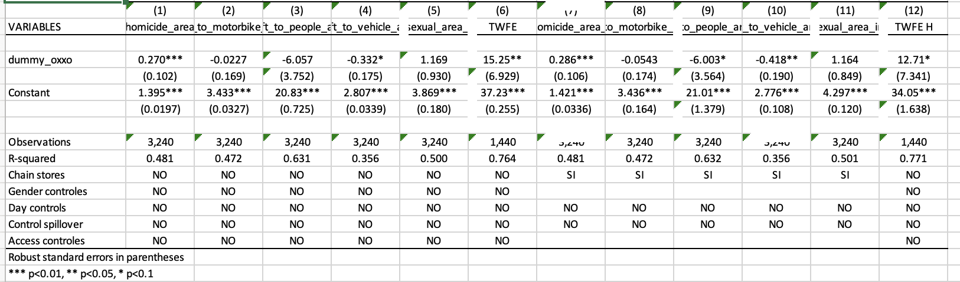
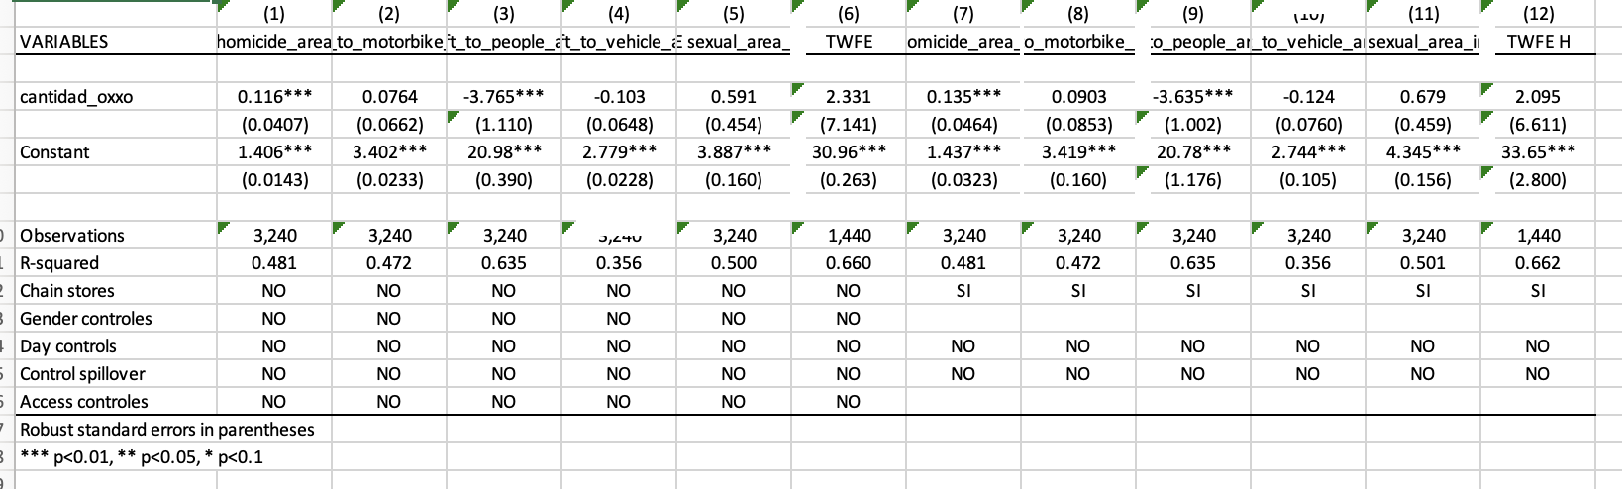
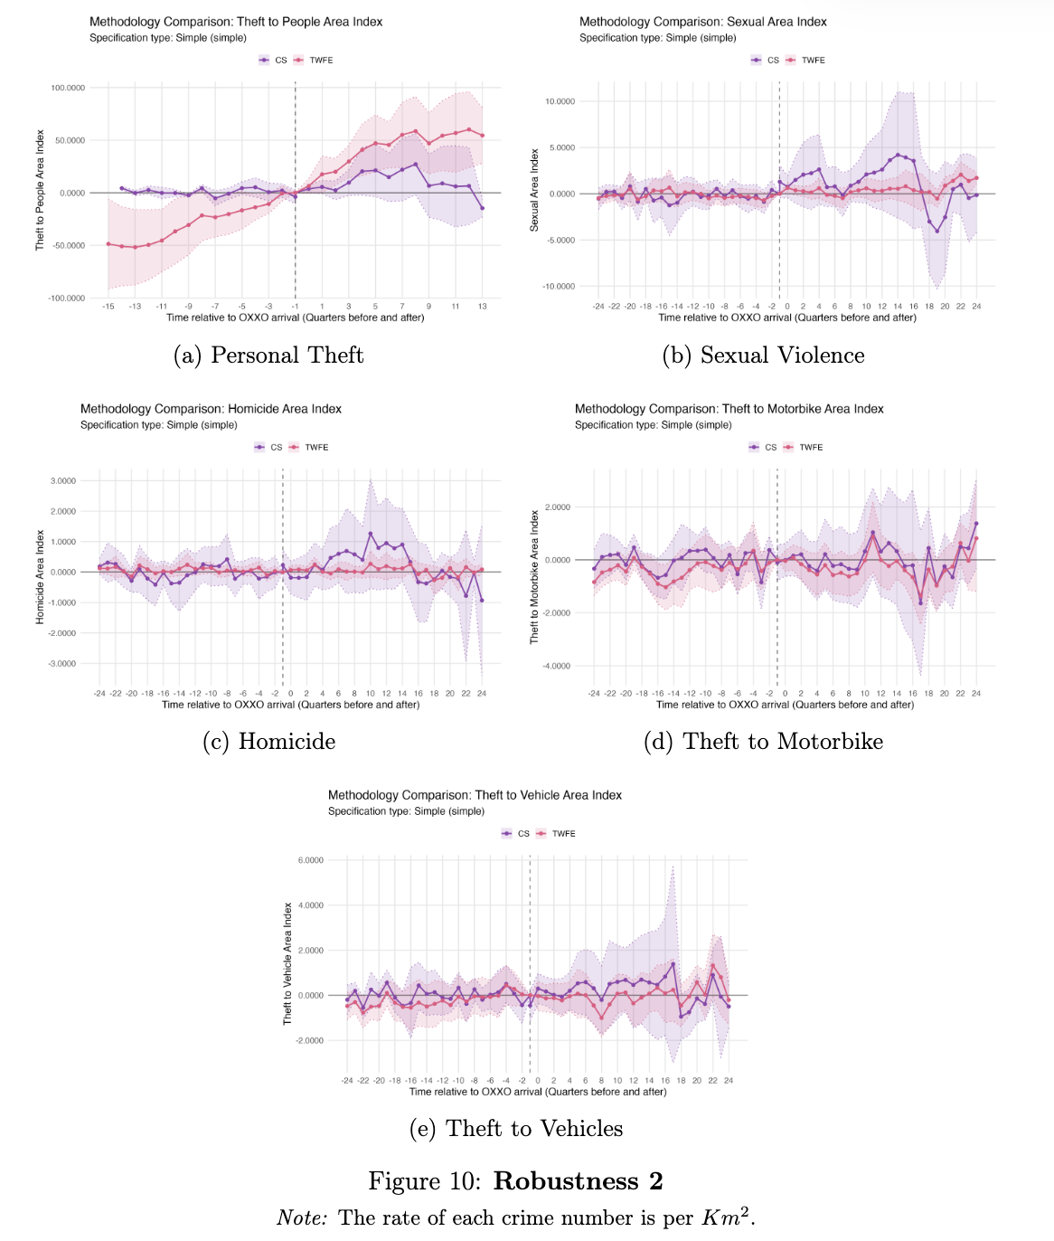

SIN NADA
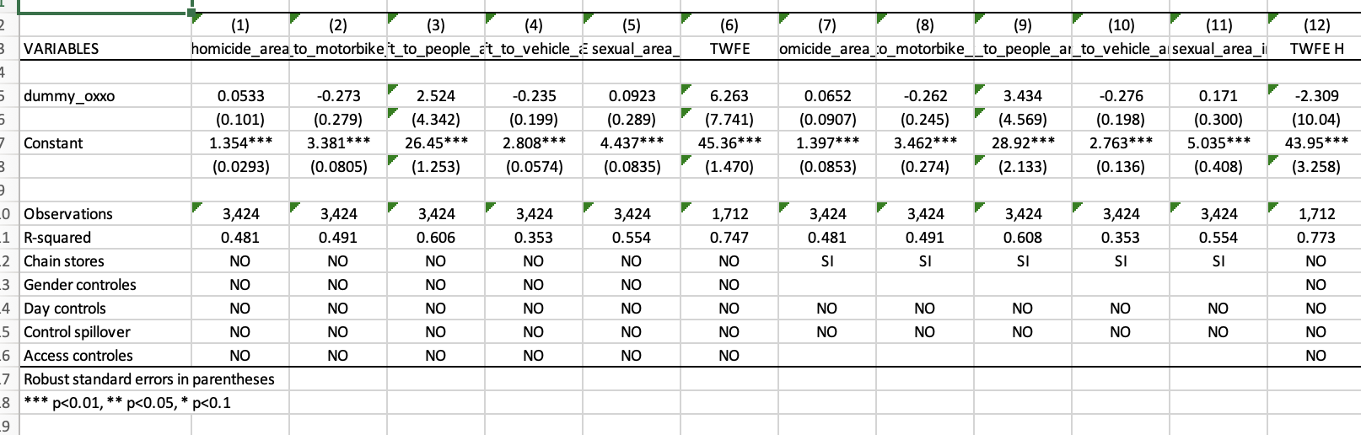
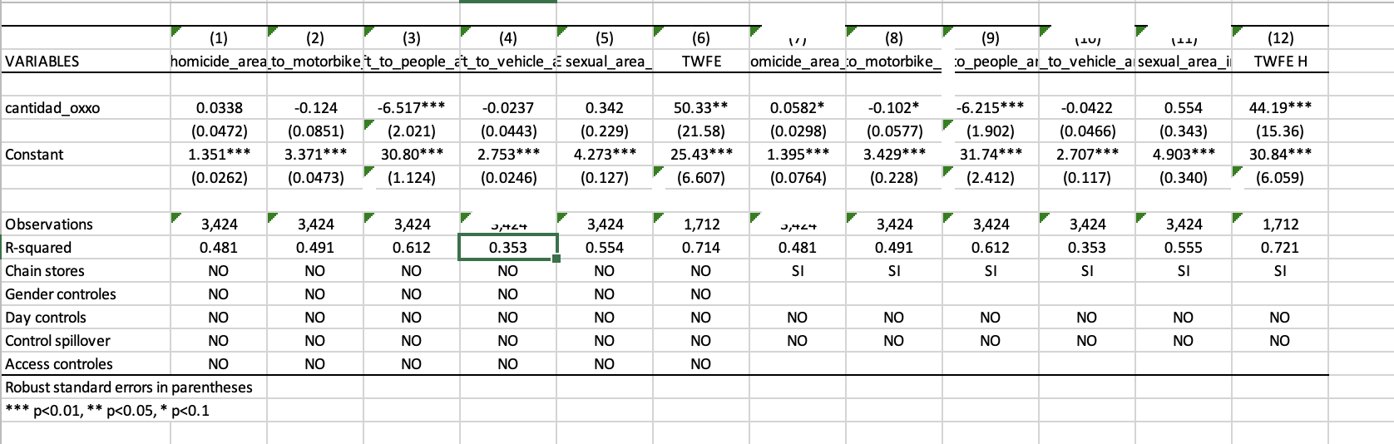

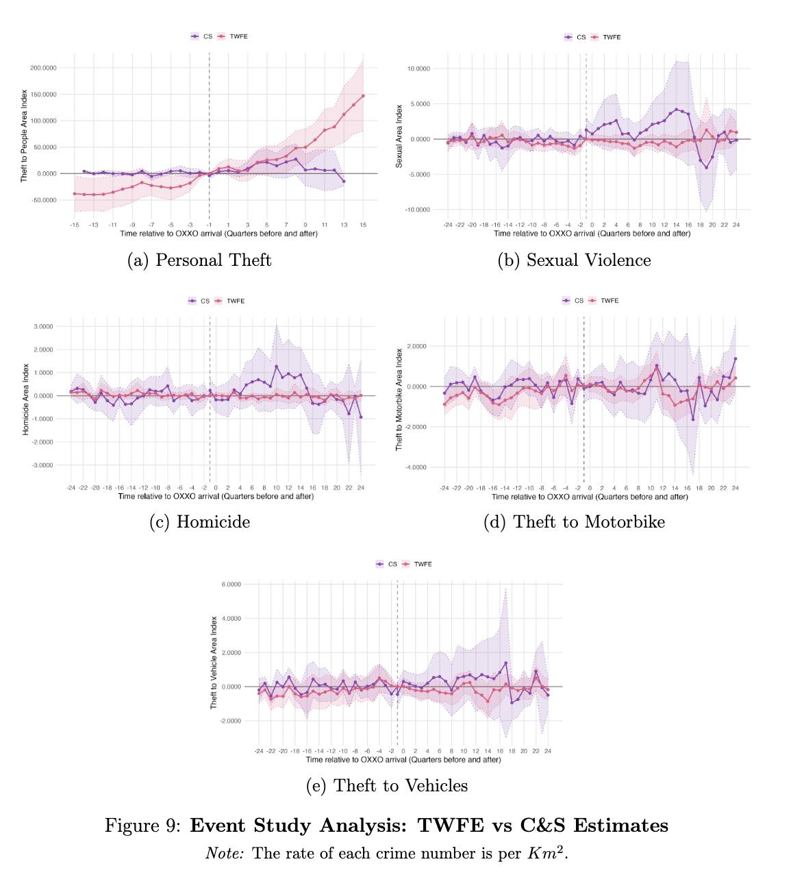
drop if codigo_upz == 97 | codigo_upz == 91 | codigo_upz == 93

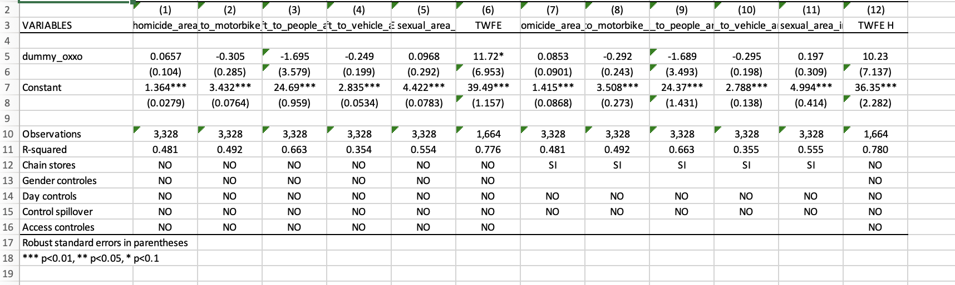
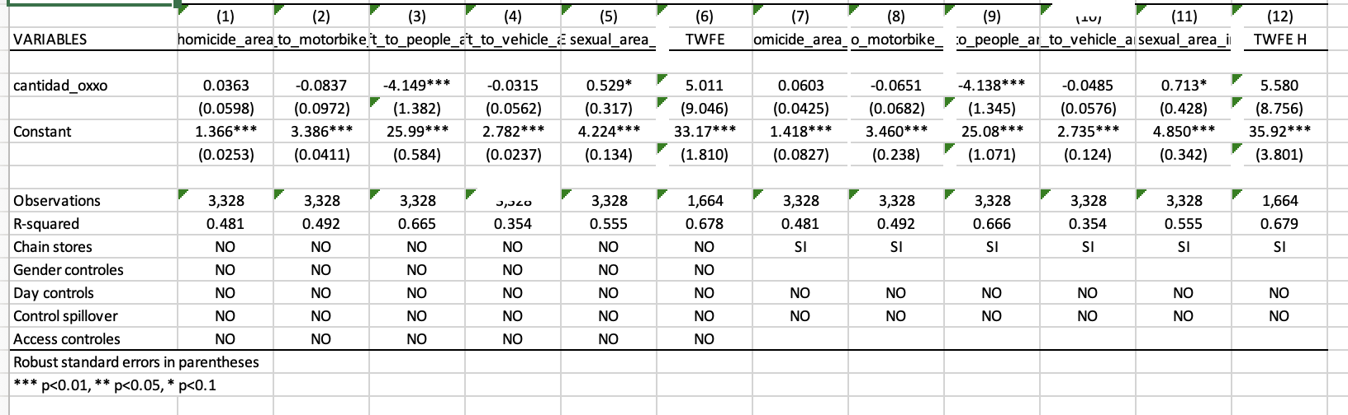

replace outliers = 1 if codigo_upz == 97 | codigo_upz == 91 | codigo_upz == 93 | theft_to_people_index_eb > 400

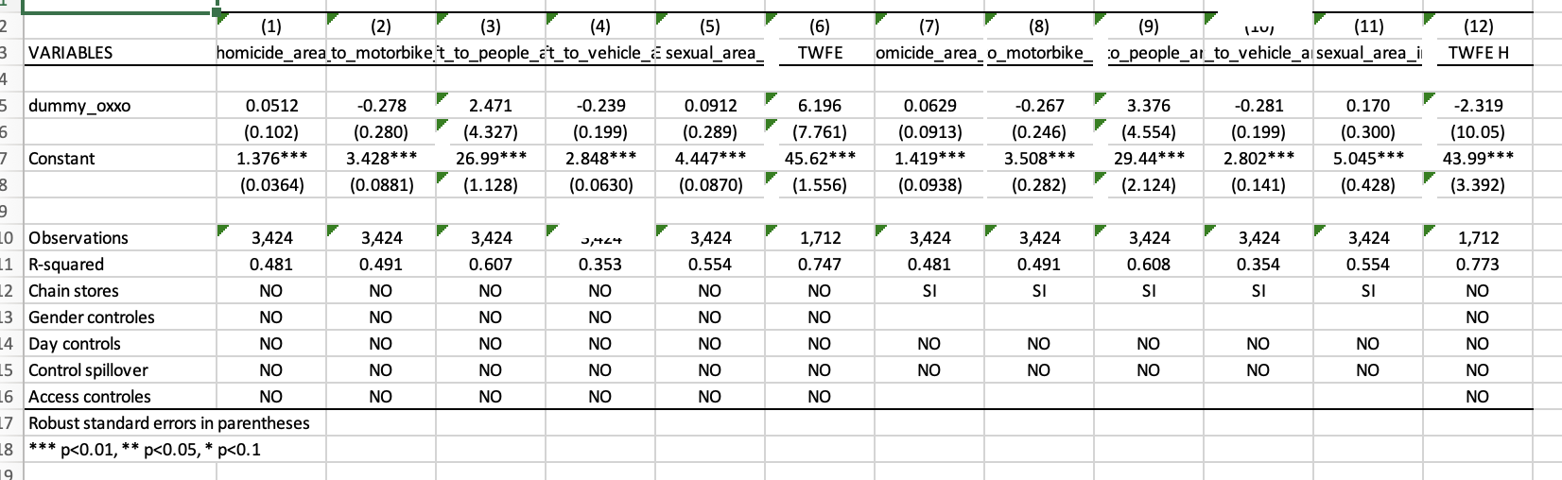
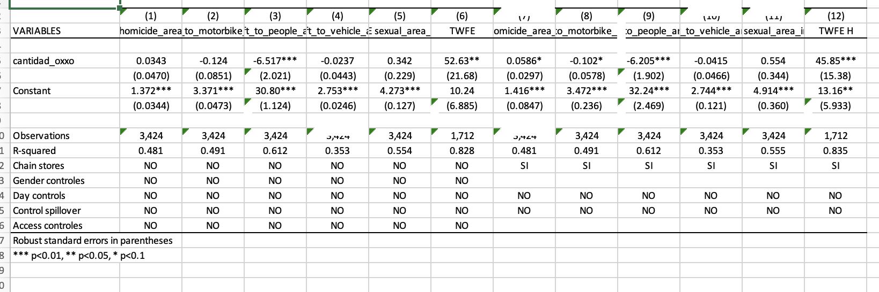
`

DISCUSSION

Their concentration in high foot-traffic areas increases the availability of potential targets for crimes such as robbery or assault \parencite{Dugato2026, shin2024dollar}. Moreover, due to their 24-hour format and alcohol sales during the night, OXXO locations may serve as informal gathering points which can, under certain conditions, escalate into conflicts or provide opportunities for illicit activities \parencite{Dugato2026}.
First, property crimes like theft are highly sensitive to situational deterrence mechanisms. The typical business model of OXXO stores includes 24/7 bright exterior lighting, high-definition security cameras, and a continuous influx of pedestrian traffic. According to the Routine Activity Theory and Jane Jacobs' concept of "eyes on the street," this increased natural surveillance drastically reduces the window of opportunity for street-level robbers, who generally seek dark, isolated areas. This operational nature explains the negative direction of the theft coefficients.
Second, the contrast in statistical significance may be heavily driven by severe underreporting (cifra negra) in official administrative data. In Bogotá, the transaction costs and lack of institutional trust often discourage citizens from formally reporting street thefts, generating substantial measurement error and inflating standard errors (as observed in the large standard error of 7.804 in Column 1). Conversely, homicides suffer from zero underreporting; every lethal event is strictly recorded by forensic and judicial authorities. Therefore, the statistical precision found exclusively in Column (3) might reflect data reliability rather than a true absence of shifting patterns in other crimes.

Finally, from a public order perspective, late-night convenience stores can inadvertently become focal points for nocturnal gatherings, alcohol consumption in adjacent public spaces, and minor disputes. In urban settings characterized by high baseline social friction, these dynamics can rapidly escalate into lethal altercations or gang-related territorial disputes. This phenomenon is widely documented in the "alcohol outlet density" literature, which links prolonged commercial hours with localized spikes in violent, rather than economic, crimes. Furthermore, since these estimates rely on a traditional Two-Way Fixed Effects (TWFE) framework under a staggered treatment design, part of this counterintuitive asymmetry could be exacerbated by negative weighting biases. If treatment effects vary dynamically over time, the traditional estimator might distort the true trajectory of property crime, a methodological limitation that highlights the necessity of the heterogeneous treatment robust estimators presented in the subsequent sections.

- Change the unit of analysis
- Treatment intensity plays a major role

CONCLUSIONS

ACKNOWLEDGEMENTS

