Metadata Exercise - Group 1

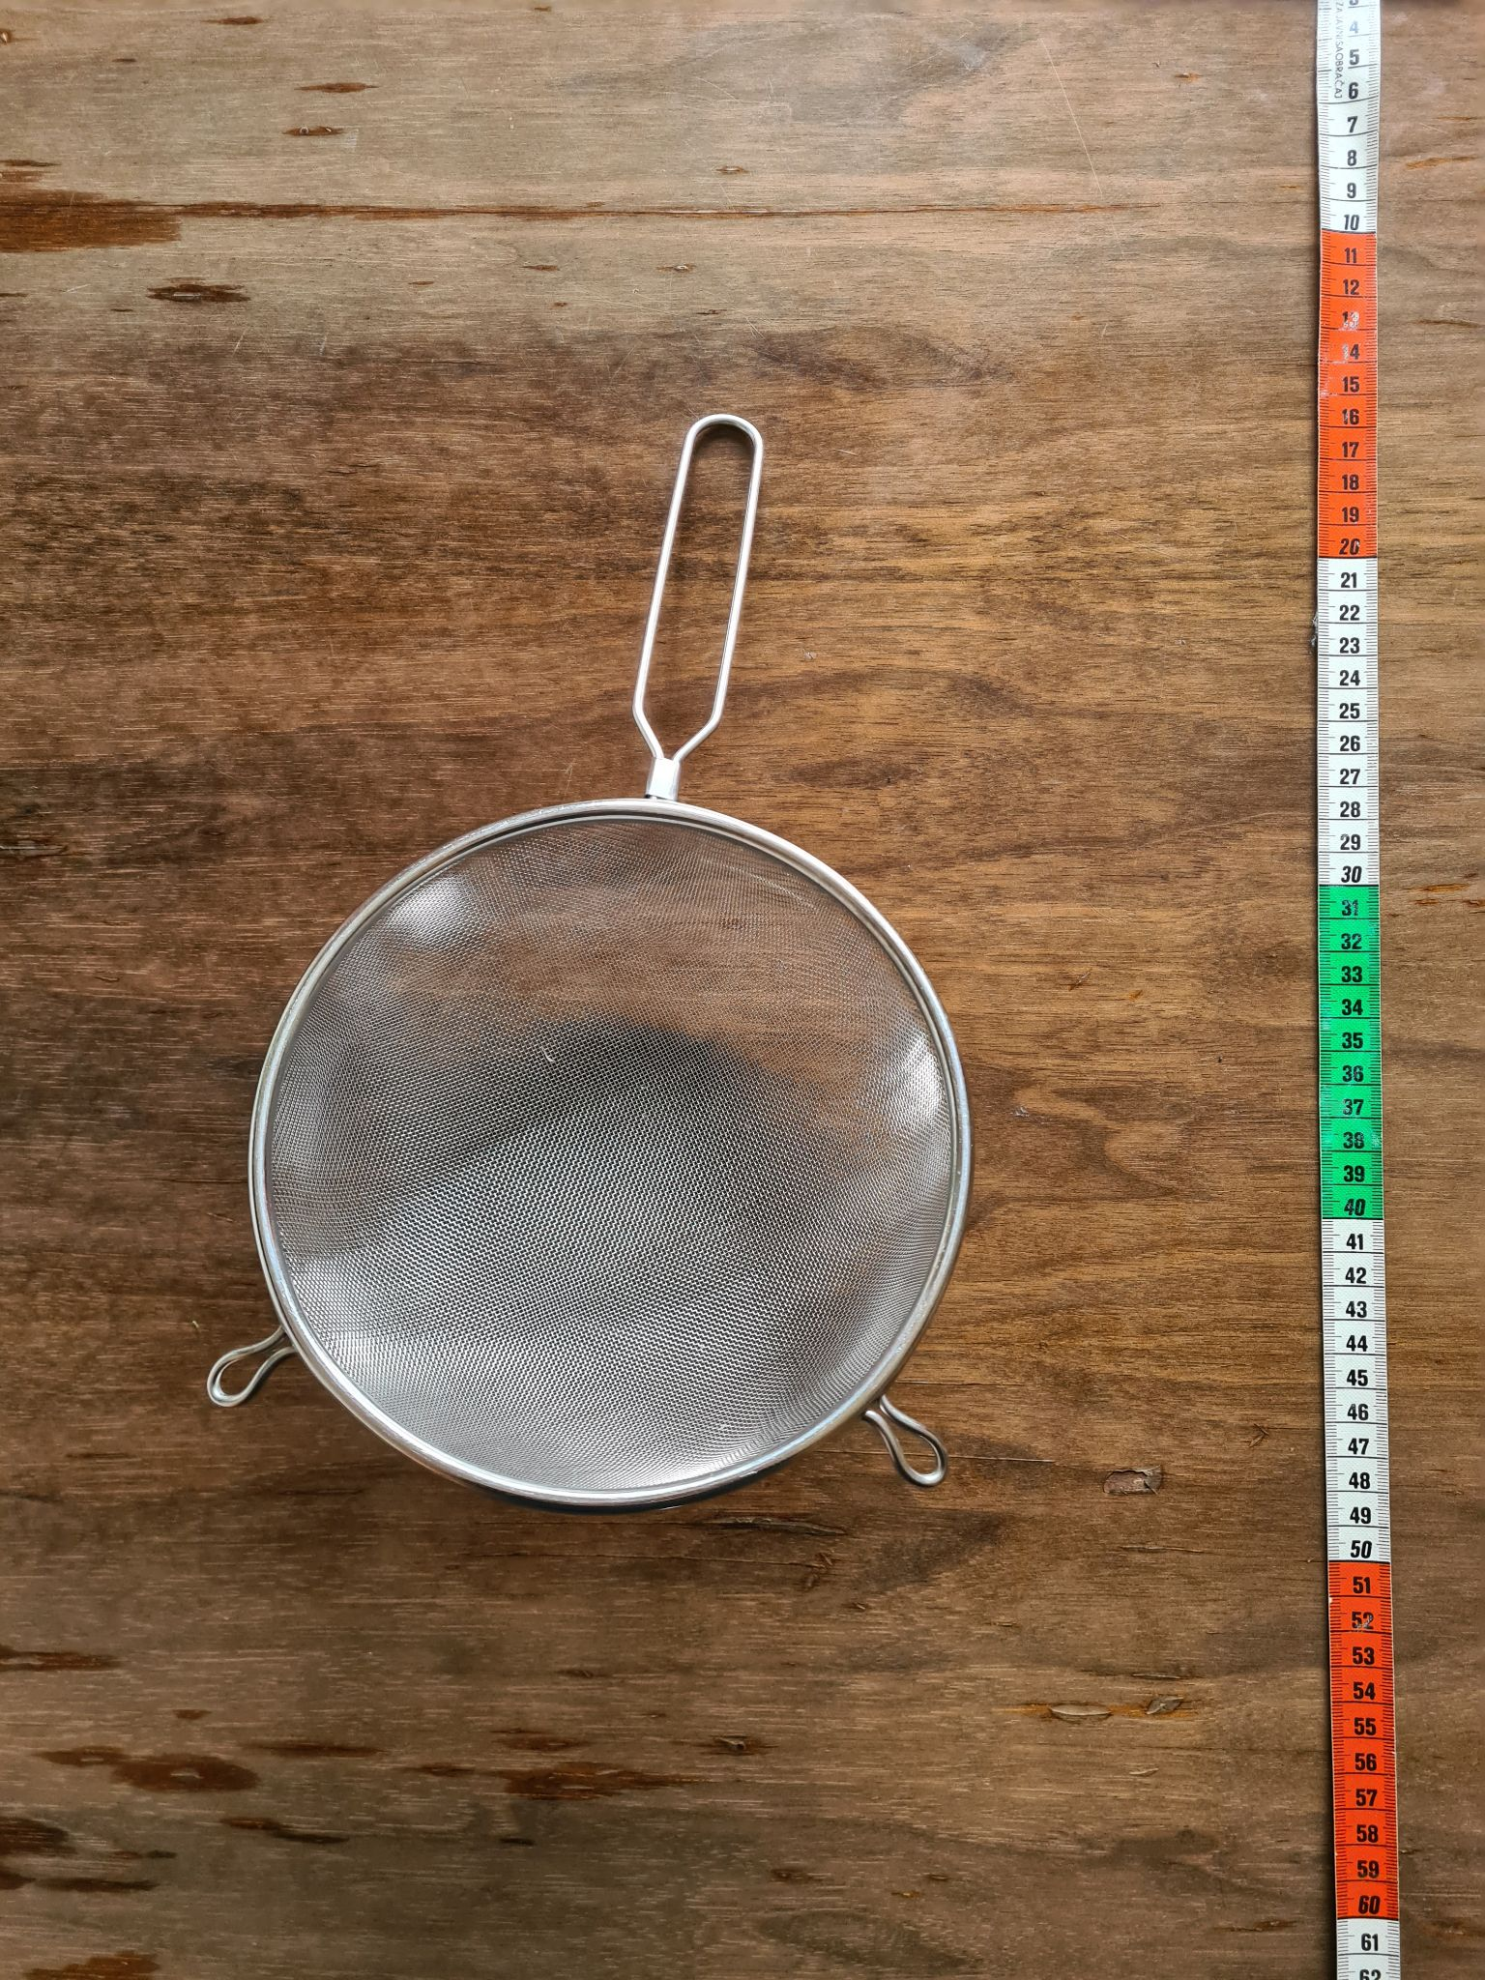Illustration: photo by Sophie Boße is licensed under CC0

Describe the object in the photo (not the photo itself) with metadata (max 10)!

1.

2.

3.

4.

5.

6.

7.

8.

9.

10.

Choose 1 Person to present your results!

