Excercise Text
You would like to combine datasets with different licenses. What is the resulting license?
- CC BY + CC BY SA =
  - CC BY
  - CC BY SA
  - Combination not possible
- CC BY SA + CC BY NC SA =
  - CC BY SA
  - CC BY NC SA
  - Combination not possible
- CC BY + CC BY ND =
  - CC BY
  - CC BY ND
  - Combination not possible

The right answers are marked in green.

Exercise images for presentation
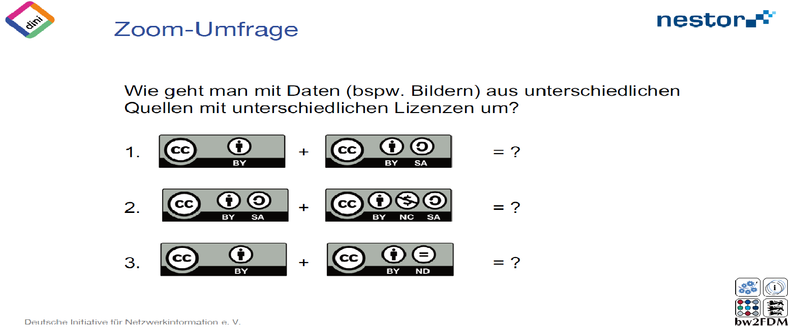
Exercise 1:
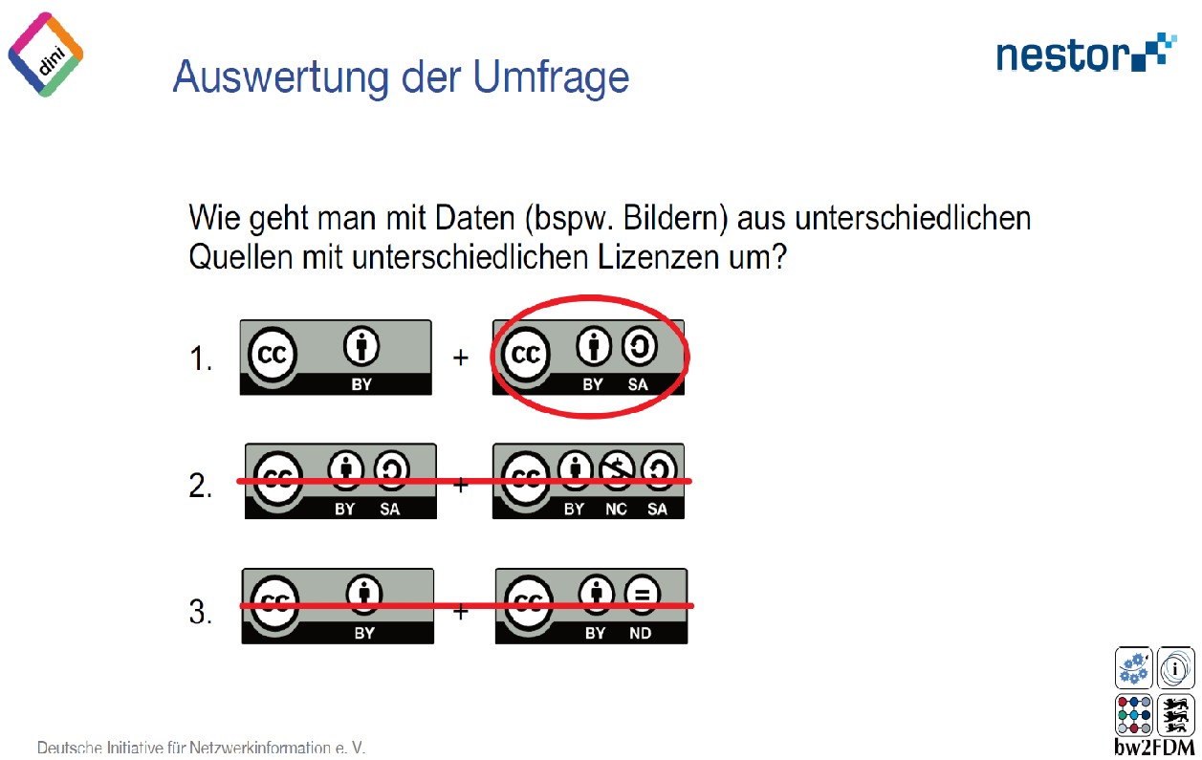

Exercise 2:

Exercise 3:
