Metadata Exercise - Room 4
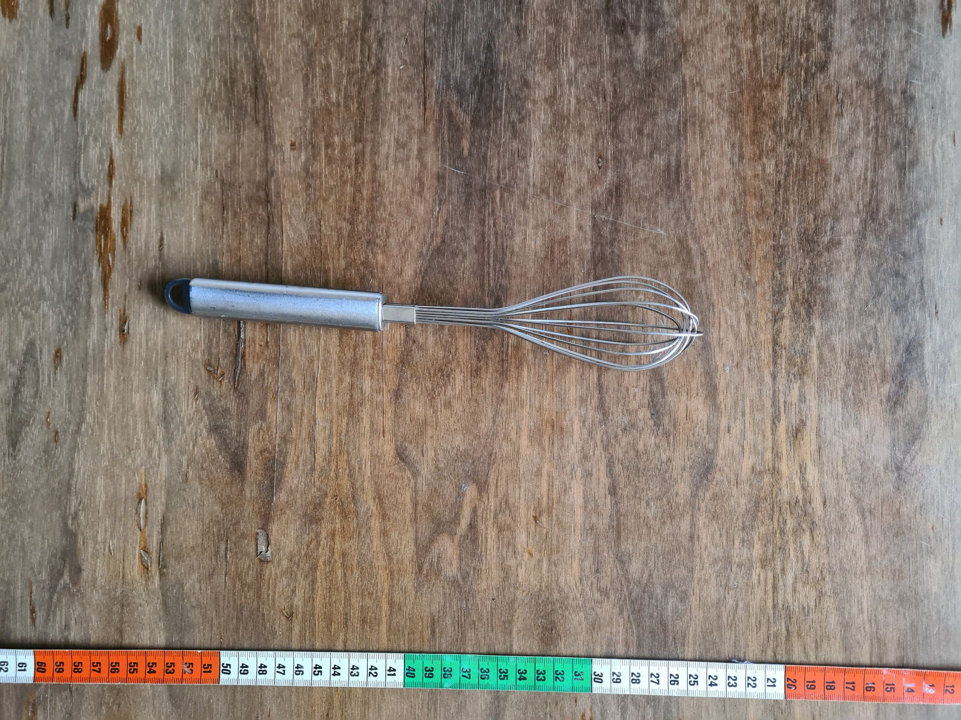
Illustration: photo by Sophie Boße is licensed under CC0

Describe the object in the photo (not the photo itself) with metadata (max 10)!

Choose 1 Person to present your results!

