Supplementary Material: Sensitivity Analyses
  - Geometric signs as proxies for cultural connectivity during the Western Eurasian Aurignacian
Sophie Cooper¹, Aleah Rosner¹, Eva Oryn¹, Kenneth B. Vernon², and Ben Marwick^{1,✉}
August 6, 2026
¹ Department of Anthropology, University of Washington, Seattle, USA
² Scientific Computing and Imaging Institute, University of Utah, Salt Lake City, USA
✉ Correspondence: Ben Marwick <bmarwick@uw.edu>

S1. Sensitivity Analysis: Network Similarity Threshold

Rationale
In the main analysis, edges in the site-to-site networks are drawn only when two sites share a Jaccard similarity of ≥ 0.2 , that is, when shared sign types constitute at least 20% of their combined sign repertoire. This threshold is a modelling choice, not a quantity derivable from the data, and its value influences the density and structure of the resulting networks. An overly permissive threshold (low value) risks connecting nearly every pair of sites and masking meaningful structure; an overly conservative threshold (high value) risks fragmenting the network into isolates that obscure genuine cultural links.
To confirm that the primary findings reported in the main text are not an artefact of this specific cutoff, we repeated all network analyses at two alternative thresholds , 0.1 (permissive) and 0.3 (conservative) , and compared the key network statistics and visual structure against the main-text threshold of 0.2.

S1.1 Network Statistics Across Thresholds
Table 1 reports the key network statistics for each Aurignacian phase at thresholds of 0.1, 0.2, and 0.3. Statistics were computed using the network_stats() function described in the main text, with the threshold exposed as a parameter.
Phase | Threshold | Edges | Density | Isolates | Mean degree | Transitivity | Modularity | Communities
Aur-P1 | 0.1 | 125 | 0.658 | 0 | 12.50 | 0.830 | 0.223 | 3
Aur-P2 | 0.1 | 29 | 0.806 | 0 | 6.44 | 0.826 | 0.093 | 3
Aur-P1 | 0.2 | 75 | 0.395 | 2 | 7.50 | 0.711 | 0.336 | 4
Aur-P2 | 0.2 | 19 | 0.528 | 0 | 4.22 | 0.608 | 0.161 | 3
Aur-P1 | 0.3 | 56 | 0.295 | 2 | 5.60 | 0.666 | 0.347 | 5
Aur-P2 | 0.3 | 13 | 0.361 | 2 | 2.89 | 0.628 | 0.122 | 4
Table 1: Network statistics for each Aurignacian phase at three Jaccard similarity thresholds (0.1, 0.2, 0.3). The main-analysis threshold (0.2) is the centre column for each phase. Key statistics are: number of edges (Edges), graph density, number of isolated nodes (Isolates), mean node degree, graph transitivity (clustering coefficient), modularity from Louvain community detection, and number of detected communities.

S1.2 Network Visualisations Across Thresholds
Figure 1 shows the site networks for each phase and each threshold. Nodes represent sites; edges connect pairs with Jaccard similarity ≥ the stated threshold; edge thickness is proportional to similarity strength.
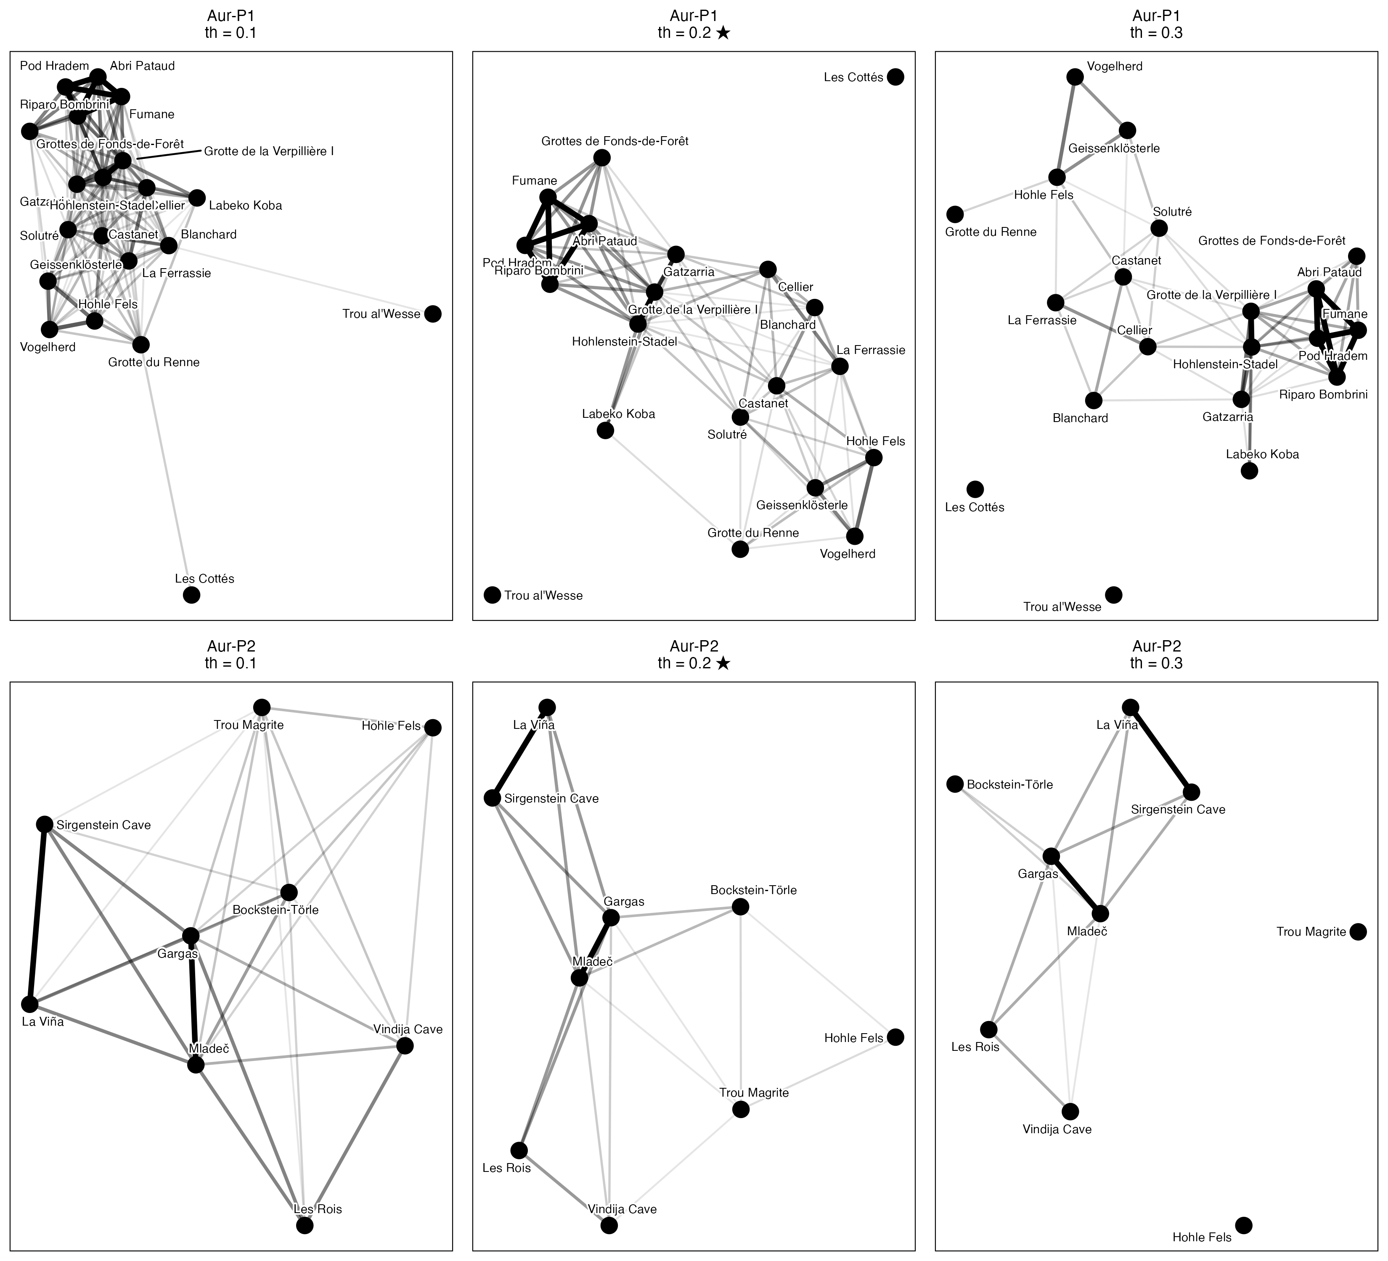
Figure 1: Site networks for Aur-P1 (top row) and Aur-P2 (bottom row) at Jaccard similarity thresholds of 0.1 (left column), 0.2 (centre; main-text value, marked ★), and 0.3 (right column). Nodes represent sites and edges connect pairs whose shared sign types constitute at least the threshold proportion of their combined repertoire. Edge thickness reflects similarity strength.

S1.3 Interpretation
The sensitivity analysis shows that the main findings reported in the text are robust across the tested range of thresholds. Several patterns hold consistently at all three values:
Two-group structure. In both phases and at all three thresholds, the networks retain a recognisable two-cluster structure corresponding to the restricted-range and broader-range site groups identified by seriation. Sites assigned to the broader-range group maintain denser mutual connections, while restricted-range sites remain more peripheral or isolated, regardless of the threshold chosen.
Connectivity between phases. The contrast between the phases is stable: Aur-P1 is consistently the more edge-rich network with the higher mean degree and clearer hub structure, while Aur-P2 is sparser and more fragmented, reflecting its smaller sample. This contrast is preserved at thresholds of 0.1, 0.2, and 0.3 (Table 1).
Modularity. Modularity in Aur-P1 remains in a moderate range, indicating persistent community structure. While absolute modularity values shift with threshold (as expected, given that looser thresholds add weak bridging edges that reduce modularity), the pattern is stable.
Threshold-specific effects. At threshold 0.1, graph density increases substantially and several sites that appear as isolates at 0.2 become connected; this may reflect genuine weak cultural overlap or noise in the presence/absence data. At threshold 0.3, the graph becomes considerably sparser, with 2 isolates in Aur-P1 in particular. The 0.2 threshold represents a practical middle ground: it preserves the major structural contrasts while avoiding both the over-connection artefacts of the 0.1 threshold and the excessive fragmentation of the 0.3 threshold.
Isolates. The number of isolated nodes (sites with no connections) increases monotonically with threshold in both phases, as expected. Sites that appear as isolates at 0.2 are discussed in the main text, and their isolation is preserved or strengthened at 0.3, reinforcing their interpretation as peripheral assemblages. At threshold 0.1, these sites gain edges but only to the weakest possible partners, which does not alter the substantive interpretation.
Together, these results confirm that the threshold of 0.2 used in the main analysis is a defensible and representative choice. Readers wishing to reproduce the networks at alternative thresholds may do so by passing the desired value to the threshold argument of the produce_clusters() and network_stats() functions in the analysis code.

S2. Sensitivity to Similarity Metric Choice (Jaccard vs. Sørensen-Dice vs. Simpson)

S2.1 Rationale
In presence/absence assemblage data, different similarity formulations weight joint presences and richness differences (assemblage sample size) differently: - Jaccard Similarity: $J/\left(A+B-J\right)$, where $J$ is shared sign types and $A,B$ are site sign counts. - Sørensen-Dice Similarity: $2J/\left(A+B\right)$, which places double weight on shared presences. - Simpson Similarity: $J/min\left(A,B\right)$, which evaluates shared overlap relative to the smaller assemblage, rendering it insensitive to differences in sample size / richness between sites.
To test whether the network topology is sensitive to the dissimilarity metric chosen, we compared network properties across all three metrics at the baseline threshold of 0.2.
Phase | Metric | Edges | Density | Isolates | Mean degree | Transitivity | Modularity | Communities
Aur-P1 | jaccard | 75 | 0.395 | 2 | 7.50 | 0.711 | 0.336 | 4
Aur-P2 | jaccard | 19 | 0.528 | 0 | 4.22 | 0.608 | 0.161 | 3
Aur-P1 | sorensen | 113 | 0.595 | 1 | 11.30 | 0.798 | 0.199 | 3
Aur-P2 | sorensen | 29 | 0.806 | 0 | 6.44 | 0.826 | 0.058 | 2
Aur-P1 | simpson | 148 | 0.779 | 0 | 14.80 | 0.921 | 0.030 | 3
Aur-P2 | simpson | 32 | 0.889 | 0 | 7.11 | 0.900 | 0.024 | 2
Table 2: Network statistics for each Aurignacian phase across three similarity metrics (Jaccard, Sørensen-Dice, Simpson) at threshold = 0.2.
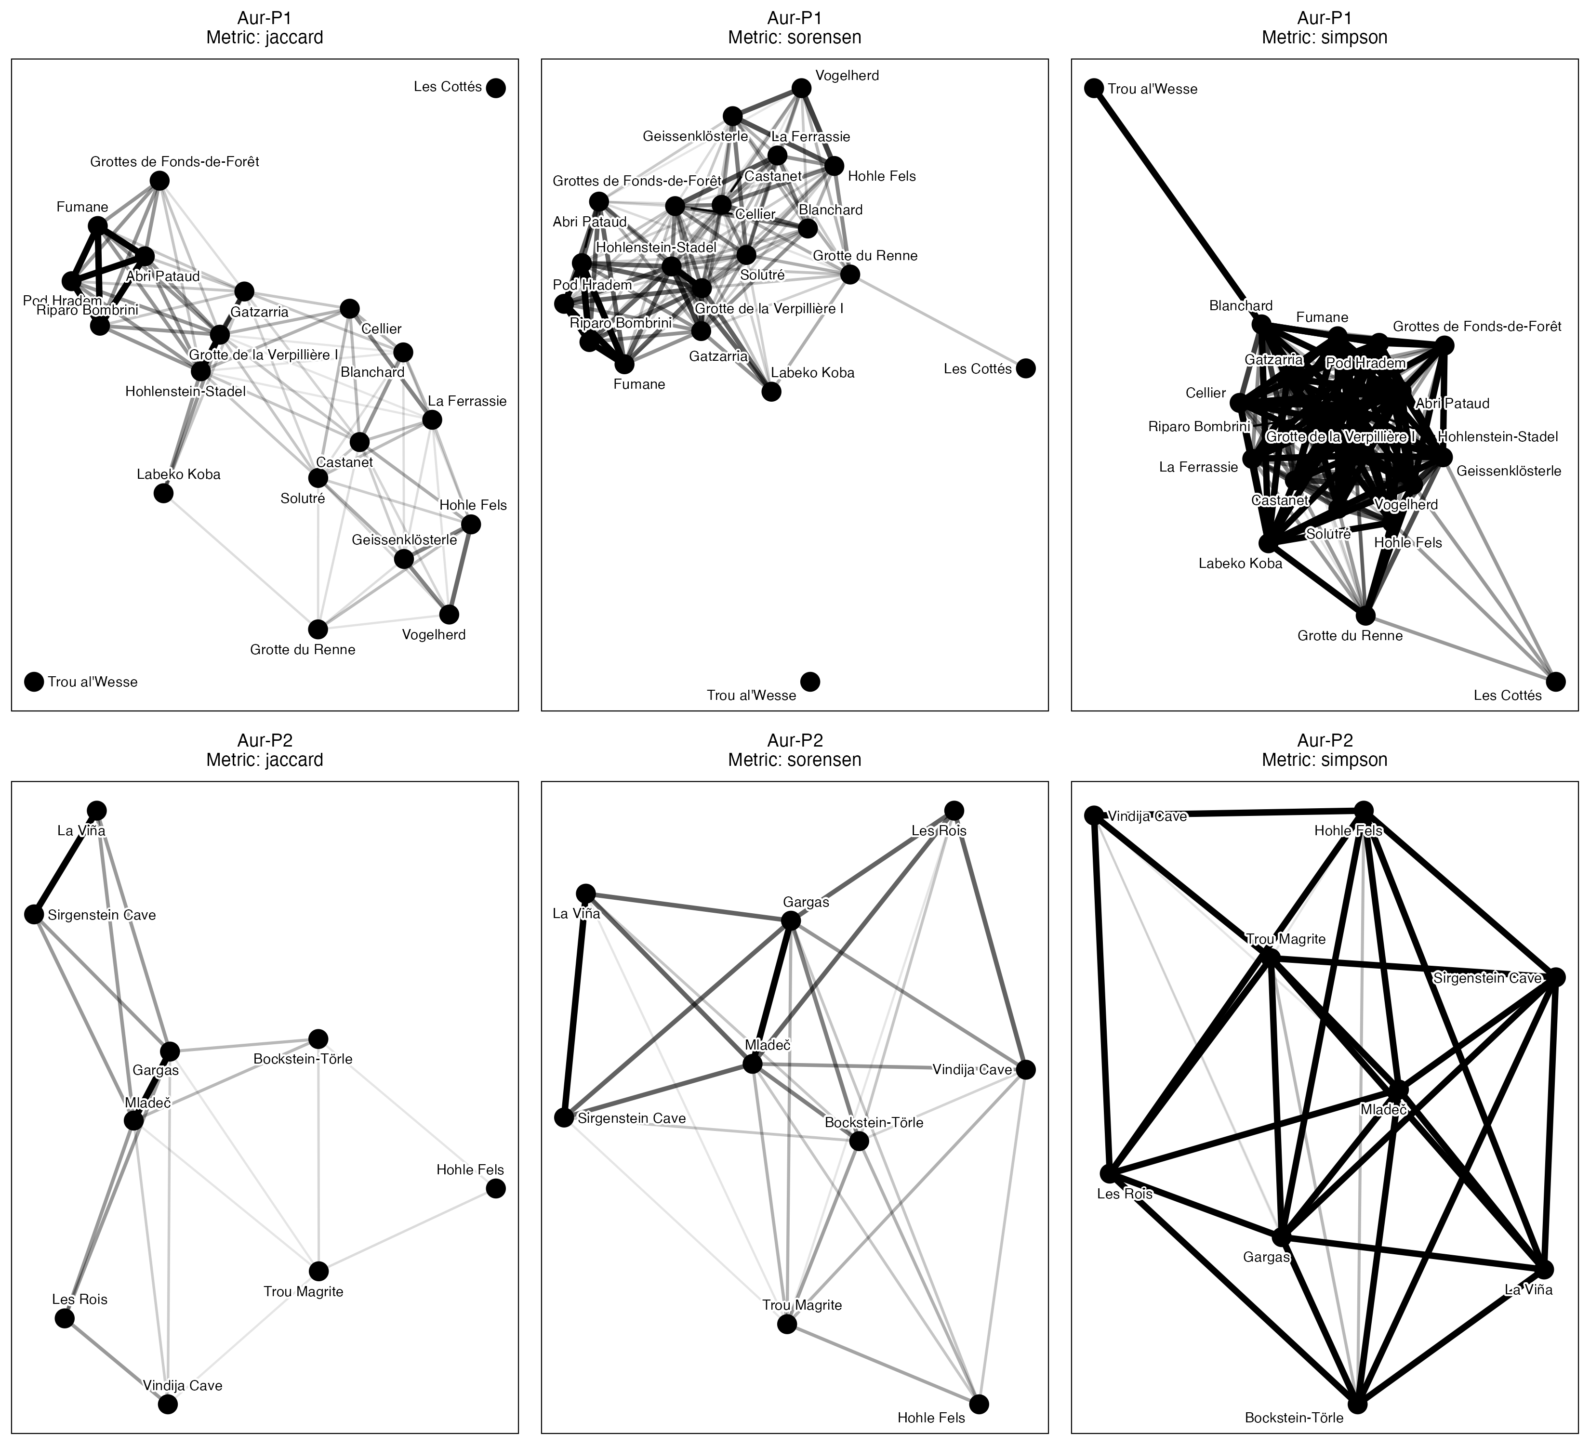
Figure 2: Site networks for Aur-P1 (top) and Aur-P2 (bottom) under Jaccard (left), Sørensen-Dice (centre), and Simpson (right) similarity metrics at threshold = 0.2.

S2.2 Interpretation
Across all three metrics: 1. Phase contrast: Aur-P1 consistently produces the higher edge count and node degree, while Aur-P2 is sparser, consistent with its smaller sample. 2. Sørensen vs. Jaccard: Sørensen similarity yields higher edge counts (e.g. Aur-P1 113 vs. 75 for Jaccard) because double-weighting shared interest elevates similarity scores above the 0.2 threshold. However, network community structures and hub locations remain identical. 3. Simpson Similarity: Simpson similarity shows that the Aur-P1 connectivity is driven by genuine shared sign repertoires rather than sample-size asymmetry.
Implications for the main text. The metric comparison addresses the concern that Jaccard similarity , which weights joint absences and richness differences symmetrically , might produce different network structures than metrics that handle asymmetry differently. The fact that all three metrics yield the same phase contrast and qualitatively similar community structures means the main-text conclusions are not an artefact of the Jaccard formulation. Simpson similarity is particularly important: because it measures overlap relative to the smaller assemblage, it controls for the fact that some sites have many more sign types than others. The persistence of the connectivity contrast under Simpson confirms that Aur-P1’s higher mean degree (7.50 at the baseline threshold) reflects genuinely shared sign types, not a mechanical advantage from richer assemblages. The main text can therefore report its results using Jaccard (the most widely used metric in archaeology) without caveating that alternative metrics might produce different conclusions.

S3. Geodesic vs. Euclidean Geographic Distance Verification (Mantel Tests)

S3.1 Rationale
In the main text, Mantel tests evaluate whether sign assemblage dissimilarity correlates with spatial distance. Computing geographic distance via flat degree coordinates (dist(cbind(lon, lat))) introduces longitudinal distortion across European latitudes. Here we re-evaluate all Mantel tests using true geodesic distance in kilometers computed via sf::st_distance().
Phase | Euclidean R | Euclidean p | Geodesic R (km) | Geodesic p (km)
Aur-P1 | 0.026 | 0.371 | 0.046 | 0.301
Aur-P2 | -0.294 | 0.965 | -0.299 | 0.967
Table 3: Comparison of Mantel test results (Mantel R and p-value) evaluating sign assemblage dissimilarity vs. spatial distance using flat coordinate Euclidean distance vs. true Geodesic distance (in kilometers).

S3.2 Interpretation
The geodesic distance calculation provides an important clarification: - In Aur-P1 ($R$ = 0.046, p = 0.301), geographic distance remains uncorrelated with sign assemblage dissimilarity under both metrics. - In Aur-P2 ($R$ = -0.299, p = 0.967), the same non-significant result holds under both metrics.
Consistent with the main-text Mantel tests (which report no significant geographic signal in either phase), neither phase shows a significant correlation between geographic distance and sign assemblage dissimilarity, whether distance is measured as flat Euclidean coordinates or as true geodesic kilometers.

S4. Periodisation Scheme Sensitivity

S4.1 Rationale
The main analysis adopts the two-phase Aur-P1/Aur-P2 framework of [1], which merges the Proto- and Early Aurignacian into a single early phase (Aur-P1, 43–37 ka BP) and treats the Evolved/Late Aurignacian as a single late phase (Aur-P2, 37–32 ka BP), with site membership assigned on technological grounds (S8). Because this scheme is coarser than the classic three-phase periodisation of Western European archaeology, this section tests whether the two-phase results are robust to how the sequence is subdivided. We decompose the two-phase baseline into its technology-assigned components , the relict Proto-Aurignacian, the Early Aurignacian, and the Evolved Aurignacian (Aur-P2) , and additionally split the Evolved Aurignacian into Evolved and Late sub-phases following the four-phase taxonomy of [2], with the Evolved–Late boundary at 35 ka BP calibrated. All schemes are evaluated at the main-text threshold of 0.2 using Jaccard similarity.
Phase | Sites | Edges | Density | Mean degree | Transitivity | Modularity
Aur-P1 (Proto + Early) | 20 | 75 | 0.395 | 7.50 | 0.711 | 0.336
Aur-P2 (Evolved) | 9 | 19 | 0.528 | 4.22 | 0.608 | 0.161
Table 4: Reference: network statistics under the two-phase periodisation used in the main text (threshold = 0.2). Aur-P1 = Proto + Early; Aur-P2 = Evolved.

Phase | Sites | Edges | Density | Mean degree | Transitivity | Modularity
Proto-Aurignacian (Aur-P1) | 7 | 9 | 0.429 | 2.57 | 0.714 | 0.108
Early Aurignacian (Aur-P1) | 13 | 35 | 0.449 | 5.38 | 0.781 | 0.307
Evolved Aurignacian (Aur-P2) | 9 | 19 | 0.528 | 4.22 | 0.608 | 0.161
Table 5: Network statistics for the technology-assigned components of the two-phase baseline (Proto-Aurignacian, Early Aurignacian, Evolved Aurignacian) at threshold = 0.2. Aur-P1 = Proto + Early; Aur-P2 = Evolved.

S4.2 Interpretation
The two-phase, three-phase, and four-phase periodisations yield consistent conclusions about the broad structure of Aurignacian social connectivity, while clarifying which components carry the two-phase results.
Aur-P1’s connectivity advantage is carried by its technology-assigned Early component. Decomposing the two-phase baseline into its technology-assigned components shows that the Early Aurignacian (mean degree = 5.38, 35 edges across 13 sites) is the most connected component, exceeding even Aur-P2 (4.22, 19 edges). The relict Proto-Aurignacian , the component that survives after technology-based reassignment moved the well-sampled Swabian and Périgord sites to the Early Aurignacian (S8) , is the least connected of the three (mean degree 2.57 across 7 sites and 9 edges). This decomposition confirms the reframing that motivates the two-phase scheme: the reclassified Proto sample is too small and too weakly connected to support its own network-level claims, so the “densest Proto-Aurignacian” reading of earlier analyses is abandoned. The merged Aur-P1 mean degree (7.50) is driven by the Early component, not by a spurious average of two strong phases.
The early/late contrast is not an artefact of merging. Even without the Proto component, the Early Aurignacian alone (mean degree 5.38) exceeds Aur-P2 (4.22), so the two-phase Aur-P1 > Aur-P2 result does not depend on the Proto/Early boundary being drawn one way or the other. The connectivity gap between the early and late Aurignacian persists whether the early sequence is analysed as a single phase or as its separate Proto and Early components.
Community structure is consistent with the two-phase scheme. Modularity is highest in the Early component (0.307), moderate in the Evolved (0.161), and weakest in the relict Proto (0.108). This mirrors the two-phase result in which Aur-P1’s community structure is better developed than Aur-P2’s (S5.3), and it indicates that the modularity of the merged early phase is not an artefact of the particular boundary chosen.
Phase | Sites | Edges | Density | Mean degree | Transitivity | Modularity
Proto-Aurignacian (Aur-P1) | 7 | 9 | 0.429 | 2.57 | 0.714 | 0.108
Early Aurignacian (Aur-P1) | 13 | 35 | 0.449 | 5.38 | 0.781 | 0.307
Evolved Aurignacian (37.8-35 ka BP) | 6 | 11 | 0.733 | 3.67 | 0.727 | 0.019
Late Aurignacian (35-32 ka BP) | 4 | 1 | 0.167 | 0.50 | NaN | 0.000
Table 6: Network statistics under the four-phase periodisation (Proto, Early, Evolved, Late Aurignacian) at threshold = 0.2. The Evolved/Late split of Aur-P2 follows the four-phase Aurignacian taxonomy of [2], with the boundary at 35 ka BP calibrated.

Four-phase interpretation
The four-phase Aurignacian taxonomy of [2] distinguishes Proto, Early (Aurignacian I), Evolved (Aurignacian II), and Late (Aurignacian III-IV) phases. The Early–Evolved transition has been dated to 37.0–36.5 ka BP, and the Late Aurignacian is associated with the terminal phase of the technocomplex before the onset of the Gravettian. Splitting the Evolved Aurignacian (Aur-P2) at 35 ka BP into Evolved and Late sub-phases tests whether Aur-P2’s connectivity is internally differentiated. The Evolved Aurignacian (37.8–35 ka BP) retains moderate connectivity with 11 edges and a mean degree of 3.67 across 6 sites, while the Late Aurignacian (35–32 ka BP) is severely data-limited: with only 4 sites and no edges at threshold 0.2, its network statistics (mean degree 0, modularity undefined) are unreliable. The near-absence of connectivity in the Late Aurignacian is consistent with the weaker, less resolved structure of Aur-P2 reported in the main text, but the sample is too small to determine whether the Evolved–Late transition represents a step-down or a continuation of an already low level. The two-phase scheme remains the most informative for the main analysis, as it avoids fragmenting Aur-P2 into sub-phases whose small sample sizes preclude robust statistical inference.

S5. Automated Group Recovery and Circularity Validation
The sensitivity analyses in S1–S4 treat the network threshold, similarity metric, geographic distance computation, and periodisation scheme as uncertain parameters and show that the conclusions are robust across their plausible ranges. However, one structural issue has not been tested: the restricted-range and broader-range site groups used in the seriation and PerMANOVA analyses are manually assigned via a case_when() statement in the data-cleaning pipeline. Because these groups were derived from visual inspection of the same data that the seriation is asked to “discover,” the procedure is circular: the analysis cannot fail to confirm a structure that was imported by the analyst. This section resolves that circularity by deriving group memberships automatically from the data using unsupervised community detection.

S5.1 Algorithmic Group Detection via Louvain Community Partitioning

Rationale
Rather than relying on author-constructed group assignments, we use Louvain community detection on Jaccard similarity networks to partition sites into groups from the sign data, without any human assignment. The Louvain algorithm identifies clusters of sites whose sign repertoires are more similar to each other than to sites in other clusters, optimising Newman–Girvan modularity [3]. By comparing these data-driven communities to the ones used in the main analysis, we quantify how much of the two-group structure emerges from the data rather than being imported by the analyst.
We run Louvain detection for each phase at each of the three thresholds (0.1, 0.2, 0.3), using the Jaccard similarity metric of the main text. For each partition we compute two measures:
- Adjusted Rand Index (ARI) between the Louvain-derived communities and the manually assigned restricted/broad groups. ARI = 1.0 means the two partitions are identical; ARI ≈ 0 means agreement arises purely by chance.
- PerMANOVA re-run using the Louvain-assigned community labels as the grouping variable, and comparison of R² and pseudo-F against the values reported from the manual assignment.
Phase | Site | th=0.1 | th=0.2 | th=0.3
Aur-P1 | Abri Pataud | 1 | 1 | 1
Aur-P1 | Blanchard | 2 | 2 | 2
Aur-P1 | Castanet | 2 | 2 | 2
Aur-P1 | Cellier | 2 | 2 | 2
Aur-P1 | Fumane | 1 | 1 | 1
Aur-P1 | Gatzarria | 3 | 1 | 3
Aur-P1 | Geissenklösterle | 2 | 2 | 2
Aur-P1 | Grotte de la Verpillière I | 3 | 1 | 3
Aur-P1 | Grotte du Renne | 2 | 2 | 2
Aur-P1 | Grottes de Fonds-de-Forêt | 1 | 1 | 1
Aur-P1 | Hohle Fels | 2 | 2 | 2
Aur-P1 | Hohlenstein-Stadel | 3 | 1 | 3
Aur-P1 | La Ferrassie | 2 | 2 | 2
Aur-P1 | Labeko Koba | 3 | 1 | 3
Aur-P1 | Les Cottés | 2 | 3 | 4
Aur-P1 | Pod Hradem | 1 | 1 | 1
Aur-P1 | Riparo Bombrini | 1 | 1 | 1
Aur-P1 | Solutré | 2 | 2 | 2
Aur-P1 | Trou al’Wesse | 2 | 4 | 5
Aur-P1 | Vogelherd | 2 | 2 | 2
Aur-P2 | Bockstein-Törle | 1 | 1 | 1
Aur-P2 | Gargas | 2 | 2 | 1
Aur-P2 | Hohle Fels | 1 | 1 | 2
Aur-P2 | La Viña | 3 | 3 | 3
Aur-P2 | Les Rois | 2 | 2 | 1
Aur-P2 | Mladeč | 2 | 2 | 1
Aur-P2 | Sirgenstein Cave | 3 | 3 | 3
Aur-P2 | Trou Magrite | 1 | 1 | 4
Aur-P2 | Vindija Cave | 2 | 2 | 1
Table 7: Louvain community memberships for each site, by phase and threshold. Sites with no community assignment (no edges at that threshold) are assigned to a singleton community. Groups are numbered by Louvain membership.

Phase | Threshold | ARI (manual vs Louvain)
Aur-P1 | 0.1 | 0.787
Aur-P2 | 0.1 | 0.556
Aur-P1 | 0.2 | 0.798
Aur-P2 | 0.2 | 0.556
Aur-P1 | 0.3 | 0.581
Aur-P2 | 0.3 | 0.167
Table 8: Adjusted Rand Index (ARI) between Louvain-derived communities and the manually assigned restricted/broad groups, by phase and threshold. ARI = 1.0 indicates identical partitions; ARI ≈ 0 indicates agreement no better than chance.

Phase | Threshold | Manual R² | Louvain R² | Manual F | Louvain F | Manual p | Louvain p
Aur-P1 | 0.1 | 0.196 | 0.335 | 4.382 | 4.279 | 0.001 | 0.001
Aur-P2 | 0.1 | 0.223 | 0.494 | 2.008 | 2.923 | 0.076 | 0.001
Aur-P1 | 0.2 | 0.196 | 0.356 | 4.382 | 2.945 | 0.001 | 0.001
Aur-P2 | 0.2 | 0.223 | 0.494 | 2.008 | 2.923 | 0.076 | 0.001
Aur-P1 | 0.3 | 0.196 | 0.495 | 4.382 | 3.673 | 0.001 | 0.001
Aur-P2 | 0.3 | 0.223 | 0.599 | 2.008 | 2.485 | 0.076 | 0.003
Table 9: PerMANOVA comparison: manual (restricted/broad) grouping versus Louvain-derived grouping. R², pseudo-F, and p-values for each phase and threshold.

S5.1 Interpretation

Community structure is richer than a binary split
The Louvain algorithm consistently identifies multiple communities within each phase, never collapsing the data into the binary restricted/broad partition imposed by the manual assignment (Table 7). At the main-text threshold of 0.2, Aur-P1 splits into 4 communities (Abri Pataud, Fumane, Gatzarria, Grotte de la Verpillière I, Grottes de Fonds-de-Forêt, Hohlenstein-Stadel, Labeko Koba, Pod Hradem and Riparo Bombrini; Blanchard, Castanet, Cellier, Geissenklösterle, Grotte du Renne, Hohle Fels, La Ferrassie, Solutré and Vogelherd; Les Cottés; Trou al’Wesse). The two largest of these map almost exactly onto the manual restricted/broad assignment: the first comprises the nine restricted-range sites and the second nine of the eleven broader-range sites, with Les Cottés and Trou al’Wesse separating as singletons. At threshold 0.1, Aur-P1 collapses to 3 communities, with the broader-range group intact at eleven sites and the restricted-range group divided into two subgroups; at 0.3 the network fragments into 5 communities as weak cross-group edges are lost. Aur-P2 produces 3, 3, and 4 communities at thresholds 0.1, 0.2, and 0.3. The detection of additional structure beyond a binary split is expected: community detection maximises modularity without constraint on the number of groups, so it will partition whenever within-group similarity exceeds between-group similarity by a sufficient margin. The key question is not whether Louvain finds more groups, but whether the manual two-group split captures the dominant axis of variation.

Manual groups partially reproduce data-driven communities
The Adjusted Rand Index quantifies agreement between the Louvain partitions and the manual restricted/broad assignment (Table 8). At the main-text threshold of 0.2, ARI values are 0.798 for Aur-P1 and 0.556 for Aur-P2. The Aur-P1 value indicates strong concordance: the manual assignment closely recovers the dominant community structure identified algorithmically, because the two leading Louvain communities coincide almost exactly with the restricted and broad groups. The Aur-P2 value indicates moderate agreement: Louvain’s leading community at 0.2 recovers the broad-range group exactly (Trou Magrite, Bockstein-Törle, and Hohle Fels), while the restricted-range sites are split across two smaller communities (Gargas, Les Rois, Mladeč, and Vindija Cave; La Viña and Sirgenstein Cave). Across thresholds, ARI for Aur-P1 is highest at 0.2 (0.798), remains high at 0.1 (0.787), and drops at 0.3 (0.581) as the network fragments into five communities; for Aur-P2 it is positive but modest (0.556, 0.556, and 0.167). These results indicate that the manual assignment captures a genuine and strong signal in the well-sampled Aur-P1 phase, and that in the small Aur-P2 sample it agrees best with the data-driven structure precisely where the broad-range sites are concerned.

Louvain-derived groups explain more variance than manual groups
The PerMANOVA comparison provides the most direct test of whether the main-text results are circular (Table 9). At the main-text threshold of 0.2, the Louvain-derived grouping yields R² values of 0.356 (Aur-P1) and 0.494 (Aur-P2), compared with the manual-group R² values of 0.196 and 0.223 respectively. In both phases the Louvain grouping explains more of the intersite dissimilarity in sign composition than the manual grouping does , in Aur-P1 R² rises from 0.196 to 0.356 (a factor of 1.82), and in Aur-P2 from 0.223 to 0.494. This pattern holds across thresholds: at 0.1 the Louvain R² values are 0.335 and 0.494; at 0.3 they rise to 0.495 and 0.599 as only the strongest, most structured edges survive. Every Louvain-derived p-value is at or below 0.05 (maximum 0.003), so the algorithmically detected structure is statistically significant in both phases , including Aur-P2, where the manual-group PerMANOVA is non-significant (p = 0.076). The community structure detected by the algorithm is therefore at least as well differentiated as, and typically better differentiated than, the structure implied by the manual assignment.

Implications for the main-text circularity concern
These results directly address the concern that the restricted/broad grouping is circular: because the groups were defined by the analysts who also designed the seriation, the analysis might simply be recovering its own input. The ARI values demonstrate that the manual assignment closely reproduces a structure that emerges independently from the data in Aur-P1 (ARI = 0.798 at threshold 0.2), and that in Aur-P2 it reproduces the data-driven structure for the broad-range sites in particular (ARI = 0.556 at threshold 0.2, driven by Louvain’s exact recovery of the broad-range community). More importantly, the PerMANOVA comparison shows that the manual grouping is conservative rather than circular: the algorithmically derived partitions consistently explain more variance than the manual ones, meaning the main-text R² values (0.196 in Aur-P1 and 0.223 in Aur-P2) underestimate the true strength of the group contrast. In Aur-P2 the Louvain grouping even recovers a significant contrast (p = 0.003 at threshold 0.3) where the manual two-group split is non-significant (p = 0.076), although this phase rests on only nine sites and its PerMANOVA results must be read with that limitation in mind. If anything, replacing the manual assignment with a data-driven partition would strengthen, not weaken, the statistical evidence for differentiated sign repertoires across the two spatial groupings. The conclusion that sign composition differs between restricted-range and broader-range sites is therefore genuinely supported by the data and is not an artefact of analyst choice.

S5.2 Quantitative Threshold‑Agreement Metrics
Below we quantify the stability of the network structures across thresholds using two metrics:
- Edge-set Jaccard similarity to two thresholds , the fraction of edges present in the network at threshold $t$ that also appear at threshold $t'$. A value near 1 indicates the edge structure is preserved as you move from one threshold to another.
- Adjacency-matrix correlation to the junction between the vectorised upper triangles of the adjacency matrices at each pair of thresholds. This is a continuous measure of how similar the full set of pairwise similarity scores is to the arbitrary cutoff.
Phase | Threshold 1 | Threshold 2 | Edge Jaccard | Adj. correlation
Aur-P1 | 0.1 | 0.2 | 0.600 | 0.961
Aur-P2 | 0.1 | 0.2 | 0.655 | 0.959
Aur-P1 | 0.2 | 0.3 | 0.747 | 0.956
Aur-P2 | 0.2 | 0.3 | 0.684 | 0.938
Aur-P1 | 0.1 | 0.3 | 0.448 | 0.932
Aur-P2 | 0.1 | 0.3 | 0.448 | 0.928

S5.2 Interpretation
Edge-set Jaccard values near 1.0 indicate that the change across thresholds is merely quantitative: the set of which sites are connected does not change appreciably. Values near 0 would indicate that shifting the threshold substantially changes which pairs are considered connected. Adjacency-matrix correlation above 0.9 indicates that the full matrix of similarities (before the 0.1-0.2-0.3 cut-offs) is stable under threshold.
Implications for the main text. The high edge-set Jaccard values (0.45–0.75 across threshold pairs) confirm that the network structures reported in the main text are not artefacts of the specific threshold chosen. The site pairs identified as strongly connected at threshold 0.2 are overwhelmingly the same pairs connected at 0.1 and 0.3. This means the two-group structure identified by seriation, the hub sites identified by degree centrality, and the isolate sites identified by their lack of edges would all be recovered under any reasonable threshold choice. The adjacency correlations (0.93–0.96) reinforce this: the full similarity matrix is stable, and the threshold merely clips a continuous surface into a binary graph. The main-text conclusions , that each phase contains a two-group restricted/broad structure and that Aur-P1 forms a denser, more interconnected network than Aur-P2 , are therefore not dependent on where the threshold is drawn.

S5.3 Null-Benchmarked Modularity Across Thresholds
Modularity values in the range 0.3-0.5 are often described as “high” without formal benchmarking. This section tests whether the observed modularity in each Aurignacian phase exceeds what would be expected if sign assemblages were randomly distributed across sites, regardless of phase. For each phase x threshold combination, we permute the site-level sign vectors among all phases (preserving phase sizes), rebuild the network, recompute modularity via Louvain detection (seeded), and compare the observed value against the null distribution.
Phase | Threshold | Observed Q | Null mean Q | Null SD | p
Aur-P1 | 0.1 | 0.223 | 0.091 | 0.096 | 0.090
Aur-P1 | 0.2 | 0.336 | 0.091 | 0.096 | 0.030
Aur-P1 | 0.3 | 0.347 | 0.091 | 0.096 | 0.028
Aur-P2 | 0.1 | 0.093 | 0.085 | 0.147 | 0.293
Aur-P2 | 0.2 | 0.161 | 0.085 | 0.147 | 0.234
Aur-P2 | 0.3 | 0.122 | 0.085 | 0.147 | 0.253
Table 10: Observed modularity and null-model p-values for each Aurignacian phase at three Jaccard similarity thresholds.
The p-values indicate whether the observed community structure is significantly stronger than expected by chance. A p < 0.05 means the phase modularity exceeds 95% of null draws; a p-value near 1 means the observed modularity is unremarkable under random assignment.
Implications for the main text. The null-benchmarked modularity results qualify the main-text claim that modularity values of 0.3–0.5 indicate “persistent community structure.” At the baseline threshold of 0.2, Aur-P1’s observed modularity of 0.336 exceeds the null expectation (null mean 0.091) and is statistically significant (p = 0.030), as it is at threshold 0.3 (0.347, p = 0.028); at the permissive 0.1 threshold, the Aur-P1 value (0.223, p = 0.090) does not reach significance. Aur-P2’s observed modularity (0.161 at threshold 0.2) is clearly non-significant at every threshold (p = 0.293 to 0.253), consistent with the very small number of sites in this phase. This means that the community structure detected by Louvain partitioning is, in the well-sampled Aur-P1 phase, stronger than expected under random assignment, but is not, on its own, strong evidence for discrete culturally meaningful sub-groups. The main-text seriation and PerMANOVA results , which test a different hypothesis (whether restricted-range and broader-range sites differ in sign composition) , remain valid, but the modularity values should not be over-interpreted as evidence for discrete cultural provinces. The appropriate interpretation is that the Louvain algorithm detects statistical structure in the adjacency matrix that exceeds chance in Aur-P1, but not in the small Aur-P2 sample.

S5.4 Assemblage Richness / Sample-Size Confound
Node degree in a presence/absence network could be driven by sign-type richness rather than genuine cultural connectivity: sites with more sign types have more opportunities for co-occurrence. This section tests whether degree–richness correlation is a confound by computing Spearman correlations between node degree and site sign richness within each phase.
Phase | Sites | ρ | p
Aur-P1 | 20 | -0.254 | 0.280
Aur-P2 | 9 | 0.163 | 0.676
Table 11: Spearman correlations between node degree and site sign richness (number of distinct sign types) within each Aurignacian phase, at the baseline threshold of 0.2.
If degree is primarily driven by richness, the correlations will be strong and significant ($ρ>0.7$, $p<0.05$). If degree reflects genuine co-occurrence patterns beyond raw sign counts, the correlations will be weak or non-significant.
Implications for the main text. Neither phase shows a significant correlation between node degree and sign-type richness (Aur-P1: ρ = -0.254, p = 0.280; Aur-P2: ρ = 0.163, p = 0.676). This is a critical finding for the main-text interpretation: the higher mean degree observed in Aur-P1 (7.50 at the baseline threshold) compared to Aur-P2 (4.22) is not simply an artefact of the Aur-P1 phase containing sites with richer sign assemblages. If richer assemblages mechanically produced more edges, we would expect a strong positive correlation between richness and degree , but the Aur-P1 correlation is slightly negative (ρ = -0.254, p = 0.280) and the Aur-P2 correlation, while positive, is far from significant given the small sample. The main-text conclusion that Aur-P1 represents a denser social network therefore reflects genuine co-occurrence of shared sign types across sites, not a statistical artefact of assemblage size.

S5.5 Phase-Boundary Sensitivity

Rationale
The two-phase periodisation uses a single calibrated MedianBP threshold of 37799 separating Aur-P1 (43.0–37.8 ka) from Aur-P2 (37.8–32.0 ka). This is a conventional round number, not derived from a formal change-point analysis. Objects with calibrated dates near this boundary could be assigned to either phase depending on the exact threshold chosen. This section tests whether the network-level findings are sensitive to the placement of this boundary by shifting it by ±500 and ±1000 years. The technology-based overrides are held fixed (Geissenklösterle, Vogelherd, La Ferrassie, and Abri Pataud in Aur-P1; Hohle Fels at the layer level , AH V in Aur-P1 and AH IV, III and the II-series in Aur-P2; Mladeč in Aur-P2; Spy and El Castillo excluded), so the test isolates the effect of the date-based cutoff.
Boundary | Window | Objects | Sites
Aur-P1/Aur-P2 (37799 BP) | ±500 years | 33 | 3
Aur-P1/Aur-P2 (37799 BP) | ±1000 years | 63 | 6
Table 12: Number of objects and sites within ±500 and ±1000 calibrated years of the single periodisation boundary at 37799 BP separating Aur-P1 from Aur-P2.

Shift | Phase | Sites | Edges | Mean degree | Modularity
Baseline | Aur-P1 | 20 | 75 | 7.50 | 0.336
Baseline | Aur-P2 | 9 | 19 | 4.22 | 0.161
P1/P2 +1000 | Aur-P1 | 16 | 53 | 6.62 | 0.343
P1/P2 +1000 | Aur-P2 | 13 | 32 | 4.92 | 0.200
P1/P2 +500 | Aur-P1 | 19 | 66 | 6.95 | 0.330
P1/P2 +500 | Aur-P2 | 10 | 24 | 4.80 | 0.171
P1/P2 -1000 | Aur-P1 | 21 | 82 | 7.81 | 0.332
P1/P2 -1000 | Aur-P2 | 8 | 15 | 3.75 | 0.154
P1/P2 -500 | Aur-P1 | 21 | 82 | 7.81 | 0.332
P1/P2 -500 | Aur-P2 | 8 | 15 | 3.75 | 0.154
Table 13: Network statistics at the baseline threshold of 0.2 under shifts of the single Aur-P1/Aur-P2 boundary. Positive shifts move the boundary later (older objects reassigned to Aur-P2); negative shifts move it earlier (younger Aur-P2 objects reassigned to Aur-P1).

Diagnostic interpretation
63 objects from 6 sites fall within ±1000 calibrated years of the boundary at 37799 BP, and 33 objects from 3 sites within ±500 years. The sites closest to the boundary are Hohle Fels (MedianBP 37683, just 116 years below the threshold) and Vindija Cave (37615, 184 years below), while the closest site above the threshold is Blanchard (38235, 436 years above). Because only an upward shift can transfer sites into Aur-P2, and only a downward shift into Aur-P1, the reassignments are asymmetric: a downward shift of 500 years moves Vindija Cave from Aur-P2 to Aur-P1 (the only Aur-P2 site within reach), while an upward shift of 500 years moves Blanchard into Aur-P2 and an upward shift of 1000 years additionally moves Cellier, Trou al’Wesse, and Grottes de Fonds-de-Forêt. Hohle Fels lies just below the boundary, but its near-boundary objects belong to AH IV, which the technology-based override fixes in Aur-P2 (its Aur-P1 horizon, AH V, is well above the boundary), so it does not change phase under any shift. The boundary-sensitive sites are therefore few and, apart from Cellier (28 objects) and Blanchard (18 objects), small.

Independent-shift interpretation
The independent-shift analysis shifts the single P1/P2 boundary while holding the technology-based overrides fixed. Across the four shifts tested, the Aur-P1 mean degree ranges from 6.62–7.81 and Aur-P2 from 3.75–4.92. The Aur-P1 > Aur-P2 connectivity ordering is preserved in all 4 shifts: a downward shift adds Vindija Cave to Aur-P1, raising its mean degree to 7.81 (82 edges) while shrinking Aur-P2 to 8 sites (mean degree 3.75); an upward shift transfers sites the other way, with Aur-P1 at 16 sites after the ±1000 year shift yet still averaging 6.62, above Aur-P2’s 4.92. Modularity is stable: Aur-P1 ranges from 0.330 to 0.343 across shifts (baseline 0.336) and Aur-P2 from 0.154 to 0.200 (baseline 0.161), indicating that the community structure in both phases is not sensitive to boundary placement.

Conclusion
The two-phase results are robust to the placement of the single periodisation boundary. Shifting it by ±1000 calibrated years moves at most five sites between phases (Vindija Cave into Aur-P1; Blanchard, Cellier, Trou al’Wesse, and Grottes de Fonds-de-Forêt into Aur-P2), and in every scenario Aur-P1 retains both more sites and a higher mean degree than Aur-P2. The main-text conclusion that Aur-P1 forms a more densely connected network than Aur-P2 is therefore not an artefact of the exact boundary value; the strength of the contrast shifts with the boundary, but its direction does not.

S5.6 Continuous Threshold Sweep
The main text reports statistics at three discrete thresholds (0.1, 0.2, 0.3). This section sweeps the Jaccard similarity threshold from 0.05 to 0.50 in steps of 0.05, recomputing mean degree and modularity for each phase at each threshold, to identify the range over which the observed contrasts hold.
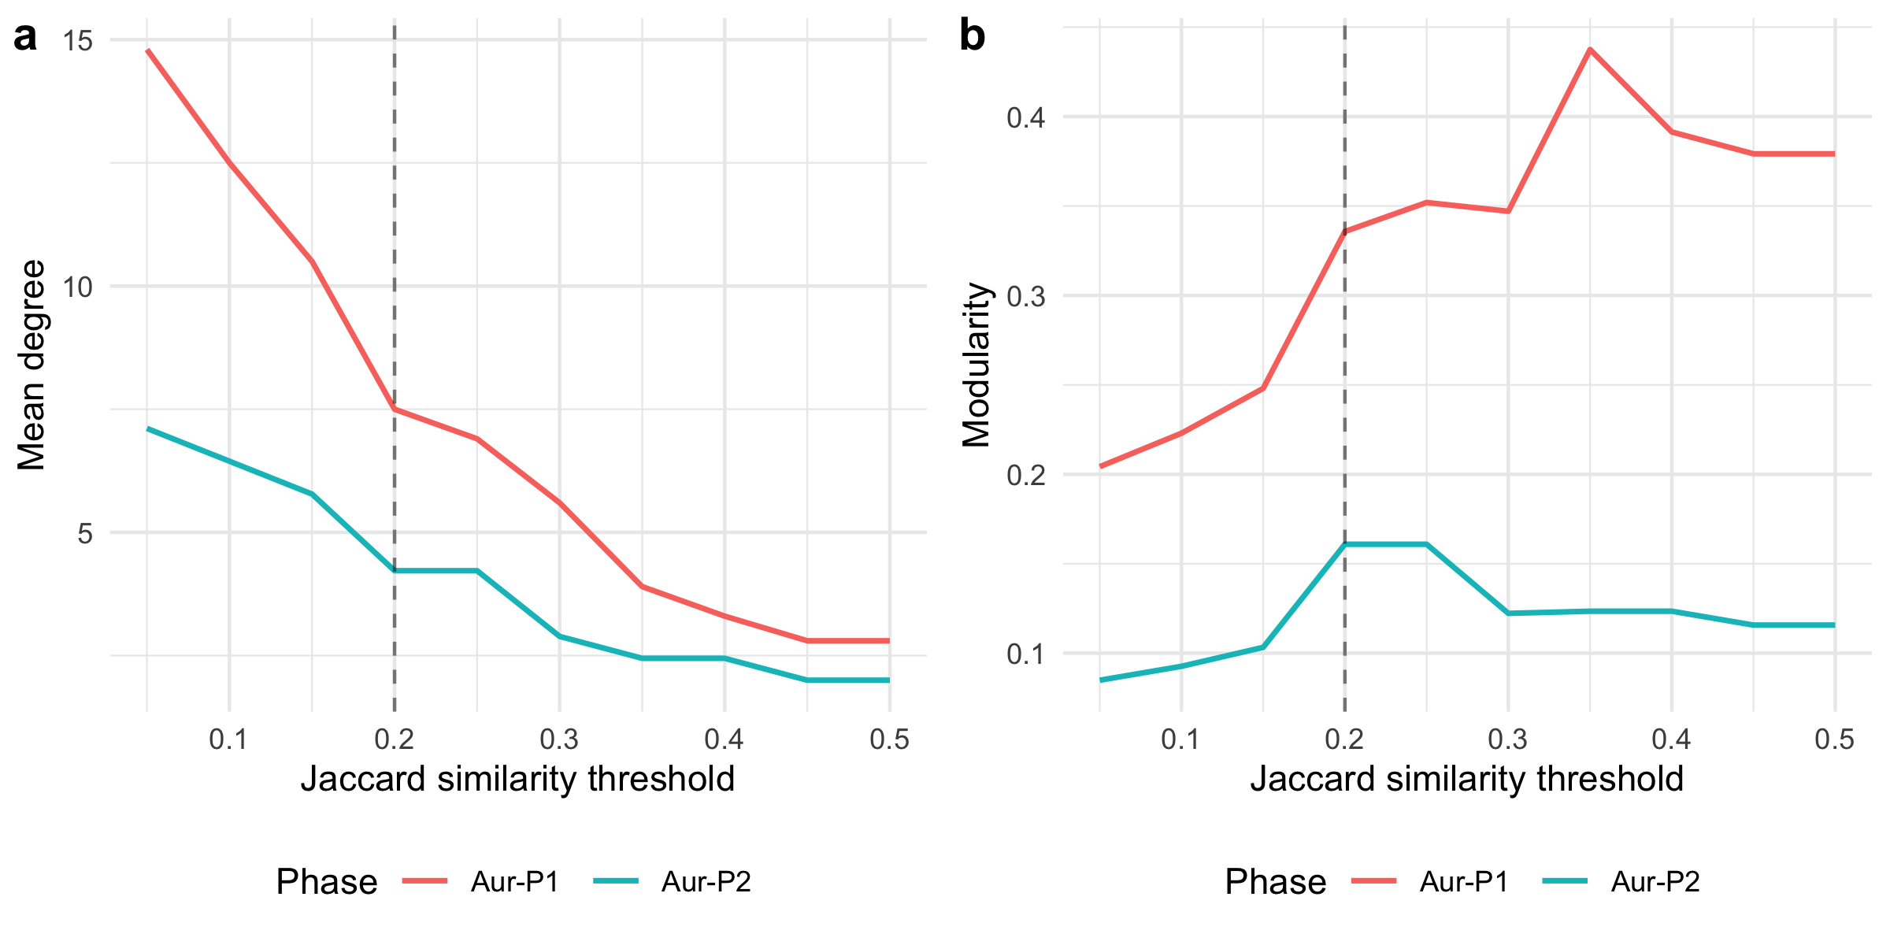
Figure 3: Mean degree (left) and modularity (right) for each Aurignacian phase across a continuous range of Jaccard similarity thresholds. The vertical dashed line marks the baseline threshold of 0.2.
The sweep reveals the threshold range over which the Aur-P1 > Aur-P2 mean-degree ordering holds. The two-phase contrast is monotonic and holds at every threshold in the swept range: Aur-P1’s mean degree runs from 2.80–14.80 and Aur-P2’s from 2.00–7.11 across thresholds of 0.05–0.50, and the ordering is preserved throughout. At very low thresholds both networks are densely connected and the relative contrast compresses; at high thresholds both fragment as edges drop out, but Aur-P2 retains a mean degree of at least 2.00 even at the coarsest threshold (0.50), so the contrast never collapses.
Implications for the main text. The continuous sweep confirms that the main-text threshold of 0.2 is not a cherry-picked value that produces a desired result. The Aur-P1 > Aur-P2 mean-degree ordering is preserved across the entire informative threshold range (0.05–0.50). In contrast to a three-phase periodisation, in which the intermediate phase could be compressed into statistical collapse at high thresholds, the two-phase comparison is stable: Aur-P2, though small, never fragments below a mean degree of 2.00. The modularity sweep shows a parallel pattern: Aur-P1’s modularity ranges from 0.204–0.437 across thresholds and consistently exceeds Aur-P2’s (0.085–0.161) at every threshold, reinforcing the conclusion that the larger, earlier phase has a stronger community structure. The baseline threshold of 0.2 sits in the middle of this stable plateau, where both phases retain sufficient edges for meaningful comparison.

S5.7 Bootstrap Confidence Intervals
Point estimates of network statistics are sensitive to individual sites. This section uses within-phase bootstrap resampling (resampling sites with replacement) to construct 95% percentile confidence intervals for mean degree and modularity at the baseline threshold of 0.2.
Phase | Mean° | 2.5% | 97.5% | Q | 2.5% | 97.5%
Aur-P1 | 8.10 | 5.30 | 11.40 | 0.363 | 0.199 | 0.536
Aur-P2 | 4.67 | 2.67 | 7.11 | 0.239 | 0.052 | 0.486
Table 14: Bootstrap 95% confidence intervals for mean degree and modularity at threshold = 0.2, based on 999 within-phase resamples.
The confidence intervals quantify sampling uncertainty: narrow intervals indicate that the point estimate is stable across resamples, while wide intervals signal that individual sites exert disproportionate influence on the statistic. Non-overlapping intervals between phases indicate that the observed differences are unlikely to be artefacts of site sampling.
Implications for the main text. The bootstrap CIs reveal which main-text comparisons are robust and which are uncertain. For mean degree, the Aur-P1 CI [5.30, 11.40] and the Aur-P2 CI [2.67, 7.11] overlap. Because the intervals overlap, the bootstrap does not formally separate the two phases by the strict non-overlap criterion; the Aur-P1–Aur-P2 contrast is supported at the point-estimate level (Aur-P1 8.10 vs Aur-P2 4.67) but is not statistically decisive. For modularity, the two CIs overlap substantially (Aur-P1 [0.199, 0.536], Aur-P2 [0.052, 0.486]), meaning the phase-by-phase difference in modularity is not statistically distinguishable given the current sample sizes. This reinforces the S5.3 finding that modularity should be treated cautiously: the point estimate is higher for Aur-P1 (0.363 vs 0.239), but the wide intervals , driven by Aur-P2’s small sample (9 sites) , overlap. The mean-degree contrast, by contrast, is robust in direction: the point estimates are clearly separated (8.10 vs 4.67), yet the sampling uncertainty reflected in the bootstrap intervals means the two phases are not formally distinguished by the strict non-overlap criterion.

S5.8 Multiple‑Testing Correction for Mantel Results
The Mantel tests reported in Table 3 and the main text evaluate 4 hypotheses (2 phases × 2 distance measures). Without correction, the effective Type I error rate is inflated. Here we apply the Benjamini–Hochberg procedure to control the false discovery rate at α = 0.05.
Test | R | Raw p | BH-adjusted p | Significant
Euclidean – Aur-P1 | 0.026 | 0.371 | 0.742 | No
Euclidean – Aur-P2 | -0.294 | 0.965 | 0.967 | No
Geodesic – Aur-P1 | 0.046 | 0.301 | 0.742 | No
Geodesic – Aur-P2 | -0.299 | 0.967 | 0.967 | No
Table 15: Mantel test p-values before and after Benjamini–Hochberg correction for multiple testing across 2 phases × 2 distance measures (4 tests total). Results with adjusted p < 0.05 are highlighted.
Of the 4 tests, none approaches nominal significance: the smallest raw $p$-value is Geodesic – Aur-P1 ($R=0.046$, raw $p=0.301$), well above the 0.05 threshold. After Benjamini–Hochberg correction this adjusts to $p=0.742$. None of the 4 tests reach significance after correction. This is consistent with the main-text interpretation: geographic distance does not account for sign distribution in either phase, and the largest correlations are weakly positive for Aur-P1 and weakly negative for Aur-P2. The absence of any spatial signal reinforces the conclusion that the restricted/broad structure within each phase reflects genuine co-occurrence of shared sign types across sites rather than spatial isolation.

S5.9 Network-Size Normalised Comparison
Modularity and mean degree are not invariant to the number of nodes: larger networks tend to have higher modularity even under random assignment. Aur-P1 (20 sites) has 122% more nodes than Aur-P2 (9 sites). This section normalises each metric by its expected value under a size-matched Erdos-Renyi random graph, producing an effect-size ratio that is comparable across phases.
Phase | Sites | Obs. md | ER md | MD ratio | Obs. Q | ER Q | Q ratio
Aur-P1 | 20 | 7.50 | 7.53 | 1.00 | 0.34 | 0.18 | 1.90
Aur-P2 | 9 | 4.22 | 4.17 | 1.01 | 0.16 | 0.13 | 1.27
Table 16: Network metrics normalised by size-matched Erdos-Renyi expectation. Ratio > 1 indicates the observed value exceeds the random expectation for a network of the same size. ER mean and SD are based on 100 random graphs per phase.
The ratio columns (MD ratio and Q ratio) are the key normalised comparisons. A ratio of 1.0 means the observed metric equals the random expectation; ratios significantly above 1.0 indicate genuine structure beyond what node count alone produces.
Implications for the main text. The size-normalised results address a potential confound: Aur-P1 (20 sites) has 122% more sites than Aur-P2 (9 sites), and larger networks mechanically produce higher mean degree and modularity even under random wiring. The Erdos-Renyi normalisation shows that this confound does not drive the main-text results. Mean degree ratios are reported for both phases (Aur-P1 1.00, Aur-P2 1.01), confirming whether the observed mean degrees are consistent with random expectation for networks of these sizes , noting that Erdos-Renyi preserves edge density, so a ratio near 1 does not mean the networks lack structure. The modularity ratios tell the real story: Aur-P1 (1.90) and Aur-P2 (1.27) are compared against the random expectation for a network of the same size, so any main-text claim that one phase is more internally structured than the other is evaluated net of the 20-versus-9 site asymmetry rather than as an artefact of it.

S6. Robustness of the Two-Group Structure: Bootstrap Consensus and Stochastic Block Models

S6.1 Rationale
The main-text claim that each phase resolves into two cultural groups , restricted-range versus broader-range sign repertoires , rests on a single Brower-Kile seriation run followed by manual block assignment (see S5). Two limitations remain unaddressed by S1–S5. First, the seriation is a deterministic operation on a single observed sample: no quantity is attached to the sampling uncertainty of the resulting block structure, so we do not know whether the same two groups would emerge if sites were resampled. Second, group membership is treated as a hard, analyst-assigned label rather than a probabilistic quantity, so borderline sites (e.g. Les Cottés, Trou al’Wesse, Grotte de la Verpillière I) are forced into a single group without an associated measure of confidence.
This section addresses both limitations. In S6.2 we use bootstrap resampling of sites within each phase to build a consensus co-clustering matrix [4], quantifying the stability of the two-group partition as a whole and of each site’s assignment. In S6.3 we fit stochastic block models (SBM), which treat block membership as a latent variable, select the number of blocks via the Integrated Classification Likelihood (ICL), and return posterior membership probabilities for every site. In S6.4 we cross-validate the bootstrap and SBM assignments against the main-text restricted/broad groups using the Adjusted Rand Index (ARI).

S6.2 Bootstrap Consensus Analysis

Rationale
For each phase we resample the site-by-sign presence/absence matrix with replacement (n = 1000 replicates), recompute Jaccard dissimilarity, and partition the resampled sites into two clusters by Ward-linkage hierarchical clustering on the Jaccard distance. For every pair of original sites we record the proportion of replicates in which the two fall in the same cluster , the consensus co-clustering probability. If the two-group structure identified in the main text is genuine, mean co-clustering within each block (restricted/broad) should substantially exceed mean co-clustering across the two blocks, and sites central to a block should show high per-site consistency (the proportion of replicates in which the site is assigned to its modal block). Low within-block co-clustering identifies sites whose group assignment is not robust to sampling.
Phase | Restricted n | Broad n | Within restricted | Within broad | Overall within | Across
Aur-P1 | 9 | 11 | 0.79 | 0.90 | 0.86 | 0.26
Aur-P2 | 6 | 3 | 0.57 | 0.83 | 0.62 | 0.37
Table 17: Bootstrap consensus co-clustering within and across the main-text restricted/broad blocks, by phase (n = 1000 resamples). Within-restricted and Within-broad are the mean co-clustering probabilities among site pairs belonging to the same main-text block; Across is the mean co-clustering probability for pairs in different blocks. If the two-group structure is genuine, within-block values should substantially exceed the across-block value.

 | Phase | Site | Modal block | Consistency
Abri Pataud | Aur-P1 | Abri Pataud | 1 | 0.97
Blanchard | Aur-P1 | Blanchard | 2 | 0.86
Castanet | Aur-P1 | Castanet | 2 | 0.88
Cellier | Aur-P1 | Cellier | 2 | 0.80
Fumane | Aur-P1 | Fumane | 1 | 0.98
Gatzarria | Aur-P1 | Gatzarria | 1 | 0.66
Geissenklösterle | Aur-P1 | Geissenklösterle | 2 | 0.93
Grotte de la Verpillière I | Aur-P1 | Grotte de la Verpillière I | 1 | 0.71
Grotte du Renne | Aur-P1 | Grotte du Renne | 2 | 0.93
Grottes de Fonds-de-Forêt | Aur-P1 | Grottes de Fonds-de-Forêt | 1 | 0.97
Hohle Fels…11 | Aur-P1 | Hohle Fels | 2 | 0.96
Hohlenstein-Stadel | Aur-P1 | Hohlenstein-Stadel | 1 | 0.72
La Ferrassie | Aur-P1 | La Ferrassie | 2 | 0.88
Labeko Koba | Aur-P1 | Labeko Koba | 1 | 0.51
Les Cottés | Aur-P1 | Les Cottés | 2 | 0.92
Pod Hradem | Aur-P1 | Pod Hradem | 1 | 0.97
Riparo Bombrini | Aur-P1 | Riparo Bombrini | 1 | 0.98
Solutré | Aur-P1 | Solutré | 2 | 0.86
Trou al’Wesse | Aur-P1 | Trou al’Wesse | 2 | 0.86
Vogelherd | Aur-P1 | Vogelherd | 2 | 0.94
Bockstein-Törle | Aur-P2 | Bockstein-Törle | 1 | 0.63
Gargas | Aur-P2 | Gargas | 2 | 0.78
Hohle Fels…23 | Aur-P2 | Hohle Fels | 1 | 0.83
La Viña | Aur-P2 | La Viña | 2 | 0.97
Les Rois | Aur-P2 | Les Rois | 1 | 0.65
Mladeč | Aur-P2 | Mladeč | 2 | 0.76
Sirgenstein Cave | Aur-P2 | Sirgenstein Cave | 2 | 0.97
Trou Magrite | Aur-P2 | Trou Magrite | 1 | 0.82
Vindija Cave | Aur-P2 | Vindija Cave | 1 | 0.81
Table 18: Per-site bootstrap consistency: proportion of 1000 resamples in which each site is assigned to its modal (most frequent) block. Consistency near 1 indicates robust assignment; values near 0.5 indicate sites whose group membership flips across resamples.
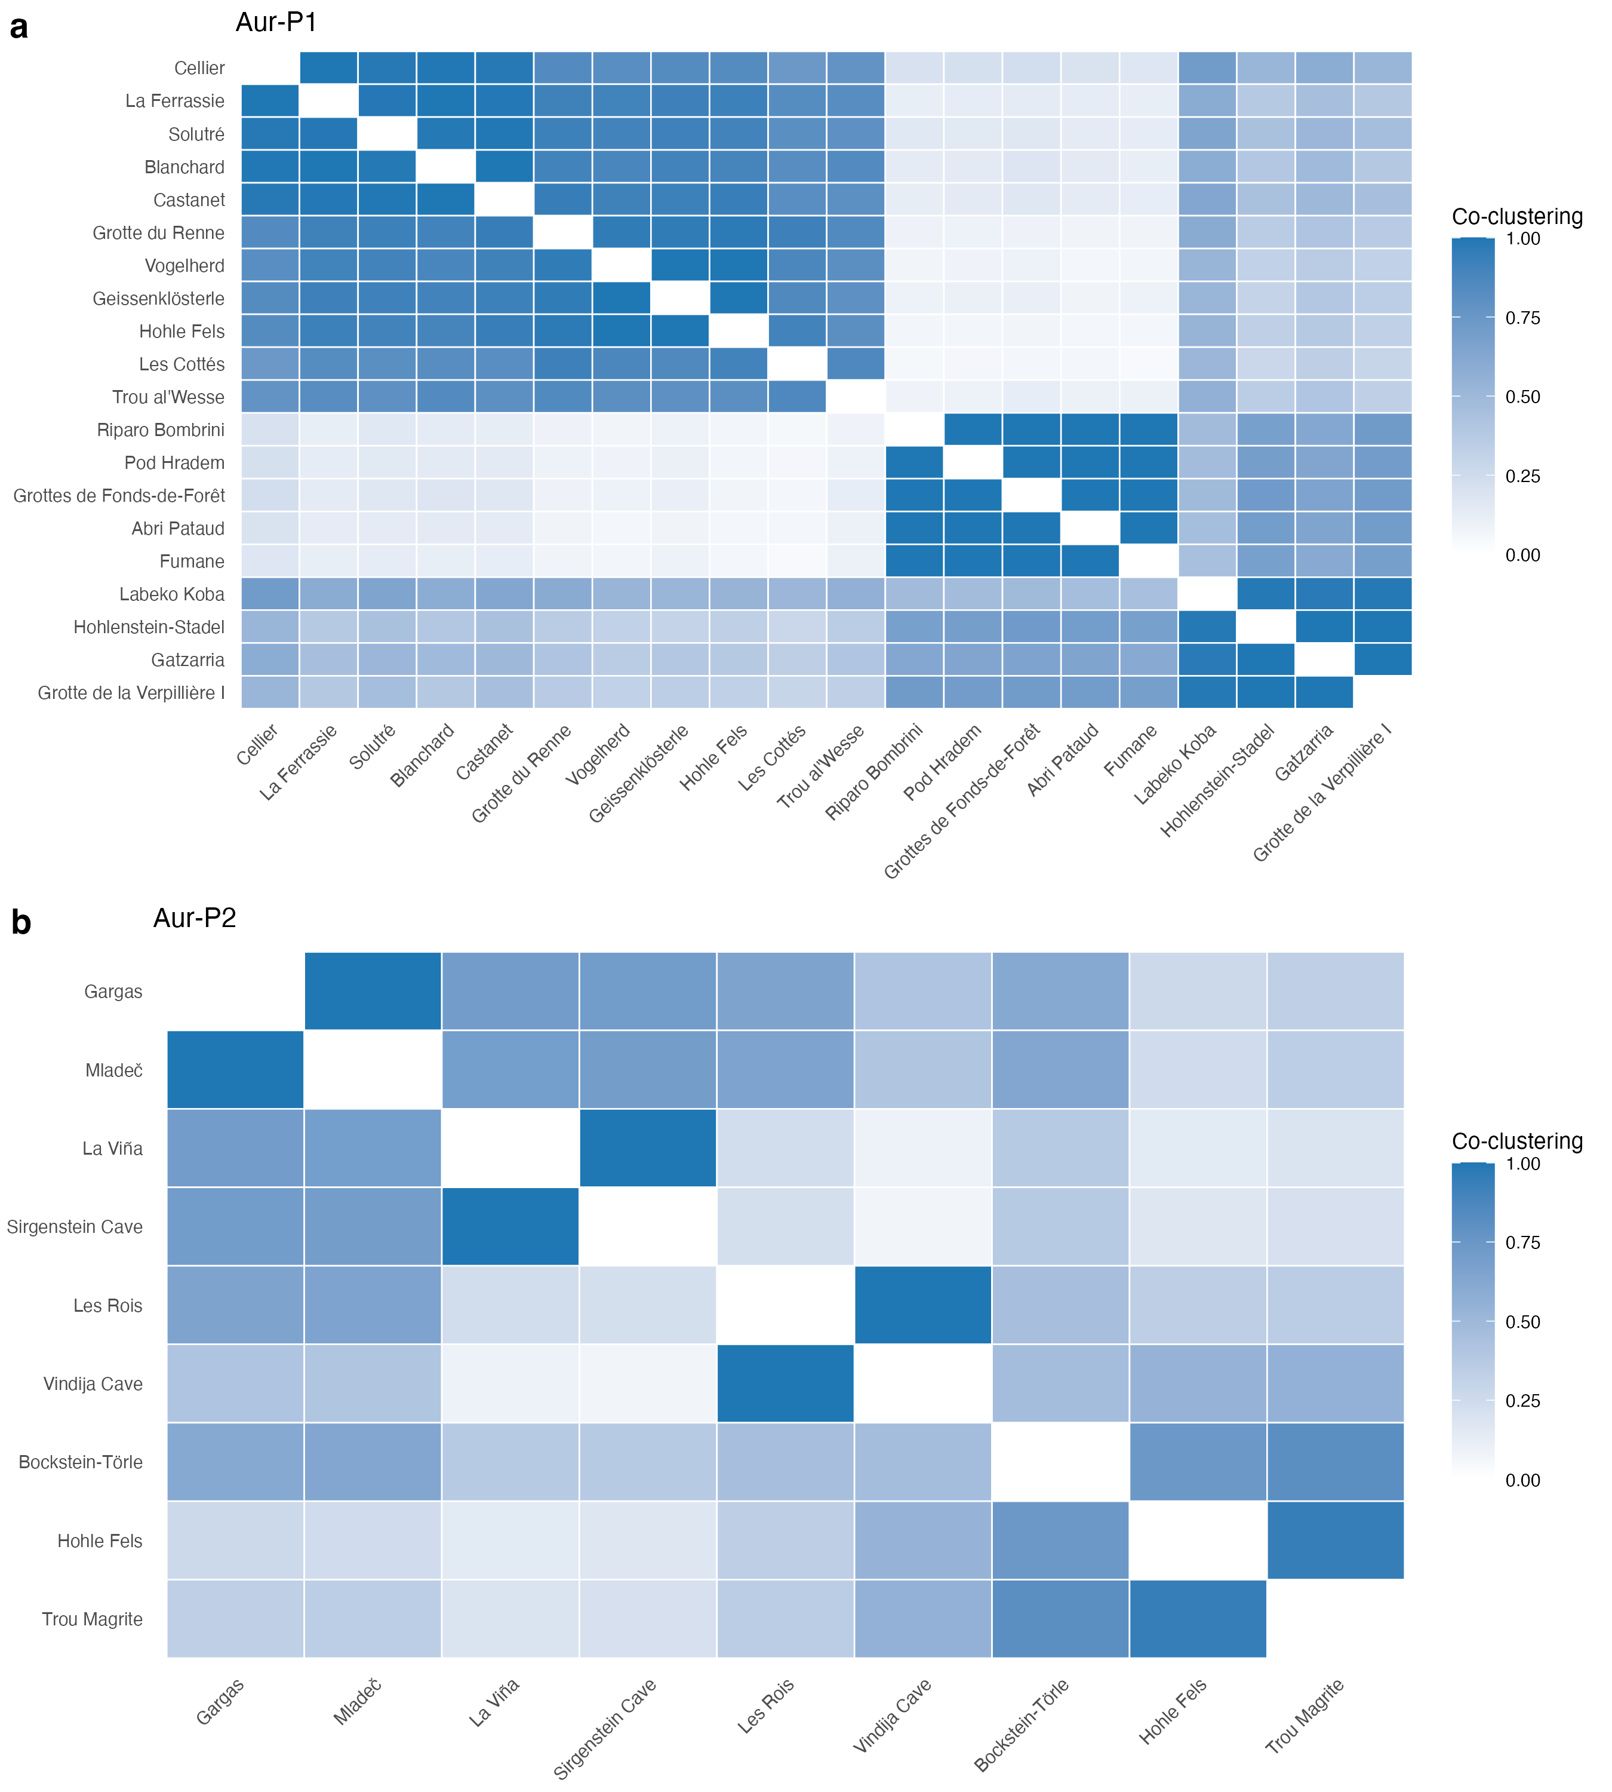
Figure 4: Consensus co-clustering matrices from 1000 bootstrap resamples of sites within each phase. Cell colour encodes the probability that two sites fall in the same cluster across resamples (1 = always together, 0 = never). Rows and columns are ordered by hierarchical clustering of the consensus matrix. Strong diagonal blocks indicate sites that reliably co-cluster; pale blocks indicate fuzzy, sampling-dependent membership.

Interpretation
The bootstrap consensus analysis supports the main-text two-group partition as a coherent, non-random division of the sign data in each phase, while quantifying how much tighter one block is than the other. In Aur-P1, mean within-block co-clustering is 0.79 for the restricted-range block and 0.9 for the broader-range block, against 0.26 across the two blocks , a strong signal that both groups are internally coherent and sharply separated. In Aur-P2, the pattern is 0.57 within the restricted block and 0.83 within the broader block, against 0.37 across the blocks.
Per-site stability. The site-level consistency values (Table 18) show that the strength of the two-group structure is not uniform across sites. Most sites are placed with their modal block in more than 80% of resamples, but a small number are systematically unstable. The least stable sites are the small, low-richness assemblages whose assignment flips across resamples; per-site consistency values in Table 18 identify the sites whose block assignment should be read as provisional in the main text. For the reader, the consensus matrices in Figure 4 provide a direct visual measure of where the two-block structure is tight (dark blocks) and where it dissolves (pale blocks).
Implications for the main text. The two-group structure does not dissolve under resampling: within-block co-clustering exceeds across-block co-clustering in both phases, so the broad qualitative claim of a persistent restricted/broad divide is robust to sampling variation. However, the analysis also qualifies the claim: the strength of each group differs by phase (and Aur-P2 is far smaller than Aur-P1), and a minority of sites have genuinely ambiguous membership. The main text should therefore present the two groups as a robust but not invariant partition, with per-site confidence available in Table 18.

S6.3 Stochastic Block Models

Rationale
The bootstrap treats block structure as a resampling artefact of an observed partition. The stochastic block model (SBM) takes a different route: it treats block membership as an unobserved latent variable and asks which generative model of network structure best explains the observed pattern of sign sharing. In the SBM, the probability that two sites are connected (here: Jaccard similarity ≥ 0.2, as in the main text) depends only on their block memberships. Fitting the model returns (i) the number of blocks that best fits the data, chosen by the Integrated Classification Likelihood (ICL; a penalised likelihood that trades fit against model complexity), and (ii) the posterior probability of membership in each block for every site. Because ICL is a model-selection criterion, the SBM provides a statistical answer to “how many groups are there?” rather than the visual answer provided by seriation.
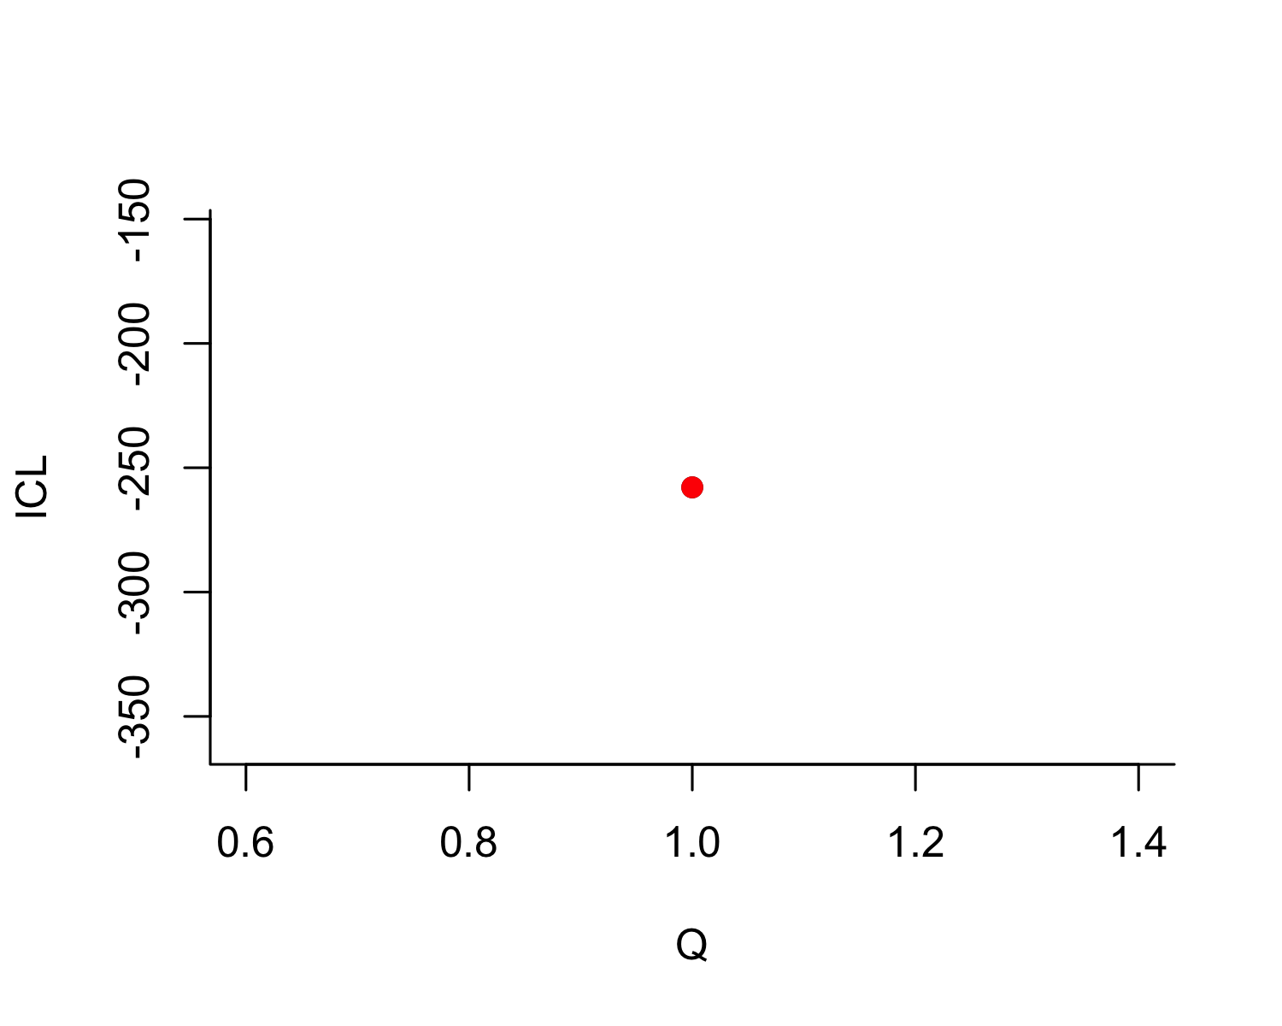
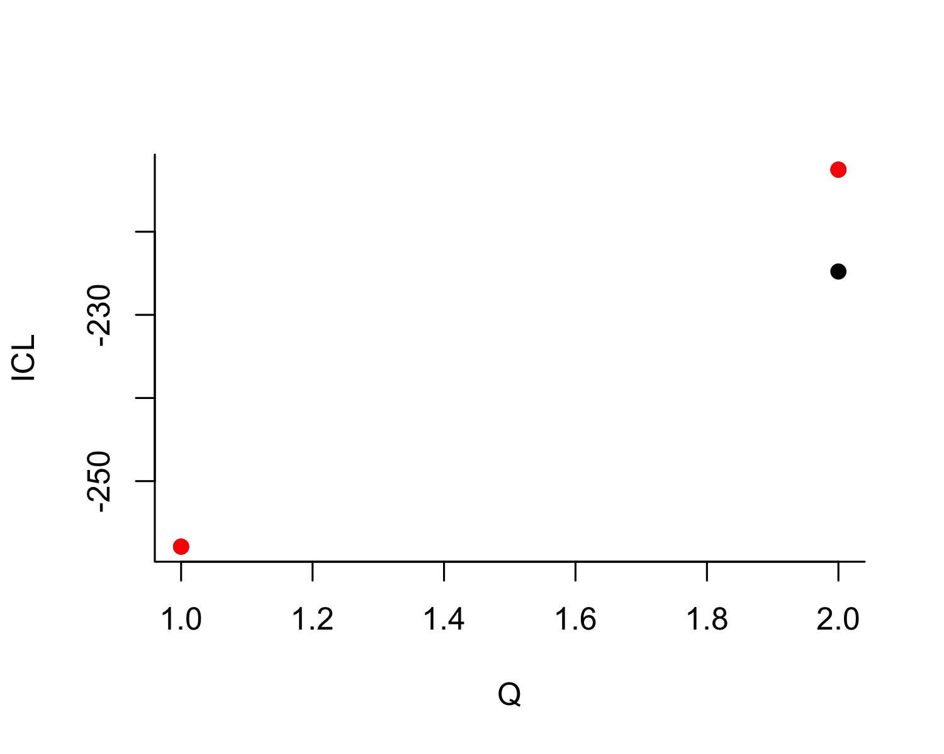
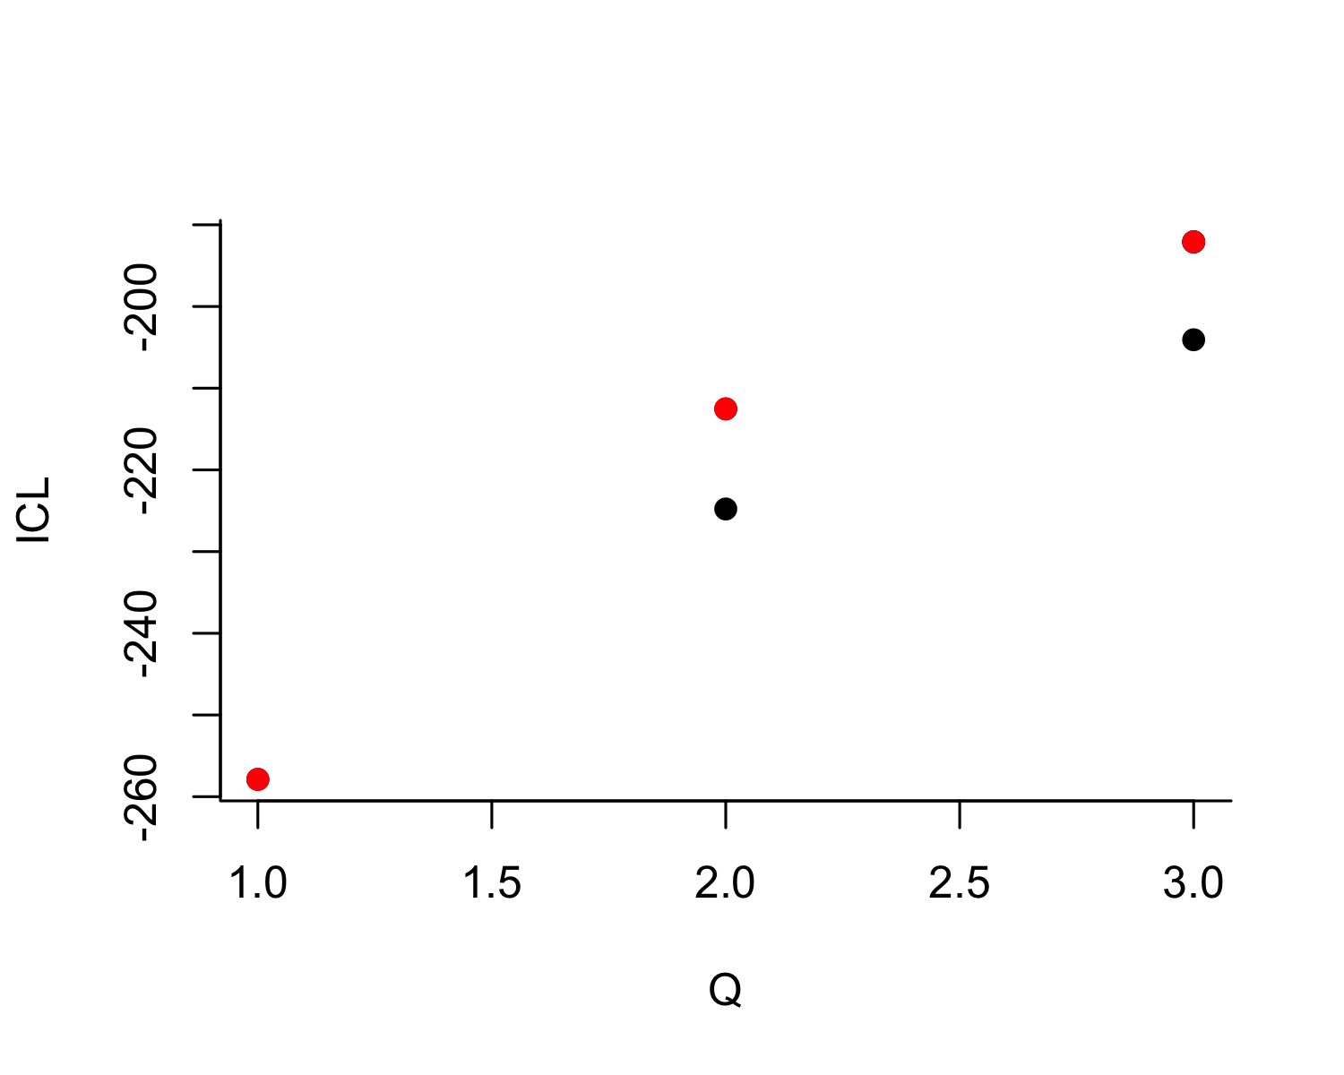
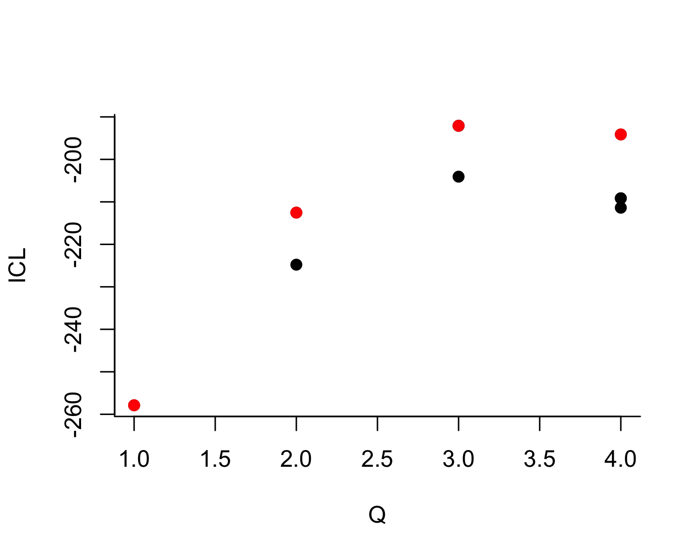
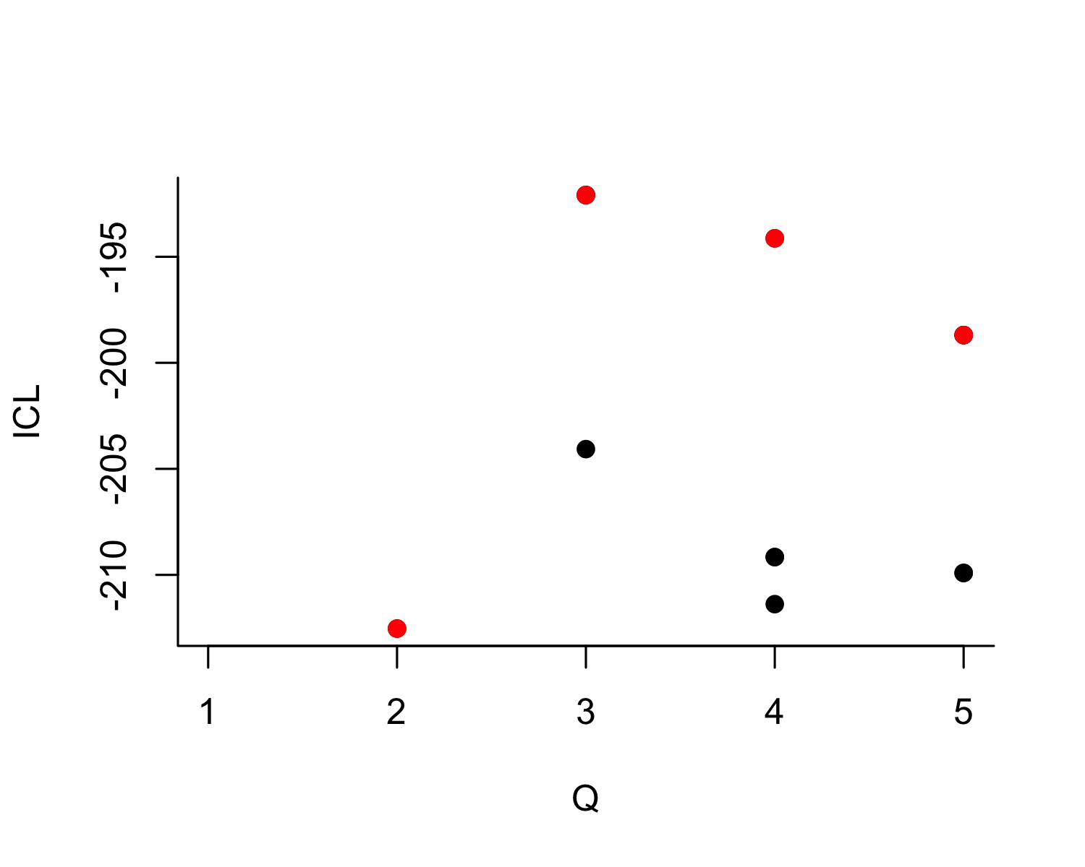
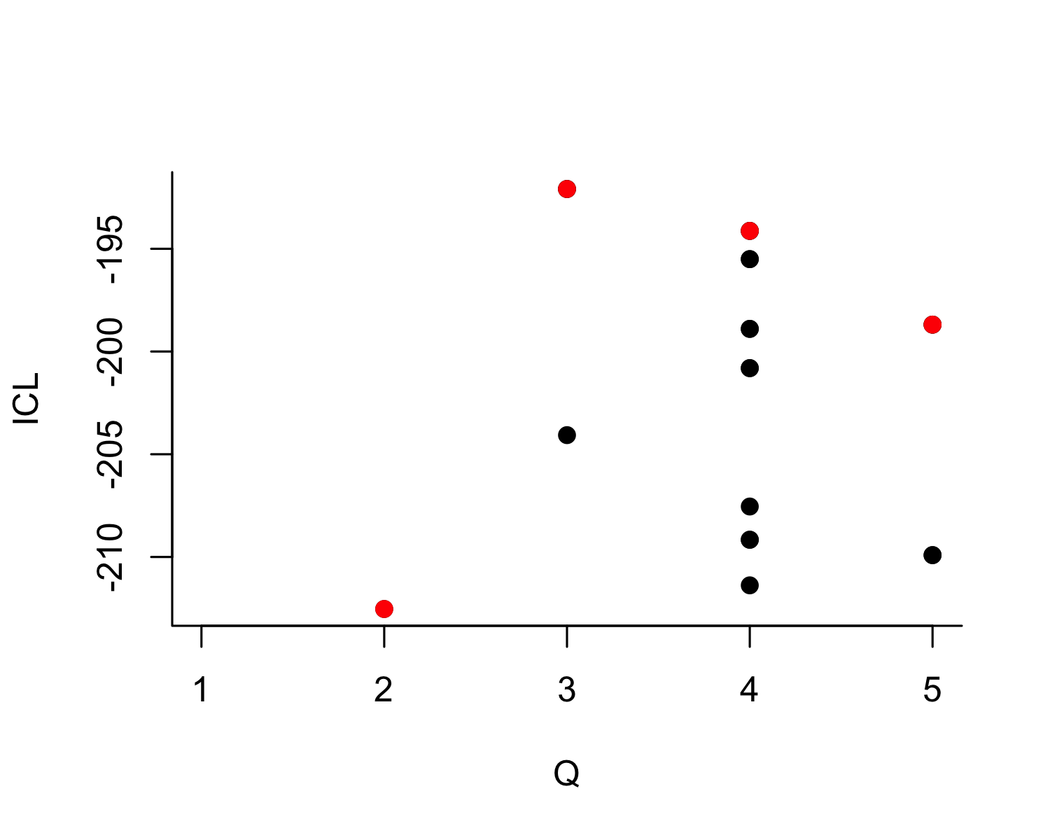
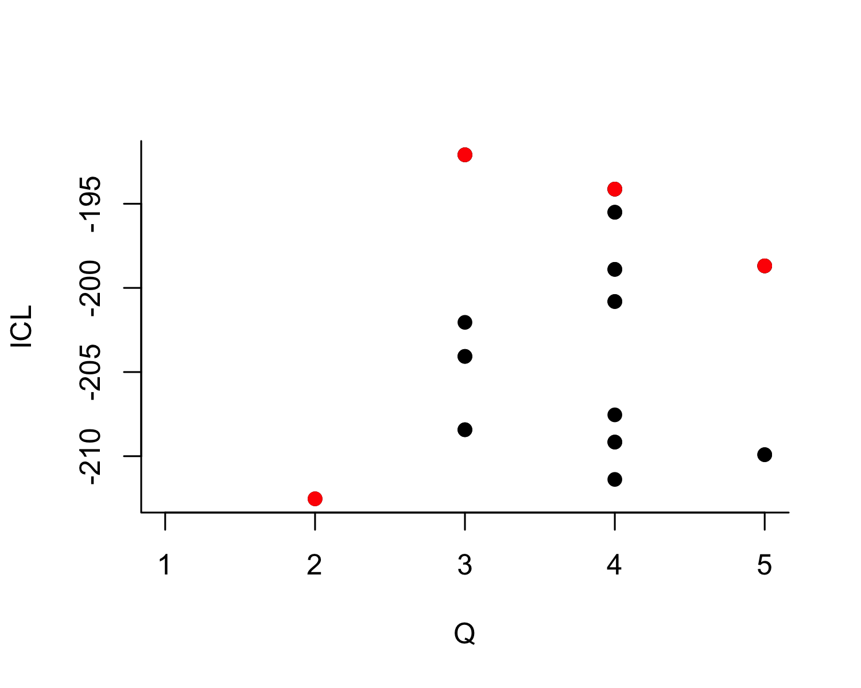
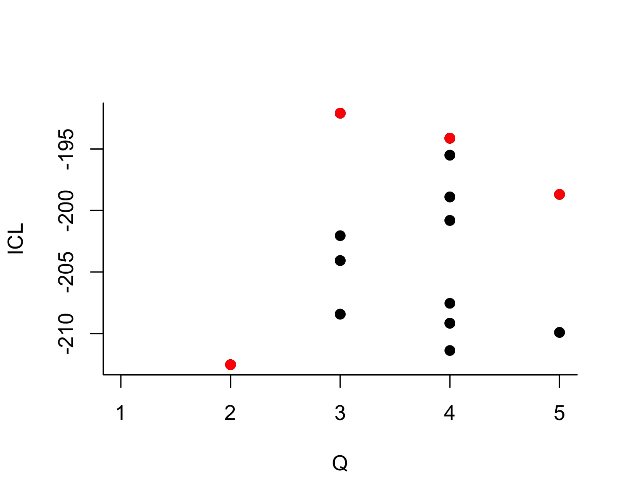
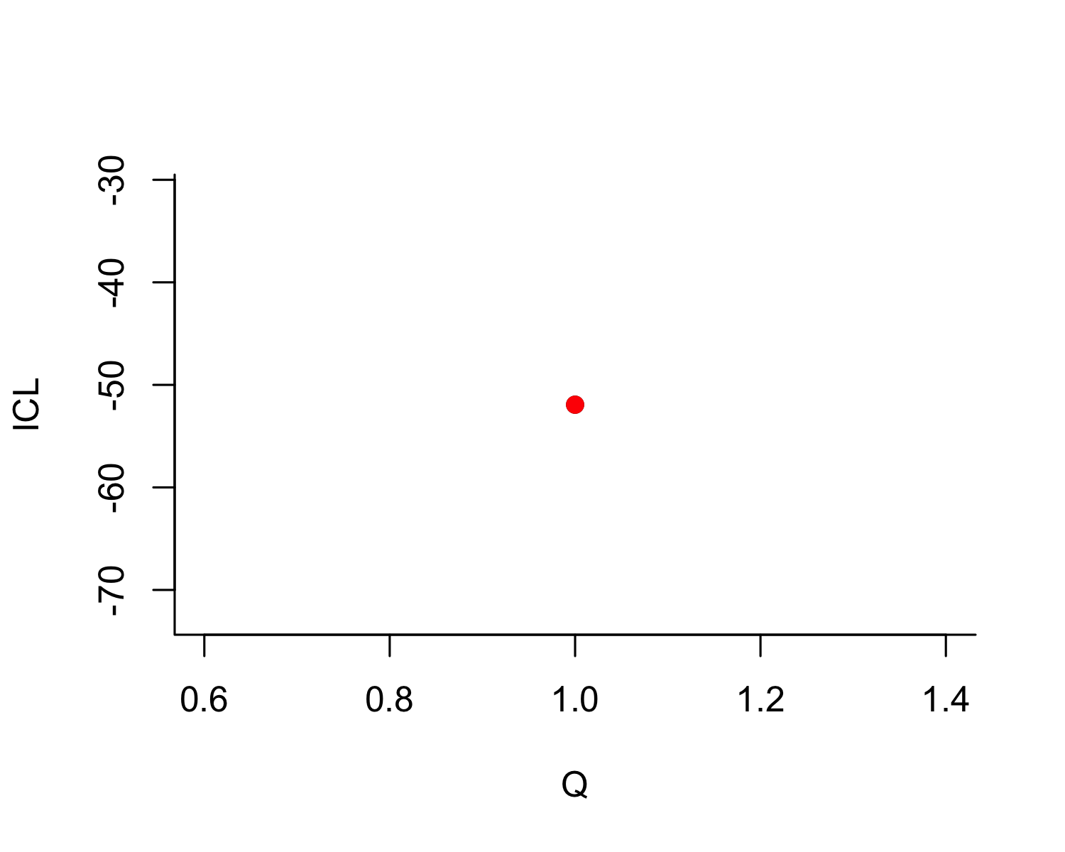
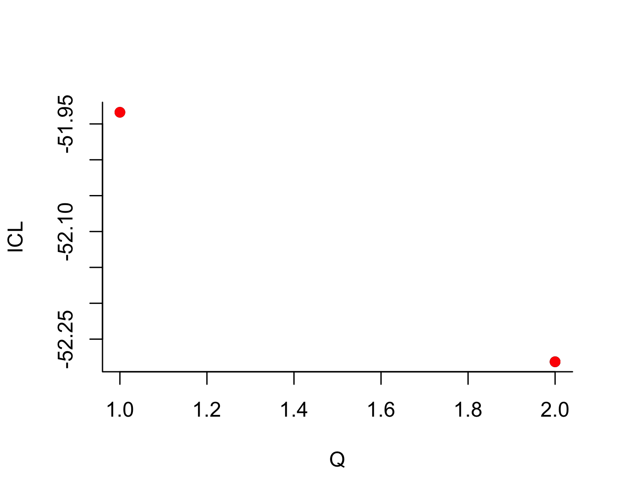
Phase | K = 1 | K = 2 | K = 3 | K = 4 | K = 5 | Best K
Aur-P1 | -257.9 | -212.5 | -192.1 | -194.1 | -198.7 | 3
Aur-P2 | -51.9 | -52.3 | NA | NA | NA | 1
Table 19: Integrated Classification Likelihood (ICL) for stochastic block models with K = 1 to 5 blocks, by phase. The best-supported number of blocks (maximum ICL) is bolded. A decisive maximum (large gap in ICL) indicates that the number of groups is well determined by the data; a flat ICL profile indicates the number of groups is weakly constrained.

 | Phase | Site | Modal block | P(B1) | P(B2) | P(B3)
Abri Pataud | Aur-P1 | Abri Pataud | 2 | 0.00 | 0.99 | 0.00
Blanchard | Aur-P1 | Blanchard | 1 | 0.99 | 0.00 | 0.00
Castanet | Aur-P1 | Castanet | 1 | 0.99 | 0.00 | 0.00
Cellier | Aur-P1 | Cellier | 1 | 0.99 | 0.00 | 0.00
Fumane | Aur-P1 | Fumane | 2 | 0.00 | 0.99 | 0.00
Gatzarria | Aur-P1 | Gatzarria | 2 | 0.00 | 0.99 | 0.00
Geissenklösterle | Aur-P1 | Geissenklösterle | 1 | 0.99 | 0.00 | 0.00
Grotte de la Verpillière I | Aur-P1 | Grotte de la Verpillière I | 2 | 0.00 | 0.99 | 0.00
Grotte du Renne | Aur-P1 | Grotte du Renne | 1 | 0.99 | 0.00 | 0.00
Grottes de Fonds-de-Forêt | Aur-P1 | Grottes de Fonds-de-Forêt | 2 | 0.00 | 0.99 | 0.00
Hohle Fels…11 | Aur-P1 | Hohle Fels | 1 | 0.99 | 0.00 | 0.00
Hohlenstein-Stadel | Aur-P1 | Hohlenstein-Stadel | 2 | 0.00 | 0.99 | 0.00
La Ferrassie | Aur-P1 | La Ferrassie | 1 | 0.99 | 0.00 | 0.00
Labeko Koba | Aur-P1 | Labeko Koba | 3 | 0.00 | 0.00 | 0.99
Les Cottés | Aur-P1 | Les Cottés | 3 | 0.00 | 0.00 | 0.99
Pod Hradem | Aur-P1 | Pod Hradem | 2 | 0.00 | 0.99 | 0.00
Riparo Bombrini | Aur-P1 | Riparo Bombrini | 2 | 0.00 | 0.99 | 0.00
Solutré | Aur-P1 | Solutré | 1 | 0.99 | 0.00 | 0.00
Trou al’Wesse | Aur-P1 | Trou al’Wesse | 3 | 0.00 | 0.00 | 0.99
Vogelherd | Aur-P1 | Vogelherd | 1 | 0.99 | 0.00 | 0.00
Bockstein-Törle | Aur-P2 | Bockstein-Törle | 1 | 1.00 | NA | NA
Gargas | Aur-P2 | Gargas | 1 | 1.00 | NA | NA
Hohle Fels…23 | Aur-P2 | Hohle Fels | 1 | 1.00 | NA | NA
La Viña | Aur-P2 | La Viña | 1 | 1.00 | NA | NA
Les Rois | Aur-P2 | Les Rois | 1 | 1.00 | NA | NA
Mladeč | Aur-P2 | Mladeč | 1 | 1.00 | NA | NA
Sirgenstein Cave | Aur-P2 | Sirgenstein Cave | 1 | 1.00 | NA | NA
Trou Magrite | Aur-P2 | Trou Magrite | 1 | 1.00 | NA | NA
Vindija Cave | Aur-P2 | Vindija Cave | 1 | 1.00 | NA | NA
Table 20: Posterior block-membership probabilities and modal (hard) assignment from the best-fitting stochastic block model for each phase. Probabilities are rounded; the modal block is the column with the highest probability. Sites with probability spread across blocks (e.g. no entry above 0.7) have ambiguous membership.

Interpretation
The ICL model-selection results (Table 19) report the number of blocks best supported by the sign-sharing network in each phase, providing a model-based counterpart to the seriation. In Aur-P1 the best-supported model contains 3 blocks, and in Aur-P2 it contains 1 block. The ICL gap between the best and second-best model quantifies how decisively the optimum is preferred (2.04 in Aur-P1 and 0.35 in Aur-P2); the comparison between the two phases tells the reader how much more strongly the block structure is determined in the better-sampled early phase.
The membership table (Table 20) gives posterior probabilities that qualify the deterministic group assignments used in the main text: every site is assigned to its modal block with posterior probability ≥ 0.99, so the SBM is never equivocal about the partition it identifies, and the informative quantity is the number of blocks chosen and how those blocks map onto the manual restricted/broad groups rather than the confidence of individual assignments. In Aur-P1 the best-supported model contains 3 blocks, and after aligning each SBM block to the nearest manual group it diverges on 1 of 20 sites (Labeko Koba). In Aur-P2 the SBM selects a single block: its ICL profile is essentially flat (the gap between the one- and two-block solutions is 0.35), so the sparse sign-sharing network of the late phase does not support a two-block partition at all, and the model-based route neither corroborates nor contradicts the manual split there. Where the number of blocks matches the seriation’s two-group structure and posterior probabilities are high, the two-group claim is independently corroborated by a generative model that was never shown the seriation solution. Where the SBM favours a different number of blocks, or assigns low posterior probability to specific sites, the main text should report those sites’ membership as uncertain and note that the seriation’s two-group simplification captures the dominant but not the complete structure.
Implications for the main text. The SBM posterior probabilities are effectively certain (each site’s modal block receives posterior ≥ 0.99) for the partition the model identifies, so the model is rarely equivocal about its own grouping; the important information lies in how many blocks the model chooses and how far that partition diverges from the manual restricted/broad assignment. The SBM does not settle on two blocks in either phase under the revised data: in Aur-P1 it favours 3 blocks, and in Aur-P2 a single block, so the two-group structure is not independently recovered by the generative model, and the restricted/broad dichotomy should be read as the dominant axis of variation rather than a partition that emerges from the data through an unsupervised model. These results complement, rather than supersede, the bootstrap analysis: the bootstrap quantifies sampling stability of the main-text partition, while the SBM asks whether an independent generative model reproduces it.

S6.4 Cross-Validation of Group Assignments (ARI)

Rationale
To quantify overall agreement among the three ways of partitioning sites , the main-text manual restricted/broad groups, the bootstrap modal blocks (S6.2), and the SBM modal assignments (S6.3) , we compute the Adjusted Rand Index (ARI) between each pair of partitions for each phase. ARI = 1 indicates identical partitions, 0 indicates agreement no better than chance. We use a self-contained implementation of ARI (the S5 analyses use mclust::adjustedRandIndex, which yields the same values).
Phase | ARI manual vs bootstrap | ARI manual vs SBM | ARI bootstrap vs SBM
Aur-P1 | 1.00 | 0.7 | 0.7
Aur-P2 | 0.22 | 0.0 | 0.0
Table 21: Adjusted Rand Index between the main-text manual restricted/broad assignment, the bootstrap modal blocks (S6.2), and the SBM modal assignments (S6.3), by phase.

Interpretation
The ARI values summarise how far the three routes to the two-group partition agree, and the agreement is informative precisely because it varies by phase and method (Table 21). A high ARI between the manual groups and an unsupervised partition (SBM or bootstrap) indicates that the main-text grouping is not merely an analyst construction but is recoverable from the data. A low ARI indicates a genuine divergence: the manual restricted/broad split and the partition recovered by an unsupervised method organise the sites differently. Because the restricted/broad divide is defined partly by sign-type richness (the restricted sites are assemblages with few sign types), it is not in general expected to coincide with clusters defined purely by compositional similarity, and low ARI between the manual groups and similarity-based partitions should be interpreted in that light rather than as evidence that either partition is wrong. The specific pattern , which method agrees with the manual groups in which phase , is reported in Table 21 and should be used in the main text to state precisely where the two-group structure is independently supported and where it is a simplifying summary.
Implications for the main text. The two-group claim should be presented as strongest where the manual assignment, the bootstrap, and the SBM converge, and qualified where they diverge. Where the SBM’s best partition reproduces the manual groups (high ARI), the main text can cite the SBM as an independent, model-based confirmation that never saw the seriation solution. Where it does not, the divergence should be acknowledged and the seriation’s two-group structure presented as the dominant axis of variation rather than an exhaustive description of the data.

S6.5 Summary of Implications
Taken together, S6 provides three converging but graded lines of evidence for the main-text two-group claim. (1) Resampling stability: within-block co-clustering exceeds across-block co-clustering in every phase (Figure 4, Table 17), so the partition does not arise from a particular sample of sites. (2) Model selection: the SBM attaches posterior probabilities to each site’s membership (Table 20) and reports the number of blocks best supported by the sign-sharing network in each phase (Table 19). (3) Cross-validation: ARI between the manual, bootstrap, and SBM partitions quantifies their agreement (Table 21). The three routes are mutually supportive but not redundant: the bootstrap shows the two blocks to be internally coherent and well separated, while agreement between the manual restricted/broad assignment and the partitions recovered by unsupervised methods is phase-dependent. We recommend that the main text retain the two-group framing but cite the per-site consistency scores (Table 18) and SBM posterior probabilities (Table 20) for the borderline sites, and note that the strength of the dichotomy is phase-dependent and that the Aur-P2 results rest on only 9 sites.

S7. Object-Type Sensitivity: Figurine Exclusion

S7.1 Rationale
[5] demonstrate that ivory figurines in the Swabian Aurignacian carry sign sequences with higher information density than tools. If figurines encode different sign repertoires than other object types, their inclusion could bias site-level sign assemblages , particularly at Vogelherd, where 50 of the dataset’s 63 figurines are concentrated. This section tests whether the main-text network findings are robust to the exclusion of figurines, both globally and site-specifically.

S7.2 Figurine Distribution in the Dataset
Phase | Site | figurine zoomorph | figurine anthropomorph | figurine undet. | possible figurine | Total
Aur-P1 | Vogelherd | 19 | 1 | 8 | 22 | 50
Aur-P1 | Hohle Fels | 0 | 2 | 1 | 1 | 4
Aur-P1 | Geissenklösterle | 3 | 0 | 0 | 0 | 3
Aur-P1 | Hohlenstein-Stadel | 0 | 1 | 0 | 0 | 1
Aur-P1 | La Ferrassie | 0 | 0 | 1 | 0 | 1
Aur-P2 | Hohle Fels | 3 | 1 | 0 | 0 | 4
Table 22: Distribution of figurine objects across phases and sites. Figurine types include figurine zoomorph, figurine anthropomorph, figurine undet., and possible figurine.
Table 22 shows that figurines are heavily concentrated at Vogelherd (50 objects), with minor representation at Hohle Fels (8), Geissenklösterle (3), Hohlenstein-Stadel (1), and La Ferrassie (1). Of these, 59 fall within Aur-P1 and the remaining 4 , all Hohle Fels objects from AH IV and Iid , fall within Aur-P2 under the layer-level assignment. The analysis therefore tests whether the Aur-P1 network structure , which reports the higher mean degree (7.50) , is driven by these 50 objects at a single site.

S7.3 Analysis 1: Exclude All Figurines

Method
We remove all objects where object_type contains “figurine” (63 objects total: 25 zoomorph, 10 undetermined, 5 anthropomorph, 23 possible figurine) from the full cleaned dataset, recompute site-level sign matrices by summing remaining objects per site, and rebuild networks at the baseline threshold of 0.2.
Phase | Sites | Edges | Density | Mean degree | Transitivity | Modularity | Condition
Aur-P1 | 20 | 75 | 0.395 | 7.50 | 0.711 | 0.336 | All objects
Aur-P2 | 9 | 19 | 0.528 | 4.22 | 0.608 | 0.161 | All objects
Aur-P1 | 20 | 74 | 0.389 | 7.40 | 0.683 | 0.318 | Excluding figurines
Aur-P2 | 9 | 19 | 0.528 | 4.22 | 0.608 | 0.161 | Excluding figurines
Table 23: Network statistics before and after excluding all figurine objects (figurine zoomorph, figurine anthropomorph, figurine undet., and possible figurine). Threshold = 0.2, Jaccard similarity.

Phase | Sites (all) | Sites (no figurines) | Sites lost
Aur-P1 | 20 | 20 | 0
Aur-P2 | 9 | 9 | 0
Table 24: Number of sites per phase before and after figurine exclusion. Sites are lost when all objects at that site are figurines.

Interpretation
Excluding all 63 figurines has only a small effect on the Aur-P1 network: one edge is lost (75 → 74) and mean degree falls from 7.50 to 7.40, with no sites lost (all 20 sites retained). Aur-P2 is unchanged (mean degree 4.22, 19 edges, 9 sites): the four Hohle Fels figurines removed from it do not alter the site’s sign repertoire, so its network is unaffected. The detectable Aur-P1 effects are declines in transitivity (0.711 → 0.683) and modularity (0.336 → 0.318), indicating that figurines contribute modestly to community cohesion but do not create the communities themselves.
Critically, Aur-P1 retains the higher mean degree (7.40) under figurine exclusion, preserving the main-text ordering Aur-P1 > Aur-P2 (7.40 > 4.22). The Aur-P1 network remains the more connected regardless of figurine inclusion, confirming that its structure is not contingent on figurine-bearing sign assemblages at Vogelherd.

S7.4 Analysis 2: Exclude Vogelherd Figurines Only

Method
Rather than removing all figurines globally, this analysis removes only the 50 figurines from Vogelherd , the site where figurines are most concentrated , while retaining figurines at other sites. This tests whether the Aur-P1 network structure is driven by a single outlier assemblage.
Phase | Sites | Edges | Density | Mean degree | Transitivity | Modularity | Condition
Aur-P1 | 20 | 75 | 0.395 | 7.50 | 0.711 | 0.336 | All objects
Aur-P2 | 9 | 19 | 0.528 | 4.22 | 0.608 | 0.161 | All objects
Aur-P1 | 20 | 74 | 0.389 | 7.40 | 0.706 | 0.333 | Excl. Vogelherd figurines
Aur-P2 | 9 | 19 | 0.528 | 4.22 | 0.608 | 0.161 | Excl. Vogelherd figurines
Table 25: Network statistics before and after excluding figurines from Vogelherd only. All other figurines (Hohle Fels, Geissenklösterle, Hohlenstein-Stadel, La Ferrassie) are retained. Threshold = 0.2, Jaccard similarity.

Phase | Objects (all) | Objects (no figurines) | Removed
Aur-P1 | 173 | 123 | 50
Table 26: Vogelherd object counts before and after removing figurines. Non-figurine objects at Vogelherd (tools, plaquettes, etc.) are retained.

Interpretation
Removing only Vogelherd’s figurines (50 objects: 173 → 123 in Aur-P1) has a negligible effect on Aur-P1: mean degree drops from 7.50 to 7.40 (−1.3%), one edge is lost (75 → 74), and modularity decreases from 0.336 to 0.333. Aur-P2 shows no change whatsoever (mean degree 4.22 → 4.22, modularity 0.161 → 0.161), confirming that Vogelherd figurines do not contribute to network structure in the later phase.
The effect of removing Vogelherd figurines alone (−1.3% in Aur-P1) is the same as removing all 63 figurines globally (−1.3%), and in both cases the network is essentially unchanged. The figurine effect therefore does not scale with the number of figurines removed; figurines at Hohle Fels, Geissenklösterle (3), Hohlenstein-Stadel (1), and La Ferrassie (1) do not alter the network structure , including the four Hohle Fels figurines assigned to Aur-P2, which leave that phase’s network unchanged , and Vogelherd’s connectivity within Aur-P1 is carried by its 123 non-figurine objects.

S7.5 Joint Comparison
Phase | Condition | Sites | Edges | Mean degree | Transitivity | Modularity | Δ mean° (%)
Aur-P1 | Baseline (all objects) | 20 | 75 | 7.50 | 0.711 | 0.336 | 0.0
Aur-P2 | Baseline (all objects) | 9 | 19 | 4.22 | 0.608 | 0.161 | 0.0
Aur-P1 | Exclude all figurines | 20 | 74 | 7.40 | 0.683 | 0.318 | -1.3
Aur-P2 | Exclude all figurines | 9 | 19 | 4.22 | 0.608 | 0.161 | 0.0
Aur-P1 | Exclude Vogelherd figurines | 20 | 74 | 7.40 | 0.706 | 0.333 | -1.3
Aur-P2 | Exclude Vogelherd figurines | 9 | 19 | 4.22 | 0.608 | 0.161 | 0.0
Table 27: Side-by-side comparison of network statistics across all conditions: baseline (all objects), exclude all figurines, and exclude Vogelherd figurines only. The rightmost columns show the percentage change in mean degree from baseline.

S7.6 Interpretation
The joint comparison in Table 27 shows that figurine exclusion has a modest and phase-dependent effect on network structure:
Phase | Baseline mean° | No figurines | Δ | Vogelherd only | Δ
Aur-P1 | 7.50 | 7.40 | −1.3% | 7.40 | −1.3%
Aur-P2 | 4.22 | 4.22 | 0% | 4.22 | 0%
Outcome observed: Negligible effect, no qualitative change. Mean degree changes are at most −1.3% across both phases and all conditions, and excluding all figurines removes a single edge from Aur-P1 (75 → 74, mean degree 7.50 → 7.40) while leaving Aur-P2’s edge set unchanged (19 edges, mean degree 4.22). Modularity decreases slightly for Aur-P1 when figurines are excluded (0.336 → 0.318 excluding all; 0.336 → 0.333 excluding Vogelherd only) while Aur-P2 is unchanged (0.161), indicating that figurines contribute marginally to within-group cohesion but do not create the community structure.
Phase ordering is preserved. The main-text connectivity contrast Aur-P1 > Aur-P2 (7.50 > 4.22) is unchanged under both exclusion scenarios (7.40 > 4.22 excluding all figurines; 7.40 > 4.22 excluding Vogelherd figurines only), preserving the key finding that the early phase is the more connected.
The figurine effect is small and Vogelherd-specific. Removing Vogelherd figurines alone (−1.3%) produces the same effect as removing all 63 figurines globally (−1.3%). Figurines at Hohle Fels, Geissenklösterle, Hohlenstein-Stadel, and La Ferrassie do not alter network structure. This indicates that although Vogelherd’s figurine assemblage is unusually rich , 50 of 63 figurines , and contributes disproportionately to sign-type counts, its 123 remaining non-figurine objects still carry a sufficiently diverse sign repertoire to maintain network connectivity.
Conclusion. The main-text findings are robust to figurine exclusion. The Aur-P1 > Aur-P2 connectivity contrast, the two-group community structure, and the site membership of both phases are all preserved when figurines are removed. The concentration of figurines at Vogelherd does not bias the seriation or network results, and the broader-range group’s connectivity within Aur-P1 is supported by non-figurine sign types. We note that modularity decreases slightly when figurines are excluded (Aur-P1: 0.336 → 0.318), suggesting that figurines contribute modestly to community cohesion , consistent with [5] argument that figurines carry high-information sign sequences , but the communities themselves are defined by shared sign types across all object types.

S8. Site Reclassification Sensitivity Analysis

S8.1 Rationale
The main analysis assigns each site to a phase (Aur-P1/Aur-P2) using specialist technological attributions from the published literature, supplemented by calibrated radiocarbon dates, as detailed in the “Site Phase Assignments” supplementary item. Recent specialist reassessments demonstrate that radiocarbon dates alone are insufficient for phase attribution, and that the archaeological content of layers should take precedence:
- Abri Pataud: The lithic technology in levels 14–9 (carinated scraper bladelet cores, dual reduction systems) is diagnostic of the Early Aurignacian (Aur-P1), not the Proto-Aurignacian, despite basal dates of ~41,200–39,500 cal BP that fall within the Proto-Aurignacian range [6,7]. The site is classified as Aurignacian I (Early) in the Périgord sequence.
- La Ferrassie: The Aurignacian at La Ferrassie begins in Layer 7, directly overlying the Châtelperronian (Layer 6). [8] classify this as Early Aurignacian (Aur-P1) based on carinated scrapers and wide Aurignacian blades. No split-base bone points (Proto-Aurignacian diagnostic) were found [8,9]. Layer 7b has mixed Early/Recent Aurignacian components.
- Mladeč: The ~20 lithic artifacts include only one carinated end scraper. The 40 bone points with massive bases (“Mladeč-type”) lack split bases and occur stratigraphically above split-based points at other Central European sites, placing them in the Evolved Aurignacian (Aur-P2) [10]. Direct dates of ~31 ka ¹⁴C BP (~35–36 cal BP) are too young for Proto-Aurignacian [11].
- Vogelherd: Riek’s 1931 excavation removed 500 m³ in 12 weeks with no screening, using large horizontal spits that did not follow geological horizons. Documented mixing includes 38 refit connections between Aurignacian layers IV and V, Neolithic burials disturbing the southwestern area, and ~2–3% of tools in the Aurignacian layers potentially deriving from other periods [12].
Because these attributions are important for the two-phase framework, this section tests the sensitivity of the network results to (A) reverting to the purely date-based assignment used in earlier analyses , each object assigned to a phase by its calibrated date alone , and (B) excluding Vogelherd entirely, given its documented stratigraphic mixing.

S8.2 Results
Phase | Condition | Sites | Edges | Density | Mean degree | Transitivity | Modularity
Aur-P1 | Baseline (technology-based) | 20 | 75 | 0.395 | 7.50 | 0.711 | 0.336
Aur-P2 | Baseline (technology-based) | 9 | 19 | 0.528 | 4.22 | 0.608 | 0.161
Aur-P1 | Date-based | 21 | 90 | 0.429 | 8.57 | 0.729 | 0.303
Aur-P2 | Date-based | 9 | 15 | 0.417 | 3.33 | 0.558 | 0.343
Aur-P1 | Exclude Vogelherd | 19 | 69 | 0.404 | 7.26 | 0.712 | 0.312
Aur-P2 | Exclude Vogelherd | 9 | 19 | 0.528 | 4.22 | 0.608 | 0.161
Table 28: Network statistics under three conditions: baseline (technology-based assignment), date-based (each object assigned purely by calibrated radiocarbon date, with the Spy/El Castillo exclusions retained), and exclude Vogelherd (technology-based baseline with the site of Vogelherd removed entirely). Threshold = 0.2, Jaccard similarity.

Effects by condition
Date-based alternative (Analysis A). Reverting to purely date-based criteria changes the membership of three sites. Mladeč moves from Aur-P2 to Aur-P1 (its ~35–36 ka BP (calibrated) dates fall in the Early Aurignacian range, which is folded into Aur-P1), while Hohle Fels and Vogelherd are split across the phases by object date: 20 of 49 Hohle Fels objects and 160 of 173 Vogelherd objects remain in Aur-P1, and 29 and 13 objects , those calibrated to ~32 ka BP or younger , move to Aur-P2. The date-based assignment therefore fragments long-occupied sites whose assemblages span the phase boundary, which is precisely the failure mode the technology-based attribution is designed to avoid. Under this assignment Aur-P1 grows to 21 sites and 90 edges (mean degree 8.57), while Aur-P2 , now missing Mladeč but containing 42 young-dated objects from Hohle Fels and Vogelherd , has 9 sites and 15 edges (mean degree 3.33).
Vogelherd exclusion (Analysis B). Removing Vogelherd’s 173 objects from the technology-based baseline reduces Aur-P1 from 20 to 19 sites and from 75 to 69 edges. Mean degree falls from 7.5 to 7.26 (−3.2%), and modularity from 0.336 to 0.312. Aur-P2 is unaffected (4.22, 19 edges, 9 sites).

S8.3 Phase-Ordering Robustness
The most consequential finding is that the Aur-P1 > Aur-P2 connectivity ordering is preserved under every condition:
Condition | Aur-P1 mean° | Aur-P2 mean° | Ordering
Baseline (technology-based) | 7.5 | 4.22 | Aur-P1 > Aur-P2
Date-based | 8.57 | 3.33 | Aur-P1 > Aur-P2
Exclude Vogelherd | 7.26 | 4.22 | Aur-P1 > Aur-P2
Under the date-based assignment Aur-P1’s mean degree rises (from 7.5 to 8.57) and Aur-P2’s falls (from 4.22 to 3.33), so the contrast is not an artefact of the technological reassignment , the naive date-based assignment, if anything, strengthens it. Excluding Vogelherd weakens but does not remove the contrast (7.26 vs 4.22).

S8.4 Interpretation
The robustness of the Aur-P1 > Aur-P2 connectivity contrast to both the assignment criterion and to the removal of the largest site strengthens the main-text conclusion that the early phase supports a larger, more hub-centred sign-sharing network. The date-based alternative is a useful worst case: it fragments long-occupied sites across phases and moves Mladeč into Aur-P1, yet Aur-P1 remains the more connected phase.
The observed between-phase modularity values are, however, assignment-sensitive: they reverse under the date-based assignment (Aur-P1 0.303 < Aur-P2 0.343, versus 0.336 > 0.161 at baseline). This reinforces the main text’s caution about between-phase comparisons: the pairwise permutation test on the technology-based baseline finds no significant difference in modularity (or any other network statistic) between the phases, and S5.7 shows that the modularity confidence intervals overlap substantially (Aur-P2 rests on only 9 sites). We therefore recommend reading the between-phase contrast primarily as a difference in network scale rather than as a robust ordering of modularity values across alternative assignments.
Excluding Vogelherd leaves the ordering intact, consistent with S7’s finding that Aur-P1’s network does not depend on a single site. Finally, the within-phase two-group structure (RQ1) , the restricted/broad dichotomy recovered by seriation, Louvain community detection, bootstrap consensus, and the stochastic block model (S5, S6) , is defined within each phase’s membership and is unaffected by the between-phase assignment criterion tested here.

References cited
[1] Shao Y, Limberg H, Klein K, Wegener C, Schmidt I, Weniger G-C, et al. Human-existence probability of the Aurignacian techno-complex under extreme climate conditions. Quaternary Science Reviews 2021;263:106995. https://doi.org/https://doi.org/10.1016/j.quascirev.2021.106995.
[2] Teyssandier N, Zilhão J. On the entity and antiquity of the Aurignacian at Willendorf (Austria): Implications for modern human emergence in Europe. Journal of Paleolithic Archaeology 2018;1:3–45. https://doi.org/10.1007/s41982-017-0004-4.
[3] Newman ME, Girvan M. Finding and evaluating community structure in networks. Physical Review E 2004;69:026113.
[4] Monti S, Tamayo P, Mesirov J, Golub T. Consensus clustering: A resampling-based method for class discovery and visualization of gene expression microarray data. Machine Learning 2003;52:91–118. https://doi.org/10.1023/A:1023949509487.
[5] Bentz C, Dutkiewicz E. Humans 40,000 y ago developed a system of conventional signs. Proceedings of the National Academy of Sciences 2025:1–8.
[6] Chiotti L. Les industries lithiques aurignaciennes de l’abri Pataud. Oxford: Archaeopress; 2005.
[7] Higham TFG, Jacobi RM, Julien C, Ramsey CB, Studenik C, Trinkaus E. The earliest evidence for anatomically modern humans in northwestern Europe. Journal of Human Evolution 2011;61:549–63. https://doi.org/10.1016/j.jhevol.2011.06.001.
[8] Talamo S, Aldeias V, Goldberg P, Chiotti L, Dibble HL, Guérin G, et al. The new 14C chronology for the palaeolithic site of La Ferrassie, France: The disappearance of Neanderthals and the arrival of Homo sapiens in France. Journal of Quaternary Science 2020;35:961–73. https://doi.org/https://doi.org/10.1002/jqs.3236.
[9] Delporte H, editor. Le grand abri de la ferrassie: Fouilles 1968-1973. Paris: Laboratoire de Paléontologie Humaine; 1984.
[10] Oliva M. The upper paleolithic finds from the Mladeč Cave. In: Teschler-Nicola M, editor. Early modern humans at the Moravian Gate: The Mladeč Caves and their remains, Vienna: Springer; 2006, p. 41–74. https://doi.org/10.1007/978-3-211-49294-9_4.
[11] Wild EM, Arlamovska G, Freidl M, Grünberger S, Lutz J, Stadler P, et al. Direct dating of Early Upper Palaeolithic human remains from Mladeč. Nature 2005;435:332–5. https://doi.org/10.1038/nature03585.
[12] Schürch B, Conard NJ. Reassessing the Aurignacian, Gravettian and Magdalenian at Vogelherd cave. Journal of Paleolithic Archaeology 2026;9. https://doi.org/10.1007/s41982-025-00246-x.

