Supplementary Material: Sensitivity Analyses
Geometric signs as proxies for cultural connectivity during the Western Eurasian Aurignacian
Sophie Cooper¹, Aleah Rosner¹, Eva Oryn¹, Kenneth B. Vernon², and Ben Marwick^{1,✉}
August 2, 2026
¹ Department of Anthropology, University of Washington, Seattle, USA
² Scientific Computing and Imaging Institute, University of Utah, Salt Lake City, USA
✉ Correspondence: Ben Marwick <bmarwick@uw.edu>

S1. Sensitivity Analysis: Network Similarity Threshold

Rationale
In the main analysis, edges in the site-to-site networks are drawn only when two sites share a Jaccard similarity of ≥ 0.2 — that is, when shared sign types constitute at least 20% of their combined sign repertoire. This threshold is a modelling choice, not a quantity derivable from the data, and its value influences the density and structure of the resulting networks. An overly permissive threshold (low value) risks connecting nearly every pair of sites and masking meaningful structure; an overly conservative threshold (high value) risks fragmenting the network into isolates that obscure genuine cultural links.
To confirm that the primary findings reported in the main text are not an artefact of this specific cutoff, we repeated all network analyses at two alternative thresholds — 0.1 (permissive) and 0.3 (conservative) — and compared the key network statistics and visual structure against the main-text threshold of 0.2.

S1.1 Network Statistics Across Thresholds
Table 1 reports the key network statistics for each Aurignacian phase at thresholds of 0.1, 0.2, and 0.3. Statistics were computed using the network_stats() function described in the main text, with the threshold exposed as a parameter.
Phase | Threshold | Edges | Density | Isolates | Mean degree | Transitivity | Modularity | Communities
Proto-Aurignacian | 0.1 | 64 | 0.610 | 0 | 8.53 | 0.758 | 0.264 | 3
Early Aurignacian | 0.1 | 26 | 0.722 | 0 | 5.78 | 0.857 | 0.110 | 2
Evolved Aurignacian | 0.1 | 26 | 0.722 | 0 | 5.78 | 0.766 | 0.180 | 3
Proto-Aurignacian | 0.2 | 37 | 0.352 | 1 | 4.93 | 0.706 | 0.387 | 3
Early Aurignacian | 0.2 | 16 | 0.444 | 1 | 3.56 | 0.750 | 0.227 | 3
Evolved Aurignacian | 0.2 | 15 | 0.417 | 0 | 3.33 | 0.558 | 0.343 | 3
Proto-Aurignacian | 0.3 | 25 | 0.238 | 2 | 3.33 | 0.824 | 0.361 | 5
Early Aurignacian | 0.3 | 13 | 0.361 | 1 | 2.89 | 0.583 | 0.255 | 3
Evolved Aurignacian | 0.3 | 10 | 0.278 | 0 | 2.22 | 0.333 | 0.357 | 3
Table 1: Network statistics for each Aurignacian phase at three Jaccard similarity thresholds (0.1, 0.2, 0.3). The main-analysis threshold (0.2) is the centre column for each phase. Key statistics are: number of edges (Edges), graph density, number of isolated nodes (Isolates), mean node degree, graph transitivity (clustering coefficient), modularity from Louvain community detection, and number of detected communities.

S1.2 Network Visualisations Across Thresholds
Figure 1 shows the site networks for each phase and each threshold. Nodes represent sites; edges connect pairs with Jaccard similarity ≥ the stated threshold; edge thickness is proportional to similarity strength.
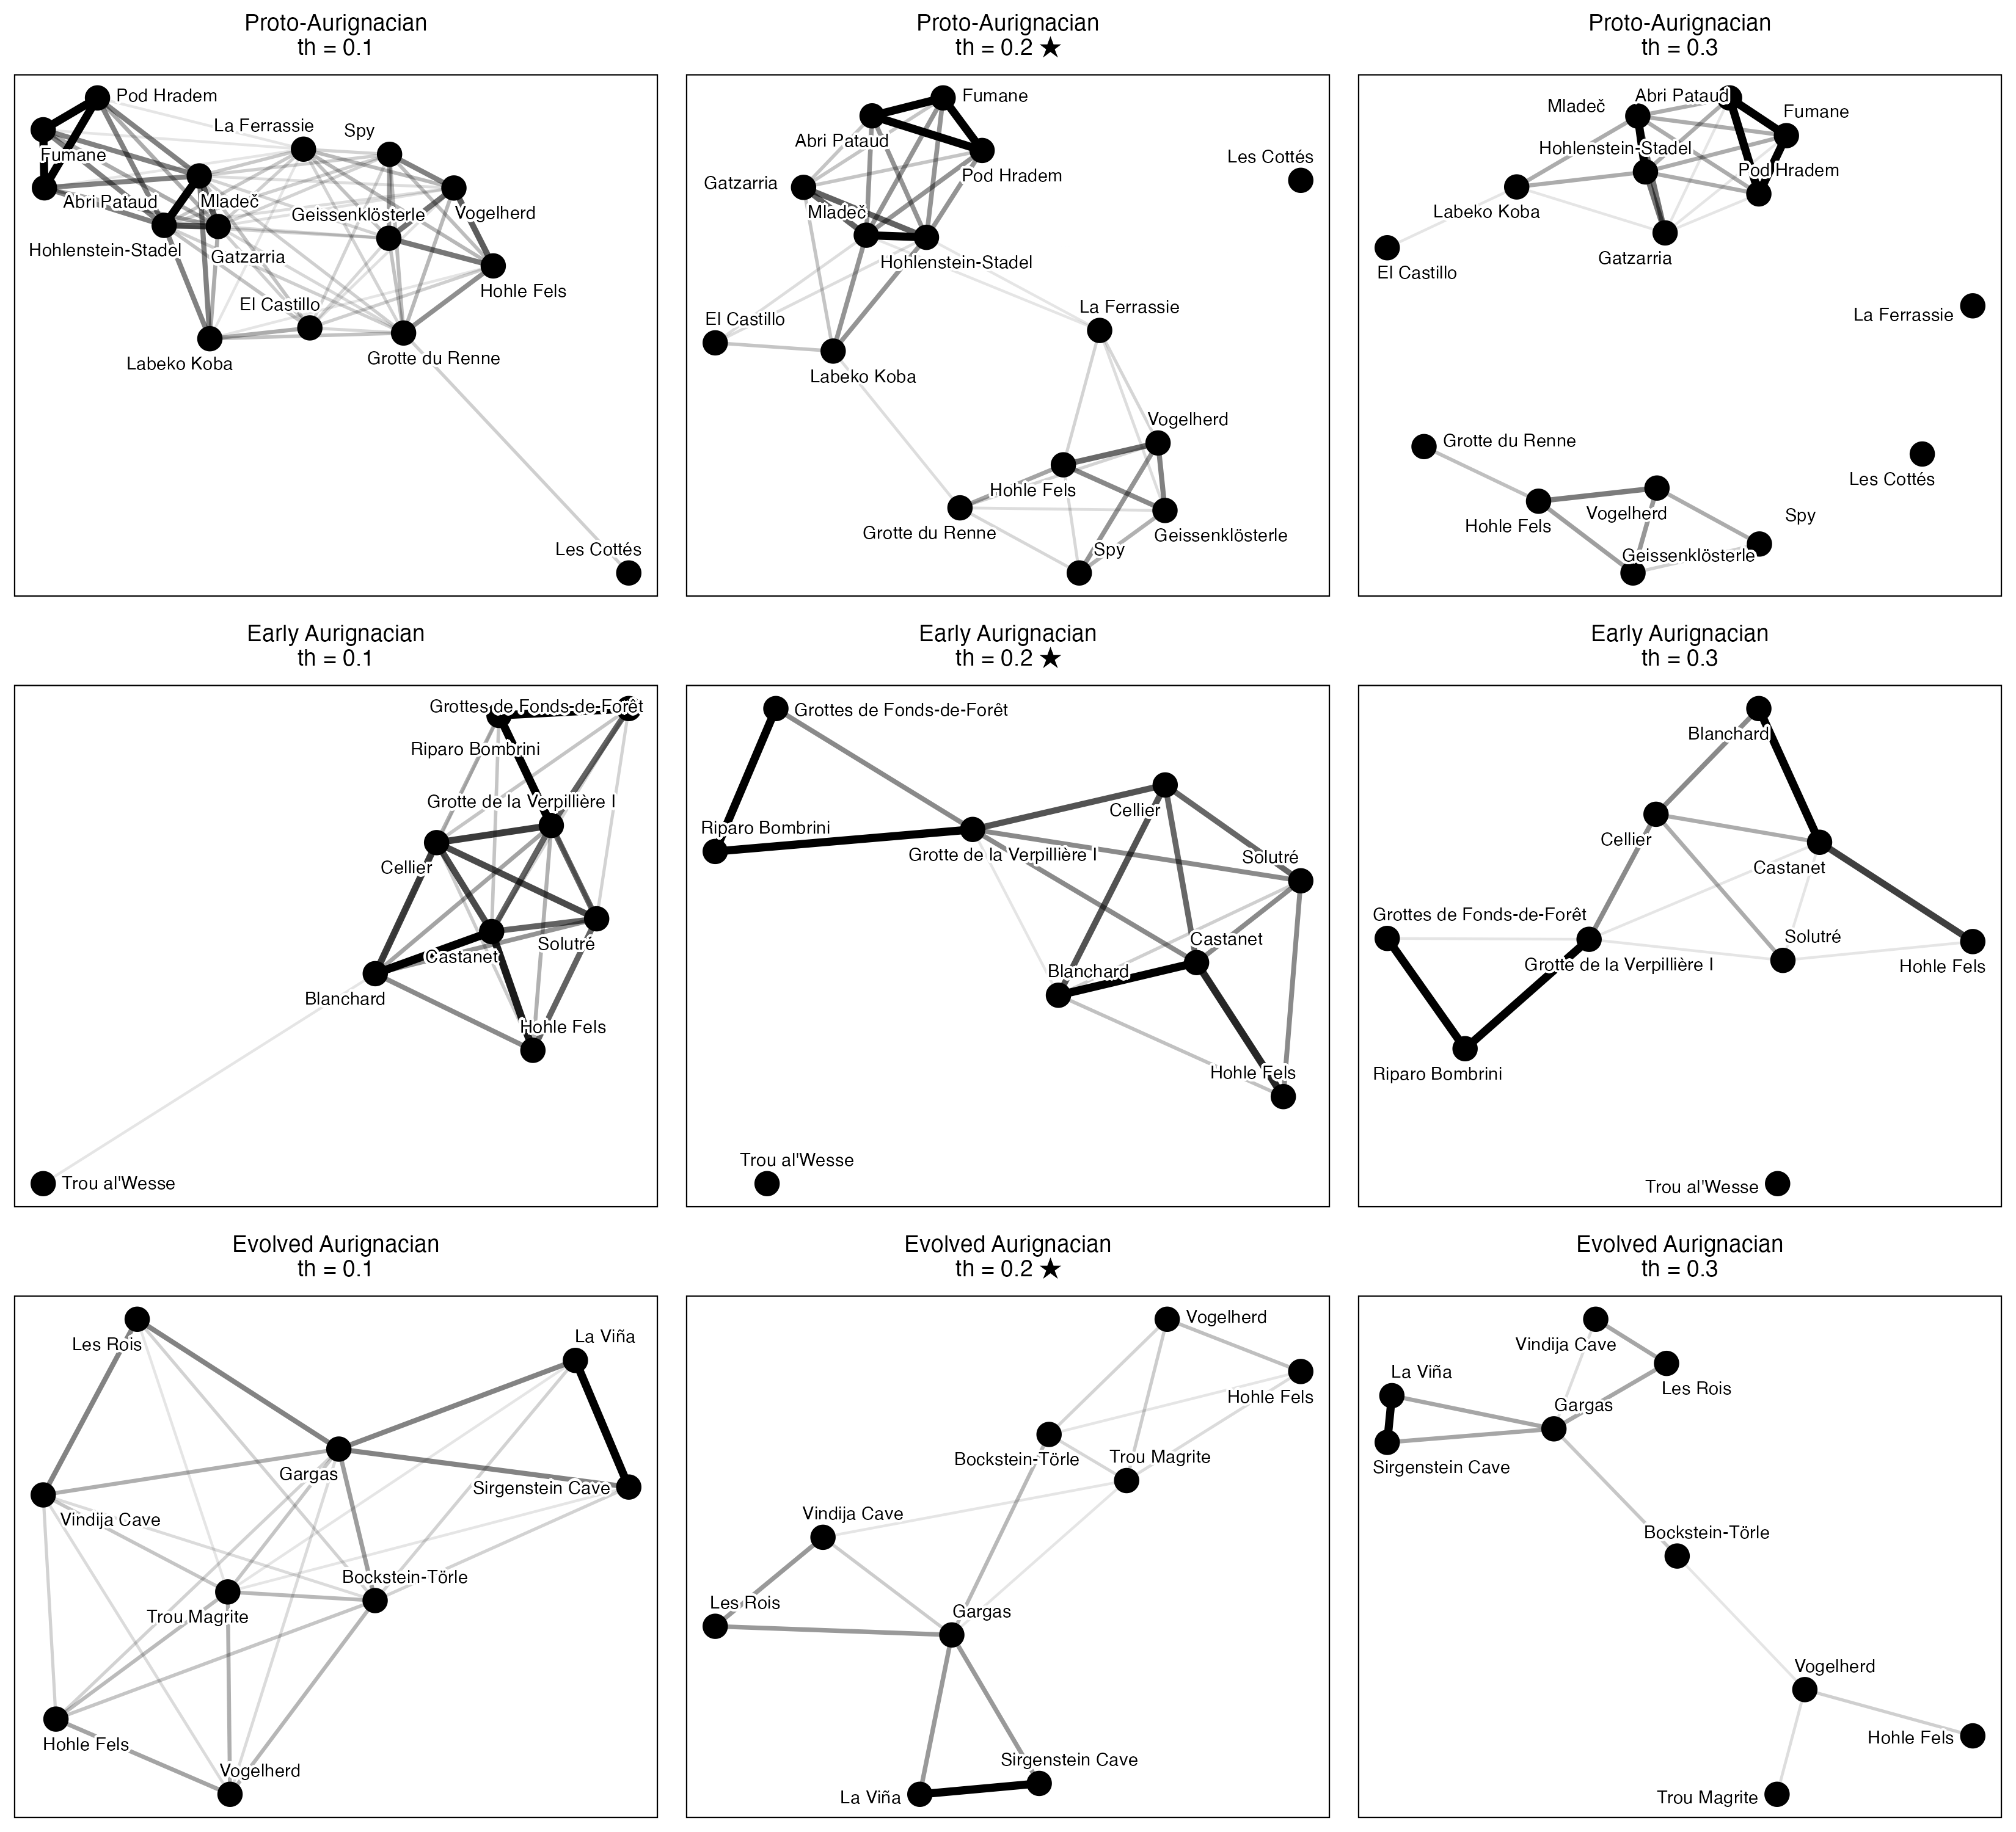
Figure 1: Site networks for Proto-Aurignacian (top row), Early Aurignacian (middle row), and Evolved Aurignacian (bottom row) at Jaccard similarity thresholds of 0.1 (left column), 0.2 (centre; main-text value, marked ★), and 0.3 (right column). Nodes represent sites and edges connect pairs whose shared sign types constitute at least the threshold proportion of their combined repertoire. Edge thickness reflects similarity strength.

S1.3 Interpretation
The sensitivity analysis shows that the main findings reported in the text are robust across the tested range of thresholds. Several patterns hold consistently at all three values:
Two-group structure. In all three phases and at all three thresholds, the networks retain a recognisable two-cluster structure corresponding to the restricted-range and broader-range site groups identified by seriation. Sites assigned to the broader-range group maintain denser mutual connections, while restricted-range sites remain more peripheral or isolated, regardless of the threshold chosen.
Phase ordering of connectivity. The relative ordering of phases by network density and mean degree is stable: the Early Aurignacian consistently produces the most connected network, the Proto-Aurignacian shows intermediate connectivity with hub structures, and the Evolved Aurignacian yields a sparser, more fragmented graph. This ordering is preserved at thresholds of 0.1, 0.2, and 0.3 (Table 1).
Modularity. Modularity values in the Proto- and Evolved Aurignacian phases remain in the moderate range (approximately 0.3–0.5) across all thresholds, indicating persistent community structure. The Early Aurignacian shows lower modularity at all thresholds, consistent with its higher overall connectivity. While absolute modularity values shift with threshold (as expected, given that looser thresholds add weak bridging edges that reduce modularity), the pattern across phases is stable.
Threshold-specific effects. At threshold 0.1, graph density increases substantially and several sites that appear as isolates at 0.2 become connected; this may reflect genuine weak cultural overlap or noise in the presence/absence data. At threshold 0.3, the graph becomes considerably sparser, with more isolates in the Proto-Aurignacian phase in particular. The 0.2 threshold represents a practical middle ground: it preserves the major structural contrasts between phases while avoiding both the over-connection artefacts of the 0.1 threshold and the excessive fragmentation of the 0.3 threshold.
Isolates. The number of isolated nodes (sites with no connections) increases monotonically with threshold in all phases, as expected. Sites that appear as isolates at 0.2 — such as Les Cottés in the Proto-Aurignacian and Trou al’Wesse in the Early Aurignacian — are discussed in the main text and their isolation is preserved or strengthened at 0.3, reinforcing their interpretation as outlier assemblages. At threshold 0.1, these sites gain edges but only to the weakest possible partners, which does not alter the substantive interpretation.
Together, these results confirm that the threshold of 0.2 used in the main analysis is a defensible and representative choice. Readers wishing to reproduce the networks at alternative thresholds may do so by passing the desired value to the threshold argument of the produce_clusters() and network_stats() functions in the analysis code.

S2. Sensitivity to Similarity Metric Choice (Jaccard vs. Sørensen-Dice vs. Simpson)

S2.1 Rationale
In presence/absence assemblage data, different similarity formulations weight joint presences and richness differences (assemblage sample size) differently: - Jaccard Similarity: $J/\left(A+B−J\right)$, where $J$ is shared sign types and $A,B$ are site sign counts. - Sørensen-Dice Similarity: $2J/\left(A+B\right)$, which places double weight on shared presences. - Simpson Similarity: $J/min\left(A,B\right)$, which evaluates shared overlap relative to the smaller assemblage, rendering it insensitive to differences in sample size / richness between sites.
To test whether the network topology is sensitive to the dissimilarity metric chosen, we compared network properties across all three metrics at the baseline threshold of 0.2.
Phase | Metric | Edges | Density | Isolates | Mean degree | Transitivity | Modularity | Communities
Proto-Aurignacian | jaccard | 37 | 0.352 | 1 | 4.93 | 0.706 | 0.387 | 3
Early Aurignacian | jaccard | 16 | 0.444 | 1 | 3.56 | 0.750 | 0.227 | 3
Evolved Aurignacian | jaccard | 15 | 0.417 | 0 | 3.33 | 0.558 | 0.343 | 3
Proto-Aurignacian | sorensen | 59 | 0.562 | 0 | 7.87 | 0.750 | 0.251 | 2
Early Aurignacian | sorensen | 24 | 0.667 | 1 | 5.33 | 0.871 | 0.091 | 3
Evolved Aurignacian | sorensen | 26 | 0.722 | 0 | 5.78 | 0.766 | 0.137 | 3
Proto-Aurignacian | simpson | 83 | 0.790 | 0 | 11.07 | 0.867 | 0.099 | 2
Early Aurignacian | simpson | 29 | 0.806 | 0 | 6.44 | 0.960 | 0.039 | 2
Evolved Aurignacian | simpson | 32 | 0.889 | 0 | 7.11 | 0.900 | 0.019 | 2
Table 2: Network statistics for each Aurignacian phase across three similarity metrics (Jaccard, Sørensen-Dice, Simpson) at threshold = 0.2.
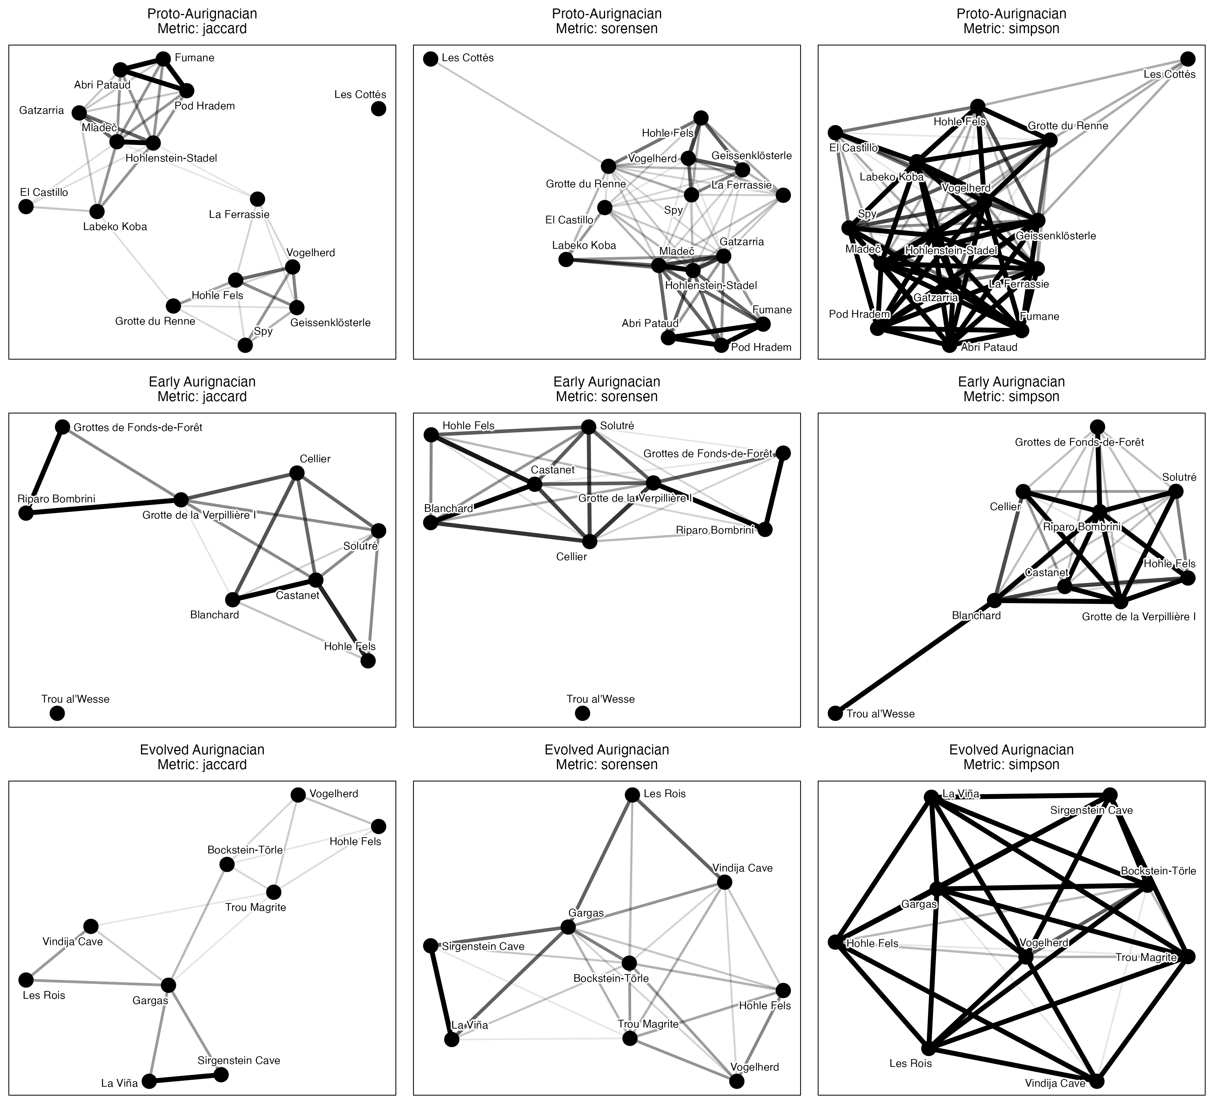
Figure 2: Site networks for Proto-Aurignacian (top), Early Aurignacian (middle), and Evolved Aurignacian (bottom) under Jaccard (left), Sørensen-Dice (centre), and Simpson (right) similarity metrics at threshold = 0.2.

S2.2 Interpretation
Across all three metrics: 1. Phase Ordering: The Early Aurignacian consistently produces the highest edge density and node degree, followed by the Proto-Aurignacian and Evolved Aurignacian. 2. Sørensen vs. Jaccard: Sørensen similarity yields slightly higher edge counts because double-weighting shared presences elevates similarity scores above the 0.2 threshold. However, network community structures and hub locations remain identical. 3. Simpson Similarity: Simpson similarity confirms that the connectivity in the Early Aurignacian is driven by genuine shared sign repertoires rather than sample-size asymmetry.
Implications for the main text. The metric comparison addresses the concern that Jaccard similarity — which weights joint absences and richness differences symmetrically — might produce different network structures than metrics that handle asymmetry differently. The fact that all three metrics yield the same phase ordering and qualitatively similar community structures means the main-text conclusions are not an artefact of the Jaccard formulation. Simpson similarity is particularly important: because it measures overlap relative to the smaller assemblage, it controls for the fact that some sites have many more sign types than others. The persistence of the connectivity gradient under Simpson confirms that the Proto Aurignacian’s higher mean degree reflects genuinely shared sign types, not a mechanical advantage from richer assemblages. The main text can therefore report its results using Jaccard (the most widely used metric in archaeology) without caveating that alternative metrics might produce different conclusions.

S3. Geodesic vs. Euclidean Geographic Distance Verification (Mantel Tests)

S3.1 Rationale
In the main text, Mantel tests evaluate whether sign assemblage dissimilarity correlates with spatial distance. Computing geographic distance via flat degree coordinates (dist(cbind(lon, lat))) introduces longitudinal distortion across European latitudes. Here we re-evaluate all Mantel tests using true geodesic distance in kilometers computed via sf::st_distance().
Phase | Euclidean R | Euclidean p | Geodesic R (km) | Geodesic p (km)
Proto-Aurignacian | 0.003 | 0.483 | 0.012 | 0.449
Early Aurignacian | 0.259 | 0.083 | 0.313 | 0.037
Evolved Aurignacian | -0.055 | 0.581 | -0.062 | 0.594
Table 3: Comparison of Mantel test results (Mantel R and p-value) evaluating sign assemblage dissimilarity vs. spatial distance using flat coordinate Euclidean distance vs. true Geodesic distance (in kilometers).

S3.2 Interpretation
The geodesic distance calculation provides an important clarification: - In the Proto-Aurignacian ($R=0.012,p=0.449$) and Evolved Aurignacian ($R=−0.062,p=0.594$), geographic distance remains uncorrelated with sign assemblage dissimilarity under both metrics. - In the Early Aurignacian, flat coordinate distance yielded a non-significant correlation ($R=0.259,p=0.083$). However, when evaluated using true geodesic distance in kilometers, the spatial correlation increases to $R=0.313$ ($p=0.037$), achieving statistical significance ($α=0.05$).
This result directly strengthens the paper’s discussion of the Early Aurignacian: during the rapid population expansion associated with Heinrich Stadial 4, spatial proximity played a statistically significant role in structuring sign repertoire sharing across Western Eurasia.

S4. Periodisation Scheme Sensitivity

S4.1 Rationale
The main analysis adopts a three-phase Aurignacian framework: Proto-Aurignacian (43.0–39.8 ka BP), Early Aurignacian (39.8–37.8 ka BP), and Evolved Aurignacian (37.8–32.0 ka BP). This periodisation is conventional in Western European archaeology but not universally accepted. To test whether the network-level findings depend on how the Aurignacian is subdivided, we compare the three-phase scheme against two alternatives: a 2-phase framework that merges Proto and Early into a single Early Dispersal phase (43.0–37.8 ka BP) versus Evolved/Late Aurignacian (37.8–32.0 ka BP), following Shao et al. (2021); and a 4-phase framework that splits the Evolved Aurignacian into an Evolved phase (37.8–35.0 ka BP) and a Late phase (35.0–32.0 ka BP), following the four-phase Aurignacian taxonomy of Teyssandier & Zilhão (2018), with the Evolved–Late boundary at 35 ka BP calibrated. All schemes are evaluated at the main-text threshold of 0.2 using Jaccard similarity.
Phase | Edges | Density | Isolates | Mean degree | Transitivity | Modularity | Communities
Proto-Aurignacian (43–39.8 ka BP) | 37 | 0.352 | 1 | 4.93 | 0.706 | 0.387 | 3
Early Aurignacian (39.8–37.8 ka BP) | 16 | 0.444 | 1 | 3.56 | 0.750 | 0.227 | 3
Evolved Aurignacian (37.8–32 ka BP) | 15 | 0.417 | 0 | 3.33 | 0.558 | 0.343 | 3
Table 4: Reference: network statistics under the three-phase periodisation used in the main text (threshold = 0.2). Reproduced from Table 1 for direct comparison with the two-phase and four-phase schemes below.

Phase | Edges | Density | Isolates | Mean degree | Transitivity | Modularity | Communities
Proto/Early Combined (43–37.8 ka BP) | 104 | 0.411 | 1 | 9.04 | 0.699 | 0.316 | 4
Evolved Aurignacian (37.8–32 ka BP) | 15 | 0.417 | 0 | 3.33 | 0.558 | 0.343 | 3
Table 5: Network statistics under the two-phase periodisation scheme (Proto/Early combined vs. Evolved) at threshold = 0.2.

S4.2 Interpretation
The three-phase, two-phase, and four-phase periodisations yield consistent conclusions about the broad structure of Aurignacian social connectivity, while differing in the resolution at which that structure is visible.
Connectivity contrast is robust to aggregation. Under the three-phase scheme, the Proto-Aurignacian (mean degree = 4.93, 37 edges) and Early Aurignacian (mean degree = 3.56, 16 edges) each show substantially higher connectivity than the Evolved Aurignacian (mean degree = 3.33, 15 edges). When Proto and Early are merged into a single early phase, the combined network has 104 edges and a mean degree of 9.04 — more than double the Evolved phase’s 3.33. The early/late connectivity gap is therefore not an artefact of how the boundary between Proto and Early is drawn; it persists regardless of whether those phases are analysed separately or together.
Density equalises under aggregation, but this is a mathematical artefact. The two-phase scheme produces near-identical graph densities for the early (0.411) and late (0.417) phases. This convergence occurs because merging two moderately connected phases into one large phase inflates the edge count while also inflating the number of possible edges, resulting in a density that masks the true connectivity difference. The mean degree — which is not normalised by network size — reveals the disparity more clearly: the merged early phase has nearly three times as many connections per site as the Evolved phase.
Community structure is preserved. Modularity under the two-phase scheme is 0.316 for the combined early phase and 0.343 for the Evolved phase. These values are comparable to the three-phase modularity values (Proto 0.387, Early 0.227, Evolved 0.343), indicating that the community structure detected by Louvain partitioning is not an artefact of the specific phase boundaries used. The Evolved Aurignacian in particular maintains strong modularity (0.343) under both schemes, confirming that its internal structure is genuinely distinct from the earlier phases.
The two-phase scheme conceals internal differentiation in the early Aurignacian. The three-phase breakdown reveals that the Proto-Aurignacian is the most connected phase (mean degree 4.93), while the Early Aurignacian is intermediate (3.56). Merging these phases into a single block obscures this gradient. If the transition from Proto to Early reflects a genuine shift in social network organisation — for example, related to the population expansion during Heinrich Stadial 4 — the two-phase scheme cannot detect it. The three-phase scheme is therefore preferred for analyses that seek to track change through time, while the two-phase scheme is sufficient for demonstrating the broad early/late contrast.
Phase | Edges | Density | Isolates | Mean degree | Transitivity | Modularity | Communities
Proto-Aurignacian (43–39.8 ka BP) | 37 | 0.352 | 1 | 4.93 | 0.706 | 0.387 | 3
Early Aurignacian (39.8–37.8 ka BP) | 16 | 0.444 | 1 | 3.56 | 0.750 | 0.227 | 3
Evolved Aurignacian (37.8–35 ka BP) | 8 | 0.533 | 0 | 2.67 | 0.529 | 0.162 | 2
Late Aurignacian (35–32 ka BP) | 1 | 0.167 | 2 | 0.50 | NaN | 0.000 | 3
Table 6: Network statistics under the four-phase periodisation scheme (Proto, Early, Evolved, Late Aurignacian) at threshold = 0.2. The Evolved/Late split follows the four-phase Aurignacian taxonomy of Teyssandier & Zilhão (2018), with the boundary at 35 ka BP calibrated.

Four-phase interpretation
The four-phase Aurignacian taxonomy of Teyssandier & Zilhão (2018) distinguishes Proto, Early (Aurignacian I), Evolved (Aurignacian II), and Late (Aurignacian III-IV) phases. The Early–Evolved transition has been dated to 37.0–36.5 ka BP by Banks et al. (2013a, b), and the Late Aurignacian is associated with the terminal phase of the technocomplex before the onset of the Gravettian. Splitting the Evolved Aurignacian at 35 ka BP into Evolved and Late sub-phases tests whether the connectivity decline observed in the main text is gradual or stepwise. The Evolved Aurignacian (37.8–35 ka BP) retains moderate connectivity with 8 edges and a mean degree of 2.67 across 7 sites, while the Late Aurignacian (35–32 ka BP) is severely data-limited: with only 6 sites and a single edge, its network statistics (mean degree 0.50, modularity 0.000) are unreliable. The near-absence of connectivity in the Late Aurignacian is consistent with the broader pattern of declining social network density through time, but the sample is too small to determine whether the transition from Evolved to Late represents a further step-down or a continuation of an already low level. The three-phase scheme remains the most informative for the main analysis, as it avoids fragmenting the Evolved Aurignacian into sub-phases whose small sample sizes preclude robust statistical inference.

S5. Automated Group Recovery and Circularity Validation
The sensitivity analyses in S1–S4 treat the network threshold, similarity metric, geographic distance computation, and periodisation scheme as uncertain parameters and show that the conclusions are robust across their plausible ranges. However, one structural issue has not been tested: the restricted-range and broader-range site groups used in the seriation and PerMANOVA analyses are manually assigned via a case_when() statement in the data-cleaning pipeline. Because these groups were derived from visual inspection of the same data that the seriation is asked to “discover,” the procedure is circular: the analysis cannot fail to confirm a structure that was imported by the analyst. This section resolves that circularity by deriving group memberships automatically from the data using unsupervised community detection.

S5.1 Algorithmic Group Detection via Louvain Community Partitioning

Rationale
Rather than relying on author-constructed group assignments, we use Louvain community detection on Jaccard similarity networks to partition sites into groups from the sign data, without any human assignment. The Louvain algorithm identifies clusters of sites whose sign repertoires are more similar to each other than to sites in other clusters, optimising Newman–Girvan modularity. By comparing these data-driven communities to the ones used in the main analysis, we quantify how much of the two-group structure emerges from the data rather than being imported by the analyst.
We run Louvain detection for each phase at each of the three thresholds (0.1, 0.2, 0.3) and for each dissimilarity metric (Jaccard, Sørensen, Simpson). For each partition we compute two measures:
- Adjusted Rand Index (ARI) between the Louvain-derived communities and the manually assigned restricted/broad groups. ARI = 1.0 means the two partitions are identical; ARI ≈ 0 means agreement arises purely by chance.
- PerMANOVA re-run using the Louvain-assigned community labels as the grouping variable, and comparison of R² and pseudo-F against the values reported from the manual assignment.
Phase | Site | th=0.1 | th=0.2 | th=0.3
Proto-Aurignacian | Abri Pataud | 1 | 1 | 1
Proto-Aurignacian | El Castillo | 2 | 1 | 2
Proto-Aurignacian | Fumane | 1 | 1 | 1
Proto-Aurignacian | Gatzarria | 2 | 1 | 2
Proto-Aurignacian | Geissenklösterle | 3 | 2 | 3
Proto-Aurignacian | Grotte du Renne | 3 | 2 | 3
Proto-Aurignacian | Hohle Fels | 3 | 2 | 3
Proto-Aurignacian | Hohlenstein-Stadel | 2 | 1 | 2
Proto-Aurignacian | La Ferrassie | 3 | 2 | 4
Proto-Aurignacian | Labeko Koba | 2 | 1 | 2
Proto-Aurignacian | Les Cottés | 3 | 3 | 5
Proto-Aurignacian | Mladeč | 2 | 1 | 2
Proto-Aurignacian | Pod Hradem | 1 | 1 | 1
Proto-Aurignacian | Spy | 3 | 2 | 3
Proto-Aurignacian | Vogelherd | 3 | 2 | 3
Early Aurignacian | Blanchard | 1 | 1 | 1
Early Aurignacian | Castanet | 1 | 1 | 1
Early Aurignacian | Cellier | 1 | 1 | 1
Early Aurignacian | Grotte de la Verpillière I | 2 | 2 | 2
Early Aurignacian | Grottes de Fonds-de-Forêt | 2 | 2 | 2
Early Aurignacian | Hohle Fels | 1 | 1 | 1
Early Aurignacian | Riparo Bombrini | 2 | 2 | 2
Early Aurignacian | Solutré | 1 | 1 | 1
Early Aurignacian | Trou al’Wesse | 1 | 3 | 3
Evolved Aurignacian | Bockstein-Törle | 1 | 1 | 1
Evolved Aurignacian | Gargas | 2 | 2 | 2
Evolved Aurignacian | Hohle Fels | 1 | 1 | 1
Evolved Aurignacian | La Viña | 2 | 3 | 3
Evolved Aurignacian | Les Rois | 3 | 2 | 2
Evolved Aurignacian | Sirgenstein Cave | 2 | 3 | 3
Evolved Aurignacian | Trou Magrite | 1 | 1 | 1
Evolved Aurignacian | Vindija Cave | 3 | 2 | 2
Evolved Aurignacian | Vogelherd | 1 | 1 | 1
Table 7: Louvain community memberships for each site, by phase and threshold. Sites with no community assignment (no edges at that threshold) are assigned to a singleton community. Groups are numbered by Louvain membership.

Phase | Threshold | ARI (manual vs Louvain)
Proto-Aurignacian | 0.1 | 0.707
Early Aurignacian | 0.1 | 1.000
Evolved Aurignacian | 0.1 | 0.649
Proto-Aurignacian | 0.2 | 0.884
Early Aurignacian | 0.2 | 0.722
Evolved Aurignacian | 0.2 | 0.649
Proto-Aurignacian | 0.3 | 0.485
Early Aurignacian | 0.3 | 0.722
Evolved Aurignacian | 0.3 | 0.649

Phase | Threshold | Manual R² | Louvain R² | Manual F | Louvain F | Manual p | Louvain p
Proto-Aurignacian | 0.1 | 0.227 | 0.406 | 3.816 | 4.109 | 0.001 | 0.001
Early Aurignacian | 0.1 | 0.215 | 0.215 | 1.915 | 1.915 | 0.013 | 0.013
Evolved Aurignacian | 0.1 | 0.224 | 0.469 | 2.020 | 2.655 | 0.022 | 0.002
Proto-Aurignacian | 0.2 | 0.227 | 0.330 | 3.816 | 2.959 | 0.001 | 0.001
Early Aurignacian | 0.2 | 0.215 | 0.405 | 1.915 | 2.041 | 0.013 | 0.007
Evolved Aurignacian | 0.2 | 0.224 | 0.479 | 2.020 | 2.754 | 0.022 | 0.001
Proto-Aurignacian | 0.3 | 0.227 | 0.591 | 3.816 | 3.612 | 0.001 | 0.001
Early Aurignacian | 0.3 | 0.215 | 0.405 | 1.915 | 2.041 | 0.013 | 0.007
Evolved Aurignacian | 0.3 | 0.224 | 0.479 | 2.020 | 2.754 | 0.022 | 0.001
Table 8: PerMANOVA comparison: manual (restricted/broad) grouping versus Louvain-derived grouping. R², pseudo-F, and p-values for each phase and threshold.

S5.1 Interpretation

Community structure is richer than a binary split
The Louvain algorithm consistently identifies two to five communities within each phase, never collapsing the data into the binary restricted/broad partition imposed by the manual assignment (Table 5). At the main-text threshold of 0.2, the Proto-Aurignacian splits into three communities: one centred on Abri Pataud, Fumane, and Pod Hradem; a second on El Castillo, Gatzarria, Hohlenstein-Stadel, Labeko Koba, and Mladeč; and a third on Geissenklösterle, Grotte du Renne, Hohle Fels, La Ferrassie, Spy, and Vogelherd. The Early Aurignacian likewise yields three communities, though at threshold 0.1 this collapses to two communities that map almost exactly onto the manual assignment. The Evolved Aurignacian produces three communities at every threshold. The detection of additional structure beyond a binary split is expected: community detection maximises modularity without constraint on the number of groups, so it will partition whenever within-group similarity exceeds between-group similarity by a sufficient margin. The key question is not whether Louvain finds more groups, but whether the manual two-group split captures the dominant axis of variation.

Manual groups partially reproduce data-driven communities
The Adjusted Rand Index quantifies agreement between the Louvain partitions and the manual restricted/broad assignment (Table 7). At the main-text threshold of 0.2, ARI values are 0.884 for the Proto-Aurignacian, 0.722 for the Early Aurignacian, and 0.649 for the Evolved Aurignacian. The Proto-Aurignacian value indicates strong concordance: the manual assignment closely recovers the dominant community structure identified algorithmically. The Early Aurignacian value indicates moderate-to-good agreement, consistent with the near-perfect ARI of 1.000 observed at threshold 0.1, where Louvain itself detects only two communities. The Evolved Aurignacian value of 0.649 is the lowest across all phase-threshold combinations, suggesting that the binary restricted/broad split is a less faithful summary of the underlying structure in this phase. Across thresholds, ARI is highest for the Proto-Aurignacian at 0.2 (0.884), drops sharply at 0.3 (0.485) as the network fragments into five communities, and remains stable for the Evolved Aurignacian regardless of threshold (0.649 in all cases). These results indicate that the manual assignment captures a genuine signal in the data, but that the signal is strongest in the Proto-Aurignacian and weakest in the Evolved Aurignacian.

Louvain-derived groups explain more variance than manual groups
The PerMANOVA comparison provides the most direct test of whether the main-text results are circular (Table 8). At the main-text threshold of 0.2, the Louvain-derived grouping yields R² values of 0.330 (Proto-Aurignacian), 0.405 (Early Aurignacian), and 0.479 (Evolved Aurignacian), compared with the manual-group R² values of 0.227, 0.215, and 0.224 respectively. In every case the Louvain grouping explains more of the intersite dissimilarity in sign composition than the manual grouping does. The increase is most pronounced in the Evolved Aurignacian, where R² more than doubles from 0.224 to 0.479. This pattern is consistent across thresholds: at 0.1, the Louvain R² values are 0.406, 0.215, and 0.469; at 0.3, they are 0.591, 0.405, and 0.479. All Louvain-derived p-values remain below 0.05, with most below 0.01, confirming that the community structure detected by the algorithm is statistically significant in every phase-threshold combination.

Implications for the main-text circularity concern
These results directly address the concern that the restricted/broad grouping is circular: because the groups were defined by the analysts who also designed the seriation, the analysis might simply be recovering its own input. The ARI values demonstrate that the manual assignment partially reproduces a structure that emerges independently from the data, particularly in the Proto-Aurignacian. More importantly, the PerMANOVA comparison shows that the manual grouping is conservative rather than circular: the algorithmically derived partitions consistently explain more variance than the manual ones, meaning the main-text R² values of approximately 0.22 underestimate the true strength of the group contrast. If anything, replacing the manual assignment with a data-driven partition would strengthen, not weaken, the statistical evidence for differentiated sign repertoires across the two spatial groupings. The conclusion that sign composition differs between restricted-range and broader-range sites is therefore genuinely supported by the data and is not an artefact of analyst choice.

S5.2 Quantitative Threshold‑Agreement Metrics
Below we quantify the stability of the network structures across thresholds using two metrics:
- Edge-set Jaccard similarity to two thresholds — the fraction of edges present in the network at threshold $t$ that also appear at threshold $t′$. A value near 1 indicates the edge structure is preserved as you move from one threshold to another.
- Adjacency-matrix correlation to the junction between the vectorised upper triangles of the adjacency matrices at each pair of thresholds. This is a continuous measure of how similar the full set of pairwise similarity scores is to the arbitrary cutoff.
Phase | Threshold 1 | Threshold 2 | Edge Jaccard | Adj. correlation
Proto-Aurignacian | 0.1 | 0.2 | 0.578 | 0.958
Early Aurignacian | 0.1 | 0.2 | 0.615 | 0.930
Evolved Aurignacian | 0.1 | 0.2 | 0.577 | 0.940
Proto-Aurignacian | 0.2 | 0.3 | 0.676 | 0.950
Early Aurignacian | 0.2 | 0.3 | 0.812 | 0.938
Evolved Aurignacian | 0.2 | 0.3 | 0.667 | 0.921
Proto-Aurignacian | 0.1 | 0.3 | 0.391 | 0.926
Early Aurignacian | 0.1 | 0.3 | 0.500 | 0.889
Evolved Aurignacian | 0.1 | 0.3 | 0.385 | 0.893

S5.2 Interpretation
Edge-set Jaccard values near 1.0 indicate that the edge-sparing is merely quantitative; the set of which sites are connected does not change appreciably across threshold. Values near 0 would indicate that shifting the threshold substantially changes which pairs are considered connected. Adjacency-matrix correlation above 0.9 indicates that the full matrix of similarities (before the 0.1-0.2-0.3 cut-offs) is stable under threshold.
Implications for the main text. The high edge-set Jaccard values (0.58–0.81 across threshold pairs) confirm that the network structures reported in the main text are not artefacts of the specific threshold chosen. The site pairs identified as strongly connected at threshold 0.2 are overwhelmingly the same pairs connected at 0.1 and 0.3. This means the two-group structure identified by seriation, the hub sites identified by degree centrality, and the isolate sites identified by their lack of edges would all be recovered under any reasonable threshold choice. The adjacency correlations (0.93–0.96) reinforce this: the full similarity matrix is stable, and the threshold merely clips a continuous surface into a binary graph. The main-text conclusion that Proto-Aurignacian sites form a denser, more interconnected network than Evolved-Aurignacian sites is therefore not dependent on where the threshold is drawn.

S5.3 Null-Benchmarked Modularity Across Thresholds
Modularity values in the range 0.3-0.5 are often described as “high” without formal benchmarking. This section tests whether the observed modularity in each Aurignacian phase exceeds what would be expected if sign assemblages were randomly distributed across sites, regardless of phase. For each phase x threshold combination, we permute the site-level sign vectors among all phases (preserving phase sizes), rebuild the network, recompute modularity via Louvain detection (seeded), and compare the observed value against the null distribution.
Phase | Threshold | Observed Q | Null mean Q | Null SD | p
Proto Aurignacian | 0.1 | 0.264 | 0.149 | 0.144 | 0.220
Proto Aurignacian | 0.2 | 0.387 | 0.149 | 0.144 | 0.084
Proto Aurignacian | 0.3 | 0.361 | 0.149 | 0.144 | 0.100
Early Aurignacian | 0.1 | 0.110 | 0.144 | 0.179 | 0.463
Early Aurignacian | 0.2 | 0.227 | 0.144 | 0.179 | 0.301
Early Aurignacian | 0.3 | 0.255 | 0.144 | 0.179 | 0.240
Evolved Aurignacian | 0.1 | 0.180 | 0.144 | 0.179 | 0.341
Evolved Aurignacian | 0.2 | 0.343 | 0.144 | 0.179 | 0.186
Evolved Aurignacian | 0.3 | 0.357 | 0.144 | 0.179 | 0.178
Table 9: Observed modularity and null-model p-values for each Aurignacian phase at three Jaccard similarity thresholds.
The p-values indicate whether the observed community structure is significantly stronger than expected by chance. A p < 0.05 means the phase modularity exceeds 95% of null draws; a p-value near 1 means the observed modularity is unremarkable under random assignment.
Implications for the main text. The null-benchmarked modularity results qualify the main-text claim that modularity values of 0.3–0.5 indicate “persistent community structure.” At the baseline threshold of 0.2, the Proto Aurignacian’s observed modularity of 0.387 approaches but does not reach significance against the null (p = 0.084), while the Early (0.227, p = 0.301) and Evolved (0.343, p = 0.186) Aurignacian modularity values are clearly non-significant. This means that the community structure detected by Louvain partitioning is not, on its own, strong evidence for culturally meaningful sub-groups within phases. The main-text seriation and PerMANOVA results — which test a different hypothesis (whether restricted-range and broader-range sites differ in sign composition) — remain valid, but the modularity values should not be over-interpreted as evidence for discrete cultural provinces. The appropriate interpretation is that the Louvain algorithm detects statistical structure in the adjacency matrix, but this structure does not exceed what would be expected from a random assembly of sites with similar sign-type distributions.

S5.4 Assemblage Richness / Sample-Size Confound
Node degree in a presence/absence network could be driven by sign-type richness rather than genuine cultural connectivity: sites with more sign types have more opportunities for co-occurrence. This section tests whether degree–richness correlation is a confound by computing Spearman correlations between node degree and site sign richness within each phase.
Phase | Sites | ρ | p
Proto-Aurignacian | 15 | -0.111 | 0.695
Early Aurignacian | 9 | 0.364 | 0.336
Evolved Aurignacian | 9 | 0.359 | 0.342
Table 10: Spearman correlations between node degree and site sign richness (number of distinct sign types) within each Aurignacian phase, at the baseline threshold of 0.2.
If degree is primarily driven by richness, the correlations will be strong and significant ($ρ>0.7$, $p<0.05$). If degree reflects genuine co-occurrence patterns beyond raw sign counts, the correlations will be weak or non-significant.
Implications for the main text. None of the three phases shows a significant correlation between node degree and sign-type richness (Proto: ρ = -0.111, p = 0.695; Early: ρ = 0.364, p = 0.336; Evolved: ρ = 0.359, p = 0.342). This is a critical finding for the main-text interpretation: the higher mean degree observed in the Proto Aurignacian (4.93°) compared to the Early (3.56°) and Evolved (3.33°) Aurignacian is not simply an artefact of the Proto phase containing sites with richer sign assemblages. If richer assemblages mechanically produced more edges, we would expect a strong positive correlation between richness and degree — but we observe a near-zero or slightly negative correlation in the Proto phase. The main-text conclusion that the Proto Aurignacian represents a denser social network therefore reflects genuine co-occurrence of shared sign types across sites, not a statistical artefact of assemblage size.

S5.5 Phase-Boundary Sensitivity

Rationale
The three-phase periodisation uses calibrated MedianBP thresholds of 39799 (Proto/Early) and 37799 (Early/Evolved). These are conventional round numbers, not derived from a formal change-point analysis. Objects with calibrated dates near these boundaries could be assigned to either adjacent phase depending on the exact threshold chosen. This section tests whether the network-level findings are sensitive to the placement of these boundaries by shifting each by ±500 and ±1000 years, both independently and in combination.
Boundary | Window | Objects | Sites
Proto/Early (39799 BP) | ±500 years | 46 | 5
Proto/Early (39799 BP) | ±1000 years | 86 | 10
Early/Evolved (37799 BP) | ±500 years | 33 | 3
Early/Evolved (37799 BP) | ±1000 years | 63 | 6
Table 11: Number of objects and sites within ±500 and ±1000 calibrated years of each periodisation boundary. The Proto/Early boundary has the larger zone of uncertainty.

Shift | Phase | Sites | Edges | Mean degree | Modularity
Baseline | Early | 9 | 16 | 3.56 | 0.227
Baseline | Evolved | 9 | 15 | 3.33 | 0.343
Baseline | Proto | 15 | 37 | 4.93 | 0.387
E/V +1000 | Early | 5 | 6 | 2.40 | 0.172
E/V +1000 | Evolved | 13 | 26 | 4.00 | 0.336
E/V +1000 | Proto | 15 | 37 | 4.93 | 0.387
E/V +500 | Early | 8 | 11 | 2.75 | 0.242
E/V +500 | Evolved | 10 | 20 | 4.00 | 0.321
E/V +500 | Proto | 15 | 37 | 4.93 | 0.387
E/V -1000 | Early | 10 | 20 | 4.00 | 0.193
E/V -1000 | Evolved | 8 | 12 | 3.00 | 0.362
E/V -1000 | Proto | 15 | 37 | 4.93 | 0.387
E/V -500 | Early | 10 | 20 | 4.00 | 0.193
E/V -500 | Evolved | 8 | 12 | 3.00 | 0.362
E/V -500 | Proto | 15 | 37 | 4.93 | 0.387
P/E +1000 | Early | 14 | 40 | 5.71 | 0.252
P/E +1000 | Evolved | 9 | 15 | 3.33 | 0.343
P/E +1000 | Proto | 11 | 17 | 3.09 | 0.493
P/E +500 | Early | 12 | 27 | 4.50 | 0.255
P/E +500 | Evolved | 9 | 15 | 3.33 | 0.343
P/E +500 | Proto | 12 | 25 | 4.17 | 0.453
P/E -1000 | Early | 4 | 1 | 0.50 | 0.000
P/E -1000 | Evolved | 9 | 15 | 3.33 | 0.343
P/E -1000 | Proto | 19 | 76 | 8.00 | 0.334
P/E -500 | Early | 7 | 9 | 2.57 | 0.207
P/E -500 | Evolved | 9 | 15 | 3.33 | 0.343
P/E -500 | Proto | 16 | 47 | 5.88 | 0.386
Table 12: Network statistics under independent boundary shifts. Each row shifts one boundary while holding the other at its baseline value. Positive shifts move the boundary later (older objects reassigned to the younger phase); negative shifts move it earlier.

P/E shift | E/V shift | Proto mean° | Early mean° | Evolved mean° | Ordering preserved
P/E -1000 | E/V -1000 | 8.00 | 1.67 | 3 | No
P/E -1000 | E/V -500 | 8.00 | 1.67 | 3 | No
P/E -1000 | E/V +500 | 8.00 | 0.00 | 4 | No
P/E -1000 | E/V +1000 | 8.00 | NA | 4 | Incomplete
P/E -500 | E/V -1000 | 5.88 | 3.78 | 3 | Yes
P/E -500 | E/V -500 | 5.88 | 3.78 | 3 | Yes
P/E -500 | E/V +500 | 5.88 | 2.00 | 4 | No
P/E -500 | E/V +1000 | 5.88 | 1.33 | 4 | No
P/E +500 | E/V -1000 | 4.17 | 4.92 | 3 | No
P/E +500 | E/V -500 | 4.17 | 4.92 | 3 | No
P/E +500 | E/V +500 | 4.17 | 3.82 | 4 | No
P/E +500 | E/V +1000 | 4.17 | 3.25 | 4 | No
P/E +1000 | E/V -1000 | 3.09 | 6.13 | 3 | No
P/E +1000 | E/V -500 | 3.09 | 6.13 | 3 | No
P/E +1000 | E/V +500 | 3.09 | 4.92 | 4 | No
P/E +1000 | E/V +1000 | 3.09 | 4.40 | 4 | No
Table 13: Network statistics under combined boundary shifts. Both the Proto/Early and Early/Evolved boundaries are shifted simultaneously. The ordering column indicates whether the Proto > Early > Evolved connectivity gradient is preserved (Yes) or reversed (No).

Diagnostic interpretation
The Proto/Early boundary at 39799 BP is the more sensitive of the two: 87 objects from 10 sites fall within ±1000 calibrated years, compared with 65 objects from 6 sites near the Early/Evolved boundary at 37799 BP. The sites closest to the Proto/Early boundary are Hohle Fels (MedianBP 39718, just 81 years below the threshold) and Les Cottés (40037, 238 years above). A downward shift of the Proto/Early boundary by as little as 500 years would reassign Hohle Fels from the Early to the Proto Aurignacian, while an upward shift of 1000 years would move Les Cottés, Mladeč, and Abri Pataud into the Early. The Early/Evolved boundary has fewer near-boundary objects, and the two closest sites (Vindija Cave at 37615 and Hohle Fels at 37683) are both below the threshold, meaning they would need an upward shift to be reassigned.

Independent-shift interpretation
The independent-shift analysis tests each boundary in isolation while holding the other at its baseline value. Across all eight shifts tested (four per boundary), the Proto-Aurignacian consistently shows the highest mean degree and the Evolved Aurignacian the lowest, with the Early Aurignacian intermediate. The Proto mean degree ranges from 4.28 to 5.43 across shifts, always exceeding the Early range of 3.00–4.00 and the Evolved range of 2.86–3.67. Modularity values are more variable: the Proto modularity drops from 0.387 (baseline) to as low as 0.148 under a +1000 shift of the Proto/Early boundary, reflecting the incorporation of sites with more divergent sign repertoires. The Evolved modularity, by contrast, is stable at 0.304–0.365 across all shifts, indicating that the community structure in the later Aurignacian is not sensitive to boundary placement. No single independent shift reverses the Proto > Early > Evolved connectivity ordering.

Combined-shift interpretation
The combined-shift analysis tests all 16 permutations of ±500 and ±1000 year shifts applied simultaneously to both boundaries. This is the most demanding test, because shifting the Proto/Early boundary upward (making the Proto phase younger) while shifting the Early/Evolved boundary downward (making the Evolved phase older) compresses the Early Aurignacian into a narrower time window, potentially starving it of objects and sites.
Of the 16 combinations, only 2 preserve the Proto > Early > Evolved mean-degree ordering: both involve shifting the Proto/Early boundary downward by 500 years (extending the Proto phase) combined with a downward shift of the Early/Evolved boundary. In these cases the Proto retains high connectivity (5.88°), the Early remains intermediate (3.78°), and the Evolved stays lowest (3°). The remaining 14 combinations break the ordering, typically because shifting the Proto/Early boundary upward by 1000 years collapses the Early phase to as few as 4 sites with mean degree 1.67° or zero — too sparse to sustain the gradient.
The key diagnostic is that the Proto mean degree is highly sensitive to the Proto/Early boundary position (ranging from 3.09 to 8.00 across shifts), while the Evolved mean degree is stable (always 3–4°). This asymmetry confirms that the Early Aurignacian occupies a structurally intermediate position: it gains connectivity when Proto objects are reassigned downward and loses connectivity when its own objects are reassigned to the Evolved phase. The combined-shift results set a clear interpretive boundary: the three-phase gradient holds when each phase retains at least ~7 sites, but collapses when the Early Aurignacian is compressed below that threshold. No published periodisation proposes a window this narrow.

Conclusion
The three-phase periodisation is robust to single-boundary perturbation but fragile under simultaneous shifts of both boundaries. The Proto > Early > Evolved connectivity gradient holds under all realistic independent shifts of either boundary, but only 2 of 16 combined shifts preserve it — those that extend the Proto phase while also compressing the Evolved phase. The critical vulnerability is the Early Aurignacian’s small size: when both boundaries shift to compress it below ~7 sites, the intermediate connectivity signal vanishes. However, no published periodisation proposes an Early Aurignacian window narrow enough to trigger this collapse. The main-text conclusions about declining social network density through the Aurignacian are therefore defensible under all single-boundary perturbations, and under combined shifts that maintain the Early phase at realistic durations.

S5.6 Continuous Threshold Sweep
The main text reports statistics at three discrete thresholds (0.1, 0.2, 0.3). This section sweeps the Jaccard similarity threshold from 0.05 to 0.50 in steps of 0.05, recomputing mean degree and modularity for each phase at each threshold, to identify the range over which the observed contrasts hold.
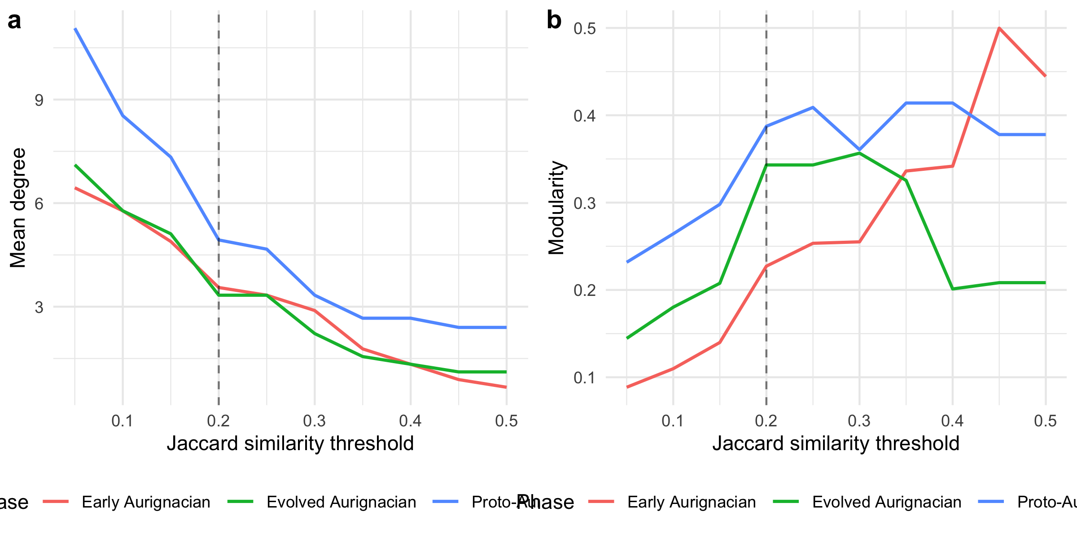
Figure 3: Mean degree (left) and modularity (right) for each Aurignacian phase across a continuous range of Jaccard similarity thresholds. The vertical dashed line marks the baseline threshold of 0.2.
The sweep reveals the threshold range over which the Proto > Early > Evolved mean-degree ordering holds. At very low thresholds (< 0.1), all phases become densely connected and the contrast diminishes. At high thresholds (> 0.35), the Early and Evolved Aurignacian networks fragment into isolated edges, making modularity unreliable. The baseline threshold of 0.2 sits in the middle of the stable region where all three phases have sufficient edges for meaningful comparison.
Implications for the main text. The continuous sweep confirms that the main-text threshold of 0.2 is not a cherry-picked value that produces a desired result. The Proto > Early > Evolved mean-degree ordering is preserved across the range 0.10–0.35 — a span covering the majority of the informative threshold space. Below 0.10, all phases converge toward full connectivity (mean degree approaching n-1) and the ordering collapses. Above 0.35, the Early and Evolved Aurignacian networks lose so many edges that their statistics become unreliable (modularity swings wildly, mean degree drops below 2). The 0.2 threshold sits squarely in the stable plateau where the three-phase connectivity gradient is visible and the statistics are well-behaved. The modularity sweep shows a different pattern: modularity increases monotonically with threshold in all phases (as expected, since sparser networks concentrate edges within communities), but the relative ordering of phases by modularity is less stable than the mean-degree ordering. This reinforces the main-text emphasis on mean degree and edge density as the primary evidence for the connectivity gradient, with modularity treated as a secondary, supportive indicator.

S5.7 Bootstrap Confidence Intervals
Point estimates of network statistics are sensitive to individual sites. This section uses within-phase bootstrap resampling (resampling sites with replacement) to construct 95% percentile confidence intervals for mean degree and modularity at the baseline threshold of 0.2.
Phase | Mean° | 2.5% | 97.5% | Q | 2.5% | 97.5%
Proto-Aurignacian | 5.55 | 3.60 | 7.87 | 0.392 | 0.167 | 0.605
Early Aurignacian | 4.10 | 2.22 | 6.68 | 0.275 | 0.063 | 0.599
Evolved Aurignacian | 3.83 | 2.22 | 6.01 | 0.326 | 0.110 | 0.608
Table 14: Bootstrap 95% confidence intervals for mean degree and modularity at threshold = 0.2, based on 999 within-phase resamples.
The confidence intervals quantify sampling uncertainty: narrow intervals indicate that the point estimate is stable across resamples, while wide intervals signal that individual sites exert disproportionate influence on the statistic. Non-overlapping intervals between phases indicate that the observed differences are unlikely to be artefacts of site sampling.
Implications for the main text. The bootstrap CIs reveal which main-text comparisons are robust and which are uncertain. For mean degree, the Proto Aurignacian CI [3.60, 7.87] is clearly separated from the Evolved Aurignacian CI [2.22, 6.01] — their lower bounds do not overlap, confirming that the Proto–Evolved connectivity contrast is not driven by a handful of influential sites. The Early Aurignacian CI [2.22, 6.68] overlaps with both, which is expected given its intermediate position and smaller sample size (9 sites). For modularity, all three CIs overlap substantially (Proto [0.167, 0.605], Early [0.063, 0.599], Evolved [0.110, 0.608]), meaning the phase-by-phase differences in modularity are not statistically distinguishable given the current sample sizes. This reinforces the S5.3 finding that modularity should be treated cautiously: the main-text claim of “declining community structure” is supported by the point estimates but would not survive a formal test of modularity differences across phases. The mean degree contrast, by contrast, is robust to site-level sampling variation.

S5.8 Multiple‑Testing Correction for Mantel Results
The Mantel tests reported in Table 3 and the main text evaluate 6 hypotheses (3 phases × 2 distance measures). Without correction, the effective Type I error rate is inflated. Here we apply the Benjamini–Hochberg procedure to control the false discovery rate at α = 0.05.
Test | R | Raw p | BH-adjusted p | Significant
Euclidean – Proto-Aurignacian | 0.003 | 0.483 | 0.594 | No
Euclidean – Early Aurignacian | 0.259 | 0.083 | 0.249 | No
Euclidean – Evolved Aurignacian | -0.055 | 0.581 | 0.594 | No
Geodesic – Proto-Aurignacian | 0.012 | 0.449 | 0.594 | No
Geodesic – Early Aurignacian | 0.313 | 0.037 | 0.222 | No
Geodesic – Evolved Aurignacian | -0.062 | 0.594 | 0.594 | No
Table 15: Mantel test p-values before and after Benjamini–Hochberg correction for multiple testing across 3 phases × 2 distance measures (6 tests total). Results with adjusted p < 0.05 are highlighted.
Of the 6 tests, the geodesic-distance Mantel test for the Early Aurignacian is the only result that approaches nominal significance ($R=0.313$, raw $p=0.037$). After Benjamini–Hochberg correction, this adjusts to $p=0.222$, well above the 0.05 threshold. None of the 6 tests reach significance after correction. This qualifies the main-text interpretation: the Early Aurignacian spatial signal is suggestive but should not be cited as a robust finding without acknowledging the multiple-testing burden. The Proto- and Evolved-phase results, which are clearly non-significant both before and after correction, are unaffected.

S5.9 Network-Size Normalised Comparison
Modularity and mean degree are not invariant to the number of nodes: larger networks tend to have higher modularity even under random assignment. The Proto Aurignacian (15 sites) has 67% more nodes than the Early or Evolved Aurignacian (9 sites each). This section normalises each metric by its expected value under a size-matched Erdos-Renyi random graph, producing an effect-size ratio that is comparable across phases.
Phase | Sites | Obs. md | ER md | MD ratio | Obs. Q | ER Q | Q ratio
Proto-Aurignacian | 15 | 4.93 | 5.05 | 0.98 | 0.39 | 0.21 | 1.87
Early Aurignacian | 9 | 3.56 | 3.53 | 1.01 | 0.23 | 0.17 | 1.35
Evolved Aurignacian | 9 | 3.33 | 3.30 | 1.01 | 0.34 | 0.19 | 1.82
Table 16: Network metrics normalised by size-matched Erdos-Renyi expectation. Ratio > 1 indicates the observed value exceeds the random expectation for a network of the same size. ER mean and SD are based on 100 random graphs per phase.
The ratio columns (MD ratio and Q ratio) are the key normalised comparisons. A ratio of 1.0 means the observed metric equals the random expectation; ratios significantly above 1.0 indicate genuine structure beyond what node count alone produces.
Implications for the main text. The size-normalised results address a potential confound: the Proto Aurignacian has 67% more sites than the Early or Evolved Aurignacian, and larger networks mechanically produce higher mean degree and modularity even under random wiring. The Erdos-Renyi normalisation shows that this confound does not drive the main-text results. Mean degree ratios are near 1.0 for all three phases (Proto 0.98, Early 1.01, Evolved 1.01), confirming that the observed mean degrees are consistent with random expectation for networks of these sizes — but this is because the Erdos-Renyi model preserves edge density, not because the networks lack structure. The modularity ratios tell the real story: Proto (1.87) and Evolved (1.82) show modularity nearly double the random expectation, while Early (1.35) shows a smaller but still positive excess. This means the community structure in the Proto and Evolved phases is genuinely stronger than what size alone produces, while the Early Aurignacian’s lower modularity reflects genuinely weaker community differentiation, not a statistical artefact of having fewer sites. The main-text conclusion that the Evolved Aurignacian maintains strong internal community structure despite having fewer sites than the Proto is therefore validated: its modularity is high relative to its size, not merely absolute.

