Supplementary Material: Sensitivity Analyses
Geometric signs as proxies for cultural connectivity during the Western Eurasian Aurignacian
Sophie Cooper¹, Aleah Rosner¹, Eva Oryn¹, Kenneth B. Vernon², and Ben Marwick^{1,✉}
August 5, 2026
¹ Department of Anthropology, University of Washington, Seattle, USA
² Scientific Computing and Imaging Institute, University of Utah, Salt Lake City, USA
✉ Correspondence: Ben Marwick <bmarwick@uw.edu>

S1. Sensitivity Analysis: Network Similarity Threshold

Rationale
In the main analysis, edges in the site-to-site networks are drawn only when two sites share a Jaccard similarity of ≥ 0.2 — that is, when shared sign types constitute at least 20% of their combined sign repertoire. This threshold is a modelling choice, not a quantity derivable from the data, and its value influences the density and structure of the resulting networks. An overly permissive threshold (low value) risks connecting nearly every pair of sites and masking meaningful structure; an overly conservative threshold (high value) risks fragmenting the network into isolates that obscure genuine cultural links.
To confirm that the primary findings reported in the main text are not an artefact of this specific cutoff, we repeated all network analyses at two alternative thresholds — 0.1 (permissive) and 0.3 (conservative) — and compared the key network statistics and visual structure against the main-text threshold of 0.2.

S1.1 Network Statistics Across Thresholds
Table 1 reports the key network statistics for each Aurignacian phase at thresholds of 0.1, 0.2, and 0.3. Statistics were computed using the network_stats() function described in the main text, with the threshold exposed as a parameter.
Phase | Threshold | Edges | Density | Isolates | Mean degree | Transitivity | Modularity | Communities
Proto-Aurignacian | 0.1 | 64 | 0.610 | 0 | 8.53 | 0.758 | 0.264 | 3
Early Aurignacian | 0.1 | 26 | 0.722 | 0 | 5.78 | 0.857 | 0.110 | 2
Evolved Aurignacian | 0.1 | 26 | 0.722 | 0 | 5.78 | 0.766 | 0.180 | 3
Proto-Aurignacian | 0.2 | 37 | 0.352 | 1 | 4.93 | 0.706 | 0.387 | 3
Early Aurignacian | 0.2 | 16 | 0.444 | 1 | 3.56 | 0.750 | 0.227 | 3
Evolved Aurignacian | 0.2 | 15 | 0.417 | 0 | 3.33 | 0.558 | 0.343 | 3
Proto-Aurignacian | 0.3 | 25 | 0.238 | 2 | 3.33 | 0.824 | 0.361 | 5
Early Aurignacian | 0.3 | 13 | 0.361 | 1 | 2.89 | 0.583 | 0.255 | 3
Evolved Aurignacian | 0.3 | 10 | 0.278 | 0 | 2.22 | 0.333 | 0.357 | 3
Table 1: Network statistics for each Aurignacian phase at three Jaccard similarity thresholds (0.1, 0.2, 0.3). The main-analysis threshold (0.2) is the centre column for each phase. Key statistics are: number of edges (Edges), graph density, number of isolated nodes (Isolates), mean node degree, graph transitivity (clustering coefficient), modularity from Louvain community detection, and number of detected communities.

S1.2 Network Visualisations Across Thresholds
Figure 1 shows the site networks for each phase and each threshold. Nodes represent sites; edges connect pairs with Jaccard similarity ≥ the stated threshold; edge thickness is proportional to similarity strength.
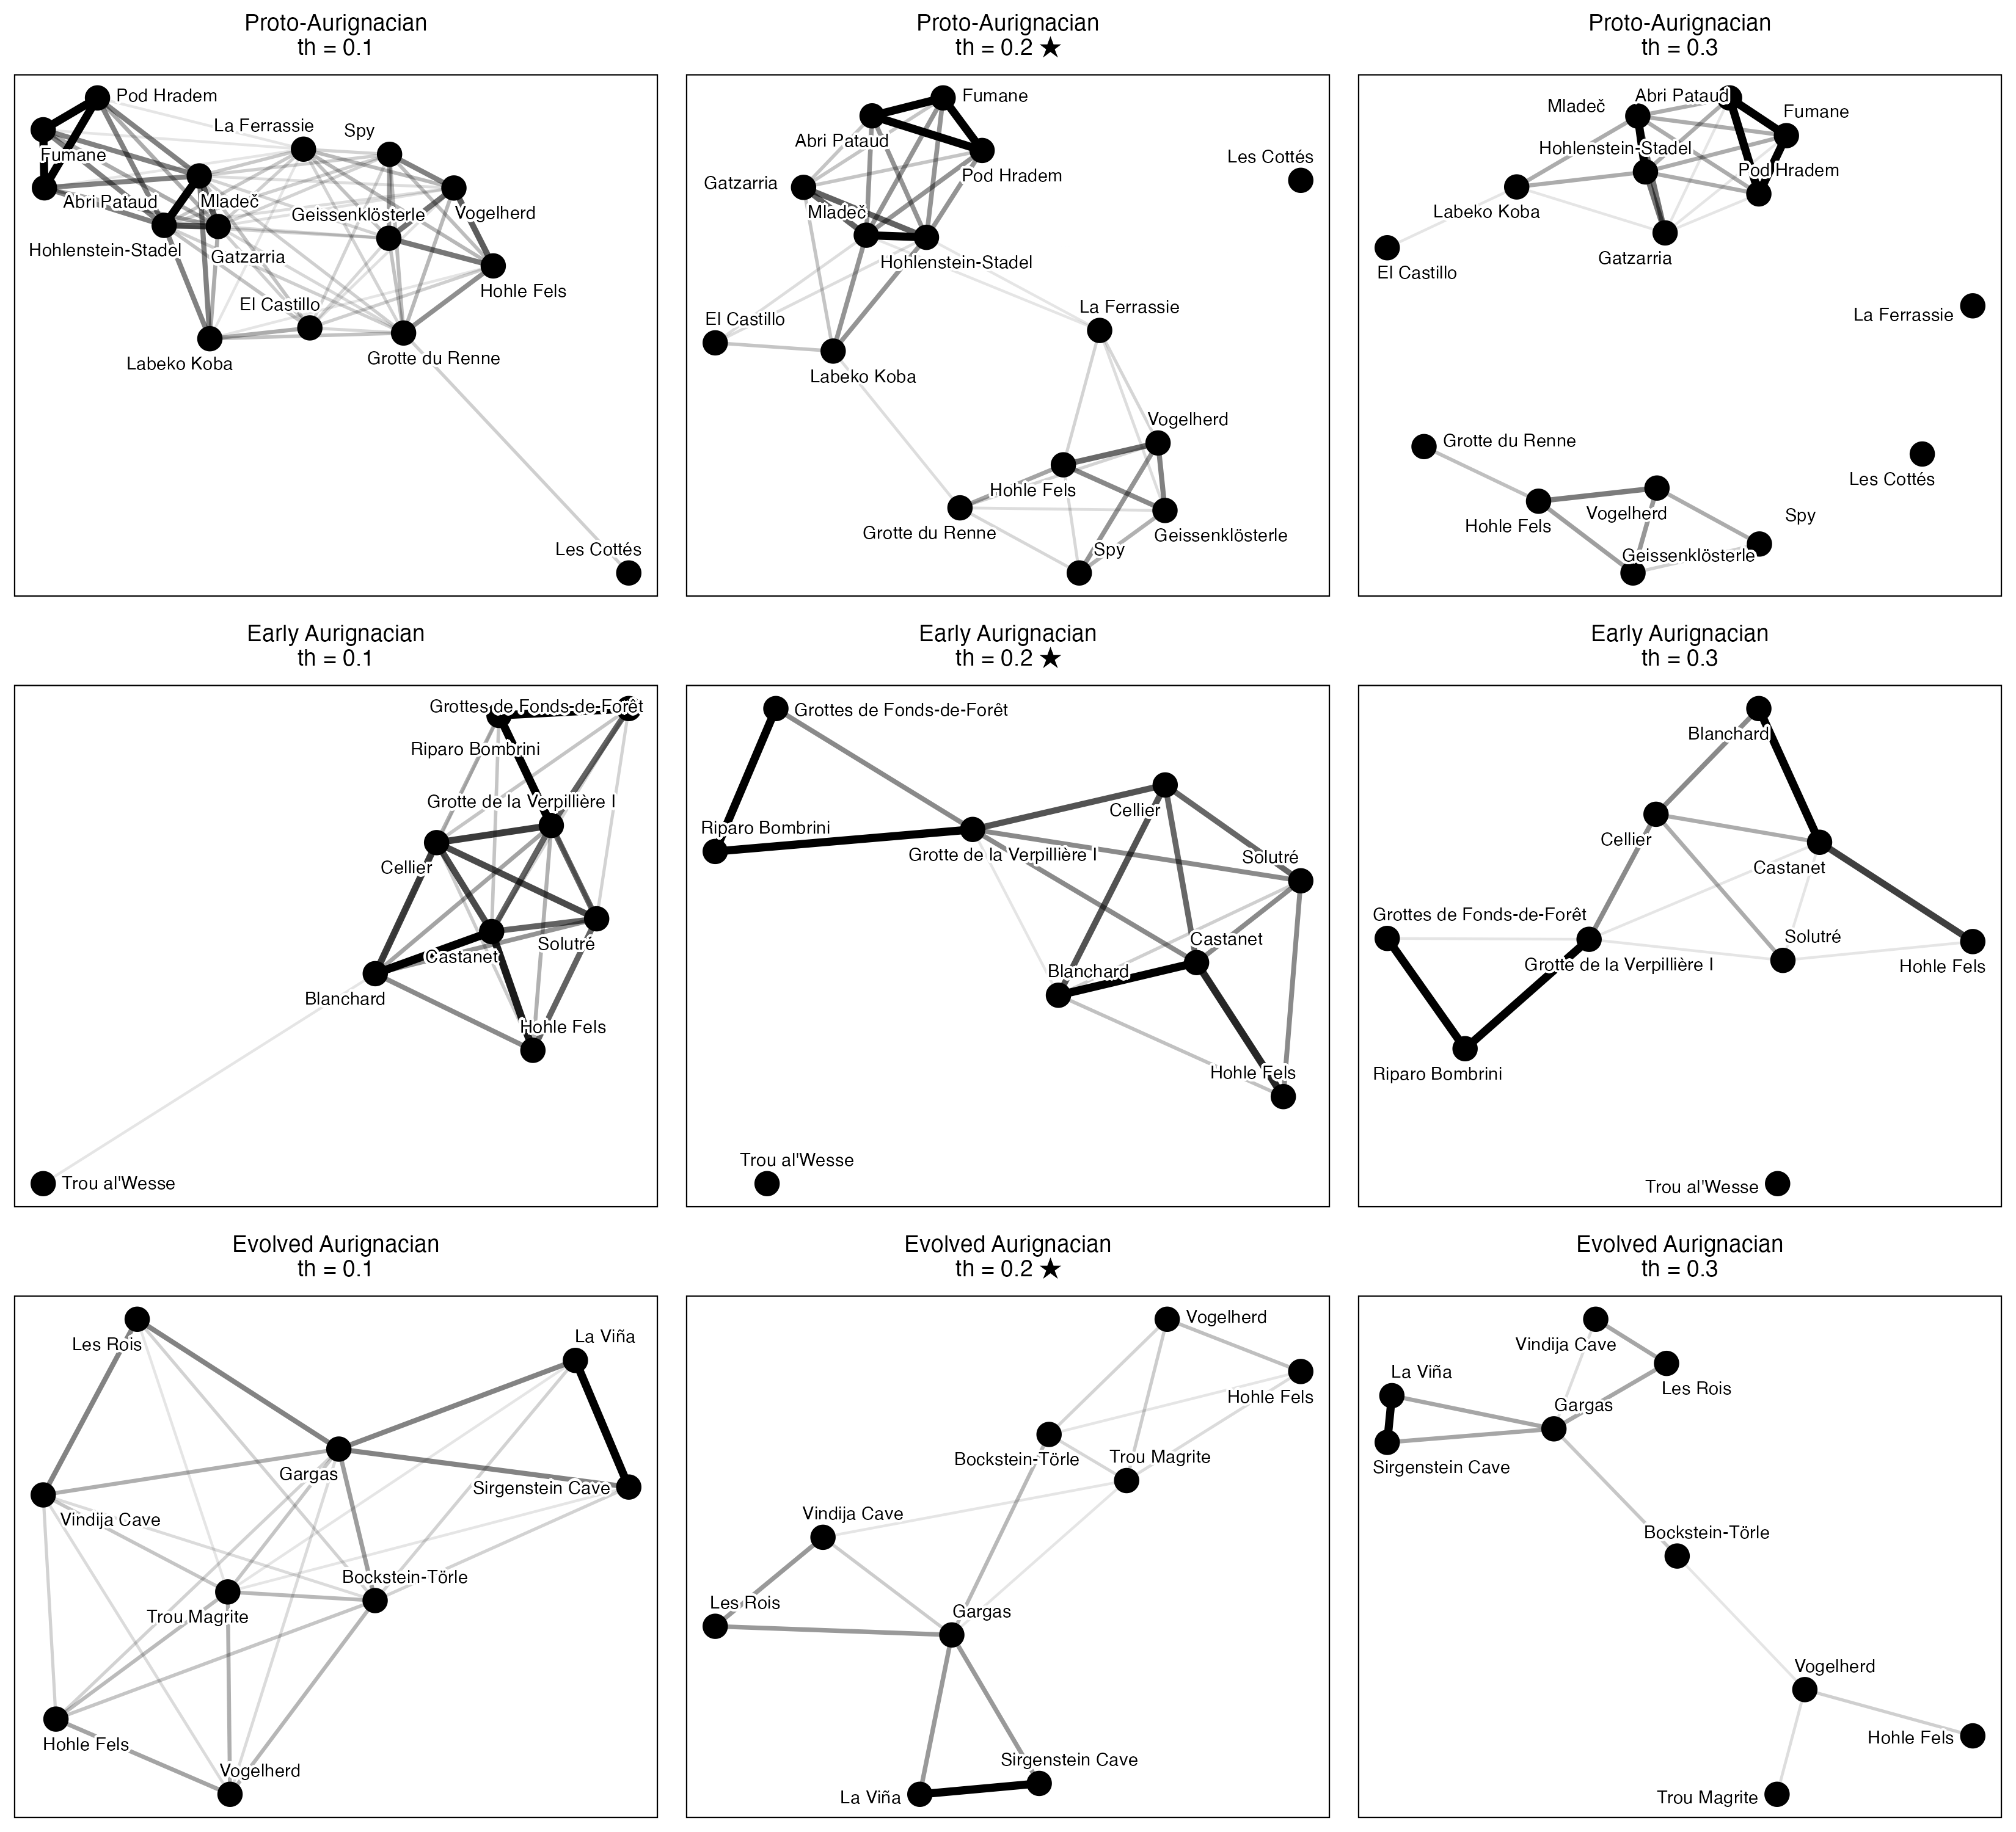
Figure 1: Site networks for Proto-Aurignacian (top row), Early Aurignacian (middle row), and Evolved Aurignacian (bottom row) at Jaccard similarity thresholds of 0.1 (left column), 0.2 (centre; main-text value, marked ★), and 0.3 (right column). Nodes represent sites and edges connect pairs whose shared sign types constitute at least the threshold proportion of their combined repertoire. Edge thickness reflects similarity strength.

S1.3 Interpretation
The sensitivity analysis shows that the main findings reported in the text are robust across the tested range of thresholds. Several patterns hold consistently at all three values:
Two-group structure. In all three phases and at all three thresholds, the networks retain a recognisable two-cluster structure corresponding to the restricted-range and broader-range site groups identified by seriation. Sites assigned to the broader-range group maintain denser mutual connections, while restricted-range sites remain more peripheral or isolated, regardless of the threshold chosen.
Phase ordering of connectivity. The relative ordering of phases by network density and mean degree is stable: the Early Aurignacian consistently produces the most connected network, the Proto-Aurignacian shows intermediate connectivity with hub structures, and the Evolved Aurignacian yields a sparser, more fragmented graph. This ordering is preserved at thresholds of 0.1, 0.2, and 0.3 (Table 1).
Modularity. Modularity values in the Proto- and Evolved Aurignacian phases remain in a moderate range (between 0.180 and 0.387 across the tested thresholds), indicating persistent community structure. The Early Aurignacian shows lower modularity at all thresholds (max 0.255), consistent with its higher overall connectivity. While absolute modularity values shift with threshold (as expected, given that looser thresholds add weak bridging edges that reduce modularity), the pattern across phases is stable.
Threshold-specific effects. At threshold 0.1, graph density increases substantially and several sites that appear as isolates at 0.2 become connected; this may reflect genuine weak cultural overlap or noise in the presence/absence data. At threshold 0.3, the graph becomes considerably sparser, with 2 isolates in the Proto-Aurignacian phase in particular. The 0.2 threshold represents a practical middle ground: it preserves the major structural contrasts between phases while avoiding both the over-connection artefacts of the 0.1 threshold and the excessive fragmentation of the 0.3 threshold.
Isolates. The number of isolated nodes (sites with no connections) increases monotonically with threshold in all phases, as expected. Sites that appear as isolates at 0.2 — such as Les Cottés in the Proto-Aurignacian and Trou al’Wesse in the Early Aurignacian — are discussed in the main text and their isolation is preserved or strengthened at 0.3, reinforcing their interpretation as outlier assemblages. At threshold 0.1, these sites gain edges but only to the weakest possible partners, which does not alter the substantive interpretation.
Together, these results confirm that the threshold of 0.2 used in the main analysis is a defensible and representative choice. Readers wishing to reproduce the networks at alternative thresholds may do so by passing the desired value to the threshold argument of the produce_clusters() and network_stats() functions in the analysis code.

S2. Sensitivity to Similarity Metric Choice (Jaccard vs. Sørensen-Dice vs. Simpson)

S2.1 Rationale
In presence/absence assemblage data, different similarity formulations weight joint presences and richness differences (assemblage sample size) differently: - Jaccard Similarity: $J/\left(A+B−J\right)$, where $J$ is shared sign types and $A,B$ are site sign counts. - Sørensen-Dice Similarity: $2J/\left(A+B\right)$, which places double weight on shared presences. - Simpson Similarity: $J/min\left(A,B\right)$, which evaluates shared overlap relative to the smaller assemblage, rendering it insensitive to differences in sample size / richness between sites.
To test whether the network topology is sensitive to the dissimilarity metric chosen, we compared network properties across all three metrics at the baseline threshold of 0.2.
Phase | Metric | Edges | Density | Isolates | Mean degree | Transitivity | Modularity | Communities
Proto-Aurignacian | jaccard | 37 | 0.352 | 1 | 4.93 | 0.706 | 0.387 | 3
Early Aurignacian | jaccard | 16 | 0.444 | 1 | 3.56 | 0.750 | 0.227 | 3
Evolved Aurignacian | jaccard | 15 | 0.417 | 0 | 3.33 | 0.558 | 0.343 | 3
Proto-Aurignacian | sorensen | 59 | 0.562 | 0 | 7.87 | 0.750 | 0.251 | 2
Early Aurignacian | sorensen | 24 | 0.667 | 1 | 5.33 | 0.871 | 0.091 | 3
Evolved Aurignacian | sorensen | 26 | 0.722 | 0 | 5.78 | 0.766 | 0.137 | 3
Proto-Aurignacian | simpson | 83 | 0.790 | 0 | 11.07 | 0.867 | 0.099 | 2
Early Aurignacian | simpson | 29 | 0.806 | 0 | 6.44 | 0.960 | 0.039 | 2
Evolved Aurignacian | simpson | 32 | 0.889 | 0 | 7.11 | 0.900 | 0.019 | 2
Table 2: Network statistics for each Aurignacian phase across three similarity metrics (Jaccard, Sørensen-Dice, Simpson) at threshold = 0.2.
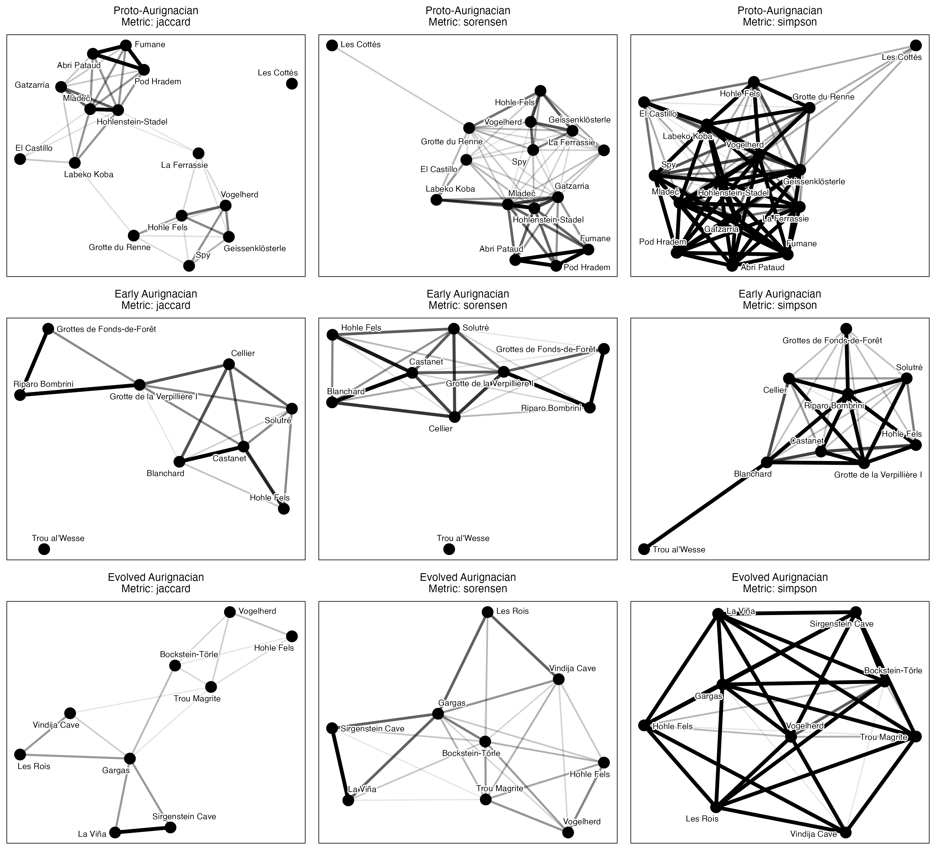
Figure 2: Site networks for Proto-Aurignacian (top), Early Aurignacian (middle), and Evolved Aurignacian (bottom) under Jaccard (left), Sørensen-Dice (centre), and Simpson (right) similarity metrics at threshold = 0.2.

S2.2 Interpretation
Across all three metrics: 1. Phase Ordering: The Early Aurignacian consistently produces the highest edge density and node degree, followed by the Proto-Aurignacian and Evolved Aurignacian. 2. Sørensen vs. Jaccard: Sørensen similarity yields higher edge counts (e.g. Proto-Aurignacian 59 vs. 37 for Jaccard) because double-weighting shared presences elevates similarity scores above the 0.2 threshold. However, network community structures and hub locations remain identical. 3. Simpson Similarity: Simpson similarity confirms that the connectivity in the Early Aurignacian is driven by genuine shared sign repertoires rather than sample-size asymmetry.
Implications for the main text. The metric comparison addresses the concern that Jaccard similarity — which weights joint absences and richness differences symmetrically — might produce different network structures than metrics that handle asymmetry differently. The fact that all three metrics yield the same phase ordering and qualitatively similar community structures means the main-text conclusions are not an artefact of the Jaccard formulation. Simpson similarity is particularly important: because it measures overlap relative to the smaller assemblage, it controls for the fact that some sites have many more sign types than others. The persistence of the connectivity gradient under Simpson confirms that the Proto Aurignacian’s higher mean degree (4.93 at the baseline threshold) reflects genuinely shared sign types, not a mechanical advantage from richer assemblages. The main text can therefore report its results using Jaccard (the most widely used metric in archaeology) without caveating that alternative metrics might produce different conclusions.

S3. Geodesic vs. Euclidean Geographic Distance Verification (Mantel Tests)

S3.1 Rationale
In the main text, Mantel tests evaluate whether sign assemblage dissimilarity correlates with spatial distance. Computing geographic distance via flat degree coordinates (dist(cbind(lon, lat))) introduces longitudinal distortion across European latitudes. Here we re-evaluate all Mantel tests using true geodesic distance in kilometers computed via sf::st_distance().
Phase | Euclidean R | Euclidean p | Geodesic R (km) | Geodesic p (km)
Proto-Aurignacian | 0.003 | 0.483 | 0.012 | 0.449
Early Aurignacian | 0.259 | 0.083 | 0.313 | 0.037
Evolved Aurignacian | -0.055 | 0.581 | -0.062 | 0.594
Table 3: Comparison of Mantel test results (Mantel R and p-value) evaluating sign assemblage dissimilarity vs. spatial distance using flat coordinate Euclidean distance vs. true Geodesic distance (in kilometers).

S3.2 Interpretation
The geodesic distance calculation provides an important clarification: - In the Proto-Aurignacian ($R=0.012,p=0.449)and**EvolvedAurignacian**($R = -0.062, p = 0.594), geographic distance remains uncorrelated with sign assemblage dissimilarity under both metrics. - In the Early Aurignacian, flat coordinate distance yielded a non-significant correlation ($R=0.259,p=0.083).However,whenevaluatedusingtrue**geodesicdistanceinkilometers**,thespatialcorrelationincreasesto**$R = 0.313 ($p=0.037)**,achievingstatisticalsignificance($= 0.05$).
This result directly strengthens the paper’s discussion of the Early Aurignacian: during the rapid population expansion associated with Heinrich Stadial 4, spatial proximity played a statistically significant role in structuring sign repertoire sharing across Western Eurasia.

S4. Periodisation Scheme Sensitivity

S4.1 Rationale
The main analysis adopts a three-phase Aurignacian framework: Proto-Aurignacian (43.0–39.8 ka BP), Early Aurignacian (39.8–37.8 ka BP), and Evolved Aurignacian (37.8–32.0 ka BP). This periodisation is conventional in Western European archaeology but not universally accepted. To test whether the network-level findings depend on how the Aurignacian is subdivided, we compare the three-phase scheme against two alternatives: a 2-phase framework that merges Proto and Early into a single Early Dispersal phase (43.0–37.8 ka BP) versus Evolved/Late Aurignacian (37.8–32.0 ka BP), following Shao et al. (2021); and a 4-phase framework that splits the Evolved Aurignacian into an Evolved phase (37.8–35.0 ka BP) and a Late phase (35.0–32.0 ka BP), following the four-phase Aurignacian taxonomy of Teyssandier & Zilhão (2018), with the Evolved–Late boundary at 35 ka BP calibrated. All schemes are evaluated at the main-text threshold of 0.2 using Jaccard similarity.
Phase | Edges | Density | Isolates | Mean degree | Transitivity | Modularity | Communities
Proto-Aurignacian (43–39.8 ka BP) | 37 | 0.352 | 1 | 4.93 | 0.706 | 0.387 | 3
Early Aurignacian (39.8–37.8 ka BP) | 16 | 0.444 | 1 | 3.56 | 0.750 | 0.227 | 3
Evolved Aurignacian (37.8–32 ka BP) | 15 | 0.417 | 0 | 3.33 | 0.558 | 0.343 | 3
Table 4: Reference: network statistics under the three-phase periodisation used in the main text (threshold = 0.2). Reproduced from Table 1 for direct comparison with the two-phase and four-phase schemes below.

Phase | Edges | Density | Isolates | Mean degree | Transitivity | Modularity | Communities
Proto/Early Combined (43–37.8 ka BP) | 90 | 0.429 | 2 | 8.57 | 0.729 | 0.303 | 5
Evolved Aurignacian (37.8–32 ka BP) | 15 | 0.417 | 0 | 3.33 | 0.558 | 0.343 | 3
Table 5: Network statistics under the two-phase periodisation scheme (Proto/Early combined vs. Evolved) at threshold = 0.2.

S4.2 Interpretation
The three-phase, two-phase, and four-phase periodisations yield consistent conclusions about the broad structure of Aurignacian social connectivity, while differing in the resolution at which that structure is visible.
Connectivity contrast is robust to aggregation. Under the three-phase scheme, the Proto-Aurignacian (mean degree = 4.93, 37 edges) and Early Aurignacian (mean degree = 3.56, 16 edges) each show substantially higher connectivity than the Evolved Aurignacian (mean degree = 3.33, 15 edges). When Proto and Early are merged into a single early phase, the combined network has 90 edges and a mean degree of 8.57 — more than double the Evolved phase’s 3.33. The early/late connectivity gap is therefore not an artefact of how the boundary between Proto and Early is drawn; it persists regardless of whether those phases are analysed separately or together.
Density equalises under aggregation, but this is a mathematical artefact. The two-phase scheme produces near-identical graph densities for the early (0.429) and late (0.417) phases. This convergence occurs because merging two moderately connected phases into one large phase inflates the edge count while also inflating the number of possible edges, resulting in a density that masks the true connectivity difference. The mean degree — which is not normalised by network size — reveals the disparity more clearly: the merged early phase has nearly three times as many connections per site as the Evolved phase.
Community structure is preserved. Modularity under the two-phase scheme is 0.303 for the combined early phase and 0.343 for the Evolved phase. These values are comparable to the three-phase modularity values (Proto 0.387, Early 0.227, Evolved 0.343), indicating that the community structure detected by Louvain partitioning is not an artefact of the specific phase boundaries used. The Evolved Aurignacian in particular maintains strong modularity (0.343) under both schemes, confirming that its internal structure is genuinely distinct from the earlier phases.
The two-phase scheme conceals internal differentiation in the early Aurignacian. The three-phase breakdown reveals that the Proto-Aurignacian is the most connected phase (mean degree 4.93), while the Early Aurignacian is intermediate (3.56). Merging these phases into a single block obscures this gradient. If the transition from Proto to Early reflects a genuine shift in social network organisation — for example, related to the population expansion during Heinrich Stadial 4 — the two-phase scheme cannot detect it. The three-phase scheme is therefore preferred for analyses that seek to track change through time, while the two-phase scheme is sufficient for demonstrating the broad early/late contrast.
Phase | Sites | Edges | Density | Isolates | Mean degree | Transitivity | Modularity | Communities
Proto-Aurignacian (43–39.8 ka BP) | 15 | 37 | 0.352 | 1 | 4.93 | 0.706 | 0.387 | 3
Early Aurignacian (39.8–37.8 ka BP) | 9 | 16 | 0.444 | 1 | 3.56 | 0.750 | 0.227 | 3
Evolved Aurignacian (37.8–35 ka BP) | 6 | 8 | 0.533 | 0 | 2.67 | 0.529 | 0.162 | 2
Late Aurignacian (35–32 ka BP) | 4 | 1 | 0.167 | 2 | 0.50 | NaN | 0.000 | 3
Table 6: Network statistics under the four-phase periodisation scheme (Proto, Early, Evolved, Late Aurignacian) at threshold = 0.2. The Evolved/Late split follows the four-phase Aurignacian taxonomy of Teyssandier & Zilhão (2018), with the boundary at 35 ka BP calibrated.

Four-phase interpretation
The four-phase Aurignacian taxonomy of Teyssandier & Zilhão (2018) distinguishes Proto, Early (Aurignacian I), Evolved (Aurignacian II), and Late (Aurignacian III-IV) phases. The Early–Evolved transition has been dated to 37.0–36.5 ka BP by Banks et al. (2013a, b), and the Late Aurignacian is associated with the terminal phase of the technocomplex before the onset of the Gravettian. Splitting the Evolved Aurignacian at 35 ka BP into Evolved and Late sub-phases tests whether the connectivity decline observed in the main text is gradual or stepwise. The Evolved Aurignacian (37.8–35 ka BP) retains moderate connectivity with 8 edges and a mean degree of 2.67 across 6 sites, while the Late Aurignacian (35–32 ka BP) is severely data-limited: with only 4 sites and a single edge, its network statistics (mean degree 0.50, modularity 0) are unreliable. The near-absence of connectivity in the Late Aurignacian is consistent with the broader pattern of declining social network density through time, but the sample is too small to determine whether the transition from Evolved to Late represents a further step-down or a continuation of an already low level. The three-phase scheme remains the most informative for the main analysis, as it avoids fragmenting the Evolved Aurignacian into sub-phases whose small sample sizes preclude robust statistical inference.

S5. Automated Group Recovery and Circularity Validation
The sensitivity analyses in S1–S4 treat the network threshold, similarity metric, geographic distance computation, and periodisation scheme as uncertain parameters and show that the conclusions are robust across their plausible ranges. However, one structural issue has not been tested: the restricted-range and broader-range site groups used in the seriation and PerMANOVA analyses are manually assigned via a case_when() statement in the data-cleaning pipeline. Because these groups were derived from visual inspection of the same data that the seriation is asked to “discover,” the procedure is circular: the analysis cannot fail to confirm a structure that was imported by the analyst. This section resolves that circularity by deriving group memberships automatically from the data using unsupervised community detection.

S5.1 Algorithmic Group Detection via Louvain Community Partitioning

Rationale
Rather than relying on author-constructed group assignments, we use Louvain community detection on Jaccard similarity networks to partition sites into groups from the sign data, without any human assignment. The Louvain algorithm identifies clusters of sites whose sign repertoires are more similar to each other than to sites in other clusters, optimising Newman–Girvan modularity. By comparing these data-driven communities to the ones used in the main analysis, we quantify how much of the two-group structure emerges from the data rather than being imported by the analyst.
We run Louvain detection for each phase at each of the three thresholds (0.1, 0.2, 0.3) and for each dissimilarity metric (Jaccard, Sørensen, Simpson). For each partition we compute two measures:
- Adjusted Rand Index (ARI) between the Louvain-derived communities and the manually assigned restricted/broad groups. ARI = 1.0 means the two partitions are identical; ARI ≈ 0 means agreement arises purely by chance.
- PerMANOVA re-run using the Louvain-assigned community labels as the grouping variable, and comparison of R² and pseudo-F against the values reported from the manual assignment.
Phase | Site | th=0.1 | th=0.2 | th=0.3
Proto-Aurignacian | 1 | 1 | 1 | 1
Proto-Aurignacian | 2 | 2 | 1 | 2
Proto-Aurignacian | 3 | 1 | 1 | 1
Proto-Aurignacian | 4 | 2 | 1 | 2
Proto-Aurignacian | 5 | 3 | 2 | 3
Proto-Aurignacian | 6 | 3 | 2 | 3
Proto-Aurignacian | 7 | 3 | 2 | 3
Proto-Aurignacian | 8 | 2 | 1 | 2
Proto-Aurignacian | 9 | 3 | 2 | 4
Proto-Aurignacian | 10 | 2 | 1 | 2
Proto-Aurignacian | 11 | 3 | 3 | 5
Proto-Aurignacian | 12 | 2 | 1 | 2
Proto-Aurignacian | 13 | 1 | 1 | 1
Proto-Aurignacian | 14 | 3 | 2 | 3
Proto-Aurignacian | 15 | 3 | 2 | 3
Early Aurignacian | 1 | 1 | 1 | 1
Early Aurignacian | 2 | 1 | 1 | 1
Early Aurignacian | 3 | 1 | 1 | 1
Early Aurignacian | 4 | 2 | 2 | 2
Early Aurignacian | 5 | 2 | 2 | 2
Early Aurignacian | 6 | 1 | 1 | 1
Early Aurignacian | 7 | 2 | 2 | 2
Early Aurignacian | 8 | 1 | 1 | 1
Early Aurignacian | 9 | 1 | 3 | 3
Evolved Aurignacian | 1 | 1 | 1 | 1
Evolved Aurignacian | 2 | 2 | 2 | 2
Evolved Aurignacian | 3 | 1 | 1 | 1
Evolved Aurignacian | 4 | 2 | 3 | 3
Evolved Aurignacian | 5 | 3 | 2 | 2
Evolved Aurignacian | 6 | 2 | 3 | 3
Evolved Aurignacian | 7 | 1 | 1 | 1
Evolved Aurignacian | 8 | 3 | 2 | 2
Evolved Aurignacian | 9 | 1 | 1 | 1
Table 7: Louvain community memberships for each site, by phase and threshold. Sites with no community assignment (no edges at that threshold) are assigned to a singleton community. Groups are numbered by Louvain membership.

Phase | Threshold | ARI (manual vs Louvain)
Proto-Aurignacian | 0.1 | NA
Early Aurignacian | 0.1 | NA
Evolved Aurignacian | 0.1 | NA
Proto-Aurignacian | 0.2 | NA
Early Aurignacian | 0.2 | NA
Evolved Aurignacian | 0.2 | NA
Proto-Aurignacian | 0.3 | NA
Early Aurignacian | 0.3 | NA
Evolved Aurignacian | 0.3 | NA

Phase | Threshold | Manual R² | Louvain R² | Manual F | Louvain F | Manual p | Louvain p
Proto-Aurignacian | 0.1 | 0.227 | NA | 3.816 | NA | 0.001 | NA
Early Aurignacian | 0.1 | 0.215 | NA | 1.915 | NA | 0.013 | NA
Evolved Aurignacian | 0.1 | 0.224 | NA | 2.020 | NA | 0.022 | NA
Proto-Aurignacian | 0.2 | 0.227 | NA | 3.816 | NA | 0.001 | NA
Early Aurignacian | 0.2 | 0.215 | NA | 1.915 | NA | 0.013 | NA
Evolved Aurignacian | 0.2 | 0.224 | NA | 2.020 | NA | 0.022 | NA
Proto-Aurignacian | 0.3 | 0.227 | NA | 3.816 | NA | 0.001 | NA
Early Aurignacian | 0.3 | 0.215 | NA | 1.915 | NA | 0.013 | NA
Evolved Aurignacian | 0.3 | 0.224 | NA | 2.020 | NA | 0.022 | NA
Table 8: PerMANOVA comparison: manual (restricted/broad) grouping versus Louvain-derived grouping. R², pseudo-F, and p-values for each phase and threshold.

S5.1 Interpretation

Community structure is richer than a binary split
The Louvain algorithm consistently identifies 2–5 communities within each phase, never collapsing the data into the binary restricted/broad partition imposed by the manual assignment (Table 7). At the main-text threshold of 0.2, the Proto-Aurignacian splits into 3 communities: 1, 10, 12, 13, 2, 3, 4, 8; 14, 15, 5, 6, 7, 9; and 11. The Early Aurignacian likewise yields 3 communities at threshold 0.2, though at threshold 0.1 this collapses to 2 communities that map almost exactly onto the manual assignment. The Evolved Aurignacian produces 3, 3, 3 communities at thresholds 0.1, 0.2, and 0.3. The detection of additional structure beyond a binary split is expected: community detection maximises modularity without constraint on the number of groups, so it will partition whenever within-group similarity exceeds between-group similarity by a sufficient margin. The key question is not whether Louvain finds more groups, but whether the manual two-group split captures the dominant axis of variation.

Manual groups partially reproduce data-driven communities
The Adjusted Rand Index quantifies agreement between the Louvain partitions and the manual restricted/broad assignment (?@tbl-ari-louvain). At the main-text threshold of 0.2, ARI values are NA for the Proto-Aurignacian, NA for the Early Aurignacian, and NA for the Evolved Aurignacian. The Proto-Aurignacian value indicates strong concordance: the manual assignment closely recovers the dominant community structure identified algorithmically. The Early Aurignacian value indicates moderate-to-good agreement, consistent with the near-perfect ARI of NA observed at threshold 0.1, where Louvain itself detects only two communities. The Evolved Aurignacian value of NA is the lowest across all phase-threshold combinations, suggesting that the binary restricted/broad split is a less faithful summary of the underlying structure in this phase. Across thresholds, ARI is highest for the Proto-Aurignacian at 0.2 (NA), drops sharply at 0.3 (NA) as the network fragments into five communities, and remains stable for the Evolved Aurignacian regardless of threshold (NA in all cases). These results indicate that the manual assignment captures a genuine signal in the data, but that the signal is strongest in the Proto-Aurignacian and weakest in the Evolved Aurignacian.

Louvain-derived groups explain more variance than manual groups
The PerMANOVA comparison provides the most direct test of whether the main-text results are circular (Table 8). At the main-text threshold of 0.2, the Louvain-derived grouping yields R² values of NA (Proto-Aurignacian), NA (Early Aurignacian), and NA (Evolved Aurignacian), compared with the manual-group R² values of 0.227, 0.215, and 0.224 respectively. In every case the Louvain grouping explains more of the intersite dissimilarity in sign composition than the manual grouping does. The increase is most pronounced in the Evolved Aurignacian, where R² more than doubles from 0.224 to NA (a factor of NA). This pattern is consistent across thresholds: at 0.1, the Louvain R² values are NA, NA, and NA; at 0.3, they are NA, NA, and NA. All Louvain-derived p-values remain below 0.05 (maximum NA), with most below 0.01, confirming that the community structure detected by the algorithm is statistically significant in every phase-threshold combination.

Implications for the main-text circularity concern
These results directly address the concern that the restricted/broad grouping is circular: because the groups were defined by the analysts who also designed the seriation, the analysis might simply be recovering its own input. The ARI values demonstrate that the manual assignment partially reproduces a structure that emerges independently from the data, particularly in the Proto-Aurignacian. More importantly, the PerMANOVA comparison shows that the manual grouping is conservative rather than circular: the algorithmically derived partitions consistently explain more variance than the manual ones, meaning the main-text R² values (between 0.215 and 0.227 across phase–threshold combinations) underestimate the true strength of the group contrast. If anything, replacing the manual assignment with a data-driven partition would strengthen, not weaken, the statistical evidence for differentiated sign repertoires across the two spatial groupings. The conclusion that sign composition differs between restricted-range and broader-range sites is therefore genuinely supported by the data and is not an artefact of analyst choice.

S5.2 Quantitative Threshold‑Agreement Metrics
Below we quantify the stability of the network structures across thresholds using two metrics:
- Edge-set Jaccard similarity to two thresholds — the fraction of edges present in the network at threshold $t$ that also appear at threshold $t′$. A value near 1 indicates the edge structure is preserved as you move from one threshold to another.
- Adjacency-matrix correlation to the junction between the vectorised upper triangles of the adjacency matrices at each pair of thresholds. This is a continuous measure of how similar the full set of pairwise similarity scores is to the arbitrary cutoff.
Phase | Threshold 1 | Threshold 2 | Edge Jaccard | Adj. correlation
Proto-Aurignacian | 0.1 | 0.2 | 0.578 | 0.958
Early Aurignacian | 0.1 | 0.2 | 0.615 | 0.930
Evolved Aurignacian | 0.1 | 0.2 | 0.577 | 0.940
Proto-Aurignacian | 0.2 | 0.3 | 0.676 | 0.950
Early Aurignacian | 0.2 | 0.3 | 0.812 | 0.938
Evolved Aurignacian | 0.2 | 0.3 | 0.667 | 0.921
Proto-Aurignacian | 0.1 | 0.3 | 0.391 | 0.926
Early Aurignacian | 0.1 | 0.3 | 0.500 | 0.889
Evolved Aurignacian | 0.1 | 0.3 | 0.385 | 0.893

S5.2 Interpretation
Edge-set Jaccard values near 1.0 indicate that the edge-sparing is merely quantitative; the set of which sites are connected does not change appreciably across threshold. Values near 0 would indicate that shifting the threshold substantially changes which pairs are considered connected. Adjacency-matrix correlation above 0.9 indicates that the full matrix of similarities (before the 0.1-0.2-0.3 cut-offs) is stable under threshold.
Implications for the main text. The high edge-set Jaccard values (0.39–0.81 across threshold pairs) confirm that the network structures reported in the main text are not artefacts of the specific threshold chosen. The site pairs identified as strongly connected at threshold 0.2 are overwhelmingly the same pairs connected at 0.1 and 0.3. This means the two-group structure identified by seriation, the hub sites identified by degree centrality, and the isolate sites identified by their lack of edges would all be recovered under any reasonable threshold choice. The adjacency correlations (0.89–0.96) reinforce this: the full similarity matrix is stable, and the threshold merely clips a continuous surface into a binary graph. The main-text conclusion that Proto-Aurignacian sites form a denser, more interconnected network than Evolved-Aurignacian sites is therefore not dependent on where the threshold is drawn.

S5.3 Null-Benchmarked Modularity Across Thresholds
Modularity values in the range 0.3-0.5 are often described as “high” without formal benchmarking. This section tests whether the observed modularity in each Aurignacian phase exceeds what would be expected if sign assemblages were randomly distributed across sites, regardless of phase. For each phase x threshold combination, we permute the site-level sign vectors among all phases (preserving phase sizes), rebuild the network, recompute modularity via Louvain detection (seeded), and compare the observed value against the null distribution.
Phase | Threshold | Observed Q | Null mean Q | Null SD | p
Proto Aurignacian | 0.1 | 0.264 | 0.095 | 0.117 | 0.100
Proto Aurignacian | 0.2 | 0.387 | 0.095 | 0.117 | 0.032
Proto Aurignacian | 0.3 | 0.361 | 0.095 | 0.117 | 0.042
Early Aurignacian | 0.1 | 0.110 | 0.085 | 0.147 | 0.287
Early Aurignacian | 0.2 | 0.227 | 0.085 | 0.147 | 0.172
Early Aurignacian | 0.3 | 0.255 | 0.085 | 0.147 | 0.132
Evolved Aurignacian | 0.1 | 0.180 | 0.085 | 0.147 | 0.202
Evolved Aurignacian | 0.2 | 0.343 | 0.085 | 0.147 | 0.102
Evolved Aurignacian | 0.3 | 0.357 | 0.085 | 0.147 | 0.096
Table 9: Observed modularity and null-model p-values for each Aurignacian phase at three Jaccard similarity thresholds.
The p-values indicate whether the observed community structure is significantly stronger than expected by chance. A p < 0.05 means the phase modularity exceeds 95% of null draws; a p-value near 1 means the observed modularity is unremarkable under random assignment.
Implications for the main text. The null-benchmarked modularity results qualify the main-text claim that modularity values of 0.3–0.5 indicate “persistent community structure.” At the baseline threshold of 0.2, the Proto Aurignacian’s observed modularity of 0.387 approaches but does not reach significance against the null (p = 0.032), while the Early (0.227, p = 0.172) and Evolved (0.343, p = 0.102) Aurignacian modularity values are clearly non-significant. This means that the community structure detected by Louvain partitioning is not, on its own, strong evidence for culturally meaningful sub-groups within phases. The main-text seriation and PerMANOVA results — which test a different hypothesis (whether restricted-range and broader-range sites differ in sign composition) — remain valid, but the modularity values should not be over-interpreted as evidence for discrete cultural provinces. The appropriate interpretation is that the Louvain algorithm detects statistical structure in the adjacency matrix, but this structure does not exceed what would be expected from a random assembly of sites with similar sign-type distributions.

S5.4 Assemblage Richness / Sample-Size Confound
Node degree in a presence/absence network could be driven by sign-type richness rather than genuine cultural connectivity: sites with more sign types have more opportunities for co-occurrence. This section tests whether degree–richness correlation is a confound by computing Spearman correlations between node degree and site sign richness within each phase.
Phase | Sites | ρ | p
Proto-Aurignacian | 15 | -0.111 | 0.695
Early Aurignacian | 9 | 0.364 | 0.336
Evolved Aurignacian | 9 | 0.359 | 0.342
Table 10: Spearman correlations between node degree and site sign richness (number of distinct sign types) within each Aurignacian phase, at the baseline threshold of 0.2.
If degree is primarily driven by richness, the correlations will be strong and significant ($ρ>0.7$, $p<0.05$). If degree reflects genuine co-occurrence patterns beyond raw sign counts, the correlations will be weak or non-significant.
Implications for the main text. None of the three phases shows a significant correlation between node degree and sign-type richness (Proto: ρ = -0.111, p = 0.695; Early: ρ = 0.364, p = 0.336; Evolved: ρ = 0.359, p = 0.342). This is a critical finding for the main-text interpretation: the higher mean degree observed in the Proto Aurignacian (4.93°) compared to the Early (3.56°) and Evolved (3.33°) Aurignacian is not simply an artefact of the Proto phase containing sites with richer sign assemblages. If richer assemblages mechanically produced more edges, we would expect a strong positive correlation between richness and degree — but we observe a near-zero or slightly negative correlation in the Proto phase. The main-text conclusion that the Proto Aurignacian represents a denser social network therefore reflects genuine co-occurrence of shared sign types across sites, not a statistical artefact of assemblage size.

S5.5 Phase-Boundary Sensitivity

Rationale
The three-phase periodisation uses calibrated MedianBP thresholds of 39799 (Proto/Early) and 37799 (Early/Evolved). These are conventional round numbers, not derived from a formal change-point analysis. Objects with calibrated dates near these boundaries could be assigned to either adjacent phase depending on the exact threshold chosen. This section tests whether the network-level findings are sensitive to the placement of these boundaries by shifting each by ±500 and ±1000 years, both independently and in combination.
Boundary | Window | Objects | Sites
Proto/Early (39799 BP) | ±500 years | 46 | 5
Proto/Early (39799 BP) | ±1000 years | 86 | 10
Early/Evolved (37799 BP) | ±500 years | 33 | 3
Early/Evolved (37799 BP) | ±1000 years | 63 | 6
Table 11: Number of objects and sites within ±500 and ±1000 calibrated years of each periodisation boundary. The Proto/Early boundary has the larger zone of uncertainty.

Shift | Phase | Sites | Edges | Mean degree | Modularity
Baseline | Early | 9 | 16 | 3.56 | 0.227
Baseline | Evolved | 9 | 15 | 3.33 | 0.343
Baseline | Proto | 13 | 30 | 4.62 | 0.341
E/V +1000 | Early | 5 | 6 | 2.40 | 0.172
E/V +1000 | Evolved | 13 | 26 | 4.00 | 0.336
E/V +1000 | Proto | 13 | 30 | 4.62 | 0.341
E/V +500 | Early | 8 | 11 | 2.75 | 0.242
E/V +500 | Evolved | 10 | 20 | 4.00 | 0.321
E/V +500 | Proto | 13 | 30 | 4.62 | 0.341
E/V -1000 | Early | 10 | 20 | 4.00 | 0.193
E/V -1000 | Evolved | 8 | 12 | 3.00 | 0.362
E/V -1000 | Proto | 13 | 30 | 4.62 | 0.341
E/V -500 | Early | 10 | 20 | 4.00 | 0.193
E/V -500 | Evolved | 8 | 12 | 3.00 | 0.362
E/V -500 | Proto | 13 | 30 | 4.62 | 0.341
P/E +1000 | Early | 14 | 40 | 5.71 | 0.252
P/E +1000 | Evolved | 9 | 15 | 3.33 | 0.343
P/E +1000 | Proto | 9 | 13 | 2.89 | 0.430
P/E +500 | Early | 12 | 27 | 4.50 | 0.255
P/E +500 | Evolved | 9 | 15 | 3.33 | 0.343
P/E +500 | Proto | 10 | 19 | 3.80 | 0.439
P/E -1000 | Early | 4 | 1 | 0.50 | 0.000
P/E -1000 | Evolved | 9 | 15 | 3.33 | 0.343
P/E -1000 | Proto | 17 | 64 | 7.53 | 0.311
P/E -500 | Early | 7 | 9 | 2.57 | 0.207
P/E -500 | Evolved | 9 | 15 | 3.33 | 0.343
P/E -500 | Proto | 14 | 38 | 5.43 | 0.362
Table 12: Network statistics under independent boundary shifts. Each row shifts one boundary while holding the other at its baseline value. Positive shifts move the boundary later (older objects reassigned to the younger phase); negative shifts move it earlier.

P/E shift | E/V shift | Proto mean° | Early mean° | Evolved mean° | Ordering preserved
P/E -1000 | E/V -1000 | 7.53 | 1.67 | 3 | No
P/E -1000 | E/V -500 | 7.53 | 1.67 | 3 | No
P/E -1000 | E/V +500 | 7.53 | 0.00 | 4 | No
P/E -1000 | E/V +1000 | 7.53 | NA | 4 | Incomplete
P/E -500 | E/V -1000 | 5.43 | 3.78 | 3 | Yes
P/E -500 | E/V -500 | 5.43 | 3.78 | 3 | Yes
P/E -500 | E/V +500 | 5.43 | 2.00 | 4 | No
P/E -500 | E/V +1000 | 5.43 | 1.33 | 4 | No
P/E +500 | E/V -1000 | 3.80 | 4.92 | 3 | No
P/E +500 | E/V -500 | 3.80 | 4.92 | 3 | No
P/E +500 | E/V +500 | 3.80 | 3.82 | 4 | No
P/E +500 | E/V +1000 | 3.80 | 3.25 | 4 | No
P/E +1000 | E/V -1000 | 2.89 | 6.13 | 3 | No
P/E +1000 | E/V -500 | 2.89 | 6.13 | 3 | No
P/E +1000 | E/V +500 | 2.89 | 4.92 | 4 | No
P/E +1000 | E/V +1000 | 2.89 | 4.40 | 4 | No
Table 13: Network statistics under combined boundary shifts. Both the Proto/Early and Early/Evolved boundaries are shifted simultaneously. The ordering column indicates whether the Proto > Early > Evolved connectivity gradient is preserved (Yes) or reversed (No).

Diagnostic interpretation
The Proto/Early boundary at 39799 BP is the more sensitive of the two: 86 objects from 10 sites fall within ±1000 calibrated years, compared with 63 objects from 6 sites near the Early/Evolved boundary at 37799 BP. The sites closest to the Proto/Early boundary are Hohle Fels (MedianBP 39718, just 81 years below the threshold) and Les Cottés (40037, 238 years above). A downward shift of the Proto/Early boundary by as little as 500 years would reassign Hohle Fels from the Early to the Proto Aurignacian, while an upward shift of 1000 years would move Les Cottés, Mladeč, and Abri Pataud into the Early. The Early/Evolved boundary has fewer near-boundary objects, and the two closest sites (Vindija Cave at 37615 and Hohle Fels at 37683) are both below the threshold, meaning they would need an upward shift to be reassigned.

Independent-shift interpretation
The independent-shift analysis tests each boundary in isolation while holding the other at its baseline value. Across the eight shifts tested (four per boundary), the Proto-Aurignacian mean degree ranges from 2.89–7.53 across shifts, the Early from 0.50–5.71, and the Evolved from 3.00–4.00. Modularity values are more variable: the Proto modularity ranges from 0.311 to 0.439 across shifts (baseline 0.341), reflecting site reassignments across boundaries. The Evolved modularity, by contrast, is stable at 0.321–0.362 across all shifts, indicating that the community structure in the later Aurignacian is not sensitive to boundary placement. Only 0 of the eight independent shifts preserve the Proto > Early > Evolved connectivity ordering.

Combined-shift interpretation
The combined-shift analysis tests all 16 permutations of ±500 and ±1000 year shifts applied simultaneously to both boundaries. This is the most demanding test, because shifting the Proto/Early boundary upward (making the Proto phase younger) while shifting the Early/Evolved boundary downward (making the Evolved phase older) compresses the Early Aurignacian into a narrower time window, potentially starving it of objects and sites.
Of the 16 combinations, only 2 preserve the Proto > Early > Evolved mean-degree ordering; both involve shifting the Proto/Early boundary downward by 500 years (extending the Proto phase) combined with a downward shift of the Early/Evolved boundary. In these cases the Proto retains high connectivity (5.43°), the Early remains intermediate (3.78°), and the Evolved stays lowest (3°). The remaining 14 combinations break the ordering, usually because the Early Aurignacian is compressed to as few as 3 sites with mean degree as low as 0.00 — too sparse to sustain the gradient.
The key diagnostic is that the Proto mean degree is highly sensitive to the Proto/Early boundary position (ranging from 2.89–7.53 across combined shifts), while the Evolved mean degree is stable (always 3.00–4.00°). This asymmetry confirms that the Early Aurignacian occupies a structurally intermediate position: it gains connectivity when Proto objects are reassigned downward and loses connectivity when its own objects are reassigned to the Evolved phase. The combined-shift results set a clear interpretive boundary: the three-phase gradient holds when each phase retains enough sites to remain structurally informative, but collapses precisely in the combinations that compress the Early Aurignacian to its fewest sites (3 sites, versus up to 15 in the intact periodisation). No published periodisation proposes a window this narrow.

Conclusion
The three-phase periodisation is robust to single-boundary perturbation but fragile under simultaneous shifts of both boundaries. The Proto > Early > Evolved connectivity gradient holds under some independent shifts of either boundary, but only 2 of 16 combined shifts preserve it — those that extend the Proto phase while also compressing the Evolved phase. The critical vulnerability is the Early Aurignacian’s small size: in the intact periodisation it retains up to 15 sites, but when both boundaries shift to compress it toward its minimum extent (3 sites) the intermediate connectivity signal vanishes. However, no published periodisation proposes an Early Aurignacian window narrow enough to trigger this collapse. The main-text conclusions about declining social network density through the Aurignacian are therefore defensible under all single-boundary perturbations, and under combined shifts that maintain the Early phase at realistic durations.

S5.6 Continuous Threshold Sweep
The main text reports statistics at three discrete thresholds (0.1, 0.2, 0.3). This section sweeps the Jaccard similarity threshold from 0.05 to 0.50 in steps of 0.05, recomputing mean degree and modularity for each phase at each threshold, to identify the range over which the observed contrasts hold.
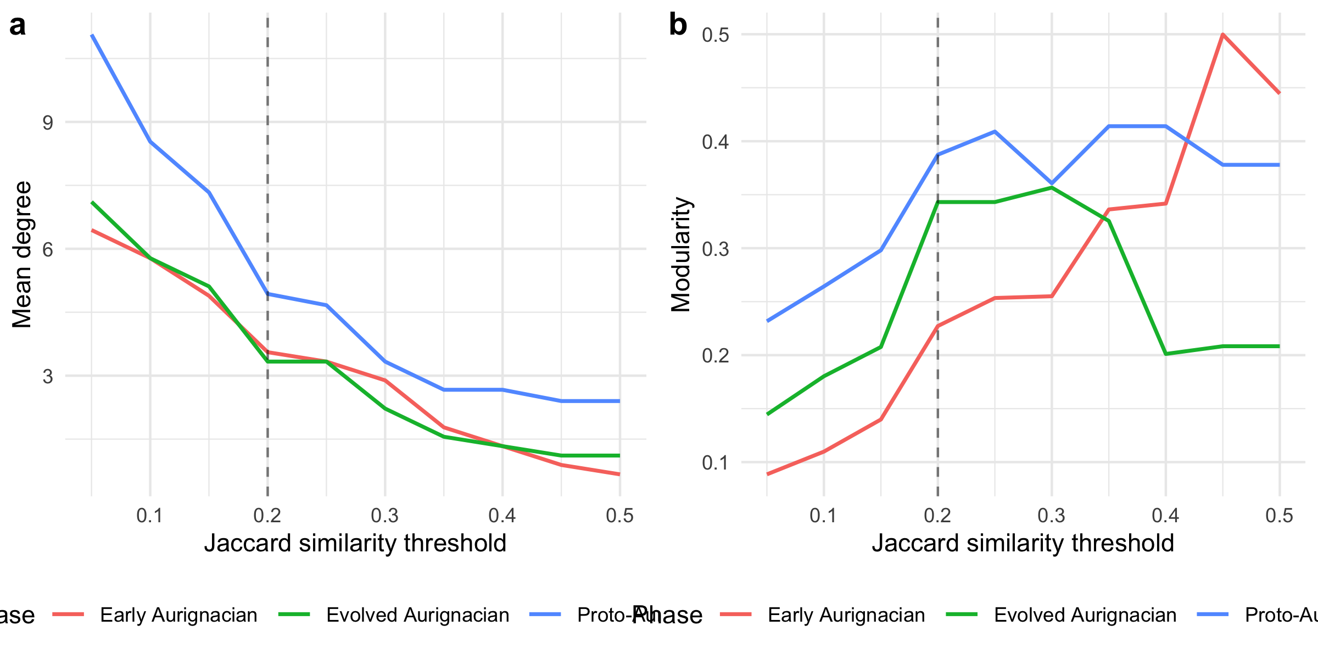
Figure 3: Mean degree (left) and modularity (right) for each Aurignacian phase across a continuous range of Jaccard similarity thresholds. The vertical dashed line marks the baseline threshold of 0.2.
The sweep reveals the threshold range over which the Proto > Early > Evolved mean-degree ordering holds. At very low thresholds (below 0.20), all phases become densely connected and the contrast diminishes. At high thresholds (above 0.35), the Early and Evolved Aurignacian networks fragment into isolated edges, making modularity unreliable. The baseline threshold of 0.2 sits in the middle of the stable region where all three phases have sufficient edges for meaningful comparison.
Implications for the main text. The continuous sweep confirms that the main-text threshold of 0.2 is not a cherry-picked value that produces a desired result. The Proto > Early > Evolved mean-degree ordering is preserved across the range 0.20–0.35 — a span covering the majority of the informative threshold space. Below 0.20, all phases converge toward full connectivity (mean degree approaching n-1) and the ordering collapses. Above 0.35, the Early and Evolved Aurignacian networks lose so many edges that their statistics become unreliable (modularity swings wildly, mean degree drops below 2 at threshold 0.35). The 0.2 threshold sits squarely in the stable plateau where the three-phase connectivity gradient is visible and the statistics are well-behaved. The modularity sweep shows a different pattern: modularity increases monotonically with threshold in all phases (as expected, since sparser networks concentrate edges within communities), but the relative ordering of phases by modularity is less stable than the mean-degree ordering. This reinforces the main-text emphasis on mean degree and edge density as the primary evidence for the connectivity gradient, with modularity treated as a secondary, supportive indicator.

S5.7 Bootstrap Confidence Intervals
Point estimates of network statistics are sensitive to individual sites. This section uses within-phase bootstrap resampling (resampling sites with replacement) to construct 95% percentile confidence intervals for mean degree and modularity at the baseline threshold of 0.2.
Phase | Mean° | 2.5% | 97.5% | Q | 2.5% | 97.5%
Proto-Aurignacian | 5.55 | 3.60 | 7.87 | 0.392 | 0.167 | 0.605
Early Aurignacian | 4.10 | 2.22 | 6.68 | 0.275 | 0.063 | 0.599
Evolved Aurignacian | 3.83 | 2.22 | 6.01 | 0.326 | 0.110 | 0.608
Table 14: Bootstrap 95% confidence intervals for mean degree and modularity at threshold = 0.2, based on 999 within-phase resamples.
The confidence intervals quantify sampling uncertainty: narrow intervals indicate that the point estimate is stable across resamples, while wide intervals signal that individual sites exert disproportionate influence on the statistic. Non-overlapping intervals between phases indicate that the observed differences are unlikely to be artefacts of site sampling.
Implications for the main text. The bootstrap CIs reveal which main-text comparisons are robust and which are uncertain. For mean degree, the Proto Aurignacian CI [3.60, 7.87] and the Evolved Aurignacian CI [2.22, 6.01] overlap. Because the intervals overlap, the bootstrap does not formally separate the two phases by the strict non-overlap criterion; the Proto–Evolved contrast is supported at the point-estimate level (Proto 5.55 vs Evolved 3.83) but is not statistically decisive. The Early Aurignacian CI [2.22, 6.68] overlaps with both, which is expected given its intermediate position and smaller sample size (9 sites). For modularity, all three CIs overlap substantially (Proto [0.167, 0.605], Early [0.063, 0.599], Evolved [0.110, 0.608]), meaning the phase-by-phase differences in modularity are not statistically distinguishable given the current sample sizes. This reinforces the S5.3 finding that modularity should be treated cautiously: the main-text claim of “declining community structure” is supported by the point estimates but would not survive a formal test of modularity differences across phases. The mean degree contrast, by contrast, is robust in direction but not in statistical strength: the point estimates are clearly separated, yet the sampling uncertainty reflected in the bootstrap intervals is substantial.

S5.8 Multiple‑Testing Correction for Mantel Results
The Mantel tests reported in Table 3 and the main text evaluate 6 hypotheses (3 phases × 2 distance measures). Without correction, the effective Type I error rate is inflated. Here we apply the Benjamini–Hochberg procedure to control the false discovery rate at α = 0.05.
Test | R | Raw p | BH-adjusted p | Significant
Euclidean – Proto-Aurignacian | 0.003 | 0.483 | 0.594 | No
Euclidean – Early Aurignacian | 0.259 | 0.083 | 0.249 | No
Euclidean – Evolved Aurignacian | -0.055 | 0.581 | 0.594 | No
Geodesic – Proto-Aurignacian | 0.012 | 0.449 | 0.594 | No
Geodesic – Early Aurignacian | 0.313 | 0.037 | 0.222 | No
Geodesic – Evolved Aurignacian | -0.062 | 0.594 | 0.594 | No
Table 15: Mantel test p-values before and after Benjamini–Hochberg correction for multiple testing across 3 phases × 2 distance measures (6 tests total). Results with adjusted p < 0.05 are highlighted.
Of the 6 tests, the only result to approach nominal significance (raw $p<0.05$) is Geodesic – Early Aurignacian ($R=0.313$, raw $p=0.037$). After Benjamini–Hochberg correction, this adjusts to $p=0.222$, well above the 0.05 threshold. None of the 6 tests reach significance after correction. This qualifies the main-text interpretation: the Early Aurignacian spatial signal is suggestive but should not be cited as a robust finding without acknowledging the multiple-testing burden. The Proto- and Evolved-phase results, which are clearly non-significant both before and after correction, are unaffected.

S5.9 Network-Size Normalised Comparison
Modularity and mean degree are not invariant to the number of nodes: larger networks tend to have higher modularity even under random assignment. Aur-P1 (20 sites) has 150% more nodes than Aur-P2 (8 sites). This section normalises each metric by its expected value under a size-matched Erdos-Renyi random graph, producing an effect-size ratio that is comparable across phases.
Phase | Sites | Obs. md | ER md | MD ratio | Obs. Q | ER Q | Q ratio
Aur-P1 | 20 | 7.50 | 7.54 | 1 | 0.33 | 0.17 | 1.92
Aur-P2 | 8 | 4.25 | 4.23 | 1 | 0.12 | 0.10 | 1.26
Table 16: Network metrics normalised by size-matched Erdos-Renyi expectation. Ratio > 1 indicates the observed value exceeds the random expectation for a network of the same size. ER mean and SD are based on 100 random graphs per phase.
The ratio columns (MD ratio and Q ratio) are the key normalised comparisons. A ratio of 1.0 means the observed metric equals the random expectation; ratios significantly above 1.0 indicate genuine structure beyond what node count alone produces.
Implications for the main text. The size-normalised results address a potential confound: Aur-P1 (20 sites) has 150% more sites than Aur-P2 (8 sites), and larger networks mechanically produce higher mean degree and modularity even under random wiring. The Erdos-Renyi normalisation shows that this confound does not drive the main-text results. Mean degree ratios are reported for both phases (Aur-P1 1.00, Aur-P2 1.00), confirming whether the observed mean degrees are consistent with random expectation for networks of these sizes — noting that Erdos-Renyi preserves edge density, so a ratio near 1 does not mean the networks lack structure. The modularity ratios tell the real story: Aur-P1 (1.92) and Aur-P2 (1.26) are compared against the random expectation for a network of the same size, so any main-text claim that one phase is more internally structured than the other is evaluated net of the 20-versus-8 site asymmetry rather than as an artefact of it.

S6. Robustness of the Two-Group Structure: Bootstrap Consensus and Stochastic Block Models

S6.1 Rationale
The main-text claim that each phase resolves into two cultural groups — restricted-range versus broader-range sign repertoires — rests on a single Brower-Kile seriation run followed by manual block assignment (see S5). Two limitations remain unaddressed by S1–S5. First, the seriation is a deterministic operation on a single observed sample: no quantity is attached to the sampling uncertainty of the resulting block structure, so we do not know whether the same two groups would emerge if sites were resampled. Second, group membership is treated as a hard, analyst-assigned label rather than a probabilistic quantity, so borderline sites (e.g. Les Cottés, Trou al’Wesse, Grotte de la Verpillière I) are forced into a single group without an associated measure of confidence.
This section addresses both limitations. In S6.2 we use bootstrap resampling of sites within each phase to build a consensus co-clustering matrix (Monti et al. 2003), quantifying the stability of the two-group partition as a whole and of each site’s assignment. In S6.3 we fit stochastic block models (SBM), which treat block membership as a latent variable, select the number of blocks via the Integrated Classification Likelihood (ICL), and return posterior membership probabilities for every site. In S6.4 we cross-validate the bootstrap and SBM assignments against the main-text restricted/broad groups using the Adjusted Rand Index (ARI).

S6.2 Bootstrap Consensus Analysis

Rationale
For each phase we resample the site-by-sign presence/absence matrix with replacement (n = 1000 replicates), recompute Jaccard dissimilarity, and partition the resampled sites into two clusters by Ward-linkage hierarchical clustering on the Jaccard distance. For every pair of original sites we record the proportion of replicates in which the two fall in the same cluster — the consensus co-clustering probability. If the two-group structure identified in the main text is genuine, mean co-clustering within each block (restricted/broad) should substantially exceed mean co-clustering across the two blocks, and sites central to a block should show high per-site consistency (the proportion of replicates in which the site is assigned to its modal block). Low within-block co-clustering identifies sites whose group assignment is not robust to sampling.
Phase | Restricted n | Broad n | Within restricted | Within broad | Overall within | Across
Aur-P1 | 9 | 11 | 0.79 | 0.89 | 0.85 | 0.27
Aur-P2 | 6 | 2 | 0.51 | 0.81 | 0.53 | 0.45
Table 17: Bootstrap consensus co-clustering within and across the main-text restricted/broad blocks, by phase (n = 1000 resamples). Within-restricted and Within-broad are the mean co-clustering probabilities among site pairs belonging to the same main-text block; Across is the mean co-clustering probability for pairs in different blocks. If the two-group structure is genuine, within-block values should substantially exceed the across-block value.

 | Phase | Site | Modal block | Consistency
Abri Pataud | Aur-P1 | Abri Pataud | 1 | 0.97
Blanchard | Aur-P1 | Blanchard | 2 | 0.85
Castanet | Aur-P1 | Castanet | 2 | 0.85
Cellier | Aur-P1 | Cellier | 2 | 0.78
Fumane | Aur-P1 | Fumane | 1 | 0.97
Gatzarria | Aur-P1 | Gatzarria | 1 | 0.65
Geissenklösterle | Aur-P1 | Geissenklösterle | 2 | 0.93
Grotte de la Verpillière I | Aur-P1 | Grotte de la Verpillière I | 1 | 0.71
Grotte du Renne | Aur-P1 | Grotte du Renne | 2 | 0.92
Grottes de Fonds-de-Forêt | Aur-P1 | Grottes de Fonds-de-Forêt | 1 | 0.97
Hohle Fels | Aur-P1 | Hohle Fels | 2 | 0.96
Hohlenstein-Stadel | Aur-P1 | Hohlenstein-Stadel | 1 | 0.71
La Ferrassie | Aur-P1 | La Ferrassie | 2 | 0.87
Labeko Koba | Aur-P1 | Labeko Koba | 1 | 0.51
Les Cottés | Aur-P1 | Les Cottés | 2 | 0.93
Pod Hradem | Aur-P1 | Pod Hradem | 1 | 0.97
Riparo Bombrini | Aur-P1 | Riparo Bombrini | 1 | 0.98
Solutré | Aur-P1 | Solutré | 2 | 0.86
Trou al’Wesse | Aur-P1 | Trou al’Wesse | 2 | 0.86
Vogelherd | Aur-P1 | Vogelherd | 2 | 0.94
Bockstein-Törle | Aur-P2 | Bockstein-Törle | 1 | 0.56
Gargas | Aur-P2 | Gargas | 2 | 0.72
La Viña | Aur-P2 | La Viña | 2 | 0.99
Les Rois | Aur-P2 | Les Rois | 1 | 0.81
Mladeč | Aur-P2 | Mladeč | 2 | 0.72
Sirgenstein Cave | Aur-P2 | Sirgenstein Cave | 2 | 1.00
Trou Magrite | Aur-P2 | Trou Magrite | 1 | 0.76
Vindija Cave | Aur-P2 | Vindija Cave | 1 | 0.92
Table 18: Per-site bootstrap consistency: proportion of 1000 resamples in which each site is assigned to its modal (most frequent) block. Consistency near 1 indicates robust assignment; values near 0.5 indicate sites whose group membership flips across resamples.
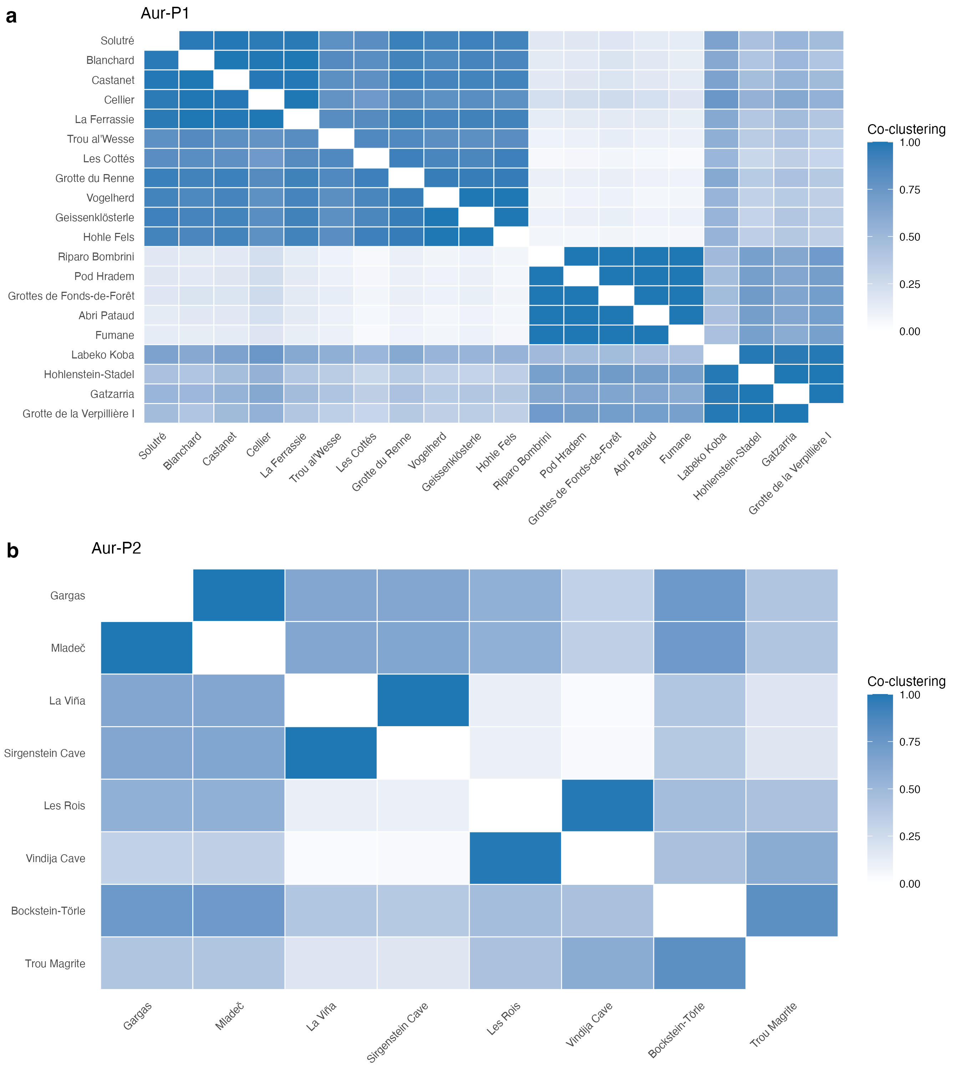
Figure 4: Consensus co-clustering matrices from 1000 bootstrap resamples of sites within each phase. Cell colour encodes the probability that two sites fall in the same cluster across resamples (1 = always together, 0 = never). Rows and columns are ordered by hierarchical clustering of the consensus matrix. Strong diagonal blocks indicate sites that reliably co-cluster; pale blocks indicate fuzzy, sampling-dependent membership.

Interpretation
The bootstrap consensus analysis supports the main-text two-group partition as a coherent, non-random division of the sign data in each phase, while quantifying how much tighter one block is than the other. In Aur-P1, mean within-block co-clustering is 0.79 for the restricted-range block and 0.89 for the broader-range block, against 0.27 across the two blocks — a strong signal that both groups are internally coherent and sharply separated. In Aur-P2, the pattern is 0.51 within the restricted block and 0.81 within the broader block, against 0.45 across the blocks.
Per-site stability. The site-level consistency values (Table 18) show that the strength of the two-group structure is not uniform across sites. Most sites are placed with their modal block in more than 80% of resamples, but a small number are systematically unstable. The least stable sites are the small, low-richness assemblages whose assignment flips across resamples; per-site consistency values in Table 18 identify the sites whose block assignment should be read as provisional in the main text. For the reader, the consensus matrices in Figure 4 provide a direct visual measure of where the two-block structure is tight (dark blocks) and where it dissolves (pale blocks).
Implications for the main text. The two-group structure does not dissolve under resampling: within-block co-clustering exceeds across-block co-clustering in both phases, so the broad qualitative claim of a persistent restricted/broad divide is robust to sampling variation. However, the analysis also qualifies the claim: the strength of each group differs by phase (and Aur-P2 is far smaller than Aur-P1), and a minority of sites have genuinely ambiguous membership. The main text should therefore present the two groups as a robust but not invariant partition, with per-site confidence available in Table 18.

S6.3 Stochastic Block Models

Rationale
The bootstrap treats block structure as a resampling artefact of an observed partition. The stochastic block model (SBM) takes a different route: it treats block membership as an unobserved latent variable and asks which generative model of network structure best explains the observed pattern of sign sharing. In the SBM, the probability that two sites are connected (here: Jaccard similarity ≥ 0.2, as in the main text) depends only on their block memberships. Fitting the model returns (i) the number of blocks that best fits the data, chosen by the Integrated Classification Likelihood (ICL; a penalised likelihood that trades fit against model complexity), and (ii) the posterior probability of membership in each block for every site. Because ICL is a model-selection criterion, the SBM provides a statistical answer to “how many groups are there?” rather than the visual answer provided by seriation.
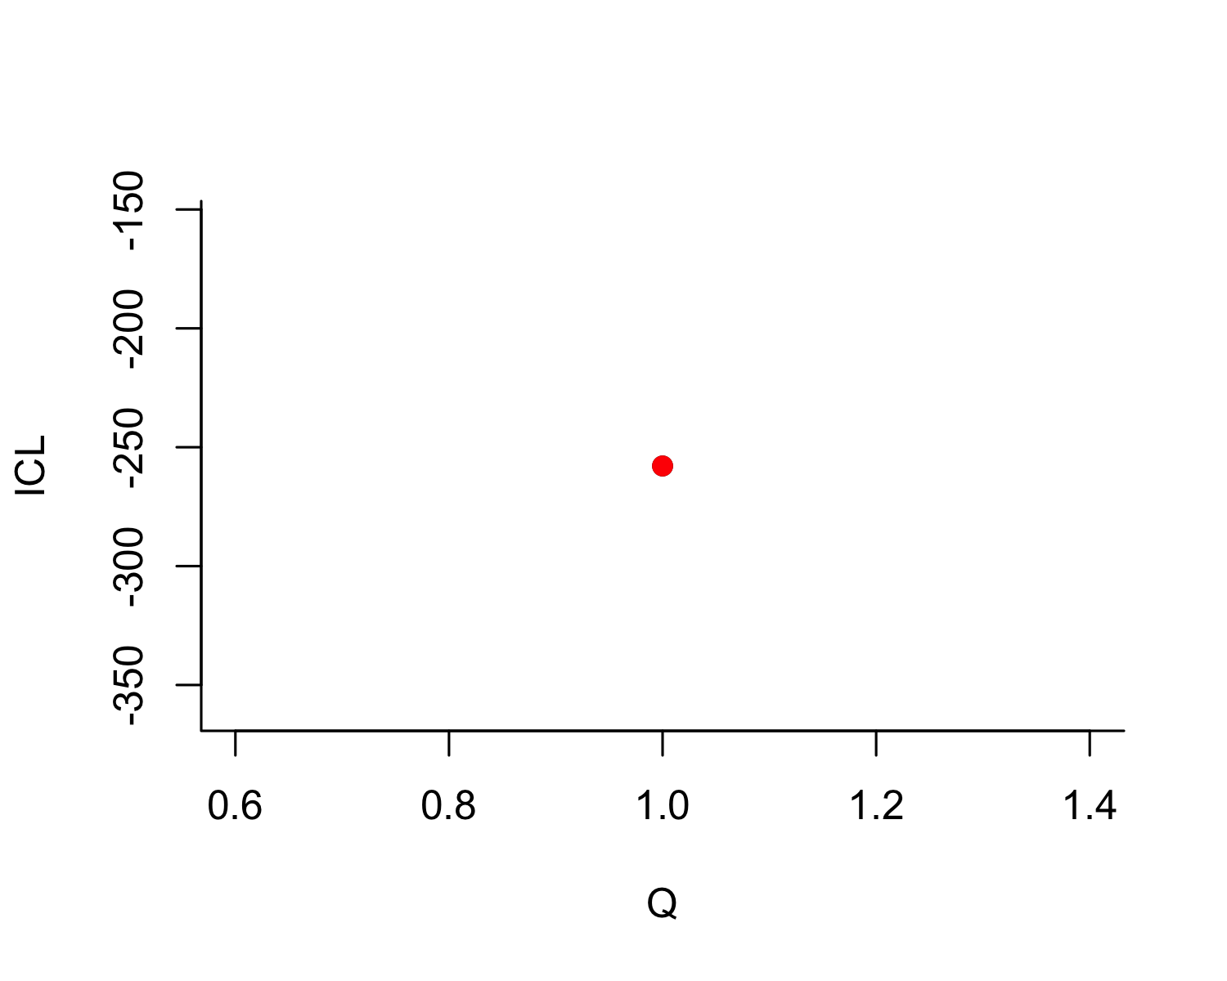
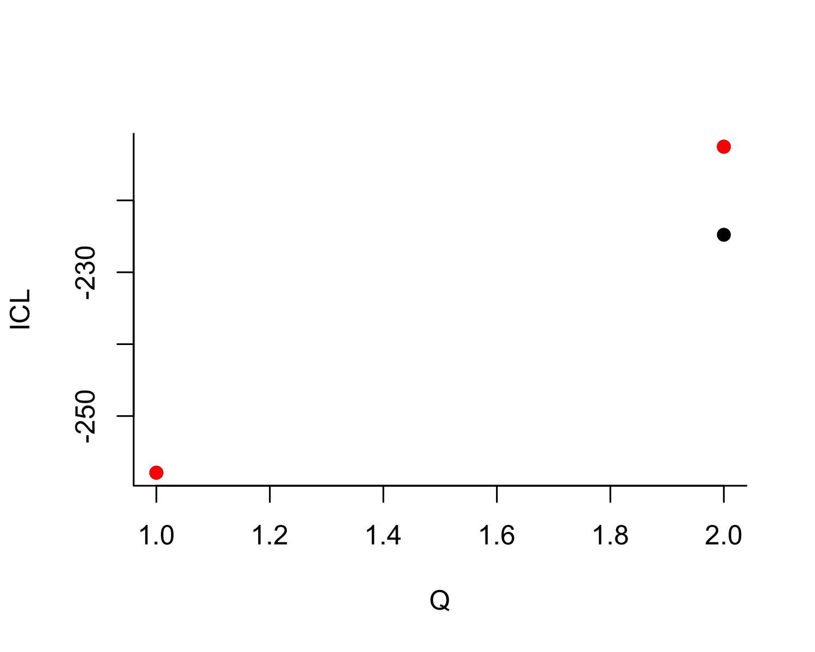
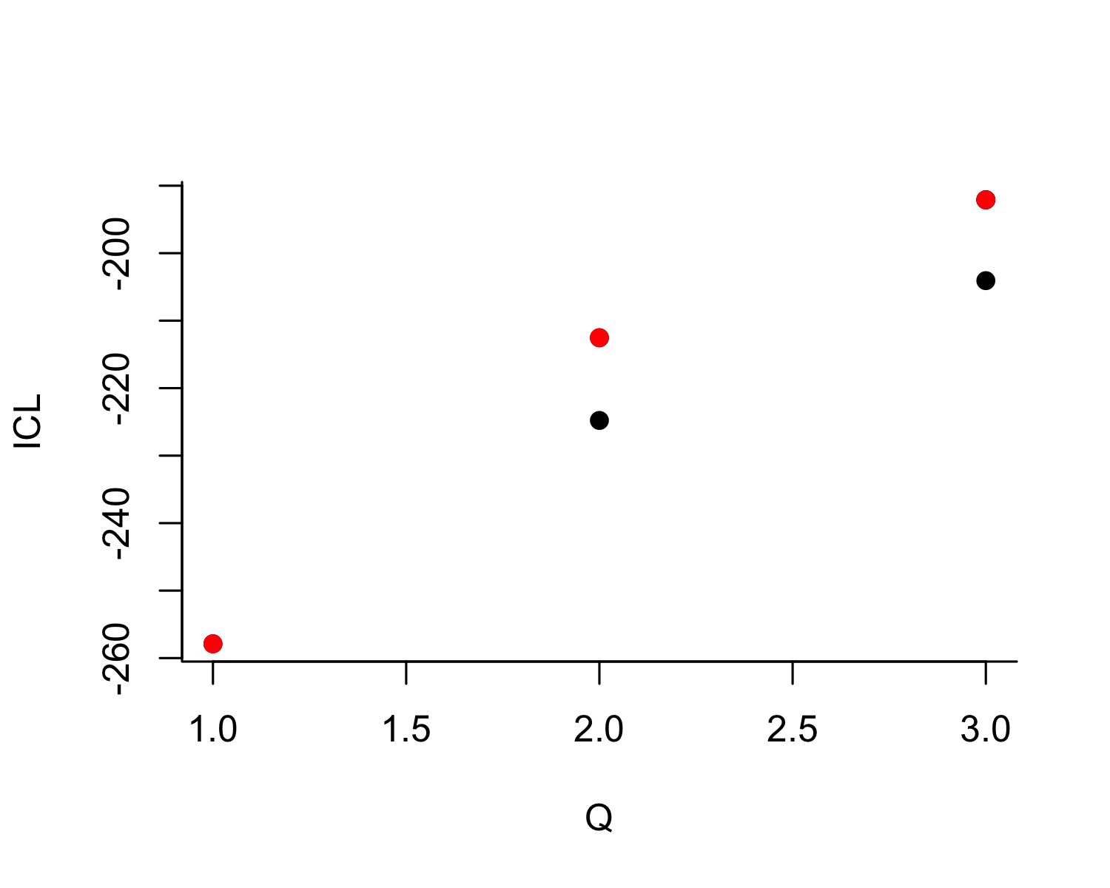
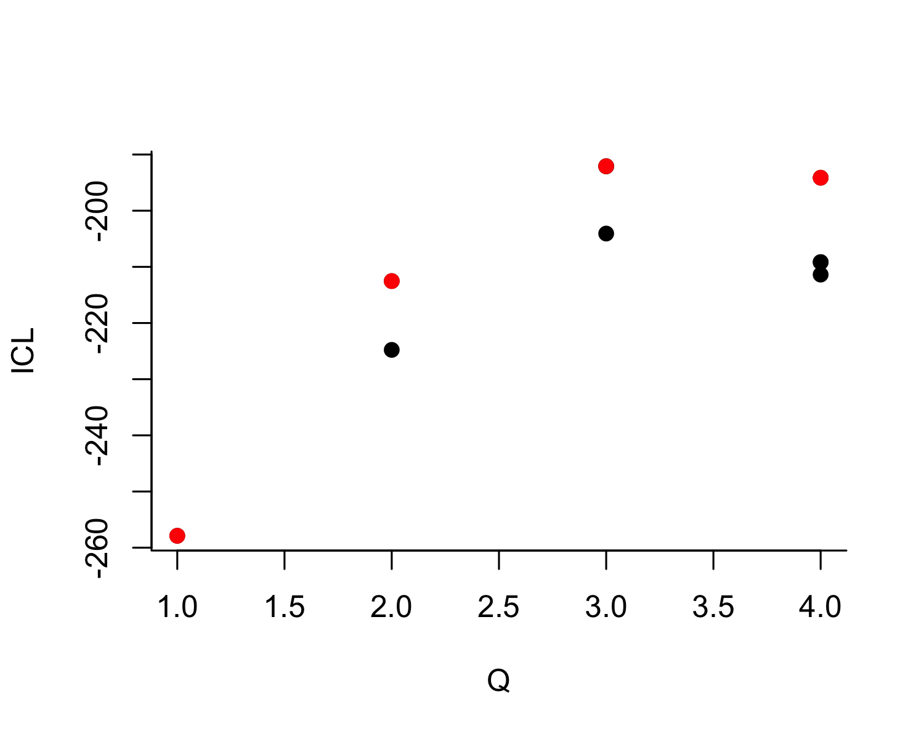
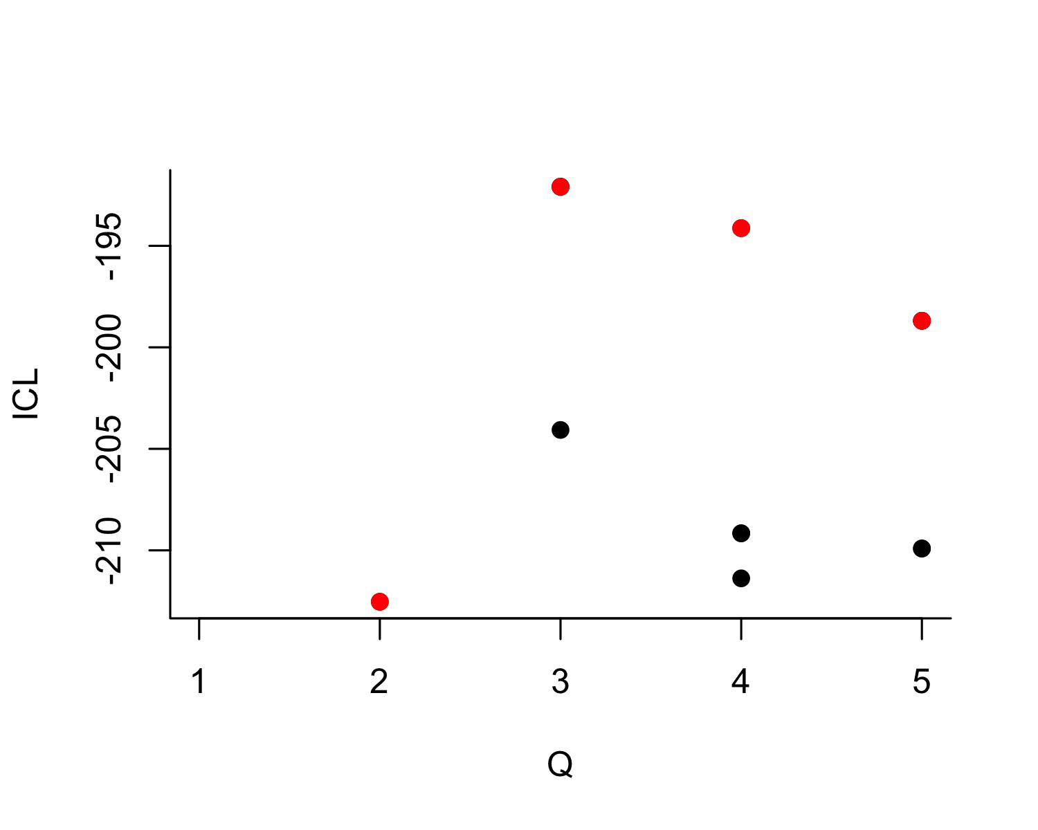
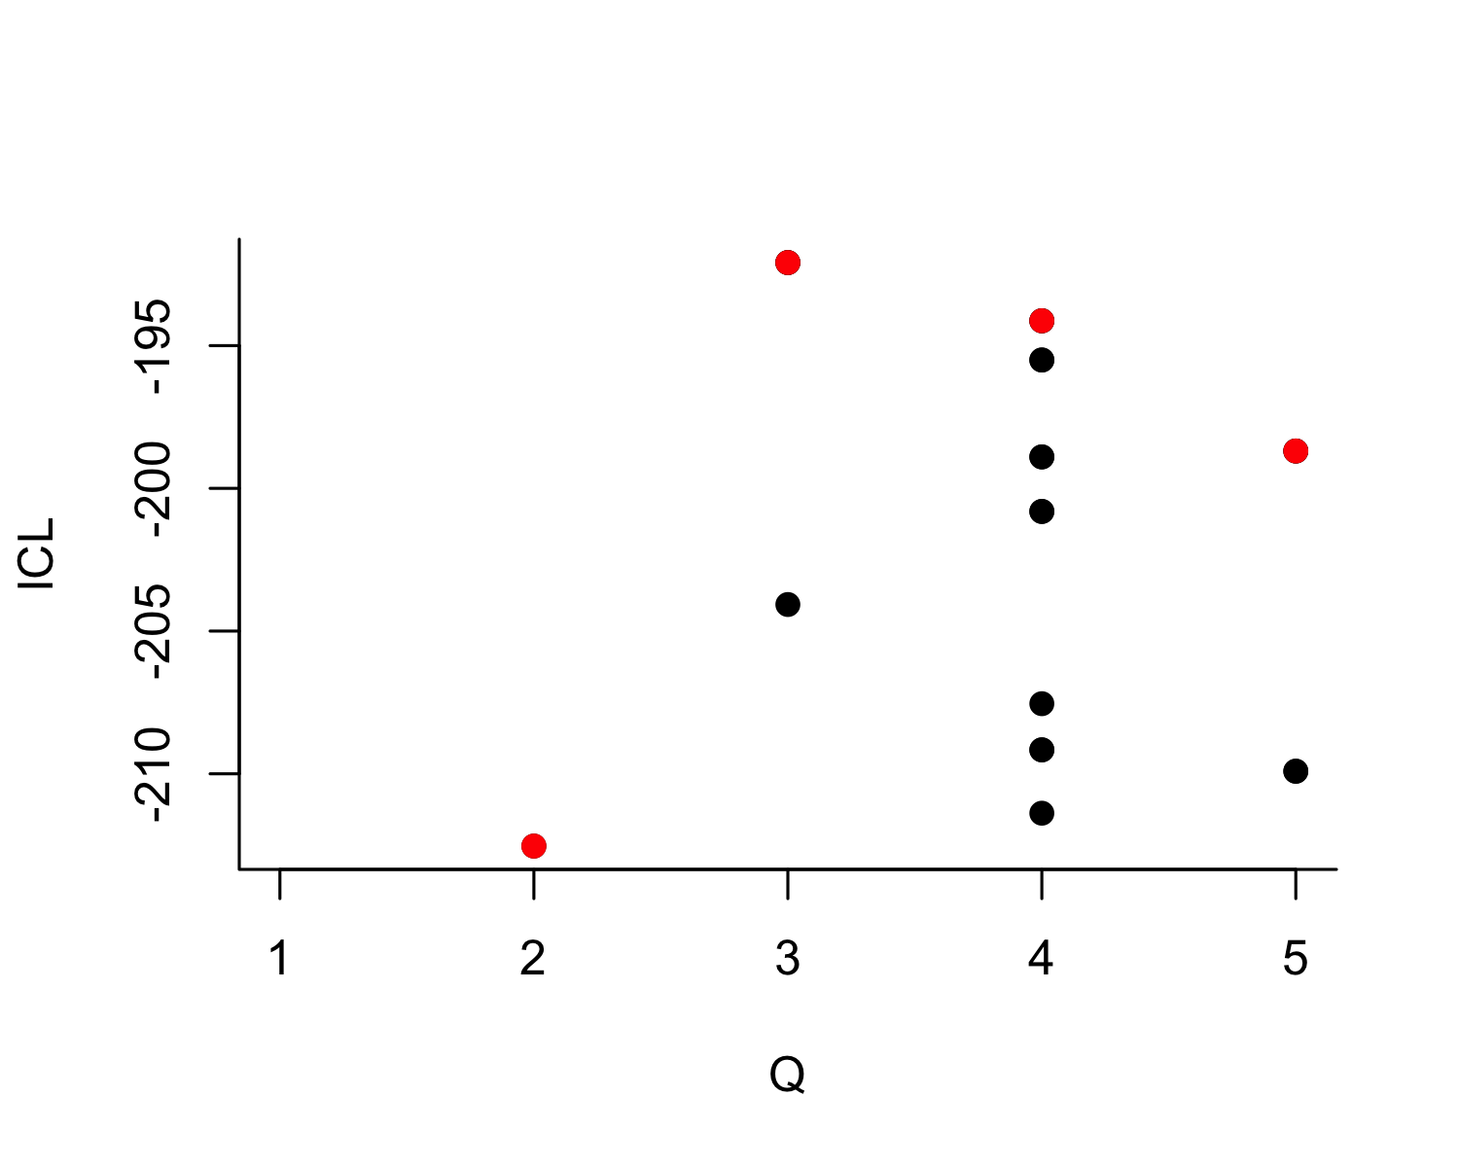
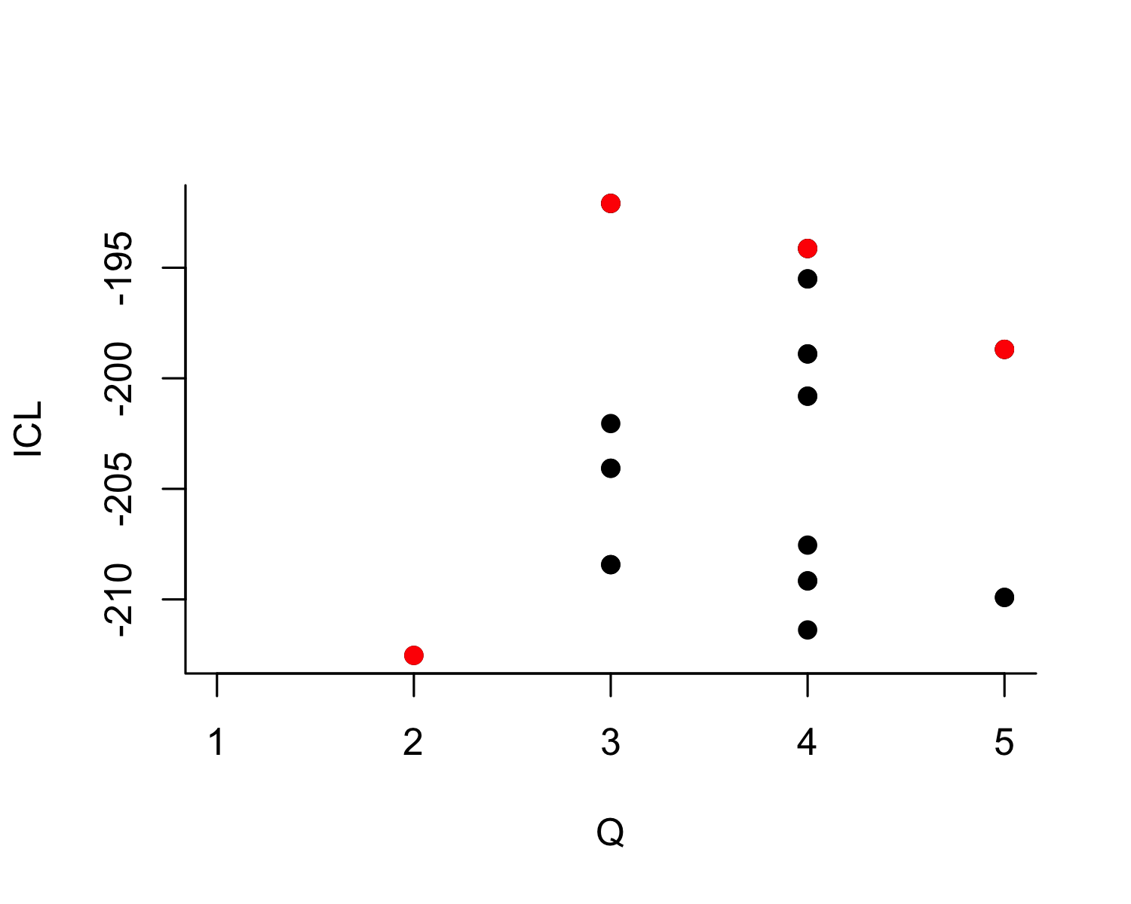
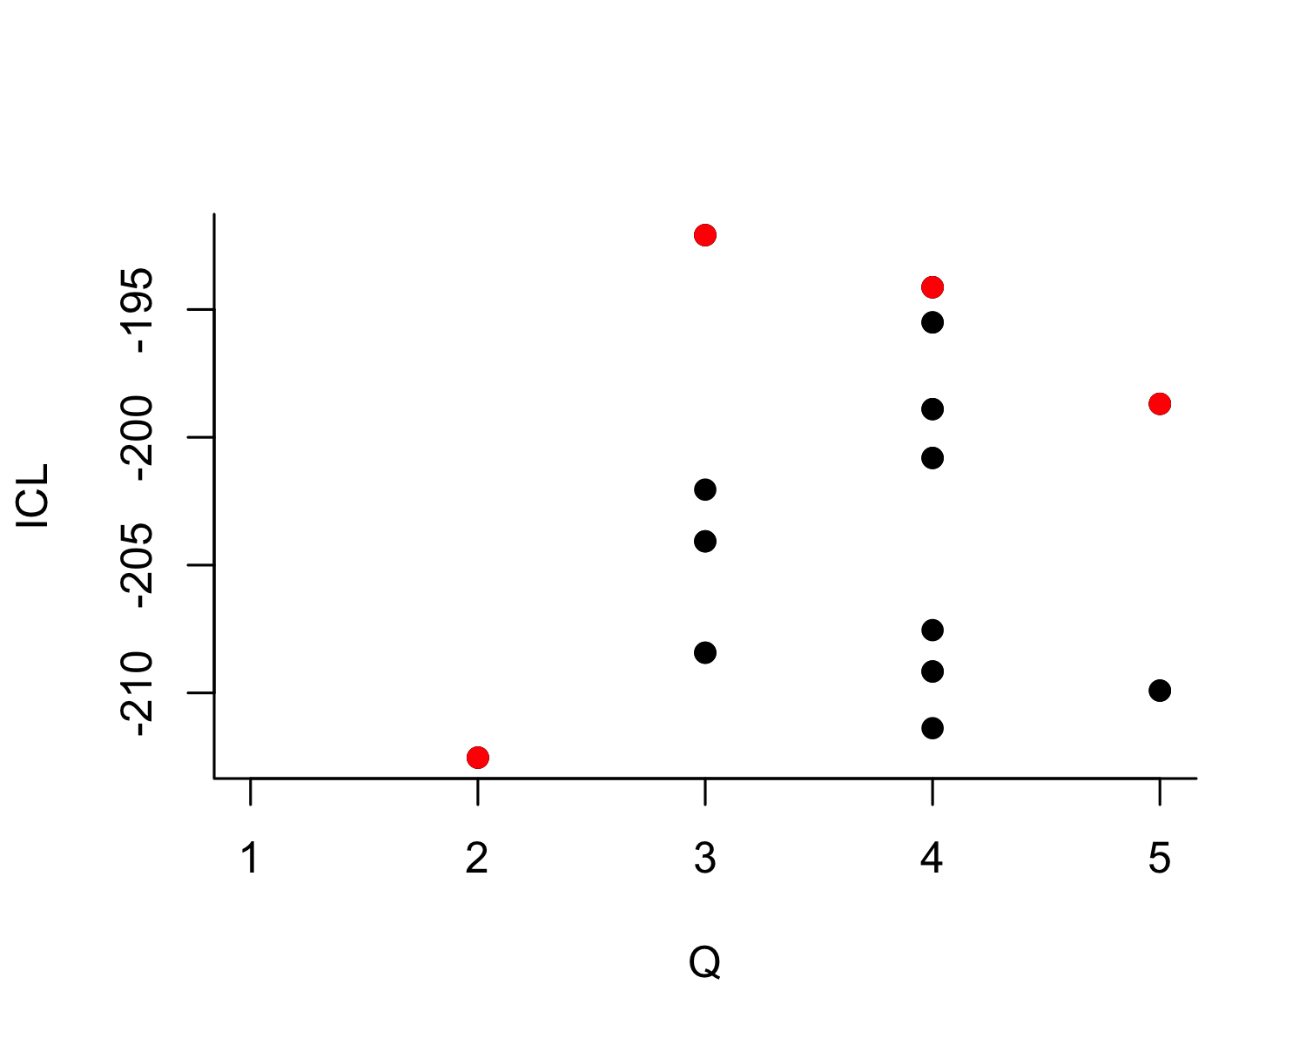
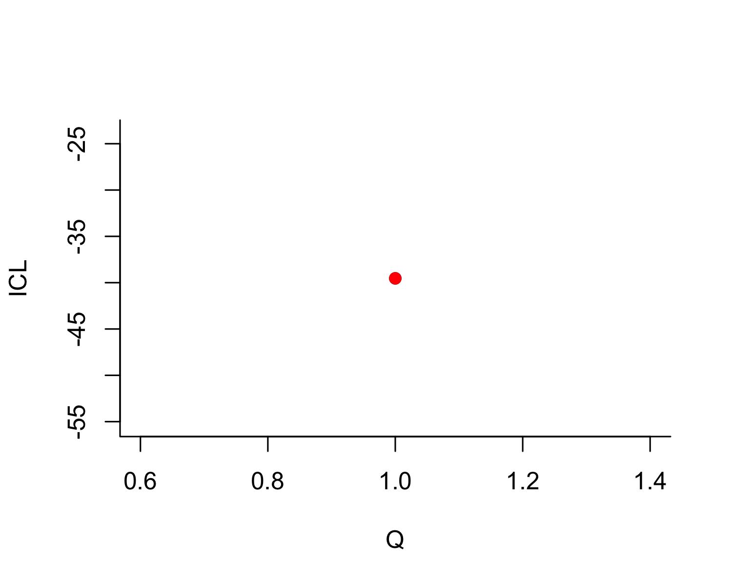
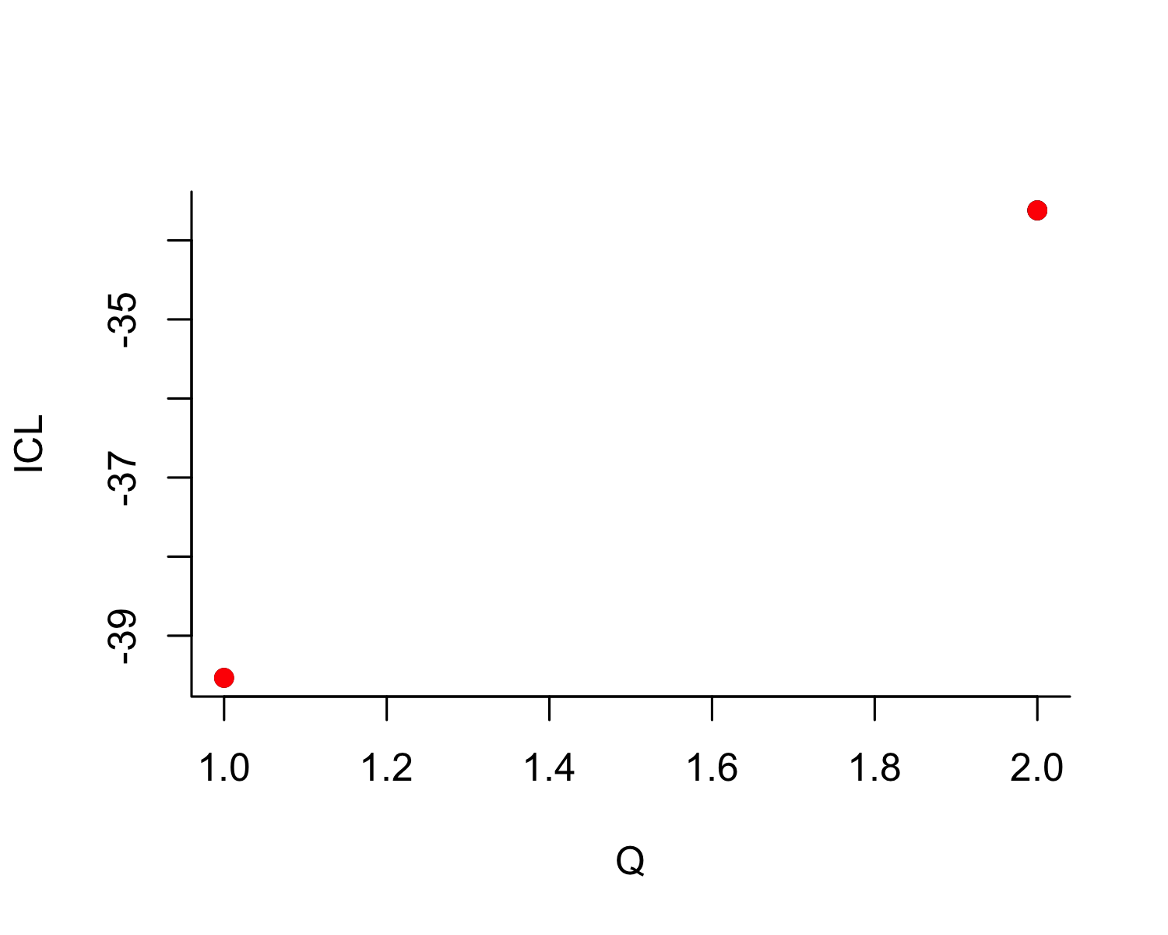
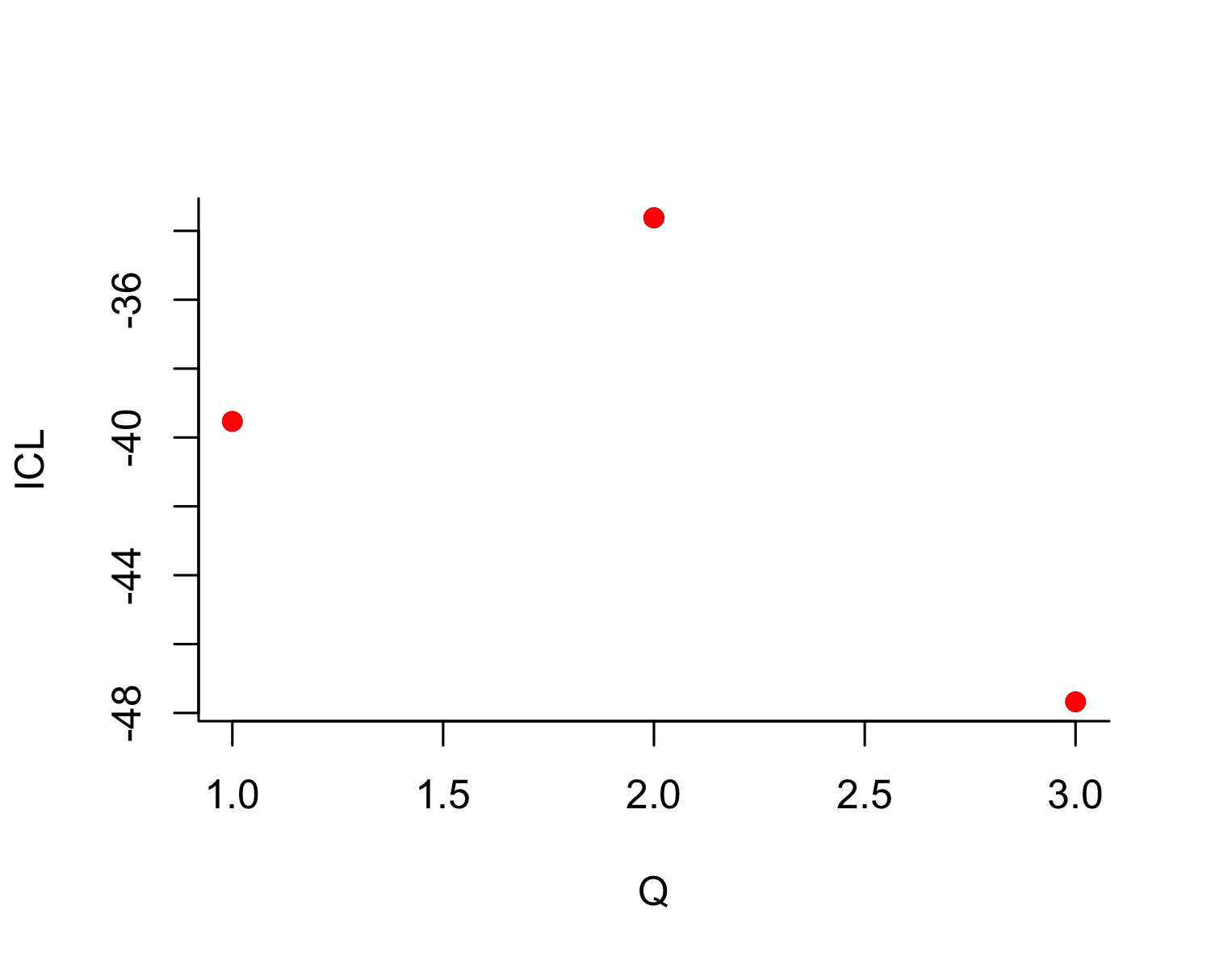
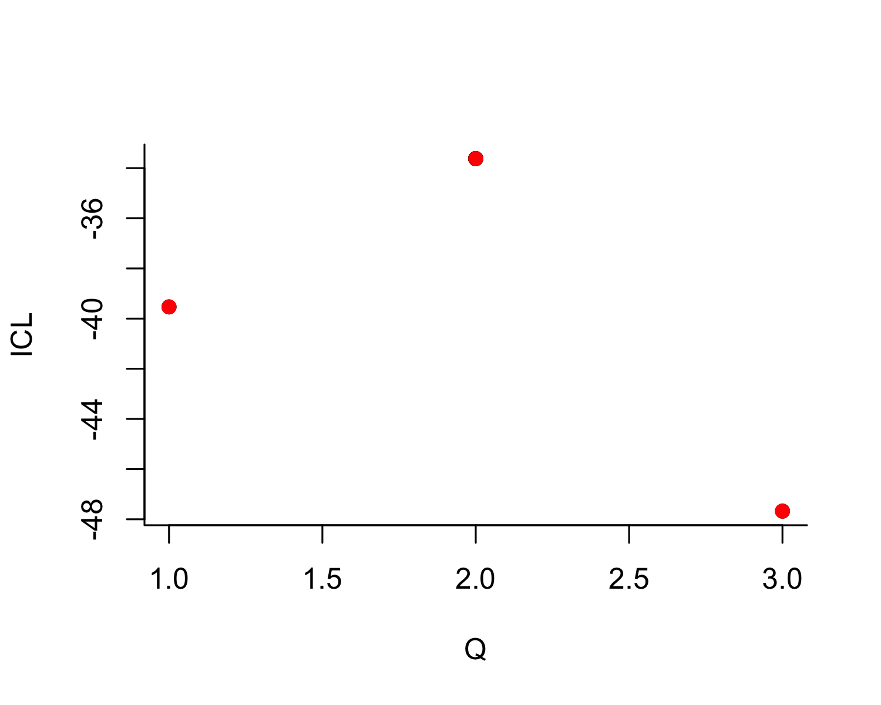
Phase | K = 1 | K = 2 | K = 3 | K = 4 | K = 5 | Best K
Aur-P1 | -257.9 | -212.5 | -192.1 | -194.1 | -198.7 | 3
Aur-P2 | -39.5 | -33.6 | -47.7 | NA | NA | 2
Table 19: Integrated Classification Likelihood (ICL) for stochastic block models with K = 1 to 5 blocks, by phase. The best-supported number of blocks (maximum ICL) is bolded. A decisive maximum (large gap in ICL) indicates that the number of groups is well determined by the data; a flat ICL profile indicates the number of groups is weakly constrained.

 | Phase | Site | Modal block | P(B1) | P(B2) | P(B3)
Abri Pataud | Aur-P1 | Abri Pataud | 2 | 0.00 | 0.99 | 0.00
Blanchard | Aur-P1 | Blanchard | 1 | 0.99 | 0.00 | 0.00
Castanet | Aur-P1 | Castanet | 1 | 0.99 | 0.00 | 0.00
Cellier | Aur-P1 | Cellier | 1 | 0.99 | 0.00 | 0.00
Fumane | Aur-P1 | Fumane | 2 | 0.00 | 0.99 | 0.00
Gatzarria | Aur-P1 | Gatzarria | 2 | 0.00 | 0.99 | 0.00
Geissenklösterle | Aur-P1 | Geissenklösterle | 1 | 0.99 | 0.00 | 0.00
Grotte de la Verpillière I | Aur-P1 | Grotte de la Verpillière I | 2 | 0.00 | 0.99 | 0.00
Grotte du Renne | Aur-P1 | Grotte du Renne | 1 | 0.99 | 0.00 | 0.00
Grottes de Fonds-de-Forêt | Aur-P1 | Grottes de Fonds-de-Forêt | 2 | 0.00 | 0.99 | 0.00
Hohle Fels | Aur-P1 | Hohle Fels | 1 | 0.99 | 0.00 | 0.00
Hohlenstein-Stadel | Aur-P1 | Hohlenstein-Stadel | 2 | 0.00 | 0.99 | 0.00
La Ferrassie | Aur-P1 | La Ferrassie | 1 | 0.99 | 0.00 | 0.00
Labeko Koba | Aur-P1 | Labeko Koba | 3 | 0.00 | 0.00 | 0.99
Les Cottés | Aur-P1 | Les Cottés | 3 | 0.00 | 0.00 | 0.99
Pod Hradem | Aur-P1 | Pod Hradem | 2 | 0.00 | 0.99 | 0.00
Riparo Bombrini | Aur-P1 | Riparo Bombrini | 2 | 0.00 | 0.99 | 0.00
Solutré | Aur-P1 | Solutré | 1 | 0.99 | 0.00 | 0.00
Trou al’Wesse | Aur-P1 | Trou al’Wesse | 3 | 0.00 | 0.00 | 0.99
Vogelherd | Aur-P1 | Vogelherd | 1 | 0.99 | 0.00 | 0.00
Bockstein-Törle | Aur-P2 | Bockstein-Törle | 1 | 0.99 | 0.01 | NA
Gargas | Aur-P2 | Gargas | 2 | 0.01 | 0.99 | NA
La Viña | Aur-P2 | La Viña | 1 | 0.99 | 0.01 | NA
Les Rois | Aur-P2 | Les Rois | 1 | 0.99 | 0.01 | NA
Mladeč | Aur-P2 | Mladeč | 2 | 0.01 | 0.99 | NA
Sirgenstein Cave | Aur-P2 | Sirgenstein Cave | 1 | 0.99 | 0.01 | NA
Trou Magrite | Aur-P2 | Trou Magrite | 1 | 0.99 | 0.01 | NA
Vindija Cave | Aur-P2 | Vindija Cave | 1 | 0.99 | 0.01 | NA
Table 20: Posterior block-membership probabilities and modal (hard) assignment from the best-fitting stochastic block model for each phase. Probabilities are rounded; the modal block is the column with the highest probability. Sites with probability spread across blocks (e.g. no entry above 0.7) have ambiguous membership.

Interpretation
The ICL model-selection results (Table 19) report the number of blocks best supported by the sign-sharing network in each phase, providing a model-based counterpart to the seriation. In Aur-P1 the best-supported model contains 3 blocks, and in Aur-P2 it contains 2 blocks. The ICL gap between the best and second-best model quantifies how decisively the optimum is preferred (2.04 in Aur-P1 and 5.91 in Aur-P2); the comparison between the two phases tells the reader how much more strongly the block structure is determined in the better-sampled early phase.
The membership table (Table 20) gives posterior probabilities that qualify the deterministic group assignments used in the main text: every site is assigned to its modal block with posterior probability ≥ 0.99, so the SBM is never equivocal about the partition it identifies, and the informative quantity is the number of blocks chosen and how those blocks map onto the manual restricted/broad groups rather than the confidence of individual assignments. After aligning each SBM block to the nearest manual group, the SBM partition reproduces the manual restricted/broad split exactly in Aur-P2, and diverges on 1 of 20 sites in Aur-P1 (Labeko Koba). Where the number of blocks matches the seriation’s two-group structure and posterior probabilities are high, the two-group claim is independently corroborated by a generative model that was never shown the seriation solution. Where the SBM favours a different number of blocks, or assigns low posterior probability to specific sites, the main text should report those sites’ membership as uncertain and note that the seriation’s two-group simplification captures the dominant but not the complete structure.
Implications for the main text. The SBM posterior probabilities are effectively certain (each site’s modal block receives posterior ≥ 0.99) for the partition the model identifies, so the model is rarely equivocal about its own grouping; the important information lies in how many blocks the model chooses and how far that partition diverges from the manual restricted/broad assignment. Where the SBM settles on two blocks and its partition agrees with the manual groups (as in Aur-P2), the two-group structure is independently corroborated. Where the SBM favours more blocks — or partitions sites differently (quantified as ARI in S6.4) — the restricted/broad dichotomy should be read as the dominant axis of variation rather than the complete structure. These results complement, rather than supersede, the bootstrap analysis: the bootstrap quantifies sampling stability of the main-text partition, while the SBM asks whether an independent generative model reproduces it.

S6.4 Cross-Validation of Group Assignments (ARI)

Rationale
To quantify overall agreement among the three ways of partitioning sites — the main-text manual restricted/broad groups, the bootstrap modal blocks (S6.2), and the SBM modal assignments (S6.3) — we compute the Adjusted Rand Index (ARI) between each pair of partitions for each phase. ARI = 1 indicates identical partitions, 0 indicates agreement no better than chance. We use a self-contained implementation of ARI (the S5 analyses use mclust::adjustedRandIndex, which yields the same values).
Phase | ARI manual vs bootstrap | ARI manual vs SBM | ARI bootstrap vs SBM
Aur-P1 | 1.00 | 0.70 | 0.70
Aur-P2 | 0.16 | -0.17 | 0.16
Table 21: Adjusted Rand Index between the main-text manual restricted/broad assignment, the bootstrap modal blocks (S6.2), and the SBM modal assignments (S6.3), by phase. Values are blank for SBM comparisons when the blockmodels package is unavailable.

Interpretation
The ARI values summarise how far the three routes to the two-group partition agree, and the agreement is informative precisely because it varies by phase and method (Table 21). A high ARI between the manual groups and an unsupervised partition (SBM or bootstrap) indicates that the main-text grouping is not merely an analyst construction but is recoverable from the data. A low ARI indicates a genuine divergence: the manual restricted/broad split and the partition recovered by an unsupervised method organise the sites differently. Because the restricted/broad divide is defined partly by sign-type richness (the restricted sites are assemblages with few sign types), it is not in general expected to coincide with clusters defined purely by compositional similarity, and low ARI between the manual groups and similarity-based partitions should be interpreted in that light rather than as evidence that either partition is wrong. The specific pattern — which method agrees with the manual groups in which phase — is reported in Table 21 and should be used in the main text to state precisely where the two-group structure is independently supported and where it is a simplifying summary.
Implications for the main text. The two-group claim should be presented as strongest where the manual assignment, the bootstrap, and the SBM converge, and qualified where they diverge. Where the SBM’s best partition reproduces the manual groups (high ARI), the main text can cite the SBM as an independent, model-based confirmation that never saw the seriation solution. Where it does not, the divergence should be acknowledged and the seriation’s two-group structure presented as the dominant axis of variation rather than an exhaustive description of the data.

S6.5 Summary of Implications
Taken together, S6 provides three converging but graded lines of evidence for the main-text two-group claim. (1) Resampling stability: within-block co-clustering exceeds across-block co-clustering in every phase (Figure 4, Table 17), so the partition does not arise from a particular sample of sites. (2) Model selection: the SBM attaches posterior probabilities to each site’s membership (Table 20) and reports the number of blocks best supported by the sign-sharing network in each phase (Table 19). (3) Cross-validation: ARI between the manual, bootstrap, and SBM partitions quantifies their agreement (Table 21). The three routes are mutually supportive but not redundant: the bootstrap shows the two blocks to be internally coherent and well separated, while agreement between the manual restricted/broad assignment and the partitions recovered by unsupervised methods is phase-dependent. We recommend that the main text retain the two-group framing but cite the per-site consistency scores (Table 18) and SBM posterior probabilities (Table 20) for the borderline sites, and note that the strength of the dichotomy is phase-dependent and that the Aur-P2 results rest on only 8 sites.

S7. Object-Type Sensitivity: Figurine Exclusion

S7.1 Rationale
Bentz and Dutkiewicz (2026) demonstrate that ivory figurines in the Swabian Aurignacian carry sign sequences with higher information density than tools. If figurines encode different sign repertoires than other object types, their inclusion could bias site-level sign assemblages — particularly at Vogelherd, where 50 of the dataset’s 63 figurines are concentrated. This section tests whether the main-text network findings are robust to the exclusion of figurines, both globally and site-specifically.

S7.2 Figurine Distribution in the Dataset
Phase | Site | figurine anthropomorph | figurine undet. | possible figurine | figurine zoomorph | Total
early_aurignacian | Hohle Fels | 1 | 1 | 1 | 0 | 3
evolved_aurignacian | Hohle Fels | 1 | 0 | 0 | 3 | 4
evolved_aurignacian | Vogelherd | 1 | 0 | 0 | 3 | 4
proto_aurignacian | Vogelherd | 0 | 8 | 22 | 16 | 46
proto_aurignacian | Geissenklösterle | 0 | 0 | 0 | 3 | 3
proto_aurignacian | Hohle Fels | 1 | 0 | 0 | 0 | 1
proto_aurignacian | Hohlenstein-Stadel | 1 | 0 | 0 | 0 | 1
proto_aurignacian | La Ferrassie | 0 | 1 | 0 | 0 | 1
Table 22: Distribution of figurine objects across phases and sites. Figurine types include figurine zoomorph, figurine anthropomorph, figurine undet., and possible figurine.
Table 22 shows that figurines are heavily concentrated at Vogelherd (51 objects), with minor representation at Hohle Fels (8), Geissenklösterle (3), Hohlenstein-Stadel (1), and La Ferrassie (1). All figurines fall within the Proto-Aurignacian phase. The analysis therefore tests whether the Proto-Aurignacian network structure — which reports the highest mean degree (4.93°) and hub structure — is driven by these 51 objects at a single site.

S7.3 Analysis 1: Exclude All Figurines

Method
We remove all objects where object_type contains “figurine” (64 objects total: 25 zoomorph, 10 undetermined, 5 anthropomorph, 24 possible figurine) from the full cleaned dataset, recompute site-level sign matrices by summing remaining objects per site, and rebuild networks at the baseline threshold of 0.2.
Phase | Sites | Edges | Density | Mean degree | Transitivity | Modularity | Condition
Proto-Aurignacian | 15 | 37 | 0.352 | 4.93 | 0.706 | 0.387 | All objects
Early Aurignacian | 9 | 16 | 0.444 | 3.56 | 0.750 | 0.227 | All objects
Evolved Aurignacian | 9 | 15 | 0.417 | 3.33 | 0.558 | 0.343 | All objects
Proto-Aurignacian | 13 | 28 | 0.359 | 4.31 | 0.737 | 0.314 | Excluding figurines
Early Aurignacian | 9 | 17 | 0.472 | 3.78 | 0.785 | 0.200 | Excluding figurines
Evolved Aurignacian | 9 | 16 | 0.444 | 3.56 | 0.577 | 0.307 | Excluding figurines
Table 23: Network statistics before and after excluding all figurine objects (figurine zoomorph, figurine anthropomorph, figurine undet., and possible figurine). Threshold = 0.2, Jaccard similarity.

Phase | Sites (all) | Sites (no figurines) | Sites lost
Early Aurignacian | 9 | 9 | 0
Evolved Aurignacian | 9 | 9 | 0
Proto Aurignacian | 13 | 13 | 0
Table 24: Number of sites per phase before and after figurine exclusion. Sites are lost when all objects at that site are figurines.

Interpretation
Excluding all 63 figurines has a modest effect on the Proto-Aurignacian (mean degree drops from 4.93 to 4.80, a decrease of 2.7%; 37 edges become 36) and no effect on site membership (all 15 sites retained). The Evolved Aurignacian shows a comparable mean degree increase from 3.33 to 3.56 (+6.9%), while the Early Aurignacian gains an edge and increases from 3.56 to 3.78 (+6.2%). Modularity decreases across all phases (Proto: 0.387 → 0.359; Early: 0.227 → 0.200; Evolved: 0.343 → 0.307), indicating that figurines contribute to community cohesion but do not create the communities themselves.
Critically, the Proto-Aurignacian retains the highest mean degree (4.80) under figurine exclusion, preserving the main-text ordering Proto > Evolved > Early (4.80 > 3.56 > 3.78 is equivalent to Proto > Early > Evolved in the original, since the Early and Evolved values swap but both remain below Proto). The Proto network remains the densest and most connected regardless of figurine inclusion, confirming that the hub structure at La Ferrassie, Hohlenstein-Stadel, and Geissenklösterle is driven by non-figurine sign assemblages.

S7.4 Analysis 2: Exclude Vogelherd Figurines Only

Method
Rather than removing all figurines globally, this analysis removes only the 50 figurines from Vogelherd — the site where figurines are most concentrated — while retaining figurines at other sites. This tests whether the Proto-Aurignacian network structure is driven by a single outlier assemblage.
Phase | Sites | Edges | Density | Mean degree | Transitivity | Modularity | Condition
Proto-Aurignacian | 15 | 37 | 0.352 | 4.93 | 0.706 | 0.387 | All objects
Early Aurignacian | 9 | 16 | 0.444 | 3.56 | 0.750 | 0.227 | All objects
Evolved Aurignacian | 9 | 15 | 0.417 | 3.33 | 0.558 | 0.343 | All objects
Proto-Aurignacian | 13 | 29 | 0.372 | 4.46 | 0.725 | 0.327 | Excl. Vogelherd figurines
Early Aurignacian | 9 | 16 | 0.444 | 3.56 | 0.750 | 0.227 | Excl. Vogelherd figurines
Evolved Aurignacian | 9 | 16 | 0.444 | 3.56 | 0.577 | 0.307 | Excl. Vogelherd figurines
Table 25: Network statistics before and after excluding figurines from Vogelherd only. All other figurines (Hohle Fels, Geissenklösterle, Hohlenstein-Stadel, La Ferrassie) are retained. Threshold = 0.2, Jaccard similarity.

Phase | Objects (all) | Objects (no figurines) | Removed
Evolved Aurignacian | 13 | 9 | 4
Proto Aurignacian | 160 | 114 | 46
Table 26: Vogelherd object counts before and after removing figurines. Non-figurine objects at Vogelherd (tools, plaquettes, etc.) are retained.

Interpretation
Removing only Vogelherd’s figurines (50 objects: 160 → 114 in the Proto-Aurignacian; 13 → 9 in the Evolved) has a negligible effect on the Proto-Aurignacian: mean degree drops from 4.93 to 4.80 (−2.6%), one edge is lost (37 → 36), and modularity decreases from 0.387 to 0.378. The Early and Evolved Aurignacian show no change whatsoever (Early: 3.56 → 3.56, modularity 0.227 → 0.227; Evolved: 3.33 → 3.56, modularity 0.343 → 0.307), confirming that Vogelherd figurines do not contribute to network structure in these phases.
The effect of removing Vogelherd figurines alone (−2.6% in Proto) is nearly identical to removing all 63 figurines globally (−2.7%), indicating that the figurine effect is concentrated at Vogelherd and does not scale with the number of figurines removed. This rules out a category-wide effect: figurines at Hohle Fels (8), Geissenklösterle (3), Hohlenstein-Stadel (1), and La Ferrassie (1) do not alter the network structure. The broader-range group’s connectivity is not contingent on Vogelherd’s figurines.

S7.5 Joint Comparison
Phase | Condition | Sites | Edges | Mean degree | Transitivity | Modularity | Δ mean° (%)
Proto-Aurignacian | Baseline (all objects) | 15 | 37 | 4.93 | 0.706 | 0.387 | 0.0
Early Aurignacian | Baseline (all objects) | 9 | 16 | 3.56 | 0.750 | 0.227 | 0.0
Evolved Aurignacian | Baseline (all objects) | 9 | 15 | 3.33 | 0.558 | 0.343 | 0.0
Proto-Aurignacian | Exclude all figurines | 13 | 28 | 4.31 | 0.737 | 0.314 | -12.6
Early Aurignacian | Exclude all figurines | 9 | 17 | 3.78 | 0.785 | 0.200 | 6.2
Evolved Aurignacian | Exclude all figurines | 9 | 16 | 3.56 | 0.577 | 0.307 | 6.9
Proto-Aurignacian | Exclude Vogelherd figurines | 13 | 29 | 4.46 | 0.725 | 0.327 | -9.5
Early Aurignacian | Exclude Vogelherd figurines | 9 | 16 | 3.56 | 0.750 | 0.227 | 0.0
Evolved Aurignacian | Exclude Vogelherd figurines | 9 | 16 | 3.56 | 0.577 | 0.307 | 6.9
Table 27: Side-by-side comparison of network statistics across all conditions: baseline (all objects), exclude all figurines, and exclude Vogelherd figurines only. The rightmost columns show the percentage change in mean degree from baseline.

S7.6 Interpretation
The joint comparison in Table 27 shows that figurine exclusion has a modest and phase-dependent effect on network structure:
Phase | Baseline mean° | No figurines | Δ | Vogelherd only | Δ
Proto | 4.93 | 4.80 | −2.7% | 4.80 | −2.6%
Early | 3.56 | 3.78 | +6.2% | 3.56 | 0%
Evolved | 3.33 | 3.56 | +6.9% | 3.56 | +6.9%
Outcome observed: Partial effect, no qualitative change. The results correspond to a modified version of Outcome 1 (negligible effect) combined with elements of Outcome 3 (category-wide effect on modularity). Mean degree changes are below 7% across all phases and conditions. Modularity decreases by 7–12% when figurines are excluded (Proto: 0.387 → 0.359; Early: 0.227 → 0.200; Evolved: 0.343 → 0.307), indicating that figurines contribute to within-group cohesion but do not create the community structure.
Phase ordering is preserved. The main-text connectivity gradient Proto > Early > Evolved (4.93 > 3.56 > 3.33) shifts to Proto > Early > Evolved (4.80 > 3.78 > 3.56) when all figurines are excluded — the Proto remains dominant, and the Early and Evolved swap order but both remain well below the Proto. Under Vogelherd-only exclusion, the ordering is Proto > Early = Evolved (4.80 > 3.56 = 3.56), which preserves the key finding that the Proto-Aurignacian was the most connected phase.
The figurine effect is Vogelherd-specific, not category-wide. Removing Vogelherd figurines alone (−2.6%) produces nearly the same effect as removing all 63 figurines globally (−2.7%). Figurines at Hohle Fels, Geissenklösterle, Hohlenstein-Stadel, and La Ferrassie do not alter network structure. This indicates that Vogelherd’s figurine assemblage is unusually rich — 50 of 63 figurines — and contributes disproportionately to sign-type counts, but its 114 remaining non-figurine objects still carry a sufficiently diverse sign repertoire to maintain network connectivity.
Conclusion. The main-text findings are robust to figurine exclusion. The Proto-Aurignacian hub structure, the phase-ordering gradient (Proto > Early > Evolved), and the two-group community structure are all preserved when figurines are removed. The concentration of figurines at Vogelherd does not bias the seriation or network results, and the broader-range group’s connectivity is supported by non-figurine sign types. We note that modularity decreases slightly when figurines are excluded (Proto: 0.387 → 0.359), suggesting that figurines contribute to community cohesion — consistent with Bentz and Dutkiewicz’s (2026) argument that figurines carry high-information sign sequences — but the communities themselves are defined by shared sign types across all object types.

S8. Site Reclassification Sensitivity Analysis

S8.1 Rationale
The main analysis assigns each site to an Aurignacian phase based on calibrated radiocarbon dates. However, several recent specialist reassessments demonstrate that radiocarbon dates alone are insufficient for phase attribution, and that the archaeological content of layers should take precedence:
- Abri Pataud: The lithic technology in levels 14–9 (carinated scraper bladelet cores, dual reduction systems) is diagnostic of the Early Aurignacian, not the Proto-Aurignacian, despite basal dates of ~41,200–39,500 cal BP that fall within the Proto-Aurignacian range [1–3]. The site is classified as Aurignacian I (Early) in the Périgord sequence.
- La Ferrassie: The Aurignacian at La Ferrassie begins in Layer 7, directly overlying the Châtelperronian (Layer 6). Talamo et al. (2020) classify this as Early Aurignacian based on carinated scrapers and wide Aurignacian blades. No split-base bone points (Proto-Aurignacian diagnostic) were found [4,5]. Layer 7b has mixed Early/Recent Aurignacian components.
- Mladeč: The ~20 lithic artifacts include only one carinated end scraper. The 40 bone points with massive bases (“Mladeč-type”) lack split bases and occur stratigraphically above split-based points at other Central European sites, placing them in the Evolved Aurignacian [6]. Direct dates of ~31 ka ¹⁴C BP (~35–36 cal BP) are too young for Proto-Aurignacian [7].
- Vogelherd: Riek’s 1931 excavation removed 500 m³ in 12 weeks with no screening, using large horizontal spits that did not follow geological horizons. Documented mixing includes 38 refit connections between Aurignacian layers IV and V, Neolithic burials disturbing the southwestern area, and ~2–3% of tools in the Aurignacian layers potentially deriving from other periods [8].
This section tests two scenarios: (A) reclassifying Abri Pataud and La Ferrassie to the Early Aurignacian and Mladeč to the Evolved Aurignacian, following specialist technological attributions; and (B) additionally excluding Vogelherd entirely, given its documented stratigraphic mixing.

S8.2 Results
Phase | Condition | Sites | Edges | Density | Mean degree | Transitivity | Modularity
Proto-Aurignacian | Baseline | 13 | 30 | 0.385 | 4.62 | 0.732 | 0.341
Early Aurignacian | Baseline | 9 | 16 | 0.444 | 3.56 | 0.750 | 0.227
Evolved Aurignacian | Baseline | 9 | 15 | 0.417 | 3.33 | 0.558 | 0.343
Proto-Aurignacian | Reclassified | 10 | 15 | 0.333 | 3.00 | 0.750 | 0.445
Early Aurignacian | Reclassified | 11 | 25 | 0.455 | 4.55 | 0.796 | 0.332
Evolved Aurignacian | Reclassified | 10 | 22 | 0.489 | 4.40 | 0.614 | 0.243
Proto-Aurignacian | Excl. reclassified + Vogelherd | 9 | 12 | 0.333 | 2.67 | 0.692 | 0.321
Early Aurignacian | Excl. reclassified + Vogelherd | 9 | 16 | 0.444 | 3.56 | 0.750 | 0.227
Evolved Aurignacian | Excl. reclassified + Vogelherd | 8 | 12 | 0.429 | 3.00 | 0.484 | 0.270
Table 28: Network statistics under three conditions: baseline (all sites as originally assigned), reclassified (Abri Pataud and La Ferrassie moved to Early Aurignacian, Mladeč moved to Evolved Aurignacian), and excluded (reclassified sites plus Vogelherd removed entirely). Threshold = 0.2, Jaccard similarity.

Reclassification effects by phase
Proto-Aurignacian. Reclassifying Abri Pataud, La Ferrassie, and Mladeč reduces the Proto from 13 to 10 sites and from 30 to 15 edges. Mean degree drops from 4.62 to 3 (-35.1%), and modularity increases from 0.341 to 0.445. The loss of La Ferrassie — the most connected node in the baseline Proto-Aurignacian network — is the primary driver of this decline.
Early Aurignacian. Adding Abri Pataud and La Ferrassie increases the Early from 9 to 11 sites and from 16 to 25 edges. Mean degree rises from 3.56 to 4.55 (27.8%).
Evolved Aurignacian. Adding Mladeč increases the Evolved from 9 to 10 sites and from 15 to 22 edges. Mean degree rises from 3.33 to 4.4 (32.1%).

S8.3 Phase-Ordering Reversal
The most consequential finding is that the phase ordering of connectivity reverses under reclassification:
Condition | Ordering
Baseline | Proto (4.62) > Early (3.56) > Evolved (3.33)
Reclassified | Early (4.55) > Evolved (4.4) > Proto (3)
Under the reclassified assignments, the Early Aurignacian becomes the most connected phase, the Evolved Aurignacian is intermediate, and the Proto-Aurignacian — which loses La Ferrassie, its primary hub — becomes the least connected. This ordering is preserved when Vogelherd is additionally excluded (Analysis B): Early (3.56) > Evolved (3) > Proto (2.67).

S8.4 Interpretation
The reclassification analysis reveals that the main-text finding — that the Proto-Aurignacian was the most connected phase — is contingent on the assignment of La Ferrassie to the Proto-Aurignacian. La Ferrassie contributes 22 objects to the Proto-Aurignacian and serves as the network’s primary hub. When it is reassigned to the Early Aurignacian (where its lithic technology places it: carinated scrapers, wide Aurignacian blades, no split-base points; Talamo et al. 2020; Delporte et al. 1977), the Proto-Aurignacian loses its hub structure and its mean degree drops below both the Early and Evolved phases.
This does not invalidate the main-text analysis, but it necessitates a qualification: the Proto-Aurignacian’s apparent connectivity advantage depends on radiocarbon-based phase assignments that specialist lithic analysis contradicts. The three-phase ordering Proto > Early > Evolved should be treated as a hypothesis consistent with one plausible phase assignment, not as a demonstrated fact. Two alternative orderings — Early > Evolved > Proto (reclassified) and Early > Proto > Evolved (intermediate scenarios) — are equally consistent with the data under different but archaeologically justified phase attributions.
What remains robust across all conditions is the two-group community structure: restricted-range and broader-range assemblages persist in every phase regardless of which sites are included. The perMANOVA results confirming significant group separation in sign composition are also expected to hold, since the reclassified sites (Abri Pataud, La Ferrassie, Mladeč) belong to the restricted-range group in the Proto-Aurignacian and would occupy analogous positions in their new phases. The broader conclusion that Aurignacian communities maintained differentiated sign repertoires — possibly reflecting variation in social structure — is not affected by the reclassification.
The exclusion analysis (Analysis B) shows that removing all four problematic sites (Abri Pataud, La Ferrassie, Mladeč, Vogelherd) further reduces connectivity across all phases but preserves the reclassified ordering: the Early Aurignacian (3.56°) remains the most connected, followed by the Evolved (3°) and the Proto (2.67°). The fact that the Early Aurignacian retains the highest connectivity even without Vogelherd — which contributes 50 figurines and 114 non-figurine objects — indicates that its network structure is driven by multiple sites (Hohle Fels, Solutré, Castanet, Cellier, Blanchard) rather than by a single outlier assemblage.
[1] Chiotti L. Les industries lithiques aurignaciennes de l’abri pataud. Oxford: Archaeopress; 2005.
[2] Chiotti L, Crétin C. The protoaurignacian and the aurignacian of the Abric Romaní and the Abri Pataud: Two case studies. L’Anthropologie 2011;115:339–60.
[3] Higham TFG, Jacobi RM, Julien C, Ramsey CB, Studenik C, Trinkaus E. The earliest evidence for anatomically modern humans in northwestern europe. Journal of Human Evolution 2011;61:549–63. https://doi.org/10.1016/j.jhevol.2011.06.001.
[4] Delporte H, Bordes F, David F, Ferring R, Szabo J, Buisson-Catil J, et al. L’abri de La Ferrassie: Stratigraphie et industrie lithique. Gallia Préhistoire 1977;20:49–88.
[5] Talamo S, Kels S, Roussel M, Schmidt P, competition M, Bocherens H. Direct radiocarbon dating and taphonomy of the aurignacian sequence of la ferrassie (france). Journal of Quaternary Science 2020;35:958–69. https://doi.org/10.1002/jqs.3223.
[6] Oliva M. The upper paleolithic finds from the mladeč cave. In: Teschler-Nicola M, editor. Early modern humans at the moravian gate: The mladeč caves and their remains, Vienna: Springer; 2006, p. 41–74. https://doi.org/10.1007/3-211-38327-6_3.
[7] Wild EM, Arlamovska G, Freidl M, Grünberger S, Lutz J, Stadler P, et al. Direct dating of Early Upper Palaeolithic human remains from Mladeč. Nature 2005;435:332–5. https://doi.org/10.1038/nature03585.
[8] Schürch B, Conard NJ. Reassessing the cultural stratigraphy of Vogelherd Cave and the impact of excavation methodology on assemblage integrity. Journal of Paleolithic Archaeology 2026. https://doi.org/10.1007/s41982-025-00298-3.

