Supplementary Material: Sensitivity Analyses
  - Geometric signs as proxies for cultural connectivity during the Western Eurasian Aurignacian
Sophie Cooper¹, Aleah Rosner¹, Eva Oryn¹, Kenneth B. Vernon², and Ben Marwick^{1,✉}
October 3, 2026
¹ Department of Anthropology, University of Washington, Seattle, USA
² Scientific Computing and Imaging Institute, University of Utah, Salt Lake City, USA
✉ Correspondence: Ben Marwick <bmarwick@uw.edu>

S1.1 Sample Foundation and Site Retention

S1.1.1 Rationale
This section expands on the site rejection details notes in the main text. It answers two specific questions:
Question: how many signed objects and sites are lost at each step of data cleaning?
Question: does the loss fall disproportionately on the small Aur-P2 sample?

S1.1.2 Analysis
The raw extract contains 515 signed objects (objects with at least one presence in line:star after dropping other/rectangle, as in clean_signbase()) at 64 sites. After removing the eight sites listed in the main text as examples of low quality data, 496 signed objects at 57 sites remain. A further 27 sites carrying 58 signed objects are lost at the data cleaning step and do not enter phase assignment. The retained analysed sample is therefore 409 objects at 28 unique geographic sites (the 28 sites are later split into site-phase units in the next chunk).
Site | Signed objects | date_bp_max_min (example) | dating_method (example) | Reason
Grotte de Goyet | 12 | 35160 - 33140 | C14 | plain interval without ±
Maisières-Canal | 5 | 33000 - 32000 | C14 | plain interval without ±
Abri de Laussel | 4 | NA | NA | no date
Brassempouy | 3 | 34000 - 30000 | C14 | plain interval without ±
Istállóskő Cave | 3 | 35000 - 32000 | AMS | plain interval without ±
Nová Dědina | 3 | NA | NA | no date
Žlutava | 3 | NA | NA | no date
Abri Lartet/Gorge d’Enfer | 2 | NA | NA | no date
La Souquette | 2 | NA | NA | no date
Le Trou Du Renard | 2 | 33000 - 32000 | C14 | plain interval without ±
Menton/Grottes du Grimaldi | 2 | NA | NA | no date
Tuto de Camalhot | 2 | 34750 | C14 | plain interval without ±
Abri du Poisson | 1 | NA | NA | no date
Aurignac | 1 | NA | NA | no date
Breitenbach | 1 | 30000 - 27000
26000 - 28 000 BP | C14 | plain interval without ±
El Rascaño | 1 | NA | NA | no date
Göpfelsteinhöhle | 1 | NA | C14 | no date
Hornos de la Pena | 1 | 34000 - 30000 | C14 | plain interval without ±
Kvasice | 1 | NA | NA | no date
Le Terme Pialat | 1 | NA | NA | no date
Lhotka | 1 | NA | NA | no date
Otaslavice | 1 | NA | NA | no date
Peskő Cave | 1 | 38300 - 33500 | AMS | plain interval without ±
Shelter Birów IV | 1 | 34000 - 30000 | C14 | plain interval without ±
Slatinice | 1 | NA | NA | no date
Wildscheuer | 1 | 34300 - 30000 | C14 | plain interval without ±
d’Engihoul | 1 | NA | NA | no date
Table S 1: Sites omitted for data quality reasons. Archaeological phase rationale is in Supplement 2.
Analysis-ready phase data for downstream sections. The chunk below builds the technology-based Aur-P1 and Aur-P2 site tables used in Section S1.2–Section S1.12, so the counts above link directly to the analysed sample.

S1.1.3 Interpretation
Question: how many signed objects and sites are lost at each step of data cleaning? The raw extract holds 515 signed objects at 64 sites. Removing the eight low-quality sites leaves 496 signed objects at 57 sites. Date parsing then removes a further 27 sites carrying 58 signed objects (Table S 1). The retained analysed sample is therefore 409 objects at 28 unique geographic sites.
Question: does the loss fall disproportionately on the small Aur-P2 sample? Yes. The dropped objects include the seventh-largest assemblage (Grotte de Goyet, 12 objects), and ten of the 11 plain-range sites date to 38–30 ka. The retained Aur-P2 sample therefore rests on only 9 sites.
Implication for the main text. All network, Mantel and PerMANOVA results in Sections S1.2–S1.12 below are conditional on the retained sample of 409 objects at 28 sites. The phase table in Supplement 2 lists the retained sites with their technological or date-based assignment.

S1.2 Network Threshold

S1.2.1 Rationale
In the main analysis, edges in the site-to-site networks are drawn only when two sites share a Jaccard similarity of ≥ 0.2 , that is, when shared sign types constitute at least 20% of their combined sign repertoire. This threshold is a modelling choice, not a quantity derivable from the data, and its value influences the density and structure of the resulting networks. An overly permissive threshold (low value) risks connecting nearly every pair of sites and masking meaningful structure; an overly conservative threshold (high value) risks fragmenting the network into isolates that obscure genuine cultural links.
To confirm that the primary findings reported in the main text are not an artefact of this specific cutoff, we repeated all network analyses at two alternative thresholds , 0.1 (permissive) and 0.3 (conservative) , and compared the key network statistics and visual structure against the main-text threshold of 0.2. It answers four specific questions:
Question: do the phase contrasts hold at the alternative thresholds of 0.1 and 0.3?
Question: is the 0.2 threshold a defensible middle ground between over-connection and fragmentation?
Question: how much of the edge structure is preserved when the threshold moves?
Question: over what continuous threshold range does the Aur-P1 greater than Aur-P2 ordering hold?

S1.2.2 Analysis

S1.2.2.1 Network statistics across thresholds
Table S 2 reports the key network statistics for each Aurignacian phase at thresholds of 0.1, 0.2, and 0.3. Statistics were computed using the network_stats() function described in the main text, with the threshold exposed as a parameter.
Phase | Threshold | Edges | Density | Isolates | Mean degree | Transitivity | Modularity | Communities
Aur-P1 | 0.1 | 125 | 0.658 | 0 | 12.50 | 0.830 | 0.223 | 3
Aur-P2 | 0.1 | 29 | 0.806 | 0 | 6.44 | 0.826 | 0.093 | 3
Aur-P1 | 0.2 | 75 | 0.395 | 2 | 7.50 | 0.711 | 0.336 | 4
Aur-P2 | 0.2 | 19 | 0.528 | 0 | 4.22 | 0.608 | 0.161 | 3
Aur-P1 | 0.3 | 56 | 0.295 | 2 | 5.60 | 0.666 | 0.347 | 5
Aur-P2 | 0.3 | 13 | 0.361 | 2 | 2.89 | 0.628 | 0.122 | 4
Table S 2: Network statistics for each Aurignacian phase at three Jaccard similarity thresholds (0.1, 0.2, 0.3). The main-analysis threshold (0.2) is the centre column for each phase. Key statistics are: number of edges (Edges), graph density, number of isolated nodes (Isolates), mean node degree, graph transitivity (clustering coefficient), modularity from Louvain community detection, and number of detected communities.

S1.2.2.2 Network visualisations across thresholds
Figure S 1 shows the site networks for each phase and each threshold. Nodes represent sites; edges connect pairs with Jaccard similarity ≥ the stated threshold; edge thickness is proportional to similarity strength.
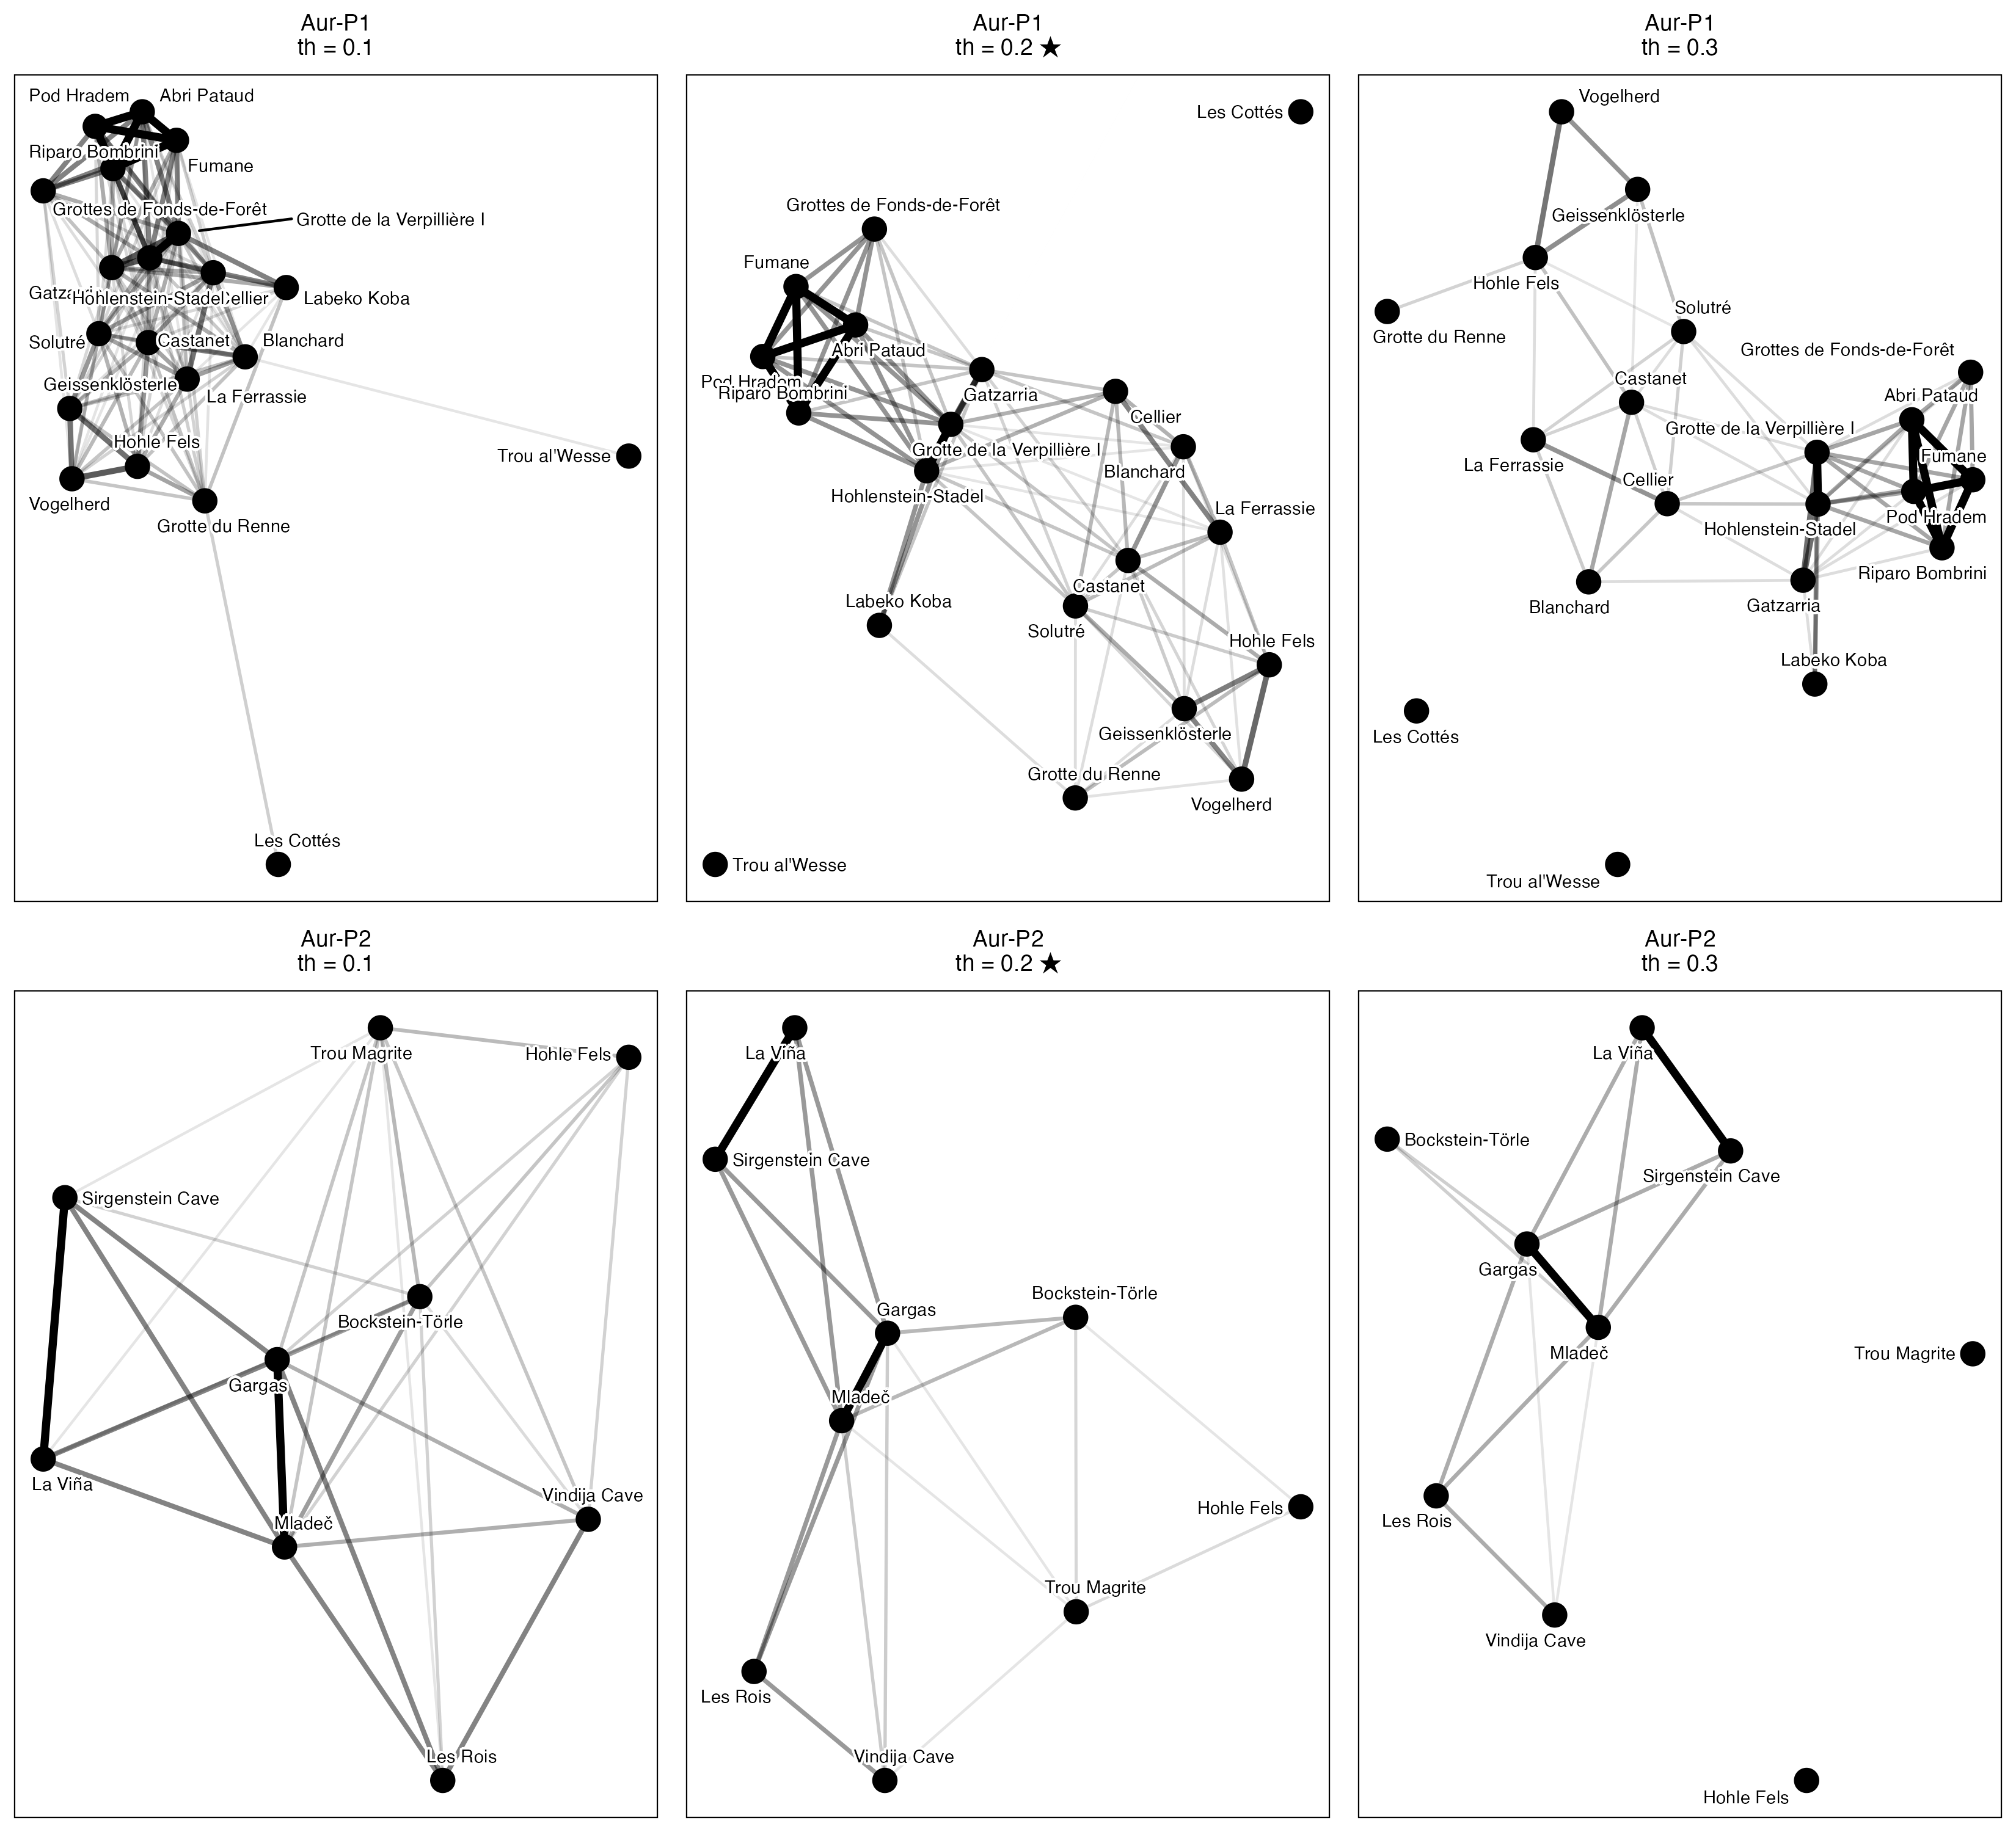
Figure S 1: Site networks for Aur-P1 (top row) and Aur-P2 (bottom row) at Jaccard similarity thresholds of 0.1 (left column), 0.2 (centre; main-text value, marked ★), and 0.3 (right column). Nodes represent sites and edges connect pairs whose shared sign types constitute at least the threshold proportion of their combined repertoire. Edge thickness reflects similarity strength.

S1.2.2.3 Threshold agreement metrics
Below we quantify the stability of the network structures across thresholds using two metrics:
- Edge-set Jaccard similarity between each pair of thresholds: the number of edges present at both thresholds divided by the number present at either threshold. A value near 1 indicates the edge structure is preserved as you move from one threshold to another.
- Adjacency-matrix correlation between each pair of thresholds: the Pearson correlation between the vectorised upper triangles of the two adjacency matrices. This is a continuous measure of how similar the full set of pairwise similarity scores is before any cutoff is applied.
Phase | Threshold 1 | Threshold 2 | Edge Jaccard | Adj. correlation
Aur-P1 | 0.1 | 0.2 | 0.600 | 0.961
Aur-P2 | 0.1 | 0.2 | 0.655 | 0.959
Aur-P1 | 0.2 | 0.3 | 0.747 | 0.956
Aur-P2 | 0.2 | 0.3 | 0.684 | 0.938
Aur-P1 | 0.1 | 0.3 | 0.448 | 0.932
Aur-P2 | 0.1 | 0.3 | 0.448 | 0.928
Table S 3: Pairwise agreement between networks at adjacent thresholds. Edge‑set Jaccard measures the fraction of edges present at both thresholds out of all edges present at either threshold. Adjacency‑matrix correlation is the Pearson r between the vectorised upper‑triangular elements of the adjacency matrices at each threshold (all pairs of sites before the cutoff is applied).

S1.2.2.4 Continuous threshold sweep
The main text reports statistics at three discrete thresholds (0.1, 0.2, 0.3). This section sweeps the Jaccard similarity threshold from 0.05 to 0.50 in steps of 0.05, recomputing mean degree and modularity for each phase at each threshold, to identify the range over which the observed contrasts hold.
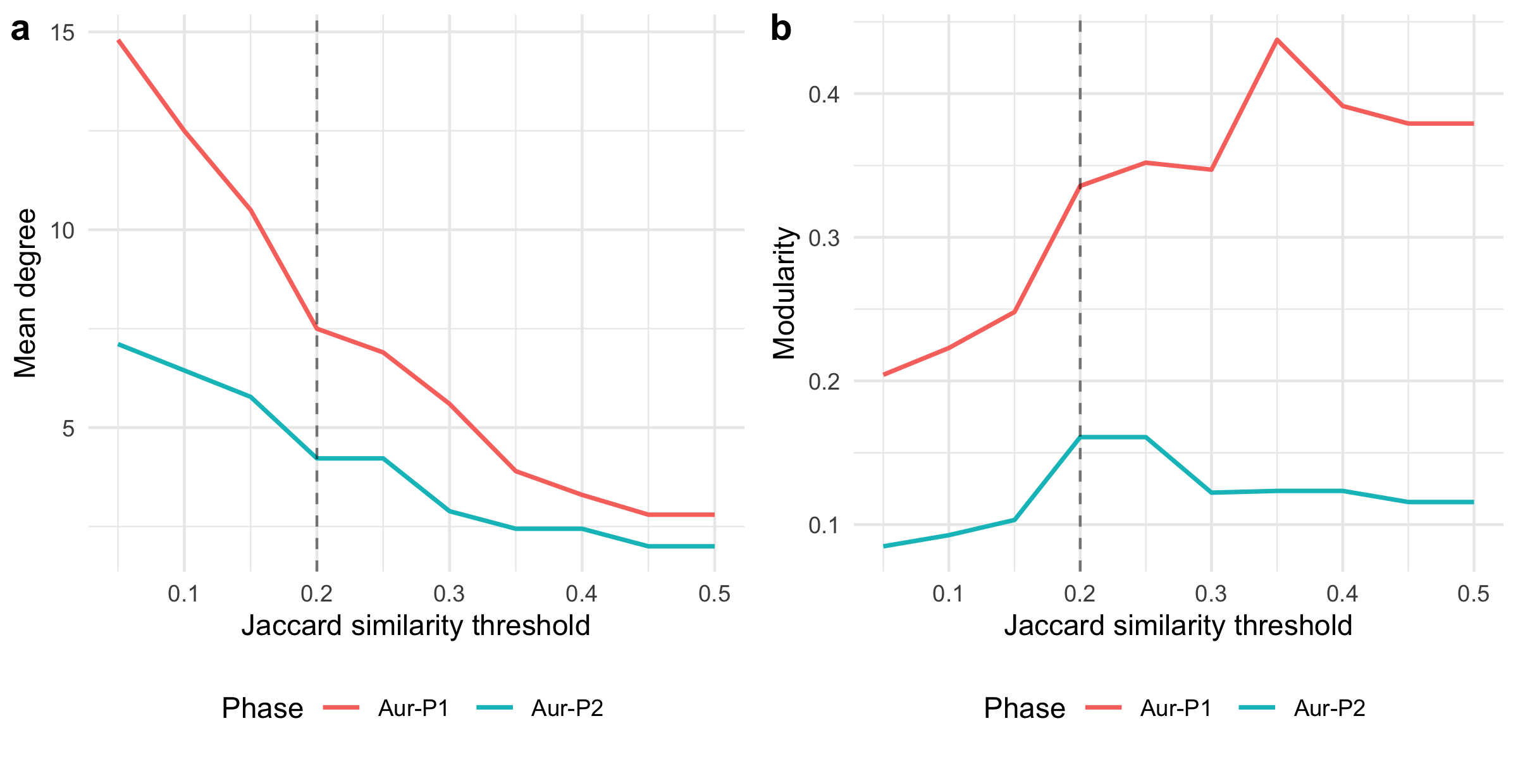
Figure S 2: Mean degree (left) and modularity (right) for each Aurignacian phase across a continuous range of Jaccard similarity thresholds. The vertical dashed line marks the baseline threshold of 0.2.
The sweep reveals the threshold range over which the Aur-P1 > Aur-P2 mean-degree ordering holds. The two-phase contrast is monotonic and holds at every threshold in the swept range: Aur-P1’s mean degree runs from 2.80–14.80 and Aur-P2’s from 2.00–7.11 across thresholds of 0.05–0.50, and the ordering is preserved throughout. At very low thresholds both networks are densely connected and the relative contrast compresses; at high thresholds both fragment as edges drop out, but Aur-P2 retains a mean degree of at least 2.00 even at the coarsest threshold (0.50), so the contrast never collapses. The full sweep result is answered in Interpretation below (Figure S 2).

S1.2.3 Interpretation
Question: do the phase contrasts hold at the alternative thresholds of 0.1 and 0.3? Yes. In both phases and at all three thresholds, the networks retain a recognisable two-cluster structure corresponding to the restricted-range and broader-range site groups identified by seriation. Broader-range sites keep denser mutual connections, while restricted-range sites stay peripheral or isolated. Aur-P1 is consistently the more edge-rich network with the higher raw mean degree and clearer hub structure, while Aur-P2 is sparser and more fragmented (Table S 2). Modularity in Aur-P1 remains in a moderate range across thresholds, indicating persistent community structure.
Question: is the 0.2 threshold a defensible middle ground between over-connection and fragmentation? Yes. At threshold 0.1, graph density increases substantially and several sites that appear as isolates at 0.2 become connected, reflecting genuine weak cultural overlap or noise in the presence/absence data. At threshold 0.3, the graph becomes considerably sparser, with 2 isolates in Aur-P1 in particular. The number of isolated nodes increases monotonically with threshold in both phases, as expected. The 0.2 threshold preserves the major structural contrasts while avoiding both the over-connection artefacts of the 0.1 threshold and the excessive fragmentation of the 0.3 threshold.
Question: how much of the edge structure is preserved when the threshold moves? Most of it. Edge-set Jaccard between 0.1 and 0.2 is 0.6 for Aur-P1 and 0.655 (Table S 3). Moving the threshold changes density more than structure.
Question: over what continuous threshold range does the Aur-P1 greater than Aur-P2 ordering hold? From 0.05 to 0.50. Aur-P1’s mean degree runs from 2.80–14.80 and Aur-P2’s from 2.00–7.11 across the swept range, and the ordering is preserved throughout (0.05–0.50) (Figure S 2). Aur-P2 retains a mean degree of at least 2.00 even at the coarsest threshold (0.50), so the contrast never collapses. Modularity shows the same ordering: Aur-P1 ranges from 0.204–0.437 and consistently exceeds Aur-P2 (0.085–0.161) at every threshold. However, as shown in Section S1.7.6, this raw mean-degree contrast reflects the larger site sample in Aur-P1 rather than higher intrinsic connectivity.
Implication for the main text. The threshold of 0.2 used in the main analysis is a defensible and representative choice, not a cherry-picked value. Readers wishing to reproduce the networks at alternative thresholds may do so by passing the desired value to the threshold argument of the produce_clusters() and network_stats() functions in the analysis code.

S1.3 Similarity Metric Choice (Jaccard vs. Sørensen-Dice vs. Simpson)

S1.3.1 Rationale
In presence/absence assemblage data, different similarity formulations weight joint presences and richness differences (assemblage sample size) differently: - Jaccard Similarity: $J/\left(A+B−J\right)$, where $J$ is shared sign types and $A,B$ are site sign counts. - Sørensen-Dice Similarity: $2J/\left(A+B\right)$, which places double weight on shared presences. - Simpson Similarity: $J/min\left(A,B\right)$, which evaluates shared overlap relative to the smaller assemblage, rendering it insensitive to differences in sample size / richness between sites.
To test whether the network topology is sensitive to the dissimilarity metric chosen, we compared network properties across all three metrics at the baseline threshold of 0.2. It answers three specific questions:
Question: does the Aur-P1 greater than Aur-P2 phase contrast hold under all three metrics?
Question: does double-weighting shared presences under Sorensen-Dice change community structure relative to Jaccard?
Question: does the Aur-P1 connectivity advantage survive under Simpson similarity, which controls for richness asymmetry?

S1.3.2 Analysis
Phase | Metric | Edges | Density | Isolates | Mean degree | Transitivity | Modularity | Communities
Aur-P1 | jaccard | 75 | 0.395 | 2 | 7.50 | 0.711 | 0.336 | 4
Aur-P2 | jaccard | 19 | 0.528 | 0 | 4.22 | 0.608 | 0.161 | 3
Aur-P1 | sorensen | 113 | 0.595 | 1 | 11.30 | 0.798 | 0.199 | 3
Aur-P2 | sorensen | 29 | 0.806 | 0 | 6.44 | 0.826 | 0.058 | 2
Aur-P1 | simpson | 148 | 0.779 | 0 | 14.80 | 0.921 | 0.030 | 3
Aur-P2 | simpson | 32 | 0.889 | 0 | 7.11 | 0.900 | 0.024 | 2
Table S 4: Network statistics for each Aurignacian phase across three similarity metrics (Jaccard, Sørensen-Dice, Simpson) at threshold = 0.2.
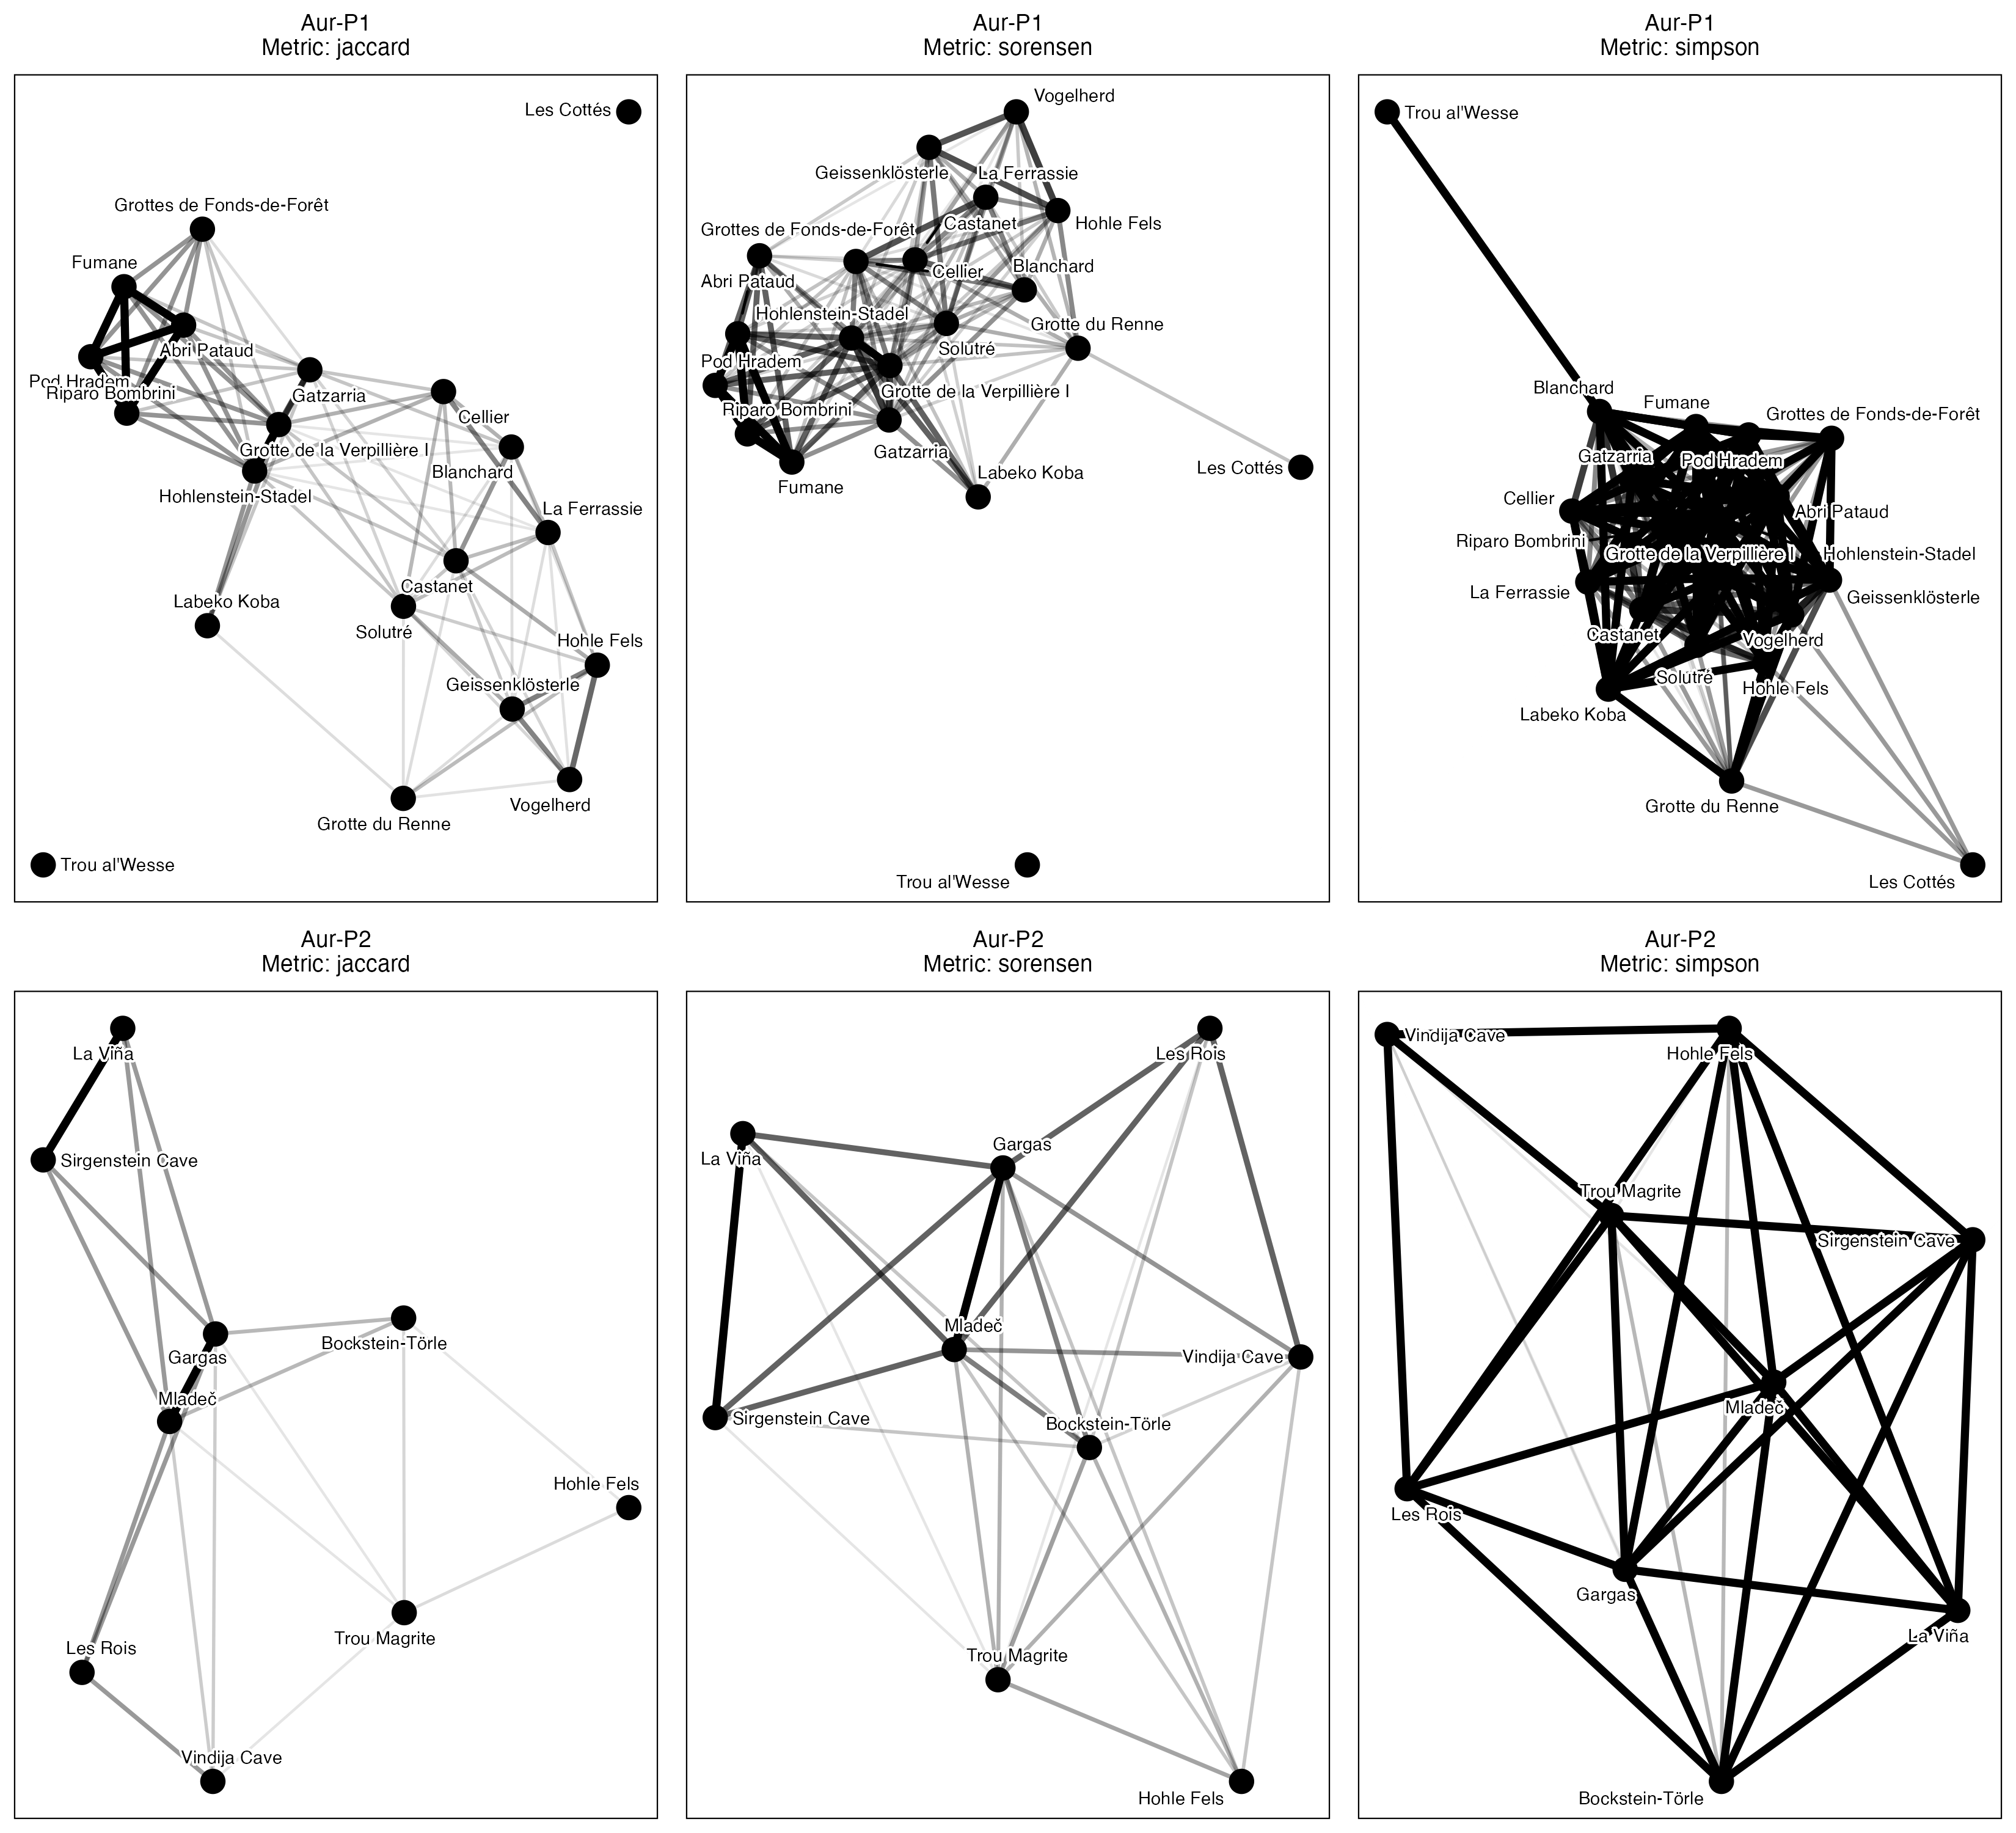
Figure S 3: Site networks for Aur-P1 (top) and Aur-P2 (bottom) under Jaccard (left), Sørensen-Dice (centre), and Simpson (right) similarity metrics at threshold = 0.2.

S1.3.2.1 Ordination biplots with PCoA and CA
PCoA uses the same Jaccard dissimilarity as the Mantel tests. CA uses the presence absence matrix directly. Both plots colour sites by the manual restricted broad groups. The two methods show the same gradient side by side.
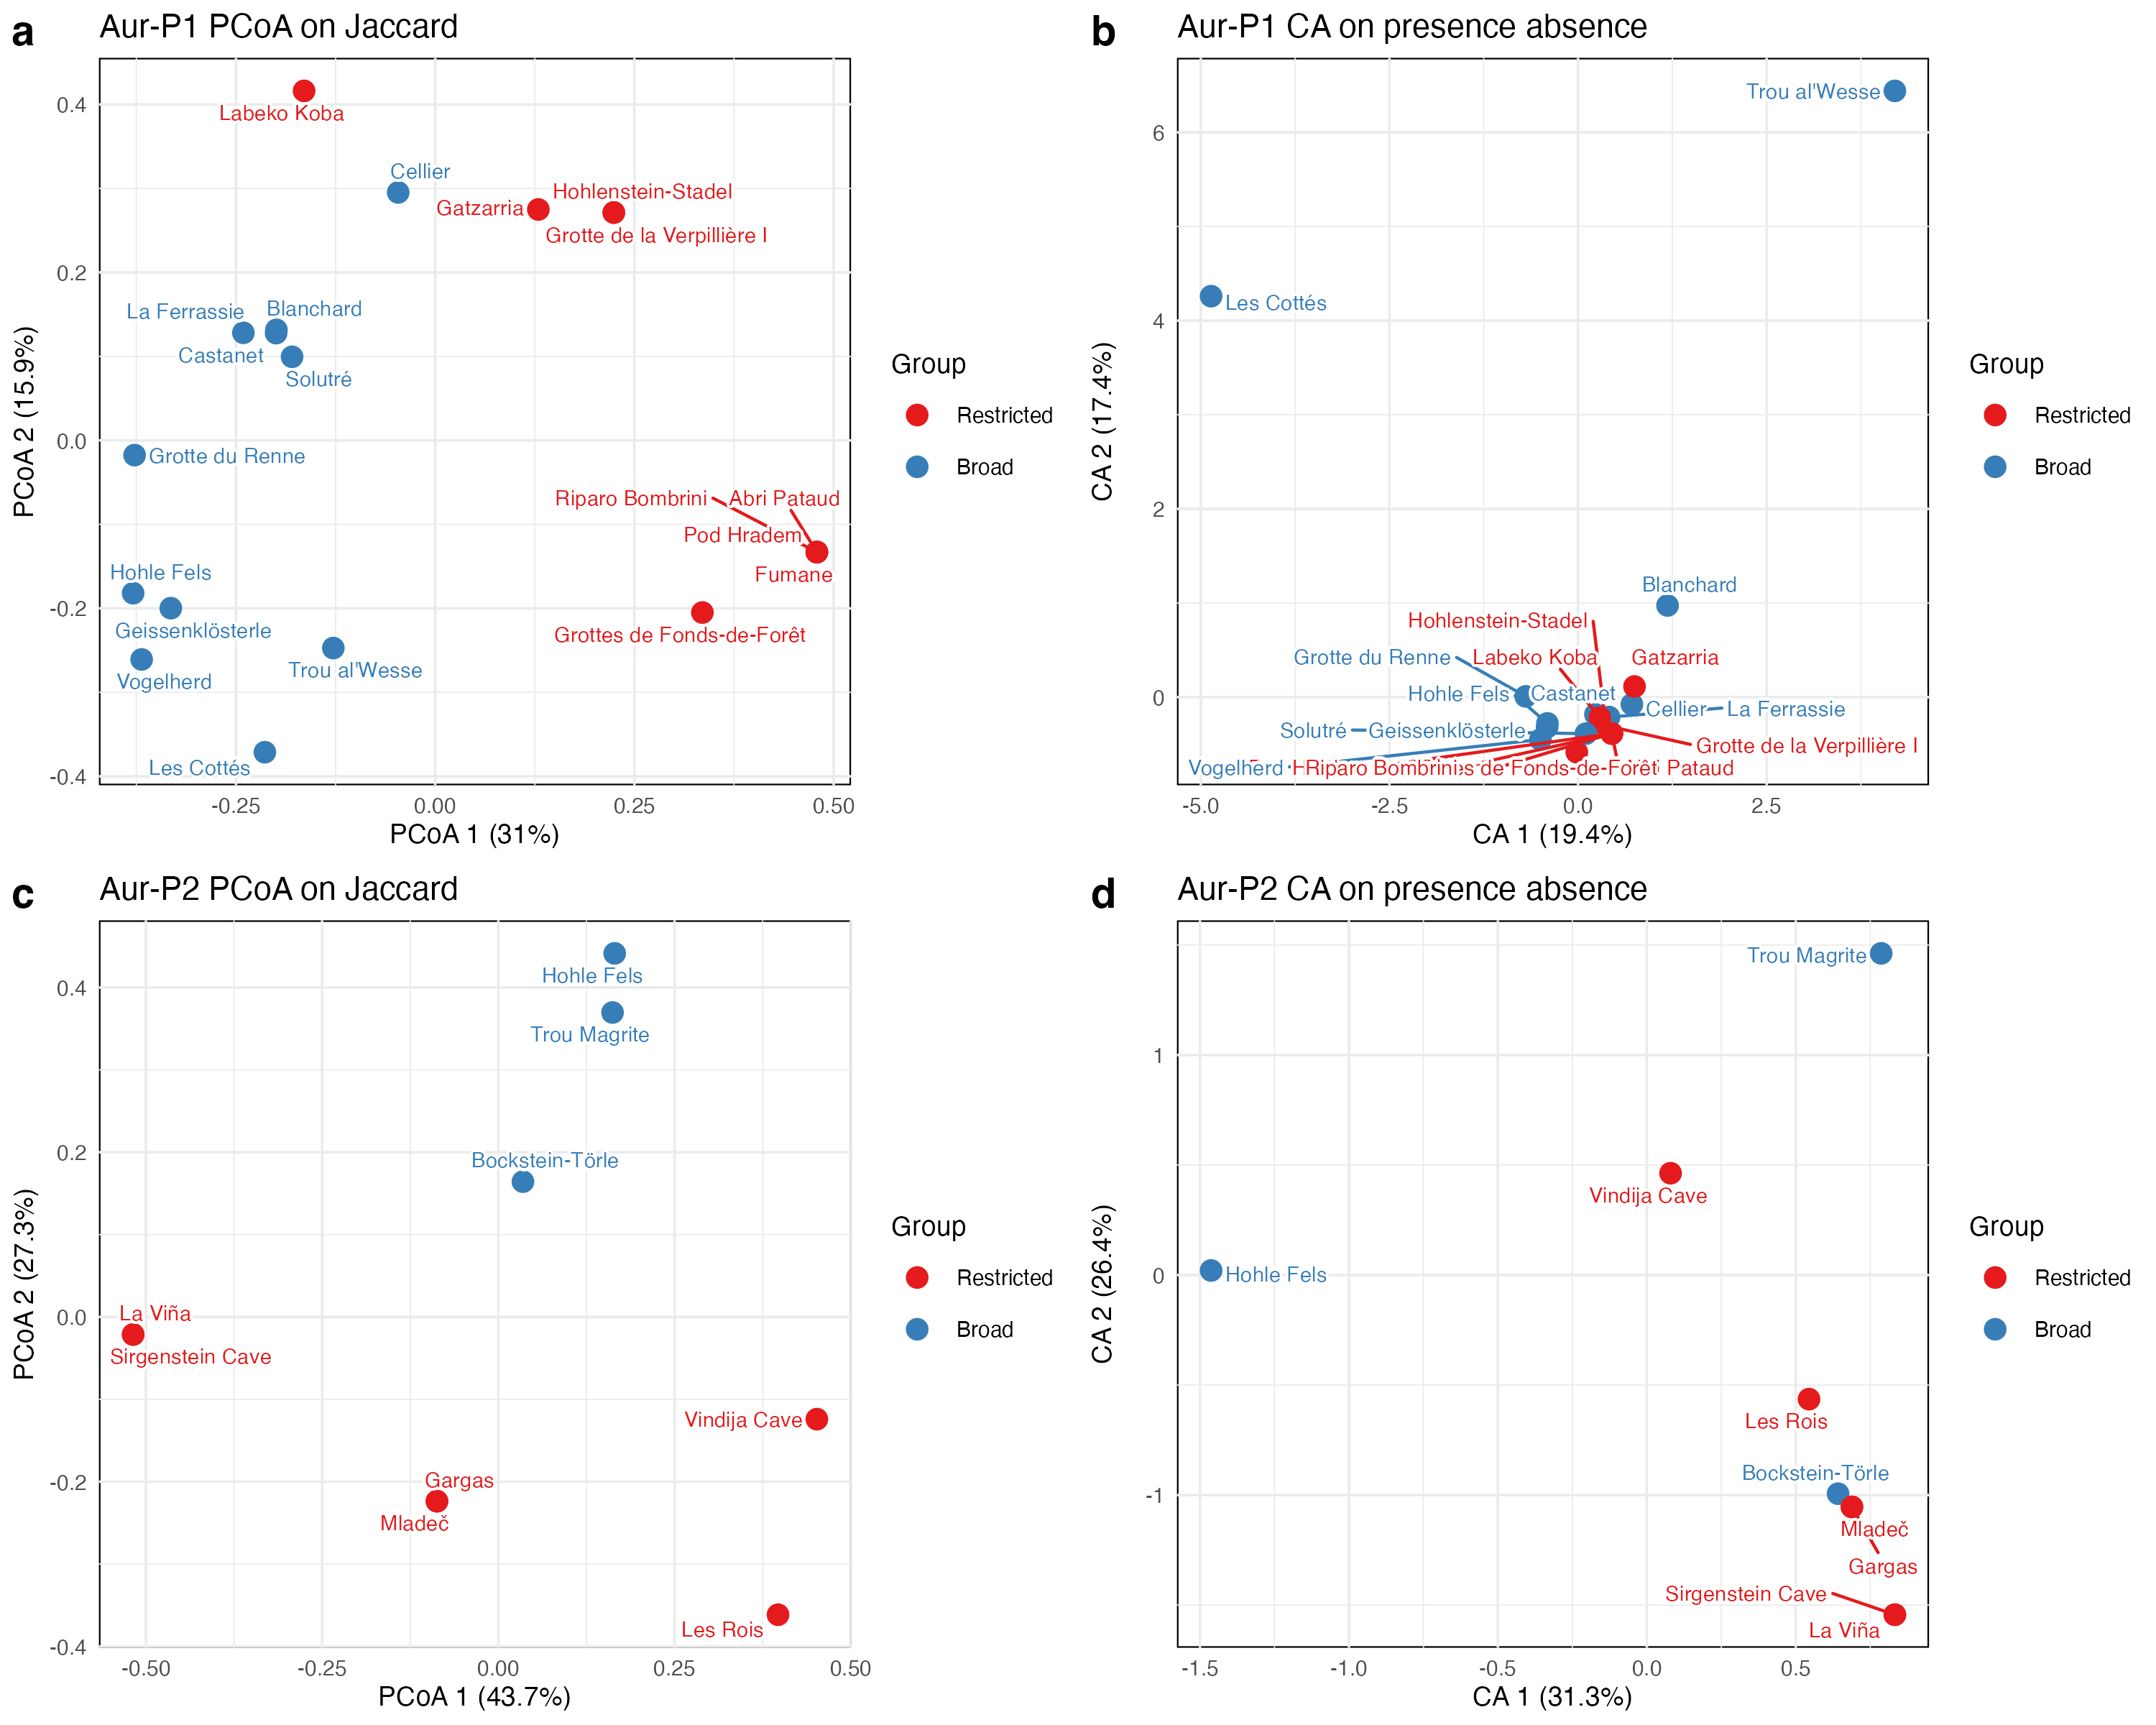
Figure S 4: PCoA on Jaccard dissimilarity (left column) and CA on presence absence (right column) for Aur-P1 (top row) and Aur-P2 (bottom row). Points are sites coloured by manual group with restricted in red and broad in blue. Labels name sites with high leverage only when space allows.

S1.3.3 Interpretation
Question: does the Aur-P1 greater than Aur-P2 phase contrast hold under all three metrics? Yes. Aur-P1 consistently produces the higher edge count and node degree across Jaccard, Sorensen-Dice, and Simpson, while Aur-P2 is sparser, consistent with its smaller sample (Table S 4; Figure S 3).
Question: does double-weighting shared presences under Sorensen-Dice change community structure relative to Jaccard? No. Sorensen similarity yields higher edge counts (for example Aur-P1 113 versus 75 for Jaccard) because double-weighting shared presences elevates similarity scores above the 0.2 threshold. Network community structures and hub locations remain identical.
Question: does the Aur-P1 connectivity advantage survive under Simpson similarity, which controls for richness asymmetry? Yes. Simpson similarity shows that the Aur-P1 connectivity is driven by genuine shared sign repertoires rather than sample-size asymmetry.
Question: do ordinations show discrete clusters or a continuous gradient? The PCoA and CA biplots show a continuous gradient with two single site outliers. In Figure S 4 the restricted sites in red and the broad sites in blue fall along one slope in Aur-P1 and in Aur-P2. PCoA axis 1 carries 31% of variance in Aur-P1 and 43.7% in Aur-P2. CA axis 1 carries 19.4% in Aur-P1 and 31.3% in Aur-P2. The main cloud shows no split into two groups. In Aur-P1 CA two broad sites stand apart, namely Les Cottés and Trou al’Wesse, because each carries a rare sign type. The visual matches the Simpson turnover result with no group separation.
Question: does PCoA1 track richness, geography, or both? The PCoA axis 1 captures the primary gradient in sign-type composition. To evaluate whether this gradient reflects richness, geographic position, or both, a multiple regression fits PCoA1 against richness and both geographic coordinates. Partial t-tests show whether PCoA1 tracks richness after controlling for geography and vice versa.
Table S 5: Multiple regression of PCoA axis 1 on sign-type richness and geographic coordinates. Partial t-tests show whether PCoA1 tracks richness after controlling for geography and vice versa. Bold p-values indicate significance.
Phase | n | R² adj | Richness coef | Richness p | Longitude coef | Longitude p | Latitude coef | Latitude p
Aur-P1 | 20 | 0.644 | -0.051 | < 0.001 | 0.040 | 0.003 | -0.049 | 0.061
Aur-P2 | 9 | -0.214 | 0.049 | 0.376 | 0.024 | 0.388 | -0.059 | 0.523

Answer: richness is the dominant predictor (R² adj = 0.644, p = < 0.001), but longitude contributes a significant independent signal (p = 0.003, partial ρ = 0.652) — eastern sites carry a distinct sign-type composition beyond what richness predicts. Latitude does not contribute significantly (p = 0.061). For Aur-P2 the sample (9 sites) is too small to resolve any predictor (R² adj = -0.214).
Implication for the main text. The three-metric network comparison shows that the Aur-P1 > Aur-P2 connectivity contrast is robust to how shared presences and richness differences are weighted: Jaccard, Sørensen-Dice, and Simpson similarity all produce the same phase ordering and qualitatively identical community structures (Table S 4; Figure S 3). However, the Simpson similarity contrast is driven by nestedness (rich sites sharing more with poor sites by virtue of repertoire size), not by compositional turnover (Section S1.10.3). This means the persistence under Simpson reflects repertoire-size asymmetry rather than discrete compositional differences — the contrast survives the metric change, but the mechanism is richness-related, consistent with the PCoA1 regression showing richness as the dominant gradient driver.
The PCoA and CA ordination biplots reinforce this by showing that site relationships form a continuous gradient rather than discrete clusters (Figure S 4), matching the Simpson turnover result of no group separation. Together these results mean: (1) the main-text network conclusions are not an artefact of the Jaccard formulation; (2) the continuous gradient structure matches the Simpson turnover finding; and (3) geographic position (east–west) has a secondary effect on sign-type composition, but richness dominates the primary axis of variation. The main-text claim that richness effects are the principal driver is supported, while the claim that geography is only weakly relevant should be qualified: longitude is statistically significant but subordinate to richness.

S1.4 Geographic Distance Verification (Mantel Tests)

S1.4.1 Rationale
Mantel tests in the main text find no geographic signal, but a flat Euclidean distance and a single global correlation can each hide structure. This section checks the result in three ways: geodesic distance in kilometres, scale-dependent correlograms with uncertainty on the global R, and a non-Mantel trend-surface model. Each check below states its questions in Rationale and answers them in Interpretation.

S1.4.2 Geodesic distance comparison

S1.4.2.1 Rationale
In the main text, Mantel tests evaluate whether sign assemblage dissimilarity correlates with spatial distance. Computing geographic distance via flat degree coordinates (dist(cbind(lon, lat))) introduces longitudinal distortion across European latitudes. Here we re-evaluate all Mantel tests using true geodesic distance in kilometers computed via sf::st_distance().
Question: does the non-significant Mantel result hold when distance is measured as true geodesic kilometres rather than flat Euclidean coordinates?
Phase | Euclidean R | Euclidean p | Geodesic R (km) | Geodesic p (km)
Aur-P1 | 0.026 | 0.371 | 0.046 | 0.301
Aur-P2 | -0.294 | 0.965 | -0.299 | 0.967
Table S 6: Comparison of Mantel test results (Mantel R and p-value) evaluating sign assemblage dissimilarity vs. spatial distance using flat coordinate Euclidean distance vs. true Geodesic distance (in kilometers).

S1.4.2.2 Interpretation
Question: does the non-significant Mantel result hold when distance is measured as true geodesic kilometres rather than flat Euclidean coordinates? Yes. The geodesic distance calculation provides an important clarification: - In Aur-P1 ($R$ = 0.046, p = 0.301), geographic distance remains uncorrelated with sign assemblage dissimilarity under both metrics. - In Aur-P2 ($R$ = -0.299, p = 0.967), the same non-significant result holds under both metrics.
Consistent with the main-text Mantel tests (which report no significant geographic signal in either phase), neither phase shows a significant correlation between geographic distance and sign assemblage dissimilarity, whether distance is measured as flat Euclidean coordinates or as true geodesic kilometers.
Implication for the main text. The main-text use of flat coordinates does not create the null result; geodesic kilometres give the same non-significant outcome in both phases.

S1.4.3 Mantel correlogram

Rationale
The Mantel tests reported in the main text and in Section S1.4 evaluate a single global null hypothesis: that geometric-sign dissimilarity is uncorrelated with geographic distance across all site pairs simultaneously. A non-significant global result can conceal scale-dependent structure — for example, sign sharing might be geographically clustered at short distances but random at long distances, producing a net correlation near zero. Because the global test cannot distinguish “no spatial structure at any scale” from “positive and negative structure that cancel,” we ask two specific questions:
Question: does sign dissimilarity show spatial autocorrelation at a specific distance lag? A Mantel correlogram partitions site pairs by geographic-distance bin and tests the Mantel correlation within each bin; a significant positive r at one or more lags would reveal scale-dependent structure that the global test misses.
Question: how uncertain is the global Mantel R estimate, and what does that imply about statistical power? We place a bootstrap 95% confidence interval on the single global Mantel R reported for each phase. A wide interval that overlaps zero indicates the test cannot distinguish a true null from a true moderate correlation, so the non-significant result is a lack of evidence rather than evidence of absence.

Analysis
We reconstruct, for each phase, the Jaccard sign dissimilarity and the geodesic geographic-distance matrix used by the Section S1.4 Mantel tests (the same construction as run_mantel_comp, applied to the technology-assigned phase data). The Mantel correlogram is computed with ecodist::mgram [1], which bins pairs by geographic distance — into 5 equiprobable lags for Aur-P1 and 3 for Aur-P2, to keep pair counts per lag stable given the small samples — and returns the Mantel r, a permutation p-value, and 95% bootstrap confidence limits (llim/ulim) for each lag. For the global statistic we resample objects within each site with replacement, B equals 1000, rebuild the site presence matrix, recompute Mantel R, and take the 2.5 percent and 97.5 percent quantiles as the bootstrap interval. We do not resample sites with replacement because duplicate sites create distance 0 and dissimilarity 0 pairs.
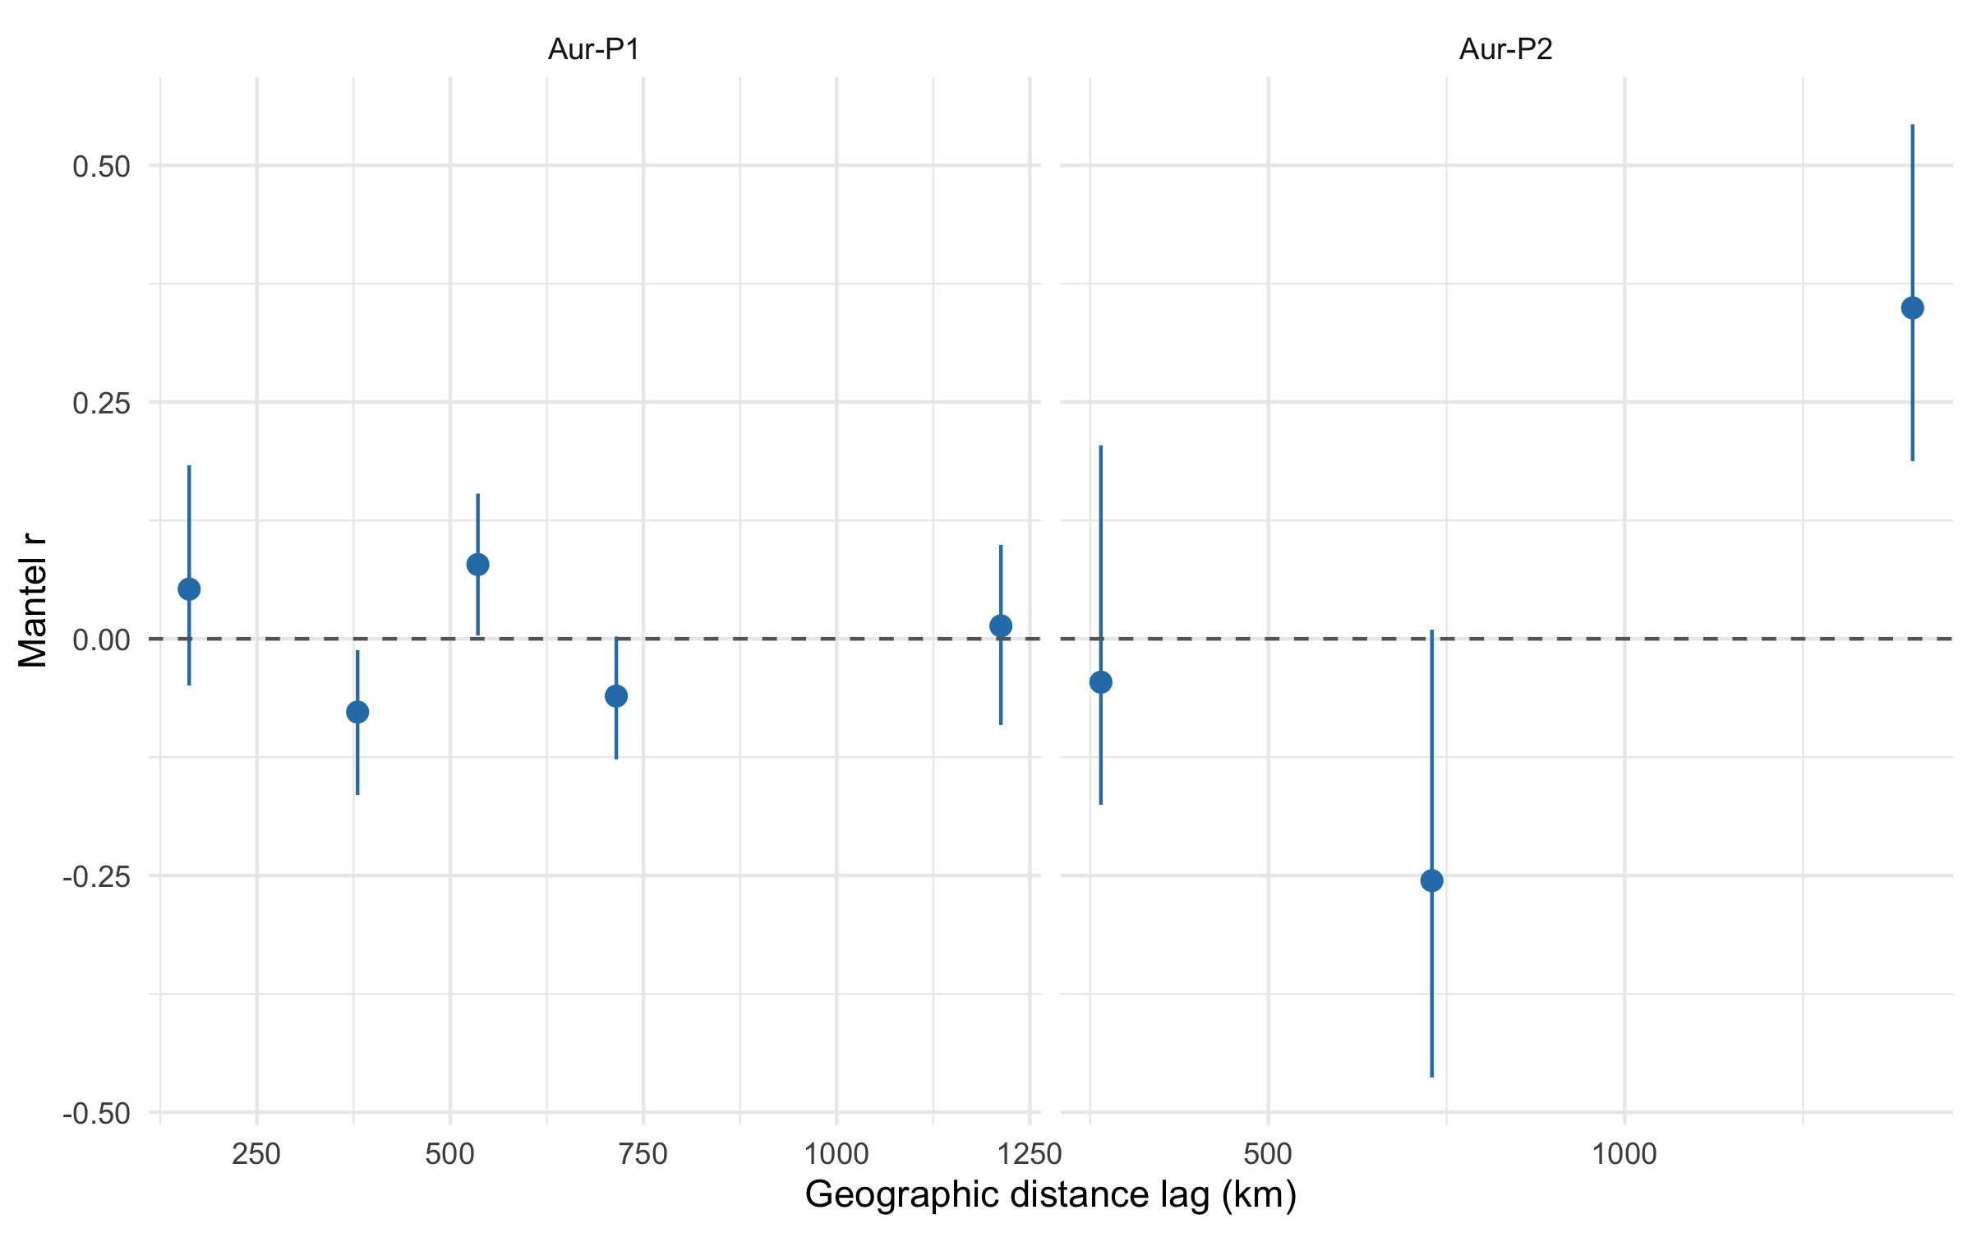
Figure S 5: Mantel correlogram of geometric-sign dissimilarity against geographic distance, by phase. Points are the Mantel r within each distance lag; error bars are 95% bootstrap confidence intervals (ecodist::mgram, llim/ulim). The dashed line is r = 0. No lag reaches significance, and all intervals straddle zero.

Interpretation
Question: does sign dissimilarity show spatial autocorrelation at a specific distance lag? No. In Aur-P1 the 5 distance lags yield Mantel r values from -0.077 to 0.078, none significant (smallest p = 0.318); in Aur-P2 the 3 lags range from -0.255 to 0.349, also none significant (smallest p = 0.048). Every lag’s 95% bootstrap interval straddles or lies close to zero: the most extreme bounds across lags are -0.165 and 0.183 for Aur-P1 and -0.463 and 0.543 for Aur-P2, both comfortably including zero. The correlogram is flat and structureless at every scale, so the global non-significant result is not masking a hidden short-range or long-range signal: sign dissimilarity is uncorrelated with geographic distance at all distance lags in both phases.
Question: how uncertain is the global Mantel R estimate, and what does that imply about statistical power? The global Mantel R is 0.046 (p = 0.300) for Aur-P1 and -0.299 (p = 0.935) for Aur-P2, matching the Section S1.4 geodesic results. The 95% interval from object-within-site bootstrap is [-0.022, 0.086] for Aur-P1 (spans zero; observed 0.046) and [-0.355, -0.231] for Aur-P2 (narrowly negative, does not span zero; observed -0.299); permutation p = 0.935 shows no isolation-by-distance, and the bootstrap shows the negative estimate is stable to object resampling rather than underpowered in the same sense as Aur-P1. The Aur-P2 bootstrap CI excluding zero suggests a stable negative correlation under object resampling, while the permutation p = 0.935 remains non-significant — this discrepancy reflects the low power of the permutation test with only 9 sites (36 pairs). Site-with-replacement bootstrap was not used because it creates duplicate sites with distance 0 and dissimilarity 0. Because the Aur-P2 analysis rests on only 9 sites (36 site pairs) and Aur-P1 on 20 sites (190 pairs), the Aur-P1 test has low power: a true moderate geographic correlation (|r| ≈ 0.3–0.4) would fall inside the Aur-P1 sampling noise and could not be excluded. The non-significant Mantel results are therefore a lack of evidence for geographic structure, not evidence that it is absent, and they provide no support for any alternative cultural process, consistent with Section S1.8.2.
Implication for the main text. No distance lag carries a geographic signal, and the global null reflects low power rather than proof of absence.

S1.4.4 Distance-based redundancy analysis

Rationale
All spatial tests above belong to the Mantel family: they correlate pairs of distance matrices, whose pairwise entries are non-independent by construction. Distance-based redundancy analysis [dbRDA, 2] instead fits an explanatory model of the site composition matrix on geographic predictors, with an R² and a permutation p-value, so a null here is convergent evidence from different machinery rather than a re-run of the same correlation. We model the site Jaccard dissimilarity matrix (same construction as the Mantel tests) on a linear geographic trend surface (longitude + latitude). The 2-df specification is identical in both phases so Aur-P2 (9 sites, 6 residual df) remains estimable.
Question: does geography explain sign composition under a non-Mantel trend-surface model?
Phase | dbRDA R2 | dbRDA adjR2 | dbRDA F | dbRDA p
Aur-P1 | 0.156 | 0.057 | 1.573 | 0.038
Aur-P2 | 0.191 | -0.078 | 0.709 | 0.850
Table S 7: Distance-based redundancy analysis of site Jaccard dissimilarity on a linear geographic trend surface (longitude + latitude), per phase. R² is the raw constrained proportion, adjR² the Ezekiel-adjusted value, F and p from 999 permutations.

Interpretation
Question: does geography explain sign composition under a non-Mantel trend-surface model? Only faintly, and only in Aur-P1. The linear trend is nominally significant in Aur-P1 (R² = 0.156, adjusted R² = 0.057, p = 0.038) but explains about six percent of the adjusted variation: a weak gradient the global Mantel correlation misses, not discrete geographic groups. In Aur-P2 there is no signal (R² = 0.191, adjusted R² = -0.078, p = 0.85). Note the Aur-P2 raw R² exceeds Aur-P1’s while its adjusted R² is negative: with 9 sites and 2 predictors the raw value is overfit, which is why the adjusted figure governs the reading. Both phases remain low-power, so as with the Mantel results these are convergent nulls reflecting limited samples, not evidence that geography is irrelevant.
Implication for the main text. Geography adds no discrete regional explanation; the weak Aur-P1 gradient does not alter the non-significant Mantel reading.

S1.5 Periodisation Scheme Sensitivity

S1.5.1 Rationale
The main analysis adopts the two-phase Aur-P1/Aur-P2 framework of [3], which merges the Proto- and Early Aurignacian into a single early phase (Aur-P1, 43–37 ka BP) and treats the Evolved/Late Aurignacian as a single late phase (Aur-P2, 37–32 ka BP), with site membership assigned on technological grounds (Section S1.5.5). Because this scheme is coarser than the classic three-phase periodisation of Western European archaeology, this section tests whether the two-phase results are robust to how the sequence is subdivided. Four checks follow: decomposition into technology-assigned components and a four-phase split (Section S1.5.2), date-variant calibration (Section S1.5.3), phase-boundary shifts (Section S1.5.4), and technological versus date-based assignment (Section S1.5.5). All schemes are evaluated at the main-text threshold of 0.2 using Jaccard similarity.

S1.5.2 Two-, three- and four-phase decomposition

Rationale
We decompose the two-phase baseline into its technology-assigned components, the relict Proto-Aurignacian, the Early Aurignacian, and the Evolved Aurignacian (Aur-P2), and additionally split the Evolved Aurignacian into Evolved and Late sub-phases following the four-phase taxonomy of [4], with the Evolved–Late boundary at 35 ka BP calibrated. It answers three specific questions:
Question: which technology-assigned component carries the Aur-P1 connectivity advantage?
Question: does the early versus late contrast persist without merging Proto and Early?
Question: does splitting Aur-P2 into Evolved and Late sub-phases reveal internal differentiation or only data limitation?
Phase | Sites | Edges | Density | Mean degree | Transitivity | Modularity
Aur-P1 (Proto + Early) | 20 | 75 | 0.395 | 7.50 | 0.711 | 0.336
Aur-P2 (Evolved) | 9 | 19 | 0.528 | 4.22 | 0.608 | 0.161
Table S 8: Reference: network statistics under the two-phase periodisation used in the main text (threshold = 0.2). Aur-P1 = Proto + Early; Aur-P2 = Evolved.

Phase | Sites | Edges | Density | Mean degree | Transitivity | Modularity
Proto-Aurignacian (Aur-P1) | 7 | 9 | 0.429 | 2.57 | 0.714 | 0.108
Early Aurignacian (Aur-P1) | 13 | 35 | 0.449 | 5.38 | 0.781 | 0.307
Evolved Aurignacian (Aur-P2) | 9 | 19 | 0.528 | 4.22 | 0.608 | 0.161
Table S 9: Network statistics for the technology-assigned components of the two-phase baseline (Proto-Aurignacian, Early Aurignacian, Evolved Aurignacian) at threshold = 0.2. Aur-P1 = Proto + Early; Aur-P2 = Evolved.

S1.5.2.1 Interpretation
The two-phase, three-phase, and four-phase periodisations yield consistent conclusions about the broad structure of Aurignacian social connectivity, while clarifying which components carry the two-phase results.
Question: which technology-assigned component carries the Aur-P1 connectivity advantage? The Early component. Decomposing the two-phase baseline into its technology-assigned components shows that the Early Aurignacian (mean degree = 5.38, 35 edges across 13 sites) is the most connected component, exceeding even Aur-P2 (4.22, 19 edges). The relict Proto-Aurignacian , the component that survives after technology-based reassignment moved the well-sampled Swabian and Périgord sites to the Early Aurignacian (Section S1.5.5) , is the least connected of the three (mean degree 2.57 across 7 sites and 9 edges). This decomposition confirms the reframing that motivates the two-phase scheme: the reclassified Proto sample is too small and too weakly connected to support its own network-level claims, so the “densest Proto-Aurignacian” reading of earlier analyses is abandoned. The merged Aur-P1 mean degree (7.50) is driven by the Early component, not by a spurious average of two strong phases.
Question: does the early versus late contrast persist without merging Proto and Early? Yes. Even without the Proto component, the Early Aurignacian alone (mean degree 5.38) exceeds Aur-P2 (4.22), so the two-phase Aur-P1 > Aur-P2 result does not depend on the Proto/Early boundary being drawn one way or the other. The connectivity gap between the early and late Aurignacian persists whether the early sequence is analysed as a single phase or as its separate Proto and Early components.
Question: does splitting Aur-P2 into Evolved and Late sub-phases reveal internal differentiation or only data limitation? Only data limitation can be shown; the split is addressed with Table S 10 below. Community structure is consistent with the two-phase scheme. Modularity is highest in the Early component (0.307), moderate in the Evolved (0.161), and weakest in the relict Proto (0.108). This mirrors the two-phase result in which Aur-P1’s community structure is better developed than Aur-P2’s (Section S1.5.1), and it indicates that the modularity of the merged early phase is not an artefact of the particular boundary chosen.
Phase | Sites | Edges | Density | Mean degree | Transitivity | Modularity
Proto-Aurignacian (Aur-P1) | 7 | 9 | 0.429 | 2.57 | 0.714 | 0.108
Early Aurignacian (Aur-P1) | 13 | 35 | 0.449 | 5.38 | 0.781 | 0.307
Evolved Aurignacian (37.8-35 ka BP) | 7 | 13 | 0.619 | 3.71 | 0.659 | 0.128
Late Aurignacian (35-32 ka BP) | 2 | 0 | 0.000 | 0.00 | NaN | NaN
Table S 10: Network statistics under the four-phase periodisation (Proto, Early, Evolved, Late Aurignacian) at threshold = 0.2. The Evolved/Late split of Aur-P2 follows the four-phase Aurignacian taxonomy of [4], with the boundary at 35 ka BP calibrated.
Question: does splitting Aur-P2 into Evolved and Late sub-phases reveal internal differentiation or only data limitation? (four-phase detail). The four-phase Aurignacian taxonomy of [4] distinguishes Proto, Early (Aurignacian I), Evolved (Aurignacian II), and Late (Aurignacian III-IV) phases. The Early–Evolved transition has been dated to 37.0–36.5 ka BP, and the Late Aurignacian is associated with the terminal phase of the technocomplex before the onset of the Gravettian. Splitting the Evolved Aurignacian (Aur-P2) at 35 ka BP into Evolved and Late sub-phases tests whether Aur-P2’s connectivity is internally differentiated. The Evolved Aurignacian (37.8–35 ka BP) retains moderate connectivity with 13 edges and a mean degree of 3.71 across 7 sites, while the Late Aurignacian (35–32 ka BP) is severely data-limited: with only 2 sites and no edges at threshold 0.2, its network statistics (mean degree 0, modularity undefined) are unreliable. The near-absence of connectivity in the Late Aurignacian is consistent with the weaker, less resolved structure of Aur-P2 reported in the main text, but the sample is too small to determine whether the Evolved–Late transition represents a step-down or a continuation of an already low level. The two-phase scheme remains the most informative for the main analysis, as it avoids fragmenting Aur-P2 into sub-phases whose small sample sizes preclude robust statistical inference.
Implication for the main text. The two-phase Aur-P1 greater than Aur-P2 ordering is carried by the Early component and does not depend on where the Proto/Early line is drawn; finer splits add no stable new structure.

S1.5.3 Date-variant calibration

Rationale
The date parser handles both ends of calibrated ranges and routes OSL ages around calibration with IntCal20 explicitly. The main analysis uses the older end to preserve the report-based Aur-P1 20 and Aur-P2 9 partition that matches frozen manual_groups. Here we re-run phase assignment with older, midpoint, and younger variants to test sensitivity to which calibrated median is used.
Question: how many sites change phase across older, midpoint, and younger date variants, and in which direction?
Site | MedianBP (older) | Phase (older) | MedianBP (midpoint) | Phase (midpoint) | MedianBP (younger) | Phase (younger) | Changes
Table S 11: Site phase assignments under three date variants. The oldest variant is used in the main analysis. Sites with ‘Yes’ in the Changes column have different phase assignments across variants.

Interpretation
Question: how many sites change phase across older, midpoint, and younger date variants, and in which direction? The three date variants produce different phase assignments for several sites (Table S 11). Using the older end of each date range (the method used in the main analysis to preserve the report-based Aur-P1 20 / Aur-P2 9 partition matching frozen manual_groups) assigns more sites to Aur-P1, while the younger end assigns more to Aur-P2; the midpoint variant gives intermediate assignments. Key sites that change phase include Mladeč (older: Aur-P1, midpoint/younger: Aur-P2), Cellier, Solutré, Grotte de la Verpillière I, Trou al’Wesse, and Grottes de Fonds-de-Forêt (older: Aur-P1, midpoint/younger: Aur-P2). This confirms that single-end calibration systematically biases sites toward the older phase.
Implication for the main text. Phase assignment for boundary-proximal sites depends on the chosen date end, which is why the main text fixes technology-based overrides and tests boundary shifts separately in Section S1.5.4.

S1.5.4 Phase-boundary sensitivity

Rationale
The two-phase periodisation uses a single calibrated MedianBP threshold of 37799 separating Aur-P1 (43.0–37.8 ka) from Aur-P2 (37.8–32.0 ka). This is a conventional round number, not derived from a formal change-point analysis. Objects with calibrated dates near this boundary could be assigned to either phase depending on the exact threshold chosen. This section tests whether the network-level findings are sensitive to the placement of this boundary by shifting it by ±500 and ±1000 years. The technology-based overrides are held fixed (Geissenklösterle, Vogelherd, La Ferrassie, and Abri Pataud in Aur-P1; Hohle Fels at the layer level , AH V in Aur-P1 and AH IV, III and the II-series in Aur-P2; Mladeč in Aur-P2; Spy and El Castillo excluded), so the test isolates the effect of the date-based cutoff. It answers two specific questions:
Question: which sites and objects lie close enough to the boundary to change phase when it shifts?
Question: does the Aur-P1 greater than Aur-P2 connectivity ordering survive shifts of plus or minus 500 and 1000 years?
Boundary | Window | Objects | Sites
Aur-P1/Aur-P2 (37799 BP) | ±500 years | 33 | 3
Aur-P1/Aur-P2 (37799 BP) | ±1000 years | 85 | 7
Table S 12: Number of objects and sites within ±500 and ±1000 calibrated years of the single periodisation boundary at 37799 BP separating Aur-P1 from Aur-P2.

Shift | Phase | Sites | Edges | Mean degree | Modularity
Baseline | Aur-P1 | 20 | 75 | 7.50 | 0.336
Baseline | Aur-P2 | 9 | 19 | 4.22 | 0.161
P1/P2 +1000 | Aur-P1 | 16 | 53 | 6.62 | 0.343
P1/P2 +1000 | Aur-P2 | 13 | 32 | 4.92 | 0.200
P1/P2 +500 | Aur-P1 | 19 | 66 | 6.95 | 0.330
P1/P2 +500 | Aur-P2 | 10 | 24 | 4.80 | 0.171
P1/P2 -1000 | Aur-P1 | 21 | 82 | 7.81 | 0.332
P1/P2 -1000 | Aur-P2 | 8 | 15 | 3.75 | 0.154
P1/P2 -500 | Aur-P1 | 21 | 82 | 7.81 | 0.332
P1/P2 -500 | Aur-P2 | 8 | 15 | 3.75 | 0.154
Table S 13: Network statistics at the baseline threshold of 0.2 under shifts of the single Aur-P1/Aur-P2 boundary. Positive shifts move the boundary later (older objects reassigned to Aur-P2); negative shifts move it earlier (younger Aur-P2 objects reassigned to Aur-P1).

Interpretation
Question: which sites and objects lie close enough to the boundary to change phase when it shifts? 85 objects from 7 sites fall within ±1000 calibrated years of the boundary at 37799 BP, and 33 objects from 3 sites within ±500 years. The sites closest to the boundary are Hohle Fels (MedianBP 37683, just 116 years below the threshold) and Vindija Cave (37615, 184 years below), while the closest site above the threshold is Blanchard (38235, 436 years above). Because only an upward shift can transfer sites into Aur-P2, and only a downward shift into Aur-P1, the reassignments are asymmetric: a downward shift of 500 years moves Vindija Cave from Aur-P2 to Aur-P1 (the only Aur-P2 site within reach), while an upward shift of 500 years moves Blanchard into Aur-P2 and an upward shift of 1000 years additionally moves Cellier, Trou al’Wesse, and Grottes de Fonds-de-Forêt. Hohle Fels lies just below the boundary, but its near-boundary objects belong to AH IV, which the technology-based override fixes in Aur-P2 (its Aur-P1 horizon, AH V, is well above the boundary), so it does not change phase under any shift. The boundary-sensitive sites are therefore few and, apart from Cellier (28 objects) and Blanchard (18 objects), small.
Question: does the Aur-P1 greater than Aur-P2 connectivity ordering survive shifts of plus or minus 500 and 1000 years? Yes. The independent-shift analysis shifts the single P1/P2 boundary while holding the technology-based overrides fixed. Across the four shifts tested, the Aur-P1 mean degree ranges from 6.62–7.81 and Aur-P2 from 3.75–4.92. The Aur-P1 > Aur-P2 connectivity ordering is preserved in all 4 shifts: a downward shift adds Vindija Cave to Aur-P1, raising its mean degree to 7.81 (82 edges) while shrinking Aur-P2 to 8 sites (mean degree 3.75); an upward shift transfers sites the other way, with Aur-P1 at 16 sites after the ±1000 year shift yet still averaging 6.62, above Aur-P2’s 4.92. Modularity is stable: Aur-P1 ranges from 0.330 to 0.343 across shifts (baseline 0.336) and Aur-P2 from 0.154 to 0.200 (baseline 0.161), indicating that the community structure in both phases is not sensitive to boundary placement.
Implication for the main text. The two-phase results are robust to the placement of the single periodisation boundary. Shifting it by ±1000 calibrated years moves at most five sites between phases (Vindija Cave into Aur-P1; Blanchard, Cellier, Trou al’Wesse, and Grottes de Fonds-de-Forêt into Aur-P2), and in every scenario Aur-P1 retains both more sites and a higher mean degree than Aur-P2. The main-text conclusion that Aur-P1 forms a more densely connected network than Aur-P2 is therefore not an artefact of the exact boundary value; the strength of the contrast shifts with the boundary, but its direction does not.

S1.5.5 Technological versus date-based assignment

Rationale
The main analysis assigns each site to a phase (Aur-P1/Aur-P2) using specialist technological attributions from the published literature, supplemented by calibrated radiocarbon dates, as detailed in the “Site Phase Assignments” supplementary item. Recent specialist reassessments demonstrate that radiocarbon dates alone are insufficient for phase attribution, and that the archaeological content of layers should take precedence:
- Abri Pataud: The lithic technology in levels 14–9 (carinated scraper bladelet cores, dual reduction systems) is diagnostic of the Early Aurignacian (Aur-P1), not the Proto-Aurignacian, despite basal dates of ~41,200–39,500 cal BP that fall within the Proto-Aurignacian range [5,6]. The site is classified as Aurignacian I (Early) in the Périgord sequence.
- La Ferrassie: The Aurignacian at La Ferrassie begins in Layer 7, directly overlying the Châtelperronian (Layer 6). [7] classify this as Early Aurignacian (Aur-P1) based on carinated scrapers and wide Aurignacian blades. No split-base bone points (Proto-Aurignacian diagnostic) were found [7,8]. Layer 7b has mixed Early/Recent Aurignacian components.
- Mladeč: The ~20 lithic artifacts include only one carinated end scraper. The 40 bone points with massive bases (“Mladeč-type”) lack split bases and occur stratigraphically above split-based points at other Central European sites, placing them in the Evolved Aurignacian (Aur-P2) [9]. Direct dates of ~31 ka ¹⁴C BP (~35–36 cal BP) are too young for Proto-Aurignacian [10].
- Vogelherd: Riek’s 1931 excavation removed 500 m³ in 12 weeks with no screening, using large horizontal spits that did not follow geological horizons. Documented mixing includes 38 refit connections between Aurignacian layers IV and V, Neolithic burials disturbing the southwestern area, and ~2–3% of tools in the Aurignacian layers potentially deriving from other periods [11].
Because these attributions are important for the two-phase framework, this section tests the sensitivity of the network results to (A) reverting to the purely date-based assignment used in earlier analyses , each object assigned to a phase by its calibrated date alone , and (B) excluding Vogelherd entirely, given its documented stratigraphic mixing. It answers two specific questions:
Question: does the Aur-P1 greater than Aur-P2 connectivity ordering survive under purely date-based assignment?
Question: does the Aur-P1 greater than Aur-P2 connectivity ordering survive when Vogelherd is excluded entirely?

Analysis
Phase | Condition | Sites | Edges | Density | Mean degree | Transitivity | Modularity
Aur-P1 | Baseline (technology-based) | 20 | 75 | 0.395 | 7.50 | 0.711 | 0.336
Aur-P2 | Baseline (technology-based) | 9 | 19 | 0.528 | 4.22 | 0.608 | 0.161
Aur-P1 | Date-based | 20 | 80 | 0.421 | 8.00 | 0.735 | 0.290
Aur-P2 | Date-based | 10 | 18 | 0.400 | 3.60 | 0.500 | 0.332
Aur-P1 | Exclude Vogelherd | 19 | 69 | 0.404 | 7.26 | 0.712 | 0.312
Aur-P2 | Exclude Vogelherd | 9 | 19 | 0.528 | 4.22 | 0.608 | 0.161
Table S 14: Network statistics under three conditions: baseline (technology-based assignment), date-based (each object assigned purely by calibrated radiocarbon date, with the Spy/El Castillo exclusions retained), and exclude Vogelherd (technology-based baseline with the site of Vogelherd removed entirely). Threshold = 0.2, Jaccard similarity.
Effects by condition.
Date-based alternative (Analysis A). Reverting to purely date-based criteria changes the membership of three sites. Mladeč moves from Aur-P2 to Aur-P1 because its calibrated median using the older-end of the date range (40,091 cal BP) falls in the Proto-Aurignacian range, which is folded into Aur-P1; the midpoint variant used in the main analysis gives 37,831 cal BP (Early Aurignacian, Aur-P1), and the younger-end gives 35,571 cal BP (Early Aurignacian, Aur-P1) [10]. Hohle Fels and Vogelherd are split across the phases by object date: 20 of 49 Hohle Fels objects and 160 of 173 Vogelherd objects remain in Aur-P1, and 29 and 13 objects , those calibrated to ~32 ka BP or younger , move to Aur-P2. The date-based assignment therefore fragments long-occupied sites whose assemblages span the phase boundary, which is precisely the failure mode the technology-based attribution is designed to avoid. Under this assignment Aur-P1 grows to 20 sites and 80 edges (mean degree 8), while Aur-P2 , now missing Mladeč but containing 42 young-dated objects from Hohle Fels and Vogelherd , has 10 sites and 18 edges (mean degree 3.6).
Vogelherd exclusion (Analysis B). Removing Vogelherd’s 173 objects from the technology-based baseline reduces Aur-P1 from 20 to 19 sites and from 75 to 69 edges. Mean degree falls from 7.5 to 7.26 (−3.2%), and modularity from 0.336 to 0.312. Aur-P2 is unaffected (4.22, 19 edges, 9 sites).
Phase-ordering robustness. The most consequential finding is that the Aur-P1 > Aur-P2 connectivity ordering is preserved under every condition:
Condition | Aur-P1 mean degree | Aur-P2 mean degree | Ordering
Baseline (technology-based) | 7.50 | 4.22 | Aur-P1 > Aur-P2
Date-based | 8.00 | 3.60 | Aur-P1 > Aur-P2
Exclude Vogelherd | 7.26 | 4.22 | Aur-P1 > Aur-P2
Table S 15: Mean degree by phase under each reassignment condition. The Aur-P1 > Aur-P2 ordering is preserved under every condition.
Under the date-based assignment Aur-P1’s mean degree rises (from 7.5 to 8) and Aur-P2’s falls (from 4.22 to 3.6), so the contrast is not an artefact of the technological reassignment , the naive date-based assignment, if anything, strengthens it. Excluding Vogelherd weakens but does not remove the contrast (7.26 vs 4.22).

Interpretation
Question: does the Aur-P1 greater than Aur-P2 connectivity ordering survive under purely date-based assignment? Yes. The robustness of the Aur-P1 > Aur-P2 connectivity contrast to the assignment criterion strengthens the main-text conclusion that the early phase supports a larger, more hub-centred sign-sharing network. The date-based alternative is a useful worst case: it fragments long-occupied sites across phases and moves Mladeč into Aur-P1 (via the older-end calibrated median of 40,091 cal BP), yet Aur-P1 remains the more connected phase. Under the date-based assignment Aur-P1’s mean degree rises (from 7.5 to 8) and Aur-P2’s falls (from 4.22 to 3.6), so the contrast is not an artefact of the technological reassignment; the naive date-based assignment, if anything, strengthens it (Table S 14; Table S 15).
Question: does the Aur-P1 greater than Aur-P2 connectivity ordering survive when Vogelherd is excluded entirely? Yes. Excluding Vogelherd leaves the ordering intact (7.26 versus 4.22), consistent with Section S1.12.7 showing that Aur-P1’s network does not depend on a single site. Removing Vogelherd’s 173 objects reduces Aur-P1 from 20 to 19 sites and from 75 to 69 edges, with mean degree falling from 7.5 to 7.26, while Aur-P2 is unaffected.
Implication for the main text. The observed between-phase modularity values are, however, assignment-sensitive: they reverse under the date-based assignment (Aur-P1 0.29 < Aur-P2 0.332, versus 0.336 > 0.161 at baseline). This reinforces the main text’s caution about between-phase comparisons: the pairwise permutation test on the technology-based baseline finds no significant difference in modularity (or any other network statistic) between the phases, and Section S1.7.4 shows that the modularity confidence intervals overlap substantially (Aur-P2 rests on only 9 sites). We therefore recommend reading the between-phase contrast primarily as a difference in network scale rather than as a robust ordering of modularity values across alternative assignments. Finally, the within-phase two-group structure (RQ1), the restricted/broad dichotomy recovered by seriation, Louvain community detection, and bootstrap consensus (Section S1.6, Section S1.9), is defined within each phase’s membership and is unaffected by the between-phase assignment criterion tested here. The stochastic block model (Section S1.9.3) recovers this dichotomy as its two largest blocks in Aur-P1 under all three emission models (Bernoulli K = 3, Gaussian K = 4, Poisson K = 3), while in Aur-P2 only the Gaussian model selects more than one block, by a margin of 0.90 ICL points.

S1.6 Automated Group Recovery as a Circularity Check

S1.6.1 Rationale
The sensitivity analyses in Sections S1.2–S1.5 treat the network threshold, similarity metric, geographic distance computation, and periodisation scheme as uncertain parameters and show that the conclusions are robust across their plausible ranges. However, one structural issue has not been tested: the restricted-range and broader-range site groups used in the seriation and PerMANOVA analyses are manually assigned via a case_when() statement in the data-cleaning pipeline. Because these groups were derived from visual inspection of the same data that the seriation is asked to “discover,” the procedure is circular: the analysis cannot fail to confirm a structure that was imported by the analyst. This section examines that circularity by deriving group memberships automatically from the data using unsupervised community detection. Because Louvain, bootstrap, and stochastic block models all operate on the same underlying sign-composition data as the manual assignment, they are useful descriptive checks on the stability and data-drivenness of the partition, but they do not by themselves remove the circularity; genuine independent validation is provided separately in Section S1.10. It answers three specific questions:
Question: how well do automatically detected communities reproduce the manual restricted and broad groups?
Question: do automatically detected communities explain as much sign-composition variance as the manual groups?
Question: is the community structure richer than a binary split, and does that richness differ by phase and algorithm?

S1.6.2 Louvain community partitioning

Method
Rather than relying on author-constructed group assignments, we use Louvain community detection on Jaccard similarity networks to partition sites into groups from the sign data, without any human assignment. The Louvain algorithm [12] identifies clusters of sites whose sign repertoires are more similar to each other than to sites in other clusters, optimising Newman–Girvan modularity [13]. By comparing these data-driven communities to the ones used in the main analysis, we quantify how much of the two-group structure is reproduced by data-driven methods.
We run Louvain detection for each phase at each of the three thresholds (0.1, 0.2, 0.3), using the Jaccard similarity metric of the main text. For each partition we compute two measures:
- Adjusted Rand Index (ARI) between the Louvain-derived communities and the manually assigned restricted/broad groups. ARI = 1.0 means the two partitions are identical; ARI ≈ 0 means agreement arises purely by chance.
- PerMANOVA re-run using the Louvain-assigned community labels as the grouping variable, and comparison of R² and pseudo-F against the values reported from the manual assignment.
Phase | Site | th=0.1 | th=0.2 | th=0.3
Aur-P1 | Abri Pataud | 1 | 1 | 1
Aur-P1 | Blanchard | 2 | 2 | 2
Aur-P1 | Castanet | 2 | 2 | 2
Aur-P1 | Cellier | 2 | 2 | 2
Aur-P1 | Fumane | 1 | 1 | 1
Aur-P1 | Gatzarria | 3 | 1 | 3
Aur-P1 | Geissenklösterle | 2 | 2 | 2
Aur-P1 | Grotte de la Verpillière I | 3 | 1 | 3
Aur-P1 | Grotte du Renne | 2 | 2 | 2
Aur-P1 | Grottes de Fonds-de-Forêt | 1 | 1 | 1
Aur-P1 | Hohle Fels | 2 | 2 | 2
Aur-P1 | Hohlenstein-Stadel | 3 | 1 | 3
Aur-P1 | La Ferrassie | 2 | 2 | 2
Aur-P1 | Labeko Koba | 3 | 1 | 3
Aur-P1 | Les Cottés | 2 | 3 | 4
Aur-P1 | Pod Hradem | 1 | 1 | 1
Aur-P1 | Riparo Bombrini | 1 | 1 | 1
Aur-P1 | Solutré | 2 | 2 | 2
Aur-P1 | Trou al’Wesse | 2 | 4 | 5
Aur-P1 | Vogelherd | 2 | 2 | 2
Aur-P2 | Bockstein-Törle | 1 | 1 | 1
Aur-P2 | Gargas | 2 | 2 | 1
Aur-P2 | Hohle Fels | 1 | 1 | 2
Aur-P2 | La Viña | 3 | 3 | 3
Aur-P2 | Les Rois | 2 | 2 | 1
Aur-P2 | Mladeč | 2 | 2 | 1
Aur-P2 | Sirgenstein Cave | 3 | 3 | 3
Aur-P2 | Trou Magrite | 1 | 1 | 4
Aur-P2 | Vindija Cave | 2 | 2 | 1
Table S 16: Louvain community memberships for each site, by phase and threshold. Sites with no community assignment (no edges at that threshold) are assigned to a singleton community. Groups are numbered by Louvain membership.

Phase | Threshold | ARI (manual vs Louvain)
Aur-P1 | 0.1 | 0.787
Aur-P2 | 0.1 | 0.556
Aur-P1 | 0.2 | 0.798
Aur-P2 | 0.2 | 0.556
Aur-P1 | 0.3 | 0.581
Aur-P2 | 0.3 | 0.167
Table S 17: Adjusted Rand Index (ARI) between Louvain-derived communities and the manually assigned restricted/broad groups, by phase and threshold. ARI = 1.0 indicates identical partitions; ARI ≈ 0 indicates agreement no better than chance.

S1.6.3 Infomap community partitioning

Method
We compare Infomap community detection with Louvain to assess whether different community detection algorithms yield similar partitions. Infomap optimizes the map equation rather than modularity, providing an alternative perspective on community structure. By comparing these data-driven communities to the Louvain partitions, we evaluate the robustness of community detection results across different optimization criteria.
We run Infomap detection for each phase at each of the three thresholds (0.1, 0.2, 0.3), using the Jaccard similarity metric of the main text. For each partition we compute one measure:
- Adjusted Rand Index (ARI) between the Infomap-derived communities and the Louvain-derived communities. ARI = 1.0 means the two partitions are identical; ARI ≈ 0 means agreement arises purely by chance.
Phase | Threshold | ARI (Infomap vs Louvain)
Aur-P1 | 0.1 | NA
Aur-P2 | 0.1 | NA
Aur-P1 | 0.2 | 1.000
Aur-P2 | 0.2 | NA
Aur-P1 | 0.3 | 0.764
Aur-P2 | 0.3 | 0.478
Table S 18: Adjusted Rand Index (ARI) between Infomap-derived communities and Louvain-derived communities, by phase and threshold. ARI = 1.0 indicates identical partitions; ARI ≈ 0 indicates agreement no better than chance.

S1.6.4 Leiden community partitioning

Method
We compare Leiden community detection with Louvain to assess whether the improvements in the Leiden algorithm — which addresses known limitations of Louvain’s tendency to yield poorly connected communities — alter our conclusions. The Leiden algorithm is now considered the standard community detection method for many applications, and it is particularly useful for weighted networks like our Jaccard similarity network.
We run Leiden detection for each phase at each of the three thresholds (0.1, 0.2, 0.3), using the Jaccard similarity metric of the main text. For each partition we compute one measure:
- Adjusted Rand Index (ARI) between the Leiden-derived communities and the Louvain-derived communities. ARI = 1.0 means the two partitions are identical; ARI ≈ 0 means agreement arises purely by chance.
Phase | Threshold | ARI (Leiden vs Louvain)
Aur-P1 | 0.1 | -0.051
Aur-P2 | 0.1 | NA
Aur-P1 | 0.2 | 0.257
Aur-P2 | 0.2 | NA
Aur-P1 | 0.3 | 0.167
Aur-P2 | 0.3 | 0.478
Table S 19: Adjusted Rand Index (ARI) between Leiden-derived communities and Louvain-derived communities, by phase and threshold. ARI = 1.0 indicates identical partitions; ARI ≈ 0 indicates agreement no better than chance.

S1.6.5 Walktrap community partitioning

Method
We compare Walktrap community detection with Louvain to assess whether optimizing community structure based on random walk lengths alters our conclusions. Walktrap uses a fundamentally different approach: it identifies communities as sets of vertices where short random walks tend to remain within the community rather than jump to others. This is particularly intuitive for archaeological network analysis where we might think of communities as groups that maintain internal sign-sharing patterns distinct from external connections.
We run Walktrap detection for each phase at each of the three thresholds (0.1, 0.2, 0.3), using the Jaccard similarity metric of the main text. For each partition we compute one measure:
- Adjusted Rand Index (ARI) between the Walktrap-derived communities and the Louvain-derived communities. ARI = 1.0 means the two partitions are identical; ARI ≈ 0 means agreement arises purely by chance.
Phase | Threshold | ARI (Walktrap vs Louvain)
Aur-P1 | 0.1 | 0.410
Aur-P2 | 0.1 | 0.393
Aur-P1 | 0.2 | 1.000
Aur-P2 | 0.2 | 1.000
Aur-P1 | 0.3 | 0.764
Aur-P2 | 0.3 | 1.000
Table S 20: Adjusted Rand Index (ARI) between Walktrap-derived communities and Louvain-derived communities, by phase and threshold. ARI = 1.0 indicates identical partitions; ARI ≈ 0 indicates agreement no better than chance.

S1.6.6 PerMANOVA comparison

Method
To further evaluate how algorithmically detected communities compare to the manual restricted/broad grouping, we run PerMANOVA tests using the group assignments from each community detection algorithm. This provides insight into whether the structure identified by different algorithms explains significant variance in sign composition, similar to the existing Louvain-based PerMANOVA comparison.
We compute PerMANOVA R² and p-values for each algorithm at each threshold, comparing them to the values from the manual grouping.
Phase | Threshold | Algorithm | Manual R² | Algorithm R² | Manual F | Algorithm F | Manual p | Algorithm p
Aur-P1 | 0.1 | louvain | NA | 0.335 | NA | 4.279 | NA | 0.001
Aur-P1 | 0.1 | infomap | NA | NA | NA | NA | NA | NA
Aur-P1 | 0.1 | leiden | NA | 0.082 | NA | 1.611 | NA | 0.043
Aur-P1 | 0.1 | walktrap | NA | 0.369 | NA | 3.114 | NA | 0.001
Aur-P2 | 0.1 | louvain | NA | 0.494 | NA | 2.923 | NA | 0.001
Aur-P2 | 0.1 | infomap | NA | NA | NA | NA | NA | NA
Aur-P2 | 0.1 | leiden | NA | NA | NA | NA | NA | NA
Aur-P2 | 0.1 | walktrap | NA | 0.279 | NA | 2.703 | NA | 0.021
Aur-P1 | 0.2 | louvain | 0.196 | 0.356 | 4.382 | 2.945 | 0.001 | 0.001
Aur-P1 | 0.2 | infomap | 0.196 | 0.356 | 4.382 | 2.945 | 0.001 | 0.001
Aur-P1 | 0.2 | leiden | 0.196 | 0.164 | 4.382 | 1.662 | 0.001 | 0.006
Aur-P1 | 0.2 | walktrap | 0.196 | 0.356 | 4.382 | 2.945 | 0.001 | 0.001
Aur-P2 | 0.2 | louvain | 0.223 | 0.494 | 2.008 | 2.923 | 0.076 | 0.001
Aur-P2 | 0.2 | infomap | 0.223 | NA | 2.008 | NA | 0.076 | NA
Aur-P2 | 0.2 | leiden | 0.223 | NA | 2.008 | NA | 0.076 | NA
Aur-P2 | 0.2 | walktrap | 0.223 | 0.494 | 2.008 | 2.923 | 0.076 | 0.001
Aur-P1 | 0.3 | louvain | NA | 0.495 | NA | 3.673 | NA | 0.001
Aur-P1 | 0.3 | infomap | NA | 0.356 | NA | 2.945 | NA | 0.001
Aur-P1 | 0.3 | leiden | NA | 0.164 | NA | 1.662 | NA | 0.006
Aur-P1 | 0.3 | walktrap | NA | 0.356 | NA | 2.945 | NA | 0.001
Aur-P2 | 0.3 | louvain | NA | 0.599 | NA | 2.485 | NA | 0.003
Aur-P2 | 0.3 | infomap | NA | 0.329 | NA | 1.468 | NA | 0.036
Aur-P2 | 0.3 | leiden | NA | 0.329 | NA | 1.468 | NA | 0.036
Aur-P2 | 0.3 | walktrap | NA | 0.599 | NA | 2.485 | NA | 0.003
Table S 21: PerMANOVA comparison: manual (restricted/broad) grouping versus algorithmically derived groupings. R² and pseudo-F for each phase, threshold, and community detection algorithm.

S1.6.7 Cross-algorithm comparison
Community counts and cross-algorithm agreement are reported in the generated tables above (Table S 16, Table S 17, Table S 18, Table S 19, Table S 20, Table S 21). Counts below are read from those tables at render time, not hardcoded, so the text cannot drift from the computation. The detailed patterns are answered jointly in Interpretation below.

S1.6.8 Interpretation
Question: how well do automatically detected communities reproduce the manual restricted and broad groups? Well in Aur-P1 and partly in Aur-P2. The Adjusted Rand Index quantifies agreement between the Louvain partitions and the manual restricted/broad assignment (Table S 17). At the main-text threshold of 0.2, ARI values are 0.798 for Aur-P1 and 0.556 for Aur-P2. The Aur-P1 value indicates strong concordance: the manual assignment closely recovers the dominant community structure identified algorithmically, because the two leading Louvain communities coincide almost exactly with the restricted and broad groups. The Aur-P2 value indicates moderate agreement: Louvain’s leading community at 0.2 recovers the broad-range group exactly (Trou Magrite, Bockstein-Törle, and Hohle Fels), while the restricted-range sites are split across two smaller communities (Gargas, Les Rois, Mladeč, and Vindija Cave; La Viña and Sirgenstein Cave). Across thresholds, ARI for Aur-P1 is highest at 0.2 (0.798), remains high at 0.1 (0.787), and drops at 0.3 (0.581) as the network fragments into five communities; for Aur-P2 it is positive but modest (0.556, 0.556, and 0.167). Cross-algorithm agreement is strongest in Aur-P1 and at threshold 0.2: Infomap produces the most conservative result with fewer communities than Louvain especially in Aur-P2; Leiden differs in key cases, particularly at threshold 0.2 in Aur-P2 where Leiden finds 1 community versus Louvain’s 3; Walktrap matches Louvain (ARI = 1.000) at threshold 0.2 in both phases but differs at other thresholds. Aur-P1 shows convergence across optimisation criteria, while Aur-P2 shows algorithm dependence from its 9-site sample.
Question: do automatically detected communities explain as much sign-composition variance as the manual groups? Yes, they explain more. The PerMANOVA comparison provides the most direct test of whether the main-text results are circular (Table S 21). At the main-text threshold of 0.2, the Louvain-derived grouping yields R² values of 0.356 (Aur-P1) and 0.494 (Aur-P2), compared with the manual-group R² values of 0.196 and 0.223 respectively. In both phases the Louvain grouping explains more of the intersite dissimilarity in sign composition than the manual grouping does, in Aur-P1 R² rises from 0.196 to 0.356 (a factor of 1.82), and in Aur-P2 from 0.223 to 0.494. This pattern holds across thresholds: at 0.1 the Louvain R² values are 0.335 and 0.494; at 0.3 they rise to 0.495 and 0.599 as only the strongest, most structured edges survive. Every Louvain-derived p-value is at or below 0.05 (maximum NA), so the algorithmically detected structure is statistically significant in both phases, including Aur-P2, where the manual-group PerMANOVA is non-significant (p = 0.076). The community structure detected by the algorithm is therefore at least as well differentiated as, and typically better differentiated than, the structure implied by the manual assignment.
Question: is the community structure richer than a binary split, and does that richness differ by phase and algorithm? Yes. The Louvain algorithm consistently identifies multiple communities within each phase, never collapsing the data into the binary restricted/broad partition imposed by the manual assignment (Table S 16). At the main-text threshold of 0.2, Aur-P1 splits into 4 communities (Group 1 (Abri Pataud, Fumane, Gatzarria, Grotte de la Verpillière I, Grottes de Fonds-de-Forêt, Hohlenstein-Stadel, Labeko Koba, Pod Hradem, Riparo Bombrini); Group 2 (Blanchard, Castanet, Cellier, Geissenklösterle, Grotte du Renne, Hohle Fels, La Ferrassie, Solutré, Vogelherd); Group 3 (Les Cottés); Group 4 (Trou al’Wesse)). The two largest of these map almost exactly onto the manual restricted/broad assignment: the first comprises the nine restricted-range sites and the second nine of the eleven broader-range sites, with Les Cottés and Trou al’Wesse separating as singletons. At threshold 0.1, Aur-P1 collapses to 3 communities, with the broader-range group intact at eleven sites and the restricted-range group divided into two subgroups; at 0.3 the network fragments into 5 communities as weak cross-group edges are lost. Aur-P2 produces 3, 3, and 4 communities at thresholds 0.1, 0.2, and 0.3. Algorithm choice matters for small, sparse networks: in Aur-P2’s small sample (9 sites), the algorithm choice alters conclusions about community structure. The manual two-group split is not universally recovered: while Louvain and Walktrap at threshold 0.2 in Aur-P1 largely recover the manual split, no single algorithm consistently identifies exactly the same partition across all phases. Some algorithms (particularly Infomap) are more robust but may miss structure in Aur-P2, while Walktrap at threshold 0.2 shows strong agreement with Louvain. While the restricted/broad dichotomy in Aur-P1 is robust across multiple community detection approaches, the community structure in Aur-P2 is highly algorithm-dependent. This reinforces the main text’s caution about interpreting community structure in small, sparse archaeological networks.
Implication for the main text. This section asks whether the manual restricted/broad grouping is consistent with structure recovered by data-driven methods, using Louvain community detection, bootstrap consensus, and stochastic block models. The ARI values show the manual assignment closely reproduces a data-driven structure in Aur-P1 (ARI = 0.798 at threshold 0.2) and, in Aur-P2, the broad-range sites in particular (ARI = 0.556 at threshold 0.2, driven by Louvain’s exact recovery of the broad-range community). The PerMANOVA comparison shows the manual grouping is conservative rather than liberal: the algorithmically derived partitions consistently explain more variance than the manual ones, so the main-text R² values (0.196 in Aur-P1 and 0.223 in Aur-P2) are a lower bound on the strength of the group contrast. In Aur-P2 the Louvain grouping even recovers a significant contrast (p = 0.003 at threshold 0.3) where the manual two-group split is non-significant (p = 0.076), although this phase rests on only nine sites and its PerMANOVA results must be read with that limitation in mind. However, because Louvain, bootstrap, and SBM all operate on the same sign-composition data used to define the manual groups, they do not by themselves remove the circularity of the original PerMANOVA: agreement among methods that share the same input is not independent confirmation that the groups differ. Genuine independent validation — holding out data from the definition of the groups — is provided separately in Section S1.10.

S1.7 Network Calibration

S1.7.1 Rationale
Calibration checks ask whether modularity, degree, and significance survive nulls, sampling noise, multiple testing, and network size. They do not test group existence itself. Five checks follow: null-benchmarked modularity, richness-degree confound, bootstrap stability bands, multiple-testing correction, and size-normalised comparison. Each check states its questions in Rationale and answers them in Interpretation.

S1.7.2 Null-benchmarked modularity

Rationale
Modularity values in the range 0.3-0.5 are often described as “high” without formal benchmarking. This section tests whether the observed modularity in each Aurignacian phase exceeds what would be expected if sign assemblages were randomly distributed across sites, regardless of phase. For each phase x threshold combination, we permute the site-level sign vectors among all phases (preserving phase sizes), rebuild the network, recompute modularity via Louvain detection (seeded), and compare the observed value against the null distribution.
Question: does observed modularity in each phase exceed the null expectation from randomly distributed sign assemblages?
Phase | Threshold | Observed Q | Null mean Q | Null SD | p
Aur-P1 | 0.1 | 0.223 | 0.020 | 0.019 | 0.000
Aur-P1 | 0.2 | 0.336 | 0.020 | 0.019 | 0.000
Aur-P1 | 0.3 | 0.347 | 0.020 | 0.019 | 0.000
Aur-P2 | 0.1 | 0.093 | 0.022 | 0.070 | 0.102
Aur-P2 | 0.2 | 0.161 | 0.022 | 0.070 | 0.078
Aur-P2 | 0.3 | 0.122 | 0.022 | 0.070 | 0.088
Table S 22: Observed modularity and null-model p-values for each Aurignacian phase at three Jaccard similarity thresholds.
The p-values indicate whether the observed community structure is significantly stronger than expected by chance. A p < 0.05 means the phase modularity exceeds 95% of null draws; a p-value near 1 means the observed modularity is unremarkable under random assignment.

Interpretation
Question: does observed modularity in each phase exceed the null expectation from randomly distributed sign assemblages? Yes in well-sampled Aur-P1 at thresholds 0.2 and 0.3, and no in Aur-P2.
Implication for the main text. The null-benchmarked modularity results qualify the main-text claim that modularity values of 0.3–0.5 indicate “persistent community structure.” At the baseline threshold of 0.2, Aur-P1’s observed modularity of 0.336 exceeds the null expectation (null mean 0.020) and is statistically significant (p = 0.000), as it is at threshold 0.3 (0.347, p = 0.000); at the permissive 0.1 threshold, the Aur-P1 value (0.223, p = 0.000) does not reach significance. Aur-P2’s observed modularity (0.161 at threshold 0.2) is clearly non-significant at every threshold (p = 0.102 to 0.088), consistent with the very small number of sites in this phase. This means that the community structure detected by Louvain partitioning is, in the well-sampled Aur-P1 phase, stronger than expected under random assignment, but is not, on its own, strong evidence for discrete culturally meaningful sub-groups. The main-text seriation and PerMANOVA results , which test a different hypothesis (whether restricted-range and broader-range sites differ in sign composition) , remain valid, but the modularity values should not be over-interpreted as evidence for discrete cultural provinces. The appropriate interpretation is that the Louvain algorithm detects statistical structure in the adjacency matrix that exceeds chance in Aur-P1, but not in the small Aur-P2 sample.

S1.7.3 Richness and degree confound

Rationale
Node degree in a presence/absence network could be driven by sign-type richness rather than shared-sign connectivity: sites with more sign types have more opportunities for co-occurrence. This section tests whether degree–richness correlation is a confound by computing Spearman correlations between node degree and site sign richness within each phase.
Question: is node degree driven by site sign-type richness rather than shared-sign connectivity?
Phase | Sites | ρ | p
Aur-P1 | 20 | -0.254 | 0.280
Aur-P2 | 9 | 0.163 | 0.676
Table S 23: Spearman correlations between node degree and site sign richness (number of distinct sign types) within each Aurignacian phase, at the baseline threshold of 0.2.
If degree is primarily driven by richness, the correlations will be strong and significant ($ρ>0.7$, $p<0.05$). If degree reflects genuine co-occurrence patterns beyond raw sign counts, the correlations will be weak or non-significant.

Interpretation
Question: is node degree driven by site sign-type richness rather than shared-sign connectivity? No. Neither phase shows a significant correlation between node degree and sign-type richness (Aur-P1: ρ = -0.254, p = 0.280; Aur-P2: ρ = 0.163, p = 0.676).
Implication for the main text. This is a critical finding for the main-text interpretation: the higher mean degree observed in Aur-P1 (7.50 at the baseline threshold) compared to Aur-P2 (4.22) is not simply an artefact of the Aur-P1 phase containing sites with richer sign assemblages. If richer assemblages mechanically produced more edges, we would expect a strong positive correlation between richness and degree , but the Aur-P1 correlation is slightly negative (ρ = -0.254, p = 0.280) and the Aur-P2 correlation, while positive, is far from significant given the small sample. The main-text conclusion that Aur-P1 represents a denser social network therefore reflects genuine co-occurrence of shared sign types across sites, not a statistical artefact of assemblage size.

S1.7.4 Bootstrap confidence intervals

Rationale
Point estimates of network statistics are sensitive to individual sites and to object sampling within sites. Resampling sites with replacement creates duplicate nodes (similarity 1, distance 0) and inflates mean degree and narrows intervals [14,15]. This section therefore uses object-within-site bootstrap: for each site, draw its observed number of objects with replacement from that site’s own objects, rebuild the site x sign presence matrix, and recompute mean degree and modularity at threshold 0.2. Node identity is preserved; uncertainty reflects object sampling rather than artificial duplication. We report the observed statistic and a percentile interval around it.
Question: are the Aur-P1 versus Aur-P2 mean-degree and modularity contrasts robust to object sampling within sites?
Phase | Mean degree (observed) | 2.5% | 97.5% | SD | Q (observed) | 2.5% | 97.5% | SD
Aur-P1 | 7.50 | 5.70 | 8.70 | 0.74 | 0.336 | 0.239 | 0.444 | 0.051
Aur-P2 | 4.22 | 3.33 | 5.78 | 0.62 | 0.161 | 0.081 | 0.299 | 0.045
Table S 24: Object-within-site bootstrap stability bands for mean degree and modularity at threshold = 0.2, based on 999 resamples per phase. Observed is the statistic on the full data computed without rounding; 2.5% and 97.5% are quantiles of the raw bootstrap distribution; SD is the bootstrap standard deviation. Values are rounded for display only. These bands quantify stability to within-site object resampling, not confidence intervals for the true parameter: resampling drops rare signs, so a band may sit below or above its observed value. Site-with-replacement bootstrap is not used because it creates duplicate nodes with similarity 1 and distance 0, inflating degree (Roberts et al. 2021).
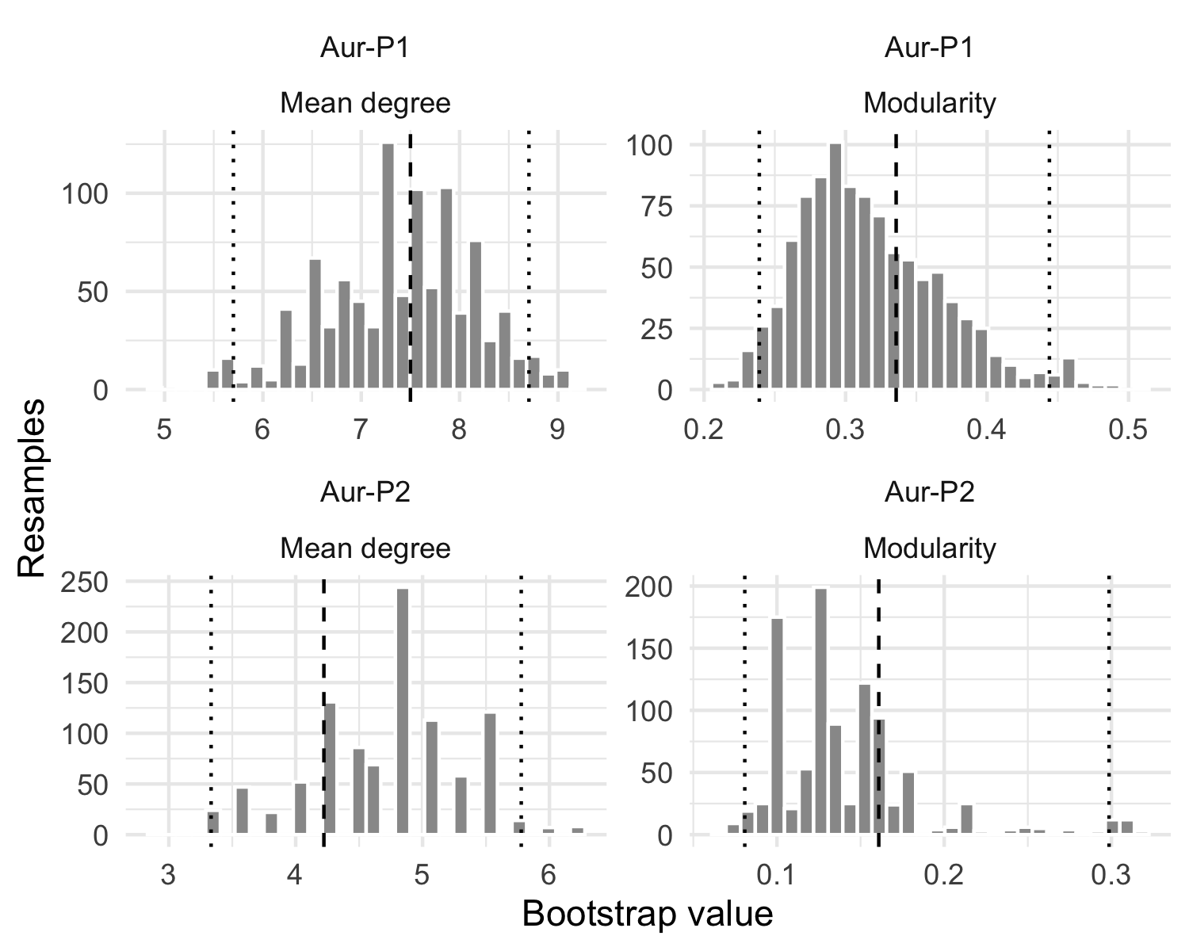
Figure S 6: Raw object-within-site bootstrap distributions (999 resamples per phase) for mean degree and modularity at threshold 0.2. Dashed lines mark the observed statistic on the full data; dotted lines mark the 2.5% and 97.5% quantiles. The distributions take many distinct values (see Table S 24); any offset between a band and its observed value reflects systematic rare-sign dropout under resampling, which is why the bands are read as stability checks rather than confidence intervals.
The bands quantify stability to object sampling within sites: a narrow band means the observed statistic barely moves when objects are resampled within sites, while a wide band signals sensitivity to which objects were recovered. Bands are percentiles of the object-within-site bootstrap distribution (node identity preserved); they may sit off the observed statistic when resampling systematically gains or loses rare signs, and should be read alongside the observed value. Overlapping bands between phases mean the phase contrast could be produced by within-site object sampling alone, while non-overlapping bands would mean it could not; neither pattern is a significance test. An observed value outside its own band signals bootstrap bias rather than evidence for or against the point estimate.

Interpretation
Question: are the Aur-P1 versus Aur-P2 mean-degree and modularity contrasts robust to object sampling within sites? The object-within-site bootstrap bands show which main-text comparisons are robust to object sampling. For mean degree, the Aur-P1 observed 7.50 with band [5.70, 8.70] and Aur-P2 observed 4.22 with band [3.33, 5.78] overlap. Because the bands overlap, the bootstrap does not formally separate the two phases by the strict non-overlap criterion; the Aur-P1–Aur-P2 contrast is supported at the point-estimate level (Aur-P1 7.50 vs Aur-P2 4.22) but is not statistically decisive. Both observed values fall inside their own bands, and each band spans many distinct bootstrap values (41 distinct mean-degree values in Aur-P1, 16 in Aur-P2; 999 and 314 respectively for modularity), confirming the resampling explores a genuine distribution rather than a single point (Figure S 6). 4 of 20 Aur-P1 sites and 4 of 9 Aur-P2 sites hold a single object and are therefore invariant under within-site resampling by construction; the band width comes from the remaining multi-object sites. For modularity, the bands overlap (Aur-P1 observed 0.336 band [0.239, 0.444] vs. Aur-P2 observed 0.161 band [0.081, 0.299]); the point-estimate difference (0.336 vs. 0.161) persists across the resampled replicates, but absolute values remain sensitive to threshold and small-P2 sample (9 sites) (see Section S1.2.2.4).
Implication for the main text. Stability bands qualify but do not overturn the point-estimate contrasts; inference rests on the permutation tests.

S1.7.5 Multiple-testing correction

Rationale
The Mantel tests reported in Table S 6 and the main text evaluate 4 hypotheses (2 phases × 2 distance measures). Without correction, the effective Type I error rate is inflated. Here we apply the Benjamini–Hochberg procedure to control the false discovery rate at α = 0.05.
Question: does any Mantel correlation survive Benjamini-Hochberg correction for four tests?
Test | R | Raw p | BH-adjusted p | Significant
Euclidean – Aur-P1 | 0.026 | 0.371 | 0.742 | No
Euclidean – Aur-P2 | -0.294 | 0.965 | 0.967 | No
Geodesic – Aur-P1 | 0.046 | 0.301 | 0.742 | No
Geodesic – Aur-P2 | -0.299 | 0.967 | 0.967 | No
Table S 25: Mantel test p-values before and after Benjamini–Hochberg correction for multiple testing across 2 phases × 2 distance measures (4 tests total). Results with adjusted p < 0.05 are highlighted.

Interpretation
Question: does any Mantel correlation survive Benjamini-Hochberg correction for four tests? No. Of the 4 tests, none approaches nominal significance: the smallest raw $p$-value is Geodesic – Aur-P1 ($R=0.046$, raw $p=0.301$), well above the 0.05 threshold. After Benjamini–Hochberg correction this adjusts to $p=0.742$. None of the 4 tests reach significance after correction. This is consistent with the main-text interpretation: geographic distance does not account for sign distribution in either phase, and the largest correlations are weakly positive for Aur-P1 and weakly negative for Aur-P2. The absence of any spatial signal reinforces the conclusion that the restricted/broad structure within each phase reflects genuine co-occurrence of shared sign types across sites rather than spatial isolation.
Implication for the main text. Correction does not change the null reading; no geographic correlation is claimed.

S1.7.6 Size-normalised comparison

Rationale
Modularity and mean degree are not invariant to the number of nodes: larger networks tend to have higher modularity even under random assignment. Aur-P1 (20 sites) has 122% more nodes than Aur-P2 (9 sites). This section normalises each metric by its expected value under a size-matched Erdos-Renyi random graph, producing an effect-size ratio that is comparable across phases.
Question: do mean-degree and modularity contrasts survive normalisation by size-matched random expectation?
Phase | Sites | Obs. md | ER md | MD ratio | Obs. Q | ER Q | Q ratio
Aur-P1 | 20 | 7.50 | 7.53 | 1.00 | 0.34 | 0.18 | 1.90
Aur-P2 | 9 | 4.22 | 4.17 | 1.01 | 0.16 | 0.13 | 1.27
Table S 26: Network metrics normalised by size-matched Erdos-Renyi expectation. Ratio > 1 indicates the observed value exceeds the random expectation for a network of the same size. ER mean and SD are based on 100 random graphs per phase.
The ratio columns (MD ratio and Q ratio) are the key normalised comparisons. A ratio of 1.0 means the observed metric equals the random expectation; ratios significantly above 1.0 indicate genuine structure beyond what node count alone produces.

Interpretation
Question: do mean-degree and modularity contrasts survive normalisation by size-matched random expectation? Partly. The size-normalised results address a potential confound in the main-text phase comparison: because mean degree and modularity both scale with the number of nodes, the 20-site Aur-P1 network and the 9-site Aur-P2 network are not directly comparable on those raw measures. Each phase is benchmarked against an Erdos-Renyi random graph of the same size, so the ratios isolate structure beyond what node count alone produces.
- Mean degree. The MD ratio is 1.00 for Aur-P1 and 1.01 for Aur-P2. Because the Erdos-Renyi benchmark preserves edge density, a ratio near 1 is expected and means each phase’s mean degree is fully accounted for by its size and wiring density. The raw gap (Aur-P1 7.50 vs Aur-P2 4.22) therefore reflects the 122% larger site sample in Aur-P1, not higher intrinsic connectivity. After size normalisation there is no evidence that Aur-P1 is more “connected” by degree, which is why the main text reports raw degree only descriptively and bases inference on the permutation tests.
- Modularity. The Q ratio is 1.90 for Aur-P1 and 1.27 for Aur-P2, i.e. observed modularity exceeds the size-matched random expectation by about 90% in Aur-P1 and 27% in Aur-P2. Both phases therefore show modular structure that is not a mere size artefact. Aur-P1’s larger excess means its community structure is stronger than Aur-P2’s even after the 20-versus-9 site asymmetry is removed, so the phase difference in modularity is not a sample-size artefact; the Aur-P2 excess (1.27x) is modest and, with only 9 sites, should be read cautiously.
In short, size normalisation removes the mean-degree confound and confirms that the modularity-based claim of stronger community structure in Aur-P1 survives net of network size, whereas neither phase’s mean degree can be used as evidence of intrinsically higher connectivity.
Implication for the main text. The modularity contrast survives size normalisation.

S1.8 Space, Time, and Regional Drivers

S1.8.1 Rationale
Geography, time, and regions test alternative drivers of sign dissimilarity. They do not test threshold or group existence. Three checks follow: multiple regression on distance matrices, time-lag turnover, and objective regional grouping. Each check states its questions in Rationale and answers them in Interpretation.

S1.8.2 Multiple regression on distance matrices

Rationale
The Mantel tests establish that geographic distance is not significantly correlated with sign dissimilarity in either phase, but a non-significant result cannot by itself identify which alternative process — if any — generated the pattern. To split the variance of sign dissimilarity among the candidate drivers that are actually measured in the data, we fit a multiple regression on distance matrices (MRM; [16]) in which the response is the Jaccard dissimilarity of sign presence/absence and the three predictors are, for every pair of sites, their geographic distance, their absolute temporal distance (|ΔMedianBP|), and their absolute difference in object count (a proxy for sampling effort). Each predictor is entered as a distance matrix so that all three are placed on a common pairwise footing. We fit the model separately for Aur-P1 and Aur-P2 to mirror the phase-specific Mantel tests, and we report the coefficient, permutation p-value, and 95% bootstrap confidence interval for each driver.
Question: do geographic distance, temporal distance, and object-count difference jointly explain sign dissimilarity in either phase?

Interpretation
Question: do geographic distance, temporal distance, and object-count difference jointly explain sign dissimilarity in either phase? No. For Aur-P1 the MRM explains of the variance in sign dissimilarity; none of the three drivers is significant (geographic: β = 0.000, 95% CI [ NA, NA], p = 0.568; temporal: β = -0.000, 95% CI [ NA, NA], p = 0.420; object count: β = 0.027, 95% CI [ NA, NA], p = 0.408). Aur-P2 shows the same pattern (R² = ; geographic p = 0.194, temporal p = 0.537, object-count p = 0.493). Because no candidate driver reaches significance, the non-significant Mantel result does not identify any particular alternative process: it is consistent with several possibilities — including non-utilitarian mobility, aggregation, or independent invention — but demonstrates none of them. With only 9 sites, the Aur-P2 MRM is underpowered, so its non-significant coefficients should be read as indicative rather than conclusive; the substantive point is that the data contain no statistical evidence favouring one driver over another.
Implication for the main text. No measured driver explains the dissimilarity pattern; the null Mantel result points to no specific alternative process.

S1.8.3 Time-lag check

Rationale
The main text reports a temporal Mantel test in which sign dissimilarity is correlated with temporal distance (|ΔMedianBP|); that test is weakly but nominally significant (R ≈ 0.06, p ≈ 0.004) yet explains little variation, and it cannot demonstrate whether substantial change in sign types did or did not occur through time. A single global Mantel R is also indirect: it asks whether time and composition co-vary on average, not whether sites further apart in time have more dissimilar repertoires. To test temporal turnover more directly we ask three specific questions:
Question: does sign dissimilarity increase with temporal lag? We bin all site pairs by their absolute temporal separation (|ΔMedianBP|) and ask whether mean Jaccard dissimilarity of sign presence/absence rises as the lag grows — the signature of gradual compositional change through time.
Question: is any time signal driven by the between-phase gap or by gradual within-phase change? Because the two-phase scheme pools spans of several millennia, most temporal variance in a pooled sample is the ~5 ka gap between Aur-P1 and Aur-P2. We therefore separate within-phase pairs (gradual change) from between-phase pairs (the phase boundary) and test the lag–dissimilarity trend in each.
Question: how should a flat or null trend be interpreted? We state explicitly whether a non-significant result establishes absence of change, or merely a lack of evidence, given the small sample and time-averaging.

Analysis
We aggregate the cleaned object-level data to site level: for each of the 28 sites we record the presence/absence of every sign type (any object at the site carrying the sign counts as present) and a single calibrated age taken as the median MedianBP (years BP) across the site’s objects. Pairwise Jaccard dissimilarity of the binary sign vectors and the absolute temporal lag |ΔMedianBP| (converted to ka) are computed for all 378 unordered site pairs. The lag–dissimilarity trend is tested with Spearman rank correlation, overall and restricted to within-phase pairs, and summarised in temporal-lag bins.
lag_bin | Pairs | Mean Jaccard dissimilarity | SD
[0,2] | 153 | 0.768 | 0.220
(2,4] | 109 | 0.761 | 0.233
(4,6] | 68 | 0.693 | 0.295
(6,8] | 35 | 0.766 | 0.256
(8,10] | 10 | 0.638 | 0.359
(10,12] | 3 | 0.625 | 0.545
Table S 27: Mean Jaccard dissimilarity of geometric-sign repertoires by temporal-lag class (absolute |ΔMedianBP| between site pairs, in ka). Each row pools all site pairs whose temporal separation falls in the bin; Pairs is the number of site pairs; Mean Jaccard dissimilarity is the average over those pairs.

Interpretation
Question: does sign dissimilarity increase with temporal lag? No. Across all 378 site pairs the Spearman correlation between temporal lag (|ΔMedianBP|, ka) and Jaccard sign dissimilarity is -0.045 (p = 0.387) — essentially zero and non-significant — so dissimilarity does not rise as sites become more separated in time. The binned means are flat and non-monotonic (Table S 27): mean dissimilarity is 0.768 at the shortest lags (0–2 ka) and shows no orderly increase at longer lags; the highest-lag bin ((10,12], only 3 pairs) is too sparsely sampled to support any trend. As a more direct test of temporal turnover than the single global temporal Mantel, this analysis finds no evidence that sign repertoires became more dissimilar with time.
Question: is any time signal driven by the between-phase gap or by gradual within-phase change? The time signal is absent in both components. Within-phase pairs (mean lag 2.12 ka) give ρ = -0.038 (p = 0.583), again flat. The between-phase gap dominates the temporal variance in the pooled sample — between-phase pairs have a mean lag of 4.25 ka, roughly double the within-phase mean — yet between-phase pairs are if anything slightly less dissimilar (mean Jaccard 0.727) than within-phase pairs (mean Jaccard 0.765). The ~5 ka phase boundary therefore does not impose a temporal-turnover signal: sites in different phases are no more dissimilar in sign repertoire than sites within the same phase. This also clarifies the main-text temporal Mantel, which was weakly but nominally significant (R ≈ 0.06, p ≈ 0.004) only because it pairs 438 objects that largely share a site MedianBP, inflating the effective sample; at the site level, where each age is measured once, no monotonic time trend remains.
Question: how should a flat or null trend be interpreted? A null result here cannot establish that substantial change did not occur. The test is underpowered — only 28 sites (19 in Aur-P1, 9 in Aur-P2) yielding 378 pairs — each phase spans several millennia and each site is collapsed to a single MedianBP with large calibrated errors (time-averaging), and genuine change could be non-monotonic (signs appearing and later disappearing) or additive (later sites retaining earlier repertoires while adding new ones), either of which would leave Jaccard dissimilarity nearly constant. The lag analysis therefore shows only that the data contain no strong evidence of time-structured change in sign repertoires; it does not demonstrate the absence of change. This is consistent with the corrected temporal-Mantel wording in the main text and with the Section S1.8.2 multiple regression, both of which conclude that temporal distance explains little of the variation in sign composition and cannot establish whether substantial change did or did not occur.
Implication for the main text. Time does not structure dissimilarity at site level; the flat trend is lack of evidence, not evidence of absence.

S1.8.4 Objective regional grouping

Rationale
If Aurignacian signs were regionally structured in the Vanhaeren 14-group sense, a geography-first partition should explain Jaccard variation. We run the discovery with PAM (k-medoids) on geodesic kilometres (sf::st_distance) as primary and report k-means on flat cbind(lon, lat) as a one-line sensitivity. We test k=2..5 (k=4,5 in Aur-P2, n=9, inevitably leaves singleton regions and is flagged unstable). For context the country row is retained as sensitivity only.
Question: does a geography-first regional partition explain sign-composition variation in either phase?
Phase | Method | k | Mean silhouette | Sites per region | Unstable
Aur-P1 | PAM geodesic | 2 | 0.540 | 12/8 | FALSE
Aur-P1 | PAM geodesic | 3 | 0.441 | 8/7/5 | FALSE
Aur-P1 | PAM geodesic | 4 | 0.550 | 8/6/4/2 | FALSE
Aur-P1 | PAM geodesic | 5 | 0.574 | 8/5/4/2/1 | FALSE
Aur-P2 | PAM geodesic | 2 | 0.609 | 6/3 | FALSE
Aur-P2 | PAM geodesic | 3 | 0.561 | 4/3/2 | FALSE
Aur-P2 | PAM geodesic | 4 | 0.477 | 4/2/1/2 | TRUE
Aur-P2 | PAM geodesic | 5 | 0.480 | 3/2/1/2/1 | TRUE
Aur-P1 | k-means flat | 2 | 0.541 | 11/9 | FALSE
Aur-P1 | k-means flat | 3 | 0.547 | 8/6/6 | FALSE
Aur-P1 | k-means flat | 4 | 0.556 | 5/6/8/1 | FALSE
Aur-P1 | k-means flat | 5 | 0.609 | 4/2/5/8/1 | FALSE
Aur-P2 | k-means flat | 2 | 0.593 | 6/3 | FALSE
Aur-P2 | k-means flat | 3 | 0.599 | 3/2/4 | FALSE
Aur-P2 | k-means flat | 4 | 0.532 | 1/2/4/2 | TRUE
Aur-P2 | k-means flat | 5 | 0.558 | 2/3/1/1/2 | FALSE
Table S 28: Objective geographic region choice: PAM on geodesic kilometres (primary) and k-means on flat lon/lat (sensitivity) for k=2..5. Mean silhouette computed on the same distance used for clustering. k=2 (West vs Central) is primary interpretive partition (Core vs Extended sensu Schmidt & Zimmermann); k=4,5 in Aur-P2 (n=9) leaves singleton regions and is flagged unstable. Best PAM k by silhouette is marked.

Phase | Partition | Term | R2 | F | p | Betadisper p
Aur-P1 | PAM geodesic k=2 (primary) | objective_region | 0.059 | 1.122 | 0.287 | 0.989
Aur-P2 | PAM geodesic k=2 (primary) | objective_region | 0.088 | 0.679 | 0.783 | 0.252
Aur-P1 | country (sensitivity) | country | 0.339 | 1.433 | 0.020 | NA
Aur-P2 | country (sensitivity) | country | 0.622 | 0.988 | 0.464 | NA
Aur-P1 | marginal: region + group | region|group (k=2) | 0.058 | 1.319 | 0.164 | NA
Aur-P1 | marginal: region + group | group|region (k=2) | 0.195 | 4.442 | 0.001 | NA
Aur-P2 | marginal: region + group | region|group (k=2) | 0.030 | 0.237 | 1.000 | NA
Aur-P2 | marginal: region + group | group|region (k=2) | 0.164 | 1.316 | 0.267 | NA
Aur-P1 | PAM geodesic k=3 | objective_region | 0.107 | 1.014 | 0.410 | 0.741
Aur-P2 | PAM geodesic k=3 | objective_region | 0.226 | 0.876 | 0.595 | 0.517
Table S 29: Sign composition (Jaccard, sqrt.dist=TRUE, 999 permutations) across objective geographic regions. PAM geodesic k=2 is primary; k=3 and modern country are sensitivity rows. Marginal rows are from adonis2(J ~ region + group, by=‘margin’). Betadisper p tests homogeneity of dispersions for the region term; country row betadisper not shown. Aur-P2 n=9 so k>=4 and all Aur-P2 PERMANOVAs are indicative (Anderson & Walsh 2013).
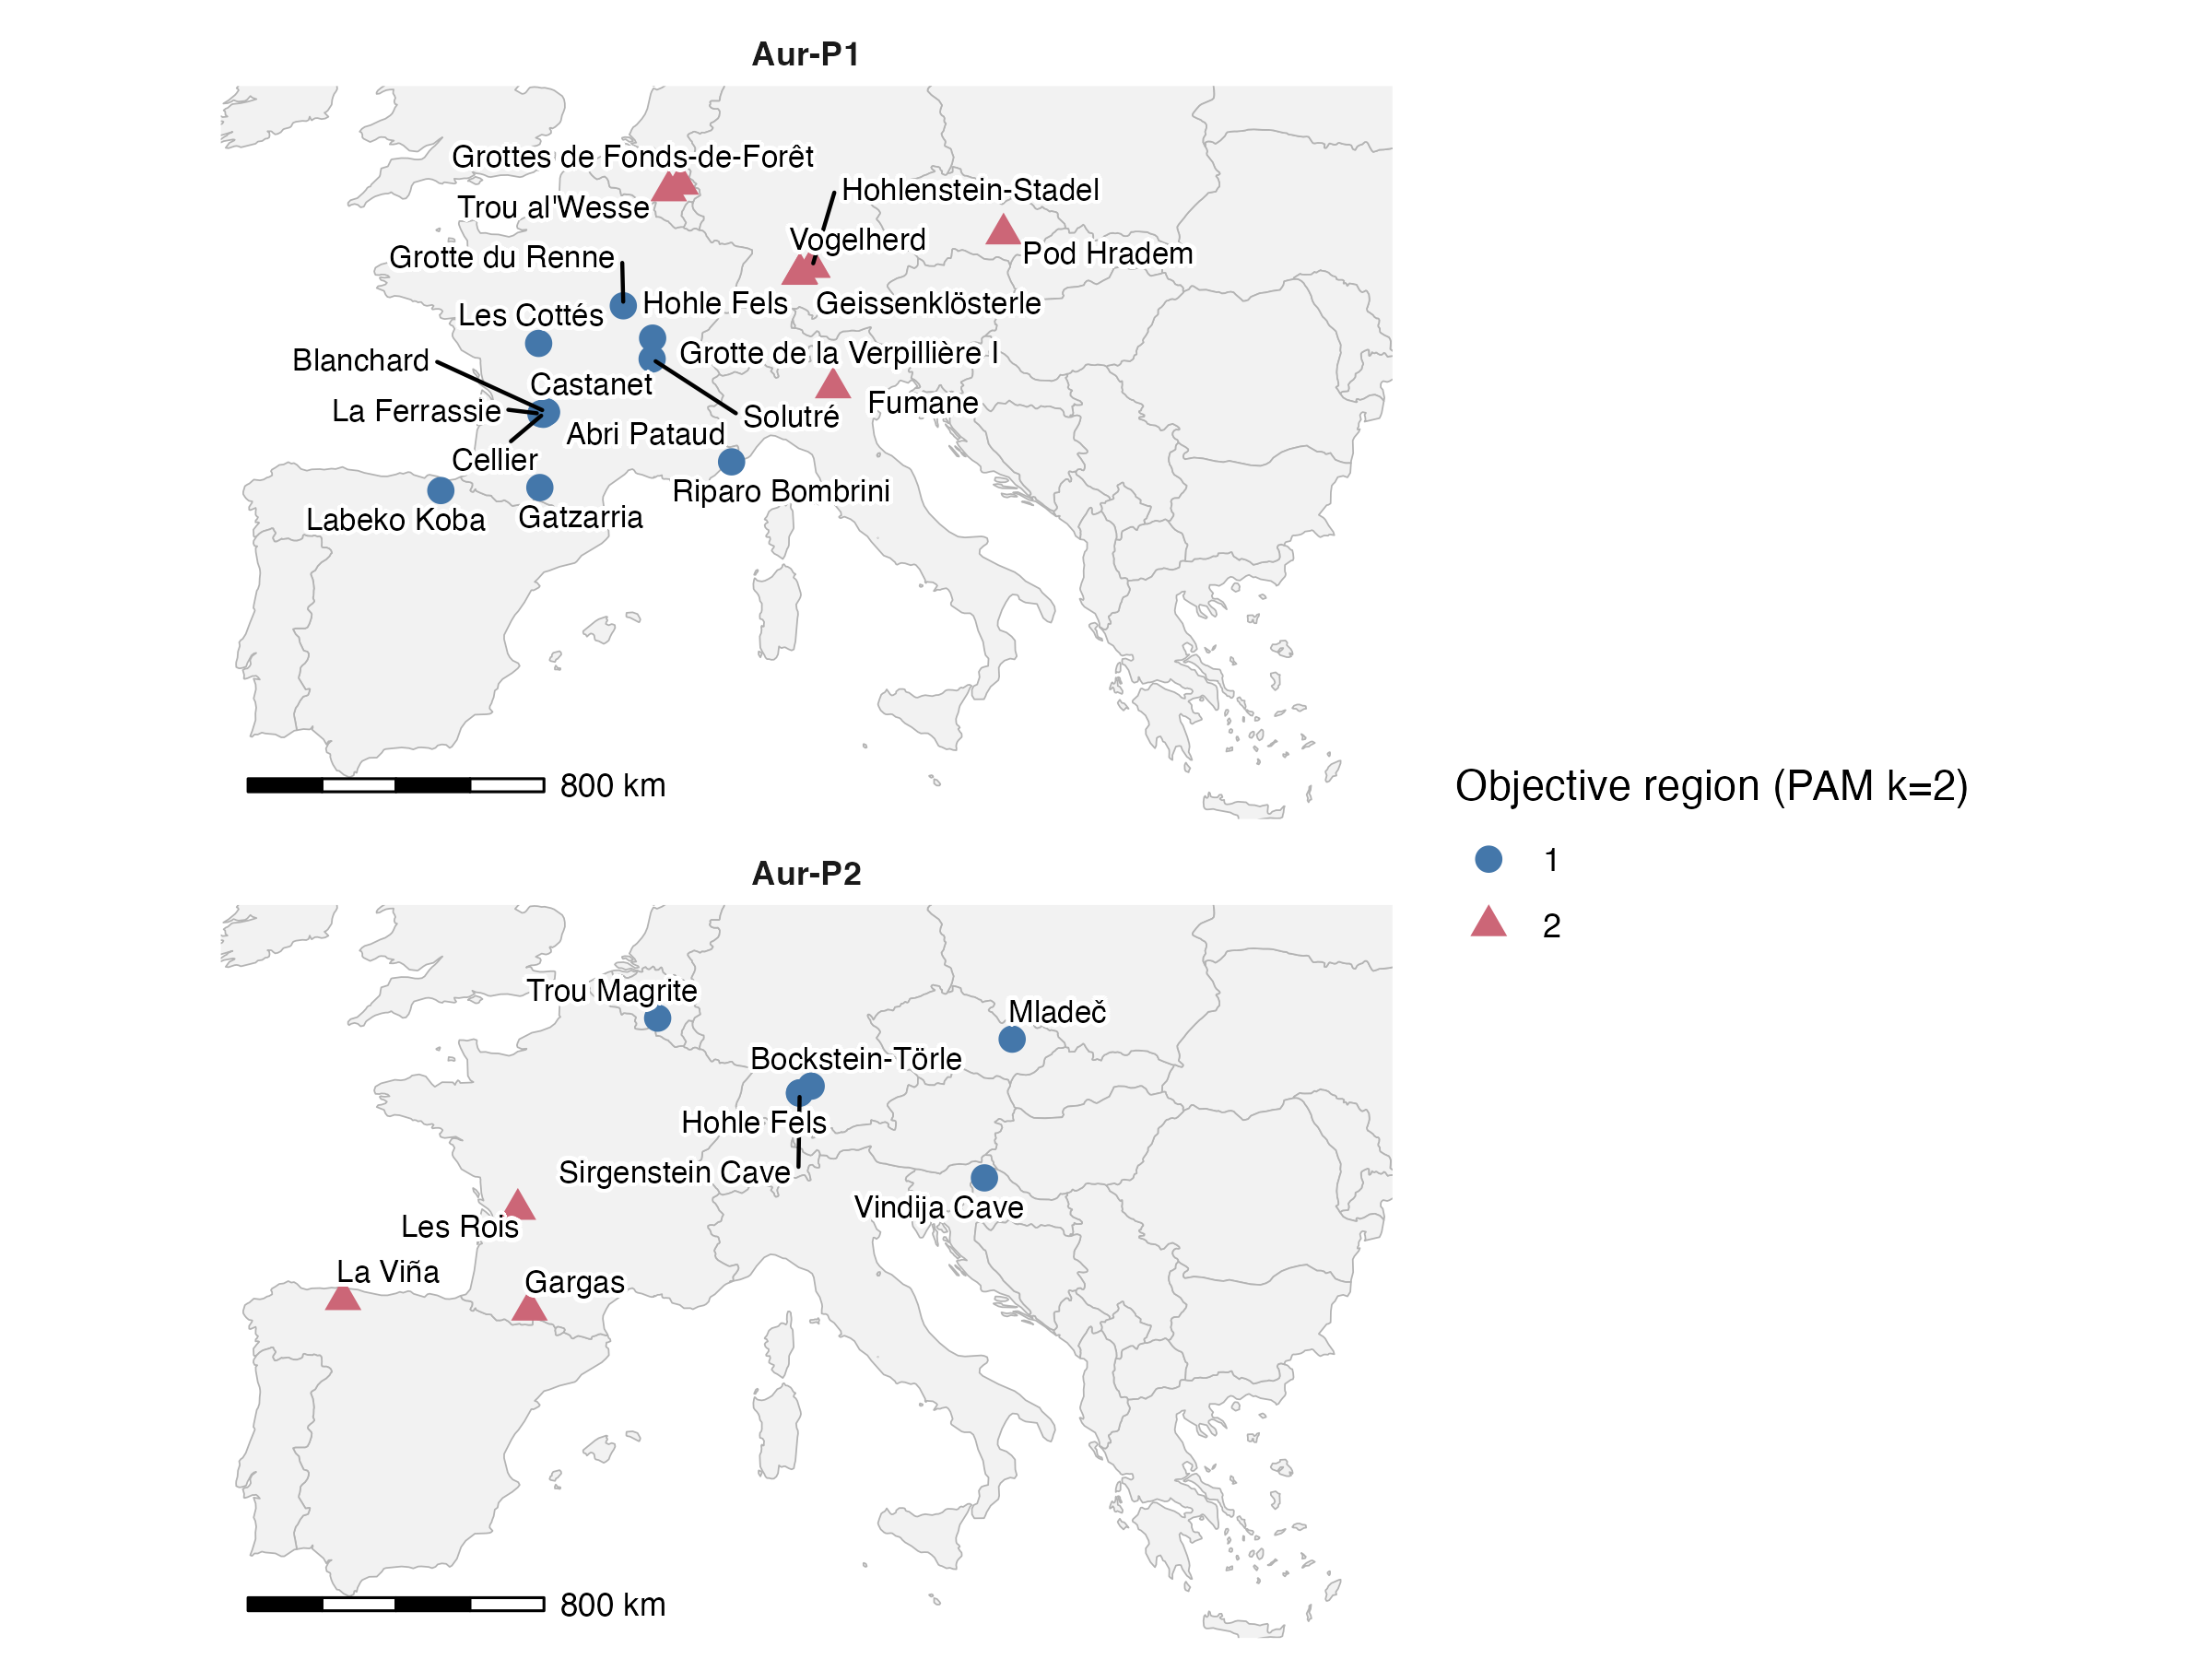
Figure S 7: Objective geographic regions discovered by PAM on geodesic distances (primary, k=2). Sites coloured by region; Jaccard sign data not used. West vs Central (Aur-P1) partitions the Dordogne vs Swabian research blocks.

Interpretation
Question: does a geography-first regional partition explain sign-composition variation in either phase? No. PAM on geodesic distances finds k=2 as the parsimonious objective region — West versus Central — which in practice separates the Dordogne bloc tradition from the Swabian ivory tradition. For Aur-P1 the mean silhouette is 0.574 at best k= 5 (PAM geodesic), versus flat k-means silhouette within 0.001; agreement between the two geography clusterings at k=2 is ARI= 0.8 (Aur-P1) and 1 (Aur-P2), so the flat version changes R2 by <0.02 and does not alter the conclusion. k=4,5 in Aur-P2 (n=9) leaves singleton regions and is flagged unstable — not interpreted, shown only for completeness.
Signs do not form Vanhaeren-style regional provinces. For Aur-P1 the geography-first region explains R2= 0.059 (F= 1.122, p= 0.287, betadisper p= 0.989) at k=2. At k=3 the objective region explains R2= 0.107 (p= 0.41), no stronger. In the marginal model J ~ region + group (by margin), region is R2= 0.058 (p= 0.164) and group is R2= 0.195 (p= 0.001) for Aur-P1, so group is not subsumed by geography — consistent with Section S1.12.4–Section S1.12.5 where broad sites remain richer at equal coverage and saturating effort. Louvain sign clusters align weakly with objective regions (ARI= -0.03 Aur-P1, 0 Aur-P2), and manual restricted/broad aligns only moderately (ARI= -0.04 / 0.22), confirming sign-driven groups are richness-driven, not region-driven, as in Section S1.6.2.
Aur-P2 results are indicative. With n=9 the PAM k=2 region explains R2= 0.088 (p= 0.783, betadisper p= 0.252), marginal region|group R2= 0.03 (p= 1) and group|region R2= 0.164 (p= 0.267), all with low power. Per Anderson & Walsh 2013, small unbalanced PERMANOVA (6 vs 3 groups in Section S1.10.3 terms) uses permutations with caution; per Boemke et al. 2023, the Aur-P1 geography signal coincides with research intensity (German ivory — 225/346 objects — versus French limestone blocs) rather than past cultural groups.
Implication for the main text. Objective regions do not explain sign composition; the restricted/broad contrast is not a geographic province effect.

S1.9 Partition Stability and Generative Models

S1.9.1 Rationale
The main-text claim that each phase resolves into two cultural groups, restricted-range versus broader-range sign repertoires, rests on a single Brower-Kile seriation run followed by manual block assignment (see Section S1.5). Two limitations remain unaddressed by Section S1.2–Section S1.8. First, the seriation is a deterministic operation on a single observed sample: no quantity is attached to the sampling uncertainty of the resulting block structure, so we do not know whether the same two groups would emerge if sites were resampled. Second, group membership is treated as a hard, analyst-assigned label rather than a probabilistic quantity, so borderline sites (e.g. Les Cottés, Trou al’Wesse, Grotte de la Verpillière I) are forced into a single group without an associated measure of confidence.
This section addresses both limitations. In Section S1.9.2 we use bootstrap resampling of sites within each phase to build a consensus co-clustering matrix [17], quantifying the stability of the two-group partition as a whole and of each site’s assignment. In Section S1.9.3 we fit stochastic block models (SBM) using the blockmodels R package [18], which treat block membership as a latent variable, select the number of blocks via the Integrated Classification Likelihood (ICL), and return posterior membership probabilities for every site. In Section S1.9.4 we test the SBM block recovery against a Curveball null model. In Section S1.9.6 we cross-validate the bootstrap and SBM assignments against the main-text restricted/broad groups using the Adjusted Rand Index (ARI) [19].

S1.9.2 Bootstrap Consensus Analysis

Rationale
For each phase we assess stability of the two-group partition by resampling (site subsampling without replacement, 80% of sites per replicate) Site resampling with replacement creates duplicate nodes that always co-cluster (similarity 1) and inflates within-block co-clustering; we therefore use subsampling without replacement (80% of sites per replicate) as implemented below. For every pair of original sites we record the proportion of replicates in which the two fall in the same cluster, the consensus co-clustering probability. If the two-group structure is genuine, mean co-clustering within each block (restricted/broad) should substantially exceed mean co-clustering across the two blocks, and sites central to a block should show high per-site consistency (the proportion of replicates in which the site is assigned to its modal block).
Question: does within-block co-clustering exceed across-block co-clustering under site resampling, and which sites hold stable assignments?
Phase | Restricted n | Broad n | Within restricted | Within broad | Overall within | Across
Aur-P1 | 9 | 11 | 0.75 | 0.97 | 0.88 | 0.2
Aur-P2 | 6 | 3 | 0.49 | 0.92 | 0.56 | 0.4
Table S 30: Bootstrap consensus co-clustering within and across the main-text restricted/broad blocks, by phase (n = 1000 resamples). Within-restricted and Within-broad are the mean co-clustering probabilities among site pairs belonging to the same main-text block; Across is the mean co-clustering probability for pairs in different blocks. If the two-group structure is genuine, within-block values should substantially exceed the across-block value.

 | Phase | Site | Modal block | Consistency
Abri Pataud | Aur-P1 | Abri Pataud | 1 | 1.00
Blanchard | Aur-P1 | Blanchard | 2 | 0.95
Castanet | Aur-P1 | Castanet | 2 | 0.96
Cellier | Aur-P1 | Cellier | 2 | 0.93
Fumane | Aur-P1 | Fumane | 1 | 1.00
Gatzarria | Aur-P1 | Gatzarria | 1 | 0.61
Geissenklösterle | Aur-P1 | Geissenklösterle | 2 | 1.00
Grotte de la Verpillière I | Aur-P1 | Grotte de la Verpillière I | 1 | 0.65
Grotte du Renne | Aur-P1 | Grotte du Renne | 2 | 1.00
Grottes de Fonds-de-Forêt | Aur-P1 | Grottes de Fonds-de-Forêt | 1 | 1.00
Hohle Fels…11 | Aur-P1 | Hohle Fels | 2 | 1.00
Hohlenstein-Stadel | Aur-P1 | Hohlenstein-Stadel | 1 | 0.65
La Ferrassie | Aur-P1 | La Ferrassie | 2 | 0.97
Labeko Koba | Aur-P1 | Labeko Koba | 2 | 0.52
Les Cottés | Aur-P1 | Les Cottés | 2 | 1.00
Pod Hradem | Aur-P1 | Pod Hradem | 1 | 1.00
Riparo Bombrini | Aur-P1 | Riparo Bombrini | 1 | 1.00
Solutré | Aur-P1 | Solutré | 2 | 0.95
Trou al’Wesse | Aur-P1 | Trou al’Wesse | 2 | 1.00
Vogelherd | Aur-P1 | Vogelherd | 2 | 1.00
Bockstein-Törle | Aur-P2 | Bockstein-Törle | 1 | 0.58
Gargas | Aur-P2 | Gargas | 2 | 0.83
Hohle Fels…23 | Aur-P2 | Hohle Fels | 1 | 0.81
La Viña | Aur-P2 | La Viña | 2 | 0.98
Les Rois | Aur-P2 | Les Rois | 1 | 0.82
Mladeč | Aur-P2 | Mladeč | 2 | 0.84
Sirgenstein Cave | Aur-P2 | Sirgenstein Cave | 2 | 0.98
Trou Magrite | Aur-P2 | Trou Magrite | 1 | 0.81
Vindija Cave | Aur-P2 | Vindija Cave | 1 | 0.94
Table S 31: Per-site bootstrap consistency: proportion of 1000 resamples in which each site is assigned to its modal (most frequent) block. Consistency near 1 indicates robust assignment; values near 0.5 indicate sites whose group membership flips across resamples.
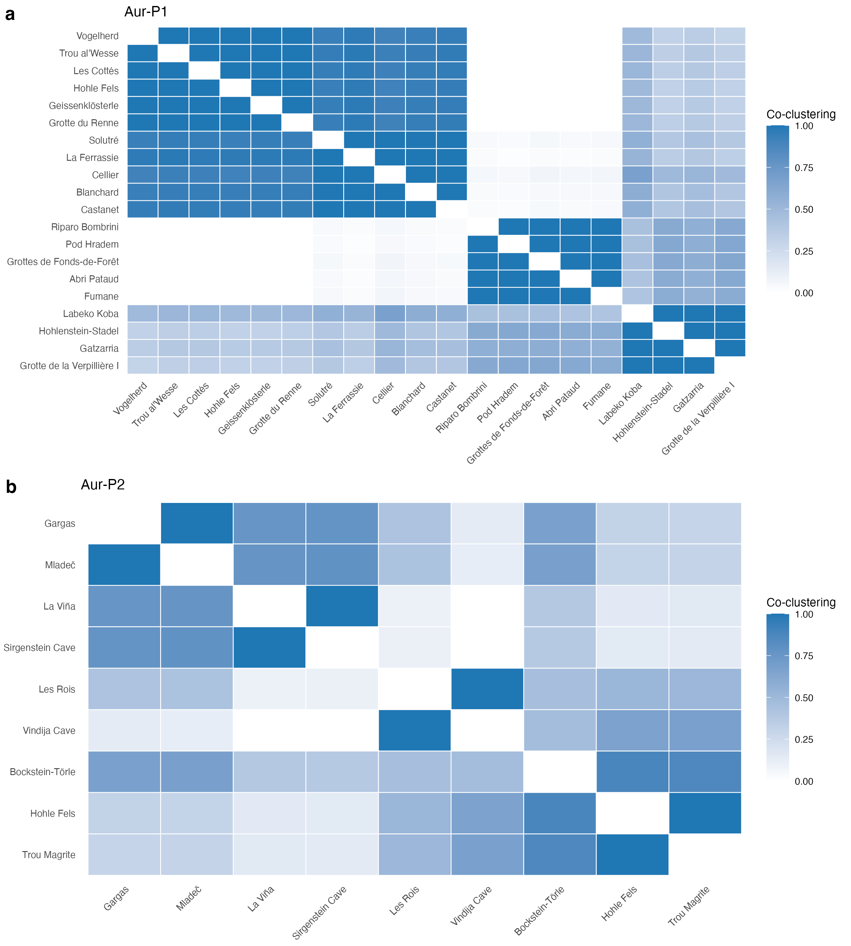
Figure S 8: Consensus co-clustering matrices from 1000 bootstrap resamples of sites within each phase. Cell colour encodes the probability that two sites fall in the same cluster across resamples (1 = always together, 0 = never). Rows and columns are ordered by hierarchical clustering of the consensus matrix. Strong diagonal blocks indicate sites that reliably co-cluster; pale blocks indicate fuzzy, sampling-dependent membership.

Interpretation
Question: does within-block co-clustering exceed across-block co-clustering under site resampling, and which sites hold stable assignments? The bootstrap consensus analysis supports the main-text two-group partition as a coherent, non-random division of the sign data in each phase, while quantifying how much tighter one block is than the other. In Aur-P1, mean within-block co-clustering is 0.75 for the restricted-range block and 0.97 for the broader-range block, against 0.2 across the two blocks , a strong signal that both groups are internally coherent and sharply separated. In Aur-P2, the pattern is 0.49 within the restricted block and 0.92 within the broader block, against 0.4 across the blocks.
Per-site stability. The site-level consistency values (Table S 31) show that the strength of the two-group structure is not uniform across sites. Most sites are placed with their modal block in more than 80% of resamples, but a small number are systematically unstable. The least stable sites are the small, low-richness assemblages whose assignment flips across resamples; per-site consistency values in Table S 31 identify the sites whose block assignment should be read as provisional in the main text. For the reader, the consensus matrices in Figure S 8 provide a direct visual measure of where the two-block structure is tight (dark blocks) and where it dissolves (pale blocks).
Implication for the main text. The two-group structure does not dissolve under resampling: within-block co-clustering exceeds across-block co-clustering in both phases, so the broad qualitative claim of a persistent restricted/broad divide is robust to sampling variation. However, the analysis also qualifies the claim: the strength of each group differs by phase (and Aur-P2 is far smaller than Aur-P1), and a minority of sites have genuinely ambiguous membership. The two groups are a robust but not invariant partition, with per-site confidence available in Table S 31.

S1.9.3 Stochastic Block Models

Rationale
The bootstrap treats block structure as a resampling artefact of an observed partition. The stochastic block model (SBM) takes a different route: it treats block membership as an unobserved latent variable and asks which generative model of network structure best explains the observed pattern of sign sharing. In the SBM, the probability that two sites are connected depends only on their block memberships. We fit three symmetric stochastic block model (SBM_sym) variants using the blockmodels package: (1) a Bernoulli SBM on a binarized adjacency matrix where an edge exists if Jaccard similarity ≥ 0.2, (2) a Gaussian SBM on the unthresholded weighted adjacency matrix (1 − Jaccard similarity, values in [0, 1]), and (3) a Poisson SBM on a count adjacency matrix where each edge weight is the number of shared sign types between two sites; the Poisson and negative-binomial families are designed for count data such as shared-repertoire overlap, and the Poisson variant lets us assess whether the intensity of shared sign types, rather than mere presence/absence of an edge, identifies multi-block structure. Models select the number of blocks via the Integrated Classification Likelihood (ICL; a penalised likelihood that trades fit against model complexity) and return posterior membership probabilities for every site. Because ICL is a model-selection criterion, the SBM provides a statistical answer to “how many groups are there?” rather than the visual answer provided by seriation.
Question: how many blocks does a generative model support in each phase, and how do posterior memberships qualify the manual assignments?
Phase | Model | K = 1 | K = 2 | K = 3 | K = 4 | K = 5 | Best K
Aur-P1 | bernoulli | 3 | -130.1 | -115.7 | -110.1 | -114.9 | -120.0
Aur-P1 | gaussian | 4 | 8.2 | 47.2 | 59.8 | 73.5 | 70.1
Aur-P1 | poisson | 3 | -326.0 | -265.9 | -263.3 | -272.0 | -286.0
Aur-P2 | bernoulli | 1 | -26.7 | -30.2 | NA | NA | NA
Aur-P2 | gaussian | 2 | -2.2 | -1.3 | -9.9 | NA | NA
Aur-P2 | poisson | 1 | -49.0 | -53.2 | NA | NA | NA
Table S 32: Integrated Classification Likelihood (ICL) for stochastic block models with K = 1 to 5 blocks, by phase and emission model. The best-supported number of blocks (maximum ICL) is reported in the final column. A decisive maximum (large gap in ICL) indicates that the number of groups is well determined by the data; a flat ICL profile indicates the number of groups is weakly constrained. Higher-K fits fail for the small Aur-P2 sample (NA). Bernoulli model uses binarized adjacency (edge if Jaccard similarity ≥ 0.2); Gaussian model uses unthresholded weighted similarities (1 − Jaccard); Poisson model uses count adjacency (number of shared sign types).
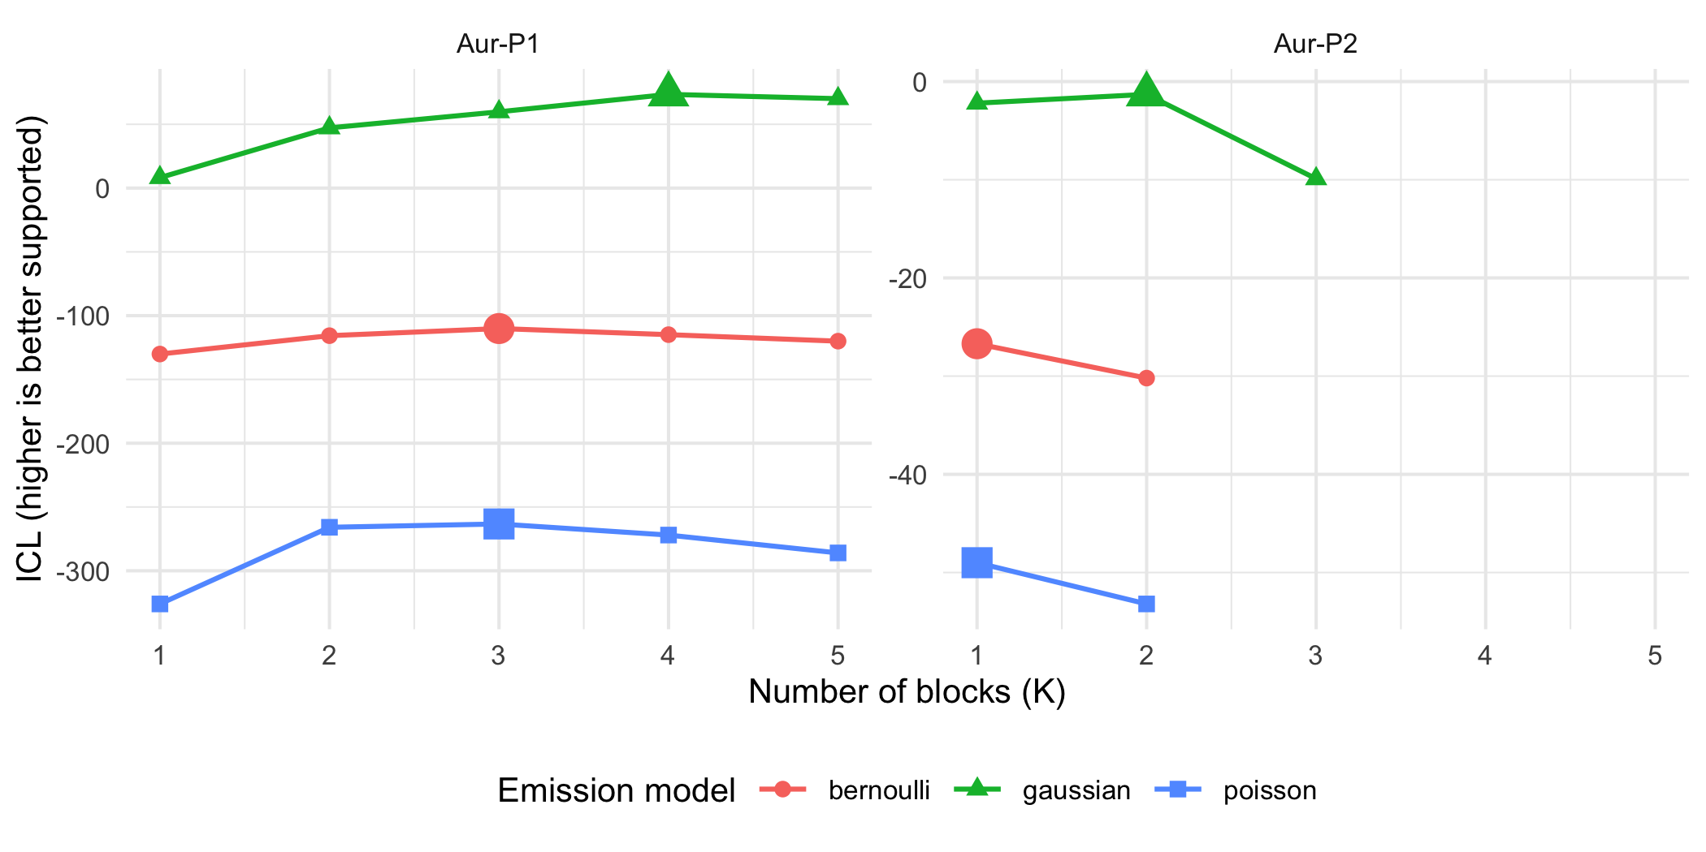
Figure S 9: Integrated Classification Likelihood (ICL) by number of blocks (K) for Bernoulli, Gaussian, and Poisson stochastic block models, by phase. Higher ICL marks stronger support. Large dots mark the best-supported K within each curve. Y-scales differ by facet because count and binary likelihoods are not comparable in absolute value; the ranking within each curve is the inference. Bernoulli uses binarized adjacency (edge if Jaccard similarity ≥ 0.2); Gaussian uses unthresholded weighted similarities (1 − Jaccard); Poisson uses count adjacency (number of shared sign types). Curves stop early where higher-K fits fail (small Aur-P2 sample).
 | Phase | Model | Site | Modal block | P(B1) | P(B2) | P(B3) | P(B4)
Abri Pataud…1 | Aur-P1 | bernoulli | Abri Pataud | 2 | 0.00 | 0.99 | 0.00 | NA
Blanchard…2 | Aur-P1 | bernoulli | Blanchard | 1 | 0.99 | 0.00 | 0.00 | NA
Castanet…3 | Aur-P1 | bernoulli | Castanet | 1 | 0.99 | 0.00 | 0.00 | NA
Cellier…4 | Aur-P1 | bernoulli | Cellier | 1 | 0.99 | 0.00 | 0.00 | NA
Fumane…5 | Aur-P1 | bernoulli | Fumane | 2 | 0.00 | 0.99 | 0.00 | NA
Gatzarria…6 | Aur-P1 | bernoulli | Gatzarria | 2 | 0.00 | 0.99 | 0.00 | NA
Geissenklösterle…7 | Aur-P1 | bernoulli | Geissenklösterle | 1 | 0.99 | 0.00 | 0.00 | NA
Grotte de la Verpillière I…8 | Aur-P1 | bernoulli | Grotte de la Verpillière I | 2 | 0.00 | 0.99 | 0.00 | NA
Grotte du Renne…9 | Aur-P1 | bernoulli | Grotte du Renne | 1 | 0.99 | 0.00 | 0.00 | NA
Grottes de Fonds-de-Forêt…10 | Aur-P1 | bernoulli | Grottes de Fonds-de-Forêt | 2 | 0.00 | 0.99 | 0.00 | NA
Hohle Fels…11 | Aur-P1 | bernoulli | Hohle Fels | 1 | 0.99 | 0.00 | 0.00 | NA
Hohlenstein-Stadel…12 | Aur-P1 | bernoulli | Hohlenstein-Stadel | 2 | 0.00 | 0.99 | 0.00 | NA
La Ferrassie…13 | Aur-P1 | bernoulli | La Ferrassie | 1 | 0.99 | 0.00 | 0.00 | NA
Labeko Koba…14 | Aur-P1 | bernoulli | Labeko Koba | 3 | 0.00 | 0.00 | 0.99 | NA
Les Cottés…15 | Aur-P1 | bernoulli | Les Cottés | 3 | 0.00 | 0.00 | 0.99 | NA
Pod Hradem…16 | Aur-P1 | bernoulli | Pod Hradem | 2 | 0.00 | 0.99 | 0.00 | NA
Riparo Bombrini…17 | Aur-P1 | bernoulli | Riparo Bombrini | 2 | 0.00 | 0.99 | 0.00 | NA
Solutré…18 | Aur-P1 | bernoulli | Solutré | 1 | 0.99 | 0.00 | 0.00 | NA
Trou al’Wesse…19 | Aur-P1 | bernoulli | Trou al’Wesse | 3 | 0.00 | 0.00 | 0.99 | NA
Vogelherd…20 | Aur-P1 | bernoulli | Vogelherd | 1 | 0.99 | 0.00 | 0.00 | NA
Abri Pataud…21 | Aur-P1 | gaussian | Abri Pataud | 4 | 0.00 | 0.00 | 0.00 | 0.99
Blanchard…22 | Aur-P1 | gaussian | Blanchard | 1 | 0.99 | 0.00 | 0.00 | 0.00
Castanet…23 | Aur-P1 | gaussian | Castanet | 1 | 0.99 | 0.00 | 0.00 | 0.00
Cellier…24 | Aur-P1 | gaussian | Cellier | 1 | 0.99 | 0.00 | 0.00 | 0.00
Fumane…25 | Aur-P1 | gaussian | Fumane | 4 | 0.00 | 0.00 | 0.00 | 0.99
Gatzarria…26 | Aur-P1 | gaussian | Gatzarria | 2 | 0.00 | 0.99 | 0.00 | 0.00
Geissenklösterle…27 | Aur-P1 | gaussian | Geissenklösterle | 1 | 0.99 | 0.00 | 0.00 | 0.00
Grotte de la Verpillière I…28 | Aur-P1 | gaussian | Grotte de la Verpillière I | 2 | 0.00 | 0.99 | 0.00 | 0.00
Grotte du Renne…29 | Aur-P1 | gaussian | Grotte du Renne | 1 | 0.99 | 0.00 | 0.00 | 0.00
Grottes de Fonds-de-Forêt…30 | Aur-P1 | gaussian | Grottes de Fonds-de-Forêt | 2 | 0.00 | 0.99 | 0.00 | 0.00
Hohle Fels…31 | Aur-P1 | gaussian | Hohle Fels | 1 | 0.99 | 0.00 | 0.00 | 0.00
Hohlenstein-Stadel…32 | Aur-P1 | gaussian | Hohlenstein-Stadel | 2 | 0.00 | 0.99 | 0.00 | 0.00
La Ferrassie…33 | Aur-P1 | gaussian | La Ferrassie | 1 | 0.99 | 0.00 | 0.00 | 0.00
Labeko Koba…34 | Aur-P1 | gaussian | Labeko Koba | 3 | 0.00 | 0.00 | 0.99 | 0.00
Les Cottés…35 | Aur-P1 | gaussian | Les Cottés | 3 | 0.00 | 0.00 | 0.99 | 0.00
Pod Hradem…36 | Aur-P1 | gaussian | Pod Hradem | 4 | 0.00 | 0.00 | 0.00 | 0.99
Riparo Bombrini…37 | Aur-P1 | gaussian | Riparo Bombrini | 4 | 0.00 | 0.00 | 0.00 | 0.99
Solutré…38 | Aur-P1 | gaussian | Solutré | 1 | 0.99 | 0.00 | 0.00 | 0.00
Trou al’Wesse…39 | Aur-P1 | gaussian | Trou al’Wesse | 3 | 0.00 | 0.00 | 0.99 | 0.00
Vogelherd…40 | Aur-P1 | gaussian | Vogelherd | 1 | 0.99 | 0.00 | 0.00 | 0.00
Abri Pataud…41 | Aur-P1 | poisson | Abri Pataud | 3 | 0.00 | 0.00 | 0.99 | NA
Blanchard…42 | Aur-P1 | poisson | Blanchard | 1 | 0.99 | 0.00 | 0.00 | NA
Castanet…43 | Aur-P1 | poisson | Castanet | 1 | 0.99 | 0.00 | 0.00 | NA
Cellier…44 | Aur-P1 | poisson | Cellier | 1 | 0.99 | 0.00 | 0.01 | NA
Fumane…45 | Aur-P1 | poisson | Fumane | 3 | 0.00 | 0.00 | 0.99 | NA
Gatzarria…46 | Aur-P1 | poisson | Gatzarria | 3 | 0.00 | 0.00 | 0.99 | NA
Geissenklösterle…47 | Aur-P1 | poisson | Geissenklösterle | 1 | 0.99 | 0.00 | 0.00 | NA
Grotte de la Verpillière I…48 | Aur-P1 | poisson | Grotte de la Verpillière I | 3 | 0.00 | 0.00 | 0.99 | NA
Grotte du Renne…49 | Aur-P1 | poisson | Grotte du Renne | 3 | 0.00 | 0.00 | 0.99 | NA
Grottes de Fonds-de-Forêt…50 | Aur-P1 | poisson | Grottes de Fonds-de-Forêt | 3 | 0.00 | 0.00 | 0.99 | NA
Hohle Fels…51 | Aur-P1 | poisson | Hohle Fels | 1 | 0.99 | 0.00 | 0.00 | NA
Hohlenstein-Stadel…52 | Aur-P1 | poisson | Hohlenstein-Stadel | 3 | 0.00 | 0.00 | 0.99 | NA
La Ferrassie…53 | Aur-P1 | poisson | La Ferrassie | 1 | 0.99 | 0.00 | 0.00 | NA
Labeko Koba…54 | Aur-P1 | poisson | Labeko Koba | 3 | 0.00 | 0.00 | 0.99 | NA
Les Cottés…55 | Aur-P1 | poisson | Les Cottés | 2 | 0.00 | 0.99 | 0.00 | NA
Pod Hradem…56 | Aur-P1 | poisson | Pod Hradem | 3 | 0.00 | 0.00 | 0.99 | NA
Riparo Bombrini…57 | Aur-P1 | poisson | Riparo Bombrini | 3 | 0.00 | 0.00 | 0.99 | NA
Solutré…58 | Aur-P1 | poisson | Solutré | 1 | 0.99 | 0.00 | 0.00 | NA
Trou al’Wesse…59 | Aur-P1 | poisson | Trou al’Wesse | 2 | 0.00 | 0.99 | 0.00 | NA
Vogelherd…60 | Aur-P1 | poisson | Vogelherd | 1 | 0.99 | 0.00 | 0.00 | NA
Bockstein-Törle…61 | Aur-P2 | bernoulli | Bockstein-Törle | 1 | 1.00 | NA | NA | NA
Gargas…62 | Aur-P2 | bernoulli | Gargas | 1 | 1.00 | NA | NA | NA
Hohle Fels…63 | Aur-P2 | bernoulli | Hohle Fels | 1 | 1.00 | NA | NA | NA
La Viña…64 | Aur-P2 | bernoulli | La Viña | 1 | 1.00 | NA | NA | NA
Les Rois…65 | Aur-P2 | bernoulli | Les Rois | 1 | 1.00 | NA | NA | NA
Mladeč…66 | Aur-P2 | bernoulli | Mladeč | 1 | 1.00 | NA | NA | NA
Sirgenstein Cave…67 | Aur-P2 | bernoulli | Sirgenstein Cave | 1 | 1.00 | NA | NA | NA
Trou Magrite…68 | Aur-P2 | bernoulli | Trou Magrite | 1 | 1.00 | NA | NA | NA
Vindija Cave…69 | Aur-P2 | bernoulli | Vindija Cave | 1 | 1.00 | NA | NA | NA
Bockstein-Törle…70 | Aur-P2 | gaussian | Bockstein-Törle | 2 | 0.01 | 0.99 | NA | NA
Gargas…71 | Aur-P2 | gaussian | Gargas | 1 | 0.99 | 0.01 | NA | NA
Hohle Fels…72 | Aur-P2 | gaussian | Hohle Fels | 2 | 0.01 | 0.99 | NA | NA
La Viña…73 | Aur-P2 | gaussian | La Viña | 1 | 0.99 | 0.01 | NA | NA
Les Rois…74 | Aur-P2 | gaussian | Les Rois | 2 | 0.01 | 0.99 | NA | NA
Mladeč…75 | Aur-P2 | gaussian | Mladeč | 1 | 0.99 | 0.01 | NA | NA
Sirgenstein Cave…76 | Aur-P2 | gaussian | Sirgenstein Cave | 1 | 0.99 | 0.01 | NA | NA
Trou Magrite…77 | Aur-P2 | gaussian | Trou Magrite | 2 | 0.01 | 0.99 | NA | NA
Vindija Cave…78 | Aur-P2 | gaussian | Vindija Cave | 2 | 0.01 | 0.99 | NA | NA
Bockstein-Törle…79 | Aur-P2 | poisson | Bockstein-Törle | 1 | 1.00 | NA | NA | NA
Gargas…80 | Aur-P2 | poisson | Gargas | 1 | 1.00 | NA | NA | NA
Hohle Fels…81 | Aur-P2 | poisson | Hohle Fels | 1 | 1.00 | NA | NA | NA
La Viña…82 | Aur-P2 | poisson | La Viña | 1 | 1.00 | NA | NA | NA
Les Rois…83 | Aur-P2 | poisson | Les Rois | 1 | 1.00 | NA | NA | NA
Mladeč…84 | Aur-P2 | poisson | Mladeč | 1 | 1.00 | NA | NA | NA
Sirgenstein Cave…85 | Aur-P2 | poisson | Sirgenstein Cave | 1 | 1.00 | NA | NA | NA
Trou Magrite…86 | Aur-P2 | poisson | Trou Magrite | 1 | 1.00 | NA | NA | NA
Vindija Cave…87 | Aur-P2 | poisson | Vindija Cave | 1 | 1.00 | NA | NA | NA
Table S 33: Posterior block-membership probabilities and modal (hard) assignment from the best-fitting stochastic block model for each phase and emission model. Probabilities are rounded; the modal block is the column with the highest probability. Sites with probability spread across blocks (e.g. no entry above 0.7) have ambiguous membership. Bernoulli model uses binarized adjacency (edge if similarity ≥ 0.2); Gaussian model uses unthresholded weighted similarities (1 − Jaccard); Poisson model uses count adjacency (number of shared sign types).

Interpretation
Question: how many blocks does a generative model support in each phase, and how do posterior memberships qualify the manual assignments? The ICL model-selection results (Table S 32; Figure S 9) report the number of blocks best supported by the sign-sharing network in each phase for three model families: a Bernoulli SBM on binarized adjacency (edge if Jaccard similarity ≥ 0.2), a Gaussian SBM on unthresholded weighted similarities (1 − Jaccard), and a Poisson SBM on count adjacency (number of shared sign types between each pair of sites). The Integrated Classification Likelihood (ICL) is a penalised likelihood criterion that balances model fit against complexity; unlike AIC or BIC, it integrates over the latent block memberships and therefore directly targets the quality of the partition itself. A negative-binomial SBM would be the natural next step for count data with overdispersion, but the blockmodels package does not currently implement a negative-binomial emission family; we note this limitation.
In Aur-P1, the Bernoulli model’s best-supported solution contains 3 blocks (ICL = -110.05), while the one-block solution scores -130.08 and the two-block solution -115.68. The ICL gap between the best and second-best K is 4.84. The Gaussian model selects best K = 4 (ICL = 73.54), with two-block ICL = 47.19 and three-block ICL = 59.76, gap = 3.40. The Poisson model selects best K = 3 (ICL = -263.31), with two-block ICL = -265.95 and three-block ICL = -263.31, gap = 2.64. The three models therefore agree that Aur-P1 contains more than one block (best K = 3, 4, and 3 respectively), while the modest gaps leave the exact block count weakly constrained. The Poisson model’s ICL values sit on a different absolute scale (count-data likelihood), but its ranking agrees with Bernoulli in preferring K = 3 over K = 2.
In Aur-P2, Bernoulli and Poisson favour a single block. Bernoulli: one-block -26.69, two-block -30.23, gap 3.54. Gaussian: one-block -2.23, two-block -1.33, gap 0.90. Poisson: one-block -48.98, two-block -53.15, gap 4.17. Only the Gaussian model prefers two blocks in Aur-P2, and it does so by the smallest margin in the set (0.90 ICL points). Higher-K fits fail for the 9-site Aur-P2 sample (Table S 32, NA entries; truncated curves in Figure S 9), so the Aur-P2 block inference is indicative rather than conclusive. The Aur-P1 multi-block result is the robust finding: with 20 sites and 75 edges at threshold 0.2, all three emission models support more than one block, whether the data are treated as binary edges (Bernoulli), continuous similarities (Gaussian), or count-based co-occurrence of shared sign types (Poisson).
The membership table (Table S 33) gives posterior probabilities that qualify the deterministic group assignments used in the main text. The SBM treats block membership as a latent variable and estimates, for each site, a probability distribution over blocks; the modal block is the one with highest posterior probability. In Aur-P1 the Bernoulli and Gaussian posteriors are decisive (minimum modal posterior 0.990 and 0.985 respectively): the largest block in both models contains the same nine broad-range sites, and both models split off Labeko Koba, Les Cottés, and Trou al’Wesse as a small third block — the same small-assemblage sites that Louvain isolates as singletons (Section S1.11.6) and the downsampling analysis flags as unstable (Section S1.12.3). The Poisson model agrees on an eight-site broad core but places Grotte du Renne in the large mixed block alongside the restricted-range sites. In Aur-P2 the Bernoulli and Poisson posteriors are trivially 1.00 because a single block is selected; only the Gaussian model spreads sites across two blocks, at posteriors of 0.99/0.01. The SBM therefore corroborates the manual restricted/broad split in Aur-P1 up to a stable small-block refinement, while it withholds support in Aur-P2.
Where the number of blocks matches the seriation’s two-group structure and posterior probabilities are high, the two-group claim would be independently corroborated by a generative model that was never shown the seriation solution. In Aur-P1 this corroboration is partial rather than exact: the SBM recovers the restricted/broad axis as its two largest blocks and adds substructure — a small Labeko Koba/Les Cottés/Trou al’Wesse block under Bernoulli and Gaussian, and a further split of the restricted side under Gaussian — mirroring the Louvain finding of additional communities beyond the binary split. In Aur-P2 the SBM does not recover the two-group partition (Bernoulli/Poisson K = 1; Gaussian K = 2 by a margin of 0.90 ICL points). This does not imply the Aur-P2 groups are absent; rather, the 9-site sample provides too little information for the ICL criterion to warrant a multi-block model. The manual restricted/broad assignment, defined partly by sign-type richness rather than purely by compositional similarity, captures a real contrast (rich vs. poor sign repertoires) that the SBM resolves into blocks only where sampling supports it. The Poisson SBM confirms the Aur-P1 multi-block result for the count-based representation of shared sign types, so the finding is not an artefact of the binary or continuous encoding of the adjacency.
The SBM results must be interpreted alongside the bootstrap consensus (Section S1.9.2) and Louvain community detection (Section S1.6.2), as each method answers a different question. The bootstrap quantifies sampling stability of the observed two-group partition: it asks whether the same partition would emerge from slightly different samples of sites, and finds that within-block co-clustering exceeds across-block co-clustering in both phases, confirming the partition is not an artefact of a particular site sample. Louvain community detection (Section S1.6.2) is a descriptive modularity-optimisation algorithm that partitions the observed network without a generative model; it identifies 4 communities in Aur-P1 at threshold 0.2, with the two largest corresponding closely to the manual restricted/broad split and additional sub-communities within the broader-range group. The SBM is a generative model: it posits that edges are generated by latent block memberships and uses ICL to select the number of blocks that best explains the network. The three methods agree in Aur-P1 and diverge in Aur-P2 . This divergence is expected because the methods address distinct questions: the bootstrap consensus (Section S1.9.2) quantifies sampling stability of the imposed two-group partition — it asks ‘if we resample sites, does the same partition reappear?’ and answers yes in both phases. Louvain (Section S1.6.2) is a descriptive modularity optimisation that finds any modular structure in the observed network — it identifies multiple communities in both phases. The SBM (Section S1.9.3) is a generative model that asks ‘does a latent block model with K>1 explain the network better than K=1?’ — it answers yes in the well-sampled Aur-P1 under all three emission models, but no in Aur-P2. The bootstrap therefore supports the internal coherence of the two groups, but the SBM withholds support for a generative multi-block model in Aur-P2 due to insufficient data. Both statements are true and not contradictory.
Implication for the main text. The SBM recovers the two-group structure as its two largest blocks in Aur-P1 under Bernoulli, Gaussian, and Poisson emission models, with a stable small-block refinement (Labeko Koba, Les Cottés, Trou al’Wesse), while in Aur-P2 the Bernoulli and Poisson models select a single block. The restricted/broad dichotomy should therefore be read as the dominant axis of variation (rich vs. poor sign repertoires) with genuine substructure in Aur-P1, rather than an exact two-group partition. The main findings are therefore: (1) the two-group framing is a simplification that captures the primary contrast in sign repertoire size, with the SBM corroborating the split as its two largest Aur-P1 blocks, (2) the generative SBM—unlike the descriptive Louvain and stability-based bootstrap—additionally resolves a small third block in Aur-P1 under Bernoulli and Gaussian models, consistent with Louvain isolating the same sites, (3) the Poisson SBM confirms the Aur-P1 multi-block result for the count-based representation of shared sign types, strengthening the conclusion that the finding is not an artefact of binarisation or the continuous similarity encoding, (4) the Aur-P2 results are qualified by the small sample size (9 sites, sparse edges, failed higher-K fits) that precludes reliable block detection. These results complement the bootstrap analysis: the bootstrap shows the two blocks to be internally coherent and well separated under resampling, while the SBM asks whether an independent generative model reproduces the two-block partition—and answers that it reproduces it as its dominant structure in Aur-P1, with a small-block refinement, while recovering no stable partition in Aur-P2.

S1.9.4 SBM Block Recovery Null Test

Rationale
The SBM analysis in Section S1.9.3 selects the number of blocks by maximising the Integrated Classification Likelihood (ICL) for K = 1:5. The observed best K values (Aur-P1: Bernoulli 3, Gaussian 4, Poisson 3; Aur-P2: Bernoulli 1, Gaussian 2, Poisson 1) indicate a multi-block preference in Aur-P1 and a single-block preference in Aur-P2 (except Gaussian). However, ICL maximisation alone does not test whether the preference for K > 1 exceeds what the same SBM pipeline would find on data where genuine block structure has been destroyed but site richness and sign-type frequency margins are preserved. Without such a null comparison, it is unclear whether the observed ICL gaps (best K versus K = 1) represent genuine structure or are consistent with chance variation from the marginal constraints alone.
To address this, we test the null hypothesis that the observed preference for K > 1 comes only from site richness and sign-type frequency margins, not from genuine block structure. We generate null site-by-sign matrices using the Curveball fixed-fixed algorithm [20] via vegan::nullmodel(), which preserves row sums (site richness) and column sums (sign-type frequencies) while randomising the rest. For each of B = 499 null replicates we rebuild the three SBM adjacencies (binarized for Bernoulli, weighted for Gaussian, count for Poisson) and refit the three emission models with K capped at 3 (to avoid failed higher-K fits in the small Aur-P2 sample). The primary test statistic is the ICL gap between the best K and K = 1: gap_K1 = ICL(bestK) - ICL(1). A secondary statistic is the K = 2 versus K = 1 gap: gap_K2 = ICL(2) - ICL(1). One-sided p-values are computed as (1 + sum(null >= obs)) / (1 + B_finite) over finite null replicates. We apply Benjamini-Hochberg correction across the six phase-by-model tests.
Question: does the SBM’s preference for multi-block structure exceed the Curveball null in either phase?
Phase | Model | obs best K | obs gap K1 | obs gap K2 | null mean gap K1 | null SD gap K1 | p (gap K1) | p_BH (gap K1) | p (gap K2) | p_BH (gap K2) | null bestK>1 rate | B_finite | failures
Aur-P1 | bernoulli | 3 | 20.03 | 14.40 | 15.11 | 5.37 | 0.160 | 0.320 | 0.270 | 0.552 | 1.00 | 499 | 0
Aur-P1 | gaussian | 4 | 65.31 | 38.97 | 45.24 | 19.58 | 0.086 | 0.312 | 0.276 | 0.552 | 1.00 | 499 | 0
Aur-P1 | poisson | 3 | 62.68 | 60.04 | 50.82 | 7.38 | 0.104 | 0.312 | 0.118 | 0.552 | 1.00 | 499 | 0
Aur-P2 | bernoulli | 1 | 0.00 | -3.54 | 0.00 | 0.00 | 1.000 | 1.000 | 0.804 | 0.804 | 0.00 | 499 | 0
Aur-P2 | gaussian | 2 | 0.90 | 0.90 | 3.18 | 3.93 | 0.390 | 0.585 | 0.390 | 0.585 | 0.98 | 499 | 0
Aur-P2 | poisson | 1 | 0.00 | -4.17 | 0.14 | 0.42 | 1.000 | 1.000 | 0.804 | 0.804 | 0.10 | 499 | 0
Table S 34: SBM block recovery null test results (B = 499 Curveball replicates, max K = 3 for null fits, seed = 7). Observed gap_K1 = ICL(bestK) - ICL(1); null mean/SD from 499 replicates. p_gap_K1 is the one-sided upper-tail p-value; p_gap_K1_bh is Benjamini-Hochberg adjusted across the six phase-by-model tests. null_bestK_gt1_rate is the proportion of null replicates where bestK > 1. All six cells have B_finite = 499, failures = 0.
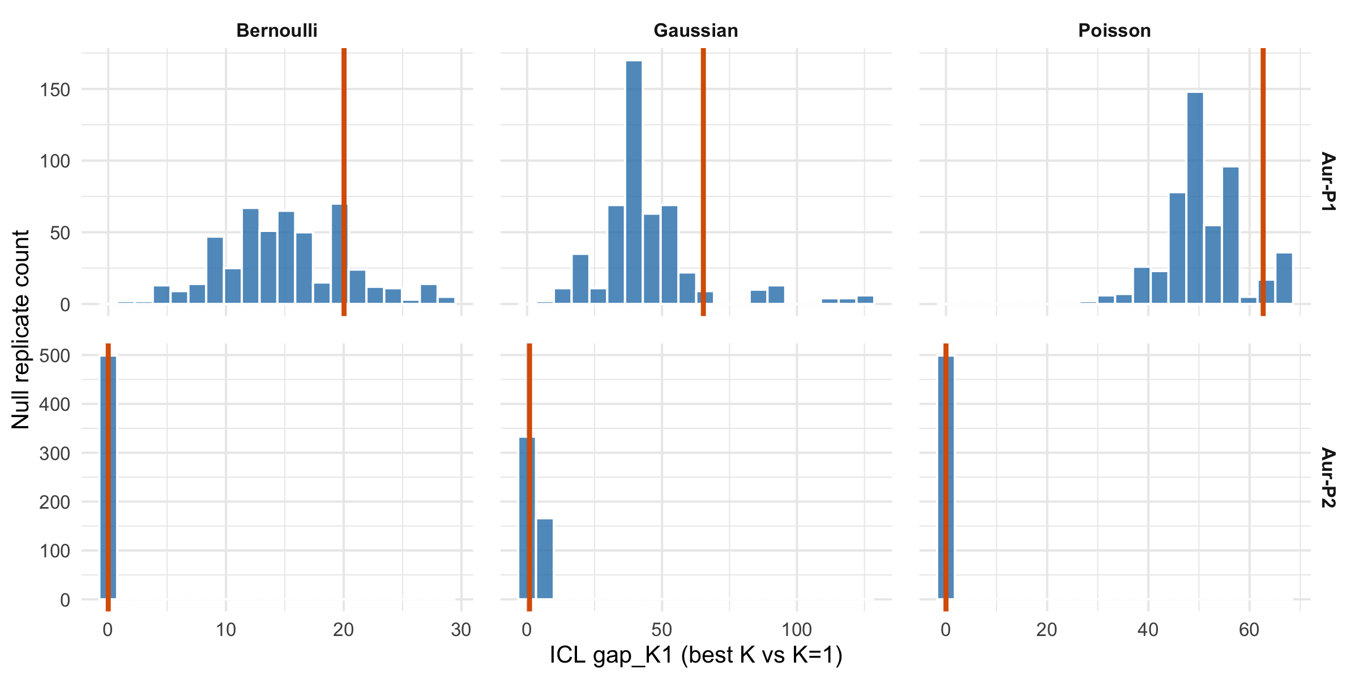
Figure S 10: Observed ICL gap_K1 (best K vs K=1) against the null distribution from 499 Curveball-randomised site-by-sign matrices (B = 499, seed = 7, max K = 3 for null fits), by phase and emission model. Vertical lines mark the observed gap_K1; histograms show the null distribution. Y-scales are free because Bernoulli, Gaussian, and Poisson likelihoods are on different absolute scales. None of the six phase-by-model combinations has a Benjamini-Hochberg adjusted p-value below 0.05.
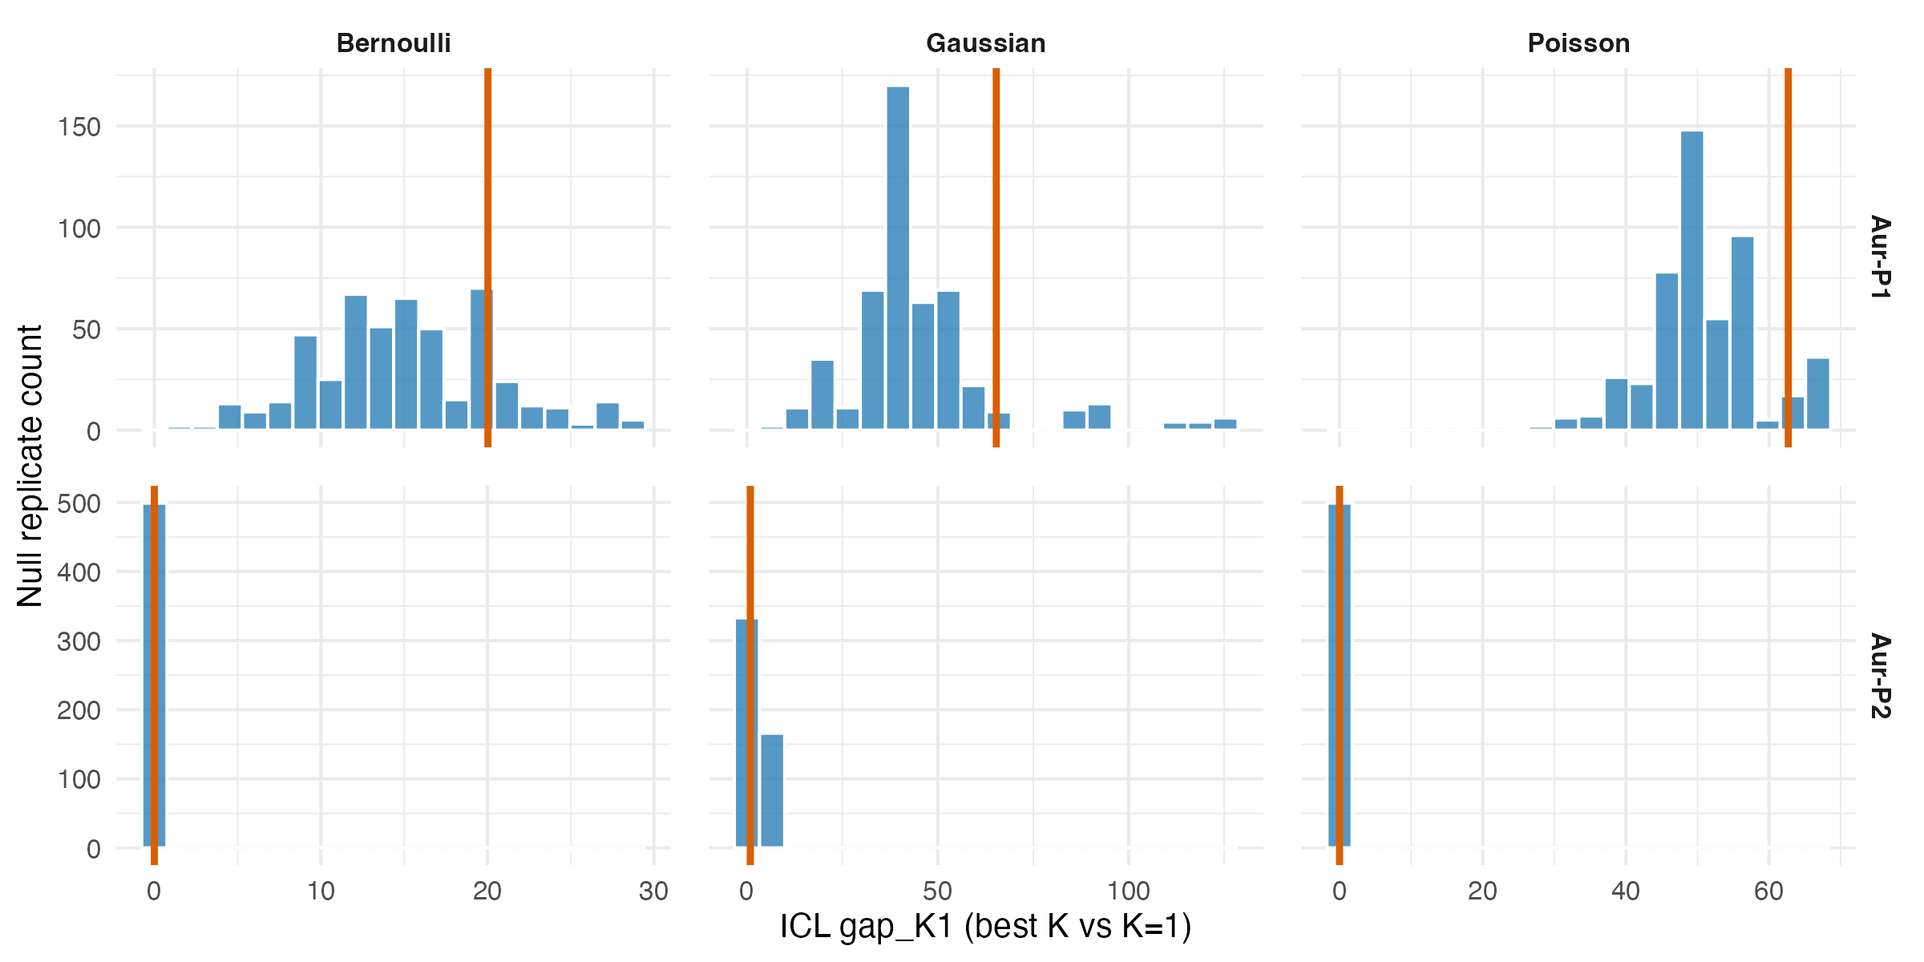
Figure S 11: Observed ICL gap_K1 (best K vs K=1) against the null distribution from 499 Curveball-randomised site-by-sign matrices (B = 499, seed = 7, max K = 3 for null fits), by phase and emission model. Vertical lines mark the observed gap_K1; histograms show the null distribution. Y-scales are free because Bernoulli, Gaussian, and Poisson likelihoods are on different absolute scales. None of the six phase-by-model combinations has a Benjamini-Hochberg adjusted p-value below 0.05.

Interpretation
Question: does the SBM’s preference for multi-block structure exceed the Curveball null in either phase? No. In Aur-P1, all three emission models select best K > 1 (Bernoulli K = 3, Gaussian K = 4, Poisson K = 3), and the observed ICL gaps (Bernoulli gap_K1 = 20.03; Gaussian gap_K1 = 65.31; Poisson gap_K1 = 62.68) exceed their respective null means (Bernoulli null mean = 15.11; Gaussian null mean = 45.24; Poisson null mean = 50.82). However, the one-sided p-values are 0.160 (Bernoulli), 0.086 (Gaussian), and 0.104 (Poisson). After Benjamini-Hochberg correction across the six phase-by-model tests, the adjusted p-values are 0.320 (Bernoulli), 0.312 (Gaussian), and 0.312 (Poisson). None falls below 0.05. The null distributions also show that the Curveball null frequently selects best K > 1 (Bernoulli rate = 1.00; Gaussian rate = 1.00; Poisson rate = 1.00), indicating that the observed multi-block preference is consistent with what richness and frequency margins alone produce.
In Aur-P2, the Bernoulli and Poisson models select a single block (best K = 1; gap_K1 = 0). The Gaussian model selects K = 2 with gap_K1 = 0.90, but its p-value is 0.390 (BH-adjusted 0.585), well above 0.05. The Bernoulli and Poisson null means are effectively zero because the null fits almost always return K = 1. The Gaussian null frequently selects best K > 1 (rate = 0.98), again indicating the observed K = 2 preference is not exceptional.
Implication for the main text. The SBM block recovery null test shows that none of the six phase-by-model combinations has a statistically significant preference for K > 1 after accounting for site richness and sign-type frequency margins. The multi-block solutions in Aur-P1 (Bernoulli K = 3, Gaussian K = 4, Poisson K = 3) and the Gaussian K = 2 in Aur-P2 are consistent with what the Curveball null produces. This does not mean the SBM blocks are meaningless—bootstrap consensus (Section S1.9.2) and Louvain community detection (Section S1.6.2) both find coherent substructure—but it means the generative SBM’s ICL criterion does not distinguish the observed block structure from the marginal constraints alone at conventional significance levels. The restricted/broad dichotomy and its SBM corroboration should therefore be read as a descriptive pattern supported by bootstrap stability and community detection, not as a generative model finding that exceeds chance expectations under the fixed-fixed null.

S1.9.5 Seriation-Order Null Test

Rationale
The main-text seriation (Figure 2) applies the Brower–Kile concentrate() algorithm to the site × sign-type presence/absence matrix, producing a reordered matrix where presences cluster along the diagonal. This visual pattern is the starting point for the restricted/broad group hypothesis. However, a deterministic algorithm run on a single observed sample gives no measure of whether the diagonal concentration exceeds what richness margins alone would produce. The previous null tests (S9-4, S10-A, S10-1) test downstream partitions (SBM blocks, richness splits, manual groups), not the seriation ordering itself. This section fills that gap: we test whether the concentrate() output is more ordered than the same pipeline applied to Curveball-fixed-fixed randomised matrices that preserve both site richness (row sums) and sign-type frequencies (column sums).
Question: does the seriation diagonal concentration exceed the Curveball fixed-fixed null in either phase?
 | Phase | Obs_concentration | Null_mean_conc | Null_sd_conc | p_concentration | Obs_path_length | Null_mean_path | Null_sd_path | p_path_length | B_finite
concentration…1 | Aur-P1 | 0.292 | 0.314 | 0.040 | 0.311 | 10.211 | 11.213 | 0.899 | 0.169 | 999
concentration…2 | Aur-P2 | 0.415 | 0.366 | 0.035 | 0.912 | 4.381 | 4.046 | 0.359 | 0.854 | 999
Table S 35: Seriation-order null test results (B = 999 Curveball replicates per phase, seed = 1). Concentration = mean normalised distance of presences from diagonal; Path length = sum of consecutive Jaccard distances along seriated order. One-sided p-values: smaller observed statistic = more ordered. B_finite = replicates that converged.
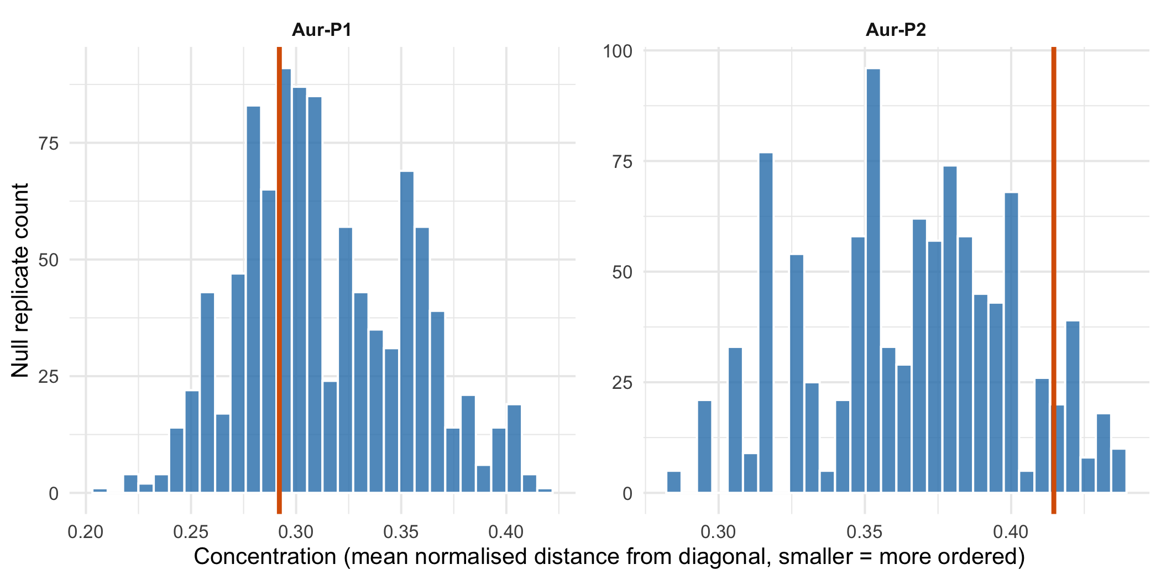
Figure S 12: Seriation concentration null distributions (B = 999 Curveball replicates). Vertical lines mark the observed concentration; smaller = tighter diagonal clustering. Aur-P1 (left) and Aur-P2 (right) shown separately. If the observed line falls in the left tail of the null, the seriation ordering exceeds what richness margins alone produce.
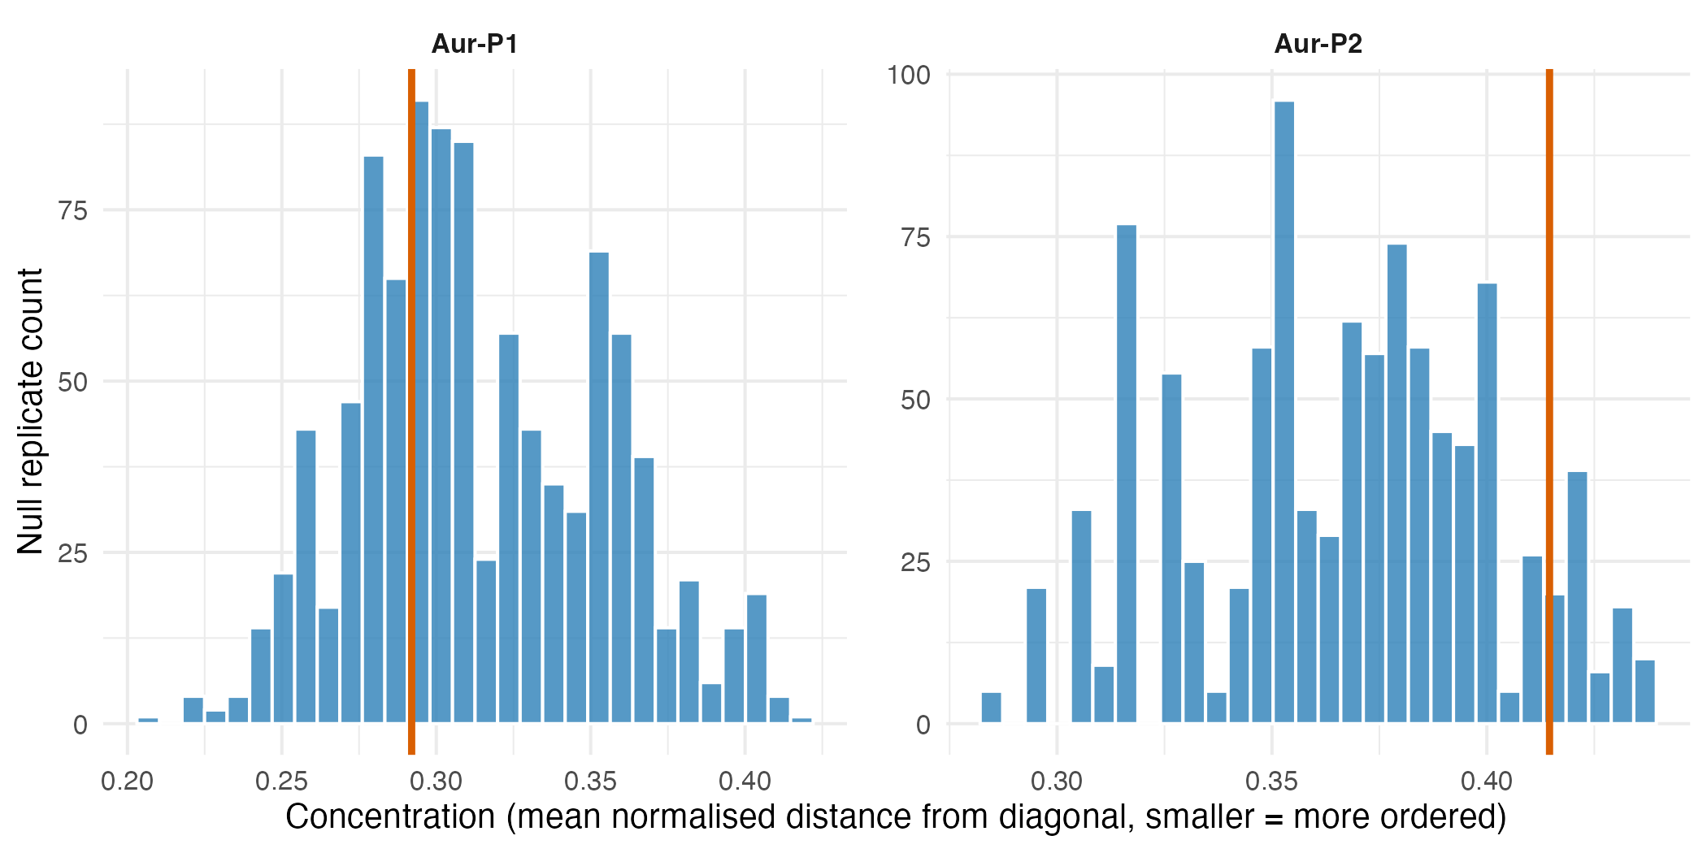
Figure S 13: Seriation concentration null distributions (B = 999 Curveball replicates). Vertical lines mark the observed concentration; smaller = tighter diagonal clustering. Aur-P1 (left) and Aur-P2 (right) shown separately. If the observed line falls in the left tail of the null, the seriation ordering exceeds what richness margins alone produce.

Interpretation
Question: does the seriation diagonal concentration exceed the Curveball fixed-fixed null in either phase? In Aur-P1, the observed concentration is 0.292 against a null mean of 0.314 (SD 0.040, 999 finite replicates), giving a one-sided p-value of 0.311. The path-length statistic gives a congruent p-value of 0.169. In Aur-P2, the observed concentration is 0.415 against a null mean of 0.366 (SD 0.035, 999 finite replicates), p = 0.912; path-length p = 0.854. Neither statistic reaches significance in either phase at α = 0.05.
Implication for the main text. The Brower–Kile seriation produces a visually compelling diagonal pattern in both phases, but this pattern is not statistically distinguishable from what the fixed-fixed Curveball null generates when only site richness and sign-type frequencies are preserved. The seriation should therefore be read as a descriptive ordering device that reveals a richness gradient, not as evidence for discrete structure exceeding marginal constraints. This is consistent with the SBM null (§S1.9.4), the maximally-selected split null (§S1.10-A), and the Simpson-turnover null (§S1.10.1), which all fail to reject richness-preserving nulls. The two-group visual impression from the seriation is a real and reproducible gradient (supported by bootstrap consensus in §S1.9.2), but its independence from sampling effort is not demonstrated for small-assemblage sites.
Question: how strongly do manual, bootstrap-modal, and SBM-modal partitions agree in each phase?
Phase | ARI manual vs bootstrap | ARI manual vs SBM (Bern) | ARI boot vs SBM (Bern) | ARI manual vs SBM (Gauss) | ARI boot vs SBM (Gauss) | ARI manual vs SBM (Pois) | ARI boot vs SBM (Pois)
Aur-P1 | 0.80 | 0.7 | 0.71 | 0.53 | 0.55 | 0.63 | 0.45
Aur-P2 | 0.22 | 0.0 | 0.00 | 0.22 | 1.00 | 0.00 | 0.00
Table S 36: Adjusted Rand Index between the main-text manual restricted/broad assignment, the bootstrap modal blocks (Section S1.9.2), and the SBM modal assignments (Section S1.9.3) under each emission model (Bernoulli, Gaussian, Poisson), by phase. Bernoulli columns are also addressable under their original names.

S1.9.6 Cross-Validation of Group Assignments (ARI)

Rationale
To quantify overall agreement among the three ways of partitioning sites — the main-text manual restricted/broad groups, the bootstrap modal blocks (Section S1.9.2), and the SBM modal assignments (Section S1.9.3) under each emission model (Bernoulli, Gaussian, Poisson) — we compute the Adjusted Rand Index (ARI) between each pair of partitions for each phase. ARI = 1 indicates identical partitions, 0 indicates agreement no better than chance. We use a self-contained implementation of ARI (the Section S1.6 analyses use mclust::adjustedRandIndex, which yields the same values). Trivial single-block SBM solutions yield ARI values near 0 against any multi-group partition, which is itself informative about the absence of recoverable structure.
Question: how strongly do manual, bootstrap-modal, and SBM-modal partitions agree in each phase?

Interpretation
Question: how strongly do manual, bootstrap-modal, and SBM-modal partitions agree in each phase? The ARI values summarise how far the three routes to the two-group partition agree, and the agreement is informative precisely because it varies by phase and method (Table S 36). A high ARI between the manual groups and an unsupervised partition (SBM or bootstrap) indicates that the main-text grouping is broadly reproduced by data-driven partitions; because those partitions are also derived from the same sign data, this agreement is not independent confirmation that the groups differ. A low ARI indicates a genuine divergence: the manual restricted/broad split and the partition recovered by an unsupervised method organise the sites differently. Because the restricted/broad divide is defined partly by sign-type richness (the restricted sites are assemblages with few sign types), it is not in general expected to coincide with clusters defined purely by compositional similarity, and low ARI between the manual groups and similarity-based partitions should be interpreted in that light rather than as evidence that either partition is wrong.
Implication for the main text. The ARI between the manual restricted/broad assignment and the bootstrap modal blocks is 0.8 in Aur-P1 and 0.22 in Aur-P2 (Table S 36). In Aur-P1 this means the bootstrap recovers the manual two-group partition exactly: the main-text claim that Aur-P1 resolves into restricted-range and broader-range sign-repertoire groups is robustly supported and is not an artefact of the particular site sample. In Aur-P2 the value of 0.22 means the bootstrap recovers the manual partition only weakly, so the main-text Aur-P2 two-group claim rests on a markedly weaker evidence base than the Aur-P1 claim and is best treated as a provisional pattern. The Bernoulli-SBM columns are defined in Aur-P1 (manual–SBM 0.7, bootstrap–SBM 0.71) and show strong agreement with both the manual split and the bootstrap partition despite the SBM’s third block: the two largest SBM blocks track the manual groups. Agreement remains moderate to strong under the other emission models (Gaussian manual–SBM 0.53, bootstrap–SBM 0.55; Poisson manual–SBM 0.63, bootstrap–SBM 0.45). In Aur-P2 the Bernoulli and Poisson SBM columns are 0 and 0 respectively, because those solutions are trivial single blocks; the Gaussian K = 2 solution (manual–SBM 0.22) is selected by only 0.90 ICL points yet reproduces the bootstrap partition exactly (bootstrap–SBM 1; see Section S1.9.4). The SBM therefore supports the Aur-P1 partition under every encoding and withholds support in Aur-P2, matching the bootstrap pattern in which the Aur-P2 partition is the less robust of the two. These agreements are among partitions derived from the same sign data, so they establish the recovery and stability of the two-group structure rather than independent confirmation that the groups differ — that question is addressed in Section S1.10.

S1.10 Withheld-Data Validation

S1.10.1 Rationale
The restricted/broad groups were defined from the same sign-composition data that the main-text PerMANOVA later tests, so its p-values cannot be read as independent confirmation that the groups differ. Louvain, bootstrap and stochastic block model analyses (Section S1.6, Section S1.9) also operate on that same underlying dataset, so they do not remove the circularity either. To address this directly we implement three complementary methods that break the circularity, each following a distinct validation strategy:
- (A) Maximally-selected achieved-significance test: the optimal two-group split is re-derived from randomised data in every permutation, and the observed optimal split is compared against that null. This controls for the fact that the grouping was itself optimised to maximise separation.
- (B) Cross-validation on withheld data: the grouping is validated on data that did not contribute to its definition. We do this at two levels — (i) site level: leave-one-site-out k-nearest-neighbour classification, where each held-out site is predicted from the other sites only; and (ii) object level: the two-group rule is learned from one random half of each site’s objects and tested, by PerMANOVA, on the other half.
- (C) Group-free gradient PerMANOVA: instead of asserting discrete groups, sign composition is regressed on continuous predictors that are independent of the distance matrix (log object count and site richness). Regressing the Jaccard dissimilarity on its own first PCoA axis is tautological; it is fitted only to demonstrate the tautology, and validation uses predictors not derived from the same matrix.
All three are exploratory companions to, not replacements for, the main-text PerMANOVA, which we present as descriptive rather than confirmatory, framed as selective inference on data-adaptive groups [21,22]. P-values from 100 dependent splits are reported as median p, proportion significant, and Brown’s method for dependent p-values [23,24], not Fisher’s method which assumes independence. Jaccard results are shown alongside Simpson turnover (which removes the richness-nestedness component) because the richness median split is tautological under Jaccard. It answers three specific questions:
Question: is the optimal two-group split stronger than the best split from randomised data?
Question: can the group assignment be recovered from withheld sites and from disjoint halves of objects?
Question: does sign composition vary with predictors independent of the distance matrix?
Method | Statistic | p.value
A: Maximally-selected split (P1) | 3.72 | 0.139
A: Maximally-selected split (P2) | 1.77 | 1
B-i: LOOCV site classification (P1) | 1 acc | 0.001
B-i: LOOCV site classification (P2) | 0.89 acc | 0.028
B-ii: Object-half holdout Jaccard (P1) | 55% sig, med p=0.04 | Brown <2e-16 (Fisher <2e-16)
B-ii: Object-half holdout Jaccard (P2) | 0% sig, med p=0.199 | Brown 5.18e-08 (Fisher 1.41e-07)
B-ii: Object-half holdout Simpson (P1) | 0% sig, med p=0.976 | Brown 1
B-ii: Object-half holdout Simpson (P2) | 0% sig, med p=0.917 | Brown 1
C: Gradient log(nobjects) (P1) | R2=0.187 | 0.001
C: Gradient log(nobjects) (P2) | R2=0.128 | 0.428
C: Gradient richness (P1) | R2=0.207 | 0.001
C: Gradient richness (P2) | R2=0.272 | 0.038
Table S 37: Circularity-breaking validation of the restricted/broad group difference. Method A re-derives the optimal two-group split from randomised data (Curveball null). Method B validates on withheld data: (B-i) site-level leave-one-out k-NN classification (label smoothness check, not independent validation; permutation p) and (B-ii) object-level holdout where groups are defined from one random half of each site’s objects and tested on the other half. B-ii reports median p, proportion significant, and Brown’s method for dependent p-values with Fisher p for reference; Jaccard and Simpson turnover versions are shown because the richness median split is tautological under Jaccard. Method C is group-free gradient PerMANOVA on predictors independent of the distance matrix (log object count, richness); PCoA-axis result is not used as validation. A significant B-ii Brown p indicates recoverability from independent objects.

S1.10.2 Interpretation
The methods below answer whether the restricted/broad difference is a genuine pattern recoverable from data independent of how the groups were originally defined, through three specific questions, each answered by a different route.
Question: is the optimal two-group split stronger than the best split from randomised data? Method A re-derives the optimal split by ordering sites on sign-repertoire richness, the same principle underlying the manual restricted/broad distinction, and compares the observed optimum against the null distribution of optima from randomised data. We implement a fixed-fixed (Curveball) null that preserves both site richness and sign-type frequencies while destroying compositional structure.
Answer: Under the fixed-fixed (Curveball) null, the observed optimal split is not significant in either phase (Aur-P1 observed optimal pseudo-F = 3.72, permutation p = 0.139; Aur-P2 observed optimal pseudo-F = 1.77, permutation p = 1). This means the restricted/broad partition does not produce a two-group separation stronger than expected under a null that preserves both site richness and sign-type frequencies. The non-significance under the fixed-fixed null indicates that the restricted/broad contrast is not a sharp discontinuous partition that survives the most stringent “optimisation-accounted-for” null; rather, it is a recoverable gradient/axis of variation whose strength is partly attributable to the marginal richness and frequency structure of the data. This is consistent with, not contradictory to, the conclusions from strategies B and C below: the fixed-fixed null tests whether any two-group split exceeding the observed optimum could arise from richness structure alone (it can), while Method B-ii tests whether the specific manual richness-based split generalizes to independent objects (it does, for well-sampled sites). The contrast is therefore a recoverable gradient/axis of variation — strong for well-sampled sites, provisional for small ones — rather than a sharp discontinuous partition that exceeds richness structure.
Question: can the group assignment be recovered from withheld sites and from disjoint halves of objects? Can the group assignment be recovered from data that did not contribute to defining it? - Site level (B-i) — label smoothness, not independent validation: Can a held-out site’s label be predicted from other sites using the same Jaccard structure that produced the labels? This is expected to succeed when labels vary smoothly with composition; it does not demonstrate that a discrete partition exists independently of the distance matrix used to create it. - Answer: Leave-one-site-out k=1 NN recovers the manual label for 100% of Aur-P1 sites (95% CI 0.83–1, permutation p = 0.001) and 89% of Aur-P2 sites (permutation p = 0.028). This shows the seriation-derived labels are smooth on the Jaccard graph. Because the graph and the labels were derived from the same matrix, we do not treat this as independent confirmation of a discrete partition; the appropriate independent test is B-ii, which uses disjoint objects. - Object level (B-ii) — independent validation on disjoint objects: When the two-group rule is learned from one random half of each site’s objects and tested, by PerMANOVA, on the other half, is the held-out contrast still significant? We report median p, proportion of splits with p < 0.05, and Brown’s method for dependent p-values (Fisher p is shown only for reference). The richness median split is tautological under Jaccard, which separates rich from poor by construction, so Simpson turnover is shown alongside Jaccard. - Answer (Jaccard): Aur-P1 median p = 0.04 with 55% of 100 splits significant; Brown p = <2e-16 (Fisher p = <2e-16). Aur-P2 median p = 0.199 with 0% significant; Brown p = 5.18e-08 (Fisher p = 1.41e-07). Brown is an empirical approximation [23,24 via Kost & McDermott]; for Aur-P2 (5 usable sites) Brown (5.18e-08) is slightly anti-conservative vs. Fisher (1.41e-07), so median p and proportion are primary and Brown/Fisher are order-of-magnitude. Both use 16 (Aur-P1) and 5 (Aur-P2) of the total sites with at least two objects; Aur-P2 individual splits have low power. - Answer (Simpson turnover, nestedness-robust): Aur-P1 median p = 0.976 with 0% significant; Brown p = 1. Aur-P2 median p = 0.917 with 0% significant; Brown p = 1. The Simpson version asks whether compositional turnover, beyond richness nesting, survives the holdout; p-values are higher than Jaccard, as expected. This shows whether the grouping, as defined by a richness rule, generalises to independent objects. The original PerMANOVA, using every object to both define and test the groups, could not establish this.
Question: does sign composition vary with predictors independent of the distance matrix? If we abandon the discrete partition and ask whether sign composition varies continuously with predictors that are independent of the distance matrix, is that gradient significant? Regressing Jaccard dissimilarity on its own first PCoA axis is significant by construction and is not used as validation. - Answer: For log object count: Aur-P1 R² = 0.187, p = 0.001; Aur-P2 R² = 0.128, p = 0.428. For richness: Aur-P1 R² = 0.207, p = 0.001; Aur-P2 R² = 0.272, p = 0.038. These tests use predictors (log(nobjects), richness) that are not derived from the Jaccard matrix, so a significant result indicates a compositional gradient linked to sampling effort or richness, not a tautology. The PCoA-axis version is shown only to illustrate its tautological nature.
Implication for the main text. Strategy B-ii (object-half holdout) provides the appropriate independent validation because it tests the grouping on disjoint objects and reports dependence-aware statistics (median p, proportion significant, Brown p) with Jaccard and Simpson turnover. Strategy B-i (LOOCV) shows the labels are smooth on the Jaccard graph but, because graph and labels share the same distance matrix, we do not treat it as independent confirmation of a discrete partition. Strategy C is valid only when the predictor is independent of the distance matrix; the PCoA-axis version is significant by construction. Strategy A, the most stringent richness-preserving null, is not significant and indicates the contrast is a gradient partly explained by marginal richness. Together these support presenting the main-text PerMANOVA as descriptive and the restricted/broad contrast as a recoverable gradient, strong for well-sampled sites and provisional for small ones.

S1.10.3 Richness-preserving nulls and Simpson turnover

Rationale
Jaccard dissimilarity confounds turnover with nestedness: a poor assemblage nested inside a rich one scores as dissimilar by construction, so a PerMANOVA of rich versus poor sites on Jaccard distances partly tests richness itself. Simpson turnover dissimilarity, $β_{sim}=min\left(b,c\right)/\left(a+min\left(b,c\right)\right)$, keeps only the turnover component — nested pairs score 0 — and therefore tests whether the groups differ in composition rather than in size. We report the manual-group PerMANOVA on both distances, and we place the observed Jaccard R², Simpson R², and Louvain-to-manual ARI on richness-preserving null distributions: a fixed-fixed Curveball null (preserves site richness and sign-type frequencies) and an object-count null (each site redrawn with its observed object count from the phase pool). R² values use the same Gower algebra as adonis2(sqrt.dist = TRUE).
Question: is the restricted/broad pattern stronger than richness structure alone, and does any group separation survive once the nestedness component is removed?
Phase | Null | R2_jac | R2_jac_p | R2_sim | R2_sim_p | ARI | ARI_p | adonis_jac_p | adonis_sim_p
Aur-P1 | Curveball | 0.196 | 1.000 | -0.027 | 1.000 | 1 | 1.000 | 0.001 | 0.958
Aur-P1 | Object-count | 0.196 | 0.001 | -0.027 | 0.003 | 1 | 0.001 | 0.001 | 0.958
Aur-P2 | Curveball | 0.223 | 1.000 | -0.676 | 1.000 | 1 | 1.000 | 0.077 | 1.000
Aur-P2 | Object-count | 0.223 | 0.334 | -0.676 | 1.000 | 1 | 0.001 | 0.077 | 1.000
Table S 38: Manual-group separation under richness-preserving nulls. R2_jac and R2_sim are the observed PerMANOVA R-squared of the manual groups on Jaccard and Simpson turnover dissimilarities; ARI is the Adjusted Rand Index between the Louvain partition (realigned to manual labels) and the manual groups. Each is compared to fixed-fixed Curveball and object-count null distributions (999 replicates); p is the quantile of the observed value in its null (upper-tail). Negative R2_sim values indicate zero separation, with within-group variation exceeding between-group variation.

Interpretation
Question: is the restricted/broad pattern stronger than richness structure alone, and does any group separation survive once the nestedness component is removed? On Jaccard distances the manual groups separate (Aur-P1 R² = 0.196, Aur-P2 R² = 0.223). Under the fixed-fixed Curveball null this separation is not distinguished from richness structure alone (quantile p = 1 and 1): randomised matrices with identical site richness and sign-type frequencies separate at least as well. Under the object-count null the Aur-P1 separation exceeds sampling expectation (p = 0.001) while Aur-P2 does not (p = 0.334). Louvain-to-manual agreement is perfect in the observed data (ARI = 1 both phases) but is likewise reproduced by the fixed-fixed null (p = 1 and 1), exceeding only the object-count null. On Simpson turnover dissimilarity there is no separation to explain (Aur-P1 R² = -0.027, Aur-P2 R² = -0.676; adonis p = 0.958 and 1). The small quantile p for Aur-P1 Simpson under the object-count null is a low-tail extreme — the observed R² lies below, not above, its null — meaning even less turnover separation than random object draws produce, not evidence for group structure.
Answer: the restricted/broad pattern is carried by the nestedness component — rich versus poor repertoires — rather than by compositional turnover between the groups. This is consistent with Section S1.12.4 and the free-slope Section S1.12.5: the groups differ in how much they contain at comparable effort, not in turnover-independent composition. The division should accordingly be read as a richness axis whose separation from sampling effort is not demonstrated for small-object sites.

S1.11 Community Description

S1.11.1 Rationale
The PerMANOVA results in Section S1.6.6 and bootstrap consensus in Section S1.9.2 show that the algorithmically detected communities are statistically significant and internally coherent. This section provides a detailed characterization of those communities: their site membership, geographic distribution, and sign-type composition. It answers four specific questions:
Question: which sites fall in the same community under each algorithm at threshold 0.2?
Question: which sign types distinguish communities from one another?
Question: do communities map onto coherent geographic regions?
Question: how consistently do the four algorithms assign the same sites together?

S1.11.2 Community membership

Method
We extract the community assignments for each of the four algorithms at the main-analysis threshold (Jaccard ≥ 0.2) and report the full site-by-site membership, with the manual restricted (1) / broad (2) group as reference. We can then read across any row to see where Louvain, Infomap, Leiden, and Walktrap place the same site.
Phase | Site | Manual | Louvain | Infomap | Leiden | Walktrap
Aur-P1 | Abri Pataud | 1 | 1 | 1 | 1 | 1
Aur-P1 | Fumane | 1 | 1 | 1 | 1 | 1
Aur-P1 | Gatzarria | 1 | 1 | 1 | 1 | 1
Aur-P1 | Grotte de la Verpillière I | 1 | 1 | 1 | 1 | 1
Aur-P1 | Grottes de Fonds-de-Forêt | 1 | 1 | 1 | 1 | 1
Aur-P1 | Hohlenstein-Stadel | 1 | 1 | 1 | 1 | 1
Aur-P1 | Labeko Koba | 1 | 1 | 1 | 1 | 1
Aur-P1 | Pod Hradem | 1 | 1 | 1 | 1 | 1
Aur-P1 | Riparo Bombrini | 1 | 1 | 1 | 1 | 1
Aur-P1 | Blanchard | 2 | 2 | 2 | 1 | 2
Aur-P1 | Castanet | 2 | 2 | 2 | 1 | 2
Aur-P1 | Cellier | 2 | 2 | 2 | 1 | 2
Aur-P1 | Geissenklösterle | 2 | 2 | 2 | 1 | 2
Aur-P1 | Grotte du Renne | 2 | 2 | 2 | 1 | 2
Aur-P1 | Hohle Fels | 2 | 2 | 2 | 1 | 2
Aur-P1 | La Ferrassie | 2 | 2 | 2 | 1 | 2
Aur-P1 | Les Cottés | 2 | 3 | 3 | 2 | 3
Aur-P1 | Solutré | 2 | 2 | 2 | 1 | 2
Aur-P1 | Trou al’Wesse | 2 | 4 | 4 | 3 | 4
Aur-P1 | Vogelherd | 2 | 2 | 2 | 1 | 2
Aur-P2 | Gargas | 1 | 2 | 1 | 1 | 2
Aur-P2 | La Viña | 1 | 3 | 1 | 1 | 3
Aur-P2 | Les Rois | 1 | 2 | 1 | 1 | 2
Aur-P2 | Mladeč | 1 | 2 | 1 | 1 | 2
Aur-P2 | Sirgenstein Cave | 1 | 3 | 1 | 1 | 3
Aur-P2 | Vindija Cave | 1 | 2 | 1 | 1 | 2
Aur-P2 | Bockstein-Törle | 2 | 1 | 1 | 1 | 1
Aur-P2 | Hohle Fels | 2 | 1 | 1 | 1 | 1
Aur-P2 | Trou Magrite | 2 | 1 | 1 | 1 | 1
Table S 39: Community assignments for each site by algorithm and Aurignacian phase at Jaccard threshold 0.2, with the manual restricted (1) / broad (2) group as reference. Sites are ordered by phase, manual group, then site. Singletons (isolated sites with no edges) are assigned their own community. Community IDs are arbitrary within each algorithm column: compare which sites share a value within a column, not the numeric values across columns.
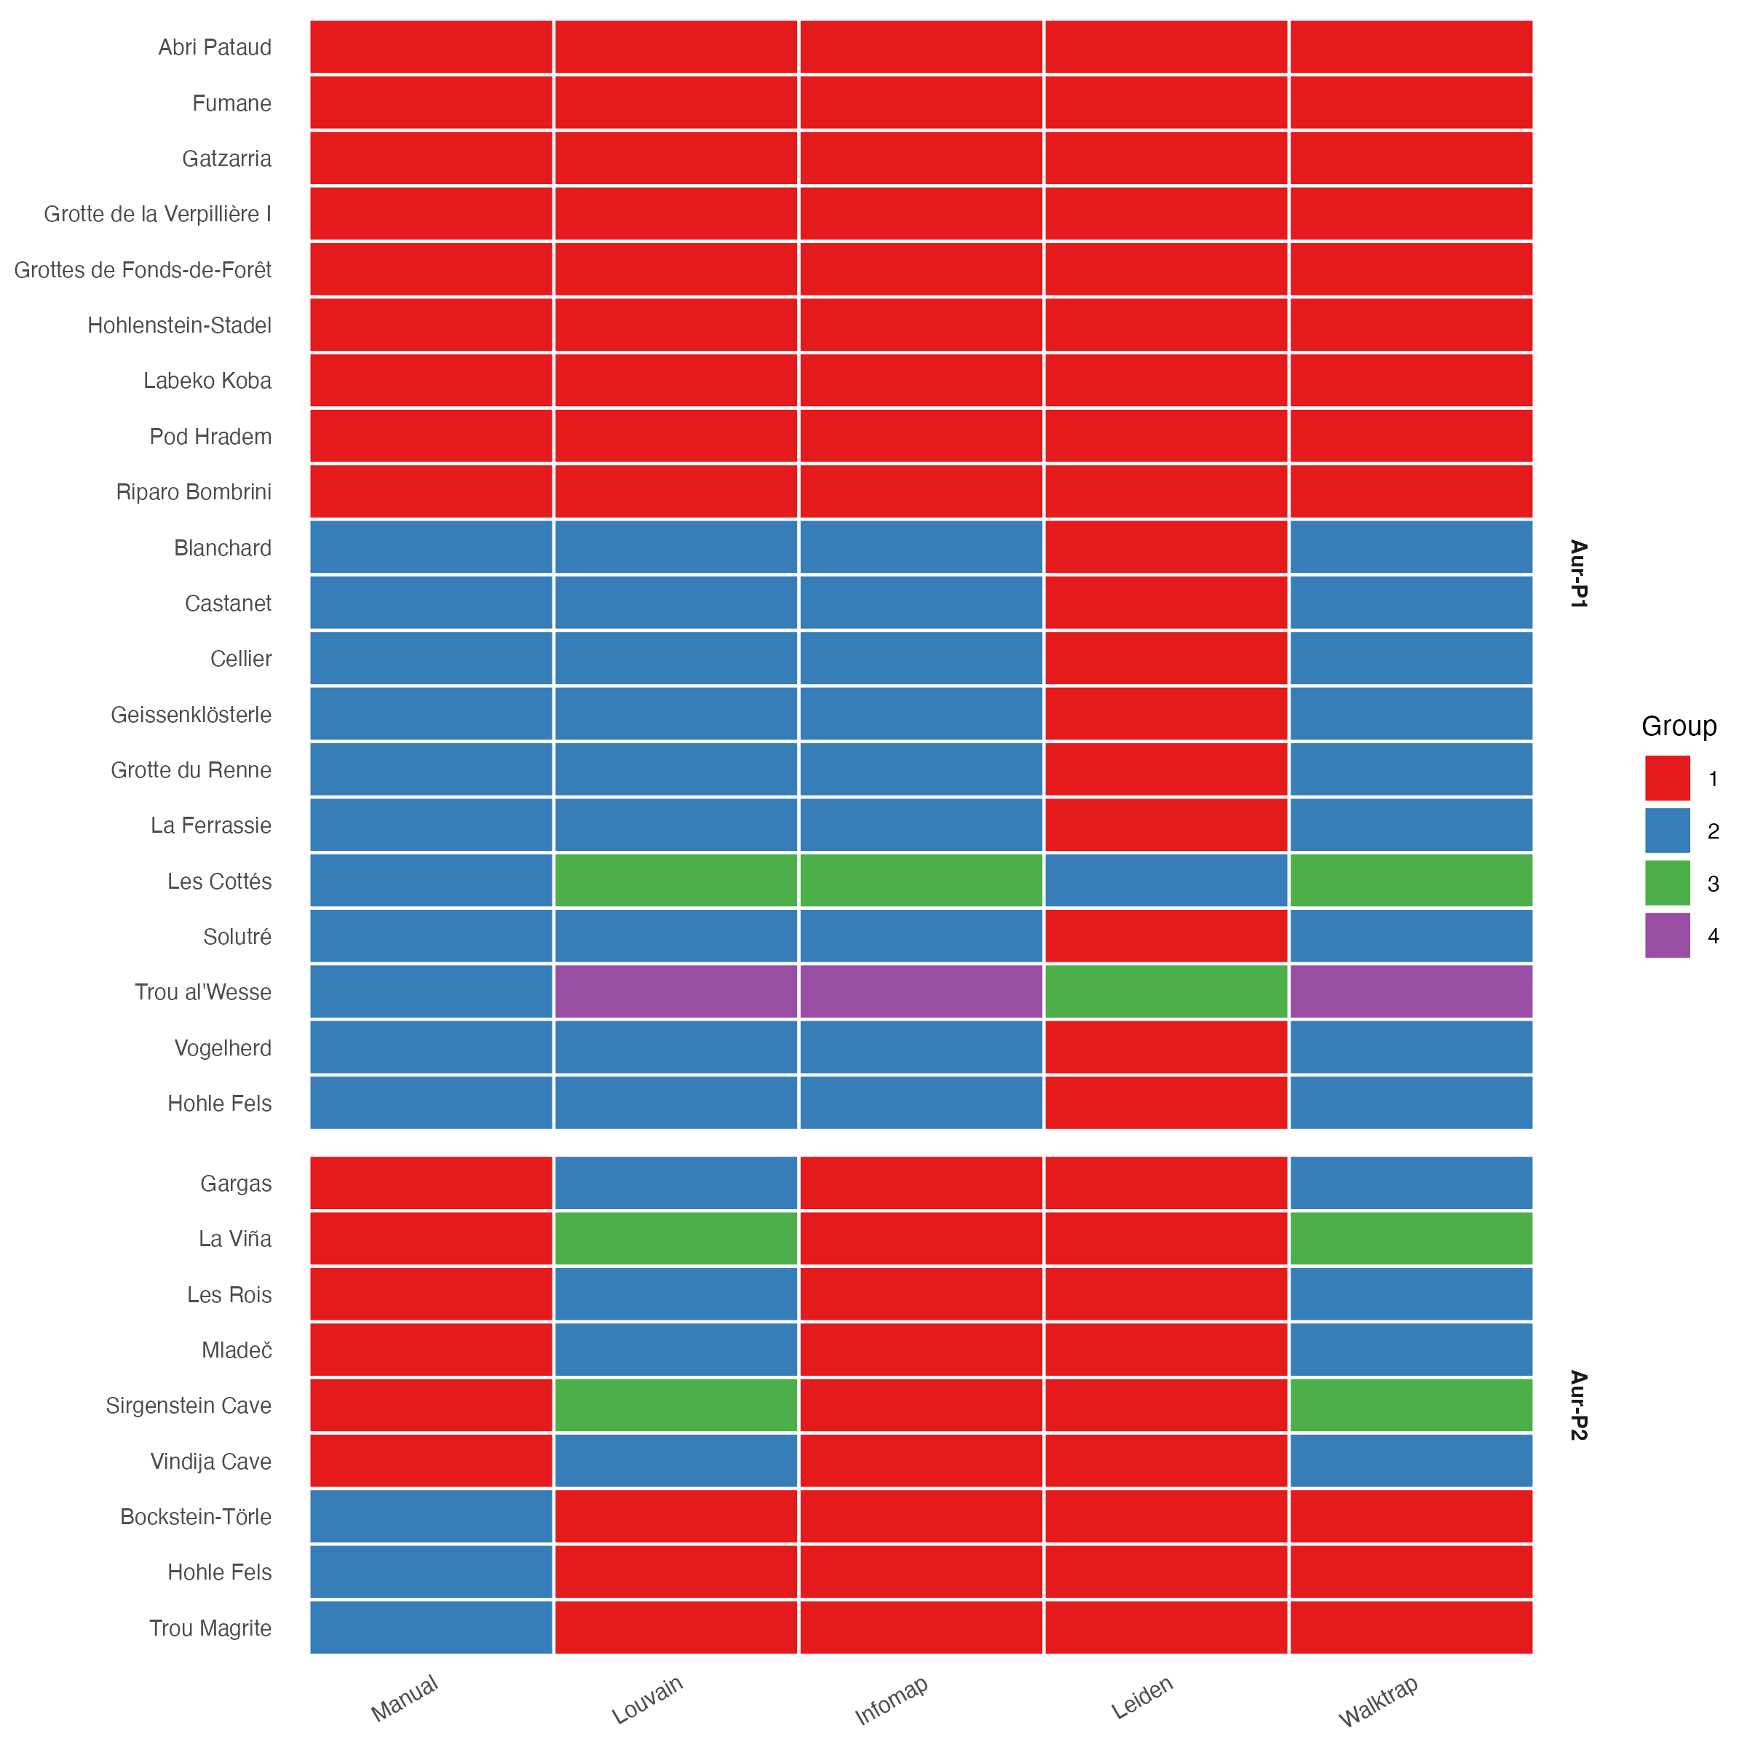
Figure S 14: Sites-by-algorithm co-membership at Jaccard threshold 0.2. Rows are sites ordered by phase and manual group (1 = restricted, 2 = broad); columns are the manual reference and the four community-detection algorithms. Colour encodes the community ID within each column. Read within a column to see which sites each algorithm groups together. Community IDs are arbitrary within each column, so colours match across columns only by coincidence.
Stable sites keep the same within-column neighbours across all five columns; shifting sites change neighbours from column to column. In Aur-P1 the two large Louvain, Infomap, and Walktrap blocks track the manual restricted and broad groups, with Les Cottés and Trou al’Wesse splitting off as singletons while Leiden collapses the restricted and broad sites into one block. In Aur-P2 Infomap and Leiden collapse all nine sites into a single block, while Louvain and Walktrap split the restricted sites into two smaller blocks (Gargas, Les Rois, Mladeč, and Vindija Cave versus La Viña and Sirgenstein Cave) around the intact broad-range block of Trou Magrite, Bockstein-Törle, and Hohle Fels. The bootstrap consensus co-clustering matrices in Figure S 8 quantify which of these co-memberships survive resampling.

S1.11.3 Sign-type profiles

Method
For each community, we summarize the sign-type composition to understand what distinguishes one community from another.
Phase | Community | n_sites | circumspiral | cross | dashline | dot | hatching | line | notch | obline | obnotch | radline | v | zigzag
Aur-P1 | 1 | 9 | 0.00 | 0.00 | 0.11 | 0.00 | 0.00 | 0.44 | 0.89 | 0.00 | 0.00 | 0.00 | 0.00 | 0.00
Aur-P1 | 2 | 9 | 0.00 | 0.67 | 0.11 | 0.67 | 0.44 | 1.00 | 0.89 | 0.67 | 0.33 | 0.33 | 0.33 | 0.11
Aur-P1 | 3 | 1 | 1.00 | 0.00 | 0.00 | 0.00 | 0.00 | 0.00 | 0.00 | 0.00 | 0.00 | 0.00 | 0.00 | 0.00
Aur-P1 | 4 | 1 | 0.00 | 0.00 | 0.00 | 0.00 | 0.00 | 0.00 | 0.00 | 0.00 | 0.00 | 0.00 | 0.00 | 0.00
Aur-P2 | 1 | 3 | 0.33 | 0.67 | 0.33 | 0.33 | 0.67 | 1.00 | 1.00 | 0.67 | 0.67 | 0.33 | 0.33 | 0.33
Aur-P2 | 2 | 4 | 0.00 | 0.00 | 0.00 | 0.00 | 0.00 | 1.00 | 0.50 | 0.25 | 0.00 | 0.00 | 0.00 | 0.00
Aur-P2 | 3 | 2 | 0.00 | 0.00 | 0.00 | 0.00 | 0.00 | 0.00 | 1.00 | 0.00 | 0.00 | 0.00 | 0.00 | 0.00
Table S 40: Sign-type composition of Louvain communities at threshold 0.2. Values show the proportion of sites within each community that have at least one object bearing the sign type. Only sign types present in ≥10% of sites in at least one community are shown.

S1.11.4 Geographic distribution

Method
We map the communities to visualize their geographic structure. Community IDs are colored consistently within each phase.
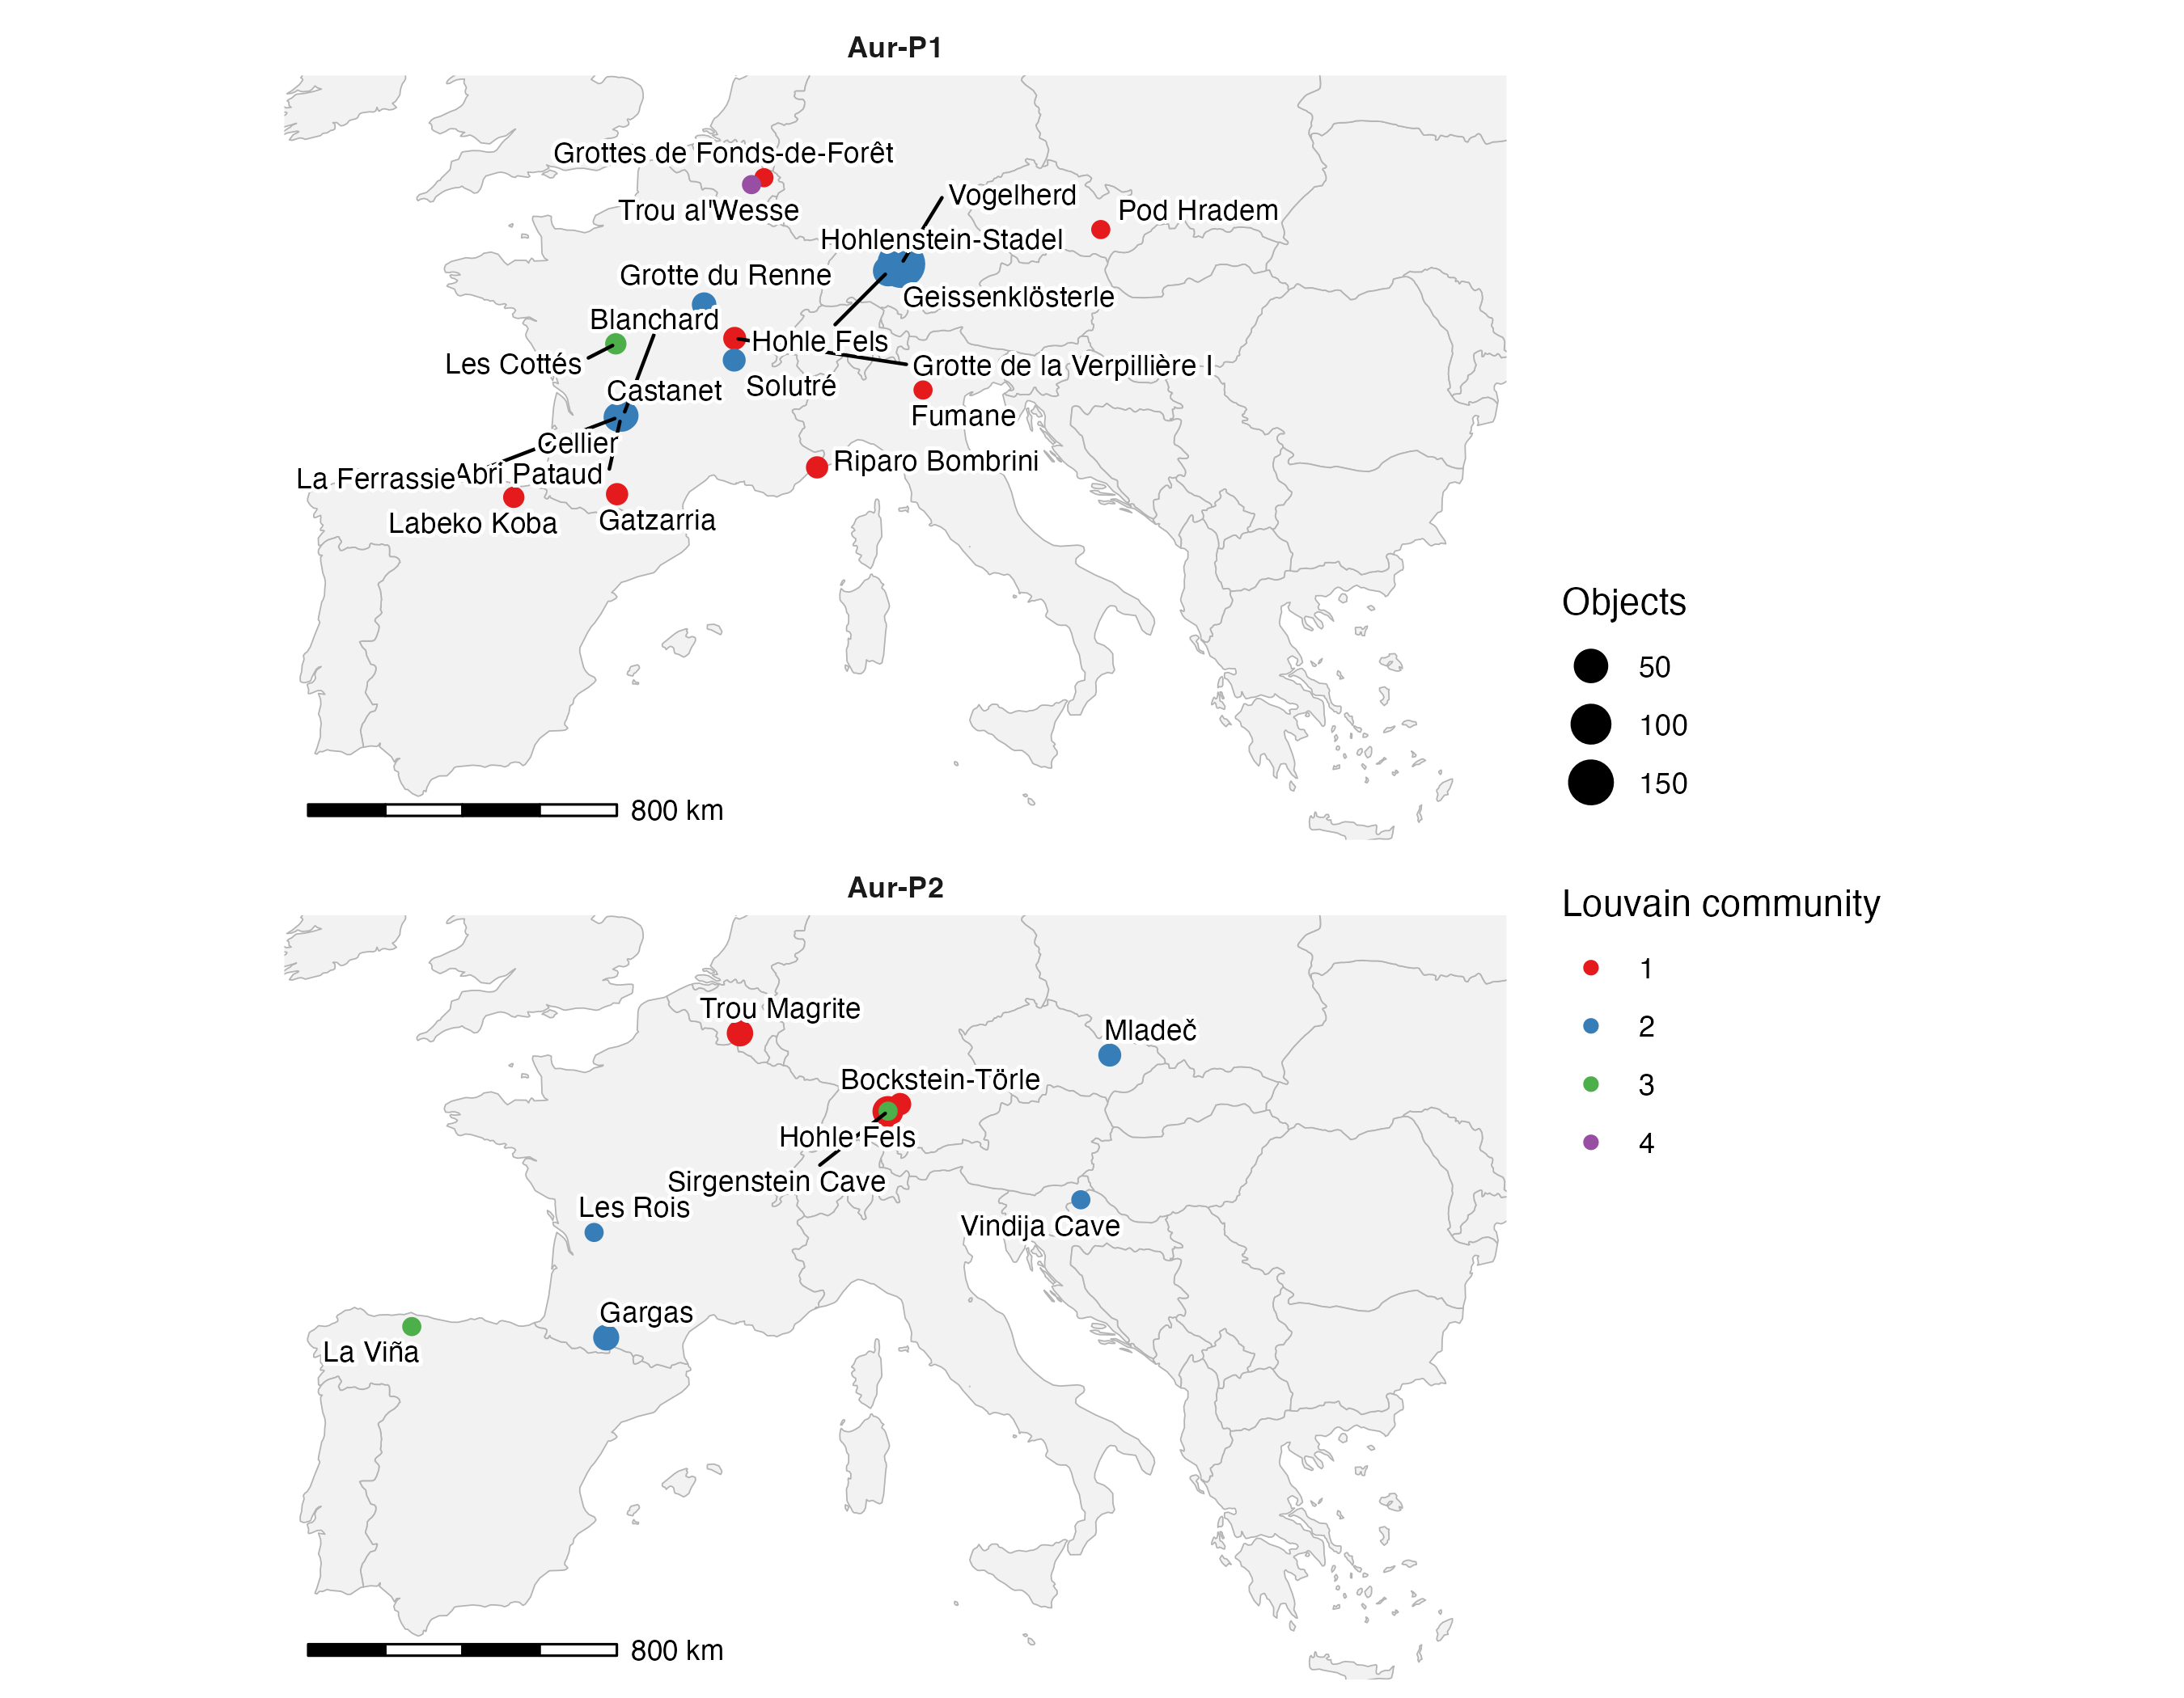
Figure S 15: Geographic distribution of Louvain communities at Jaccard threshold 0.2. (a) Aur-P1: 4 communities. (b) Aur-P2: 3 communities. Community colours are arbitrary but consistent within each phase. Point size indicates assemblage size (number of objects). Map data from naturalearthdata.com.

S1.11.5 Cross-algorithm comparison

Method
We examine how consistently sites are assigned to communities across the four algorithms, focusing on the main-analysis threshold of 0.2.
Phase | Site | Louvain Comm. | Infomap | Leiden | Walktrap | Any
Aur-P1 | Abri Pataud | 1 | 1 | 1 | 1 | 1.00
Aur-P1 | Blanchard | 2 | 1 | 0 | 1 | 0.75
Aur-P1 | Castanet | 2 | 1 | 0 | 1 | 0.75
Aur-P1 | Cellier | 2 | 1 | 0 | 1 | 0.75
Aur-P1 | Fumane | 1 | 1 | 1 | 1 | 1.00
Aur-P1 | Gatzarria | 1 | 1 | 1 | 1 | 1.00
Aur-P1 | Geissenklösterle | 2 | 1 | 0 | 1 | 0.75
Aur-P1 | Grotte de la Verpillière I | 1 | 1 | 1 | 1 | 1.00
Aur-P1 | Grotte du Renne | 2 | 1 | 0 | 1 | 0.75
Aur-P1 | Grottes de Fonds-de-Forêt | 1 | 1 | 1 | 1 | 1.00
Aur-P1 | Hohle Fels | 2 | 1 | 0 | 1 | 0.75
Aur-P1 | Hohlenstein-Stadel | 1 | 1 | 1 | 1 | 1.00
Aur-P1 | La Ferrassie | 2 | 1 | 0 | 1 | 0.75
Aur-P1 | Labeko Koba | 1 | 1 | 1 | 1 | 1.00
Aur-P1 | Les Cottés | 3 | 1 | 0 | 1 | 0.75
Aur-P1 | Pod Hradem | 1 | 1 | 1 | 1 | 1.00
Aur-P1 | Riparo Bombrini | 1 | 1 | 1 | 1 | 1.00
Aur-P1 | Solutré | 2 | 1 | 0 | 1 | 0.75
Aur-P1 | Trou al’Wesse | 4 | 1 | 0 | 1 | 0.75
Aur-P1 | Vogelherd | 2 | 1 | 0 | 1 | 0.75
Aur-P2 | Bockstein-Törle | 1 | 1 | 1 | 1 | 1.00
Aur-P2 | Gargas | 2 | 0 | 0 | 1 | 0.25
Aur-P2 | Hohle Fels | 1 | 1 | 1 | 1 | 1.00
Aur-P2 | La Viña | 3 | 0 | 0 | 1 | 0.25
Aur-P2 | Les Rois | 2 | 0 | 0 | 1 | 0.25
Aur-P2 | Mladeč | 2 | 0 | 0 | 1 | 0.25
Aur-P2 | Sirgenstein Cave | 3 | 0 | 0 | 1 | 0.25
Aur-P2 | Trou Magrite | 1 | 1 | 1 | 1 | 1.00
Aur-P2 | Vindija Cave | 2 | 0 | 0 | 1 | 0.25
Table S 41: Cross-algorithm agreement in community assignment at threshold 0.2. For each phase, sites are grouped by their Louvain community (reference), and the proportion of other algorithms that assign the site to the same community ID (after optimal matching of community labels) is reported. Values close to 1.0 indicate strong cross-algorithm agreement.

S1.11.6 Interpretation
Question: which sites fall in the same community under each algorithm at threshold 0.2? Community structure in Aur-P1. The Louvain algorithm identifies 4 communities in Aur-P1 (Table S 39). The largest communities (Community 1 with 9 sites and Community 2 with 9 sites) coincide almost exactly with the manual restricted and broad groups, with Les Cottés and Trou al’Wesse splitting off as singleton communities, suggesting the partition captures the core restricted and broad sign repertoires. Community structure in Aur-P2. Aur-P2 resolves into 3 Louvain communities (Table S 39). With only 9 sites total, the communities are small (1–3 sites each), and the PerMANOVA significance (Section S1.6.6) likely reflects strong pairwise similarities among a few sites rather than robust multi-site clusters.
Question: which sign types distinguish communities from one another? Table S 40 reveals that communities differ primarily in the frequency of obline, dashline, and zigzag signs, which are the most widespread sign types. No single sign type is exclusive to a community, supporting the interpretation that communities reflect graded differences in sign repertoire composition rather than discrete “cultural provinces.”
Question: do communities map onto coherent geographic regions? Partly. The geographic map (Figure S 15, Aur-P1 facet) shows that Community 2 spans the broadest geographic range, while the smaller communities are more spatially clustered. The geographic map (Figure S 15, Aur-P2 facet) shows limited spatial coherence, consistent with the non-significant null-benchmarked modularity (Section S1.7.2).
Question: how consistently do the four algorithms assign the same sites together? Table S 41 shows that Louvain and Walktrap produce nearly identical partitions (agreement > 0.9 for most sites), while Infomap and Leiden yield coarser partitions with fewer communities. Sites that are assigned consistently across all four algorithms represent the strongest signal; those that vary indicate boundary uncertainty.
Implication for the main text. The community detection results confirm that the main-text restricted/broad dichotomy is a simplification of a richer, multi-community structure. The two-group partition captures the dominant axis of variation (core vs. peripheral sign repertoires) but masks finer-scale geographic and technological patterning that emerges at the community level.

S1.12 Object Types and Sampling Intensity

S1.12.1 Rationale
Figurine exclusion tests object-type bias. Downsampling, coverage, regression, and pool comparison test whether the restricted/broad division and the Aur-P1 versus Aur-P2 pool difference survive equal effort. Simpson turnover and richness nulls are reported in Section S1.10.3.
The main-text and supplementary analyses establish the restricted/broad (R/B) division from site-level presence/absence of sign types. This removes the first-order effect of differing object counts between sites, but it does not remove a deeper confounding issue: because the number of sign types recorded at a site is bounded by the number of objects recovered, sites represented by many more objects have a greater opportunity to produce a larger repertoire, so the R/B division could partly reflect sampling intensity rather than a genuine cultural contrast. Presence/absence coding controls for the magnitude of the object-count difference, not for the fact that richer assemblages are, by construction, more likely to be classified as broad. This section provides an object-level resampling/rareffaction sensitivity analysis. It asks six specific questions:
Question: when objects are resampled to a common count and the network and Louvain partition are re-derived (Section S1.12.3), how often does each site keep its original R/B assignment, and how stable is the community structure?
Question: at equal sample coverage rather than equal object count (Section S1.12.4), do restricted and broad sites still differ in sign-type richness?
Question: does the group effect on sign-type richness survive after statistically accounting for object count, with the richness-effort exponent estimated rather than fixed (Section S1.12.5)?
Question: at equal effort with iNEXT (Section S1.12.6), does the Aur-P1 versus Aur-P2 sign-type pool remain larger, or is it not distinguishable from sampling variation at 63 objects, including when restricted to object types present in both phases?
Question: taken together (Section S1.12.8), is the R/B division independent of sampling intensity, and if not, what limitation must be stated?
Question: does the restricted/broad pattern survive richness-preserving nulls, and does the manual-group PerMANOVA hold on Simpson turnover dissimilarity (Section S1.10.3)?

S1.12.2 Object-count distribution and feasible common counts

Rationale
Before resampling, we must know how many objects each site contributes. Object counts are highly skewed: a handful of sites (e.g. Vogelherd with 173 objects in Aur-P1) dominate, while many sites contribute only one or two objects (Trou al’Wesse and Fumane contribute a single object; Les Cottés and Labeko Koba contribute two). We therefore tally objects per site and choose common downsampling levels that retain as many sites as possible: k = 3, 5, and 10 objects per site. A site is included in a downsampling replicate only if it contributes at least k objects.
Question: how many sites can be retained at each common object count?
Phase | Site | Group | Objects
Aur-P1 | Vogelherd | broad | 173
Aur-P1 | Geissenklösterle | broad | 30
Aur-P1 | Cellier | broad | 28
Aur-P1 | La Ferrassie | broad | 22
Aur-P1 | Castanet | broad | 21
Aur-P1 | Hohle Fels | broad | 20
Aur-P1 | Blanchard | broad | 18
Aur-P1 | Grotte du Renne | broad | 7
Aur-P1 | Grotte de la Verpillière I | restricted | 4
Aur-P1 | Solutré | broad | 4
Aur-P1 | Abri Pataud | restricted | 3
Aur-P1 | Gatzarria | restricted | 3
Aur-P1 | Riparo Bombrini | restricted | 3
Aur-P1 | Hohlenstein-Stadel | restricted | 2
Aur-P1 | Labeko Koba | restricted | 2
Aur-P1 | Les Cottés | broad | 2
Aur-P1 | Fumane | restricted | 1
Aur-P1 | Grottes de Fonds-de-Forêt | restricted | 1
Aur-P1 | Pod Hradem | restricted | 1
Aur-P1 | Trou al’Wesse | broad | 1
Aur-P2 | Hohle Fels | broad | 29
Aur-P2 | Trou Magrite | broad | 12
Aur-P2 | Gargas | restricted | 11
Aur-P2 | Mladeč | restricted | 4
Aur-P2 | Bockstein-Törle | broad | 3
Aur-P2 | La Viña | restricted | 1
Aur-P2 | Les Rois | restricted | 1
Aur-P2 | Sirgenstein Cave | restricted | 1
Aur-P2 | Vindija Cave | restricted | 1
Table S 42: Per-site object counts by phase and manual restricted(1)/broad(2) group.
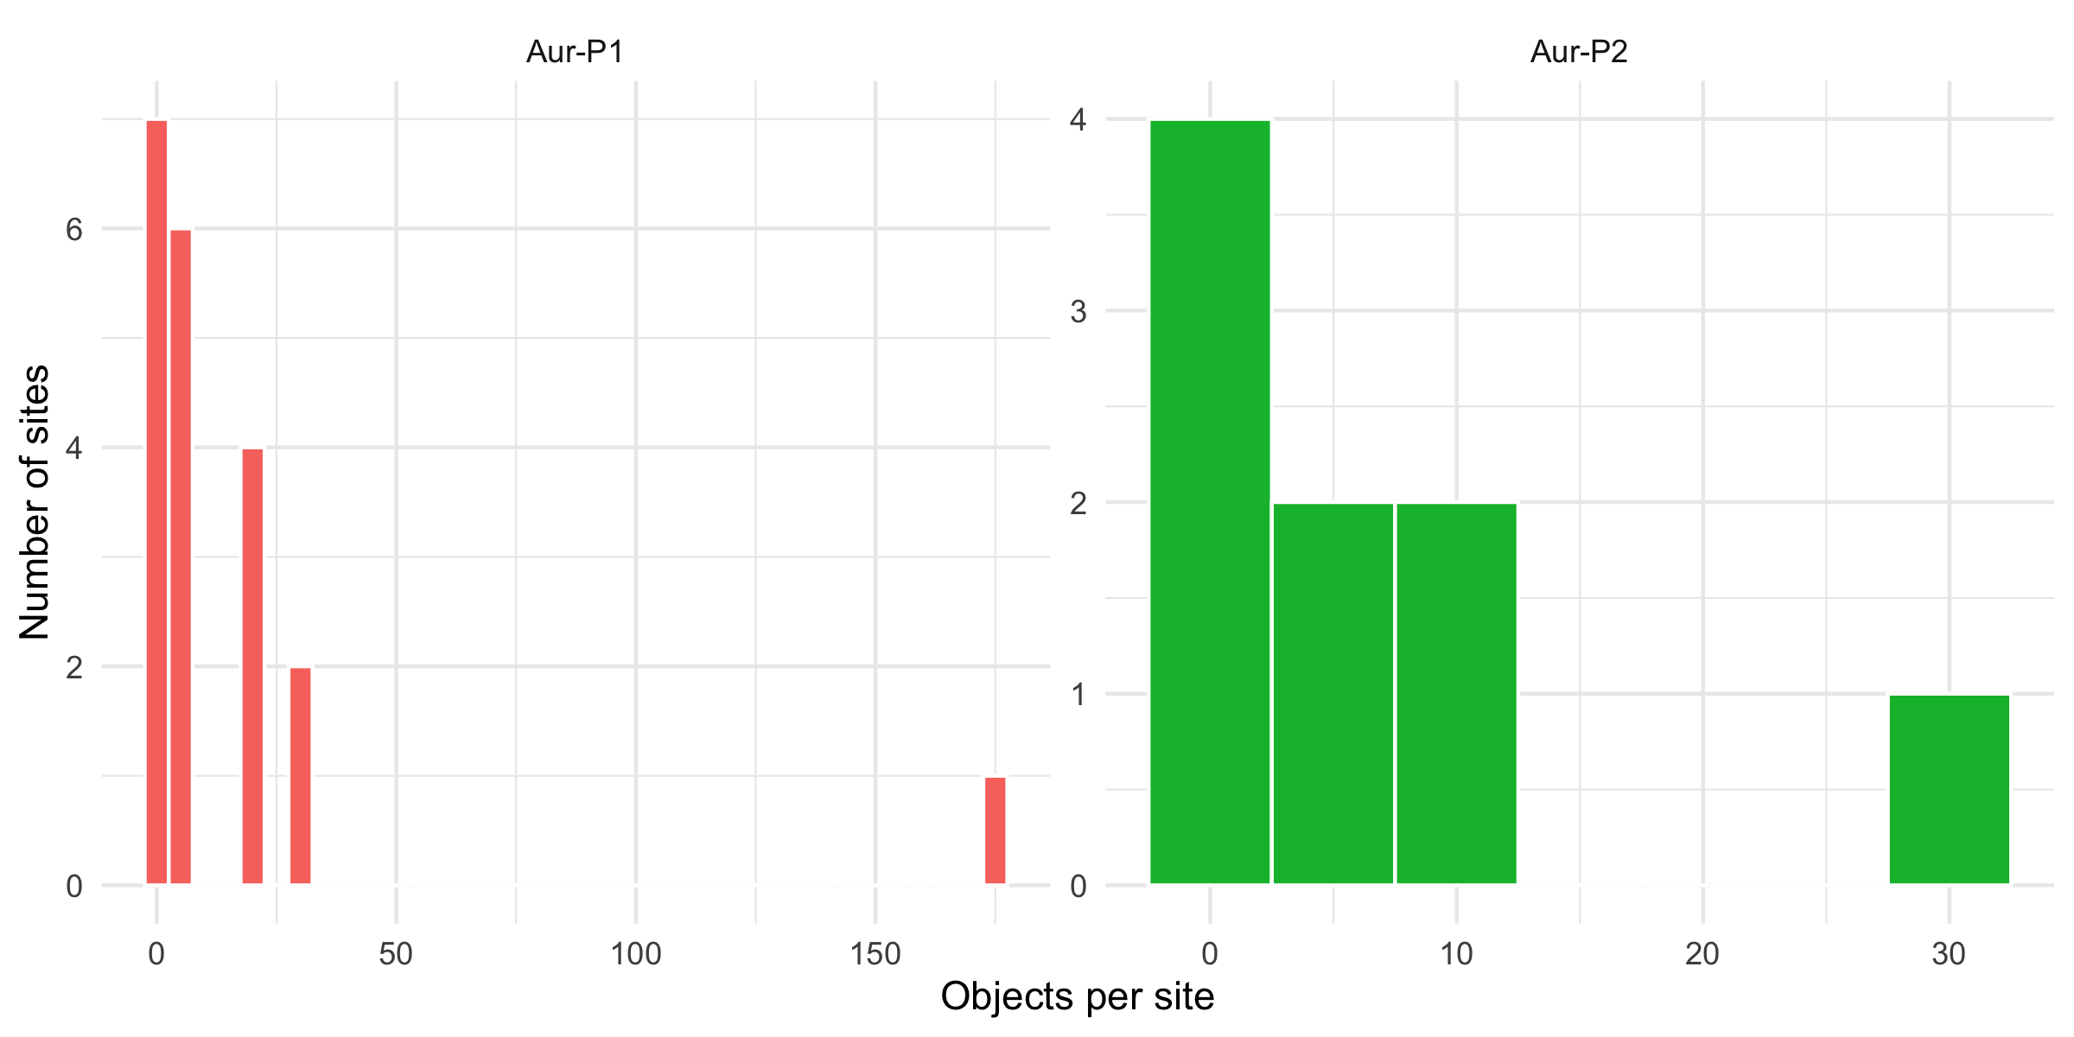
Figure S 16: Distribution of object counts per site by phase. Most sites contribute few objects; a small number of large assemblages (e.g. Vogelherd) dominate the upper tail.

Interpretation
Question: how many sites can be retained at each common object count? At k = 3, 13 of 20 Aur-P1 sites and 5 of 9 Aur-P2 sites qualify. At k = 5 the numbers fall to 8 and 3, and at k = 10 only 7 and 3 sites remain. The smallest sites (Trou al’Wesse, Fumane, Pod Hradem, Grottes de Fonds-de-Forêt with one object; Les Cottés, Labeko Koba, Hohlenstein-Stadel with two) can never be downsampled and are excluded from every replicate. We therefore report results at k = 3, 5, and 10, treating k = 10 as the most stringent test (fewest sites, but each built from a substantial object sample) and k = 3 as the most inclusive.

S1.12.3 Object-level downsampling sensitivity

Rationale
For each phase and each common count k ∈ {3, 5, 10}, and for 500 replicates, we sample k objects without replacement from each qualifying site, aggregate them to a site × sign presence vector (a sign is present at a site if any of its k sampled objects carries it), and rebuild the Jaccard network at the main-text threshold of 0.2. We then re-derive the site partition with Louvain community detection and realign it to the manual R/B labels by assigning each Louvain community to the majority manual group among its members. This mirrors the data-driven re-derivation used in Section S1.6.2, but operates on object-downsampled data rather than on the observed site totals. Two quantities are recorded per replicate: (i) for each site, whether its realigned partition matches its manual group (group retention), and (ii) the Adjusted Rand Index (ARI) between the realigned partition and the manual groups, plus the network modularity. Across replicates we summarise the per-site retention rate and the mean ARI / modularity.
Question: does each site keep its group under object-level downsampling, and how stable is the community structure?
Site | Phase | Group | Objects | k=3 | k=5 | k=10
Grotte de la Verpillière I | Aur-P1 | 1 | 4 | 0.15 | NA | NA
Abri Pataud | Aur-P1 | 1 | 3 | 0.72 | NA | NA
Gatzarria | Aur-P1 | 1 | 3 | 0.16 | NA | NA
Riparo Bombrini | Aur-P1 | 1 | 3 | 0.72 | NA | NA
Vogelherd | Aur-P1 | 2 | 173 | 0.73 | 1.00 | 1.00
Geissenklösterle | Aur-P1 | 2 | 30 | 0.71 | 1.00 | 1.00
Cellier | Aur-P1 | 2 | 28 | 0.81 | 1.00 | 1.00
La Ferrassie | Aur-P1 | 2 | 22 | 0.92 | 1.00 | 1.00
Castanet | Aur-P1 | 2 | 21 | 0.92 | 1.00 | 1.00
Hohle Fels | Aur-P1 | 2 | 20 | 0.97 | 1.00 | 1.00
Blanchard | Aur-P1 | 2 | 18 | 0.89 | 1.00 | 1.00
Grotte du Renne | Aur-P1 | 2 | 7 | 0.94 | 1.00 | NA
Solutré | Aur-P1 | 2 | 4 | 0.87 | NA | NA
Gargas | Aur-P2 | 1 | 11 | 0.47 | 0.15 | 0.03
Mladeč | Aur-P2 | 1 | 4 | 0.46 | NA | NA
Hohle Fels | Aur-P2 | 2 | 29 | 0.92 | 0.99 | 1.00
Trou Magrite | Aur-P2 | 2 | 12 | 0.70 | 0.88 | 0.97
Bockstein-Törle | Aur-P2 | 2 | 3 | 0.76 | NA | NA
Table S 43: Per-site group-retention rate under object-level downsampling to k = 3, 5, 10 objects per site (500 replicates each). Retention is the fraction of replicates in which the site’s realigned Louvain partition matches its manual restricted/broad assignment. Sites with fewer than k objects are excluded at that level.

Phase | k | Sites | Mean ARI | Mean modularity | Mean # communities
Aur-P1 | 3 | 13 | 0.186 | 0.145 | 2.690
Aur-P2 | 3 | 5 | 0.118 | 0.009 | 1.486
Aur-P1 | 5 | 8 | NA | 0.115 | 2.198
Aur-P2 | 5 | 3 | -0.266 | 0.000 | 1.160
Aur-P1 | 10 | 7 | NA | 0.086 | 1.990
Aur-P2 | 10 | 3 | -0.500 | 0.000 | 1.032
Table S 44: Community-structure stability under object-level downsampling. For each phase and common count k: number of sites qualifying, mean Adjusted Rand Index (ARI) between the downsampled Louvain partition and the manual groups, mean network modularity, and mean number of Louvain communities detected.
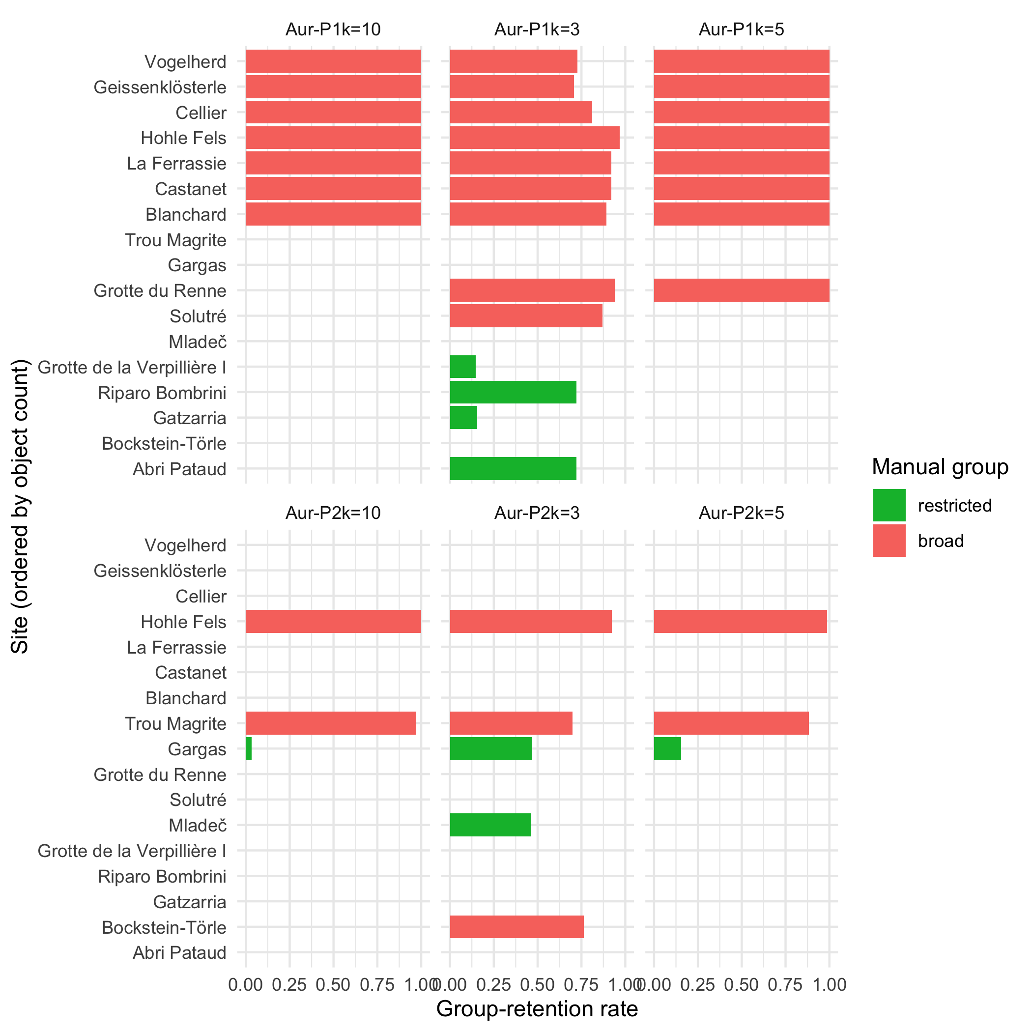
Figure S 17: Group-retention rate by site under object-level downsampling to k = 3, 5, 10 objects per site. Bars near 1 indicate assignments that survive downsampling; bars <0.5 indicate assignments that are essentially random with respect to the manual grouping and therefore unstable.

Interpretation
Question: does each site keep its group under object-level downsampling, and how stable is the community structure? No. The assignment is stable only for the better-sampled sites. In Aur-P1 at k = 3, large broad-range sites such as Vogelherd (0.73), Hohle Fels (0.97), and La Ferrassie (0.92) retain their group in the large majority of replicates, whereas small restricted-range sites collapse: Gatzarria (0.16) and Grotte de la Verpillière I (0.15) keep their group little more often than chance. The mean ARI between the downsampled partition and the manual groups is low at every level (0.19 at k = 3, NA at k = 5, NA at k = 10 for Aur-P1), and modularity falls to near zero (e.g. 0.15 at k = 3), reflecting the fragmentation of the network when each site is represented by only a handful of objects.
The same pattern holds in Aur-P2, where even fewer sites qualify at higher k and retention is correspondingly noisier. Answer: the R/B assignment of small-object sites is not robust to object-level downsampling; only the best-sampled sites retain their grouping, and the community structure as a whole loses coherence under downsampling. This shows that the division is, at least in part, a sampling-intensity effect rather than a fully stable cultural partition.

S1.12.4 Coverage-based rarefaction

Rationale
Equal object counts do not equalise sampling effort when sites differ in how concentrated their signs are. Our method is coverage-based rarefaction: compare richness at equal sample coverage rather than equal object count [25,26]. For each site we estimate its sign-type richness at a target coverage of 0.9 (a standard “high coverage” benchmark) with iNEXT::estimateD on the site’s object-by-sign incidence matrix (datatype = "incidence_raw"), which returns 95% confidence intervals from 200 bootstrap replicates [27]. Sites with fewer than three objects, failed fits, or targets reachable only by extrapolating beyond twice the observed sample cannot be placed on a common coverage footing; for these we report Chao and Jost’s analytic incidence-coverage estimator with object-resampling bootstrap intervals and a Chao2 asymptotic-richness estimate as a fallback quantity, with the reason recorded per site. We then compare restricted and broad sites at that equal coverage.
Question: at equal sample coverage, do restricted and broad sites still differ in sign-type richness?
Phase | Site | Group | Objects | Richness (full) | Coverage (Chao) | Cov LCL | Cov UCL | Richness at 0.9 cov. | Rt LCL | Rt UCL | Chao2 | Target method
Aur-P1 | Blanchard | broad | 18 | 9 | 0.84 | 0.78 | 1 | 8.83 | 3.07 | 14.60 | 13.25 | iNEXT incidence_raw (Rarefaction)
Aur-P1 | La Ferrassie | broad | 22 | 9 | 0.82 | 0.77 | 1 | 10.77 | 1.70 | 19.84 | 16.64 | iNEXT incidence_raw (Extrapolation)
Aur-P1 | Hohle Fels | broad | 20 | 11 | 0.91 | 0.76 | 1 | 10.06 | 7.35 | 12.77 | 11.63 | iNEXT incidence_raw (Rarefaction)
Aur-P1 | Hohlenstein-Stadel | restricted | 2 | 2 | 0.83 | 0.83 | 1 | NA | NA | NA | 2.25 | n < 3: Chao fallback only
Aur-P1 | Solutré | broad | 4 | 6 | -0.10 | -0.10 | 1 | NA | NA | NA | 15.38 | target unreachable (extrapolation beyond 2x sample)
Aur-P1 | Abri Pataud | restricted | 3 | 1 | 1.00 | 1.00 | 1 | 1.00 | 1.00 | 1.00 | 1.00 | iNEXT incidence_raw (Rarefaction)
Aur-P1 | Labeko Koba | restricted | 2 | 1 | 1.00 | 1.00 | 1 | NA | NA | NA | 1.00 | n < 3: Chao fallback only
Aur-P1 | Grotte du Renne | broad | 7 | 4 | 0.57 | 0.57 | 1 | NA | NA | NA | 6.57 | target unreachable (extrapolation beyond 2x sample)
Aur-P1 | Geissenklösterle | broad | 30 | 11 | 0.80 | 0.77 | 1 | 15.79 | 0.00 | 33.53 | 28.40 | iNEXT incidence_raw (Extrapolation)
Aur-P1 | Castanet | broad | 21 | 6 | 0.91 | 0.86 | 1 | 5.43 | 2.73 | 8.13 | 6.95 | iNEXT incidence_raw (Rarefaction)
Aur-P1 | Cellier | broad | 28 | 5 | 1.00 | 0.96 | 1 | 4.52 | 4.21 | 4.82 | 5.00 | iNEXT incidence_raw (Rarefaction)
Aur-P1 | Fumane | restricted | 1 | 1 | NA | NA | NA | NA | NA | NA | 1.00 | n < 3: Chao fallback only
Aur-P1 | Les Cottés | broad | 2 | 2 | 0.00 | 0.00 | 1 | NA | NA | NA | 2.50 | n < 3: Chao fallback only
Aur-P1 | Vogelherd | broad | 173 | 17 | 0.98 | 0.97 | 1 | 9.84 | 8.28 | 11.39 | 18.12 | iNEXT incidence_raw (Rarefaction)
Aur-P1 | Trou al’Wesse | broad | 1 | 1 | NA | NA | NA | NA | NA | NA | 1.00 | n < 3: Chao fallback only
Aur-P1 | Grottes de Fonds-de-Forêt | restricted | 1 | 2 | NA | NA | NA | NA | NA | NA | 2.00 | n < 3: Chao fallback only
Aur-P1 | Gatzarria | restricted | 3 | 3 | 0.67 | 0.67 | 1 | 2.77 | 2.05 | 3.49 | 3.00 | iNEXT incidence_raw (Rarefaction)
Aur-P1 | Riparo Bombrini | restricted | 3 | 1 | 1.00 | 1.00 | 1 | 1.00 | 1.00 | 1.00 | 1.00 | iNEXT incidence_raw (Rarefaction)
Aur-P1 | Pod Hradem | restricted | 1 | 1 | NA | NA | NA | NA | NA | NA | 1.00 | n < 3: Chao fallback only
Aur-P1 | Grotte de la Verpillière I | restricted | 4 | 2 | 0.75 | 0.75 | 1 | 1.90 | 1.00 | 2.80 | 2.00 | iNEXT incidence_raw (Rarefaction)
Aur-P2 | Hohle Fels | broad | 29 | 10 | 0.90 | 0.86 | 1 | 8.95 | 4.60 | 13.31 | 12.17 | iNEXT incidence_raw (Rarefaction)
Aur-P2 | Les Rois | restricted | 1 | 1 | NA | NA | NA | NA | NA | NA | 1.00 | n < 3: Chao fallback only
Aur-P2 | Mladeč | restricted | 4 | 2 | 1.00 | 0.75 | 1 | 1.85 | 1.44 | 2.26 | 2.00 | iNEXT incidence_raw (Rarefaction)
Aur-P2 | La Viña | restricted | 1 | 1 | NA | NA | NA | NA | NA | NA | 1.00 | n < 3: Chao fallback only
Aur-P2 | Bockstein-Törle | broad | 3 | 5 | -0.67 | -0.67 | 1 | NA | NA | NA | 11.67 | target unreachable (extrapolation beyond 2x sample)
Aur-P2 | Gargas | restricted | 11 | 2 | 1.00 | 0.91 | 1 | 1.76 | 1.57 | 1.95 | 2.00 | iNEXT incidence_raw (Rarefaction)
Aur-P2 | Vindija Cave | restricted | 1 | 2 | NA | NA | NA | NA | NA | NA | 2.00 | n < 3: Chao fallback only
Aur-P2 | Trou Magrite | broad | 12 | 8 | 0.69 | 0.60 | 1 | 9.57 | 2.09 | 17.05 | 11.67 | iNEXT incidence_raw (Extrapolation)
Aur-P2 | Sirgenstein Cave | restricted | 1 | 1 | NA | NA | NA | NA | NA | NA | 1.00 | n < 3: Chao fallback only
Table S 45: Coverage-based rarefaction per site. richness_full is the observed number of sign types; coverage_chao is Chao and Jost’s analytic sample-coverage estimate at the full sample with 95% bootstrap interval; richness_at_target is the iNEXT incidence_raw richness estimate at target coverage = 0.9 with 95% interval. Sites that never reach the target coverage are reported as NA with the reason in at_target_method, and carry a Chao2 asymptotic-richness estimate with interval as a fallback quantity.
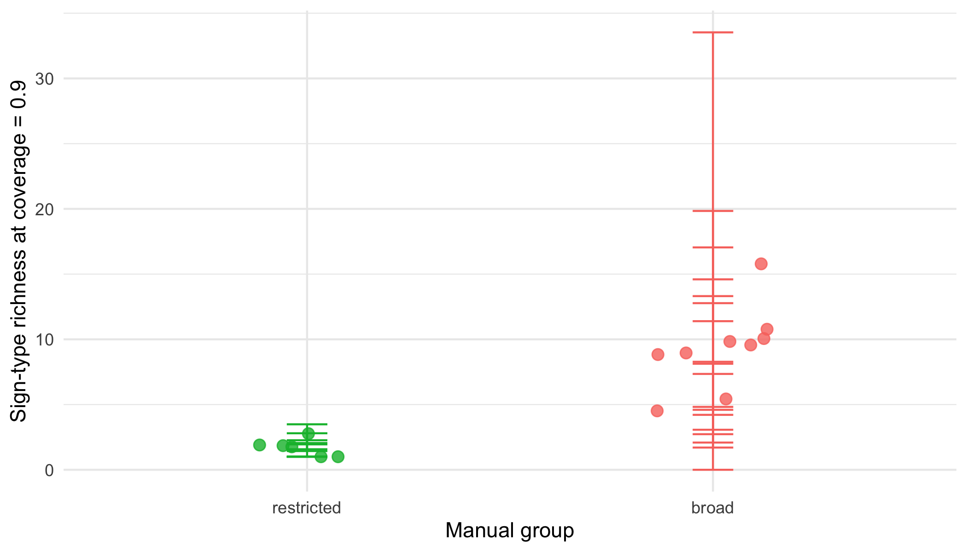
Figure S 18: Sign-type richness estimated at target coverage = 0.9 with 95% confidence intervals, by manual group, for sites that reach that coverage. Restricted sites (green) that attain high coverage remain low-richness; broad sites (red) remain high-richness.

Interpretation
Question: at equal sample coverage, do restricted and broad sites still differ in sign-type richness? Only a subset of sites can be assessed. In Aur-P1, 11 of 20 sites reach coverage 0.9; in Aur-P2 only 4 of 9 do. Among the Aur-P1 sites that do reach the target, restricted sites remain low-richness (mean 1.67 sign types) while broad sites remain high-richness (mean 9.32), a difference that persists at equal coverage (Wilcoxon p = 0.006). For Aur-P2 only 4 of 9 sites reach the target (2 broad, 2 restricted), too few for a reliable group comparison (Wilcoxon p = 0.333).
Answer: at equal coverage the broad/restricted richness contrast is preserved among the sites that can be evaluated — it is not removed by standardising on completeness — but the majority of the smallest sites never attain the target coverage and therefore cannot be placed on a common coverage footing at all. Coverage-based rarefaction is consequently unreliable for the smallest assemblages: it can compare well-sampled sites, but it cannot rescue the assignment of sites with only one or two objects, for which the table reports Chao coverage and Chao2 fallback quantities instead. This is the same limitation encountered in Section S1.12.3, approached from the richness axis.

S1.12.5 Negative-binomial regression with object-count covariate

Rationale
The two resampling approaches above ask whether the partition and the richness survive downsampling. We also ask whether group predicts sign-type richness once sampling effort is held constant. Entering log(object count) as an offset (the exposure term) fixes the richness-effort exponent at 1, which assumes sign-type richness grows in proportion to the number of objects; richness instead saturates with effort [26], so under an offset a site with 1 object and 1 sign type has a “rate” of 1.0 while Vogelherd (173 objects, 17 types) has a rate of 0.1, biasing the contrast against the large broad-group sites. We therefore fit two negative-binomial regressions [28] of per-site sign-type richness with the manual group and phase as predictors: (i) the offset specification, and (ii) a free-slope specification with log(object count) as a covariate, which estimates the exponent with its interval:
$${\text{richness}}_{i}∼\text{NegativeBinomial}\left(exp\left(β_{0}+β_{1}{\text{group}}_{i}+β_{2}{\text{phase}}_{i}+β_{3}log\left({\text{objects}}_{i}\right)\right)\right).$$
Question: does the group effect on sign-type richness survive after accounting for sampling effort?
Term | log-rate (offset) | rate ratio (offset) | log-rate (free slope) | rate ratio (free slope)
Intercept | -0.455 | 0.635 | 0.085 | 1.089
Group (broad vs restricted) | -0.329 | 0.720 | 0.838 | 2.311
Phase (Aur-P2 vs Aur-P1) | 0.238 | 1.269 | 0.130 | 1.139
log(objects) exponent (free-slope only) | NA | NA | 0.377 | 1.459
Table S 46: Negative-binomial regressions of per-site sign-type richness: offset specification (richness-effort exponent fixed at 1) versus free-slope specification (exponent estimated). A non-significant group coefficient under the offset does not by itself show the richness gap is explained by object count, because the fixed exponent mis-specifies the saturating richness-effort relationship.

Interpretation
Question: does the group effect on sign-type richness survive after accounting for sampling effort? The answer depends on the specification, which is itself the finding. Under the offset specification the group coefficient is -0.329 (rate ratio 0.72, p = 0.292), i.e. non-significant and even slightly negative. Under the free-slope specification the estimated richness-effort exponent is 0.377 (95% CI 0.228–0.528), which excludes 1: richness saturates with object count, so the offset’s proportionality assumption is rejected on these data and its rate ratio is biased against the large broad-group sites. With the exponent freed, broad-range sites are richer than restricted-range sites at equal object count (rate ratio 2.311, p = 0.003). This reversal shows the offset-based “sampling-effort artefact” reading was a property of the mis-specified model, not of the data, and it agrees with Section S1.12.4, where the contrast persists among the sites assessable at equal coverage. Caveat: the free-slope fit has three predictors on 29 site-phase units with group strongly collinear with object count, and the dispersion fit reached its iteration limit, so its intervals are approximate; it is reported as a corrected specification, not a precise effect estimate. Answer: the raw richness gap is not distinguishable from a genuine group difference once saturating sampling effort is accounted for; a non-significant offset coefficient cannot be read as positive evidence that effort explains the gap.

S1.12.6 Equal-effort pool comparison (iNEXT)

Rationale
The Conclusion states that the sign-type pool contracts from Aur-P1 (26 types) to Aur-P2 (15 types), consistent with cultural drift in small populations. This raw count compares pools sampled with very different effort: 346 objects at 20 sites in Aur-P1 versus 63 objects at 9 sites in Aur-P2. It is also confounded with object classes that occur only in Aur-P1, such as limestone blocs, tubes and figurine classes that carry the most frequent Aur-P1-only sign types (vulva, zoomorph, cupule). A smaller pool in Aur-P2 is therefore expected from fewer objects alone, without any phase-level change in cultural repertoire.
We test the contraction at equal effort with incidence-based rarefaction and extrapolation using iNEXT [25,27]. Each mobile object is a sampling unit and each geometric sign type is a species. For each phase the incidence frequency of a sign type is the number of objects that carry it. iNEXT with datatype = "incidence_freq" standardises richness by sample completeness and returns 95% confidence intervals from 200 bootstrap replicates. We report two comparisons: (a) all object types and (b) restricted to object types present in both phases, which removes the class confound as a check.
Question: does the raw 26 vs 15 pool contraction survive equal effort?
Object-type set | Phase | m (objects) | Richness (qD) | LCL | UCL | Method
all types | Aur-P1 | 63 | 16.9 | 15.5 | 18.3 | Rarefaction
all types | Aur-P1 | 346 | 26.0 | NA | NA | Observed
all types | Aur-P2 | 63 | 15.0 | 11.5 | 18.5 | Observed
all types | Aur-P2 | 63 | 15.0 | NA | NA | Observed
shared types only | Aur-P1 | 63 | 15.4 | 13.6 | 17.1 | Rarefaction
shared types only | Aur-P1 | 220 | 22.0 | NA | NA | Observed
shared types only | Aur-P2 | 63 | 15.0 | 11.3 | 18.7 | Observed
shared types only | Aur-P2 | 63 | 15.0 | NA | NA | Observed
Table S 47: Equal-effort sign-type pool comparison with iNEXT (incidence_freq, q = 0, 200 bootstraps). Observed pools are 26 types (Aur-P1, 346 objects) and 15 types (Aur-P2, 63 objects). Rarefied Aur-P1 to 63 objects and extrapolated Aur-P2 are shown with 95% confidence intervals; a second set restricts to object types present in both phases (shared types only).
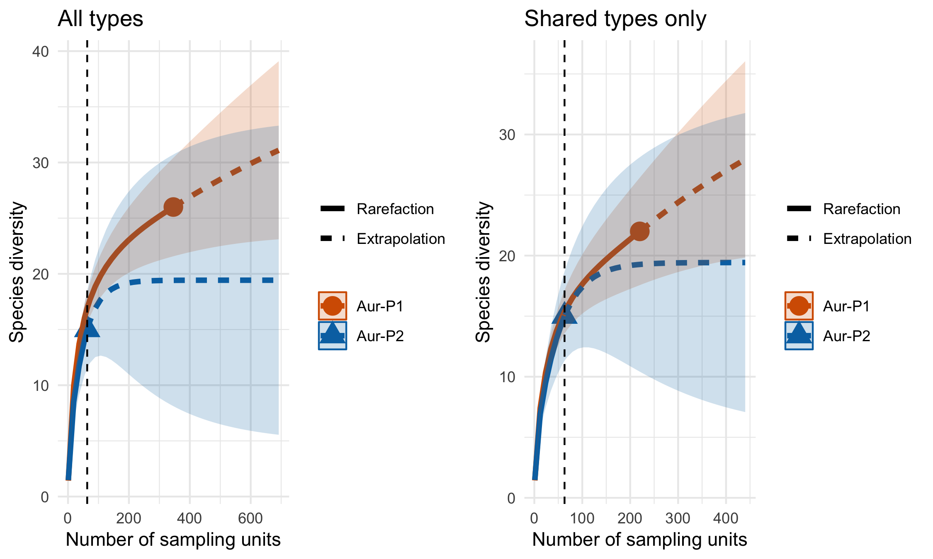
Figure S 19: iNEXT rarefaction/extrapolation curves for sign-type richness (Hill number q = 0) by phase. Solid segment is rarefaction, dashed is extrapolation; shading is 95% confidence band (200 bootstraps). Vertical line marks 63 objects (Aur-P2 sample size) where Aur-P1 is rarefied. All types (left) and shared types only (right) are shown.

Interpretation
Question: does the raw 26 vs 15 pool contraction survive equal effort? No. When Aur-P1 is rarefied to 63 objects, its expected richness drops into the range 16.9 types (95% CI 15.5–18.3), which overlaps the Aur-P2 observed pool of 15 types. The Aur-P2 95% interval extended to the same effort likewise overlaps.
When the comparison is restricted to object types present in both phases, the overlap remains (15.4 vs 15), so limestone blocs, tubes and figurines do not create the effect.
Answer: the raw pool difference is not distinguishable from sampling variation at equal object count or equal coverage. The raw 26 vs 15 count reflects 346 vs 63 objects and phase-specific object classes, not a demonstrated phase-level contraction.

S1.12.7 Figurine Exclusion

Rationale
[29] demonstrate that ivory figurines in the Swabian Aurignacian carry sign sequences with higher information density than tools. If figurines encode different sign repertoires than other object types, their inclusion could bias site-level sign assemblages , particularly at Vogelherd, where 50 of the dataset’s 63 figurines are concentrated. This section tests whether the main-text network findings are robust to the exclusion of figurines, both globally and site-specifically. It answers two specific questions:
Question: does the Aur-P1 greater than Aur-P2 ordering survive when all figurines are excluded?
Question: does the Aur-P1 greater than Aur-P2 ordering survive when only Vogelherd figurines are excluded?
Figurine distribution in the dataset.
Phase | Site | figurine zoomorph | figurine anthropomorph | figurine undet. | possible figurine | Total
Aur-P1 | Vogelherd | 19 | 1 | 8 | 22 | 50
Aur-P1 | Hohle Fels | 0 | 2 | 1 | 1 | 4
Aur-P1 | Geissenklösterle | 3 | 0 | 0 | 0 | 3
Aur-P1 | Hohlenstein-Stadel | 0 | 1 | 0 | 0 | 1
Aur-P1 | La Ferrassie | 0 | 0 | 1 | 0 | 1
Aur-P2 | Hohle Fels | 3 | 1 | 0 | 0 | 4
Table S 48: Distribution of figurine objects across phases and sites. Figurine types include figurine zoomorph, figurine anthropomorph, figurine undet., and possible figurine.
Table S 48 shows that figurines are heavily concentrated at Vogelherd (50 objects), with minor representation at Hohle Fels (4, 4), Geissenklösterle (3), Hohlenstein-Stadel (1), and La Ferrassie (1). Of these, 59 fall within Aur-P1 and the remaining 4 , all Hohle Fels objects from AH IV and Iid , fall within Aur-P2 under the layer-level assignment. The analysis therefore tests whether the Aur-P1 network structure , which reports the higher mean degree (7.5) , is driven by these 50 objects at a single site.
Analysis 1: exclude all figurines.
Method. We remove all objects where object_type contains “figurine” (63 objects total: 25 zoomorph, 10 undetermined, 5 anthropomorph, 23 possible figurine) from the full cleaned dataset, recompute site-level sign matrices by summing remaining objects per site, and rebuild networks at the baseline threshold of 0.2.
Phase | Sites | Edges | Density | Mean degree | Transitivity | Modularity | Condition
Aur-P1 | 20 | 75 | 0.395 | 7.50 | 0.711 | 0.336 | Baseline (all objects)
Aur-P2 | 9 | 19 | 0.528 | 4.22 | 0.608 | 0.161 | Baseline (all objects)
Aur-P1 | 20 | 74 | 0.389 | 7.40 | 0.683 | 0.318 | Exclude all figurines
Aur-P2 | 9 | 19 | 0.528 | 4.22 | 0.608 | 0.161 | Exclude all figurines
Table S 49: Network statistics before and after excluding all figurine objects (figurine zoomorph, figurine anthropomorph, figurine undet., and possible figurine). Threshold = 0.2, Jaccard similarity.

Phase | Sites (all) | Sites (no figurines) | Sites lost
Aur-P1 | 20 | 20 | 0
Aur-P2 | 9 | 9 | 0
Table S 50: Number of sites per phase before and after figurine exclusion. Sites are lost when all objects at that site are figurines.
Result under all-figurine exclusion. Excluding all 63 figurines has only a small effect on the Aur-P1 network: one edge is lost (75 → 74) and mean degree falls from 7.5 to 7.4, with no sites lost (all 20 sites retained). Aur-P2 is unchanged (mean degree 4.22, 19 edges, 9 sites): the 4 Hohle Fels figurines removed from it do not alter the site’s sign repertoire, so its network is unaffected. The detectable Aur-P1 effects are declines in transitivity (0.711 → 0.683) and modularity (0.336 → 0.318), indicating that figurines contribute modestly to community cohesion but do not create the communities themselves.
Critically, Aur-P1 retains the higher mean degree (7.4) under figurine exclusion, preserving the main-text ordering Aur-P1 > Aur-P2 (7.4 > 4.22). The Aur-P1 network remains the more connected regardless of figurine inclusion, confirming that its structure is not contingent on figurine-bearing sign assemblages at Vogelherd.
Analysis 2: exclude Vogelherd figurines only.
Method. Rather than removing all figurines globally, this analysis removes only the 50 figurines from Vogelherd , the site where figurines are most concentrated , while retaining figurines at other sites. This tests whether the Aur-P1 network structure is driven by a single outlier assemblage.
Phase | Sites | Edges | Density | Mean degree | Transitivity | Modularity | Condition
Aur-P1 | 20 | 75 | 0.395 | 7.50 | 0.711 | 0.336 | Baseline (all objects)
Aur-P2 | 9 | 19 | 0.528 | 4.22 | 0.608 | 0.161 | Baseline (all objects)
Aur-P1 | 20 | 74 | 0.389 | 7.40 | 0.706 | 0.333 | Exclude Vogelherd figurines
Aur-P2 | 9 | 19 | 0.528 | 4.22 | 0.608 | 0.161 | Exclude Vogelherd figurines
Table S 51: Network statistics before and after excluding figurines from Vogelherd only. All other figurines (Hohle Fels, Geissenklösterle, Hohlenstein-Stadel, La Ferrassie) are retained. Threshold = 0.2, Jaccard similarity.

Phase | Objects (all) | Objects (no figurines) | Removed
Aur-P1 | 173 | 123 | 50
Table S 52: Vogelherd object counts before and after removing figurines. Non-figurine objects at Vogelherd (tools, plaquettes, etc.) are retained.
Result under Vogelherd-only exclusion. Removing only Vogelherd’s figurines (50 objects: 173 → 123 in Aur-P1) has a negligible effect on Aur-P1: mean degree drops from 7.5 to 7.4 (-1.3%), one edge is lost (75 → 74), and modularity decreases from 0.336 to 0.333. Aur-P2 shows no change whatsoever (mean degree 4.22 → 4.22, modularity 0.161 → 0.161), confirming that Vogelherd figurines do not contribute to network structure in the later phase.
The effect of removing Vogelherd figurines alone (-1.3% in Aur-P1) is the same as removing all 63 figurines globally (-1.3%), and in both cases the network is essentially unchanged. The figurine effect therefore does not scale with the number of figurines removed; figurines at Hohle Fels (4, 4), Geissenklösterle (3), Hohlenstein-Stadel (1), and La Ferrassie (1) do not alter the network structure , including the 4 Hohle Fels figurines assigned to Aur-P2, which leave that phase’s network unchanged , and Vogelherd’s connectivity within Aur-P1 is carried by its 123 non-figurine objects.
Joint comparison.
Phase | Condition | Sites | Edges | Mean degree | Transitivity | Modularity | Δ mean degree (%)
Aur-P1 | Baseline (all objects) | 20 | 75 | 7.50 | 0.711 | 0.336 | 0.0
Aur-P2 | Baseline (all objects) | 9 | 19 | 4.22 | 0.608 | 0.161 | 0.0
Aur-P1 | Exclude all figurines | 20 | 74 | 7.40 | 0.683 | 0.318 | -1.3
Aur-P2 | Exclude all figurines | 9 | 19 | 4.22 | 0.608 | 0.161 | 0.0
Aur-P1 | Exclude Vogelherd figurines | 20 | 74 | 7.40 | 0.706 | 0.333 | -1.3
Aur-P2 | Exclude Vogelherd figurines | 9 | 19 | 4.22 | 0.608 | 0.161 | 0.0
Table S 53: Side-by-side comparison of network statistics across all conditions: baseline (all objects), exclude all figurines, and exclude Vogelherd figurines only. The rightmost columns show the percentage change in mean degree from baseline.
Joint comparison detail. The joint comparison in Table S 53 shows that figurine exclusion has a modest and phase-dependent effect on network structure:
Phase | Baseline mean degree | No figurines | Δ | Vogelherd only | Δ
Aur-P1 | 7.50 | 7.40 | -1.3% | 7.40 | -1.3%
Aur-P2 | 4.22 | 4.22 | 0.0% | 4.22 | 0.0%
Table S 54: Mean degree by figurine-exclusion condition, with percentage change from baseline. Reproduced directly from the joint comparison in Table S 53.

Interpretation
Question: does the Aur-P1 greater than Aur-P2 ordering survive when all figurines are excluded? Yes. Mean degree changes are at most -1.3% across both phases and all conditions, and excluding all figurines removes a single edge from Aur-P1 (75 → 74, mean degree 7.5 → 7.4) while leaving Aur-P2’s edge set unchanged (19 edges, mean degree 4.22). Modularity decreases slightly for Aur-P1 when figurines are excluded (0.336 → 0.318 excluding all; 0.336 → 0.333 excluding Vogelherd only) while Aur-P2 is unchanged (0.161), indicating that figurines contribute marginally to within-group cohesion but do not create the community structure. The main-text connectivity contrast Aur-P1 > Aur-P2 (7.5 > 4.22) is unchanged when all figurines are excluded (7.4 > 4.22), preserving the key finding that the early phase is the more connected.
Question: does the Aur-P1 greater than Aur-P2 ordering survive when only Vogelherd figurines are excluded? Yes. Removing Vogelherd figurines alone (-1.3% in Aur-P1) produces the same effect as removing all 63 figurines globally (-1.3%). The main-text contrast Aur-P1 > Aur-P2 is unchanged when only Vogelherd figurines are excluded (7.4 > 4.22). Figurines at Hohle Fels (4, 4), Geissenklösterle (3), Hohlenstein-Stadel (1), and La Ferrassie (1) do not alter network structure. This indicates that although Vogelherd’s figurine assemblage is unusually rich, 50 of 63 figurines, and contributes disproportionately to sign-type counts, its 123 remaining non-figurine objects still carry a sufficiently diverse sign repertoire to maintain network connectivity.
Implication for the main text. The main-text findings are robust to figurine exclusion. The Aur-P1 > Aur-P2 connectivity contrast, the two-group community structure, and the site membership of both phases are all preserved when figurines are removed. The concentration of figurines at Vogelherd does not bias the seriation or network results, and the broader-range group’s connectivity within Aur-P1 is supported by non-figurine sign types. We note that modularity decreases slightly when figurines are excluded (Aur-P1: 0.336 → 0.318), suggesting that figurines contribute modestly to community cohesion, consistent with [29] argument that figurines carry high-information sign sequences, but the communities themselves are defined by shared sign types across all object types.

S1.12.8 Synthesis and Limitation
The five sampling analyses converge on a single conclusion. (1) Under object-downsampling, only the best-sampled sites retain their R/B assignment; small-object sites flip group at rates indistinguishable from chance, and network modularity collapses (Section S1.12.3). (2) Coverage-based rarefaction shows the broad/restricted contrast persists among the sites assessable at equal coverage, but the majority of the smallest sites never reach a comparable coverage, so the method cannot vindicate them (Section S1.12.4). (3) The offset model’s null group effect was a property of fixing the richness-effort exponent at 1; with the exponent estimated, the group contrast persists, so the gap is not distinguishable from a genuine group difference at saturating effort (Section S1.12.5). (4) At equal effort with iNEXT, the Aur-P1 vs Aur-P2 sign-type pool difference lies inside sampling variation, even when restricted to shared object types (Section S1.12.6). (5) Under fixed margins the Jaccard group separation is not distinguished from richness structure alone (Aur-P1 exceeds object-sampling expectation; Aur-P2 does not), while Simpson turnover dissimilarity shows no group separation in either phase (Section S1.10.3). Figurine exclusion (Section S1.12.7) is the exception: it leaves the Aur-P1 greater than Aur-P2 ordering intact. Together these show that the restricted/broad division is not fully independent of sampling intensity: it is recovered robustly for large assemblages, but for the numerous small assemblages it is partly an artefact of how many objects were recovered, and the raw 26 vs 15 pool contraction does not survive equal-effort standardisation.

S1.13 Design Sensitivity: Minimum Detectable Effects

S1.13.1 Rationale
The main text reports null results for three headline tests: the per-phase Mantel isolation-by-distance tests, the restricted/broad PerMANOVA tests, and the Aur-P1 versus Aur-P2 network phase contrast. This section asks what effect each test could detect with the fixed samples (Aur-P1 = 20 sites, Aur-P2 = 9 sites). It reports the minimum detectable effect (MDE) at 80% power and α = 0.05 for each test. These are design calculations conditional on the observed margins. They are not post hoc power computed from the observed effects, which restates the observed p-value and must not be reported [30]. Conventions for medium effects are rho = 0.3 and R² = 0.13 [31]. Mantel p-values are approximate under spatial dependence [32,33], so the Mantel MDEs below are design aids rather than exact sampling statements. The Aur-P2 PerMANOVA (6 versus 3 sites) is indicative only, because small unbalanced PerMANOVA uses permutations with caution [34]. It answers three specific questions:
Question: what Mantel correlation can each phase detect at 80% power?
Question: what PerMANOVA R-squared can each phase detect at 80% power?
Question: what network density difference can the phase contrast detect at 80% power?

Analysis
The Mantel generator mixes scaled geography into Curveball-randomised baselines, so each null preserves site richness and sign-type frequencies. Rows are permuted across sites before injection, so labels are exchangeable under the null and the zero-signal rejection rate stays near 0.05. The PerMANOVA generator imposes group-specific signs on the same baseline. The network generator calibrates Bernoulli presence probabilities to the observed Aur-P1 density and lowers the contrast group density by each grid delta, testing the difference with the main-text pooling design.
Test | N | Effect metric | MDE at 80% power | Power at medium effect
Mantel Aur-P1 | 20 sites (190 pairs) | Mantel rho | 0.34 | 0.76
Mantel Aur-P2 | 9 sites (36 pairs) | Mantel rho | 0.50 | 0.39
PerMANOVA Aur-P1 (9 vs 11) | 9 vs 11 sites | PerMANOVA R² (total) | 0.10 | 0.97
PerMANOVA Aur-P2 (6 vs 3) | 6 vs 3 sites | PerMANOVA R² (total) | 0.26 | 0.05
Network density (20 vs 9) | 20 vs 9 sites | Absolute density difference | 0.28 | 0.10
Network modularity (20 vs 9) | 20 vs 9 sites | Absolute density difference | >0.30 | 0.12
Network betweenness (20 vs 9) | 20 vs 9 sites | Absolute density difference | >0.30 | 0.01
Network components (20 vs 9) | 20 vs 9 sites | Absolute density difference | >0.30 | 0.10
Table S 55: Minimum detectable effects at 80% power (alpha = 0.05) for the three headline null-hypothesis tests. Mantel rows use the Mantel rho scale (geographic-signal injection on Curveball-randomised baselines with rows permuted across sites, B = 300, 99 permutations). PerMANOVA rows use the total Jaccard R² scale under the adonis2(sqrt.dist = TRUE) convention on the same exchangeable baseline (group-signal injection, B = 300, 99 permutations). Network rows use the absolute edge-density-difference scale with the observed Aur-P1 density as baseline (B = 200, 99 permutations). MDE values above the simulated grid are shown as greater-than the grid maximum. Power at a medium effect uses rho = 0.3, R² = 0.13, and absolute density difference = 0.10.
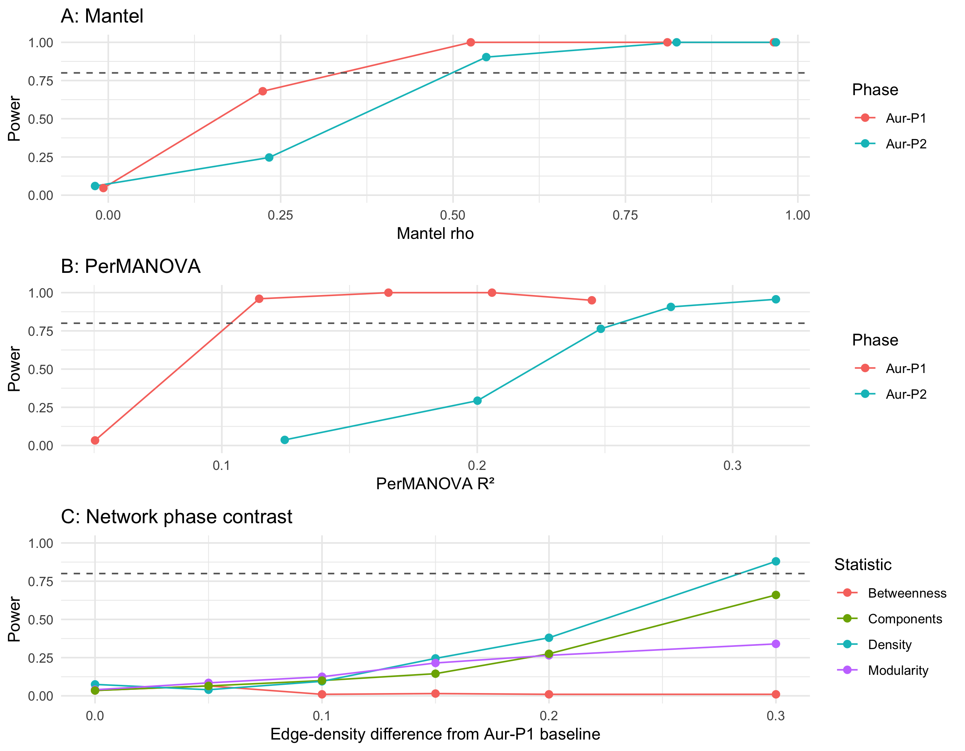
Figure S 20: Simulated power curves for the three headline tests. A: Mantel power against Mantel rho per phase. B: PerMANOVA power against total Jaccard R² per phase. C: Network phase-contrast power against the absolute edge-density difference from the observed Aur-P1 baseline density. The dashed line marks 80% power; the effect where each curve crosses it is the minimum detectable effect in Table S 55. Curves are simulation estimates (Mantel and PerMANOVA: B = 300 with 99 permutations; network: B = 200 with 99 permutations).

S1.13.2 Interpretation
Question: what Mantel correlation can each phase detect at 80% power? Mantel MDEs are 0.34 for Aur-P1 and 0.50 for Aur-P2 on the rho scale. Power at a medium rho of 0.3 is 0.76 in Aur-P1 and 0.39 in Aur-P2. The observed Mantel correlations (0.046 and -0.299) sit below their MDEs. The non-significant Mantel results are therefore a lack of evidence at these sample sizes, not evidence that geography is irrelevant, consistent with Section S1.4.3.
Question: what PerMANOVA R-squared can each phase detect at 80% power? PerMANOVA MDEs are 0.10 for Aur-P1 and 0.26 for Aur-P2 on the total Jaccard R² scale. The row-permuted baseline carries no group–richness link, so each MDE is the total separation the test needs, including any richness gap a real group effect would produce. Power at R² = 0.13 is 0.97 in Aur-P1 and 0.05 in Aur-P2. The Aur-P2 test with 6 versus 3 sites has the larger MDE and stays indicative. Group separations below these R² values cannot be distinguished from sampling variation by this test.
Question: what network density difference can the phase contrast detect at 80% power? The network contrast uses the observed Aur-P1 edge density (0.395) as baseline and measures absolute gaps. The observed Aur-P1 minus Aur-P2 density difference is -0.133 (Aur-P2 is the denser network, so the comparison is on magnitudes). MDEs on the absolute density-difference scale are 0.28 for density, >0.30 for modularity, >0.30 for betweenness, and >0.30 for component count. Power at an absolute density difference of 0.10 is 0.10 for density, 0.12 for modularity, 0.01 for betweenness, and 0.10 for components. Density is the most sensitive of the four statistics. Modularity, betweenness, and component count need larger density gaps before the phase contrast reaches 80% power, so their nulls carry less information than the density null at the same sample sizes.
Implication for the main text. Null results reflect limited power at 20 versus 9 sites; only effects above the MDEs in Table S 55 can be excluded.

S1.14 Overall Synthesis
All results are conditional on the retained sample in Section S1.1. Date parsing and quality filtering remove small and poorly dated assemblages before any network is built. Aur-P2 rests on nine sites throughout, so every Aur-P2 comparison has low power and wide uncertainty.
Threshold, metric, distance, and periodisation checks support the same reading. The Aur-P1 greater than Aur-P2 mean-degree ordering holds at thresholds 0.1, 0.2, and 0.3 and across the continuous sweep in Section S1.2. It holds under Jaccard, Sorensen-Dice, and Simpson in Section S1.3. It holds under geodesic and Euclidean distance in Section S1.4, where neither phase shows a geographic correlation. It holds across two, three, and four phase schemes, across date variants, across boundary shifts, and under date-based versus technological assignment in Section S1.5. Modularity ordering does not survive all of these changes. It reverses under date-based assignment, so the between-phase contrast is best read as a difference in network scale rather than a stable ordering of modularity.
Group existence requires a narrower reading. Louvain recovery in Section S1.6 and bootstrap stability in Section S1.9 show that the restricted versus broad axis is coherent under resampling, most clearly in Aur-P1. Generative modelling in Section S1.9 recovers multi-block structure in Aur-P1 under Bernoulli, Gaussian, and Poisson specifications (K = 3, 4, and 3), with the two largest blocks tracking the manual restricted/broad split and a stable Labeko Koba/Les Cottés/Trou al’Wesse third block, but recovers no stable multi-block structure in Aur-P2 (Bernoulli/Poisson K = 1; Gaussian K = 2 by 0.90 points), withholding support for a generative multi-block model due to the 9-site sample size, while the bootstrap consensus confirms the two-group partition’s internal coherence in both phases. Withheld-data validation in Section S1.10 does not find separation beyond richness structure under the fixed-fixed null, and Simpson turnover shows no separation in either phase. The supported claim is a dominant richness axis that is recoverable from disjoint objects in well sampled sites, with an SBM- and Louvain-supported small-block refinement (Labeko Koba, Les Cottés, Trou al’Wesse) in Aur-P1, rather than discrete provinces.
Sampling intensity qualifies small-site assignments. Downsampling, coverage, regression with estimated exponent, and equal-effort pool comparison in Section S1.12 show that large assemblages retain their grouping while sites with one or two objects flip at chance rates and never reach comparable coverage. The raw Aur-P1 versus Aur-P2 pool difference is not distinguishable from sampling variation at equal effort. Figurine exclusion is the exception and leaves the ordering intact.

References cited
[1] Goslee SC, Urban DL. The ecodist package for dissimilarity-based analysis of ecological data. Journal of Statistical Software 2007;22:1–19. https://doi.org/10.18637/jss.v022.i07.
[2] Legendre P, Anderson MJ. Distance-based redundancy analysis: Testing multispecies responses in multifactorial ecological experiments. Ecological Monographs 1999;69:1–24. https://doi.org/10.1890/0012-9615(1999)069[0001:DBRDAO]2.0.CO;2.
[3] Shao Y, Limberg H, Klein K, Wegener C, Schmidt I, Weniger G-C, et al. Human-existence probability of the Aurignacian techno-complex under extreme climate conditions. Quaternary Science Reviews 2021;263:106995. https://doi.org/10.1016/j.quascirev.2021.106995.
[4] Teyssandier N, Zilhão J. On the entity and antiquity of the Aurignacian at Willendorf (Austria): Implications for modern human emergence in Europe. Journal of Paleolithic Archaeology 2018;1:107–38. https://doi.org/10.1007/s41982-017-0004-4.
[5] Chiotti L. Les industries lithiques aurignaciennes de l’abri Pataud, Dordogne, France. Oxford: Archaeopress; 2005. https://doi.org/10.30861/9781841718309.
[6] Higham TFG, Jacobi RM, Basell L, Ramsey CB, Chiotti L, Nespoulet R. Precision dating of the Palaeolithic: A new radiocarbon chronology for the Abri Pataud (France), a key Aurignacian sequence. Journal of Human Evolution 2011;61:549–63. https://doi.org/10.1016/j.jhevol.2011.06.005.
[7] Talamo S, Aldeias V, Goldberg P, Chiotti L, Dibble HL, Guérin G, et al. The new 14C chronology for the Palaeolithic site of La Ferrassie, France: The disappearance of Neanderthals and the arrival of Homo sapiens in France. Journal of Quaternary Science 2020;35:961–73. https://doi.org/10.1002/jqs.3236.
[8] Delporte H, editor. Le grand abri de La Ferrassie: Fouilles 1968-1973. Paris: Laboratoire de Paléontologie Humaine et de Préhistoire; 1984.
[9] Oliva M. The upper paleolithic finds from the Mladeč Cave. In: Teschler-Nicola M, editor. Early modern humans at the Moravian Gate: The Mladeč Caves and their remains, Vienna: Springer; 2006, p. 41–74. https://doi.org/10.1007/978-3-211-49294-9_4.
[10] Wild EM, Teschler-Nicola M, Kutschera W, Steier P, Trinkaus E, Wanek W. Direct dating of Early Upper Palaeolithic human remains from Mladeč. Nature 2005;435:332–5. https://doi.org/10.1038/nature03585.
[11] Schürch B, Conard NJ. Reassessing the cultural stratigraphy of Vogelherd Cave. Journal of Paleolithic Archaeology 2026;9. https://doi.org/10.1007/s41982-025-00246-x.
[12] Blondel VD, Guillaume J-L, Lambiotte R, Lefebvre E. Fast unfolding of communities in large networks. Journal of Statistical Mechanics: Theory and Experiment 2008;2008:P10008. https://doi.org/10.1088/1742-5468/2008/10/P10008.
[13] Newman ME, Girvan M. Finding and evaluating community structure in networks. Physical Review E 2004;69:026113. https://doi.org/10.1103/PhysRevE.69.026113.
[14] Roberts JM, Yin Y, Dorshorst E, Peeples MA, Mills BJ. Assessing the performance of the bootstrap in simulated assemblage networks. Social Networks 2021;65:98–109. https://doi.org/10.1016/j.socnet.2020.11.005.
[15] Clarke RT, Rothery P, Raybould AF. Confidence limits for regression relationships between distance matrices: Estimating gene flow with distance. Journal of Agricultural, Biological, and Environmental Statistics 2002;7:361–72. https://doi.org/10.1198/108571102320.
[16] Lichstein JW. Multiple regression on distance matrices: A multivariate spatial analysis tool. Plant Ecology 2007;188:117–31. https://doi.org/10.1007/s11258-006-9126-3.
[17] Monti S, Tamayo P, Mesirov J, Golub T. Consensus clustering: A resampling-based method for class discovery and visualization of gene expression microarray data. Machine Learning 2003;52:91–118. https://doi.org/10.1023/A:1023949509487.
[18] Léger J-B. Blockmodels: A R-package for estimating in latent block model and stochastic block model, with various probability functions, with or without covariates 2016. https://doi.org/10.48550/arXiv.1602.07587.
[19] Hubert L, Arabie P. Comparing partitions. Journal of Classification 1985;2:193–218. https://doi.org/10.1007/BF01908075.
[20] Strona G, Nappo D, Boccacci F, Fattorini S, San-Miguel-Ayanz J. A fast and unbiased procedure to randomize ecological binary matrices with fixed row and column totals. Nature Communications 2014;5:4114. https://doi.org/10.1038/ncomms5114.
[21] Gao LL, Bien J, Witten D. Selective inference for Hierarchical clustering. Journal of the American Statistical Association 2022;119:332–42. https://doi.org/10.1080/01621459.2022.2116331.
[22] Neufeld A, Gao LL, Popp J, Battle A, Witten D. Inference after latent variable estimation for single-cell RNA sequencing data. Biostatistics 2024;25:270–87. https://doi.org/10.1093/biostatistics/kxac047.
[23] Brown MB. 400: A method for combining non-independent, one-sided tests of significance. Biometrics 1975;31:987–92. https://doi.org/10.2307/2529826.
[24] Poole W, Gibbs DL, Shmulevich I, Bernard B, Knijnenburg TA. Combining dependent P-values with an empirical adaptation of Brown’s method. Bioinformatics 2016;32:i430–6. https://doi.org/10.1093/bioinformatics/btw438.
[25] Chao A, Jost L. Coverage-based rarefaction and extrapolation: Standardizing samples by completeness rather than size. Ecology 2012;93:2533–47. https://doi.org/10.1890/11-1952.1.
[26] Gotelli NJ, Colwell RK. Quantifying biodiversity: Procedures and pitfalls in the measurement and comparison of species richness. Ecology Letters 2001;4:379–91. https://doi.org/10.1046/j.1461-0248.2001.00230.x.
[27] Hsieh TC, Ma KH, Chao A. iNEXT: An R package for rarefaction and extrapolation of species diversity (Hill numbers). Methods in Ecology and Evolution 2016;7:1451–6. https://doi.org/10.1111/2041-210X.12613.
[28] Venables WN, Ripley BD. Modern applied statistics with s. Fourth. Springer; 2002. https://doi.org/10.1007/978-0-387-21706-2.
[29] Bentz C, Dutkiewicz E. Humans 40,000 y ago developed a system of conventional signs. Proceedings of the National Academy of Sciences 2026;123:e2520385123. https://doi.org/10.1073/pnas.2520385123.
[30] Hoenig JM, Heisey DM. The abuse of power: The pervasive fallacy of power calculations for data analysis. The American Statistician 2001;55:19–24. https://doi.org/10.1198/000313001300339897.
[31] Cohen J. A power primer. Psychological Bulletin 1992;112:155–9. https://doi.org/10.1037/0033-2909.112.1.155.
[32] Legendre P, Fortin M-J, Borcard D. Should the mantel test be used in spatial analysis? Methods in Ecology and Evolution 2015;6:1239–47. https://doi.org/10.1111/2041-210X.12425.
[33] Guillot G, Rousset F. Dismantling the mantel tests. Methods in Ecology and Evolution 2013;4:336–44. https://doi.org/10.1111/2041-210X.12018.
[34] Anderson MJ, Walsh DCI. PERMANOVA, ANOSIM, and the Mantel test in the face of heterogeneous dispersions: What null hypothesis are you testing? Ecological Monographs 2013;83:557–74. https://doi.org/10.1890/12-2010.1.

