Geometric signs as proxies for cultural connectivity during the Western Eurasian Aurignacian
Sophie Cooper¹, Aleah Rosner¹, Eva Oryn¹, Kenneth B. Vernon², and Ben Marwick^{1,✉}
September 5, 2026
¹ Department of Anthropology, University of Washington, Seattle, USA
² Scientific Computing and Imaging Institute, University of Utah, Salt Lake City, USA
✉ Correspondence: Ben Marwick <bmarwick@uw.edu>
Abstract: The Aurignacian technocomplex (ca. 43–30 ka cal BP) marks a pivotal expansion of Homo sapiens into Western Eurasia, yet the evolution of social organization during this transition remains debated. Here we investigate social dynamics through the analysis of geometric signs on mobile objects within a two-phase framework based on specialist technological attributions in site assignment. Using seriation and network analyses, we examine patterns of sign production in each phase, and investigate how the sign-sharing network differs between the Early and Late Aurignacian. Within the early phase (Aur-P1; 20 sites) we hypothesize a two-group structure of restricted versus broad geometric-sign repertoires. Stochastic block modelling does not support hypothesis, with the richness gap between the groups not distinguishable from a group difference once the saturating richness–effort relationship is modelled. The early phase has a larger site network, but permutation tests indicate that the phases do not differ significantly in edge density, modularity, mean betweenness, or component count. The observed differences in network connectivity track the larger size of the early phase, not a statistically distinguishable community structure. The late phase (Aur-P2; 9 sites) shows a weaker, less resolved structure. Mantel tests did not detect a significant correlation between geographic distance and sign distribution in either phase, and the isolation-by-distance relationship does not differ between them, but bootstrap confidence intervals indicate these tests are underpowered at these sample sizes. This sample of geometric signs does not show the geographically distinct clusters found in personal ornaments; their function (notation, calendrical, identity) remains unresolved.

Archaeological evidence from the Upper Palaeolithic period indicates increasingly complex social organization across Europe [1]. Archaeologists have frequently used ancient art, the abundance of which is a distinctive quality of the period, as a proxy for cultural difference to understand the shifting patterns of social organization and diversity of the Upper Palaeolithic [2–7]. The Aurignacian technocomplex (ca. 43–30 ka cal BP) is often linked to the dispersal of Homo sapiens across Western Eurasia, and is characterized by lithic and osseous markers [8,9], some of which are decorated with geometric signs [10]. Personal ornaments, such as the 41,500 year-old decorated ivory pendant from Stajnia Cave [11], provide direct evidence of symbolic behavior and connectivity in sign repertoires during this period. Here we investigate human social organization dynamics implied by the distribution and variation of geometric sign types found on mobile objects in Europe within a two-phase framework [Aur-P1/Aur-P2; [12]].

Cultural group identification in the Upper Palaeolithic
Previous work has fruitfully explored social organization dynamics of the Upper Palaeolithic using statistical analyses of objects to make claims about past cultural groups. Multivariate analyses of beads from the Gravettian technocomplex suggest an east to west cline of nine cultural groups [3]. Seriation analysis, PCoA, and network analysis were used to identify groups from 134 discrete bead types recovered from both burial and occupation sites. To validate their claims of cultural groups, [3] used a Mantel test to evaluate an isolation-by-distance hypothesis, which proposes that cultural difference can be primarily explained by geographic distance. They found that geographic distance alone did not solely account for the bead distribution. The nine geographically discrete groups encompass the regions of eastern, northwestern and central Europe, the northern and southern Iberian peninsula, southern and northern Italy, and the eastern and western Mediterranean regions.
Similar analyses of personal ornament types from the Aurignacian identified fourteen geographically cohesive groups [6]. Drawing on ethnographic studies that show how body decoration and ornamentation indicate ethno-linguistic identity, [6] used Aurignacian personal ornamentation as a proxy for ethno-linguistic diversity. The variation in personal ornament types is interpreted as evidence of long-lasting cultural differences and as robustly establishing the ethno-linguistic diversity of the Aurignacian period. Seriation, correspondence, and GIS analyses of 157 distinct ornament types from 98 Aurignacian sites in Europe and the Near East identified geographically cohesive groups sharing similar ornament type associations. These groups sweep counter-clockwise throughout western France, northern Spain, the Pyrenees, and the Mediterranean region. Combining Aurignacian personal ornaments with bone points, [13] identified three regions that can be defined by variations in material culture: southwestern France, southern Europe, and the area encompassing the Meuse River basin and the Swabian Jura.
Cultural groups have also been claimed from forty-two quadrilateral geometric signs from four cave sites in the Cantabrian region of Spain, likely associated with the Magdalenian period, spanning a distance of 30 km [4]. Multivariate analysis of 45 morphological characteristics of the signs revealed two clusters. To interpret these clusters, [4] drew on case studies of geometric signs as identity markers, including South African engraved ostrich shells from 60 ka BP, maker’s marks on Gallo-Roman pottery, and 19th century French craft guild members’ personal marks. Using these case studies as analogies, [4] interpreted the Magdalenian geometric signs as identity markers, and the two clusters as representative of two cultural groups.
In this study, we extend this previous work using geometric signs as identity markers to investigate group dynamics in the Aurignacian period, providing insights into our understanding how early groups of Homo sapiens interacted with each other and their environments. We present the first systematic application of seriation and network analysis to Aurignacian mobile-object geometric signs, complemented by robust sensitivity and validation analyses.

Periodization of the Aurignacian
The Aurignacian period (~43–30 ka cal BP) is largely characterized by material culture indicators such as carinated scrapers, blades and bladelets, and split-based bone and ivory tools [14]. Periodization of the Aurignacian is complicated by regional variation with phases starting and ending at different times [15,16], and a lack of compositional integrity over time [17], with supposed index fossils persisting through multiple phases [18]. While earlier work on the Aquitaine/Périgord sequences proposed as many as five phases [19], recent work generally rejects notions of sharply-bounded, universally-portable cultures separated by neat horizons in favour of heterogeneous representations of diagnostic traits across and within temporal classes of assemblages [20]. For example, [21] divided the Aurignacian into two main phases, Aur-P1 (Proto/Early, 43–37 ka cal BP), and Aur-P2 (Evolved/Late, 37–32 ka cal BP), noting that the technological and chronological differences between the Proto and Early Aurignacian are difficult to distinguish. [22] used Bayesian modeling methods to estimate the timing of the transition between the Proto and Early Aurignacian, placing the Proto-Aurignacian at 41.5–39.9 ka cal BP, and the Early Aurignacian at 39.8–37.8 ka cal BP. They found that the Proto-Aurignacian occurs during the Greenland Interstadials (GI) 9 and 10, periods of climatic amelioration, while the Early Aurignacian began with the Heinrich Stadial, which is characterized by dry and arid conditions, and ends with GI 8.
We adopt the two-phase framework (Aur-P1/Aur-P2) of [21] and [12] as a first-order chronological scaffold, acknowledging that phases are analytical conveniences rather than discrete cultural entities [17,20]. The chronological and technological distinctness of the Proto- and Early Aurignacian is difficult to sustain [21], and some analyses suggest these represent coexisting facies rather than successive phases [23]. We therefore pool the Proto- and Early Aurignacian into Aur-P1 (43–37 ka cal BP) and treat the Evolved/Late Aurignacian as Aur-P2 (37–32 ka cal BP), following the two-phase scheme of [12]. This merger is also chronologically warranted: South-west German sites whose lithic technology is assigned to the Early Aurignacian commonly overlap in calibrated age with Mediterranean assemblages attributed to the Proto-Aurignacian. Thus the Proto/Early boundary is a coeval boundary [21,23,e.g. 24].
Time Period Name | Dates (ka cal BP) | Material Culture Markers | Environmental Context
Aur-P1 (Proto/Early) | 43 - 37 | Blades and bladelets initially produced within a single, continuous reduction sequence from the same unipolar/prismatic core, rather than from separate blade and bladelet cores; bladelets are the main target, large, straight-profiled, and turned into Dufour bladelets of the Dufour subtype via marginal direct, inverse or alternate retouch; split-based bone/antler points are initially very rare, then regionally variable. Blade and bladelet production later run as separate reduction sequences, with carinated and nosed end-scrapers systematically used as bladelet cores; thick blades with invasive, scalar Aurignacian retouch, sometimes waisted/strangled; Dufour bladelets later include the smaller Roc-de-Combe subtype alongside Dufour. | Starts at Greenland Stadial 12, ends at Greenland Interstadial 8
Aur-P2 (Evolved/Late) | 37 - 32 | Carinated/nosed-scraper bladelet-core technology intensifies further; busked (busqué) burins become numerous, later joined/replaced by the closely related Vachons-type burin; Dufour bladelets now dominated by the smaller, twisted Roc-de-Combe subtype; split-based points become rare, replaced first by flattened lozenge-shaped bone/antler points (with the busked burins), then oval-sectioned lozenge points (with Vachons burins), and finally biconical points | GI 8 - 6
Table 1: Summary of chronological, cultural and environmental characteristics of Aurignacian periods [12,14,22,25]
We hypothesize that the early and late phases, and the environmental changes across them, may correspond to differences in the dynamics of groups differentiated by their geometric‑sign repertoires. We aim to address two questions. First, within each phase (Aur-P1, Aur-P2), are there any regularities in the repertoires of geometric signs at Aurignacian sites that suggest sign use was structured in some way? Second, how does the sign-sharing network differ between Aur-P1 and Aur-P2 in connectivity, community structure, and centrality, once network size is accounted for, and does geographic distance explain sign assemblage dissimilarity in either phase? To answer these questions we use seriation analysis, network analysis, and PerMANOVA tests. We also explore the sensitivity and robustness of each of our analyses, for example with bootstrap and cross-validation tests.

Geometric signs from the Aurignacian
Our data come from SignBase 1.0, an open-access collection of geometric signs on mobile objects from Upper Palaeolithic Europe. SignBase 1.0 is a record of objects noting only the presence or absence of each sign on the object, without details of the quantity or sequence of individual signs on a given object. We used the identification of sign types provided by SignBase’s curators [10]. The data set consists of 531 objects found at 65 sites in 13 countries, and records 30 geometric sign types. We excluded signs classified by [10] as “other”. To improve the quality of our data we excluded sites from the sample for the following reasons: only one sign present (e.g. Willendorf); extreme geographic distance from the other sites (e.g. Riparo di Fontana Nuova, Muralovka, Shanidar Cave, Hayonim Cave; lacking reliable chronological and archaeological contextual information (e.g. El Salitre, Grotte De La Princesse Pauline), and dated much later than the rest of the assemblages (e.g. Šandalja II). A full accounting of how we excluded archaeological sites and assigned sites to Aurignacian phases is presented in our S2 “Site Phase Assignments”. Our sample for analysis includes 409 objects found at 28 unique geographic sites, yielding 29 site-phase assemblages (Hohle Fels has objects in both phases) in 7 countries, and 29 sign types (Figure 1).
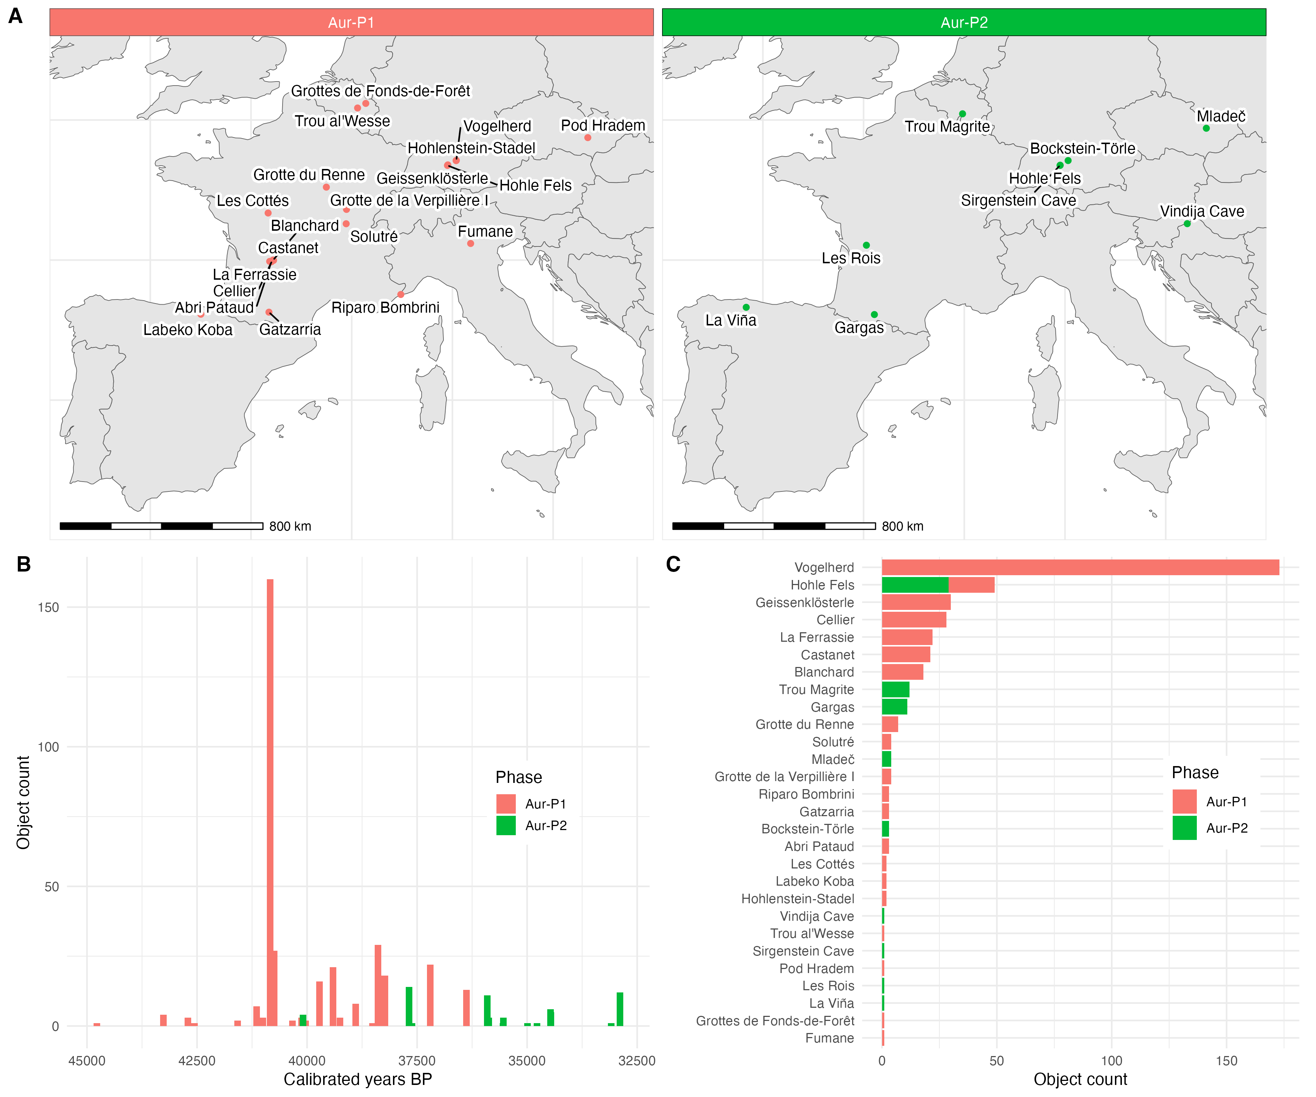
Figure 1: A: Map of sites in each Aurignacian phase that contain geometric signs on mobile objects. B: Abundance of signs over time, phases indicated by colours. C: Distribution of object count by site, phases indicated by colours. Map data from naturalearthdata.com [26,27]
Each object was assigned to a chronological phase following specialist technological attributions from the published literature, with the calibrated radiocarbon dates used to supplement the classification (Table 1 and see our S2 “Site Phase Assignments” for more details about specific sites). Ages of the objects were determined by calibrating the uncalibrated ages in SignBase using the rcarbon package [28] with the IntCal20 calibration curve. The calibrated radiocarbon dates of the sampled data range from approximately 33 to 45 ka cal BP, spanning an overall time range of 12 ka. The Aur-P1 phase has 20 sites and 26 sign types, and the Aur-P2 phase has 9 sites and 15 sign types. A Mantel test to evaluate the correlation between distance in time and distribution of sign types found a weak but nominally statistically significant correlation (R = 0.062, p = 0.008). The very small effect size (R ≈ 0.06) indicates that temporal distance explains only a small fraction of the variation in sign-type distribution. This weak association shows only that time has little explanatory power for sign composition; it does not demonstrate whether substantial change in sign types did or did not occur through time. We tested this inference more directly with a time-lag analysis (S1 “Sensitivity Analyses” S5.12): we binned all 28 sites (378 site pairs) by their absolute temporal separation (|ΔMedianBP|) to see if Jaccard sign dissimilarity rises with lag. It does not: the Spearman correlation between temporal lag and dissimilarity is -0.04 (p = 0.39) overall and -0.04 (p = 0.58) within phase. Sites in different phases are no more dissimilar (mean Jaccard 0.73) than sites within the same phase (0.76). As with the temporal Mantel, this flat trend is a lack of evidence for time-structured change in sign repertoires, not evidence that change was absent.

Methods
The distribution of objects across sites is highly skewed, as seen in Figure 1 C. To minimize the influence of this skewed distribution, we followed [29] in using presence/absence data for each sign at each site, reducing the effect of variation in object count between sites. We used Mantel tests with a Euclidean object abundance distance matrix and a Jaccard dissimilarity matrix of sign types. These tests determine the level of correspondence between the matrices through permutational evaluation (here 1000 permutations) of the null distribution [30], producing a Mantel R statistic and a p-value. The R statistic falls between -1, meaning a strong negative correlation, and 1, meaning a strong positive correlation, while a value of 0 means no correlation. The p-value estimates the probability of obtaining the observed correlation (or greater) if the null hypothesis of no correlation were true (we use an alpha value of 0.05 for the threshold of statistical significance). The Mantel tests were performed using the vegan package [31]. The test showed no significant correlation between object abundance and sign type distribution (R = 0.151, p = 0.082), validating our decision to use presence/absence data. Beyond presence/absence coding, we additionally tested the residual object-count confound directly at the object level via downsampling, coverage-based rarefaction, and a negative-binomial regression with log object count as a covariate (see our S1 “Sensitivity Analyses” S9).
If the distribution of sign types can be mostly explained by geographic distance, then we would see similarity in sign type distribution decreasing as geographic distance increases [32]. This relationship can be investigated using the isolation-by-distance framework, which proposes that cultural difference can be primarily explained by geographic distance [29]. To assess whether the distribution of sign types is primarily structured by geographic distance, we calculated the correlation between sign type distribution and geographic distance for each phase. We used Mantel tests with a geographic distance matrix and a Jaccard dissimilarity matrix, with the results shown in Table 2. None of the phases have a statistically significant correlation between sign type distribution and geographical distance, suggesting that isolation-by-distance alone does not fully account for the observed patterns, although this null result should be interpreted cautiously given the small sample sizes (see our S1 “Sensitivity Analyses” S5.8). To test whether the non-significant Mantel result reflects a particular alternative process, we additionally fit a multiple regression on distance matrices with sign dissimilarity as the response and geographic, temporal, and object-count distances as predictors (see our S1 “Sensitivity Analyses” S5.10). This reveals no candidate is significant, so the null Mantel does not identify any specific alternative process. A Mantel correlogram likewise shows no significant spatial structure at any distance lag, and bootstrap confidence intervals on the Mantel R indicate the test is underpowered at these sample sizes, so the non-significant result is best read as a lack of evidence rather than evidence of absence (S1 “Sensitivity Analyses” S5.11).
Aurignacian phase | Mantel R | Mantel p
Aur-P1 | 0.046 | 0.301
Aur-P2 | -0.299 | 0.933
Table 2: Table of the results per phase for the Mantel test between a Jaccard dissimilarity matrix of sign type diversity and a geographic distance matrix

Sign Group Detection Using Seriation and Network Analysis
Seriation arranges data into a linear order to reveal patterns [33]. We used the Brower-Kile [34] seriation algorithm implemented as an iterative reordering procedure that arranges rows and columns to group the presences along the diagonal. This algorithm was adapted from the original Brower-Kile approach and implemented in R, the code is openly available in our research compendium.
To investigate connectivity among the sites the seriation grouped, we used network analysis [35]. Each node is a site, and each edge weight is the Jaccard similarity between the two sites’ sign-type presence/absence vectors, computed as 1 − Jaccard(dissimilarity) so that higher values mean more shared sign types. To avoid cluttering the graph, all edges below the value of 0.2 were removed: an edge is only drawn if two sites share ≥ 20% Jaccard similarity, i.e., the intersection of their sign types is at least 20% of their union. We justify this threshold and demonstrate its robustness through sensitivity analyses at alternative thresholds (0.1 and 0.3), alternative similarity metrics (Sørensen-Dice, Simpson), a continuous threshold sweep from 0.05 to 0.50, and quantitative edge-set and adjacency-matrix agreement metrics across thresholds (see our S1 “Sensitivity Analyses” S1, S2, S5.2, S5.6). Results were plotted with the Fruchterman-Reingold layout [36], a force-directed graph layout for uniform edge lengths, and network analysis was performed using the vegan [31], statnet [37] and igraph [38] packages.

PerMANOVA for Sign Composition Differences Between Groups
PerMANOVA quantifies the level of variation between groups versus the level of variation within groups [39,40] and is used here as exploratory, rather than confirmatory. The results are expressed by an R² statistic, which quantifies how much of the variation in sign distribution can be explained by group membership, a pseudo-F statistic, and a p-value. The pseudo-F statistic compares the total sum of squared dissimilarities between groups to total sum of squared dissimilarities within groups. Larger pseudo-F statistics indicate more separation between groups. The p-value quantifies the probability of obtaining the observed difference if the null hypothesis were true (we use an alpha value of 0.05 for the threshold of statistical significance). The perMANOVA was performed using the vegan [31] package.
Because the restricted/broad group assignments were derived from visual inspection of the seriation results using the same sign data tested here, the PerMANOVA p-values therefore cannot be presented as independent confirmation that the groups differ. Thus we interrogate these assignments with several additional cross-validation and permutation methods. These are described in our S1 “Sensitivity Analyses” and reported briefly below.

Data Availability
All data and code needed to reproduce the analyses in this paper are publicly available. The original unprocessed dataset is available in the signBase_Version1.0.csv file from the SignBase repository [10]. The processed dataset is included with our Open Access research compendium at https://doi.org/10.5281/zenodo.21829663. This compendium includes a list of all the R package names, their version numbers, and custom R functions used to generate the results presented here. The compendium includes the Quarto documents paper.qmd, S1-supplement-sensitivity.qmd, and S2-supplement-site-assignment.qmd which can be rendered to reproduce the full analysis pipeline. This computational reproducibility approach follows best practices for transparent and open archaeological science [41,42].

Results

Detection of Groups Differentiated by Sign Repertoire
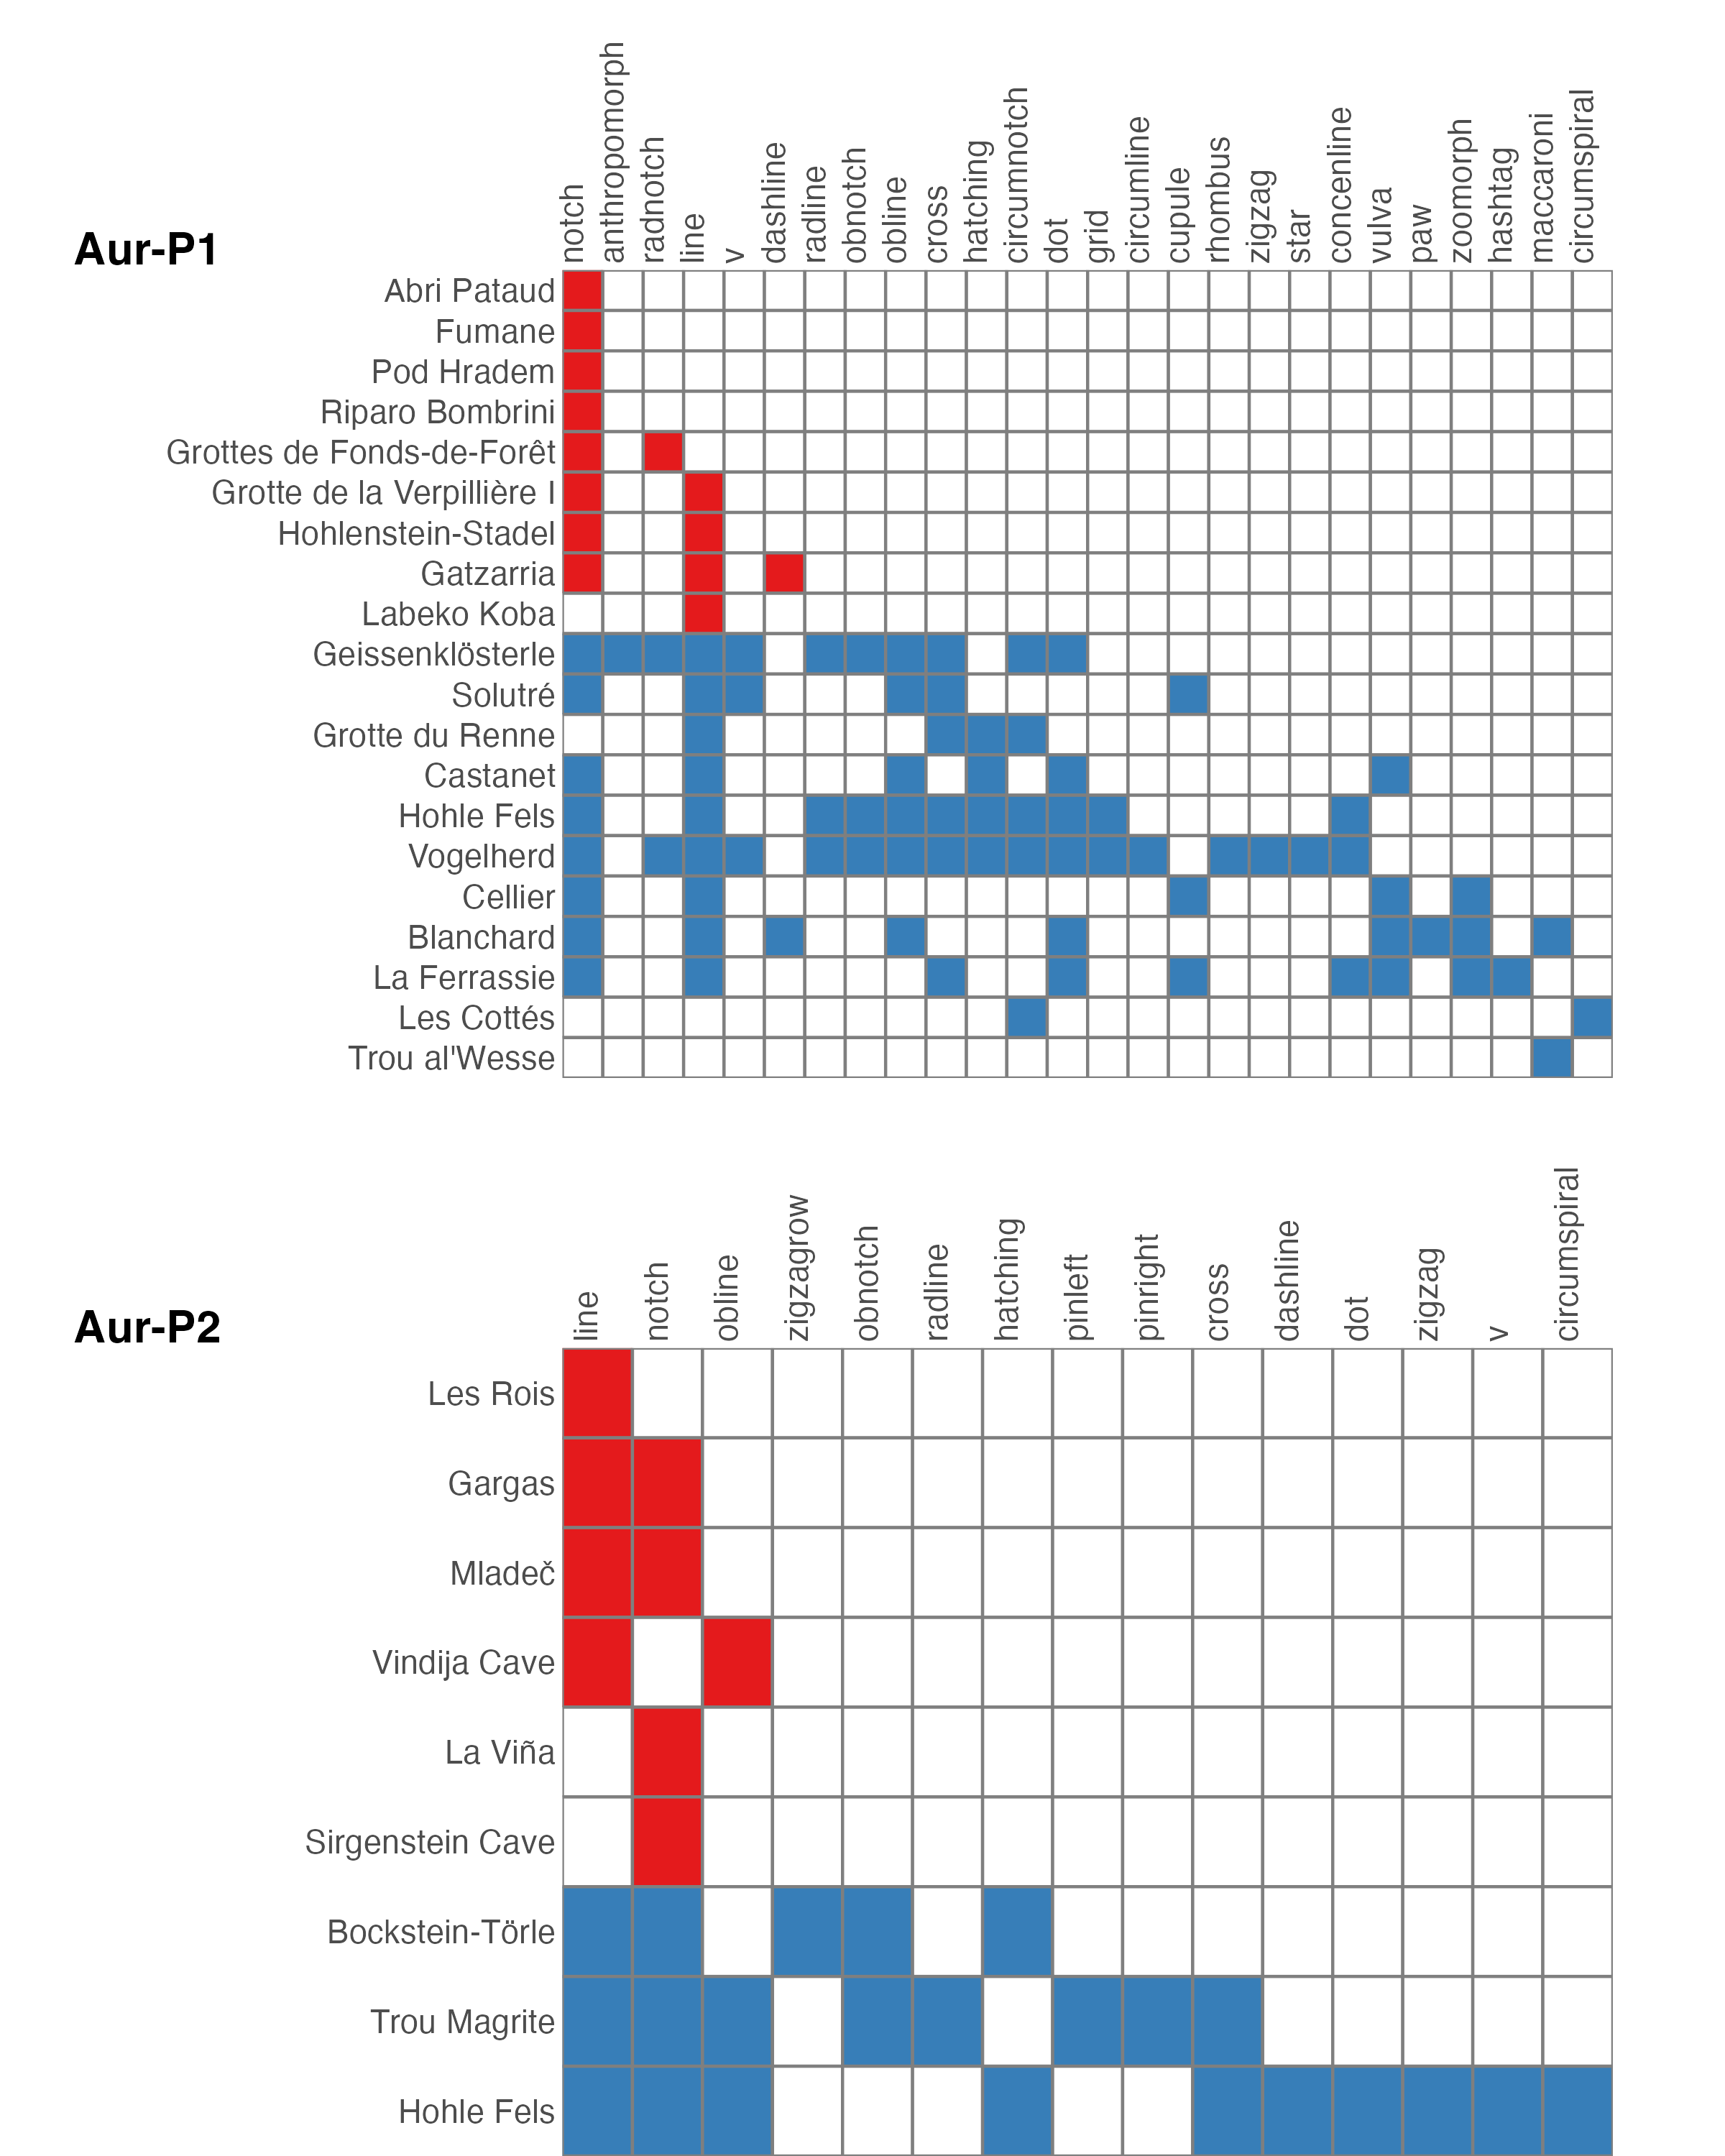
Figure 2: Presence–absence matrices of geometric sign types reordered using Brower‑Kile seriation for (A) Aur-P1 and (B) Aur-P2 phases. Rows represent sites and columns represent sign types. Hypothesized site grouping indicated by colour: restricted group is in red, broader group is in blue.
From visual inspection of our seriation results, we can hypothesize two groups of sign type composition for each of the two phases. One group has a restricted range of sign types (1-3 types), which tend to be visually simpler. A second group has a broader range (up to 17 types), which include more complex signs. Simpler signs composed of fewer components, like line and notch, are the most prevalent across both phases. In Aur-P1 the restricted-range group (9 sites) is slightly smaller than the broad-range group (11 sites); in Aur-P2 the restricted-range group (6 sites) is larger than the broad-range group (3 sites).
In Aur-P1 the restricted-range group consists of Abri Pataud, Fumane, Pod Hradem, Riparo Bombrini, Grottes de Fonds-de-Forêt, Labeko Koba, Hohlenstein-Stadel, Gatzarria, and Grotte de la Verpillière I, which carry only a few, visually simple sign types. The broad-range group consists of Geissenklösterle, Hohle Fels, Vogelherd, Cellier, Blanchard, La Ferrassie, Castanet, Solutré, Grotte du Renne, Les Cottés, and Trou al’Wesse, where a more diverse range of signs is found; in addition to line and notch, signs such as the obline, radial notch (radnotch), cross, hatching, and circumferential notch (circumnotch) are more frequent. Group assignment reflects sign composition as well as type diversity, which is why a small site such as Les Cottés (with few sign types) is placed in the broad-range group: its sign types are shared only with broad-range sites.
In Aur-P2 the restricted-range group consists of Les Rois, Sirgenstein Cave, La Viña, Mladeč, Gargas, and Vindija Cave, carrying few sign types, while the broad-range group consists of Trou Magrite, Bockstein-Törle, and Hohle Fels, which share a wider repertoire (including hatching and oblique notch, obnotch; Hohle Fels additionally contributes dashline, dot, cross, zigzag, v, and circumspiral). While inferring a two-group structure from the Aur-P1 seriation results seems straightforward, this is less clear for Aur-P2 where the partition rests on only 9 sites.
To quantitatively explore the robustness of the two-group hypothesis inferred from the seriation analysis, we used bootstrap resampling and stochastic block models, which we describe in detail in S1 “Sensitivity Analyses”. Bootstrap resampling tests the stability of the two groups as an imposed partition. It shows that for Aur-P1, mean within-block co-clustering is 0.75 for the restricted-range block and 0.97 for the broader-range block, against 0.2 across the two blocks. The within-block values substantially exceed the across-block value, which is a signal that both groups are internally coherent and sharply separated. The strength of this signal is much lower for Aur-P2, where the pattern is 0.49 within the restricted block and 0.92 within the broader block, against 0.4 across the blocks. However the two-group hypothesis is not supported by the results of the stochastic block model analysis, this tests whether the proposed groups emerge as latent network communities without being supplied to the model in advance. All three emission models (Bernoulli, Gaussian, and Poisson) provide no model-based support for the two-group pattern inferred from the seriation (S1 “Sensitivity Analyses”). Because stochastic block modelling does not consistently recover a multi-block structure, we reject the restricted/broad group hypothesis and instead hypothesize a dominant axis of sign type composition variation (rich vs. poor sign repertoires), rather than an exact partition that emerges from compositional similarity through an unsupervised model. Network analysis allows us to evaluate how these sites may have been connected along this axis.
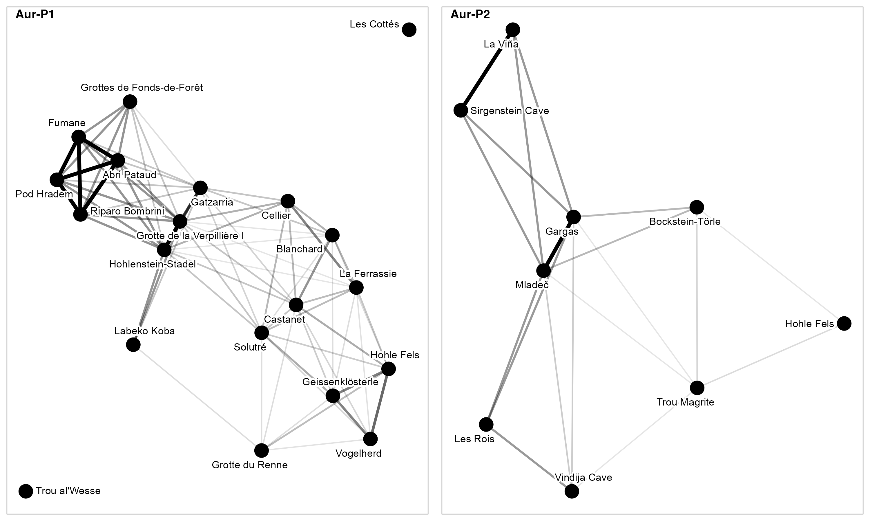
Figure 3: Networks depicting inter‑site affinity in geometric‑sign repertoires for each phase, derived from the Jaccard similarity of sign presence/absence. Nodes represent sites and edges connect pairs whose Jaccard similarity is ≥0.2 (i.e., the intersection of their sign types is at least 20% of their union). Node size reflects degree centrality, and edge thickness corresponds to similarity strength.
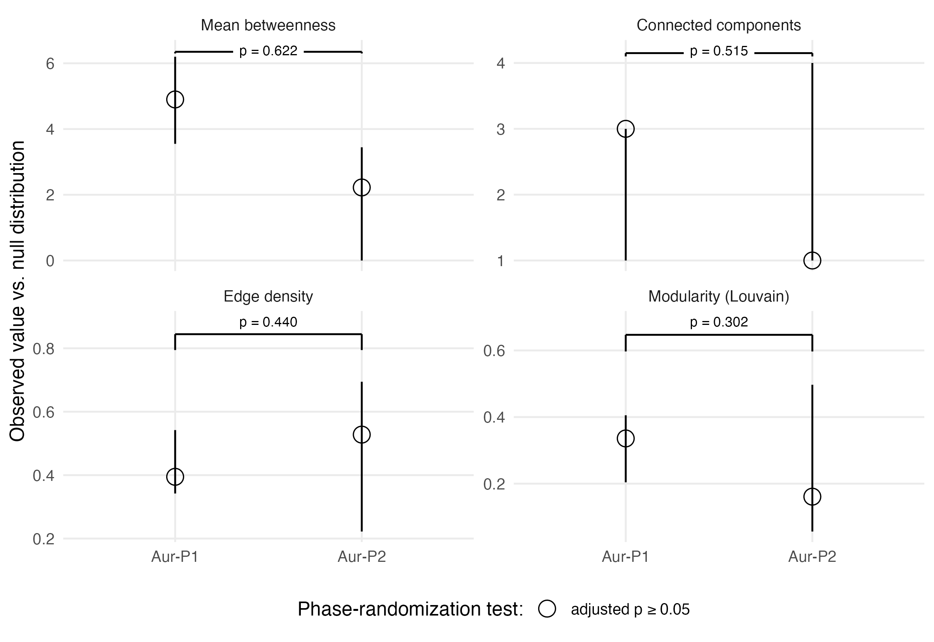
Figure 4: Network statistics for the two phases. The vertical black lines are the null 95% confidence interval, the observed statistic value is shown as a solid black circle (BH-adjusted p < 0.05) or a hollow circle (not significantly different from a phase-randomized null distribution). The horizontal brackets at the top of each panel show p-values of pairwise randomisation tests for significant differences in network statistics between phases.
Distinct groups of sites are not evident in Figure 3, supporting the hypothesis of a gradient of sign type composition variation. Figure 4 shows the results of permutation tests (n = 10,000) assessing whether the observed statistics differ from a phase-randomized null distribution, and pairwise randomisation tests comparing the two phases. Under phase randomization, none of the network statistics, edge density, modularity (Louvain), mean betweenness, or component count, differs significantly from its null distribution in either phase. All observed values fall within the null 95% confidence intervals and all Benjamini–Hochberg-adjusted p-values are ≥ 0.05. The Aur-P1–Aur-P2 contrast is therefore primarily one of network scale rather than a statistically distinguishable community structure.
We assessed the sensitivity of our network analysis to site assignment criteria in three ways: (1) reverting to purely date-based assignment; (2) excluding Vogelherd entirely, as a site with an unsually large sign assemblage; (3) excluding figurines concentrated at Vogelherd (S1 “Sensitivity Analyses”). Under all conditions, the Aur-P1 > Aur-P2 connectivity ordering is preserved (Aur-P1 mean degree: 7.50 baseline, 7.26 no Vogelherd, 7.40 no figurines; Aur-P2: 4.22). Excluding Vogelherd reduces Aur-P1 edges by 8% and mean degree by 3.2%, but does not alter the phase contrast or the within-phase two-group pattern. Because the principal results are unchanged when Vogelherd is excluded entirely, our conclusions do not depend on its inclusion or on its precise archaeological attribution.

Figure 5: Geographic distribution of sites with signs in the two Aurignacian phases (Aur-P1, Aur-P2). Sites are colored according to their hypothesized group membership (Restricted-range or Broader range) as inferred from the seriation. The spatial arrangement shows that sites belonging to the same sign-use group are not strictly clustered geographically, consistent with the Mantel test results that did not detect a significant correlation between geographic proximity and geometric sign similarity. Map data from naturalearthdata.com and [27]
Spatial clusters of sites are not evident in the sites with signs (Figure 5), perhaps due to the small numbers of sites in each phase . In Aur-P1, sites are distributed widely across Western and Central Europe, with some geographical overlapping between the restricted- and broad-range groups, consistent with the connectivity between sign-use groups evident in the network analysis. In Aur-P2, the surviving sites are more widely dispersed, though this reflects the much smaller sample of this phase. Partitions Around Medoids on geodesic distances between sites finds two groups as a parsimonious grouping for Aur-P1 only (S1 “Sensitivity Analyses”). These two groups are roughly West versus Central Europe, separating the Dordogne bloc tradition from the Swabian ivory tradition, and likely reflective research effort history rather than past cultural groups.

Sign Composition Differences Between Groups
Aurignacian phase | PerMANOVA R2 | PerMANOVA F | PerMANOVA p
Aur-P1 | 0.196 | 4.382 | 0.001
Aur-P2 | 0.223 | 2.008 | 0.076
Table 3: Table of the results per phase for the perMANOVA
Because the restricted/broad labels were defined from the same sign data used in the PerMANOVA, we treat this analysis as exploratory rather than confirmatory. The PerMANOVA showed a nominal difference in Jaccard sign composition between the groups in Aur-P1 and a weaker difference in Aur-P2 (Table 3). Betadisper did not detect a significant difference in within-group dispersion in either phase; this does not establish equal dispersions, so the PerMANOVA results should be interpreted cautiously. Complementary analyses provide mixed evidence (see our S1 “Sensitivity Analyses”). Object-half holdout shows that a richness-based contrast can be recovered from disjoint objects, but the contrast is weaker when Jaccard’s nestedness component is removed using Simpson turnover. Leave-one-out classification indicates that the labels vary smoothly across the Jaccard composition space rather than independently confirming a discrete partition, and the fixed-fixed Curveball test does not show that the optimised split exceeds richness-preserving expectations. Taken together, these results support the hypothesis of the restricted/broad pattern as a descriptive richness gradient that is strongest for well-sampled sites, and do not support the hypothesis of a discrete two-group structure.

Discussion

Group Dynamics Within and Between the Two Aurignacian Phases
Our first aim was to determine whether any structure in sign type composition exists within each phase, and how diversity, size, connectivity, and distribution vary between the phases. The results from Figure 2 initially suggested a hypothesis of two main sign-use groups, with sign type frequency and diversity serving as the major dividing factor. This parallels a richness-driven split found in sites with ornaments by [2], whose k-means with silhouette criterion divided those sites into >10 vs ≤10 types regardless of geography, similar to our seriation-inferred divide. However, quantitative investigation of our sign type composition groups indicates the two group contrast is a recoverable only as gradual axis rather than a sharp partition. Group size differed between phases: in Aur-P1 the restricted-range group (9 sites) was slightly smaller than the broad-range group (11 sites), whereas in the much smaller Aur-P2 the restricted-range group (6 sites) exceeded the broad-range group (3 sites). The removal of Vogelherd, as a site with an unusally high number of signs, does not change the gradient observation.
Figure 3 suggests apparent differences in connectivity between the phases. At first glance, Aur-P1 appears the more edge-rich network with the higher mean degree (7.50) and a hub structure centred on key sites, while Aur-P2 shows fewer edges and a lower mean degree (4.22). However, pairwise permutation tests indicate that the phases do not differ significantly in any of the tested network statistics (edge density, modularity, mean betweenness, or component count), so the Aur-P1–Aur-P2 contrast is best described as a difference in network scale rather than in overall connectedness or community structure. An exploratory PerMANOVA returns a nominal separation of the restricted- and broad-range groups in Aur-P1 sign composition (R² = 0.196, p = 0.001) but not in Aur-P2 (R² = 0.223, p = 0.076), consistent with the smaller Aur-P2 sample. That said, our sensitivity analyses show that this result is best taken as a gradual axis of variation (see our S1 “Sensitivity Analyses”).
This restricted/broader gradient may be influenced by variation in social structure. Variation in hunter-gatherer social structures is well-known from ethnographic and archaeological research [43–50]. Studies have established how variation in ornamentation and other forms of material culture can be used to communicate information about the numbers and types of social roles and statuses within groups [4,50–61]. Drawing on this work, we might speculate that the broader/restricted gradient in the geometric sign data may be consistent with variation in social structure. For example, the broader range groups, with a higher variety of signs and visually complex signs, may indicate communities with a greater variety of formalized social roles, whereas the sites with a restricted range of signs may indicate communities with fewer formalized social roles.
Sampling effort is a major qualification on this social structure interpretation: object count and sign-type richness are strongly correlated, and the absence of a detectable association between node degree and richness does not establish that the restricted/broad assignments are independent of sampling effort. Object-level downsampling shows that assignments are retained mainly by the best-sampled sites, whereas small-site assignments often approach chance. Among the subset of sites that attain comparable coverage, broad-range sites remain richer, and a negative-binomial model with an estimated, rather than fixed, richness–effort exponent is consistent with a residual group difference at equal object count; however, this estimate is imprecise because the sample is small and group membership is strongly collinear with object count (S1 S12.2–S12.4). At the phase level, the Jaccard separation is not greater than expected under a fixed-margin null preserving site richness and sign-type frequencies, and no separation remains on Simpson turnover, which removes the nestedness component of Jaccard (S1 S10.1). The restricted/broad pattern is therefore best treated as a descriptive richness gradient that is most credible for well-sampled assemblages; assignments for small assemblages remain provisional. The analyses do not provide strong support for discrete social structures in the sign data.
The connectivity between sites represented in Figure 3 may be consistent with possible non-utilitarian mobility among these larger communities, among other processes. Previous studies have shown a range of variation in magnitudes and types of mobility among hunter-gatherer groups [62]; [63]; [48]; [64]; [49]. Non-utilitarian mobility establishes regional social networks which facilitate the spread of information and the survival of hunter-gatherers in uncertain environments [65]; [66]; [67]; [68]; [69]. The exchange and production of decorative items, such as objects with geometric signs, has been associated with non-utilitarian mobility and recognized as an indicator of social contact [65]; [70]; [71]; [72]; [73]. Our Mantel tests did not detect a significant correlation between sign-type distribution and geographic distance in any phase (Table 2), although this null result should be interpreted cautiously given the small sample sizes and limited statistical power (see our S1 “Sensitivity Analyses”), and bootstrap confidence intervals on the Mantel R show that a moderate geographic correlation could not be excluded at these sample sizes (S1 “Sensitivity Analyses” S5.11). A non-significant Mantel result cannot establish any particular social process: it indicates only that isolation-by-distance was not detected. Non-utilitarian mobility thus remains a possible interpretation of the network structure, but it is not specifically demonstrated by this analysis.
Non-utilitarian mobility can be divided into shorter-term information exchange and longer-term residential movement. One form of longer-term residential movement that may be related to non-utilitarian mobility is aggregation/dispersion patterns, which are a type of hunter-gatherer settlement pattern in which groups both disperse and congregate in large groups, typically for subsistence or social reasons [74]. Aggregation sites are the places where group fragments or individuals congregate. In the archaeological literature, aggregation sites are often associated with high degrees of social connectivity and identified by indicators including proximity to certain environmental resources and a more diverse artifact assemblage, including, in some cases, decorative objects [2,70,75–81]. Of these indicators, only assemblage diversity is testable in our data. Notably, our results complicate the association between aggregation and high connectivity: the sites whose diversity lies above the simulated mean (a possible indicator of aggregation) are, with one exception, not the highly connected hubs in Figure 3. This is consistent with a decoupling between aggregation contexts and long‑distance connectivity in sign repertoires, which we discuss further below.
One way to potentially identify aggregation sites is by measuring sign diversity. Sites with a higher than expected sign diversity index may be consistent with aggregation. However, a limitation of this approach is that while higher diversity may be consistent with interpretation as an aggregation site, it may also result from sample size, recovery history, research intensity, preservation, and site function. Figure 6 plots the expected Shannon diversity index for a given sample size against the actual diversity index per site computed per site from counts of objects per sign type, within each phase. The expected distribution was generated by multinomial resampling from the phase-pooled per-sign-type totals, at each sample size from 1 to the maximum count, with 1000 replicates [82,83]. The sign-type pool — the number of distinct geometric signs recovered in each phase — was 26 in Aur-P1 and 15 in Aur-P2.
When each site’s observed diversity is compared with the expectation for its sample size, 5 of 20 Aur-P1 sites and 4 of 9 Aur-P2 sites exceed their expected diversity (the mean simulated diversity for the equivalent count of sign types). Notably, most of these sites are not shown as highly connected in Figure 3. The relative diversity does not track the phase-level pool size (Aur-P1 mean excess -0.2, Aur-P2 mean excess -0.07), so the sites’ relative diversity fluctuates independently of the sign-type pool. This suggests a distinction between shorter-term information exchange (e.g. the highly interconnected sites in Figure 3) and longer-term residential movement for aggregation (e.g. the sites with higher than average diversity in Figure 6). Supporting this distinction, sites whose diversity lies above the simulated mean (as a possible indicator of aggregation) showed a weak, non-significant trends with network degree after Benjamini‑Hochberg correction (ρ = -0.35, p = 0.095). However, because this trend is not significant, it is not evidence either way about whether these sites are more or less connected. Object count was weak, non-significantly positively correlated with degree centrality after correction (degree: ρ = 0.35, p = 0.095). The sites’ diversity excess (how much more diverse a site is than the randomised null would predict for its sample size) is distributed significantly differently for the restricted‑range group versus the broad‑range group (Wilcoxon W = 59, p = 0.044), so the diversity‑excess measure is associated with which of the broad-restricted gradient.
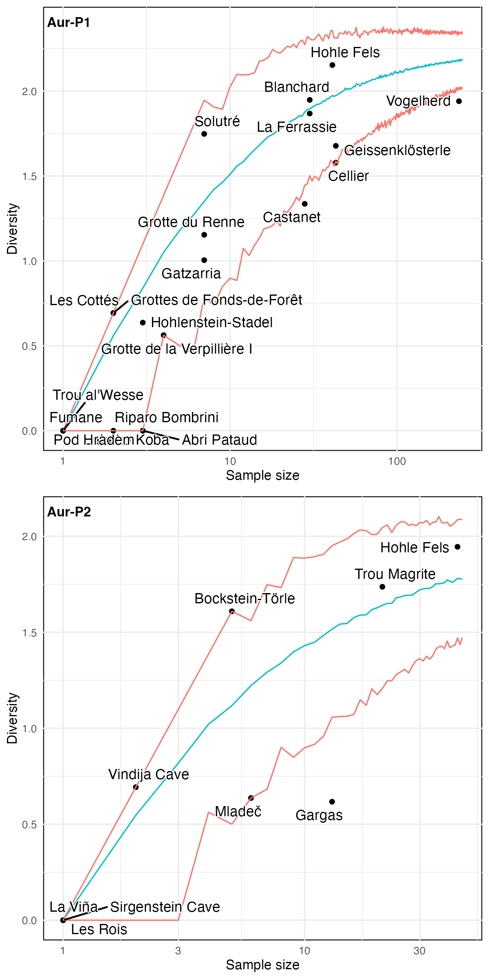
Figure 6: Observed geometric sign diversity at each site compared with expectations derived from randomised assemblages controlling for sample size. The blue expectation curve is the mean simulated diversity index per sample size. The red lines enclose a band that is the 95% confidence interval of the null distribution (no sites exceed this interval). Sites above the blue expectation curve have higher than average diversity, given their sample size.

Interpreting Network Patterns: Population, Transmission, and Social Structure
Our second aim was to determine what these patterns reveal about the dynamics of social organization throughout the Aurignacian. The results suggest that the phases do not differ significantly in size-adjusted network statistics and that raw differences in inter-site connectivity mainly reflect the early Aurignacian (Aur-P1) having more sites. Geographic distance had little influence on sign distribution in Aur-P1 (Mantel R = 0.046; Table 2), and no significant geographic signal was detected in either phase (Aur-P2: R = -0.299). A permutation test of the difference between these Mantel correlations (D = 0.34, p = 0.153; sites permuted between phases 1,000 times) shows that the isolation-by-distance relationship does not differ significantly between the phases, so the spatial-proximity explanation is not supported by this analysis. This null result reflects limited statistical power at these sample sizes rather than positive evidence that geography is irrelevant, as quantified by bootstrap confidence intervals on the Mantel R (S1 “Sensitivity Analyses”). [2] report a similar pattern for ornaments, a non-significant, near-zero global Mantel with spatial structure only in correlograms at short lags (≤~300 km). We did not find structure in correlograms at short lags.
How do our results align with previous work on the environmental and population change during these phases? From 45–43.25 ka cal BP, the population density in Europe was extremely low, due to the unfavorable environmental conditions of Greenland Stadial 12 (44 ka cal BP) and the slow westward expansion of early modern humans [84]. This was followed by rapid expansion from 43.25–41 ka cal BP, with the maximum extent of early Aurignacian (Aur-P1) settlement being reached around 41 ka cal BP ([21]). Other studies have also found similar associations in other regions and time periods between increases in quantity and diversity of art, and increases in population density [85–93]. Although population growth is one condition under which sign systems typically gain a communicative function, our results do not establish a causal link between demographic expansion and the emergence of geometric signs as a group-membership marker in the Aurignacian. Quantitative demographic reconstructions suggest that western and central European Aurignacian populations numbered approximately 1500 individuals [21], a relatively small number that may partly explain why our networks remain small and sparsely connected across both phases. [21] distinguish “Core Areas” of viable, year-round occupation from “Extended Areas” of seasonal or satellite use, with Core Areas corresponding to regions such as the Dordogne. This Core/Extended framework is consistent with our finding from the larger Aur-P1 network, with the lower-connectivity periphery potentially representing periodically visited Extended Areas. In Aur-P2 the reduced network is consistent with more localised interaction as populations consolidated. That said, the contraction of the geometric sign-type pool from Aur-P1 (26 types) to Aur-P2 (15 types) does not survive sensitivity testing. At equal sampling effort with incidence-frequency rarefaction to 63 objects (all types and shared object types only), the rarefied Aur-P1 pool overlaps the Aur-P2 pool, so the raw difference in the number of sign types is not distinguishable from sampling variation. Neither the networks or sign diversity patterns can be clearly linked to demographic dynamics with the current sample.
[22] used eco-cultural niche modeling to show that Heinrich Stadial 4 (HS4) at the very beginning of the Early Aurignacian resulted in an expansion of people into new environmental niches, hypothesised to involve an expansion of social networks both within and between populations. Our finding of no significant changes in networks over time suggests that if [22]’s model is accurate, we do not see a signal of it in the geometric sign data. Neither phase shows a significant geographic signal (Aur-P1 Mantel R = 0.046, Aur-P2 Mantel R = -0.299), suggesting that sign sharing was not primarily driven by expansion into new, spatially structured niches. Similarly, [12] developed a human-existence probability model for the Aurignacian, finding an expanded, more dispersed settlement area for the Evolved/Late Aurignacian, and [84] also identifies increased expansion marking the beginning of the Evolved Aurignacian. In our data Aur-P2’s wider spatial spread was not accompanied by stronger sign-type sharing. These patterns of connectivity and geographic structure also have implications for understanding how geometric signs functioned as markers of group identity.
Although previous work has argued for geometric signs as a form of cultural identification and communication during the Palaeolithic [3], our results do not identify geographically distinct groups differentiated by sign repertoire. Geographic distance had little influence on sign distribution in either phase (Aur-P1: R = 0.046; Aur-P2: R = -0.299). Further analysis of sign composition differences across sites grouped by geography alone (Partioning Around Medoids on geodesic distances, k=2 to 5, with Jaccard dissimilarity and PERMANOVA) found no significant differences across geographic groups (S1 S5.13). Thus our findings contrast with previous work such as [6] and [3] who found distinct cultural clusters in their analysis of personal ornaments. One possible explanation for this contrast is that the geometric signs studied here encode different kinds of group information compared to the personal ornament objects studied by [6]. Another explanation may be that a distinguishing factor between the Aurignacian and Gravettian is the appearance of geographically distinct cultural groups in the Gravettian, as reported by [3]. We might hypothesize that the distribution found in the Aur-P2 phase (Figure 5) evolved into the clusters proposed by [3] for the Gravettian period. This transition is consistent with recent evidence for cultural continuity in personal ornaments between these technocomplexes [2], though our geometric sign data do not show the same pattern. The data used by [6] was also analyzed by [94], who used Approximate Bayesian Computation to simulate and compare Aurignacian personal ornament distribution as a result of structured ethnic identity versus as a result of cultural identity by-descent with modification and isolation-by-distance. Their results show the latter was best supported by the data. Cultural identity by-descent with modification is defined as group difference generated by unconscious cultural mutation and drift, and largely influenced by spatial proximity to other groups. These results from [94] complicate claims by [6] for geographically distinct cultural groups in the Aurignacian, and like our data, does not establish the absence of geographically structured identity; both our analyses are underpowered for that claim (see S1 S5.11). To understand how these patterns of sign sharing might have been produced, we now turn to cultural transmission theory.
Our results can be interpreted through the lens of cultural transmission theory [95–97]. Smaller populations are predicted to experience greater drift and reduced capacity to maintain complex cultural repertoires [98], which is consistent with our observation that the sign-type pool is larger in the Aur-P1 phase (26 types) than in the Aur-P2 phase (15 types). Network structure also shapes cultural information flow: highly connected networks with high-degree node structures facilitate rapid transmission and reduce drift [99,100], while more clustered networks promote localised conformist transmission and differentiation within subgroups [101]. Our finding of no statistically significant difference in connectivity metrics across the two phases suggests that relative interaction levels remained consistent over time, even as populations consolidated into fewer sites. The lack of significant geographic structure in either phase contradicts simple isolation-by-distance models [98,102]. A non-significant Mantel result cannot establish which social process generated the pattern; ritual gatherings or ceremonial exchange remain speculative possibilities, not demonstrated mechanisms. These interpretations are speculative: network structure reflects sign-sharing patterns, not direct evidence of social organisation, and simpler sign types may reflect independent invention or functional constraints rather than social transmission. Our caution matches [103], who treats stable bison-horse-ibex centrality in Magdalenian parietal art along the Bay of Biscayas an organisational grammar and refrains from claims about symbolic meaning, narrative content, or cultural meaning.
The contrast with personal ornaments, such as the decorated ivory pendant from Stajnia Cave [11], is informative. [6] identified fourteen geographically structured Aurignacian groups using ornaments; [3] found similar Gravettian clusters. Our Mantel tests show no significant geographic correlation for geometric signs (Aur-P1: R = 0.046, p = 0.301; Aur-P2: R = -0.299, p = 0.933). This null result does not by itself establish the signs’ function. One speculative possibility is that different material classes encode different identity dimensions, for example, ornaments may signal ethnic affiliation, while geometric signs could serve functions such as notation, calendrical recording, or information storage. But these remain untested hypotheses. This aligns with work by [104] (sign sequences having protocuneiform-like information density, suggesting notational function) and [105] (some signs recording seasonal prey information). However, both hypotheses are contested: [106] note methodological issues in Bentz & Dutkiewicz; [107] and [108] argue the lunar calendar hypothesis is untestable, circular, and selectively uses data; [109] finds multiple theoretical weaknesses. Our results neither confirm nor rule out these hypotheses, and sign-type ambiguity remains a limitation.

Conclusion
Previous work [3,76,110–113] has used material culture analysis to reconstruct Upper Palaeolithic social networks, which have been argued to be a driver of cultural and evolutionary change [2,69,114–118]. Our results show that the current sample of geometric signs does not support any significant change over the Aurignacian.
A restricted/broad repertoire axis is visually evident in seriation and supported by bootstrap co-clustering (Aur-P1: within-block 0.75/0.97 vs. across-block 0.2; Aur-P2: 0.49/0.92 vs. 0.4). However, stochastic block models do not recover a two-group partition for either phase (single block selected under both Bernoulli and Gaussian emission models; S6.3). Cross-validation (leave-one-out, object-half holdout, gradient PerMANOVA) recovers the axis, yet the maximally-selected split test under a fixed-fixed (Curveball) null is not significant in either phase (Aur-P1 p = 0.106; Aur-P2 p = 0.984). Critically, a negative-binomial regression with an estimated richness–effort exponent finds the group contrast persists at equal object count (rate ratio 2.31, p = 0.003; S9.4). Richness-preserving nulls bound this reading both ways: the Jaccard separation falls within richness structure alone under fixed margins, exceeds object-sampling expectation in Aur-P1 only, and vanishes entirely on Simpson turnover dissimilarity, which shows no group separation in either phase (S9.7). The raw richness gap is therefore not distinguishable from a real group difference carried by the nestedness component. The restricted/broad division should be read only as a descriptive gradient whose independence from sampling effort is not demonstrated for sites with small numbers of signs.
No significant isolation-by-distance signal is detected in either phase (Mantel R = 0.046, p = 0.301; R = -0.299, p = 0.933), but bootstrap confidence intervals (S5.11) show the tests are underpowered at n = 20 and 9 sites — these are null results reflecting limited power, not evidence of geographic irrelevance. Geometric signs do not exhibit the geographically distinct clusters reported for personal ornaments [3,6]; whether they encode different identity dimensions (notation, calendrical recording, information storage) remains speculative and untested [104–109]. Our findings are consistent with the conclusions of [94] that cultural identity by-descent with modification is a likely explanation for the distribution of Aurignacian ornaments.
Our study has four limitations. First is the ambiguity of some of the sign types. While [119] argues in favor of Aurignacian geometric signs as symbolic expression, potential ambiguity still remains over whether function is consistent across all sign type occurrences, particularly in regards to the simpler sign types composed from fewer elements. We included the more ambiguous sign types because similar sign occurrence may still serve as evidence of connectivity in sign repertoires regardless of function, even if it is random copying [120], and additionally, greater quantities of included sign types serve to establish stronger connections [121]. This ambiguity may be addressed in the future through the usage of the data recently released in SignBase 2.0 covering sites in Germany, which contains more detailed information on the specific order and patterns in which signs occurred on individual objects [104].
A second limitation concerns the effects of time-averaging on our network reconstructions. [122] demonstrate that time-averaging reduces the fidelity of network interpretations compared to non-time-averaged networks, and that these effects are highly dependent on initial network structures. Our division of the Aurignacian into two phases partially addresses this issue, but each phase still spans several thousand years, and individual sites may contain occupations from multiple millennia. The palimpsest nature of archaeological deposits means that our networks likely compress diachronic changes in social connectivity, potentially obscuring shorter-term fluctuations in interaction patterns. [64] further show that hunter-gatherer mobility patterns profoundly affect our ability to reconstruct social networks from archaeological assemblages, with implications for how we interpret network metrics such as mean degree and transitivity. These methodological constraints should be borne in mind when inferring social organisation patterns from the analyses discussed above.
A third limitation relates to the reliability of site-level phase assignments, and the small size of the Aur-P2 sample in particular. Our primary analysis assigns each site to a phase on the basis of specialist technological attributions from the published literature rather than radiocarbon dates alone, which can conflict with the archaeological content of a layer: Abri Pataud’s lithic technology places it in the Early Aurignacian despite basal dates within the Proto-Aurignacian range [123,124], La Ferrassie’s Aurignacian begins with the Early Aurignacian directly above the Châtelperronian [125], and Mladeč’s massive-base bone points and ~31 ka ¹⁴C BP (~35–36 ka cal BP) dates indicate an Evolved (Aur-P2) attribution [126]. Additionally, Vogelherd Cave’s stratigraphy is compromised by excavation methodology and post-depositional disturbance, with documented mixing between Aurignacian, Gravettian, and Magdalenian layers [127]. After exclusions, Aur-P2 rests on only 9 sites and 63 objects, so its two-group structure and network statistics have limited power. To manage this limitation we tested the sensitivity of our assignments to reverting to purely date-based criteria in S1 “Sensitivity Analyses” and find that the main structures are generally robust.
Fourth, the restricted/broad division may not be independent from sampling intensity. Object-level resampling shows that only the best-sampled sites retain stable group assignments when compared at a common object count. A negative-binomial regression with an estimated richness–effort exponent finds the group contrast persists at equal object count (rate ratio 2.31, p = 0.003; S1 S9.4); the offset specification that found no effect fixed the exponent at 1, which the data reject. The raw richness gap is therefore not distinguishable from a genuine group difference, and for sites represented by only a few objects the restricted/broad membership remains provisional. The division should accordingly be read as a descriptive axis of variation whose separation from sampling effort is not demonstrated for small-object sites.

References
[1] Boyd R, Silk JB. How humans evolved. W.W. Norton; 2020.
[2] d’Errico F, Baker J, Pereira D, Álvarez-Fernández E, Lázničková-Galetová M, Rigaud S. Multivariate analyses of Aurignacian and Gravettian personal ornaments support cultural continuity in the Early Upper Palaeolithic. PLOS ONE 2025;20:e0323148. https://doi.org/10.1371/journal.pone.0323148.
[3] Baker J, Rigaud S, Pereira D, Courtenay LA, d’Errico F. Evidence from personal ornaments suggest nine distinct cultural groups between 34,000 and 24,000 years ago in Europe. Nature Human Behaviour 2024;8:431–44. https://doi.org/10.1038/s41562-023-01803-6.
[4] Sauvet G, Bourrillon R, Garate D, Petrognani S, Rivero O, Robert E, et al. The function of graphic signs in prehistoric societies: The case of Cantabrian quadrilateral signs. Quaternary International 2018;491:99–109. https://doi.org/10.1016/j.quaint.2017.01.039.
[5] Kuhn SL, Stiner MC. Paleolithic ornaments: Implications for cognition, demography and identity. Diogenes 2007;54:40–8. https://doi.org/10.1177/0392192107076870.
[6] Vanhaeren M, d’Errico F. Aurignacian ethno-linguistic geography of Europe revealed by personal ornaments. Journal of Archaeological Science 2006;33:1105–28. https://doi.org/10.1016/j.jas.2005.11.017.
[7] Fuentes O, Lucas C, Robert E. An approach to Palaeolithic networks: The question of symbolic territories and their interpretation through Magdalenian art. Quaternary International 2019;503:233–47. https://doi.org/10.1016/j.quaint.2017.12.017.
[8] Tejero J-M, Grimaldi S. Assessing bone and antler exploitation at riparo mochi (Balzi Rossi, Italy): Implications for the characterization of the Aurignacian in South-Western Europe. Journal of Archaeological Science 2015;61:59–77. https://doi.org/10.1016/j.jas.2015.05.003.
[9] Tartar E. The recognition of a new type of bone tools in early Aurignacian assemblages: Implications for understanding the appearance of osseous technology in Europe. Journal of Archaeological Science 2012;39:2348–60. https://doi.org/10.1016/j.jas.2012.02.003.
[10] Dutkiewicz E, Russo G, Lee S, Bentz C. SignBase, a collection of geometric signs on mobile objects in the Paleolithic. Scientific Data 2020;7:364. https://doi.org/10.1038/s41597-020-00704-x.
[11] Talamo S, Nowaczewska W, Picin A, Vazzana A, Binkowski M, Bosch MD, et al. A 41,500 year-old decorated ivory pendant from Stajnia Cave (Poland). Scientific Reports 2021;11:22078. https://doi.org/10.1038/s41598-021-01221-6.
[12] Shao Y, Limberg H, Klein K, Wegener C, Schmidt I, Weniger G-C, et al. Human-existence probability of the Aurignacian techno-complex under extreme climate conditions. Quaternary Science Reviews 2021;263:106995. https://doi.org/10.1016/j.quascirev.2021.106995.
[13] Doyon L. Le paysage socio-symbolique aurignacien : Regards croisés entre les parures, les symboles et la morphologie des armatures en matière osseuse. Bulletin Du Musée d’Anthropologie Préhistorique de Monaco 2022.
[14] Chu W, Richter J. Aurignacian cultural unit. In: Smith C, editor. Encyclopedia of global archaeology. 2nd ed., Cham: Springer International Publishing; 2020, p. 1–10. https://doi.org/10.1007/978-3-319-51726-1_3441-1.
[15] Dinnis R, Bessudnov A, Chiotti L, Flas D, Michel A. Thoughts on the structure of the European Aurignacian, with particular focus on Hohle Fels IV. Proceedings of the Prehistoric Society 2019;85:29–60. https://doi.org/10.1017/ppr.2019.11.
[16] Falcucci A, Conard NJ, Peresani M. Breaking through the Aquitaine frame: A re-evaluation on the significance of regional variants during the Aurignacian as seen from a key record in southern Europe. Journal of Anthropological Sciences 2020;98:99–140. https://doi.org/10.4436/JASS.98021.
[17] Clark GA, Riel-Salvatore J. What’s in a name? Observations on the compositional integrity of the Aurignacian. In: Camps M, Szmidt C, editors. The Mediterranean from 50 000 to 25 000 BP: Turning points and new directions, Oxford: Oxbow Books; 2009, p. 323–38.
[18] Zilhão J, d’Errico F, Banks WE, Teyssandier N. A data-driven paradigm shift for the Middle-to-Upper Palaeolithic transition and the Neandertal debate. Quaternary Environments and Humans 2024;2:100037. https://doi.org/10.1016/j.qeh.2024.100037.
[19] Bordes J-G. News from the West: A reevaluation of the classical Aurignacian sequence of the Périgord. In: Bar-Yosef O, Zilhão J, editors. Towards a definition of the Aurignacian, vol. 45, Instituto Português de Arqueologia Lisbon; 2006, p. 147–71.
[20] Canessa T, Peña P de la. Unpacking lithic assemblage variability in the Early Upper Palaeolithic: A multivariate approach to the structure of the Iberian Aurignacian. PLOS ONE 2026;21:e0345202. https://doi.org/10.1371/journal.pone.0345202.
[21] Schmidt I, Zimmermann A. Population dynamics and socio-spatial organization of the Aurignacian: Scalable quantitative demographic data for western and Central Europe. PLOS ONE 2019;14:e0211562. https://doi.org/10.1371/journal.pone.0211562.
[22] Banks WE, d’Errico F, Zilhão J. Human–climate interaction during the Early Upper Paleolithic: Testing the hypothesis of an adaptive shift between the Proto-Aurignacian and the early Aurignacian. Journal of Human Evolution 2013;64:39–55. https://doi.org/10.1016/j.jhevol.2012.10.001.
[23] Falcucci A, Conard NJ, Peresani M. A critical assessment of the Protoaurignacian lithic technology at Fumane Cave and its implications for the definition of the earliest Aurignacian. PLOS ONE 2017;12:e0189241. https://doi.org/10.1371/journal.pone.0189241.
[24] Bataille G, Conard NJ. Burin-core technology in Aurignacian horizons IIIa and IV of Hohle Fels cave (Southwestern Germany). Quartär 2018;65:7–49. https://doi.org/10.7485/QU65_1.
[25] Fletcher WJ, Sánchez Goñi MF, Allen JRM, Cheddadi R, Combourieu-Nebout N, Huntley B, et al. Millennial-scale variability during the last glacial in vegetation records from Europe. Quaternary Science Reviews 2010;29:2839–64. https://doi.org/10.1016/j.quascirev.2009.11.015.
[26] Pebesma E. Simple features for R: Standardized support for spatial vector data. The R Journal 2018;10:439–46. https://doi.org/10.32614/rj-2018-009.
[27] Massicotte P, South A. Rnaturalearth: World map data from Natural Earth. 2026.
[28] Crema ER, Bevan A. Inference from large sets of radiocarbon dates: Software and methods. Radiocarbon 2021;63:23–39. https://doi.org/10.1017/RDC.2020.95.
[29] Lycett SJ. Confirmation of the role of geographic isolation by distance in among-tribe variations in beadwork designs and manufacture on the High Plains. Archaeological and Anthropological Sciences 2019;11:2837–47. https://doi.org/10.1007/s12520-018-0742-3.
[30] Smouse PE, Long JC. Matrix correlation analysis in anthropology and genetics. American Journal of Physical Anthropology 1992;35:187–213. https://doi.org/10.1002/ajpa.1330350608.
[31] Oksanen J, Simpson GL, Blanchet FG, Kindt R, Legendre P, Minchin PR, et al. Vegan: Community ecology package 2023. https://doi.org/10.32614/CRAN.package.vegan.
[32] Rigaud S, d’Errico F, Vanhaeren M. Ornaments reveal resistance of North European cultures to the spread of farming. PLOS ONE 2015;10:e0121166. https://doi.org/10.1371/journal.pone.0121166.
[33] Hahsler M, Hornik K, Buchta C. Getting things in order: An introduction to the R package seriation. Journal of Statistical Software 2008;25:1–34. https://doi.org/10.18637/jss.v025.i03.
[34] Brower JC, Kile KM. Seriation of an original data matrix as applied to paleoecology. Lethaia 1988;21:79–93. https://doi.org/10.1111/j.1502-3931.1988.tb01756.x.
[35] Mills BJ. Social network analysis in archaeology. Annual Review of Anthropology 2017;46:379–97. https://doi.org/10.1146/annurev-anthro-102116-041423.
[36] Fruchterman TMJ, Reingold EM. Graph drawing by force-directed placement. Software: Practice and Experience 1991;21:1129–64. https://doi.org/10.1002/spe.4380211102.
[37] Handcock MS, Hunter DR, Butts CT, Goodreau SM, Krivitsky PN, Bender-deMoll S, et al. Statnet: Software tools for the statistical analysis of network data 2019.
[38] Csardi G, Nepusz T. The igraph software package for complex network research. InterJournal 2006;Complex Systems:1695.
[39] Anderson MJ. Permutational multivariate analysis of variance (PERMANOVA). Wiley StatsRef: Statistics reference online, John Wiley & Sons, Ltd; 2017, p. 1–15. https://doi.org/10.1002/9781118445112.stat07841.
[40] Shennan SJ, Crema ER, Kerig T. Isolation-by-distance, homophily, and “core” vs. “Package” cultural evolution models in Neolithic Europe. Evolution and Human Behavior 2015;36:103–9. https://doi.org/10.1016/j.evolhumbehav.2014.09.006.
[41] Marwick B. Computational reproducibility in archaeological research: Basic principles and a case study of their implementation. Journal of Archaeological Method and Theory 2017;24:424–50. https://doi.org/10.1007/s10816-015-9272-9.
[42] Marwick B. Is archaeology a science? Insights and imperatives from 10,000 articles and a year of reproducibility reviews. Journal of Archaeological Science 2025;180:106281. https://doi.org/10.1016/j.jas.2025.106281.
[43] Finlayson B, Warren G. The diversity of hunter-gatherer pasts: An introduction. In: Finlayson B, Warren G, editors. The diversity of hunter gatherer pasts. 1st ed., Oxbow Books; 2017, p. 1–14.
[44] Riches D. Hunter-gatherer structural transformations. The Journal of the Royal Anthropological Institute 1995;1:679–701. https://doi.org/10.2307/3034956.
[45] Price TD, Brown JA. Aspects of hunter–gatherer complexity. In: Price TD, Brown JA, editors. Prehistoric hunters-gatherers, Academic Press; 1985, p. 3–20. https://doi.org/10.1016/B978-0-12-564750-2.50006-8.
[46] Lane PJ. Archaeological dimensions of past and present hunter-fisher-gatherer diversity. In: Finlayson B, Warren G, editors. The diversity of hunter gatherer pasts. 1st ed., Oxbow Books; 2017, p. 185–96.
[47] Pate F. Hunter-gatherer social complexity at Roonka Flat, South Australia. In: David B, Barker B, McNiven IJ, editors. The social archaeology of Australian Indigenous societies, Aboriginal Studies Press; 2006, p. 226–41.
[48] Johnson AL. Exploring adaptive variation among hunter-gatherers with Binford’s frames of reference. Journal of Archaeological Research 2014;22:1–42. https://doi.org/10.1007/s10814-013-9068-y.
[49] Singh M, Glowacki L. Human social organization during the Late Pleistocene: Beyond the nomadic-egalitarian model. Evolution and Human Behavior 2022;43:418–31. https://doi.org/10.1016/j.evolhumbehav.2022.07.003.
[50] Schwendler RH. Diversity in social organization across Magdalenian Western Europe ca. 17–12,000 BP. Quaternary International 2012;272–273:333–53. https://doi.org/10.1016/j.quaint.2012.03.054.
[51] Morwood MJ. The archaeology of social complexity in South-east Queensland. Proceedings of the Prehistoric Society 1987;53:337–50. https://doi.org/10.1017/S0079497X00006265.
[52] Mattson HV. Personal adornment and identity construction in archaeology: An introduction. In: Mattson HV, editor. Personal adornment and the construction of identity, Oxbow Books; 2021, p. 1–24. https://doi.org/10.2307/j.ctv24q4z2g.5.
[53] Larsson L. A tooth for a tooth: Tooth ornaments from the graves at the cemeteries of Zvejnieki. In: Larsson L, Zagorska I, editors. Back to the origin: New research in the Mesolithic-Neolithic Zvejnieki cemetery and environment, Northern Latvia, vol. 52, Almqvist & Wiksell International; 2006, p. 253–87.
[54] Moore CR. A macroscopic investigation of technological style and the production of Middle to Late Archaic fishhooks at the Chiggerville, Read, and Baker sites, Western Kentucky. Southeastern Archaeology 2010;29:197–221. https://doi.org/10.1179/sea.2010.29.1.013.
[55] Alfonso-Durrruty MP, Giles BT, Misarti N, San Roman M, Morello F. Antiquity and geographic distribution of cranial modification among the prehistoric groups of Fuego-Patagonia, Chile. American Journal of Physical Anthropology 2015;158:607–23. https://doi.org/10.1002/ajpa.22832.
[56] Vanhaeren M. Speaking with beads: The evolutionary significance of personal ornaments. In: d’Errico F, Backwell L, editors. From tools to symbols: From early hominids to modern humans, Wits University Press; 2005, p. 525–54.
[57] Conkey MW. Ritual communication, social elaboration, and the variable trajectories of Paleolithic material culture. In: Price TD, Brown JA, editors. Prehistoric hunters-gatherers, Academic Press; 1985, p. 299–323. https://doi.org/10.1016/B978-0-12-564750-2.50016-0.
[58] Conkey M. Style and information in cultural evolution: Toward a predictive model for the Paleolithic. In: Redman CL, Berman MJ, Curtin EV, Langhorne Jr William T., Versaggi NM, Wanser JC, editors. Social archaeology: Beyond subsistence and dating, New York: Academic Press; 1978, p. 61–85.
[59] Tilley C. Social formation, social structures and social change. In: Hodder I, editor. Symbolic and structural archaeology, Cambridge: Cambridge University Press; 1982, p. 26–38. https://doi.org/10.1017/CBO9780511558252.004.
[60] Hodder I. Economic and social stress and material culture patterning. American Antiquity 1979;44:446–54. https://doi.org/10.2307/279544.
[61] Hodder I. The distribution of material culture items in the Baringo District, Western Kenya. Man 1977;12:239–69. https://doi.org/10.2307/2800797.
[62] Binford LR. Mobility, housing, and environment: A comparative study. Journal of Anthropological Research 1990;46:119–52. https://doi.org/10.1086/jar.46.2.3630069.
[63] Kelly RL. Hunter-gatherer mobility strategies. Journal of Anthropological Research 1983;39:277–306. https://doi.org/10.1086/jar.39.3.3629672.
[64] Padilla-Iglesias C, Bischoff RJ. Hunter-gatherer mobility patterns influence the reconstruction of social networks from archaeological assemblages. Journal of Archaeological Science: Reports 2024;59:104798. https://doi.org/10.1016/j.jasrep.2024.104798.
[65] Whallon R. Social networks and information: Non-“utilitarian” mobility among hunter-gatherers. Journal of Anthropological Archaeology 2006;25:259–70. https://doi.org/10.1016/j.jaa.2005.11.004.
[66] Fitzhugh B, Phillips SC, Gjesfjeld E. Modeling hunter-gatherer information networks: An archaeological case study from the Kuril Islands. In: Whallon R, Lovis WA, Hitchcock RK, editors. Information and its role in hunter-gatherer bands, Cotsen Institute of Archaeology Press at UCLA; 2011, p. 85–116.
[67] Lovis WA, Donahue RE. Space, information and knowledge: Ethnocartography and North American Boreal Forest hunter-gatherers. In: Whallon R, Lovis WA, Hitchcock RK, editors. Information and its role in hunter-gatherer bands, Cotsen Institute of Archaeology Press at UCLA; 2011, p. 59–84. https://doi.org/10.2307/j.ctvdmwwz4.7.
[68] Hitchcock RK, Ebert JI. Where is that job? Hunter-gatherer information systems in complex social environments in the Eastern Kalahari Desert, Botswana. In: Whallon R, Lovis WA, Hitchcock RK, editors. Information and its role in hunter-gatherer bands, Cotsen Institute of Archaeology Press at UCLA; 2011, p. 133–66. https://doi.org/10.2307/j.ctvdmwwz4.10.
[69] Romano V, Lozano S, Fernández-López de Pablo J. Reconstructing social networks of Late Glacial and Holocene hunter–gatherers to understand cultural evolution. Philosophical Transactions of the Royal Society B 2022;377:20200318. https://doi.org/10.1098/rstb.2020.0318.
[70] Kelly P. Comparing Australian message sticks and sequentially marked objects of the Upper Palaeolithic: Problems and opportunities. Topics in Cognitive Science 2026;18:126–46. https://doi.org/10.1111/tops.12762.
[71] Kinahan J. The acquisition of ceramics by hunter-gatherers on the Middle Zambezi in the first and second millennium AD. Journal of African Archaeology 2013;11:197–209. https://doi.org/10.3213/2191-5784-10243.
[72] Newlander KS. Exchange, embedded procurement, and hunter-gatherer mobility: A case study from the North American Great Basin. Ph.D. University of Michigan, 2012.
[73] Iizuka F, Ferguson JR, Izuho M. Late Pleistocene pottery production and exchange: Provenance studies of hunter-gatherer wares from southern Kyushu, Japan by neutron activation analysis. PLOS ONE 2022;17:e0265329. https://doi.org/10.1371/journal.pone.0265329.
[74] Conkey MW. The identification of prehistoric hunter-gatherer aggregation sites: The case of Altamira [and comments and reply]. Current Anthropology 1980;21:609–30. https://doi.org/10.1086/202540.
[75] Maher LA, Conkey M. Homes for hunters? Exploring the concept of home at hunter-gatherer sites in Upper Paleolithic Europe and Epipaleolithic Southwest Asia. Current Anthropology 2019;60:91–137. https://doi.org/10.1086/701523.
[76] Bahn PG. Inter-site and inter-regional links during the Upper Palaeolithic: The Pyrenean evidence. Oxford Journal of Archaeology 1982;1:247–68. https://doi.org/10.1111/j.1468-0092.1982.tb00313.x.
[77] Bourdier C. Rock art and social geography in the Upper Paleolithic. Contribution to the socio-cultural function of the Roc-aux-Sorciers rock-shelter (Angles-sur-l’Anglin, France) from the viewpoint of its sculpted frieze. Journal of Anthropological Archaeology 2013;32:368–82. https://doi.org/10.1016/j.jaa.2013.05.005.
[78] Svoboda J. Art gravettien de Pavlov i et VI: Comparaison d’un site d’agrégation et d’un site épisodique. Palethnologie Archéologie Et Sciences Humaines 2013;5. https://doi.org/10.4000/palethnologie.4945.
[79] White R. Rethinking the Middle/Upper Paleolithic transition [and comments and replies]. Current Anthropology 1982;23:169–92. https://doi.org/10.1086/202802.
[80] Soffer O, Adovasio JM. The roles of perishable technologies in Upper Paleolithic lives. In: Zubrow EBW, Audouze F, Enloe JG, editors. The Magdalenian household, SUNY Press; 2010, p. 235–44.
[81] Montet-White A. Alternative interpretations of the Late Upper Paleolithic in Central Europe. Annual Review of Anthropology 1994;23:483–506. https://doi.org/10.1146/annurev.an.23.100194.002411.
[82] Frerebeau N. Tabula: Analysis and visualization of archaeological count data 2025. https://doi.org/10.5281/zenodo.15397990.
[83] Kintigh KW. Measuring archaeological diversity by comparison with simulated assemblages. American Antiquity 1984;49:44–54. https://doi.org/10.2307/280511.
[84] Shao Y, Wegener C, Klein K, Schmidt I, Weniger G-C. Reconstruction of human dispersal during Aurignacian on pan-European scale. Nature Communications 2024;15:7406. https://doi.org/10.1038/s41467-024-51349-y.
[85] Smith C. Designed dreaming: Assessing the relationship between style, social structure and environment in Aboriginal Australia. Australian Archaeology 1992:51. https://doi.org/10.1080/03122417.1992.11681454.
[86] Hays KA. When is a symbol archaeologically meaningful? Meaning, function, and prehistoric visual arts. In: Yoffee N, Sherratt A, editors. Archaeological theory: Who sets the agenda?, Cambridge University Press; 1993, p. 81–92.
[87] McDonald J, Veth P. Rock art and social identity: A comparison of Holocene graphic systems in arid and fertile environments. In: Lilley I, editor. Archaeology of Oceania: Australia and the Pacific Islands, Malden, Mass: Blackwell Publishing; 2006, p. 96–115. https://doi.org/10.1002/9780470773475.ch5.
[88] Lourandos H. Intensification and Australian prehistory. In: Price TD, Brown JA, editors. Prehistoric hunters-gatherers, Academic Press; 1985, p. 385–423. https://doi.org/10.1016/B978-0-12-564750-2.50020-2.
[89] Barton CM, Clark GA, Cohen AE. Art as information: Explaining Upper Palaeolithic art in Western Europe. World Archaeology 1994;26:185–207. https://doi.org/10.1080/00438243.1994.9980272.
[90] McDonald J, Veth P. The social dynamics of aggregation and dispersal in the Western Desert. In: McDonald J, Veth P, editors. A companion to rock art, Oxford: Wiley-Blackwell; 2012, p. 90–102. https://doi.org/10.1002/9781118253892.ch6.
[91] Bernardini W. Reconsidering spatial and temporal aspects of prehistoric cultural identity: A case study from the American Southwest. American Antiquity 2005;70:31–54. https://doi.org/10.2307/40035267.
[92] Wiessner P. Reconsidering the behavioral basis for style: A case study among the Kalahari San. Journal of Anthropological Archaeology 1984;3:190–234. https://doi.org/10.1016/0278-4165(84)90002-3.
[93] Smith C. Colonising with style: Reviewing the nexus between rock art, Territoriality and the colonisation and occupation of Sahul. Australian Archaeology 1992;34:34–42. https://doi.org/10.1080/03122417.1992.11681450.
[94] Kovacevic M, Shennan S, Vanhaeren M, d’Errico F, Thomas MG. Simulating geographical variation in material culture: Were early modern humans in Europe ethnically structured? In: Mesoudi A, Aoki K, editors. Learning strategies and cultural evolution during the Palaeolithic, Springer Japan; 2015, p. 103–20. https://doi.org/10.1007/978-4-431-55363-2_8.
[95] Cavalli-Sforza L, Feldman MW. Cultural transmission and evolution: A quantitative approach. Princeton University Press; 1981.
[96] Boyd R, Richerson PJ. Culture and the evolutionary process. University of Chicago Press; 1985.
[97] Richerson PJ, Boyd R. Not by genes alone: How culture transformed human evolution. University of Chicago Press; 2005.
[98] Henrich J. Demography and cultural evolution: How adaptive cultural processes can produce maladaptive losses—The Tasmanian Case. American Antiquity 2004;69:197–214. https://doi.org/10.2307/4128416.
[99] Migliano AB, Battiston F, Viguier S, Page AE, Dyble M, Schlaepfer R, et al. Hunter-gatherer multilevel sociality accelerates cumulative cultural evolution. Science Advances 2020;6:eaax5913. https://doi.org/10.1126/sciadv.aax5913.
[100] Romano V, Lozano S, Fernández-López de Pablo J. A multilevel analytical framework for studying cultural evolution in prehistoric hunter–gatherer societies. Biological Reviews 2020;95:1020–35. https://doi.org/10.1111/brv.12599.
[101] Buchanan B, Hamilton MJ. Networks and cultural transmission in hunter-gatherer societies. In: Brughmans T, Mills B, Munson J, Peeples M, editors. The oxford handbook of archaeological network research, Oxford University Press; 2023, p. 459–74. https://doi.org/10.1093/oxfordhb/9780198854265.013.34.
[102] Eerkens JW, Lipo CP. Cultural transmission, copying errors, and the generation of variation in material culture and the archaeological record. Journal of Anthropological Archaeology 2005;24:316–34. https://doi.org/10.1016/j.jaa.2005.08.001.
[103] Intxaurbe I. Mapping the symbolic structure of Palaeolithic Rock Art using co-occurrence network analysis. Journal of Archaeological Method and Theory 2026;33. https://doi.org/10.1007/s10816-026-09796-y.
[104] Bentz C, Dutkiewicz E. Humans 40,000 y ago developed a system of conventional signs. Proceedings of the National Academy of Sciences 2026;123:e2520385123. https://doi.org/10.1073/pnas.2520385123.
[105] Bacon B, Khatiri A, Palmer J, Freeth T, Pettitt P, Kentridge RW. An Upper Palaeolithic proto-writing system and phenological calendar. Cambridge Archaeological Journal 2023;33:371–89. https://doi.org/10.1017/S0959774322000415.
[106] d’Errico F, Santos da Rosa N, Courtenay LA, Núñez R, Liu C, Sproat R, et al. Inferring conventional sign systems from Paleolithic engravings: Methodological and theoretical challenges. SSRN Electronic Journal 2026. https://doi.org/10.2139/ssrn.7053279.
[107] Garcı́a-Bustos M, Rivero O, Sauvet G, Garcı́a Bustos P. Discussion: “An Upper Palaeolithic proto-writing system and phenological calendar” by Bennett Bacon et al. (2023). Journal of Paleolithic Archaeology 2023;6:32. https://doi.org/10.1007/s41982-023-00158-8.
[108] Magli G. The alleged phenological calendar in Palaeolithic art: Critical analysis from the viewpoint of statistics and cultural astronomy. Time and Mind 2024;17:181–9. https://doi.org/10.1080/1751696X.2024.2441115.
[109] Nowell A, Bahn P, Le Quellec J-L. Evaluating the evidence for lunar calendars in Upper Palaeolithic parietal art. Cambridge Archaeological Journal 2025;35:38–55. https://doi.org/10.1017/S0959774324000155.
[110] Horiuchi S, Takakura J. Modeling learning strategies and the expansion of the social network in the beginning of Upper Palaeolithic Europe: Analysis by agent-based simulation. In: Nishiaki Y, Jöris O, editors. Learning among Neanderthals and Palaeolithic modern humans: Archaeological evidence, Springer Nature Singapore; 2019, p. 179–91. https://doi.org/10.1007/978-981-13-8980-1_12.
[111] Rogers L. Human-material interaction in the Aurignacian of Europe, 35,000-27,000 BP: An analysis of marine shell ornament distribution. Master’s thesis. University of Victoria, 2018.
[112] Golovanova LV, Doronichev VB, Doronicheva EV, Sapega VF, Shackley MS. Long-distance contacts and social networks of the Upper Palaeolithic humans in the North-Western Caucasus (on data from Mezmaiskaya Cave, Russia). Journal of Archaeological Science: Reports 2021;39:103118. https://doi.org/10.1016/j.jasrep.2021.103118.
[113] Gamble C. Interaction and alliance in Palaeolithic society. Man 1982;17:92–107. https://doi.org/10.2307/2802103.
[114] Greenbaum G, Friesem DE, Hovers E, Feldman MW, Kolodny O. Was inter-population connectivity of Neanderthals and modern humans the driver of the Upper Paleolithic transition rather than its product? Quaternary Science Reviews 2019;217:316–29. https://doi.org/10.1016/j.quascirev.2018.12.011.
[115] Creanza N, Kolodny O, Feldman MW. Greater than the sum of its parts? Modelling population contact and interaction of cultural repertoires. Journal of The Royal Society Interface 2017;14:20170171. https://doi.org/10.1098/rsif.2017.0171.
[116] Cullen BRS. Cultural virus theory and the eusocial pottery assemblage. In: Maschner HDG, editor. Darwinian archaeologies, Boston, MA: Springer US; 1996, p. 43–59. https://doi.org/10.1007/978-1-4757-9945-3_4.
[117] Hill KR, Wood BM, Baggio J, Hurtado AM, Boyd RT. Hunter-gatherer inter-band interaction rates: Implications for cumulative culture. PLOS ONE 2014;9:e102806. https://doi.org/10.1371/journal.pone.0102806.
[118] Derex M, Boyd R. Partial connectivity increases cultural accumulation within groups. Proceedings of the National Academy of Sciences 2016;113:2982–7. https://doi.org/10.1073/pnas.1518798113.
[119] Von Petzinger G. Making the abstract concrete: The place of geometric signs in French Upper Paleolithic parietal art. Master’s thesis. University of Victoria, 2009.
[120] Herskind LLP. A case for idle graffiti: Challenging the semiotic resurgence within prehistoric art research. Hunter Gatherer Research 2023;9:59–93. https://doi.org/10.3828/hgr.2023.12.
[121] Gravel-Miguel C, Coward F. Paleolithic social networks and behavioral modernity. The oxford handbook of archaeological network research, Oxford University Press; 2023, p. 443–58. https://doi.org/10.1093/oxfordhb/9780198854265.013.31.
[122] Daems D, Coco E, Gillreath-Brown A, Kafetzaki D. The effects of time-averaging on archaeological networks. Journal of Archaeological Method and Theory 2024;31:473–506. https://doi.org/10.1007/s10816-023-09608-7.
[123] Chiotti L. Les industries lithiques aurignaciennes de l’abri Pataud, Dordogne, France. Oxford: Archaeopress; 2005. https://doi.org/10.30861/9781841718309.
[124] Higham TFG, Jacobi RM, Basell L, Ramsey CB, Chiotti L, Nespoulet R. Precision dating of the Palaeolithic: A new radiocarbon chronology for the Abri Pataud (France), a key Aurignacian sequence. Journal of Human Evolution 2011;61:549–63. https://doi.org/10.1016/j.jhevol.2011.06.005.
[125] Talamo S, Aldeias V, Goldberg P, Chiotti L, Dibble HL, Guérin G, et al. The new 14C chronology for the Palaeolithic site of La Ferrassie, France: The disappearance of Neanderthals and the arrival of Homo sapiens in France. Journal of Quaternary Science 2020;35:961–73. https://doi.org/10.1002/jqs.3236.
[126] Wild EM, Teschler-Nicola M, Kutschera W, Steier P, Trinkaus E, Wanek W. Direct dating of Early Upper Palaeolithic human remains from Mladeč. Nature 2005;435:332–5. https://doi.org/10.1038/nature03585.
[127] Schürch B, Conard NJ. Reassessing the cultural stratigraphy of Vogelherd Cave. Journal of Paleolithic Archaeology 2026;9. https://doi.org/10.1007/s41982-025-00246-x.

