IMPLICIT GENDER BIAS IN LANGUAGE PROCESSING

FINAL REPORT
Acquisition and analysis of eye-tracking data

Submitted to: Jun.-Prof. Dr. Benedikt Ehinger
Jun.-Prof. Dr. Titus von der Malsburg
M. Sc. Judith Schepers
Institute of Linguistics
University of Stuttgart
Aylina Ashkenov
Degree Program: Information Systems
Matriculation Number:
Qianyue Li
Degree Program: Information Systems
Matriculation Number:
Sakshi Takawale
Degree Program: Information Systems
Matriculation Number:
Sophie Schüttler
Degree Program: Information Systems
Matriculation Number:

Date of Submission: TT.MM.JJJJ
Table of Contents

List of Abbreviations 3
List of Figures 4
List of Tables 5
1. Introduction 1
1.1 Background 1
1.2 Motivation 1
1.3 Research Question 1
1.3.1 Hypotheses 1
1.3.2 Independent Measures 1
1.3.3 Dependent Measures 2
2. Experimental methods 3
2.1 Participants 3
2.2 Materials/Stimuli 3
2.3 Study Design 3
2.4 Experiment (implementation) 3
3. Analysis methods 3
3.1 Preprocessing 3
3.2 Expected Results 4
3.3 Quality Control (includes plots) 5
3.4 Analysis pipeline 6
4. Results 7
5. Discussion 7
Appendix 4
Bibliography 6

List of Abbreviations

AOI Area of Interest

List of Figures

Abbildung 1: Abbildung 1 Fehler! Textmarke nicht definiert.
Abbildung 2: Abbildung 2 Fehler! Textmarke nicht definiert.
Abbildung 3: Abbildung 3 Fehler! Textmarke nicht definiert.

List of Tables

Tabelle 1: Tabelle 1 Fehler! Textmarke nicht definiert.

1. Introduction

1.1 Background
Why does grammatical gender matter?
German role nouns can appear in different forms:
Masculine: Studenten
Feminine: Studentinnen
Gender-inclusive: Student*innen

1.2 Motivation
Previous research suggests:
Different forms influence readers mental representations (Redl et al., 2021)
Masculine forms evoke stronger male bias (Irmen 2007; Körner et al., 2022)
Most effects appear during language processing (Redl et al., 2021)

1.3 Research Question
Do different forms of German role nouns (masculine, feminine, and gender-inclusive) elicit male and female biases in native German speakers, and what is the magnitude of these biases?

1.3.1 Hypotheses
H1: Masculine forms produce the strongest male bias.
H2: Feminine forms produce the strongest female bias.
H3: Gender-inclusive forms produce the weakest overall gender bias.

1.3.2 Independent Measures
Neutral Language (e.g. Studierende)
With Star (e.g. Student*innen)
With : (e.g. Student:innen)
Written with both pairs w/ f first; w/ m first (e.g. Studenten und Studentinnen)
Subjects:
their stance on gender-inclusive language (after the experiment)

1.3.3 Dependent Measures
The fixation time on the interested region (anaphors in the second part of the sentence)
regressions may indicate processing difficulty or uncertainty
Eye movement measurement:
Early Measure(start time):fixation duration on role roun / anaphor
Late measure: regression

2. Experimental methods

2.1 Participants
- German native speaker

2.2 Materials/Stimuli
108 sentences constructed across all conditions
Each participant reads only 18 sentences (avoids fatigue and repetition effects)
Sentences distributed across lists so every participant sees all 6 conditions exactly 3 times
Fixed sequence per trial:
Instruction
Fixation Cross
Sentence presentation
Comprehension question
Example
Auf einer schulischen Tagung werden aktuelle Kontroversen rund um Vorlesungsführung und Leistungsbewertung diskutiert. Die <RN>Dozent*innen</RN> fordern erhöhte Leistungsorientierung und strengere Notenvergabe im Lehrplan, doch diese <AN>Männer</AN> stoßen dabei auf Gegendruck von Eltern. Die Debatte über das Thema hält weiter an.

2.3 Study Design

2.4 Experiment (implementation)

3. Analysis methods

3.1 Preprocessing
- Eye movements recorded
  - participants read 18 sentences
- Exclude invalid trials
  - Participant looked away
  - Participant did not read the whole sentence
- Exclude invalid data
  - remove blinks
  - track loss
- Extract Areas of Interest (AOIs)
  - Role noun
  - Anaphor
  - Spillover

3.2 Expected Results
Condition | Expected Result
Masculine -> Männer | Fastest processing (gender match)
Masculine -> Frauen | Longer processing (possible male bias)
Feminine -> Frauen | Fastest processing (gender match)
Feminine -> Männer | Longest processing (gender mismatch)
Gender-inclusive -> Männer | Slightly longer processing (slight female bias)
Gender-inclusive -> Frauen | No strong gender bias expected (reduced bias)

3.3 Quality Control (includes plots)
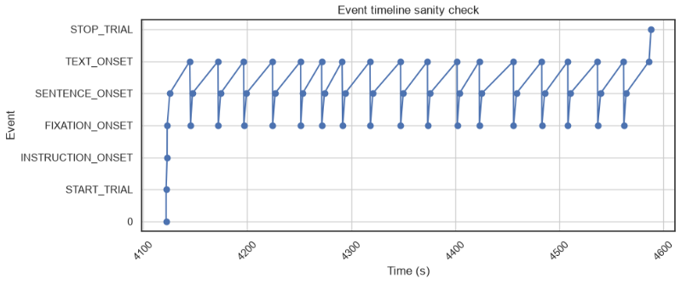
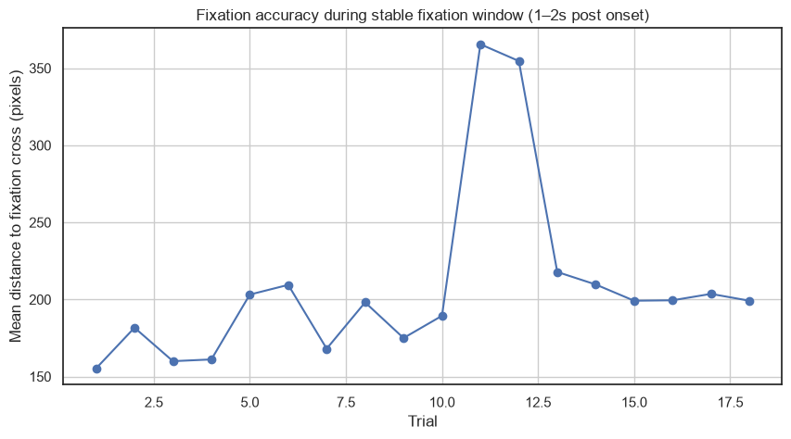
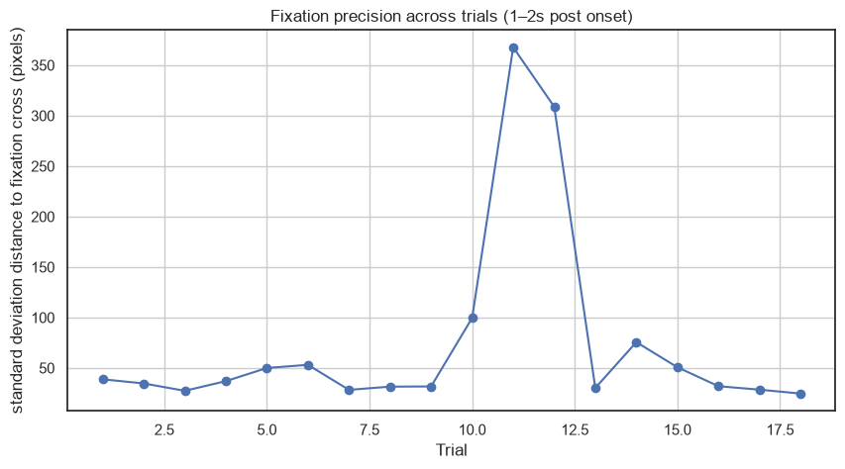
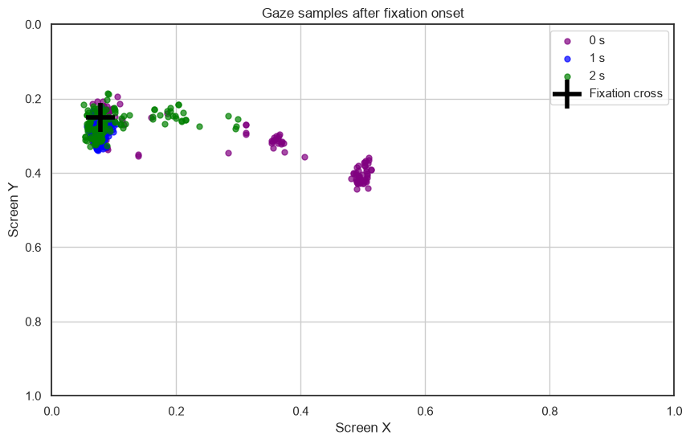

3.4 Analysis pipeline
- Extract eye-tracking measures for AOIs
  - Fixation Duration
  - Regression Probabilities
  - Go-past Time
- Compare eye-tracking measures across conditions

Fixation Duration

Regression Probabilities

Go-past Time

Questionnaire
- Analyze questionnaire responses
- Compare questionnaire responses with eye-tracking measures and explore correlations

4. Results

5. Discussion
1-paragraph summary
How do findings relate to literature?
Limitations
Challenges during the project
Outlook / improvements / lessons learned

Appendix
Appendix 1: Questionnaire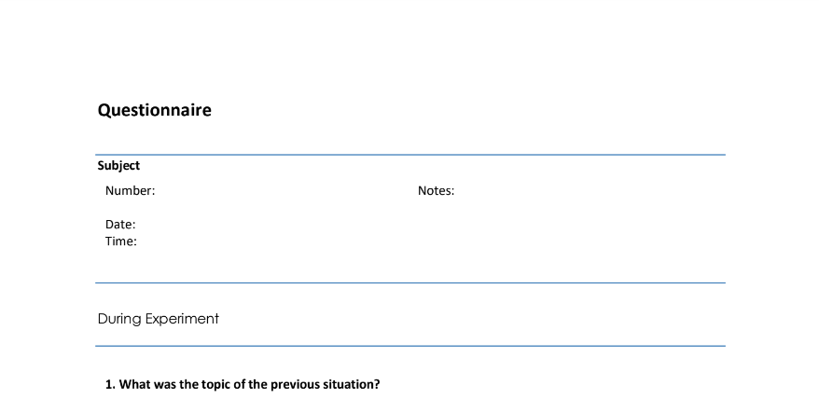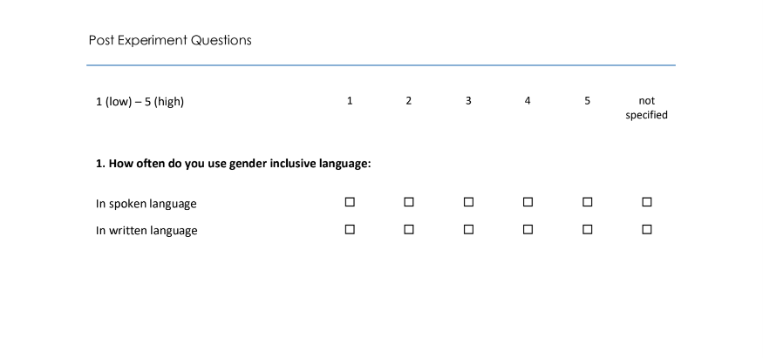
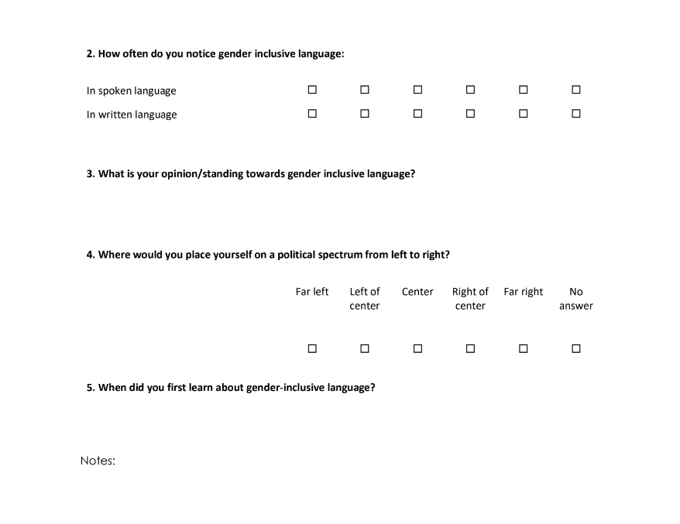

Appendix 2:
Appendix 3:

Bibliography

