**Gender of Film Directors and the Presence of the Male Gaze**

**Sophie Smith**

**COMM 4260- Gender and the Media**

**Prof. Brooke Duffy**

**12/7/17**

**Introduction**

“Movies are the male gaze. Movies show how it feels to be a man for the most part,” says Jill Soloway, creator of the groundbreaking TV series, Transparent. Laura Mulvey (1975) coined the term “male gaze” and explained it as a perspective in which the viewer of a film identifies with the active male and admires the passive female. This phenomenon intrigued me. I had heard conversations my friends were having about their favorite directors and I realized they were (for the most part) white, heterosexual men. From there, I looked up the winners/nominations for Best Director and realized the only female winner was Kathryn Bigelow in 2010 in centuries of Oscar history. Obviously, there is a huge gender gap among feature film directors in Hollywood. My research will examine how this gap manifests itself in the content of the films, specifically how present the theory of the male gaze is. I’m wondering what the impact of predominantly male directors is on feel of movies, and further, are most contemporary, American movies governed by the male gaze? I hypothesize that female directors will create movies that more heavily use the female gaze and movies created by male directors will more heavily feature the male gaze.

**Literature Review**

When conducting my literature review, I found a gap in research on gender, film production, and the male gaze. Laura Mulvey defined and piloted research on the male gaze in her 1975 essay, “Visual Pleasure and Narrative Cinema.” Since then, many scholars have commented on and critiqued her work. They used her framework to identify the male gaze or lack thereof in both recent and dated films (Cooper, 2000; Keller & Gibson, 2014). Filmmakers have speculated on a female gaze in interviews and articles within the popular press (Blake, 2017). In these works, coding for a gendered gaze is hard to quantify. Studies like Cooper’s and Keller & Gibson’s analyzed specific scenes and discussed general themes in their respective films without assigning statistical significance to their findings.

There is also some research on the differences that occur with male and female directors (Sun & Liberman, 2007). Discussions of my topic are present in popular press more than in scholarly articles (O’Neill, 2017; Rickey, 2017; Todd, 2016). Thus, a quantitative study in a research setting hasn’t been done before on the male or female gaze in films directed by male or female directors. On the broader topic of female representation in front of and behind the camera, much research focuses on international films, on teen movies, or on female characters which I didn’t feel was relevant enough to my project to include.

**Methods**

*Research Question: How does the gender of a film director impact the presence of a male or female gaze in their film?*

*Hypothesis: Movies directed by male directors will have more scenes containing the male gaze and movies directed by women will have more scenes containing the female gaze.*

To explore my research question, I will be doing a content analysis, coding films for instances of the male and female gaze. I will focus on features recently released (within the last 10 years) which are made in the U.S. I will randomly sample two movies from the last 10 years by male directors and two movies from the last 10 years for female directors. After reviewing many lists of the top-grossing movies by male and female directors, I realized that this method may not give me a representative sample. Typically, the movies that make the most money are action-based movies for men. For the top female directors, this list is more diverse with romantic comedies, teen movies, and animated movies targeted at children. Thus, I decided to narrow my sample down to one genre: romantic comedies. To choose the movies, I researched the top-grossing romantic comedies ever and randomly selected two from male directors and two from female directors. I must note that even this list of movies was very disproportionately occupied by men. Of the 50 movies that the *International Movie Database* listed, 10 were directed by women. Of those 10, three were made in the last ten years. I acknowledge that because my sample size was much smaller for female directors, my results may be skewed.

The movies I ended up coding were *Silver Linings Playbook* (2012), directed by David O. Russell, *Knocked Up* (2007), directed by Judd Apatow, *The Proposal (*2009), directed by Anne Fletcher, and *It’s Complicated* (2009), directed by Nancy Meyers. These were all movies I had viewed prior to the study so I was able to focus my attention on coding interactions between characters rather than on the plots. Each movie was about 2 hours in length and I watched the movie all the way through, stopping it every time I noticed elements of a male or female gaze and recording what was happening in the scene at those times.

To identify characteristics associated with the male gaze and the female gaze, I extrapolated descriptions from Mulvey’s paper and my research. She defines the male gaze in a few terms. She notes that the bearer of the gaze must get “pleasure in looking” and that it stems from a “satisfaction with the human form” (Mulvey, 1975). On camera, the woman is “isolated, glamourous, on display, sexualized.” This gaze combines the look of a male character within the story and the audience who are seeing scenes through the eyes of the camera.

My first red flag for any type of gaze at all was instances when the shot only shows one part of the body, separate from the whole form. For example, if the camera has a shot of only a women’s chest, that would count as the male gaze, with the character previously shown and the audience as the bearer of the look. Other instances of the gaze were present in camera movements that mimic the eye line of a viewer. If the camera starts by showing a women’s shoes and moves up her body, the viewer is led to believe the character who’s gaze the camera is following is sizing up a woman’s body. Typically, the gaze was associated with close-up shots. The objects the camera had in focus versus out-of-focus also proved important.

For a scene to show the male gaze specifically, Mulvey looked for interactions when the woman is seen as an image. Men are the bearers of the look and view women as sexual objects. The woman might hold the look or derive her own pleasure from being looked at. She might be playing to male desire in how she behaves or appears. In love stories, the male gaze means that the male possesses the woman and she falls in love with him. The spectator identifies with the man’s perspective because he is the one in control, pushing the action of the story forward. He controls the subject of his actions, the woman. The female gaze is harder to perceive, partially because Mulvey didn’t mention its existence in her essay. For the purposes of this study, I defined the female gaze as being the exact reverse of the male gaze. The female protagonist is the bearer of the look and her male interest is the sexual object. The man might hold her gaze and he might signify female sexual desire. The viewer identifies with her perspective as she controls the action in the narrative. These qualities are difficult to standardize and I acknowledge that my judgements of what might constitute a woman as a sexual object might not be the same as someone else’s. I found that most of the scenes I picked out as exemplifying the male or female gaze showed a shot of a character’s face with their eyes moving to look at something. The filmmaker then cuts to the next shot which is usually what they are looking at. Another possibility is that the camera shows the audience something and then pans to the reaction of a character, who has just seen what the audience saw. I will illustrate some examples of these techniques later, in my results section.

**Results**

The results of my study disprove my hypothesis. I found that of the four movies I coded, all but one had more instances of a male gaze than a female gaze. These numbers were higher for the films directed by men (See Table 1).

Table 1

|  |  |  |  |  |  |
| --- | --- | --- | --- | --- | --- |
| Movie | Gender of Director | # of Male Gaze Scenes | # of Female Gaze Scenes | Total Scenes with Gaze | Male Gaze as a % of Total |
| Knocked Up | **Male** | **17** | **8** | **25** | **68%** |
| Silver Linings Playbook | **Male** | **27** | **12** | **39** | **69%** |
| It’s Complicated | **Female** | **10** | **10** | **20** | **50%** |
| The Proposal | **Female** | **19** | **12** | **31** | **61%** |

According to my definition of the male and female gaze, most of the instances I coded involved a look of longing from one character to another, the object. In *Silver Linings Playbook*, there was more frequent usage of the fragmented body part technique, especially when Tiffany was dancing. One very deliberate example of the male gaze occurred when Pat meets Tiffany and immediately glances down at her exposed cleavage, then back up at her eyes. There were a few cases when Tiffany “returned” the gaze to Pat and commented on his attire and many other characters also noticed Pat’s weight loss.

*Knocked Up,* by nature of its pregnancy story line, featured many remarks about Alison’s body. Jason, a male supporting character, tells her,

“Your body is responding really well to the pregnancy.”

implying that she looks better than he expected and separating her body from her persona. In one more explicit scene, a gynecologist even exclaims,

"You do look a lot like your sister,"

after surveying her genitals. This quote reduces Alison to her vagina’s appearance. In a stereotypical fashion, the scenes that take place outside a nightclub exhibit the male gaze heavily: a male bouncer decides if women should be let in based on their appearance and youth. Instances of the female gaze in this film were centered around male nudity, though the men who exposed themselves were not fit or traditionally attractive.

*The Proposal* had many shots that expressly represented a female gaze, usually by Margaret, taking her visual perspective. One memorable scene was the definition of the female gaze in that we saw a group of women watch a male striptease and respond with excitement. At the same time, the film objectifies Margaret and the way she dresses, shaming her for wearing heels on a trip to rural Alaska. Margaret, in spite of her position of power, is put in her place in one of the film’s final moments in which a co-worker looks on as she kisses Andrew and says,

“Yeah, show her who’s boss Andrew!”

*It’s Complicated* was the most equal of the films when it came to the presence of the male/female gaze. There were shots in which Jake saw Jane only in terms of her appearance such as when the camera pans over her behind as Jake watches from a window. Additionally, when Jane is happy after spending time with Jake, her male employees take notice and comment on her mood.

“What'd you do, something to your hair?”

one asks, assuming that she must be up because of a change in her physical appearance. That said, much of the film solely follows Jane and we see her view more than anyone else’s, providing a heavy female gaze.

**Analysis**

I was initially surprised by my findings because each of the films I coded starred a main female character who made a significant portion of the decisions that drove the films forward. I thought that there would be more instances of the female gaze than I found. This discrepancy could’ve occurred due to a multitude of reasons. Firstly, since Mulvey doesn’t define the female gaze in her work, there is less familiarity with it, and thus, it is harder to recognize. Secondly, because these films were among the most successful in their genre, it is safe to assume they resonated with much of the American audience. Consequently, their value systems aligned with the still male-dominated society we live in, especially when it comes to romantic relationships.

Romantic comedies are not known for their portrayals of feminist ideals and my study did not differ from this pattern. As men and women get to know each other and fall in love, they exhibit signs of the male and female gaze fairly regularly in their pursuit. Unfortunately, I found most of these interactions could be categorized as male-driven, regardless of the gender of the director. I was surprised by these findings because the reputation and situation around these films was often that of female empowerment. Here, I will delve more deeply into each of the films and analyze them holistically for their use of a male or female perspective within the plot. I will briefly contextualize the films on a qualitative level, as some of the papers I read did, to explain why their results on the specific instances of the male/female gaze occurred the way they did.

*Silver Linings Playbook* features Bradley Cooper as its main character, Pat. The story is told through his eyes and we see many of his interactions with women in his life through this lens. Jennifer Lawrence plays Tiffany, Pat’s love interest, and is present for most of the film. Though Lawrence won the Oscar for Best Actress for her part in this film, her character clearly supports Cooper’s. On occasion, we see things from her perspective but the plot of the film surrounds Pat’s mental illness, his relationship with his family, and his marital problems. These facts, coupled with the fact that the film was directed by a man, explain the camera’s overwhelming use of the male gaze.

*Knocked Up* is also directed by a man, Judd Apatow, who is well-known in the industry for championing women and their stories by heralding projects such as HBO’s *Girls* and Amy Schumer’s *Trainwreck*. He cast his own wife, Leslie Mann, and kids in this movie and focuses on Katherine Heigl’s character, Alison, and her actions throughout the film. Despite this, the film is overtly misogynistic. Alison’s male counterpart in the film, Ben, played by Seth Rogen, is developing a website for cataloging female nude scenes in entertainment. His friends, played by comical actors like Jonah Hill and Jason Siegel, are immature stoners who make crude jokes about sex despite their inexperience with women. We do see Alison struggle with the choice of whether to raise her own baby or terminate the pregnancy, a plot device which solidified the film’s female-driven nature. As a result, the film did have more instances of the male gaze but wasn’t completely absent of the female gaze.

I thought that *The Proposal* would be a prime example of the use of the female gaze because of its accomplished, powerful female protagonist, Margaret, played by Sandra Bullock, but I was wrong. Margaret is the boss of her office and is feared by all who work with her. She is called a “bitch” but is praised for her work ethic and results. As the film goes on, Margaret lets her guard down with her secretary and husband-to-be, Andrew, played by Ryan Reynolds. He falls in love with her as she becomes less controlling and unemotional, in other words, less like a man. This transition demonstrates how Andrew really drives the film’s plot. We learn about his family, dreams, and past relationships while Margaret remains a mystery for much of the film, giving her power but also making Andrew propel the action forward. At the end of the film, Margaret shows her love for Andrew by letting him out of their deal that caused him to betray his family. Though she is the one making this decision, it is Andrew that must go running after her, in the genre’s stereotypical grand gesture of love. While it might seem that both parties have almost equal shares in the film’s line of action, the majority of the instances of the gaze I coded were male. I believe that this result can be explained by the way Margaret is portrayed in the film: wearing tight clothes and heels, and often strutting around past groups of men.

*It’s Complicated* proved, unlike the other films, that a relationship between a man and a woman can have both male gaze and female gaze. The film stars Meryl Streep as Jane, a divorcee who starts an affair with her now remarried ex-husband. While we see much of the film from her perspective, the scenes of their courting are almost entirely egalitarian in their use of the gaze. We constantly see the two looking at each other with longing, though Jake, her ex, played by Alec Baldwin, regularly checks her out when they aren’t together. This pattern is coupled with Jane’s interest in her architect, Adam, and her pursuit of him. We watch her deal with a range of emotions and make concrete choices that dictate the film’s plot. Given this strong female perspective, one might expect more instances of the female gaze in this film. I attribute these results to Jane and Jake’s characterizations. Jane is guilt-ridden, caring, and moral while Jake seems to greedily take what he wants and gets upset when things don’t go his way. Thus, though Jane does her fair share in starting and maintaining the affair, Jake is the one outwardly viewing her in a sexual way during the film.

Overall, these romantic comedies had feminist themes and female perspectives present but often were led by sex-driven males who took up most of the look-bearing in the films.

**Limitations**

I acknowledge that I was limited by the smaller sample size of female-directed films which might not make my selection representative. I also acknowledge that I did not mention TV, where female directors are becoming more common. For example, a woman, Reed Morano, just won Best Directing for “The Handmaid’s Tale” last year at the Emmys. I was also limited by how I coded for the male and female gaze, a process that was highly subjective. Lastly, I only coded four movies by the very famous directors which performed well at the box office. Movies on a smaller scale with less publicity and notoriety might’ve given a different, fuller picture of how the industry works and views women.

**Conclusion**

The problem of gender inequity in Hollywood is vast and hard to tackle. Both the production and the representation sides of entertainment media are suffering from a lack of female voices. In film, a director’s vision defines their work and many attribute the success of certain movies to the work of their directors. Needless to say, the impact a director has on the films they make and on those around them cannot be understated. From this study, we learned that the male gaze is still a common, frequently-used device in romantic comedies. With this knowledge, future film directors could consider these results when deciding how to frame their characters. Every choice they make, whether it be the camera movement or focus, could impact how female characters are understood by audiences. Perhaps putting more women behind the camera in these positions could reduce the dominant male perspective plaguing modern cinema and give opportunities to women to tell their side of the story.

**References**

Blake, M. (2017). Women writers and directors reflect on the female gaze. *Los Angeles Times*. Retrieved from <http://www.latimes.com/entertainment/tv/la-et-st-female-gaze-sidebar-20170505-story.html>

Cooper, B. (2000). ‘Chick Flicks’ as Feminist Texts: The Appropriation of the Male Gaze in Thelma & Louise. *Women’s Studies in Communication*, 23(3). Retrieved from <http://web.b.ebscohost.com/ehost/detail/detail?vid=8&sid=74f82525-9be4-4983-a8b6-1fe7e1310db1%40sessionmgr103&bdata=JnNpdGU9ZWhvc3QtbGl2ZQ%3d%3d#AN=3966683&db=cax>

Fol, I. (2004). The dominance of the male gaze in Hollywood Films: Patriarchal Hollywood Images of women at the turn of the Millenium. Retrieved from <https://books.google.com/books?hl=en&lr=&id=xZ1vAQAAQBAJ&oi=fnd&pg=PA1&dq=male+gaze+codebook&ots=mdDcyo-tdB&sig=cq18RnHEUxG7XMTkf-F7HgkqiH0#v=onepage&q=male%20gaze%20codebook&f=false>

Gibson, K. & Wolske, M. (2011). Disciplining Sex in Hollywood: A Critical Comparison of Blue Valentine and Black Swan. *Women & Language*, 34(2). Retrieved from <http://web.b.ebscohost.com/ehost/detail/detail?vid=6&sid=74f82525-9be4-4983-a8b6-1fe7e1310db1%40sessionmgr103&bdata=JnNpdGU9ZWhvc3QtbGl2ZQ%3d%3d#AN=70502461&db=cax>

Keller, A. & Gibson, K. L. (2014). Appropriating the Male Gaze in The Hunger Games: The Rhetoric of a Resistant Female Vantage Point. *Texas Speech Communication Journal*, 38(1). Retrieved from <http://web.b.ebscohost.com/ehost/detail/detail?vid=10&sid=74f82525-9be4-4983-a8b6-1fe7e1310db1%40sessionmgr103&bdata=JnNpdGU9ZWhvc3QtbGl2ZQ%3d%3d#AN=116830052&db=cax>

Maule, R. (2010). Women Filmmakers and Postfeminism in the Age of Multimedia Reproduction: A Visual Archive for Women’s Cinema. *Framework: The Journal of Cinema and Medi*a, 51(2). Retrieved from <http://web.b.ebscohost.com/ehost/detail/detail?vid=4&sid=74f82525-9be4-4983-a8b6-1fe7e1310db1%40sessionmgr103&bdata=JnNpdGU9ZWhvc3QtbGl2ZQ%3d%3d#AN=54854421&db=cax>

Mulvey, L. (1975). Visual Pleasure and Narrative Cinema. *Scree*n (16.3). Retrieved from <https://blackboard.cornell.edu/bbcswebdav/pid-3462899-dt-content-rid-9957130_1/courses/18467_2017FA/visualpleasureandnarrativecinema.pdf>

O’Neil, L. (2017). Oscars: No Women Nominated for Best Director-Again. *The Hollywood Reporter.* Retrieved from <http://www.hollywoodreporter.com/news/oscars-no-women-nominated-best-director-again-967284>

Rickey, C. (2017). The ‘Beguiled’ Test: Does the Director’s Gender Matter?. *The New York Times*. Retrieved from <https://www.nytimes.com/2017/06/23/movies/the-beguiled-test-sofia-coppola.html?mcubz=0&_r=0>

Rizzo, C. (2016). Jill Soloway: ‘Movies Are the Male Gaze’. *Forbes*. Retrieved from <https://www.forbes.com/sites/thecut/2016/03/11/jill-soloway-movies-are-the-male-gaze/#24a5d6673ebe>

Sun, C. & Liberman, R. (2007). A Comparison of Male and Female Directors in Pornography: What Happens When Women Are at the Helm?. *Conference Papers-International Communication Association*. Retrieved from <http://web.b.ebscohost.com/ehost/detail/detail?vid=3&sid=6661c0de-0bc7-4cf0-be5e-daaf9da5d59a%40sessionmgr102&bdata=JnNpdGU9ZWhvc3QtbGl2ZQ%3d%3d#AN=26949665&db=ufh>

Todd, C. L. (2016). “A Female Perspective” Challenges The Male Gaze in Movies. *Refinery 29*. Retrieved from <http://www.refinery29.com/2016/03/105205/male-gaze-female-perspective>

<http://www.imdb.com/list/ls004066533/>

**Appendix**

1. **Codebook for Silver Linings Playbook**

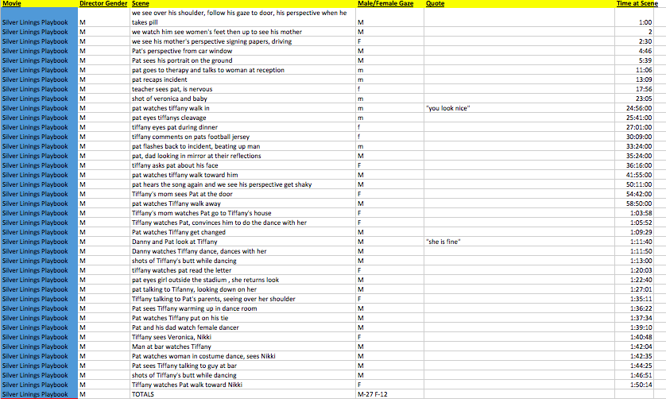

1. **Codebook for Knocked Up**

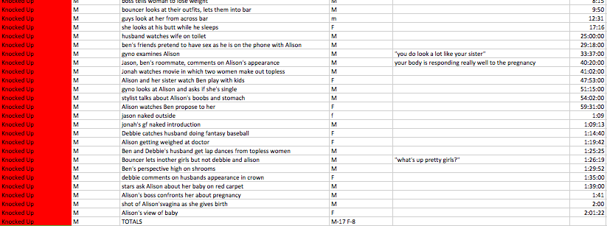

1. 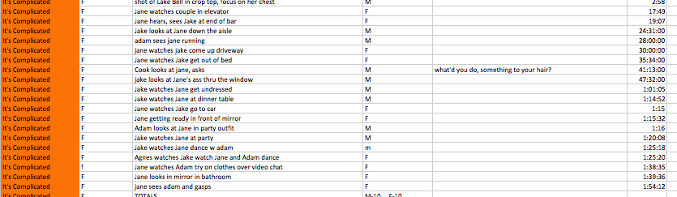**Codebook for *It’s Complicated***
2. 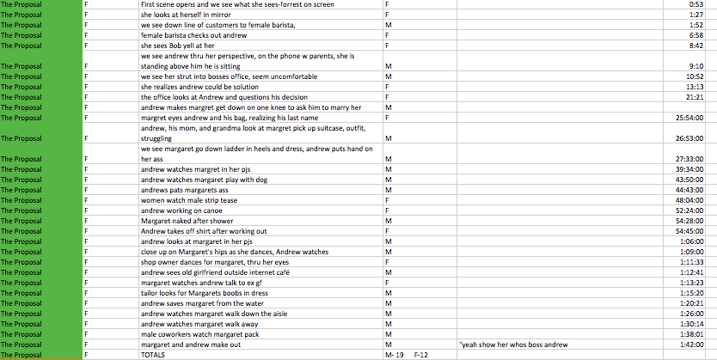**Codebook for *The Proposa****l*