 $$P_{2}$$ $$P_{1}$$ $$P_{1}$$ $$P_{1}$$ $$P_{2}$$ $$P_{2}$$ $$\left\{\begin{aligned}G_{1} \\ G_{2}\end{aligned}\right.$$





**Triples**

**Bloom Filter**

$${SW}_{1}$$

**Triples**

**Bloom Filter**



**Triples**

$${SW}_{2}$$

$$G_{3}$$

**Bloom Filter**

**Bloom Filter**

**Join**

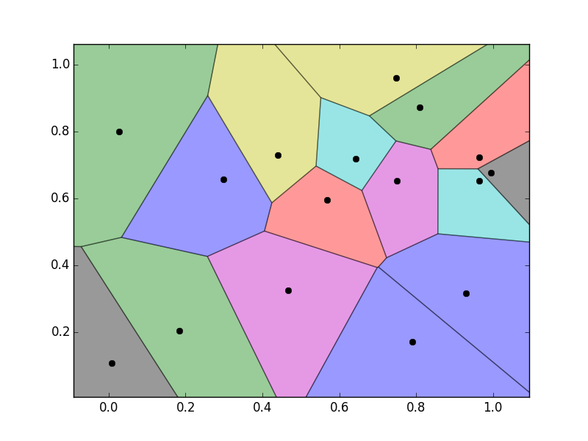

**Corresponding S partition**