**R**

**S**

**Bordeaux**

$$⋈$$

$$⋈$$

**R**

**Join2**

**Join1**

$$P_{1}$$

$$P_{2}$$

$$P_{3}$$

$$P_{4}$$

**Zumba**

**attendEvent**

**Sophie**

**hasFriend**

**?S**

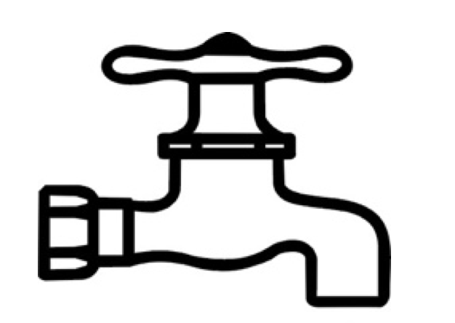

**Sophie**

**attendEvent**

**hasFriend**

**?S**

**Zumba**

**<Z, hasFriend, Y>**

**<A, attendEvent, B>**

**<X, hasFriend, W>**

**<V, hasFriend, Sophie>**

**<F, hasFriend, Sophie>**

**<E, attendEvent, Zumba>**

**<C, attendEvent, D>**

**<F, attendEvent, Zumba>**

**hasFriend**

**attendEvent**

**Bloom Filter**

**Bloom Filter**

**<F, hasFriend, Sophie>**

$$⋈$$

**<V, hasFriend, Sophie>**

**<F, hasFriend, Sophie>**

**<F, hasFriend, Sophie>**

**<V, hasFriend, Sophie>**

**<F, attendEvent, Zumba>**

**<E, attendEvent, Zumba>**

**Prober**

**Builder**

**Insert**

**Check**

**Bloom Filter**

**Bloom Filter**

**S**

**=**

**Sj**

**=**

**R**

**S**

**Sj**

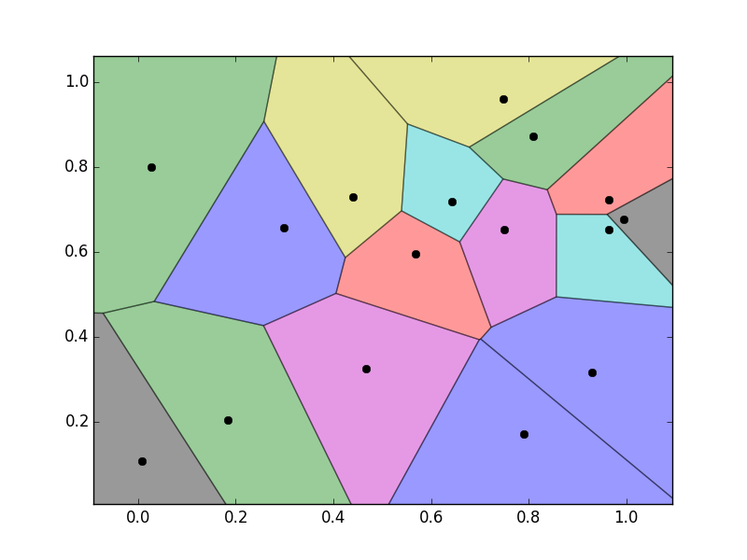

**?**

**?**

**?**

**?**

**?**

**?**

**?**

**?**

**?**

**?**

**Job II**

**Job I**

**Nice**

**Lyon**

**Nice**

**Paris**

**Lyon**

**Nice**

**Nantes**

**Bordeaux**

**Toulouse**

**Bordeaux**

**Nice**

**Toulouse**

**Nice**

**Lyon**

**Nice**

**Lyon**

**Bordeaux**

**Nice**

**Bordeaux**

**R**

**Paris**

**Lyon**

**Nantes**

**Bordeaux**

**Toulouse**

**Lyon**

**Toulouse**

**Paris**

**Lyon**

**Toulouse**

**Bordeaux**

**Toulouse**

**Lyon**

**Bordeaux**

**Toulouse**

**Nantes**

**Bordeaux**

**S**

**Global Sort**

**Merge**

**Local Sort**

**Distance**

**Distance**

**Sort**

**Nice**

**Paris**

**Lyon**

**Nantes**

**Bordeaux**

**Toulouse**

**Paris**

**Lyon**

**Nantes**

**Bordeaux**

**Results**

**Nice**

**Lyon**

**Bordeaux**

**Nantes**

**Paris**

**Toulouse**

**Bordeaux**

**Nice**

**Lyon**

**Toulouse**

**Bordeaux**

**Lyon**

**Nantes**

**Paris**

**S**

**Paris**

**Lyon**

**Nantes**

**Bordeaux**

**R**

**Nice**

**Toulouse**