Methods

Participants
Eighty-one participants were recruited for the eye-tracking experiment and viewed naturalistic videos depicting everyday activities. Eye movement data were recorded during passive viewing. A separate group of participants completed an event segmentation task on the same stimuli, providing behavioral indices of perceived event boundaries at both fine and coarse temporal grains.

Stimuli
Four videos from the META corpus were selected, depicting everyday activities including making breakfast, grooming, exercise, and cleaning. Videos were presented at a display resolution of 1280 × 720 pixels at approximately 60 Hz. Gaze data were collected using an EyeLink eye-tracker during unconstrained passive viewing.

Gaze Entropy Measurement
For each video frame, we computed the spatial entropy of the gaze distribution across observers. Individual fixation locations were transformed into probability density maps using 2D Gaussian kernels (σ = 50 pixels). Shannon entropy was then calculated from the normalized density map, yielding a frame-level measure of gaze dispersion. Higher entropy indicates more spatially dispersed (exploratory) gaze patterns, while lower entropy indicates more focused attention across observers.

Intersubject Gaze Correlation
We computed frame-level intersubject correlation (ISC) of gaze using a leave-one-out approach. For each frame, individual gaze heatmaps were constructed and normalized to sum to 1. Each participant's heatmap was correlated (Pearson r) with the mean heatmap of all other participants. The average correlation across all leave-one-out iterations provided a measure of gaze synchrony for each frame.

Eye Movement Metrics
Fixations and saccades were extracted using standard velocity-based algorithms. Frame-level aggregates were computed for mean fixation duration (ms) and mean saccade amplitude (pixels and degrees). Time series were smoothed using kernel smoothing (bandwidth = 120 frames) to reduce noise while preserving temporal dynamics.
Fixations and saccades were extracted using standard velocity-based algorithms. We computed frame-level aggregates in two ways. First, mean fixation duration (ms) and mean saccade amplitude (pixels and degrees) were averaged across all participants for each frame, providing a group-level measure of oculomotor dynamics. Second, following (Eisenberg & Zacks, 2016), we also computed these metrics at the individual participant level to preserve subject-specific variance and enable analyses with crossed random effects for movie and subject. Time series were smoothed using kernel smoothing (bandwidth = 120 frames) to reduce noise while preserving temporal dynamics.

Computational Model of Prediction Error and Prediction Uncertainty
We derived frame-level computational measures from the updated Structured Event Memory (SEM) model. SEM-PE (prediction error) represents the Euclidean distance between predicted and actual scene feature vectors, indexing moment-to-moment surprise. SEM-Uncertainty represents the model's epistemic uncertainty about upcoming events—the variability in its predictions given the current event representation.
Segmentation Probabilities
To characterize participants' segmentation behavior, we estimated the probability density of event segmentation over time for each movie at both fine and coarse temporal grains. Segmentation density was computed by convolving the time course of individual button presses with a Gaussian kernel using a 2-second bandwidth (equivalent to 120 frames at 60 fps), selected to match the temporal smoothing applied to gaze measures. Segmentation probability was then derived by multiplying the segmentation density by the average number of button presses.

Normative Event Boundaries
To derive binary event boundary indicators for the FIR models, we identified discrete boundary timepoints from the continuous segmentation probability curves. For each movie, we first detected local peaks in the segmentation probability time series, defined as frames where probability exceeded both adjacent frames and surpassed a minimum threshold (0.01). We then selected the top N peaks ranked by probability magnitude, where N corresponded to the median number of boundaries identified by participants for that movie at each grain (coarse: M = 8.5 boundaries, range 7–10; fine: M = 29.25 boundaries, range 21–35). This peak-selection procedure yielded binary boundary vectors (1 = boundary, 0 = non-boundary) that preserved the temporal precision of segmentation probability while reducing continuous measures to discrete events suitable for FIR modeling.

Statistical Analysis
Linear mixed-effects models were fitted using lme4 in R, with movie as a random effect to account for stimulus-specific variance. Model comparisons used likelihood ratio tests. To examine temporal dynamics around event boundaries, we employed finite impulse response (FIR) modeling with a ±10 second window centered on boundary onsets. Binary boundary indicators were shifted at 1-second lags from −10 to +10 seconds, and all lagged predictors were entered simultaneously into mixed-effects models with random intercepts for movie. Omnibus tests compared full FIR models against reduced intercept-only models.

Data Availability
This study was not preregistered. All data and analysis code are publicly available via the Open Science Framework (OSF) at XXX.

Results

Gaze Entropy Tracks Computational Uncertainty
We first examined whether gaze entropy corresponds to computational indices of predictive processing. Gaze entropy showed a significant positive association with SEM-Uncertainty (β = 38.55, SE = 11.04, t = 3.49, p = .032), indicating that when the computational model experienced greater uncertainty about upcoming events, observers' gaze patterns became more spatially dispersed. In contrast, gaze entropy was not significantly related to SEM-PE (β = 0.32, SE = 0.13, t = 2.49, p = .071), suggesting that gaze dispersion tracks anticipatory uncertainty rather than reactive surprise to prediction errors.

Relationship with Intersubject Gaze Correlation
As expected, gaze entropy and intersubject correlation were strongly inversely related (β = −2.50, SE = 0.05, t = −47.2, p < .001), confirming that high entropy (dispersed gaze) corresponds to low gaze similarity across observers.

Eye Movement Correlates of Gaze Entropy
Gaze entropy was significantly associated with traditional oculomotor measures. Higher gaze entropy corresponded to shorter fixation durations (β = −5.65 × 10⁻⁴, SE = 1.36 × 10⁻⁴, t = −4.17, p < .001) and larger saccade amplitudes (β = 8.78 × 10⁻⁴, SE = 2.56 × 10⁻⁴, t = 3.44, p < .001). This pattern suggests that uncertainty states are characterized by more exploratory visual sampling—shorter fixations and larger eye movements that distribute attention more broadly across the scene.

Gaze Entropy Predicts Coarse Event Boundaries
Mixed-effects modeling revealed that gaze entropy significantly predicted the probability of coarse event segmentation (β = 4.17 × 10⁻³, SE = 1.06 × 10⁻³, t = 3.94, p < .001). Greater gaze dispersion was associated with higher likelihood that observers would perceive a major event boundary. However, gaze entropy did not predict fine-grained boundary probability (p = .75), suggesting that distributed attention specifically signals transitions at the level of meaningful activity units rather than moment-to-moment action boundaries.

Temporal Dynamics: Anticipatory Uncertainty Signaling
FIR modeling revealed that the relationship between gaze entropy and event boundaries was predominantly anticipatory. The omnibus test comparing the full FIR model (21 lagged boundary predictors) against the reduced model was significant (χ²(21) = 61.38, p < .001). Critically, inspection of the impulse response function revealed that 5 of 10 anticipatory lags (−5 to −1 seconds prior to boundaries) showed significant positive effects on gaze entropy, while none of the 10 reactive lags (post-boundary) reached significance. Gaze entropy began increasing approximately 5 seconds before boundaries, peaked around the time of the boundary, and declined afterward(Figure 1).
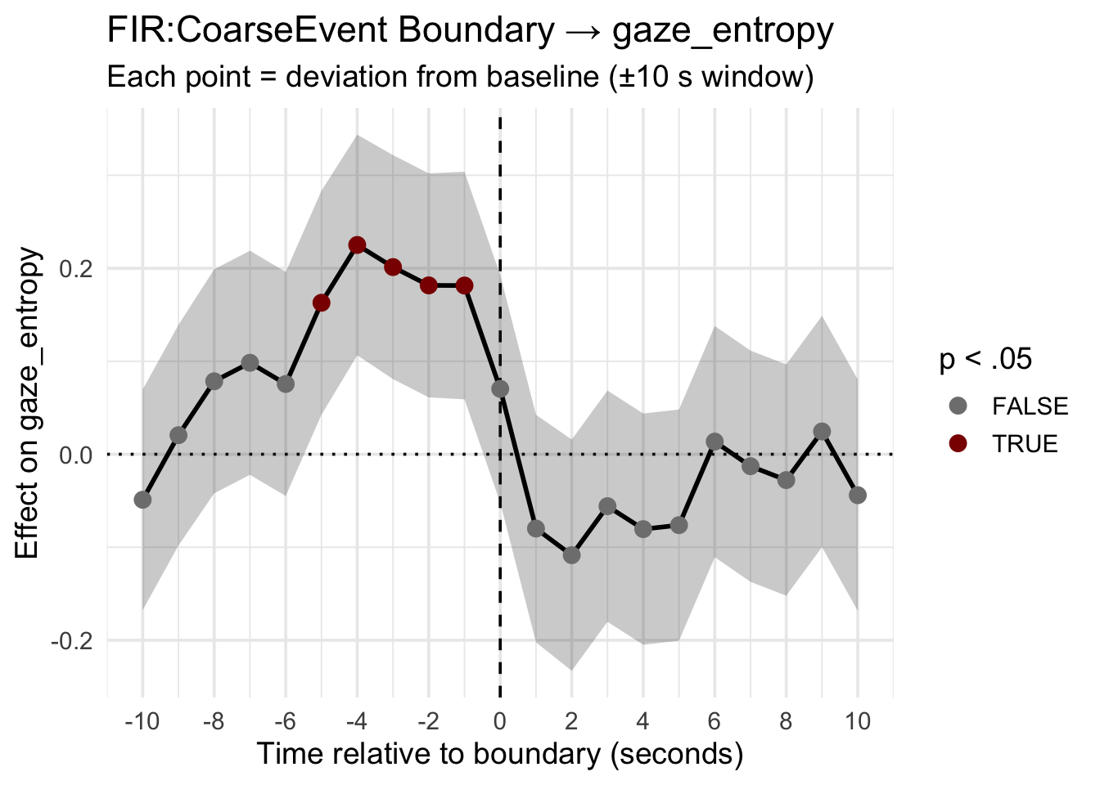
Figure 1. Finite impulse response (FIR) estimates for the effect of coarse event boundaries on gaze entropy. Each point represents the regression coefficient for a binary boundary predictor shifted by the corresponding lag (−10 to +10 seconds relative to boundary onset). The shaded ribbon denotes 95% confidence intervals. The vertical dashed line indicates boundary onset (t = 0); the horizontal dotted line indicates no effect. Points are colored by statistical significance (dark red: p < .05; gray: p ≥ .05). Gaze entropy increased significantly in the seconds preceding event boundaries (lags −5 to −1), with no significant effects following boundaries, consistent with an anticipatory uncertainty signal.

Traditional Eye Metrics Show Weaker Temporal Dynamics
In contrast to gaze entropy, FIR models for traditional eye movement measures revealed less consistent temporal patterns. For frame-level fixation duration, the omnibus test was not significant (χ²(21) = 16.79, p = .72), indicating no reliable relationship with boundary timing at the aggregate level. For saccade amplitude at the frame level, the omnibus test was also non-significant (χ²(21) = 19.55, p = .55) (see Figure 2).
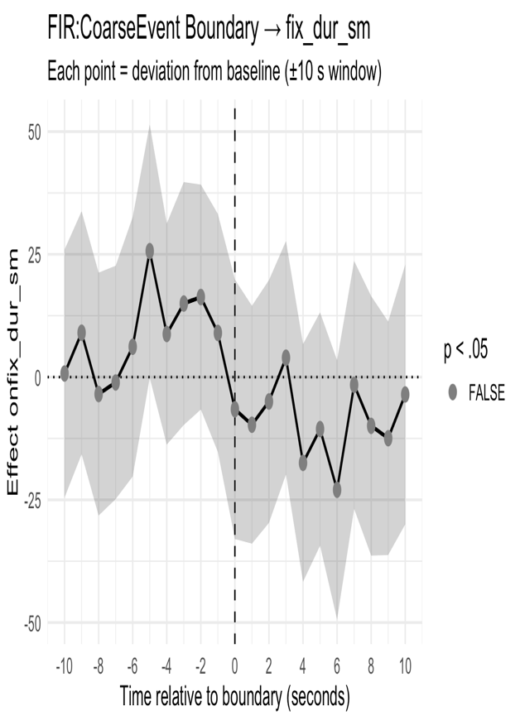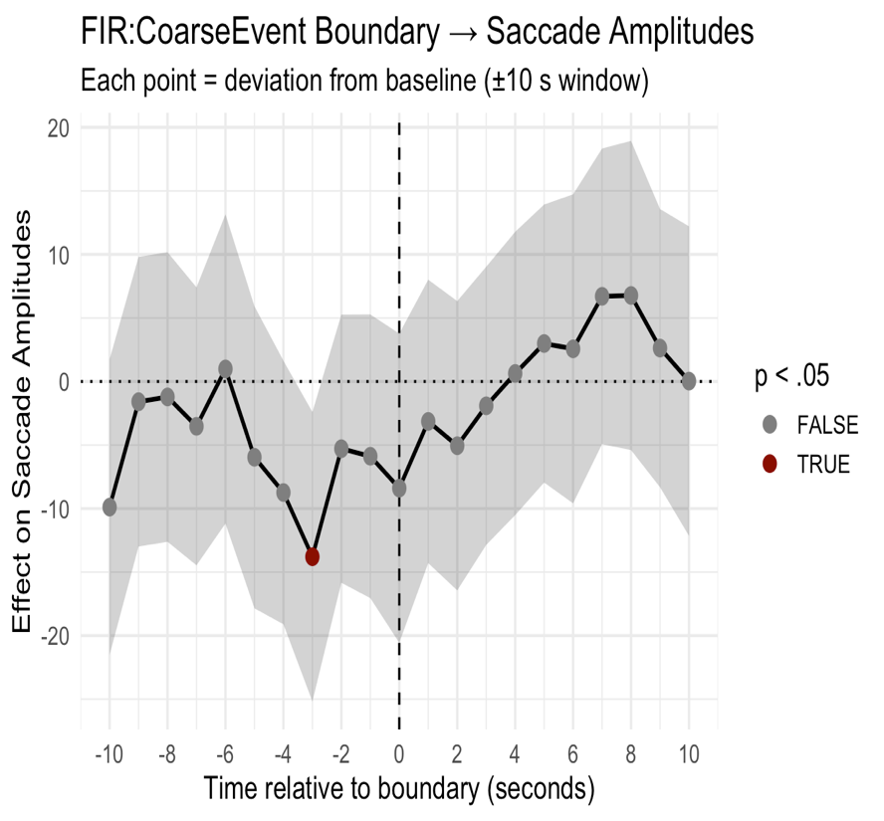
Figure 2. Finite impulse response (FIR) estimates for the effect of coarse event boundaries on eye movement measures: (A) mean fixation duration and (B) mean saccade amplitude, aggregated across participants at the frame level. Each point represents the regression coefficient for a binary boundary predictor shifted by the corresponding lag (−10 to +10 seconds relative to boundary onset). Shaded ribbons denote 95% confidence intervals. Vertical dashed lines indicate boundary onset (t = 0); horizontal dotted lines indicate no effect. Points are colored by statistical significance (dark red: p < .05; gray: p ≥ .05).

When analyzed at the individual participant level (with both movie and subject as random effects), saccade amplitude showed a significant omnibus effect (χ²(21) = 56.79, p < .001), with significant effects at −10 and −3 seconds (anticipatory) and at +4 and +9 seconds (reactive). However, participant-level fixation duration remained non-significant (χ²(21) = 23.35, p = .33). These results suggest that while saccade amplitude may track boundary-related processing at the individual level, gaze entropy provides a more robust and temporally specific marker of anticipatory uncertainty (see Figure 3).
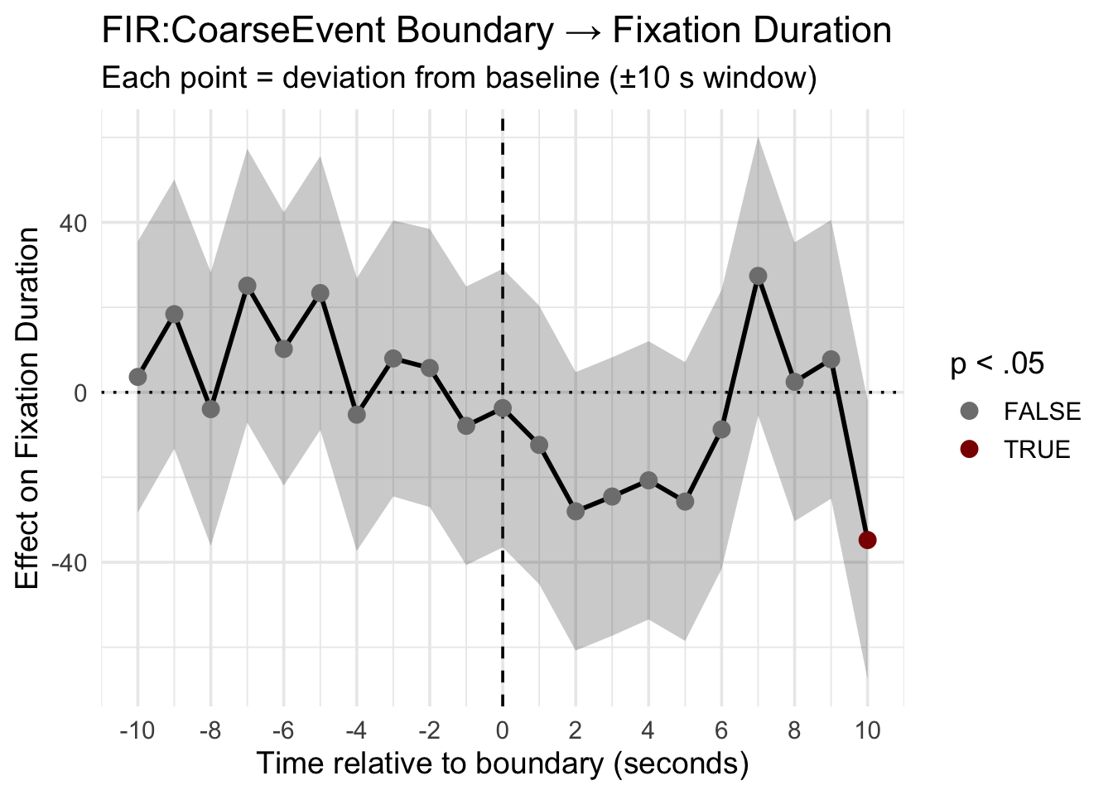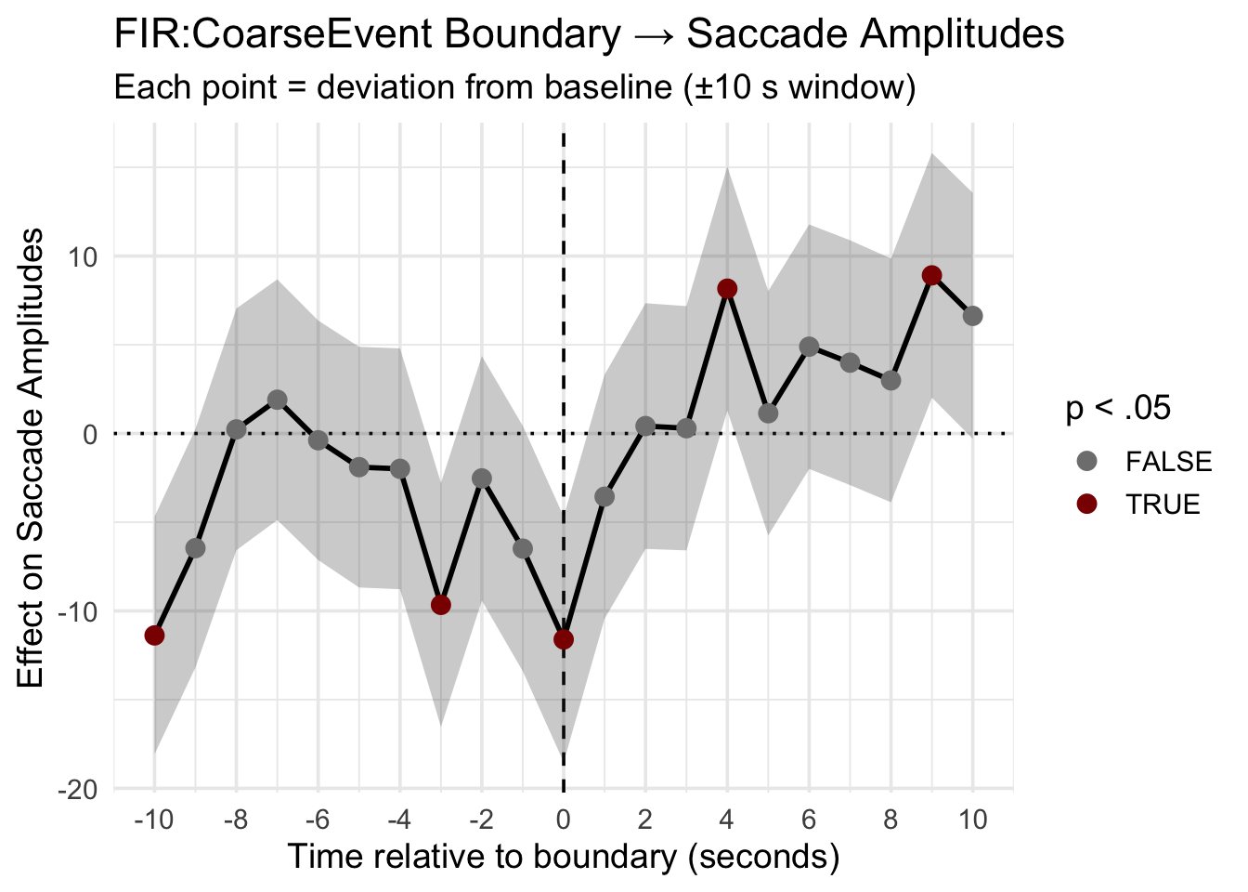
Figure 3. Finite impulse response (FIR) estimates for the effect of coarse event boundaries on traditional eye movement measures at the individual participant level: (A) mean fixation duration and (B) mean saccade amplitude. Models included crossed random intercepts for movie and subject. Each point represents the regression coefficient for a binary boundary predictor shifted by the corresponding lag (−10 to +10 seconds relative to boundary onset). Shaded ribbons denote 95% confidence intervals. Vertical dashed lines indicate boundary onset (t = 0); horizontal dotted lines indicate no effect. Points are colored by statistical significance (dark red: p < .05; gray: p ≥ .05).

Summary
Collectively, these results demonstrate that gaze entropy serves as a behavioral marker of predictive uncertainty during naturalistic viewing. The anticipatory increase in gaze dispersion before event boundaries supports a proactive control mechanism whereby the cognitive system detects rising uncertainty and initiates event model updating. The spatial distribution of gaze across observers (where people look) appears more diagnostic of uncertainty states than traditional measures of eye movement dynamics (how people move their eyes).

