**Kathmandu University**

**Department of Computer Science and Engineering**

**Dhulikhel, Kavre**



**Lab Report No. 2 [Code No: COMP 232]**

**Submitted by:**

**Sophiya Shrestha**

**Roll no. 46**

**Computer Science (2nd Year/2nd Semester)**

**Submitted to:**

**Mr. Sanjog Sigdel**

**Department of Computer Science and Engineering**

**Submission Date: 22-11-2024**

**Task: Preparing database with two tables associated with foreign key**

**database: Patient_records**

**Creating 1st table “Patients”**

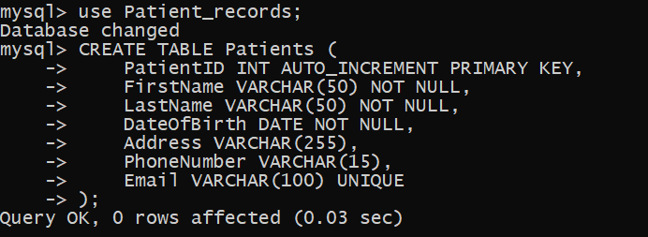

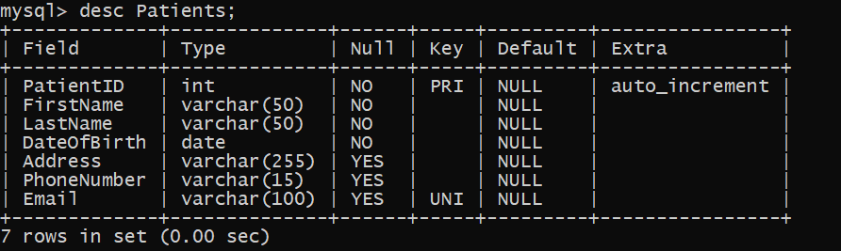

**Creating 2nd table “MedicalHistory” and creating a relationship model between these tables**

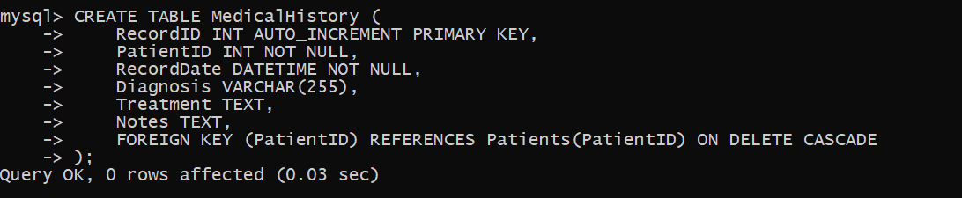

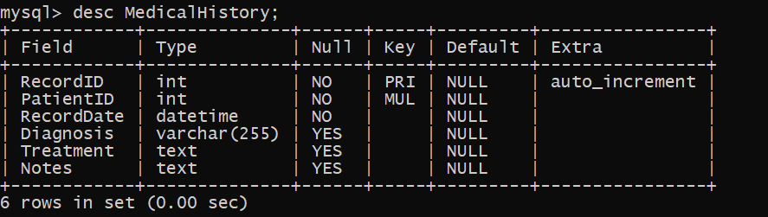

**Foreign Keys:** The PatientID in the MedicalHistory establishes a relationship with the Patients table, ensuring that every medical record and appointment is linked to a patient.

**Now we insert the datas in the respected tables,**

**Insert data in Patient Table**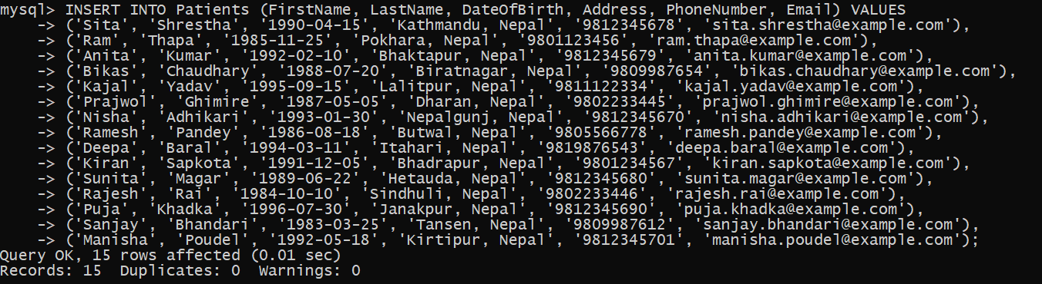

**View Patient Table:** 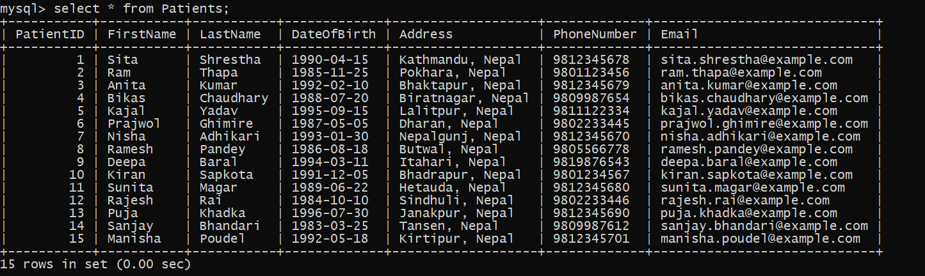

1. **Insert data in the MedicalHistory Table:**

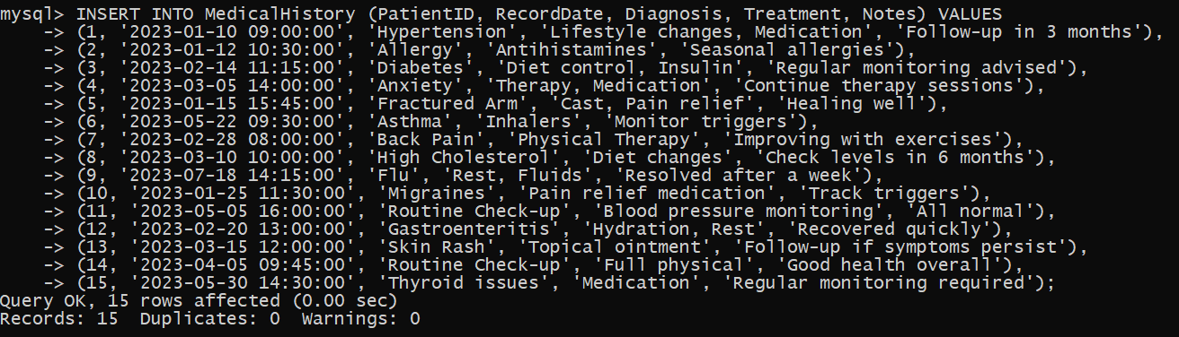**View MedicalHistory table:**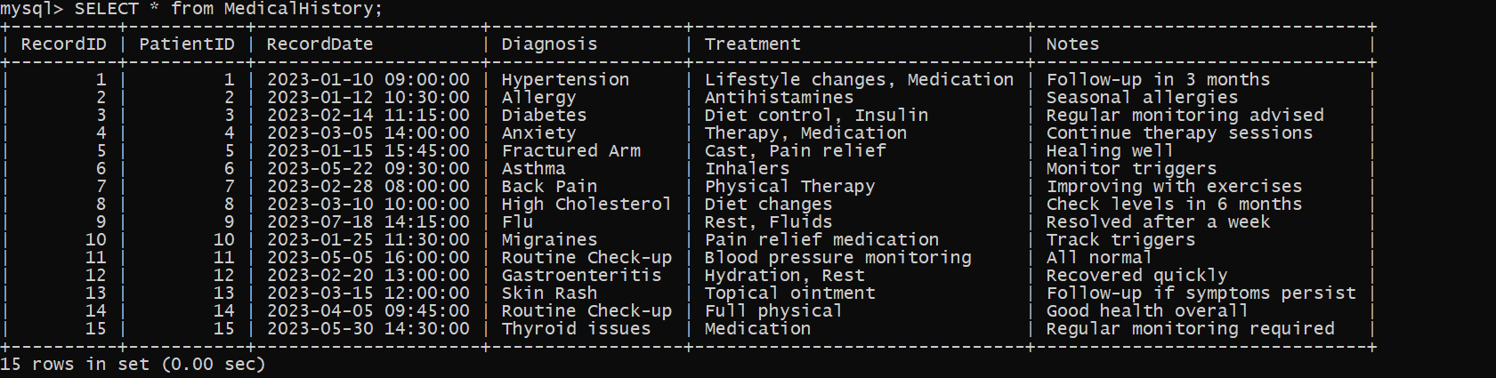

**Performing the following Relational Algebraic Operations:**

1. Selection (σ)

Select all patients who were born after 1990

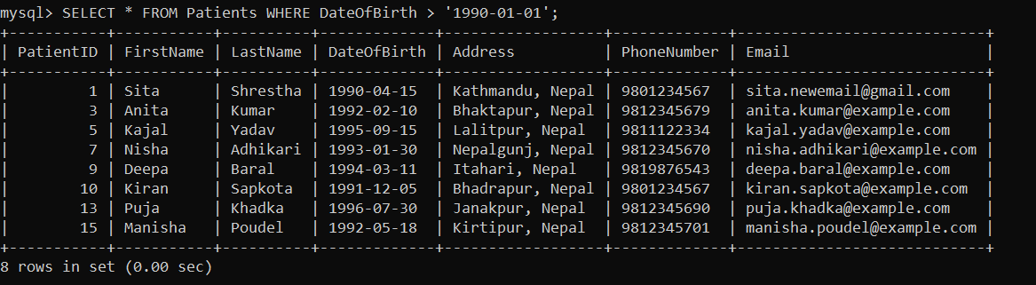

Select all records where the diagnosis is "Asthma".

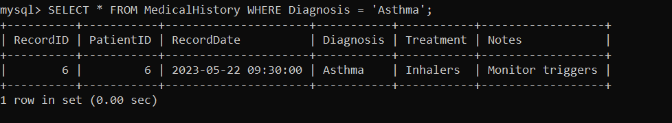

1. **Projection (π)**: This operation is used to select specific columns from the table.

Select the FirstName and LastName of all patients

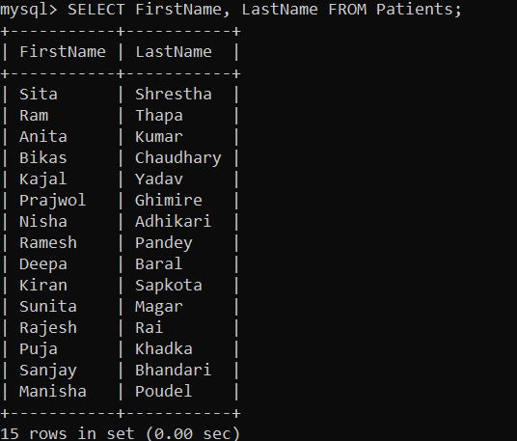

Select only PatientID, Diagnosis, and Treatment columns

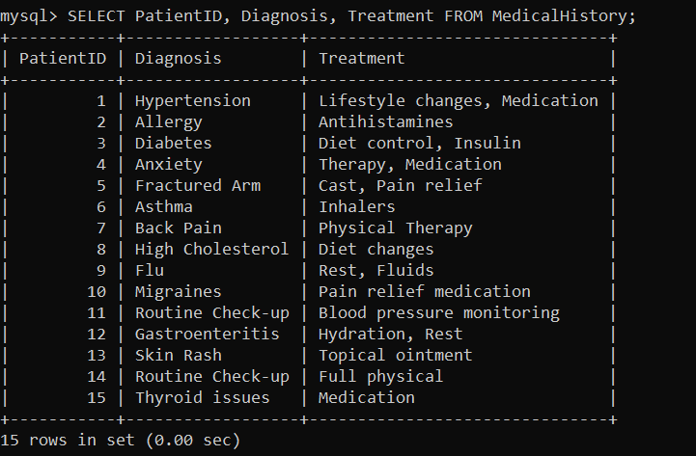

1. **Cartesian Product (×)**
2. **UNION:** Combines the results of two queries that return the same number of columns with compatible data types.

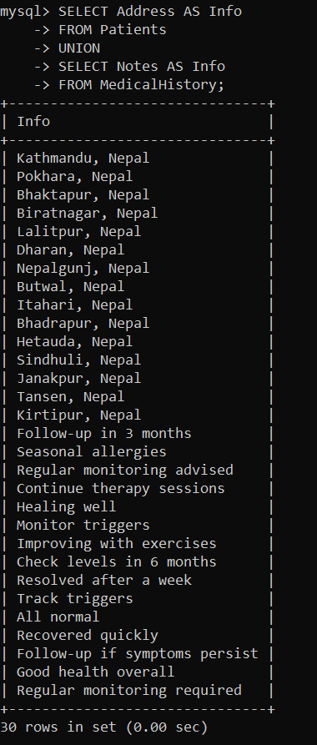

1. **INTERSECTION:** The Intersection operation finds records that are common between two sets.

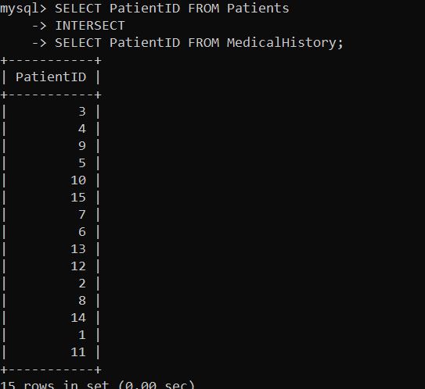

1. **SET DIFFERENCE (EXCEPT):**

The Set Difference operation finds records that are present in one table but not in another. This is typically implemented in SQL using the EXCEPT keyword.

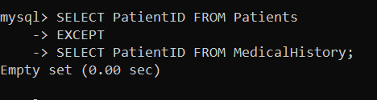

**In this case:**

* Every patient listed in the Patients table also appears in the MedicalHistory table (with a diagnosis).
* So, the set difference between Patients and MedicalHistory results in norecords because there are no PatientID values in the Patients table that don't also exist in the MedicalHistory table.