ActivPAL Breakdown Program 2025 by Sophie Rayner
This program provides the following outputs:
- Sedentary, upright, standing, stepping, cycling time by day (min/day)
- Sedentary bout breakdown (<10min,<15m, <30m, >30m, 10-20m, 20-30m, 30-40m, 40-50m, 50-60m, 1-2hr, 2-3hr, 3-4hr, >4hr) in # of bouts and total minutes
- Standing bout breakdown (<10min,<15m, <30m, >30m, 10-20m, 20-30m, 30-40m, 40-50m, 50-60m, 1-2hr, 2-3hr, 3-4hr, >4hr) in # of bouts and total minutes
- Active and Passive standing breakdown (active standing, passive standing, short standing, active/passive ratio)
- #STS transitions by day
- Hourly breakdown of behaviour (currently only for bedridden participants)
How the code works:
This program is organized to loop through participants with no user input for each individual participant. The program will run on its own over minutes-hours depending on # of participants and computer processing speed. This means you can set it up to run while you are not physically at your computer (watch a show, go to sleep, shower, or do anything else).
My hope is that as I perfect this program, there will be very few/no cases that cause errors, streamlining our analyses, and saving precious time. Although in the meantime it is not perfect, and errors are inevitable. When/if you run into errors please contact me via email with the error message.

How to use:
To run this program, you will need the .datx files for each of your participants.
Download the activPAL proprietary software (PALconnect, PALbatch, and PALanalysis) V9
Once you have all of these you must determine whether you have accurate sleep logs or not.
Step 1. PALanalysis set up
If you have sleep logs:
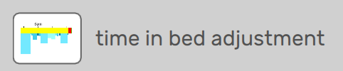

Open each file within PALanalysis. Ensure you are in the ‘CREA’ algorithm by clicking on settings in the top right.
Click on in the top left corner, and select
For each day, input the sleep and wake times either by dragging the ends of the arrows, or the start and end time boxes. The start time is the time they fell asleep, and the end is when they woke up. If these icons are not visible for a day, click ‘Add’ and they will appear. Make sure the first night of sleep starts after midnight! Even if they fell asleep before this!


Once the sleep and wake times are inputted into the PALanalysis app, click in the top right corner.

Once this is complete you can export files.
To export files click on in the top left, and select the following boxes:
- Daily summary outcomes (and all the boxes that appear in the dropdown)
- Events (extended)
- Custom duration epochs (5s)
- Daily time in bed
- Accelerometer (csv file, uncompressed, g format, select calibrated if possible otherwise ignore)

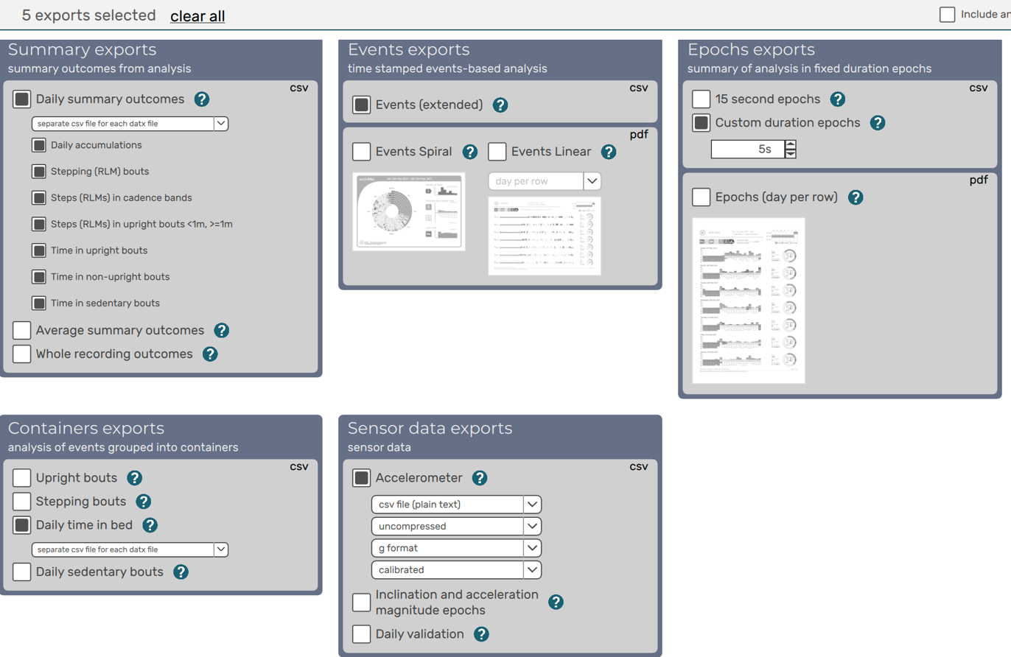
Click and wait for files to be created.
Repeat this process for all participants. Skip to Step 2. Preparing for Program

If you do not have sleep logs:
Open PALbatch
Folder: As the input folder select the folder that contains all of your .datx files. Make the output folder the same as the input
Validation algorithm: ensure ‘CREA’ algorithm is selected, leave minimum periods at 10s each.
Export selection: select the following:
- Daily summary outcomes (and all the boxes that appear in the dropdown)**
- Events (extended)
- Custom duration epochs (5s)
- Daily time in bed**
- Accelerometer (csv file, uncompressed, g format, calibrated if possible)
** ensure ‘separate csv file for each datx file’ is selected from the dropdown menu**

Click and wait, it will take several minutes.

Step 2. Preparing for Program
Now that all the necessary files are exported, we must organize them so that the program can identify each participants files. To do this we will use a nested folder design.
Start by making a ‘main folder’, name it something associated with the data you are processing (‘NW_pals’, ‘SDSpals’, etc.)
Within this main folder, you will make several ‘subfolders’, exactly one for each activPAL file. If you have the same participants at multiple time points you must make separate folders for pre and post. Name these by participant code (ex. P01, P02, etc.) and if there are multiple timepoints distinguish them (ex. P01Pre, P02post, etc.).
Bring the contents of the export folder into the main folder (you will have many activPAL exports and many ‘subfolders’ named after each participant. Place the files for each participant within their respective subfolder. You should have one main folder, which has subfolders that contain their participant’s .datx, .pml, .csv, etc. files.
That’s the hard part over!
Step 3 Running the Program
We are ready to run the program. Download the most updated code from teams, and make sure it is not a duplicate (shows the (1) at the end of the file name). If this happens, simply rename it or find the original.
Click on the .m file to open it in MATLAB (must be version 2024B or later).
Once the program opens, the ‘Run’ button is under the ‘Editor” tab at the top of the window.
Click Run
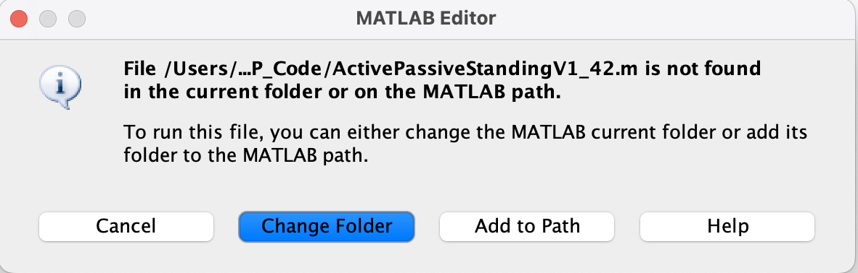
You may see the following message: If this is the case, select ‘Change Folder’

The first thing that will happen will be a window opens, to choose the directory that you want to process. Find your ‘main folder’ from earlier, select it, and click open.
A text box will appear asking you to confirm the participants being analyzed. Check to make sure none are missing and click ‘OK’.
Another box will appear, asking you to indicate whether there is valid sleep time or not. If there is type “Y” in the textbox, and if not type “N”. Hit enter.
The code should now be running. A progress bar will appear, that indicates how many files are analyzed of the total. Words will appear at the bottom of the screen, this is to 1) indicate what part of the program is working and 2) to show you that something is happening. Each participant may take several minutes to process.
If files are missing from the subfolders, a box will appear telling you which file is missing and from which subfolder. Check if others are missing and go back to the PAL software to export the missing files.
If RED text appears in the bottom of the screen (orange is fine), you have run into an error.
If you run into an error: please contact me with a screenshot of the whole error message (all red text) and send me the participant subfolder. I will try to fix it as quickly as possible.
In the meantime, remove that subfolder from the main folder, and re-run the program. Continue removing participants until all analyses are complete.

Once each subfolder has been analyzed, there will be a .csv file named “PARTICIPANTCODE_ActivPAL_CompleteBreakdown”. This contains your export. With daily totals, means, stdevs, and average real variability.
If you have data without sleep logs, you will also have a file named “PARTICIPANTCODE_ActivPAL_HourlyBreakdown”. This contains an hour by hour breakdown of sedentary, upright, stepping, stepcount, and cycling time across all days and hourly means. Hour 1 is midnight until 1am, Hour 2 is 1am to 2am, and so on.

Below you will find the definitions of each exported variable:
ActiveStand m/day: Standing that included micromovements
PassiveStand m/day: Standing without micromovements
ShortStand m/day: Standing epochs that were interrupted by activity, thus could not be analyzed.
Active/Passive ratio: Active Standing divided by Passive Standing time
Sedentary m/day: Total daily sedentary time
Upright m/day: Total upright time (standing + stepping + cycling)
Standing m/day: Total daily standing time
Stepping m/day: Total daily stepping time
Step counts: Total daily step counts
Cycling m/day: Total daily cycling time
Less10minSedT: Total daily time in sedentary bouts under 10m (in minutes)
Less15minSedT: Total daily time in sedentary bouts under 15m (in minutes)
Less30minSedT: Total daily time in sedentary bouts under 30m (in minutes)
Ovr30minSedT: Total daily time in sedentary bouts over 30m (in minutes)
Btw10_20minSedT: Total daily time in sedentary bouts between 10-20m (in minutes)
Btw20_30minSedT: Total daily time in sedentary bouts between 20-30m (in minutes)
Btw30_40minSedT: Total daily time in sedentary bouts between 30-40m (in minutes)
Btw40_50minSedT: Total daily time in sedentary bouts between 40-50m (in minutes)
Btw50_60minSedT: Total daily time in sedentary bouts between 50-60m (in minutes)
Btw1_2hrSedT: Total daily time in sedentary bouts between 1-2hr (in minutes)
Btw2_3hrSedT: Total daily time in sedentary bouts between 2-3hr (in minutes)
Btw3_4hrSedT: Total daily time in sedentary bouts between 3-4hr (in minutes)
Ovr4hrSedT: Total daily time in sedentary bouts over 4hrs (in minutes)
Same as above with ‘N’ instead of ‘T’: the number of bouts
Same as above for standing with “N” and “T”, the number of and total time of standing bouts
STS transitions: total daily sit-to-stand transitions

