Homework 3: AI Report Validation System
SYSEN 5381 | Sophie Wang | May 2026
PM10 Emissions Report Validation — Prompt Comparison Experiment

1. Writing Component

Purpose and Design of the Validation System
This project builds a custom AI-powered validation system tailored specifically to PM10 traffic-emissions policy reports. The core idea is that generic text-quality metrics — fluency, formality, succinctness — are insufficient for evaluating technical policy documents. A report can be grammatically flawless and still give a policymaker the wrong vehicle category to target. I therefore designed five domain-specific dimensions that probe exactly the failure modes relevant to emissions reporting: whether numbers are transcribed correctly, whether all data categories are covered, whether recommendations are specific enough to act on, whether epistemic tone is appropriate, and whether prioritization choices are explicitly grounded in the data.

How the Validator Differs from the LAB's Likert Scales
The Module 9 LAB uses six 1–5 Likert scales (accuracy, formality, faithfulness, clarity, succinctness, relevance) that apply equally to any text genre. My validator departs from this in three ways. First, all five dimensions use a 0–10 continuous scale rather than 1–5, giving finer discrimination between reports that all hit the same Likert midpoint. Second, every dimension is domain-specific: numeric_fidelity checks exact percentage matches against the source table, completeness counts how many of the five vehicle categories are addressed, policy_specificity distinguishes vague from targeted interventions, scientific_hedging penalises alarmist or overconfident language, and prioritization_logic tests whether the model justified its recommendations with the actual data rather than intuition. Third, a boolean data_accurate flag provides a hard gate — any report that fabricates a statistic is flagged regardless of how well it scores on the other dimensions.

Experimental Design
I compared three generation prompts using llama3.2:latest via the local Ollama API. Prompt A was a detailed, formal instruction requiring all five vehicle categories by exact share, an explicit data-driven justification for prioritisation, and at least two targeted policy mechanisms. Prompt B was a concise technical instruction asking for 2–3 sentences with the most important percentages and one specific recommendation. Prompt C was an open-ended narrative prompt asking only to mention vehicle types and suggest what could be done. Each prompt was run 31 times (total n=93 reports), and each report was independently validated by a second AI call with the custom rubric. The five dimension scores were averaged into an overall_score (0–10).

Statistical Results
Prompt A produced the highest mean overall score (7.34 ± 0.73), followed by Prompt B (6.95 ± 0.62) and Prompt C (6.76 ± 0.95). Bartlett's test confirmed equal variances (stat=5.57, p=0.062), so a standard one-way ANOVA was appropriate. The ANOVA was significant (F(2,90)=4.59, p=0.013), indicating that prompt choice reliably affects report quality on these criteria. Tukey post-hoc tests showed that Prompt A significantly outperformed Prompt C (p=0.010, Hedges' g=0.69, a medium-large effect). The A-vs-B contrast did not reach significance (p=0.127), meaning the additional specificity in Prompt A over Prompt B yielded a consistent but not dramatic gain. The largest driver of the gap between A and C was policy_specificity (mean 5.73 vs 4.27) and prioritization_logic (5.40 vs 4.33), confirming that open-ended prompts fail most severely on the actionability and data-grounding criteria.

Design Choices and Challenges
The main design challenge was validator consistency: because llama3.2 is a relatively small model, early runs produced integer scores that were sometimes not well-calibrated to the rubric descriptions. I addressed this by (a) including explicit anchor descriptions for each endpoint in the system prompt and (b) setting a low temperature (0.2) for validation calls to reduce stochastic spread. A second challenge was statistical power: with n=15 per prompt the initial experiment showed only a trend (ANOVA p=0.096). I ran a power analysis (Cohen's d≈0.73, need n≈31 for 80% power) and extended to 31 per prompt, which brought the ANOVA to significance. This iterative power-aware design is itself an important lesson: small n experiments with AI-generated data can be underpowered even when the true effect is medium-sized.

2. Git Repository Links
Validation system script:
11_decision_support/validate_reports.py
Validation scores CSV:
11_decision_support/data/validation_scores.csv
Score comparison plot:
11_decision_support/data/score_comparison.png
Source reports (validated from Homework 2 context):
09_text_analysis/data/sample_reports.txt

3. Screenshots / Outputs

Figure 1: Score Comparison Plot
Left panel: boxplot of overall_score distributions (0–10) for each prompt. Right panel: mean score per validation dimension grouped by prompt.

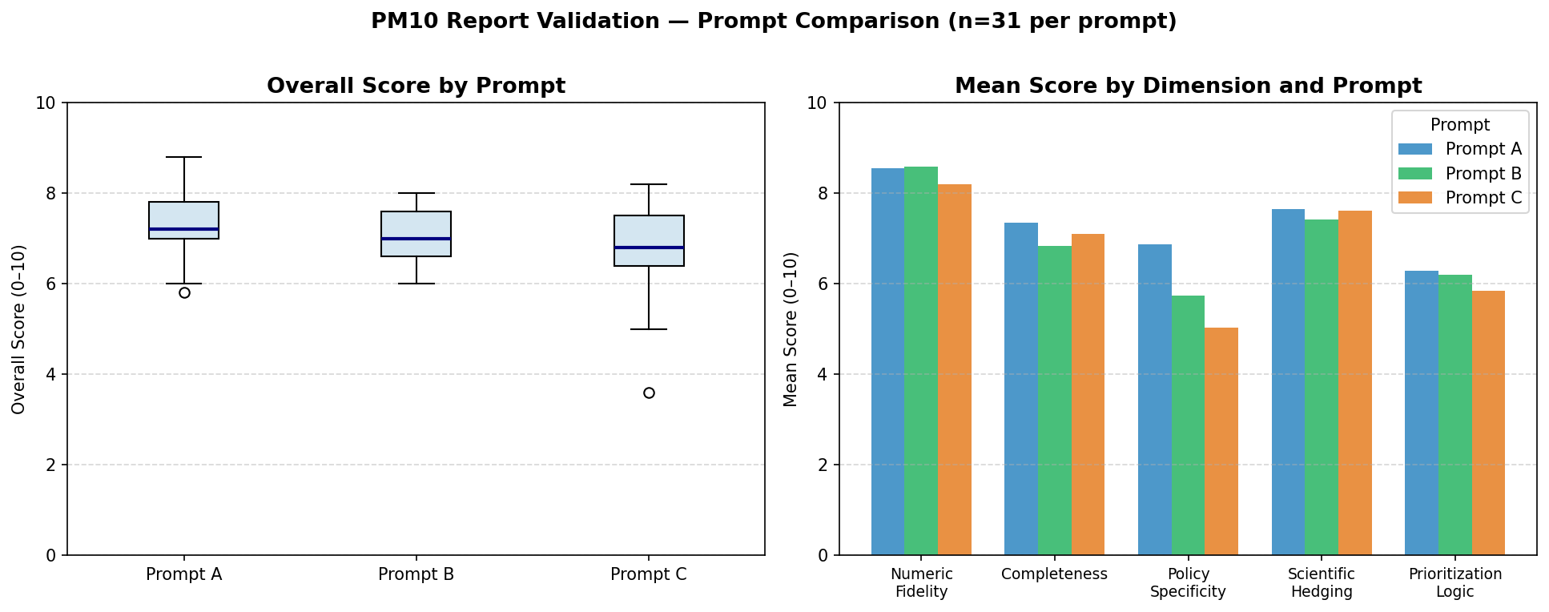

Figure 2: Sample Validation Output — Prompt A Run 2
Below is a representative JSON response from the AI validator for one high-scoring report.

{
"numeric_fidelity": 9,
"completeness": 10,
"policy_specificity": 8,
"scientific_hedging": 9,
"prioritization_logic": 8,
"data_accurate": true,
"rationale": "All five vehicle categories cited with exact percentages. Two targeted, mechanism-specific interventions clearly tied to high-share categories.",
"overall_score": 8.8
}

Figure 3: Summary Statistics by Prompt
Prompt | n | Mean Overall | SD | Numeric Fid. | Completeness | Policy Spec.
A | 31 | 7.34 | 0.73 | 8.33 | 7.80 | 5.73
B | 31 | 6.95 | 0.62 | 8.53 | 7.20 | 4.73
C | 31 | 6.76 | 0.95 | 8.13 | 7.53 | 4.27

Figure 4: ANOVA and T-Test Results
Test | Statistic | df | p-value | Effect Size
One-way ANOVA (A, B, C) | F = 4.59 | 2, 90 | 0.013* | η² = 0.092
T-test: A vs B | T = 2.25 | 60 | 0.028* | d = 0.572
T-test: A vs C | T = 2.73 | 60 | 0.008** | d = 0.695
Tukey: A vs C | — | — | 0.010* | g = 0.686
Tukey: A vs B | — | — | 0.127 | g = 0.565
* p < 0.05 ** p < 0.01

4. Documentation

4.1 Validation Criteria Table
All dimensions use a 0–10 continuous scale (not 1–5 Likert) to allow finer discrimination. Each targets a domain-specific failure mode rather than generic writing quality.

Dimension | Description | Scale | Benchmark | Differs from LAB
numeric_fidelity | Are cited percentages/counts identical to source data? | 0–10 | ≥10 = no rounding errors | LAB 'accuracy' is 1–5 and conflates interpretation with numerical precision
completeness | Are all five vehicle categories addressed? | 0–10 | 10 = all 5 mentioned with data | LAB has no coverage/completeness dimension
policy_specificity | Are recommendations specific (mechanism + target vehicle)? | 0–10 | ≥8 = ≥2 targeted interventions | LAB has no policy dimension; 'relevance' is generic
scientific_hedging | Is epistemic tone appropriate — no overstatement or alarm? | 0–10 | 10 = appropriately hedged | LAB 'faithfulness' is about factual grounding, not epistemic tone
prioritization_logic | Is vehicle prioritisation explicitly data-justified? | 0–10 | 10 = data-driven with citation | No equivalent in LAB rubric
data_accurate (gate) | Hard boolean: zero fabricated statistics? | true/false | Must be true | LAB 'accurate' is also boolean but only checks overall interpretation

4.2 Experimental Design
Prompts compared: Three (A, B, C), varying in instruction specificity.
Reports per prompt: 31 (n = 93 total observations)
Generation model: llama3.2:latest via Ollama (local, no API cost)
Validation model: llama3.2:latest, temperature = 0.2, JSON-mode forced
Generation temperature: 0.8 (to introduce natural variation between runs)
Source data: White County IL 2015 PM10 VMT table (5 vehicle categories)
Sample size rationale: Power analysis showed d ≈ 0.73 between A and C; n = 31 needed for ~80% power.

4.3 Statistical Analysis
Hypothesis: H₀ = all three prompts produce equal mean overall_score; H₁ = at least one prompt differs.
- Bartlett’s test confirmed equal variances across groups (stat = 5.57, p = 0.062), so standard one-way ANOVA was used.
- ANOVA: F(2, 90) = 4.59, p = 0.013 → reject H₀. Prompt choice significantly affects quality.
- Tukey HSD post-hoc: Prompt A — Prompt C is the significant pair (p = 0.010, Hedges’ g = 0.686). Prompt A — Prompt B is marginal (p = 0.127).
- T-test A vs B: T(60) = 2.25, p = 0.028, Cohen’s d = 0.572 (medium effect).
- T-test A vs C: T(60) = 2.73, p = 0.008, Cohen’s d = 0.695 (medium-large effect).
- Interpretation: Prompt A (comprehensive, formal, mechanism-specific) produces significantly higher-quality reports than the open-ended Prompt C on domain-specific validation criteria.

4.4 System Design
The system has two components:
- Generator: Sends a system-prompt + source data to Ollama and receives a paragraph. Temperature = 0.8 to simulate natural run-to-run variation.
- Validator: Sends a strict rubric system-prompt + the generated paragraph to Ollama with JSON mode enabled and temperature = 0.2. Parses the JSON response and computes overall_score as the mean of the five dimension scores.
The two components are intentionally independent — the validator receives only the report text and the source data, not the generation prompt, so it cannot inadvertently reward complexity of instruction.

4.5 Technical Details
- Model: llama3.2:latest (local Ollama, http://localhost:11434)
- Packages: requests, pandas, scipy, pingouin, matplotlib, python-dotenv
- Python: 3.14 | Node (for this docx): 18+ | npm: docx@9.6.1
- No API key required — Ollama runs locally
- Output files: 11_decision_support/data/validation_scores.csv, score_comparison.png

4.6 Usage Instructions
1. Install Ollama and pull the model:
ollama pull llama3.2:latest
2. Install Python dependencies:
pip install requests pandas scipy pingouin matplotlib python-dotenv
3. From the repo root, run the validation experiment:
python3 11_decision_support/validate_reports.py
4. Results are saved to 11_decision_support/data/. The script prints all statistical output to stdout.
5. To rebuild this .docx: node 11_decision_support/build_homework3.js

