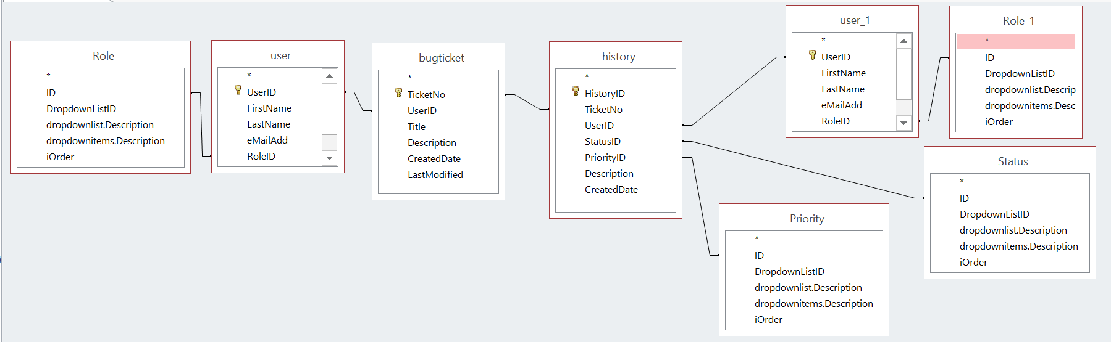
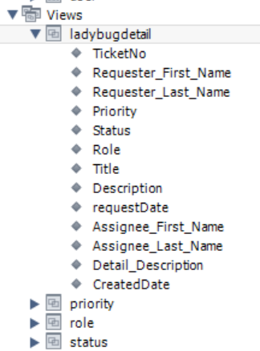
MS Access query:
SELECT bugticket.TicketNo, user.FirstName AS Requester_First_Name, user.LastName AS Requester_Last_Name, Priority.dropdownitems.Description AS Priority, Status.dropdownitems.Description AS Status, Role.dropdownitems.Description AS Role, bugticket.Title, bugticket.Description, bugticket.CreatedDate, user_1.FirstName AS Assignee_First_Name, user_1.LastName AS Assignee_Last_Name, history.Description AS Detail_Description, history.CreatedDate
FROM (((((bugticket INNER JOIN history ON bugticket.TicketNo = history.TicketNo) INNER JOIN [user] ON bugticket.UserID = user.UserID) INNER JOIN Role ON user.RoleID = Role.ID) INNER JOIN Priority ON history.PriorityID = Priority.ID) INNER JOIN Status ON history.StatusID = Status.ID) INNER JOIN ([user] AS user_1 INNER JOIN Role AS Role_1 ON user_1.RoleID = Role_1.ID) ON history.UserID = user_1.UserID;

MySQL script:
USE `ladybugtracker`;
CREATE OR REPLACE VIEW `ladybugdetail` AS
SELECT bugticket.TicketNo, user.FirstName AS Requester_First_Name, user.LastName AS Requester_Last_Name, Priority.Description AS Priority, Status.Description AS Status, Role.Description AS Role, bugticket.Title, bugticket.Description, bugticket.CreatedDate AS requestDate, user_1.FirstName AS Assignee_First_Name, user_1.LastName AS Assignee_Last_Name, history.Description AS Detail_Description, history.CreatedDate
FROM (((((bugticket INNER JOIN history ON bugticket.TicketNo = history.TicketNo) INNER JOIN user ON bugticket.UserID = user.UserID) INNER JOIN Role ON user.RoleID = Role.ID) INNER JOIN Priority ON history.PriorityID = Priority.ID) INNER JOIN Status ON history.StatusID = Status.ID) INNER JOIN (user AS user_1 INNER JOIN Role AS Role_1 ON user_1.RoleID = Role_1.ID) ON history.UserID = user_1.UserID;

