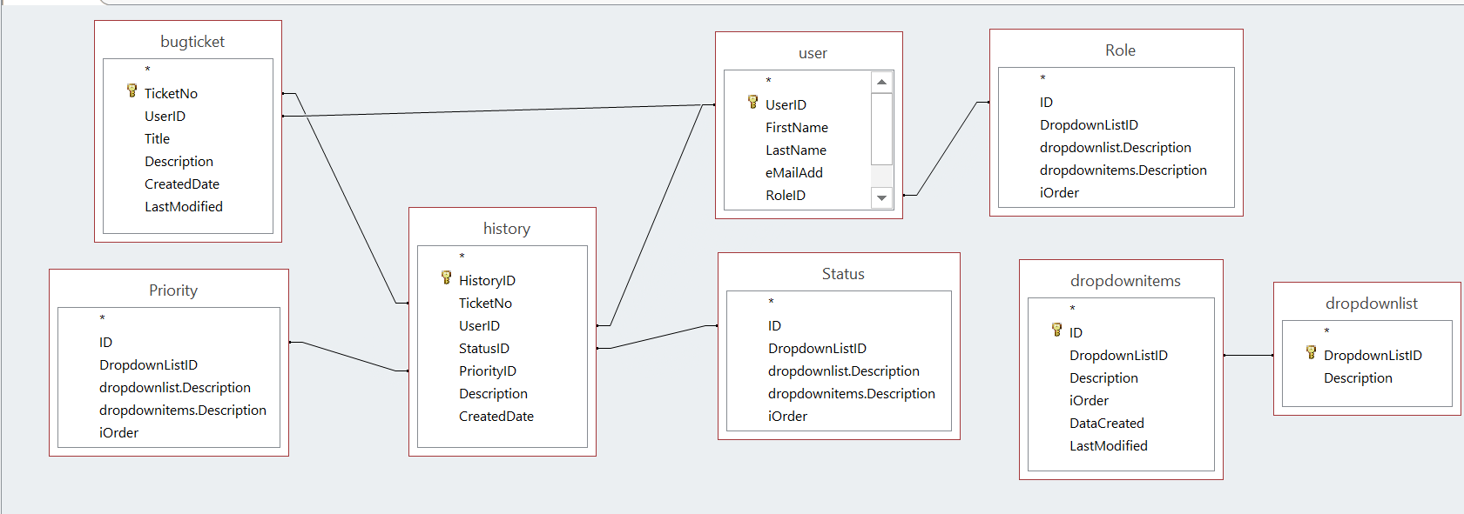
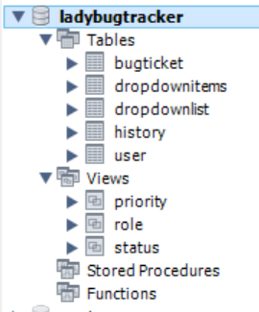
5 tables: bugticket, dropdownitems, dropdownlist, history and user
3 views: priority, role and status

