Mapping the MPI_SEND/MPI_Isend to MPI_Recv/MPI_Irece between manager program and worker program.
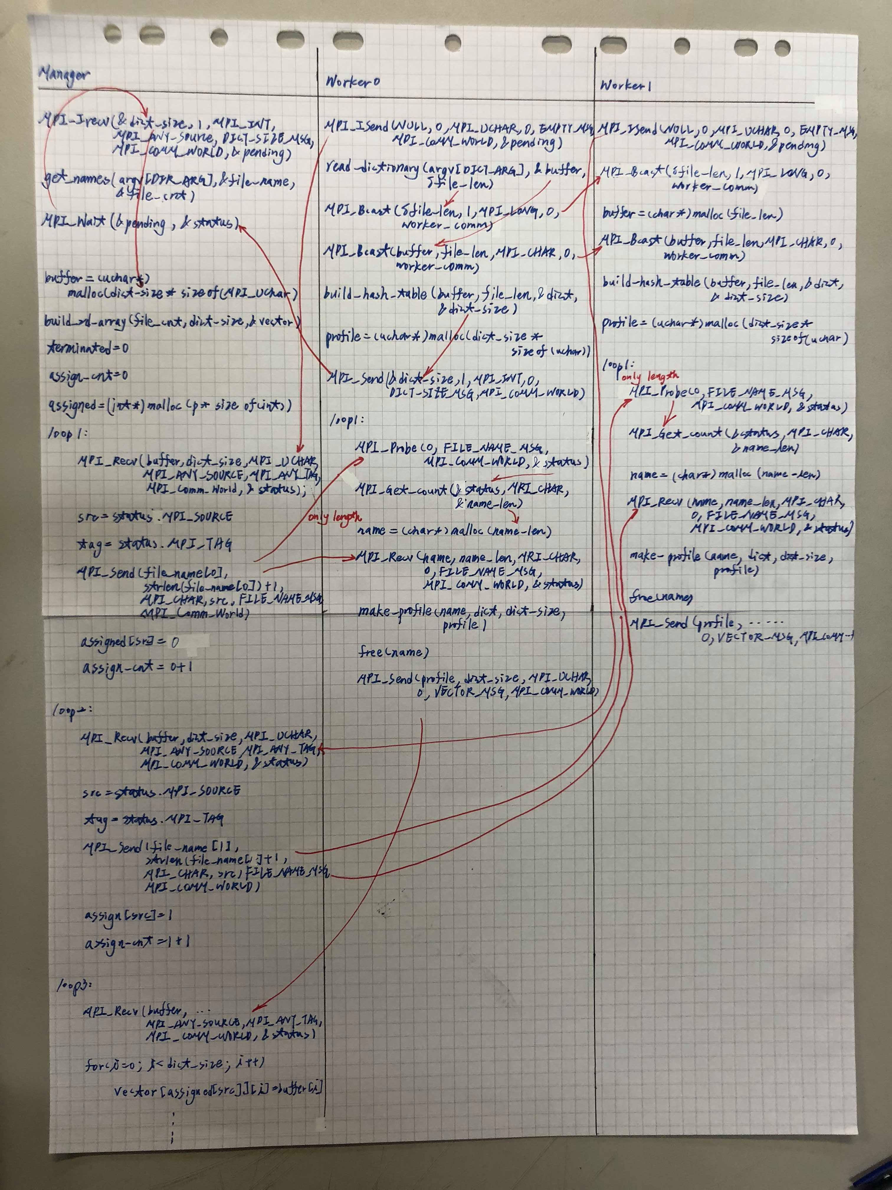

Explain why the program uses non-blocking send/receive MPI functions. Explain why there is no dead-lock problem.

因為在manager 使用Irecv來從worker0取得字典的大小時，他可以先做recognize document，直到call wait function，藉此節省一點時間。由於Irecv, Isend都是non-blocking point-to-point communication ，所以不會因為all process recv before send的dead-lock問題。

