

Department of Computer Science

CPSC 490 Undergraduate Seminar in Computer Science - Proposal for Capstone Project

Project title | Secure Member Portal (EXAMPLE)
Semester: | Fall, 2026 | Proposal date: | October 11, 2026
Team name: | Group 00 — Example Team
GitHub repository URL: | https://github.com/kyoungshin/CPSC490
Member name: | Doe, Jane | Email
Member name: | Roe, Richard | Email:
Member name: |  | Email:
Member name: |  | Email:
Member name |  | Email:
Faculty advisor | Kyoung Shin | Reviewer (optional)

Abstract
Small clubs keep their member records in shared spreadsheets that anyone with the link can edit. This project builds a member portal with secure accounts, proves the riskiest part — session handling — in a prototype by the end of Sprint 2, and documents the design that CPSC 491 will build on.

Introduction
Volunteer-run clubs rarely have anyone whose job is security, yet they hold names, emails and payment notes for hundreds of members. A portal with real accounts removes the shared-link problem without asking volunteers to run a server.

Related Work
Hosted membership tools exist but charge per member and lock the data in their own format; open-source portals assume an administrator who patches the server [1].

Problem Statements
Shared spreadsheets give every member write access to every record, and nothing records who changed what.

Goals and Objectives
Each goal is tracked as an epic and each objective as a user story; every one is cited by its issue reference.
Goal 1: Secure account management [epic:#1]
Objective 1.1: Implement member registration and login with hashed credentials and session expiry. [story:#2]
Objective 1.2: Demonstrate the login round-trip in a runnable prototype at the end-of-Sprint-2 demo. [story:#3]
Objective 1.3: Document the authentication architecture and data model for CPSC 491. [story:#4]

Proposed Approaches
We will build the login round-trip first, because session handling is the design choice most likely to force a rewrite if it is wrong, and every other feature depends on it. A hosted identity provider was considered and rejected: it would hide exactly the part the project has to prove. The implementation stack is detailed in §4.

Required Environment, Resources, and Planned Activities

Environment and resources
The prototype runs on Node.js 22 with PostgreSQL 16 in Docker, so every team member runs the same stack locally. Standing up that stack, with a health check the demo can call, is the first piece of work. [task:#5]

Specification and design documents
The account-management specification, docs/specs/account-management.md, defines what the login endpoint accepts and rejects, including the input rules that stop malformed requests before they reach the database. [feature:#6]
The authentication design, docs/design/architecture.md, chooses a salted digest for stored passwords so that no plain-text credential is ever stored or logged. [sub-task:#7]

Diagrams
Figure 1 shows the login round-trip the prototype demonstrates: the browser sends credentials, the login API checks them against the salted hash in PostgreSQL, and a session cookie comes back.
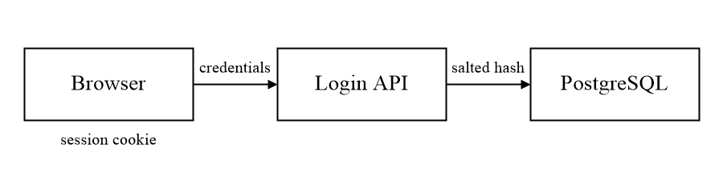
Figure 1. Login round-trip architecture. [feature:#6]

Planned activities
The login endpoint is planned for Sprint 2: it issues a session on a successful login, and its hashing step lands first so the demo never handles a plain-text password. [feature:#6] [sub-task:#7]

Project Outcomes
When the project is finished, a club officer can invite members, each member signs in with their own account, and every change to a record is attributed. The deliverables are the team repository, the prototype in prototype/, and the final report; the prototype demonstrates the login round-trip.

Project Timeline
The spring plan builds the objectives in §2 in order: accounts first, then records, then the audit trail.

AI Usage
No AI tool drafted the prose of this proposal.

References
[1] OWASP Foundation. Password Storage Cheat Sheet. https://cheatsheetseries.owasp.org/cheatsheets/Password_Storage_Cheat_Sheet.html, accessed Oct 8, 2026.

Appendix A. Issue References
Issues cited in the text by their tag, in order of first citation.
[epic:#1] Goal 1: Secure account management. https://github.com/kyoungshin/CPSC490/issues/1
[story:#2] Objective 1.1: Implement member registration and login. https://github.com/kyoungshin/CPSC490/issues/2
[story:#3] Objective 1.2: Demonstrate the login round-trip. https://github.com/kyoungshin/CPSC490/issues/3
[story:#4] Objective 1.3: Document the authentication architecture. https://github.com/kyoungshin/CPSC490/issues/4
[task:#5] Task 1.2.1: Stand up the prototype login endpoint. https://github.com/kyoungshin/CPSC490/issues/5
[feature:#6] Feature 1.2.a: Login endpoint with session issuance. https://github.com/kyoungshin/CPSC490/issues/6
[sub-task:#7] Sub-task 1.2.1.a: Hash and verify passwords. https://github.com/kyoungshin/CPSC490/issues/7

