# Intro to JavaScript Week 5 Coding Assignment

**Points possible:** 75  
  
**URL to Your GitHub Repository:**

<https://github.com/soppon323/JS_MenuDrivenApp>

**URL to Your Coding Assignment Video:**

https://drive.google.com/file/d/1XV3_kvOZfRMPnGXCGJwN1vWsbcaxur0z/view?usp=sharing

**Instructions:** In VS Code, or an IDE of your choice, write the code that accomplishes the objectives listed below. Ensure that the code compiles and runs as directed. Take screenshots of the code and of the running program (make sure to get screenshots of all required functionality) and paste them in this document where instructed below. Create a new repository on GitHub for this week’s assignments and push this document, with your JavaScript project code, to the repository. Add the URL for this week’s repository to this document where instructed and submit this document to your instructor when complet

**Coding Steps:**

1. Create a menu app as seen in this week’s video. What you create is up to you as long as it meets the following requirements.
   1. Use at least one array.
   2. Use at least two classes.
   3. Your menu should have the options to create, view, and delete elements.

**Video Steps:**

Create a video, up to five minutes max, showing and explaining how your project works with an emphasis on the portions you contributed. This video should be done using screen share and voice over. This can easily be done using Zoom, although you don't have to use Zoom, it's just what we recommend. You can create a new meeting, start screen sharing, and start recording. This will create a video recording on your computer. This should then be uploaded to a publicly accessible site, such as YouTube, Dropbox, or Google Drive. MAKE SURE THE LINK YOU SHARE IS PUBLIC or UNLISTED. If it is not accessible by your grader, your project will be graded based on what they can access. The link should be pasted in the submission text box after the GitHub repo link. REQUIRED: PUBLIC link to video, and GitHub repo link with everything listed above!

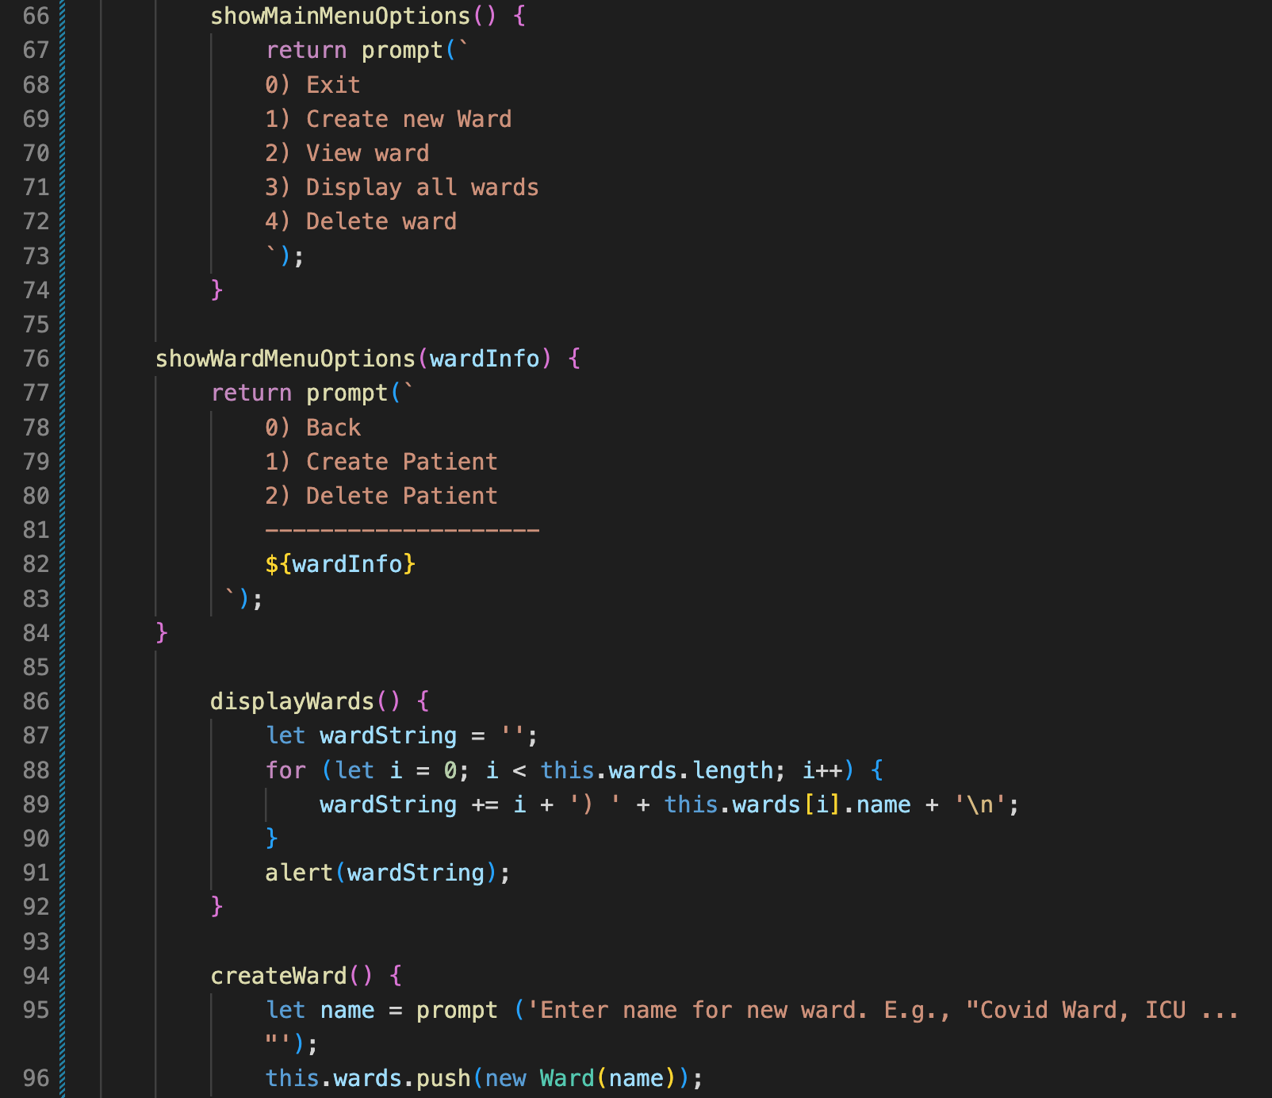

**Screenshots of Running Application:**

