**Software engineering lab**

**FS22 - Group 21**

**Milestone 1 – Report**

Jordi Küffer (Teamlead) – 20-714-051

Jasmin Hochuli – 20-705-711

Luisa Stückelberger – 20-711-421

Christoph Bachmann – 20-701-090

Lars Bösch – 18-921-981

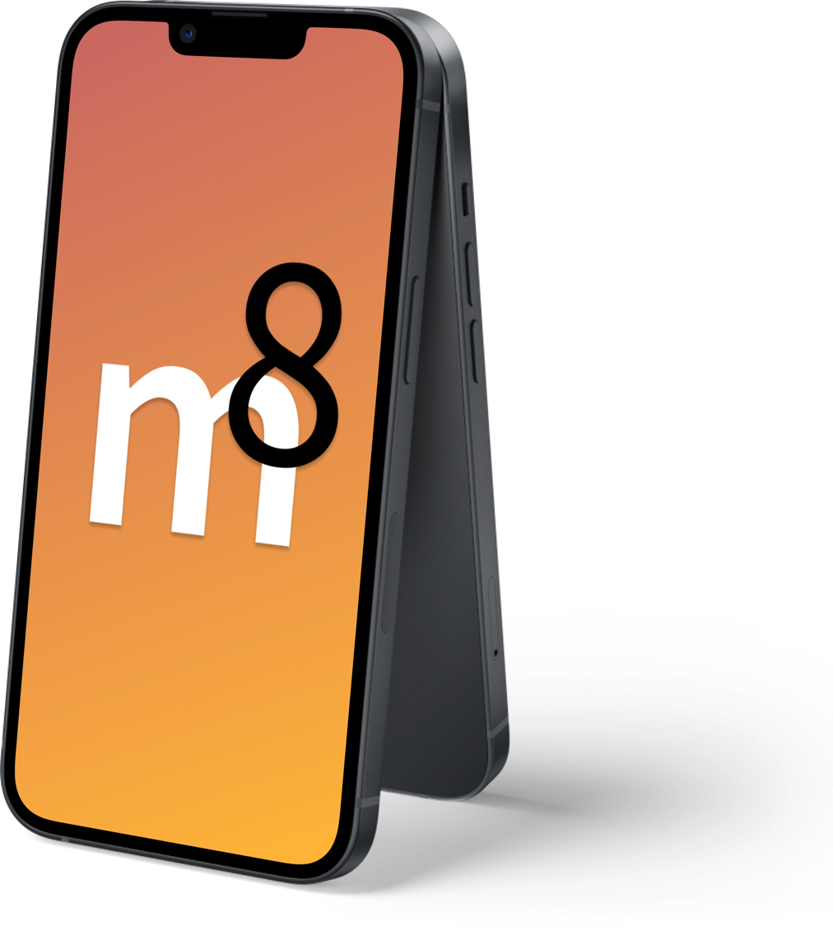

## Component Diagramm:

## Activity Diagramm:

## 

## Class Diagramm:

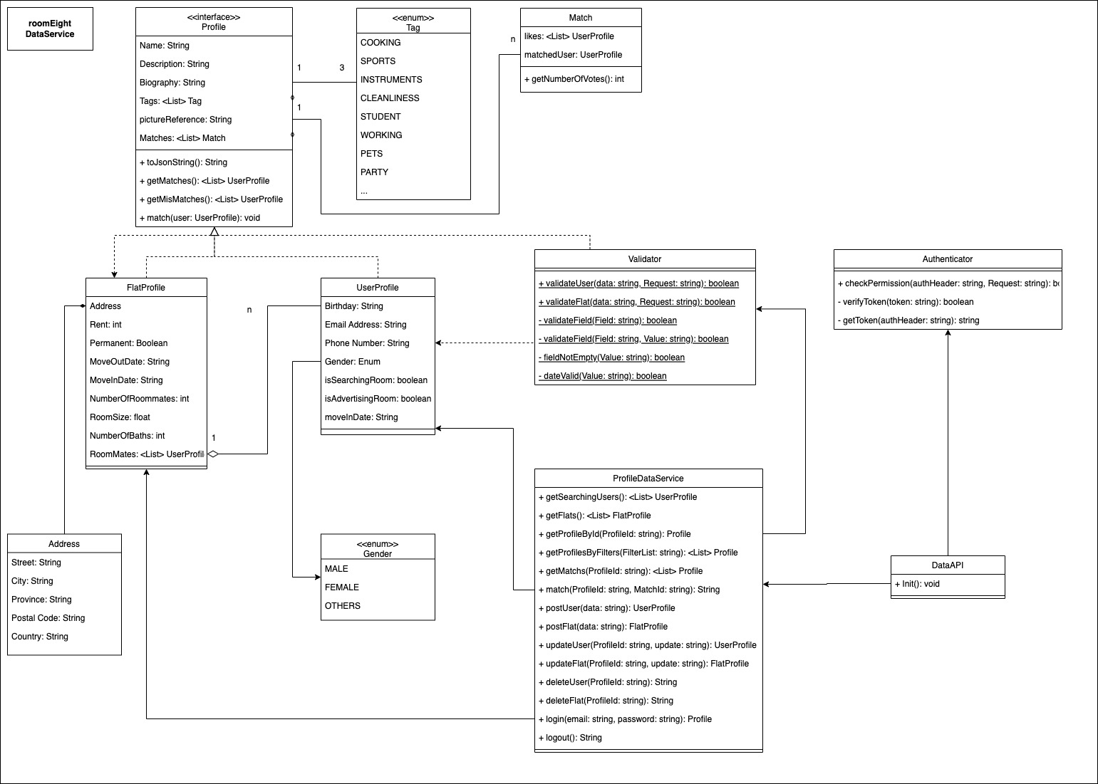

## Specification of the REST Interface:



## Mockups

🡪 our mockups are accessable on figma:

<https://www.figma.com/proto/f5dV9K8c6NhJooI5fhPXqq/roomeight-design?page-id=1605%3A3601&node-id=1691%3A6378&viewport=241%2C48%2C0.2&scaling=scale-down&starting-point-node-id=1605%3A4058>