**Software engineering lab**

**FS22 - Group 21**

**Milestone 4 – Report**

Jordi Küffer (Teamlead) – 20-714-051

Jasmin Hochuli – 20-705-711

Luisa Stückelberger – 20-711-412

Christoph Bachmann – 20-701-090

Lars Bösch – 18-921-981

# Project

roomeight - find a new wave of living

roomeight is a mobile application platform, where room seekers can easily find the flat of their dreams and the roommates of a flat can match with a person fitting perfectly in their group.

Once somebody has set up a profile, a user is able to set its own preferences which can be filtered by the other side of the platform. On the discover page, each user is able to approve or dislike a person or flat. Once a room seeking user and 50% of the roommates of a flat have committed to a like, a match is generated. If only one party likes a user or flat nothing happens. However, if the user and min. one person of a flat have liked each other, a match in progress is initialized. A match in progress leads to a notification to all the other roommates of a flat telling them to like the flat. An overview of the matches in progress shows how many and which roommates have already liked the user. From this overview a roommate is able to like the user directly, which accelerates the matching process and implements the required real-time feature.

Once a match is generated, a room seeker can get in touch with a flat through a chat to get to know each other and talk about the further steps. In addition, the user has an overview map, where the matched flats are displayed.

These features all contribute to flat searching made a lot easier, funnier and more exciting.

# Screenshots

 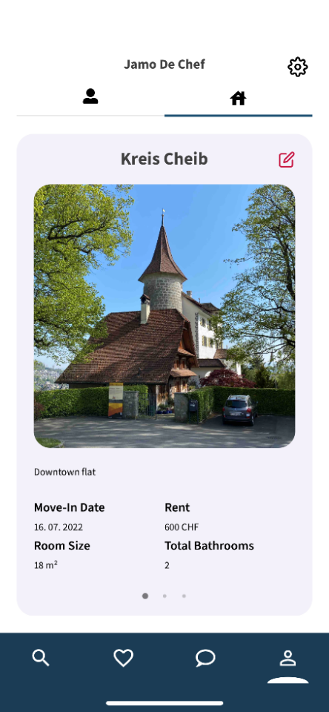 Ein Bild, das Text enthält.

welcome screen profile page of the flat matches in progress

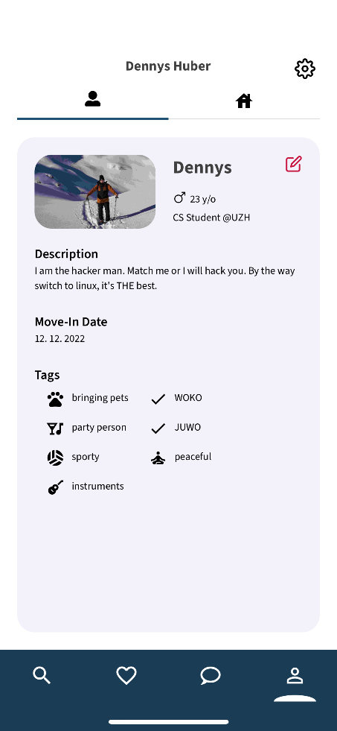 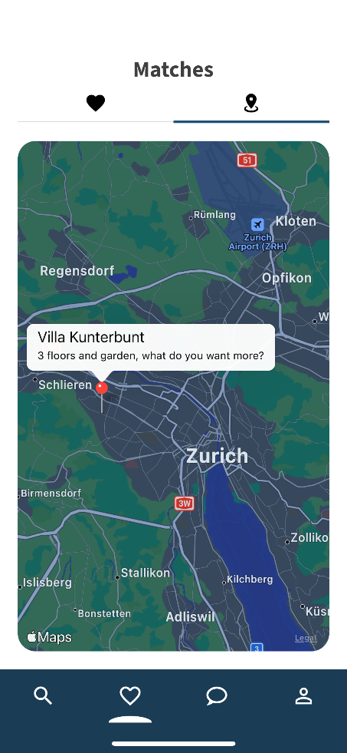 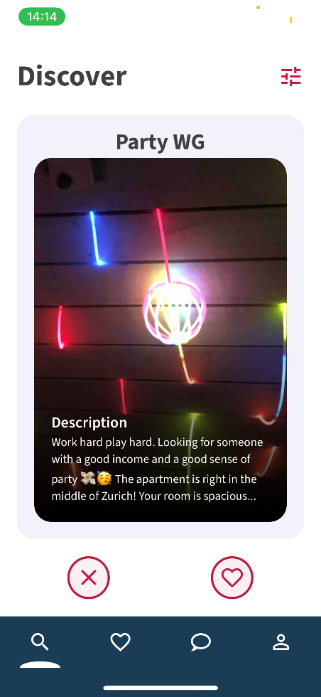

single profile map of matches discover page

# Learnings and Challenges

## Learnings

* Usage of the firebase framework
* Working as a team
* Communication is crucial
* Usage of the expo frontend framework
* Improvement of Javascript, Typescript and React Native knowledge
* Coordination of a middle scale project
* Testing makes refactoring easier

## Challenges

* Not breaking anything while refactoring
* Drawing an exact outline of the features which should be implemented and keep the overview
* Matching, pre matching and liking logic got quite tricky
* Filter logic: How many profiles should be returned? What to do when fields are not set which are needed for filters? Which filters should exist?
* Testing the app with Windows