SE 126

Lab 6a

B. The file lab6a.csv is arranged in the following manner:

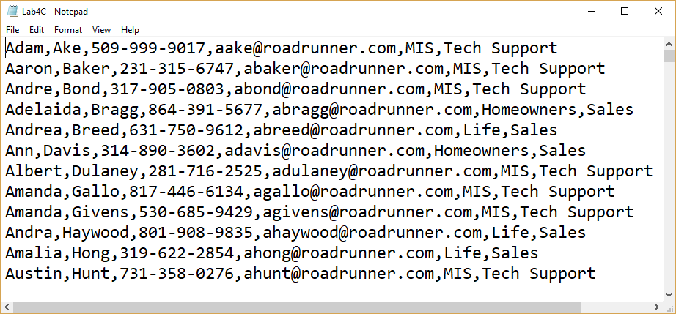

|  |  |
| --- | --- |
| Field | Represents |
| 0 | Employee’s first name |
| 1 | Employee’s last name |
| 2 | Phone number |
| 3 | Email address |
| 4 | Department |
| 5 | Employee’s position in the department |

Using the “binary search” write a program that searches for an employee. If the employee is found list all information that is avaiable on the employee (all 6 fields). If the employee is not found display an appropriate message.

Use the following code for the binary search.

searchName = input("Enter name: ")

min = 0

max = **This will be the length of the *list***you created to store the last names in.

guess = int((min + max)/2)

while(searchName != **xxx**[guess] and min <= max):

if (searchName < **xxx**[guess]):

max = guess -1

else:

min = guess + 1

guess = int((min + max)/2)

Replace **xxx**  with the name of the list you used to store the last name in.

if (searchName == **xxx**[guess]):

**Name is found.**

else:

**Name is not found.**

Grading Criteria for Lab6a.

|  |  |
| --- | --- |
|  | Points |
| Comments: | 5 |
| Program places data into arrays before processing | 20 |
| The binary search is used to lookup the employee’s name | 30 |
| All information on an employee is displayed | 10 |
| If the employee is not found an appropriate message is displayed. | 5 |
| Two functions were used. | 20 |
|  | 10 |
|  |  |
|  |  |
| Total | 100 |