**Lab 2: Searching Products Basics**

**Screen Shots should include both SQL and ALL Available Results**

**Name: Sebastian Oquendo**

1. Please show me the two ways in SQL that you can show all records and all fields?  
   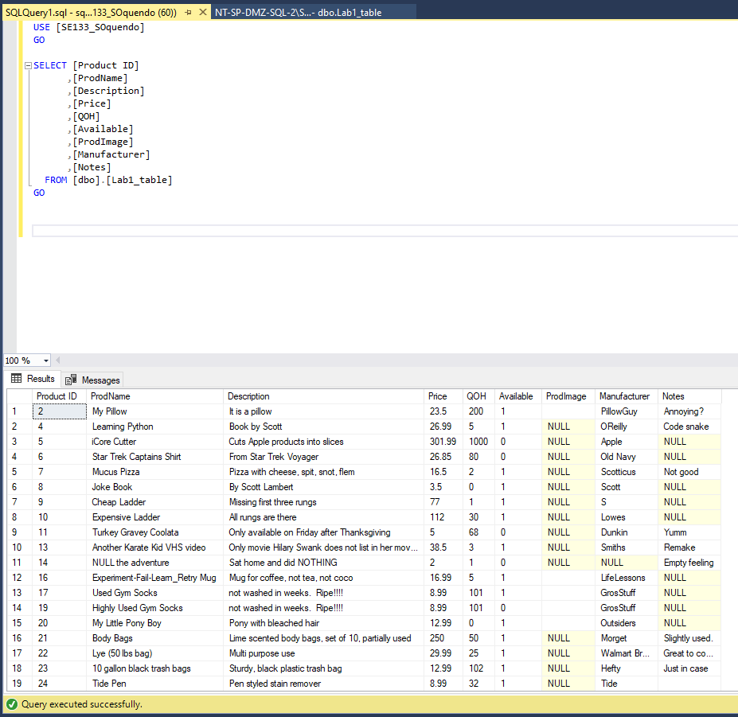

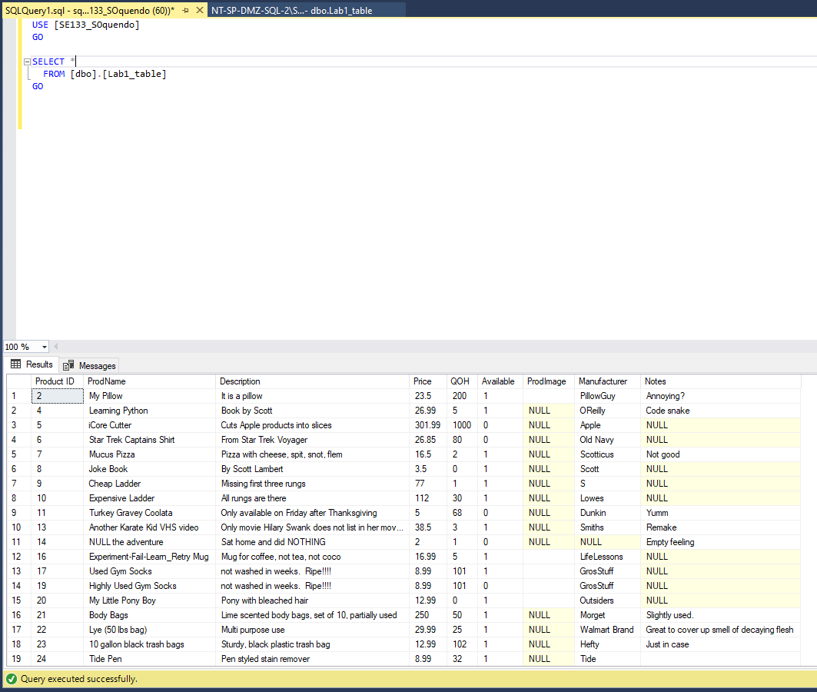

1. Please display all records with the following fields: Product_ID, ProdName, Price, QOH, Available  
   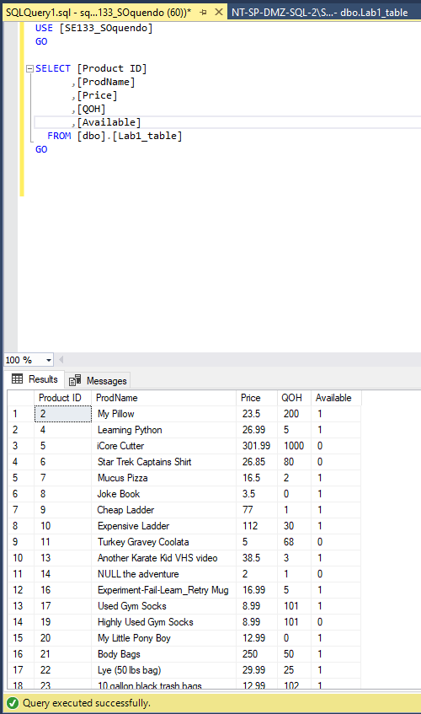

1. Same as #2, but in Ascending order by the QOH field.  
   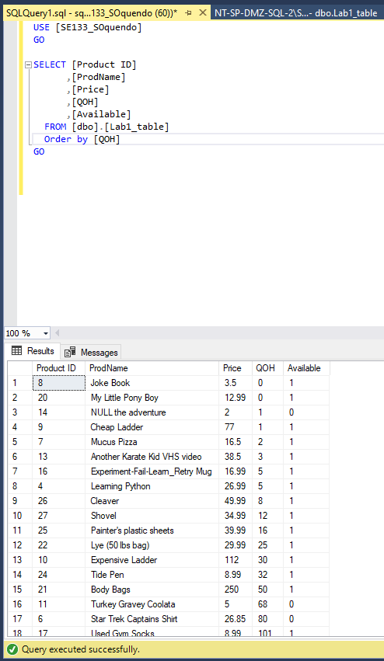
2. Same as #2, but in Descending order by the QOH field.
3. Limit the results to products with Price less than 50 dollars.
4. Limit the results to products with Prices that are greater than or equal to $20 AND less than $200.
5. Concatenated the ProdName with “ by “ and Manufacturer into one Prod_Description field.
6. Calculate how much money the company will earn by selling all of each product (QOH * Price) into an EarningPotential field.
7. Same as #8, but limit the results to Available products: (Available = 1).
8. Same as #8, but limit the results to non-Available products: (Available = 0).
9. Make sure that you have multiple records with the same Manufacturers. Based on my sample data, you should have at least 2 GrosStuff products….Maybe one misspelled? Try listing all the distinct Manufacturers. If you see duplicates showing, checking for spelling differences and fix.
10. Try #11, but with distinct Manufacturer and ProdName.
11. Pull up all fields and records, but limit it to the first/top 10 records.
12. Pull up all fields and records, but limit it to the first/top 25% of records.