**Lessons 4**

**Online Activity: Cars Table:   
Screen Shots should include both SQL and ALL Available Results**

**Name: Sebastian Oquendo**

1. Display the cars that are 4-cylinder cars.  
   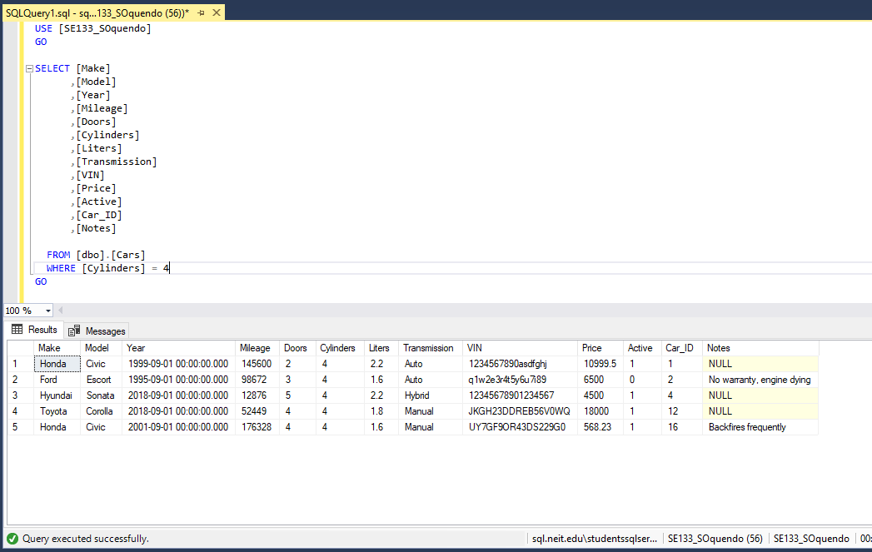
2. Display the cars that cost more than $6500.  
   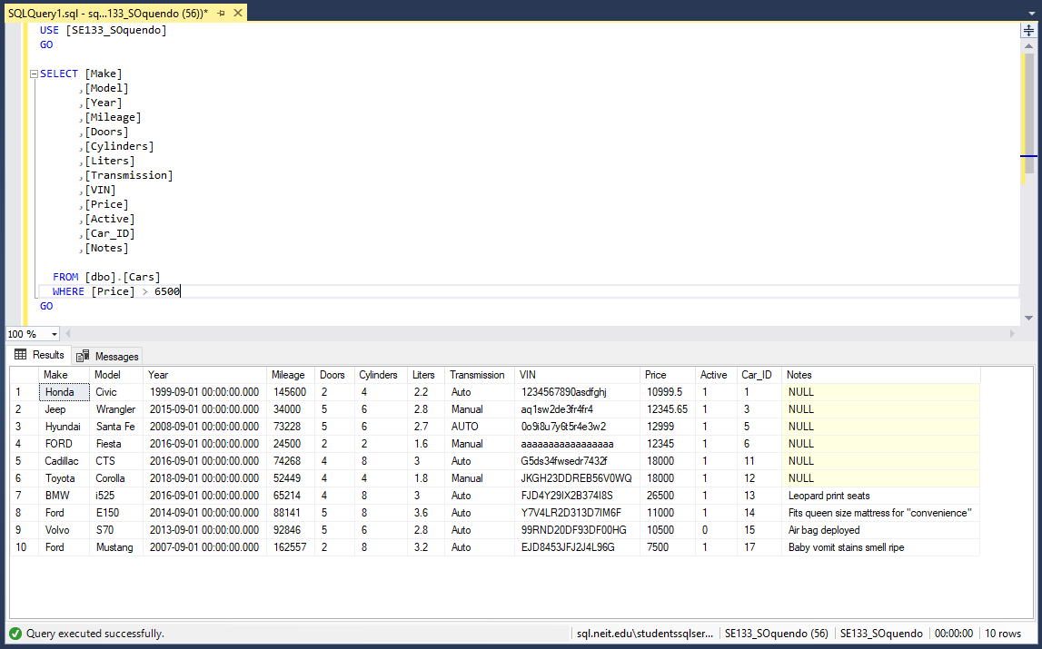
3. Display the cars that cost $6500 or more.  
   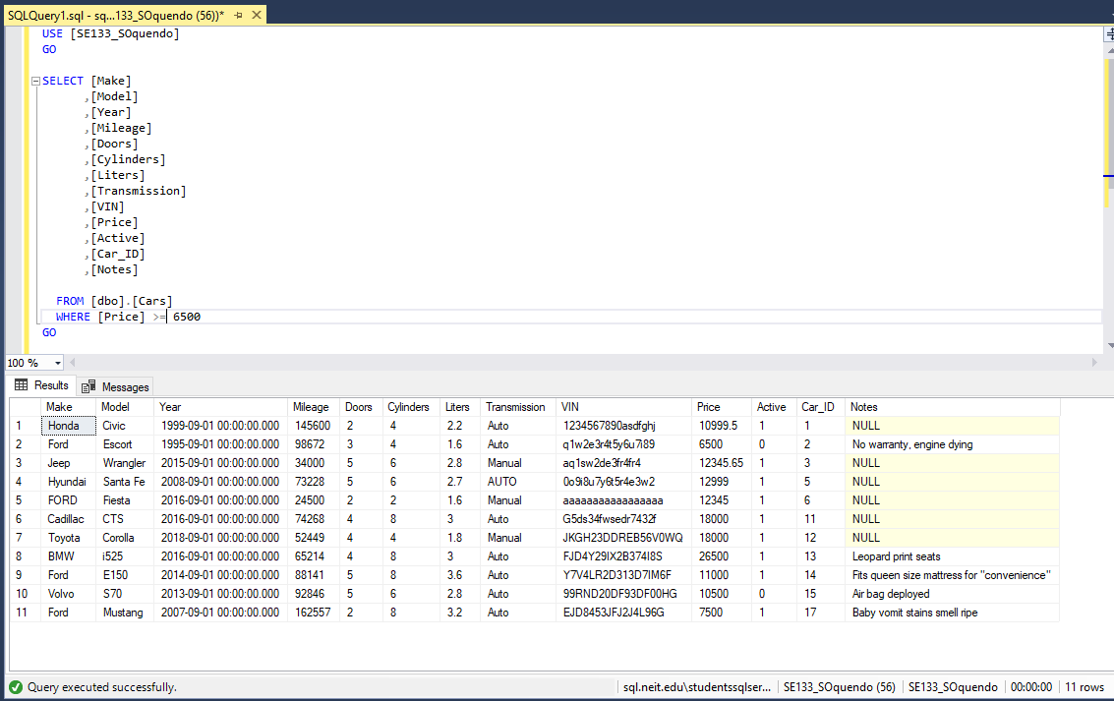
4. Display the cars that are 2.2 Liters or less.  
   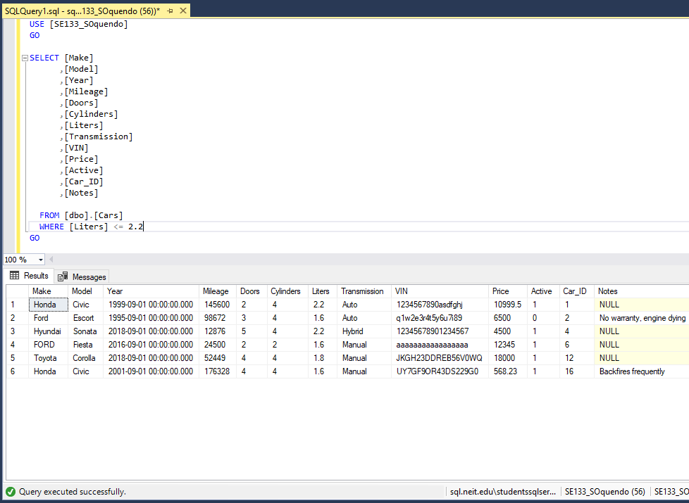
5. Display the cars that are less than 2.2 Liters.  
   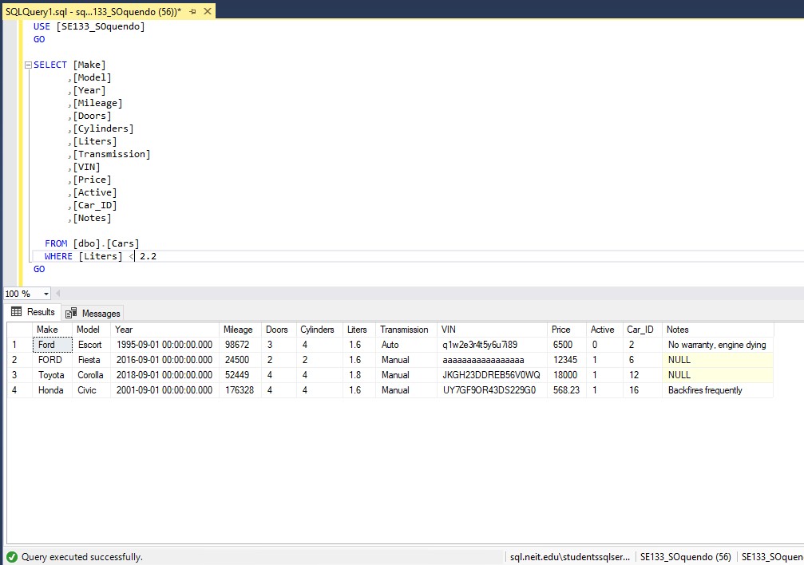
6. Display the cars that are not 4 Cylinders.  
   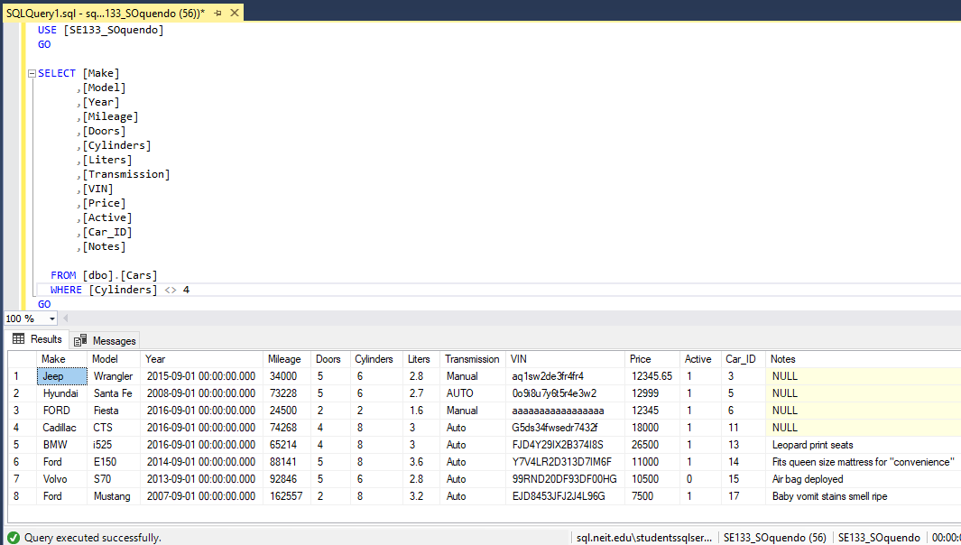
7. Display the cars that are 5 Years old or less.  
   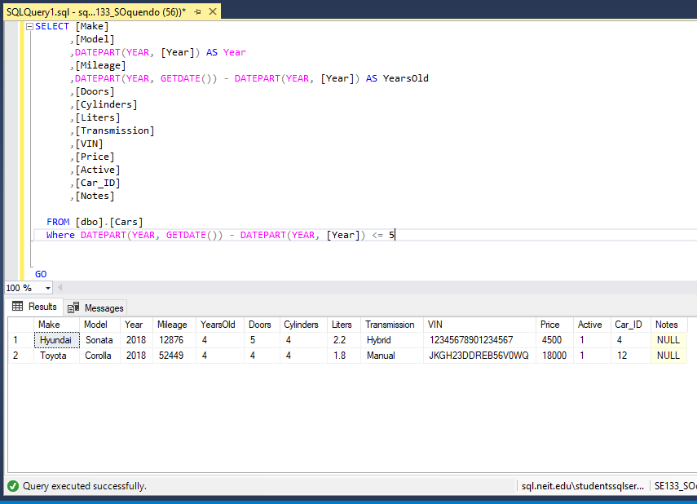
8. Display the cars that have an average miles per year value of 15000 or more.  
   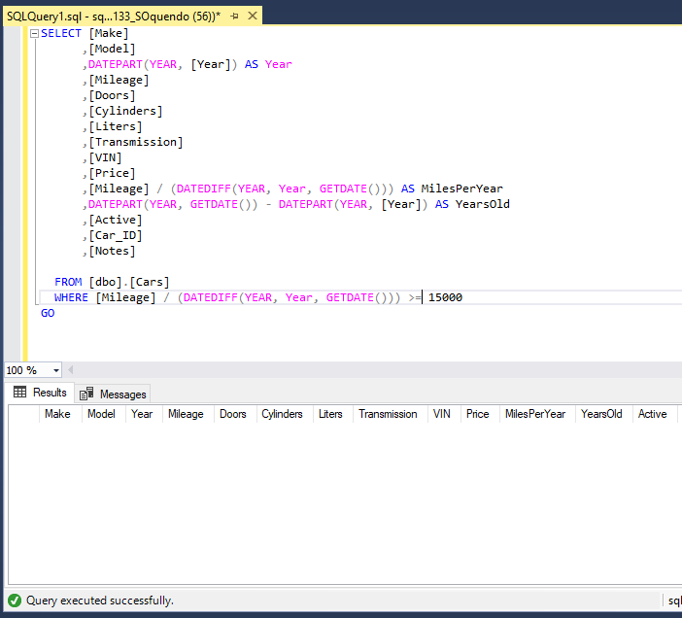
9. Display cars that were created in 2015 and later.  
   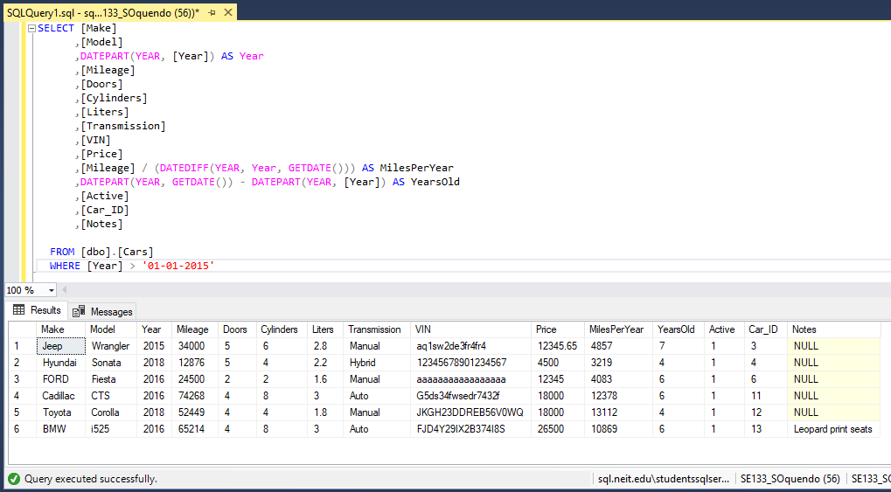
10. Display cars that have 6 cylinders and 2.8 liters.  
    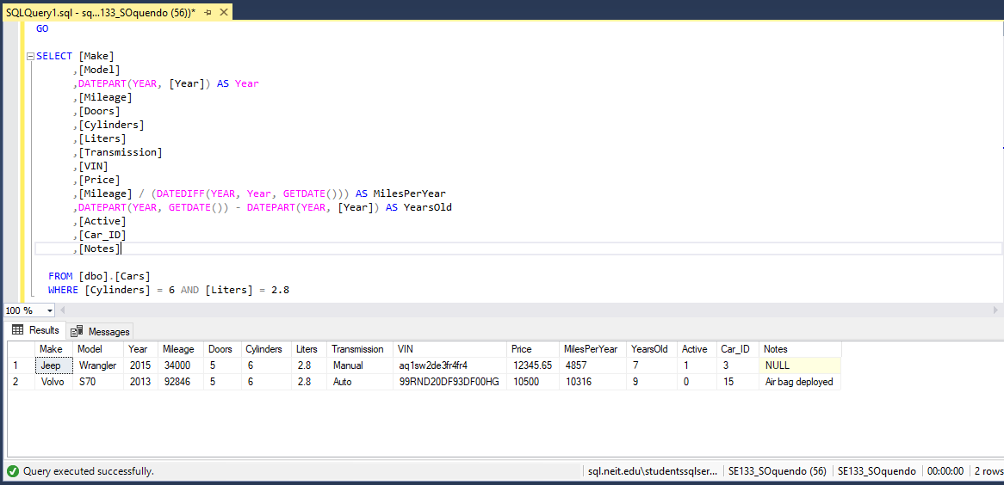
11. Display cars that have 4 cylinders or 1.6 liters.  
    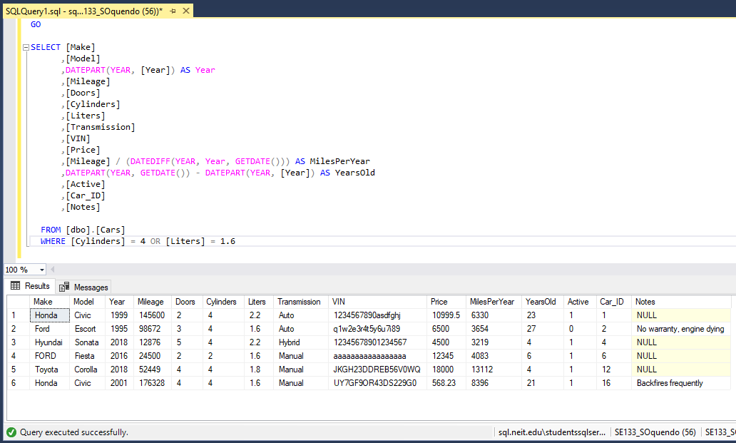
12. Display cars where the Notes field is null. Order by Price (Most expensive to least expensive.)  
    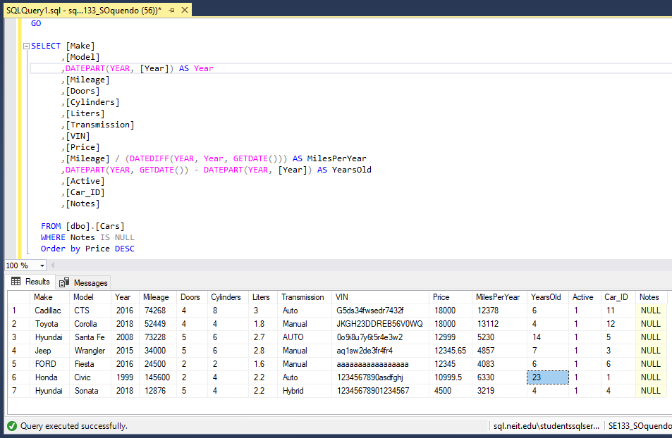
13. Display cars where the Notes field is not null.  
    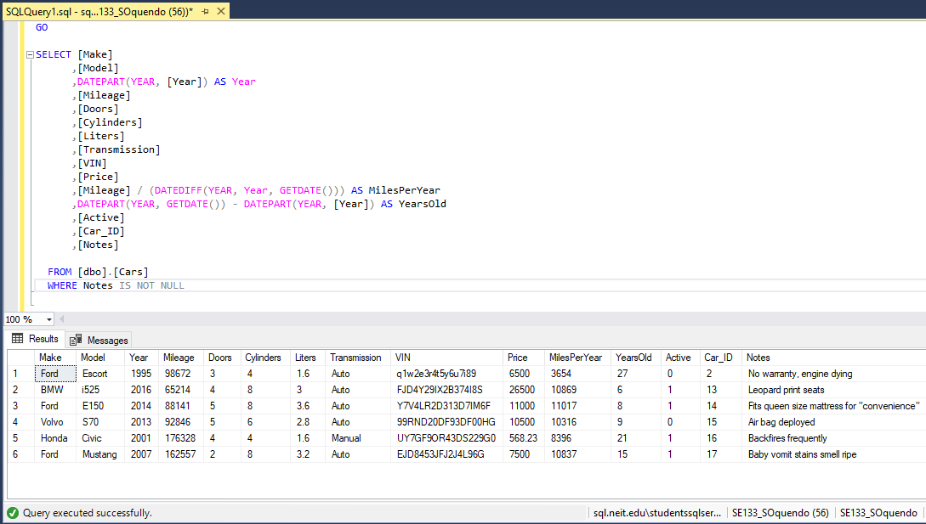
14. Display cars that are not 4 cylinders using “NOT”  
    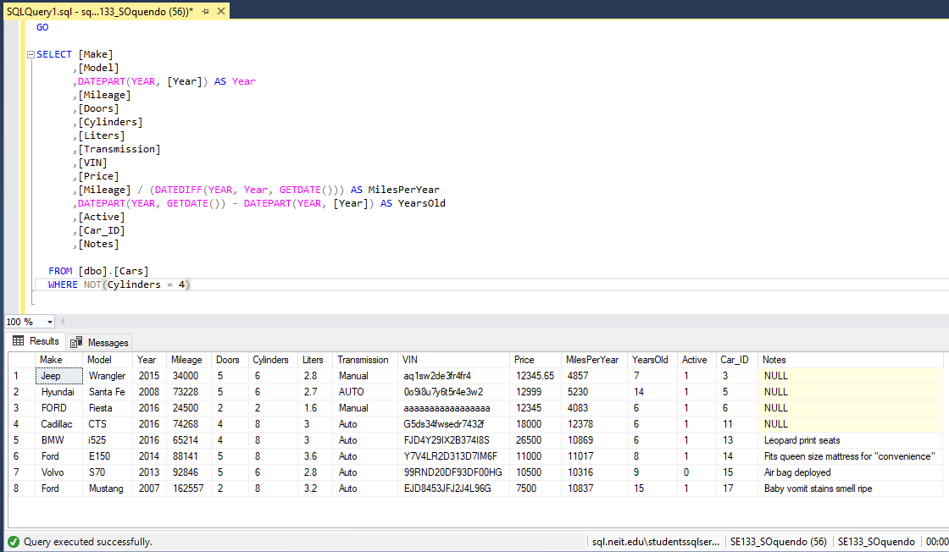
15. Using the “IN” clause, list the cars that are made by Honda, Hyundai, Toyota.  
    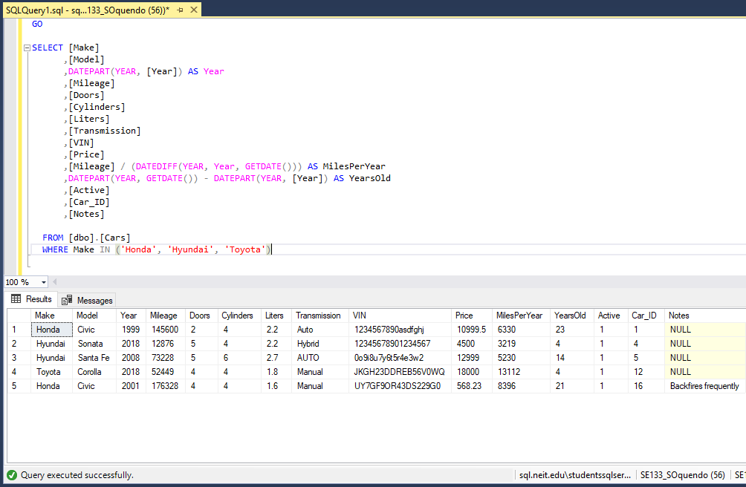
16. Using the “NOT IN” clause, list the cars that are not made by Honda, Hyundai, Toyota.  
    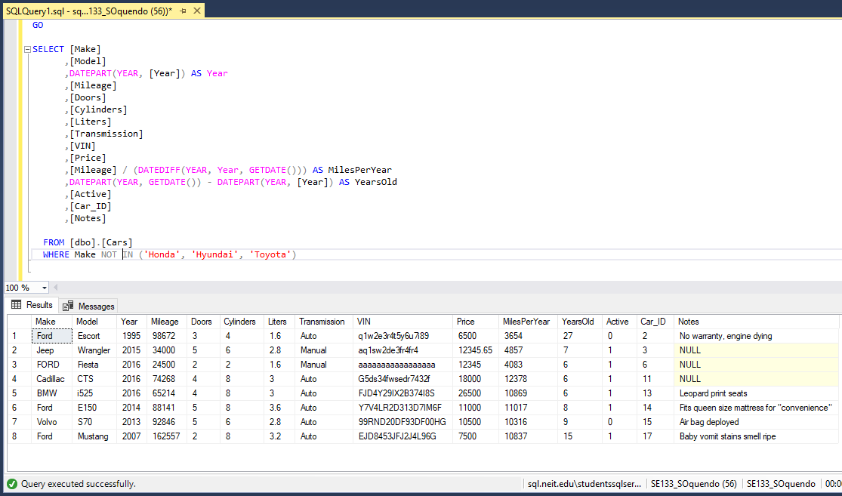
17. List the cars with prices between $5000 and $12500, using the BETWEEN clause.  
    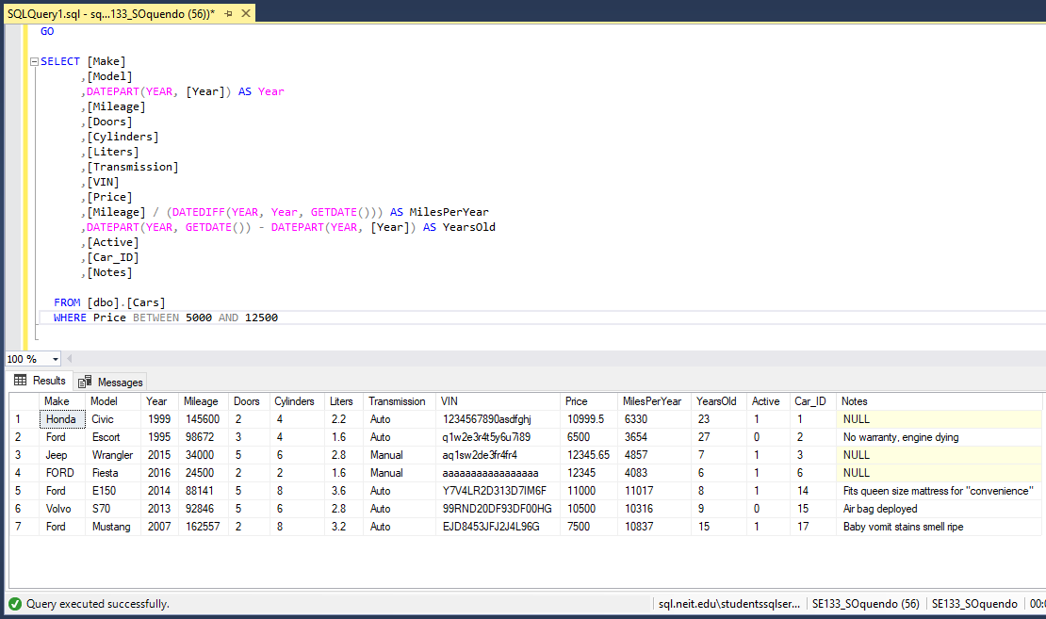
18. List the cars made in years between 9/1/2010 and 9/1/2018, using the BETWEEN clause.  
    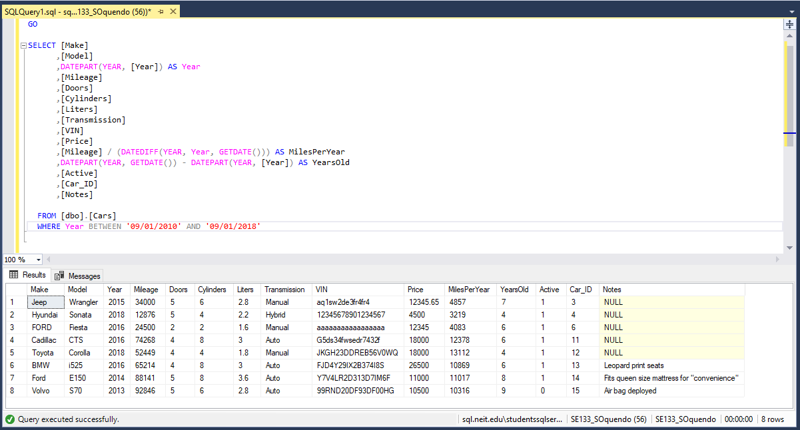
19. List the cars for Models that start with an “S” using LIKE.  
    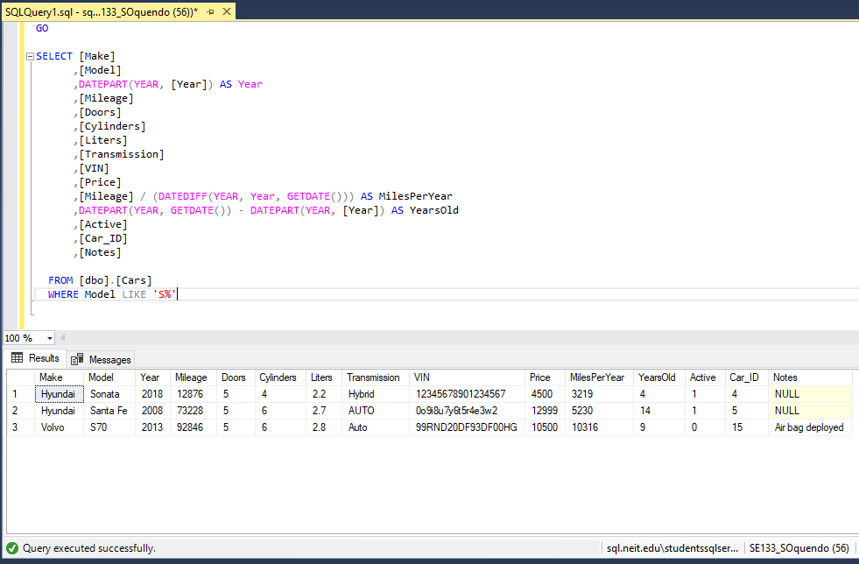
20. List the cars for Models that end with an “A” using LIKE.   
    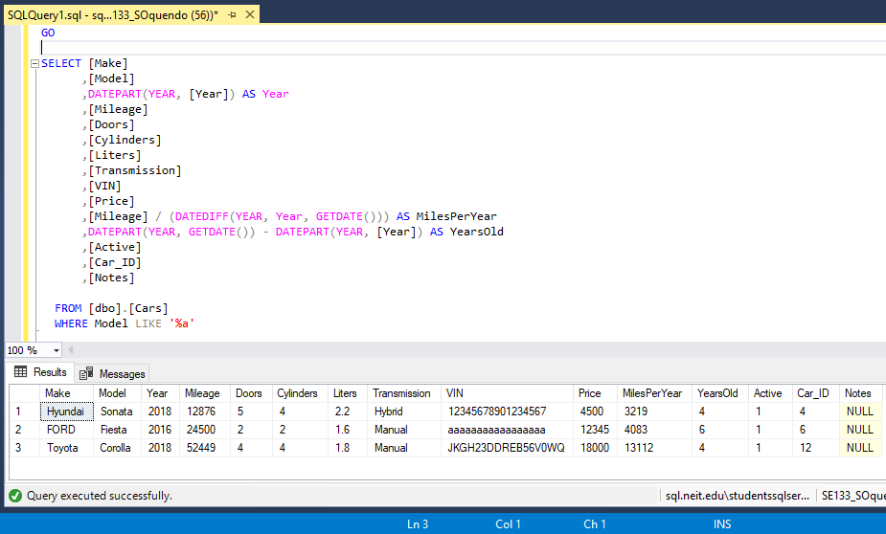
21. List the cars for Models that contain an “N” using LIKE. Order by Make and Model  
    