**Lab 5: Inserting, Deleting, Updating Car Records and Joining Tables**

For every request, show the code for the query, any code calling it, the results below, and a listing of the records so we can see what happened to the data.

1. Display all records and fields for the Products table

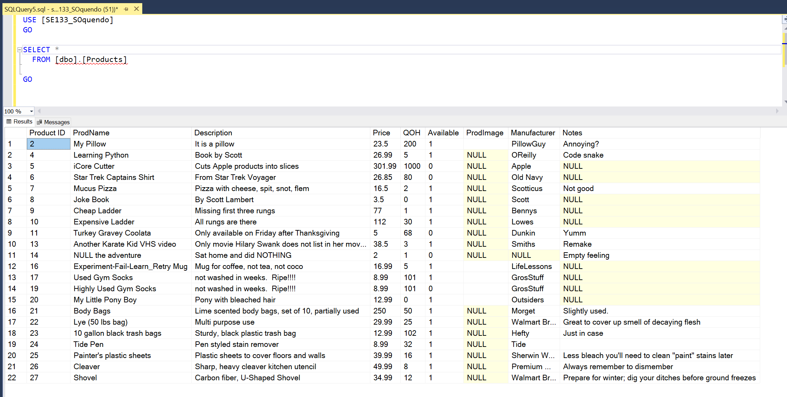

1. Create a SQL Insert query to add a new product to the Products table with the following values:  
   Product Name: Playstation 5 Description: Faster and Cooler  
   Price: 499.99 QOH: 200  
   Available: 1 Manufacturer: Sony  
   Notes: Great for games and as a personal heater in the winter.  
   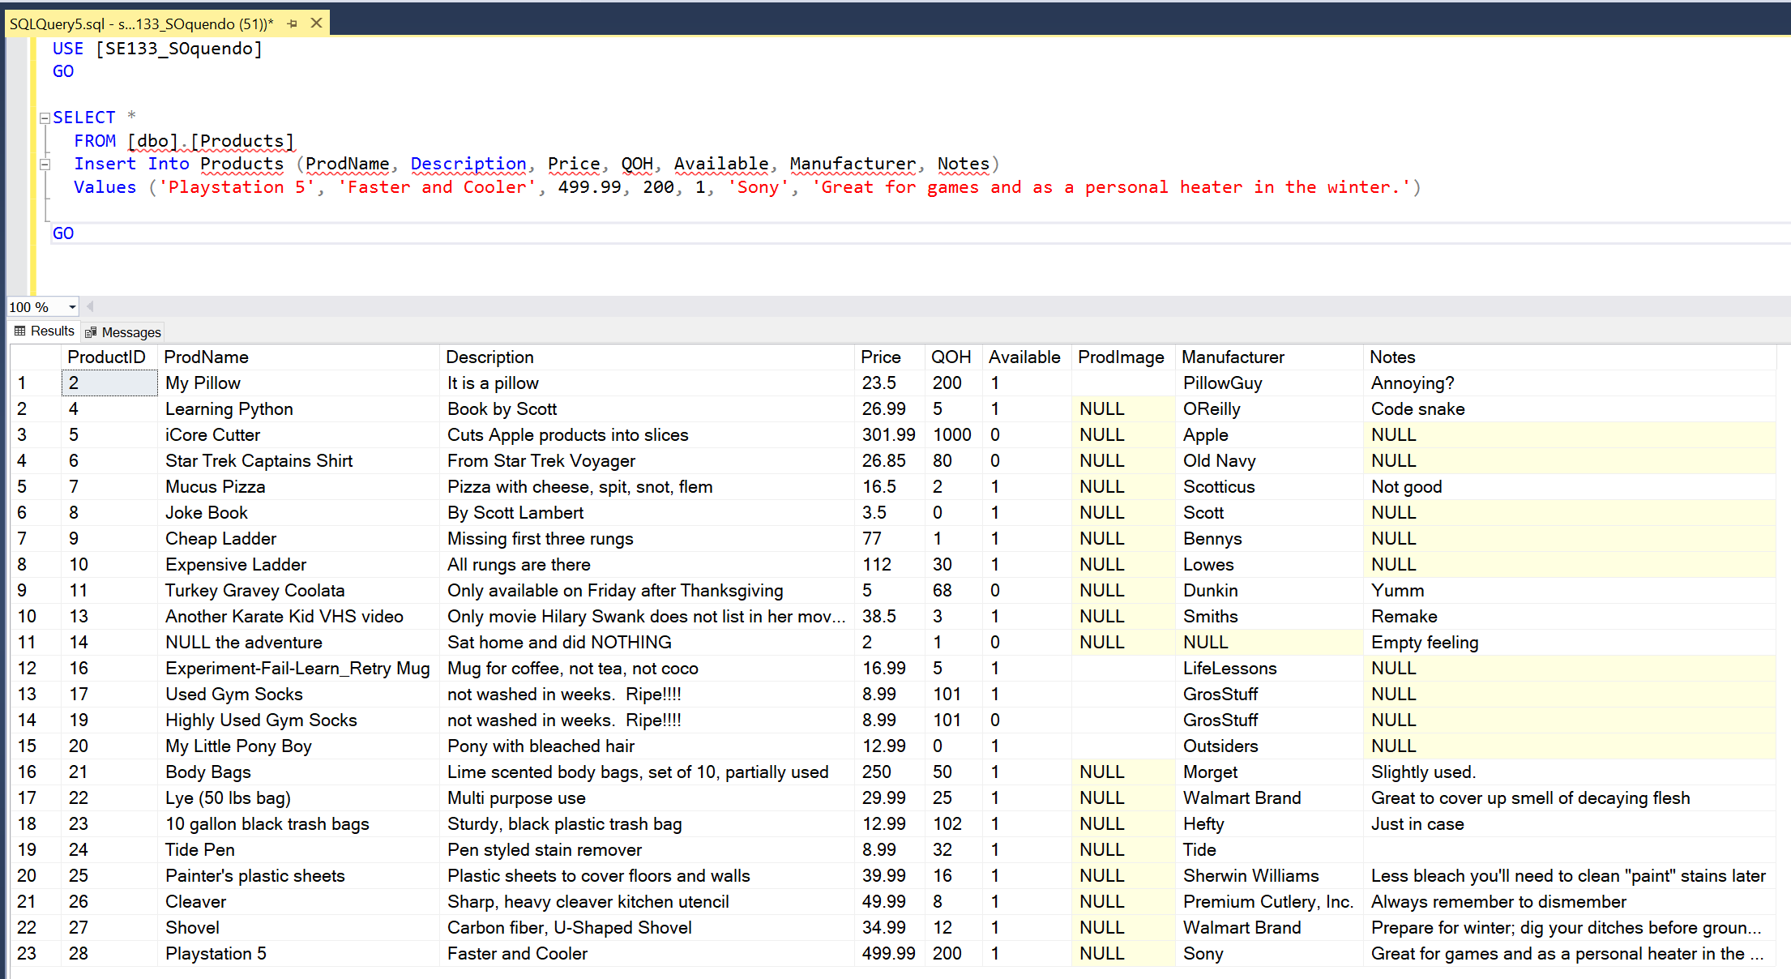
2. Create a SQL Insert query to add a new product to the Products table with the following values:  
   Product Name: Call of Duty 18 Description: The same but different  
   Price: 69.99 QOH: 55  
   Available: 1 Manufacturer: Bungie  
   Notes: Different images and sounds, same game.  
   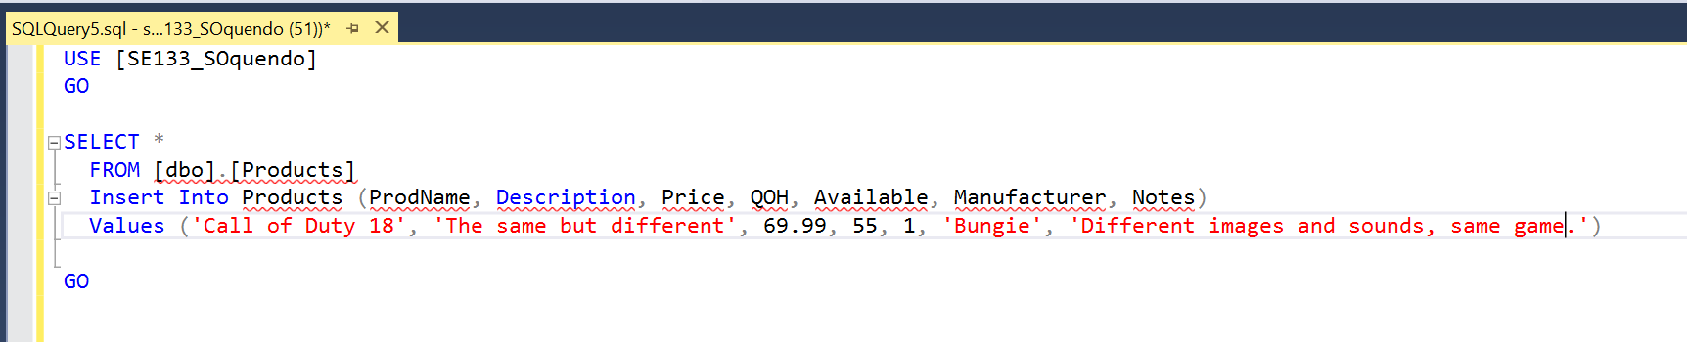

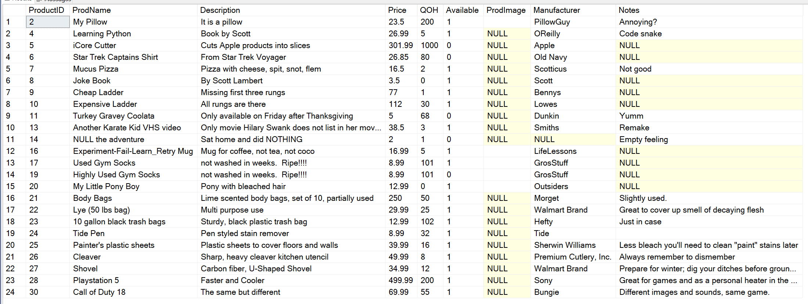

1. Gather the ProductID for the new product created in #2 and create an Update query that will update this new with the following:  
   Price: 450.00 , Notes: Two months later, QOH: 400  
   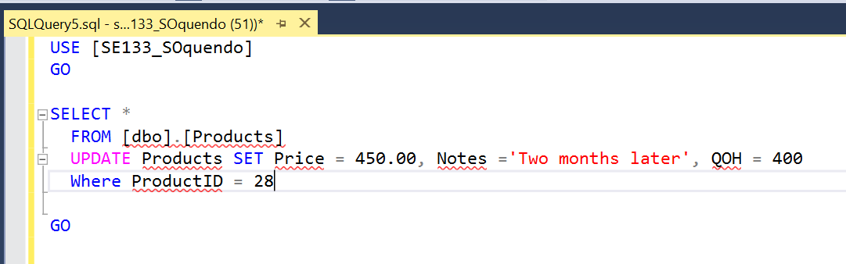

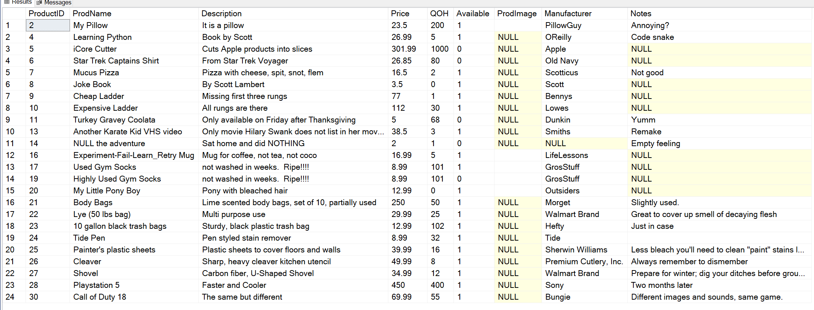

1. Create an Update query that sets all products to UnAvailable (Available = 0).

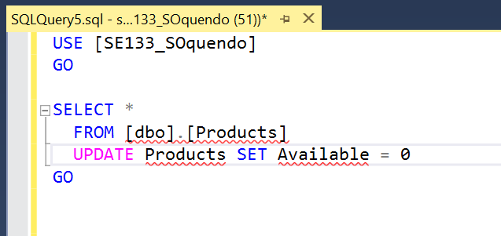

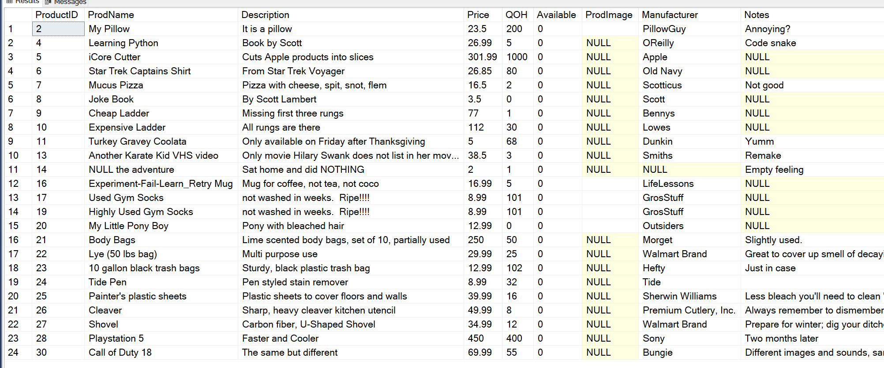

1. Create an Update query that decreases the Price by $50 (Price = Price - 50), if the product has a QOH of 100 or more products.  
   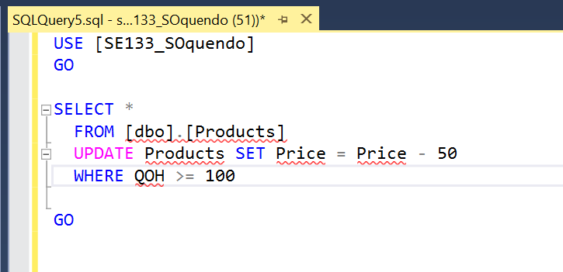

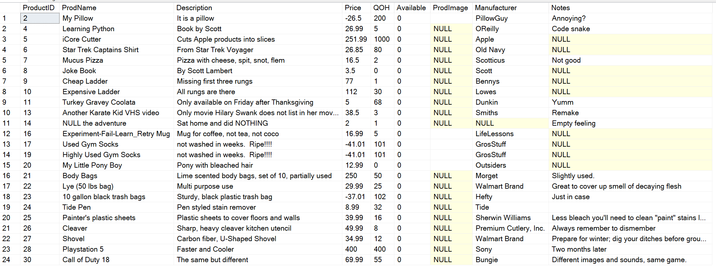

1. Create an Update query that sets a product to Available (Available = 1) based on the ProductID.  
   **Bonus (+5)** Create a Stored Procedure that receives a ProductID as a parameter and makes that product Available.

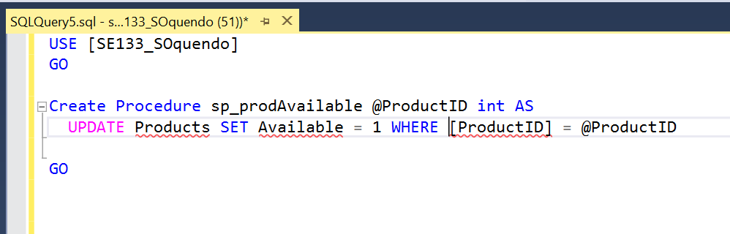

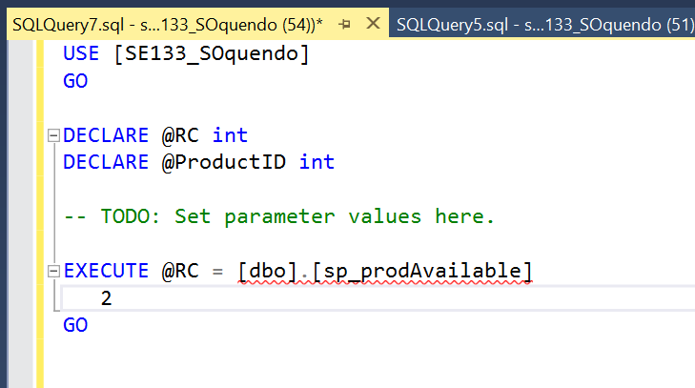

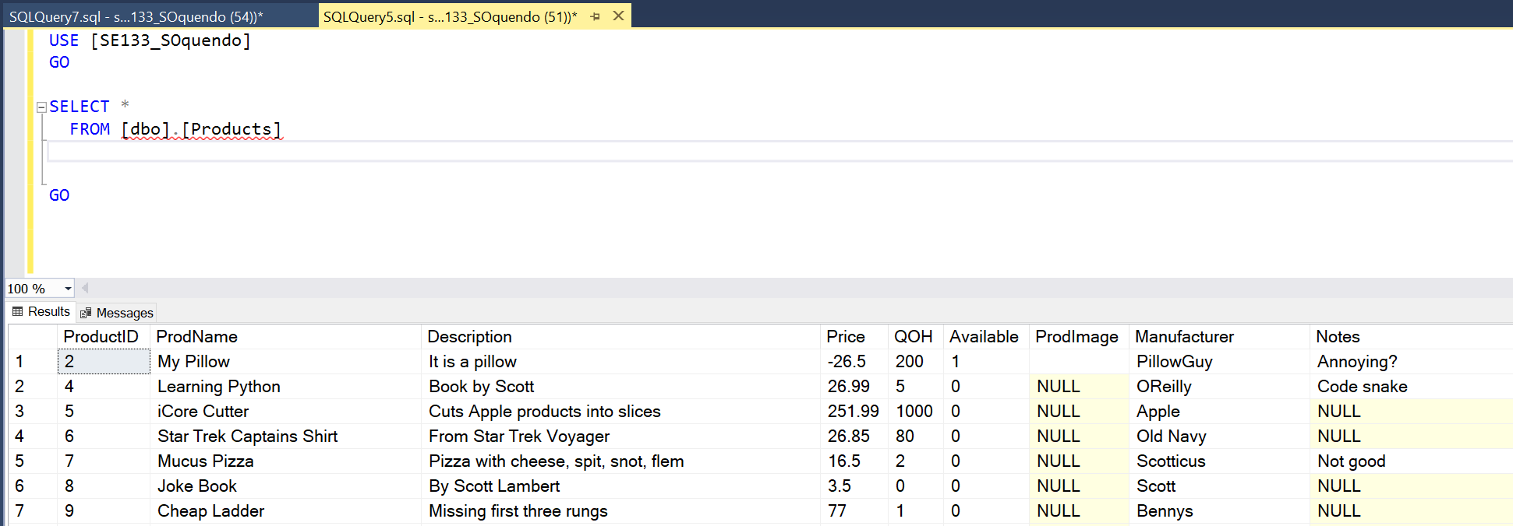

1. Create a Delete query that deletes products based on the specified ProductID   
   **Bonus (+5)** Create a Stored Procedure that receives a ProductsID as a parameter and deletes that product.  
   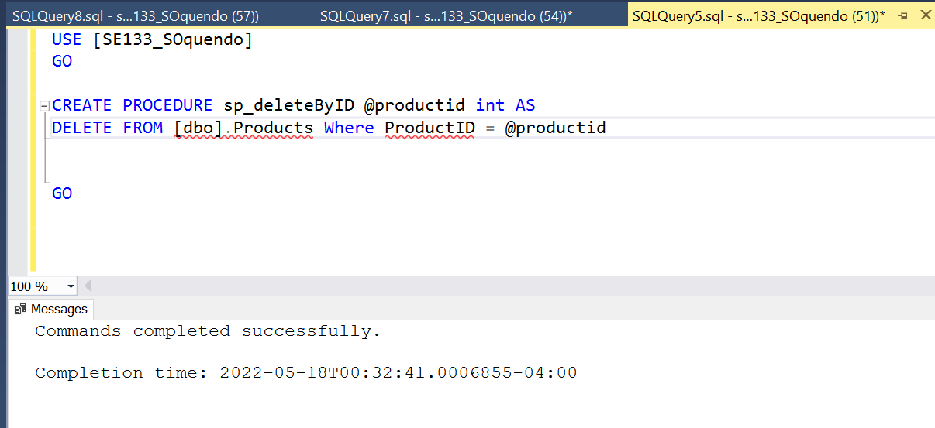

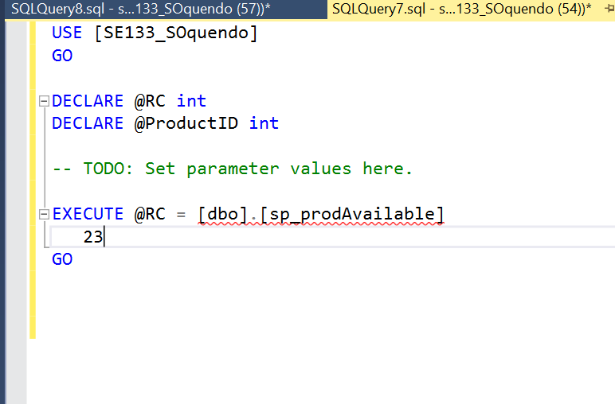



1. Display all records and fields for the Products table.  
   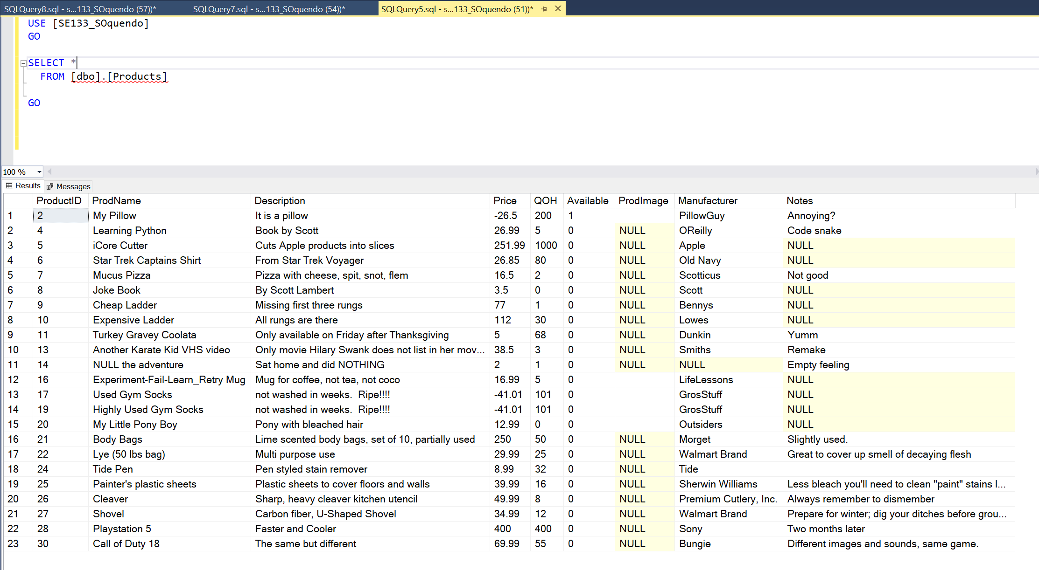
2. Display all records and fields for the Purchases table.   
   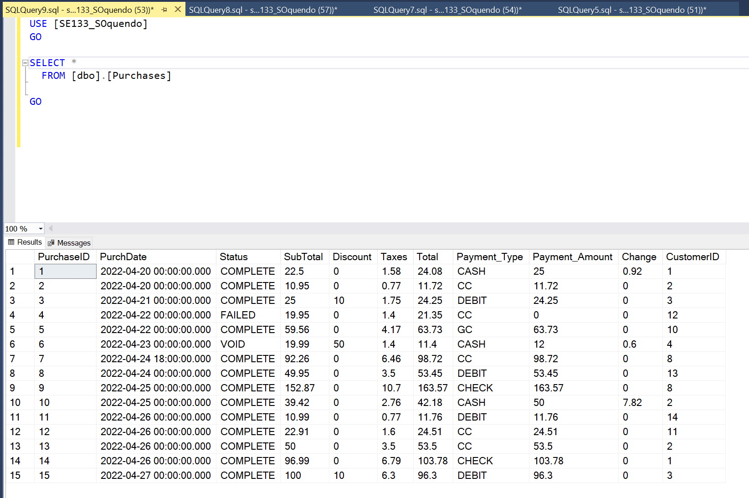
3. Display all records and fields for the PurchasedProducts table.  
   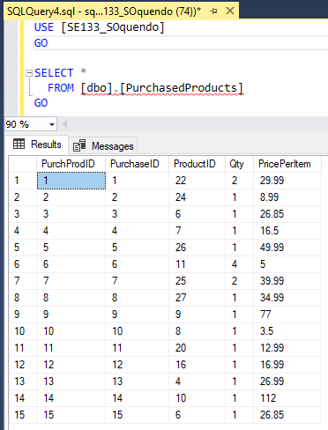
4. Display all records and fields for the Customers table.  
   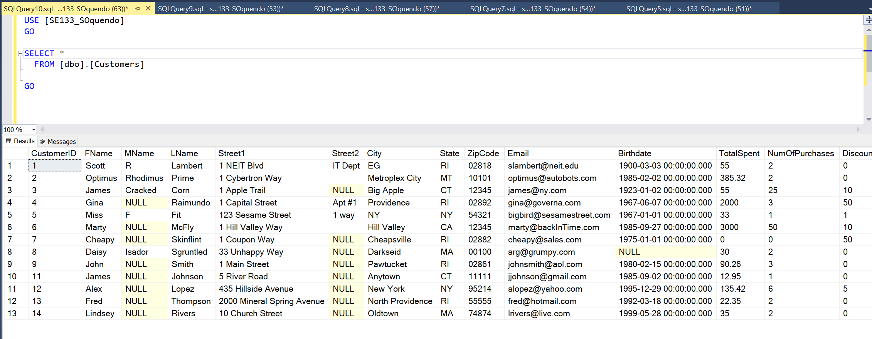
5. Use an Inner Join with the PurchasedProducts and Products tables to list the Manufacturer and ProdName for each purchases recorded in PurchasedProducts.  
   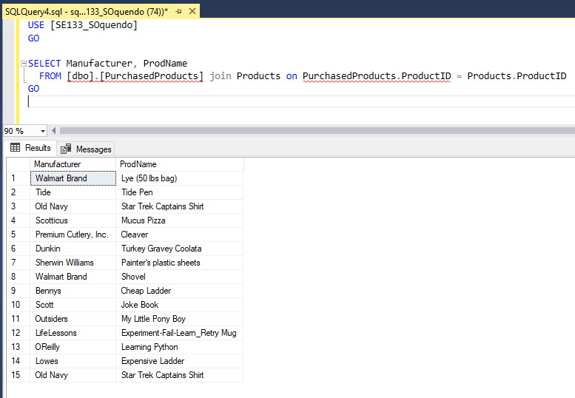
6. Use an Inner Join with the Purchases and Customers tables to list the Customer’s First, Last, and Email for each purchase recorded in Purchases.

