**Lessons 6 & 7 Activity:**

**Inserting, Deleting, Updating Car Records and Joining Tables**

For every request, show the code for the query, any code calling it, the results below, and a listing of the records so we can see what happened to the data.

1. Display all records and fields for the Cars table

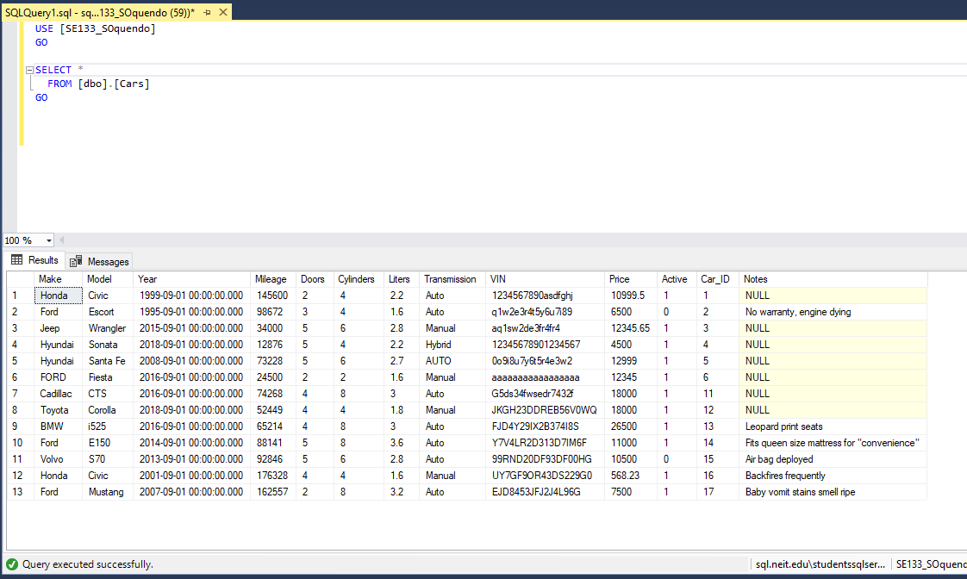

1. Create a SQL Insert query to add a new car to the Cars table with the following values:  
   Year: 09/01/2019 Transmission: Auto  
   Make: Toyota Active: 0 / False  
   Model: Tundra Liters: 3.4  
   Doors: 4 Cylinder: 6  
   Mileage: 34000 Notes: Still gathering car history

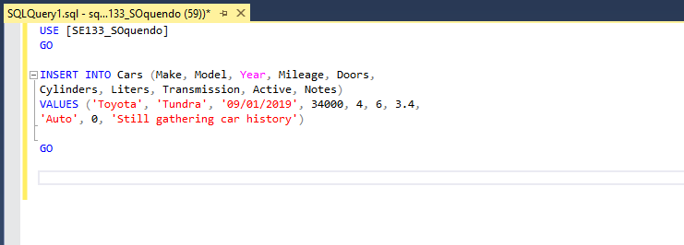

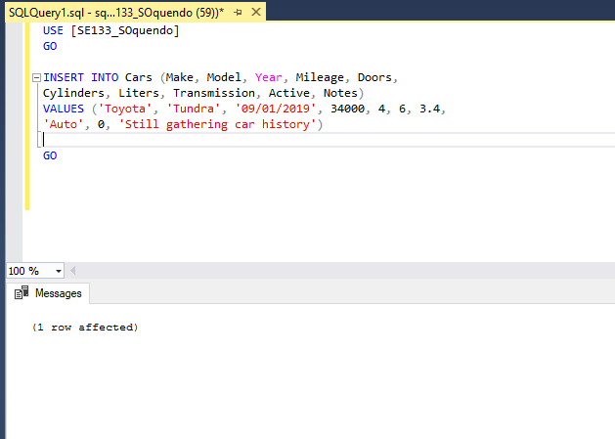

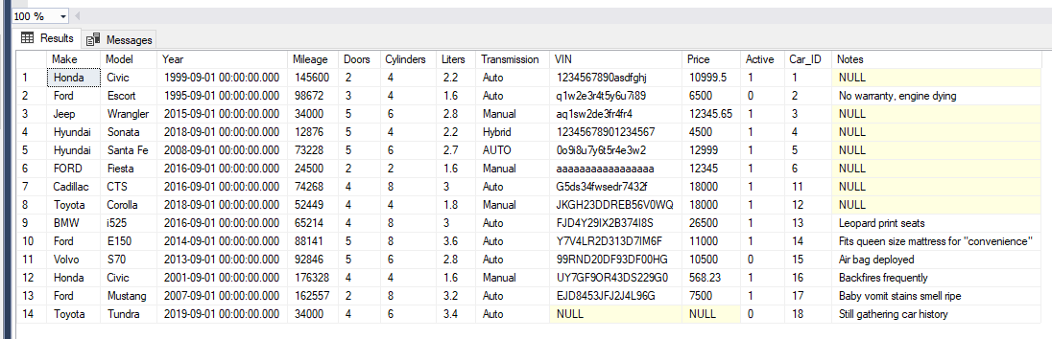

1. Create a SQL Insert query to add a new car to the Cars table with the following values:  
   Year: 09/01/2015 Transmission: Manual  
   Make: Toyota Active: 0 / False  
   Model: Corolla Liters: 2.2  
   Doors: 4 Cylinder: 4  
   Mileage: 56000 Notes: Still gathering car history  
   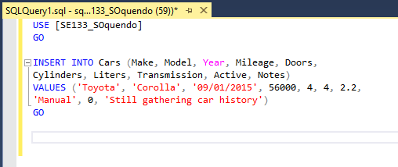

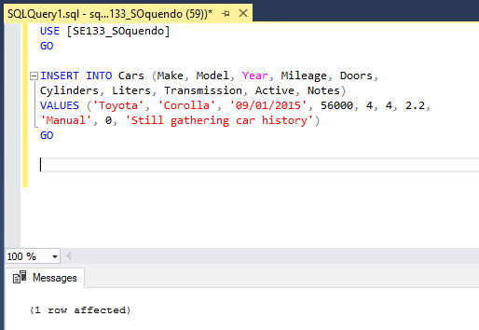

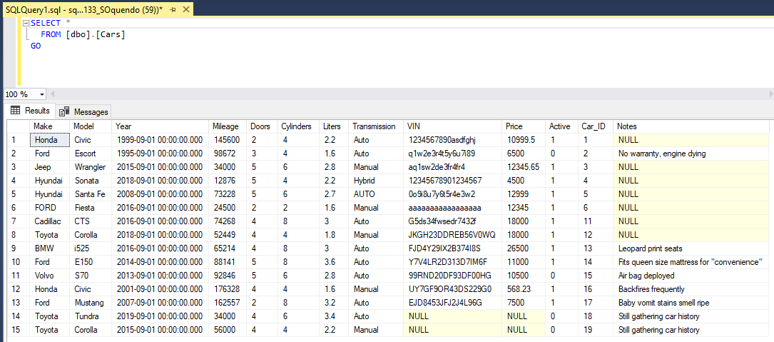

1. Gather the Car_ID for the new car created in #2 and create an Update query that will update this new with the following:  
   VIN: “000DESTRUCT0” , Price: 28999.99 , Notes: Deal! Driven only on Sundays  
   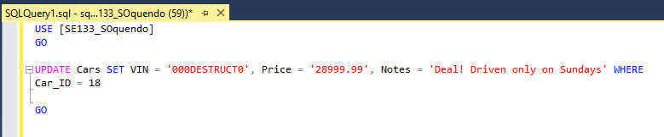

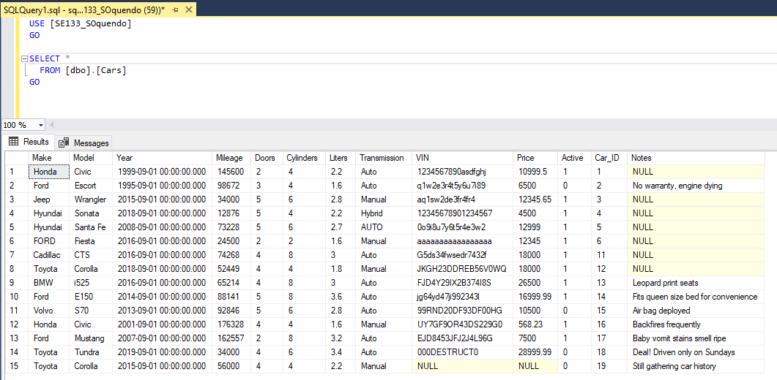

1. Create an Update query that sets all cars to Inactive (Active = 0).  
   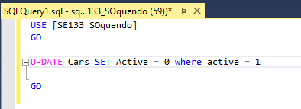

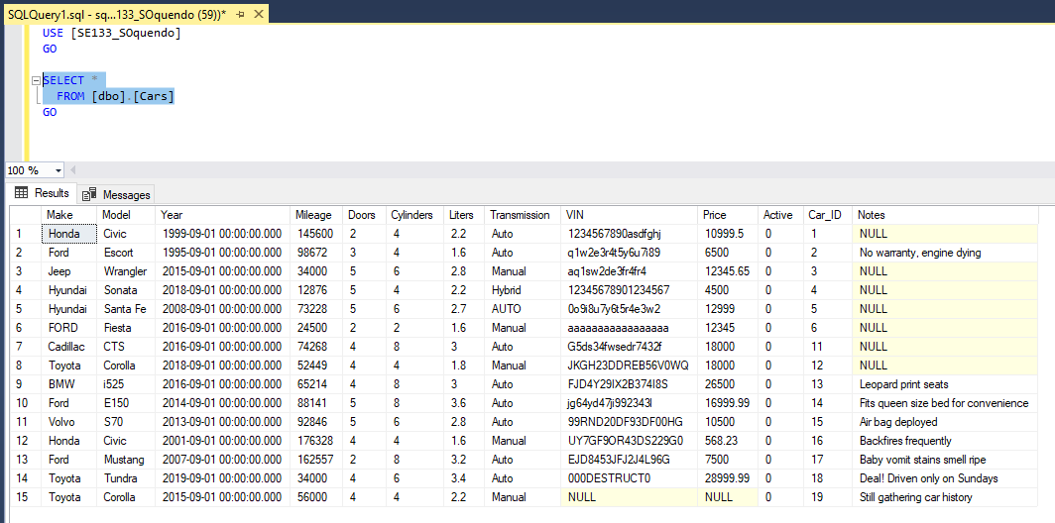

1. Create an Update query that increases the Price by $500 (Price = Price + 500), if the car has 4 cylinders and Transmission is Auto.  
   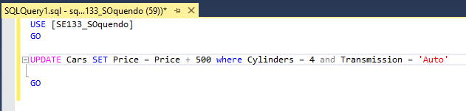

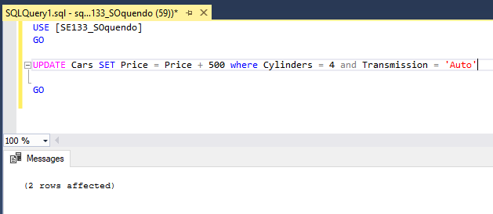

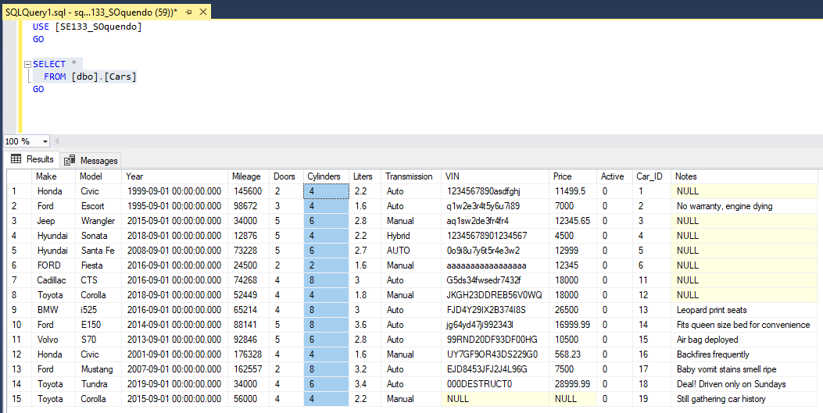

1. Create an Update query that sets a car to Active (Active = 1) based on the Car_ID.  
   **Bonus (+5)** Create a Stored Procedure that receives a Car_ID as a parameter and makes that car Active.
2. Create a Delete query that deletes the Yugo based on the specified Car_ID (Car_ID is 7 on my sample data).  
   **Bonus (+5)** Create a Stored Procedure that receives a Car_ID as a parameter and deletes that car.
3. Display all records and fields for the Cars table
4. Create new table: CarPurchases and show your design below.  
   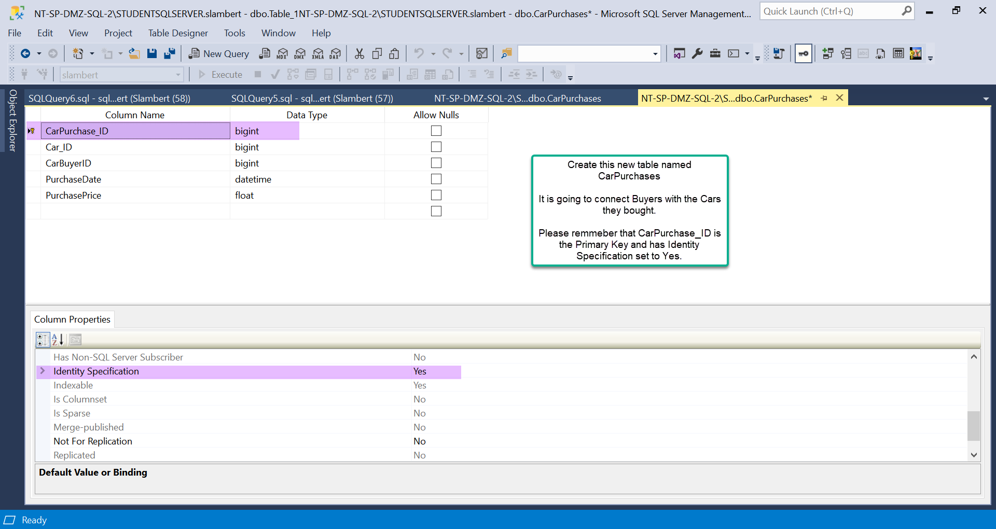
5. Add the sample data shown as well as create 3 new sample records of your own using existing Cars and Buyers. Show all records below.  
   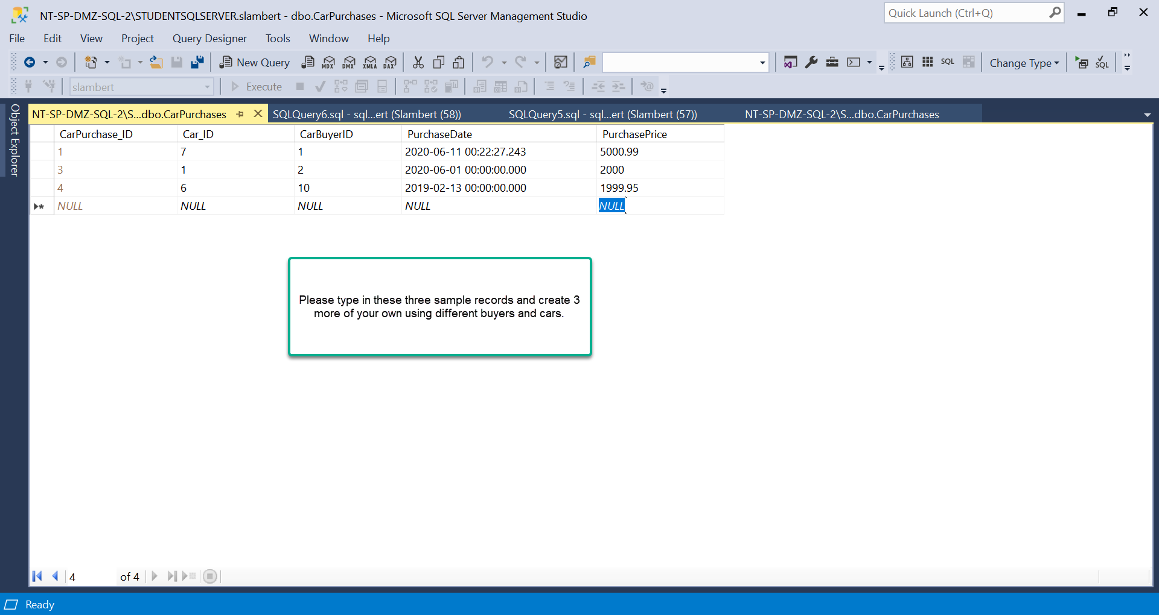
6. Use an Inner Join with the CarPurchases and Cars tables to list the Car’s Make and Model for each purchase recorded in CarPurchases.
7. Use an Inner Join with the CarPurchases and CarBuyers tables to list the Buyer’s First, Last, and Email for each purchase recorded in CarPurchases.